**ÇANKIRI KARATEKİN UNIVERSITY**

**GRADUATE SCHOOL OF APPLIED SCIENCES**

**MASTER'S THESIS**



**THE RELATIONSHIP BETWEEN GROWTH DIFFERENTIATION FACTOR-15 AND TESTOSTERONE HORMONE LEVEL IN PROSTATE CANCER PATIENTS**

**SAIF ABDALAZIZ METEAB BANIDAHIR**

**SUPERVISOR**

**Prof. Dr. Ayşe Şahin YAĞLIOĞLU**

**CO-** **SUPERVISOR**

**Prof. Dr. Maysaa Jalal MAJEED**

**BIOCHEMISTRY /CHEMISTRY DEPARTMENT**

**ÇANKIRI**

**2021**

**All rights reserved**

**THESIS APPROVAL**

The thesis **"The Relationship between Growth Differentiation Factor-15 and Testosterone hormone level in Prostate Cancer Patients"** prepared by **Saif Abdulaziz Meteab BANIDAHIR** was unanimously accepted by the following jury as a MASTER THESIS in the Department of Biochemistry at Çankırı Karatekin University Institute of Science and Technology..

**Supervisor:** Prof. Dr. Ayşe Şahin YAĞLIOĞLU

**Co-supervisor:** Prof. Dr. Maysaa Jalal Majeed

**Committee Member**

**Prof. Dr. ……………………………**

**........... University**

**Committee Member**

**Assist. Prof. Dr. ………………………**

**……… University**

**Committee Member**

**Assos. Prof. Dr…………………………**

**……. University**

**I confirm the results above**

**Pro. Dr. Ibrahim ÇİFTÇİ**

# Director of the Institute

**I hereby declare that all information in this document has been obtained and presented in accordance with academic rules and ethical conduct. I also declare that, as required by these rules and conduct, I have fully cited and referenced all material and results that are not original to this work.**

**Saif Abdalaziz Meteab BANIDAHIR**

**1**

**ÖZET**

Yüksek Lisans Tezi

Prostat Kanserli Hastalarda Büyüme Farklılaşma Faktörü-15 Ile Testosteron Hormon Düzeyi Arasındaki İlişki

Saif Abdalaziz Meteab BANIDAHIR

Çankırı Karatekin Üniversitesi

Fen Bilimleri Enstitüsü

Biyokimya /Kimya Anabilim Dali

Danışman: Prof. Dr.Ayşe Şahin YAĞLIOĞLU

Eş-danışman: Prof. Dr. Maysaa Jalal MAJEED

Prostat kanseri (PCa), birçok ülkede, özellikle Asya'da sık sık erkeklerin ölümüne neden olan ve sürekli artış gösteren yaygın deri dışı kötü huylu bir kanser türüdür. Bu nedenle, hastalığın sonucunu ve tedavinin etkinliğini tahmin etmek için prognostik belirteçlere ihtiyaç artmaktadır. Çalışma kapsamında, hasta grubu olarak 70 erkek vakanın ve kontrol grubu olarak 30 erkek vakanın serum ve klinik verileri toplandı.. Serum büyüme farklılaşma faktörü 15 (GDF15), prostata özgü antijen (PSA), toplam serum testosteron, folikül uyarıcı hormon (FSH) ve C ‑ reaktif protein (CRP) değerleri BioTek Elisa ve Roche Cobas c 311 kullanılarak test edildi. PCa hastaların serumlarında hastalık ilerlemesine bağlı olarak, GDF-15 seviyelerinde bir artış belirlendi. Ayrıca, PSA seviyelerinde önemli bir artış gözlenmekle birlikte, serum toplam testosteron ve FSH seviyelerinde küçük bir azalma eğilimi tespit edildi. Pearson Ölçeği ile ilgili olarak, prostat spesifik antijen (PSA) seviyeleri ile serum GDF-15 arasında pozitif anlamlı (P <0.0023) korelasyon görüldü. Ek olarak, serumdaki C-reaktif protein (CRP) seviyesi ile hastalık süresi arasında pozitif (P <0.002) bir korelasyon tespit edildi. Sonuç olarak, artan (GDF-15), PSA ve vücut kitle indeksi (VKİ) ile PCa riski arasında güçlü bir ilişki görüldü. Ayrıca prostat kanserinin, FSH ve toplam testosteron seviyelerinin düşüşü ile ilişkili olduğu gözlendi. Bu çalışmada, PCa'da prognostik biyolojik belirteçler olarak GDF15 ve PSA incelemelerinin kullanılabilineceği tespit edildi. Ayrıca hastalığın ilerlemesini belirlemektedir.

**2021, 71 sayfa**

# Anahtar Kelimeler: Prostat kanseri, GDF-15, Toplam testosteron, PSA, S. C.R.P, FSH, Roche Cobas c 311, Prognostik belirteç

# ABSTRACT

Master Thesis

The Relationship between Growth Differentiation Factor-15 and Testosterone hormone level in Prostate Cancer Patients

SAIF ABDALAZIZ METEAB BANIDAHIR

Çankırı Karatekin University

Graduate School of Applied Sciences

Department of Chemistry/Biochemistry

Supervisors: Prof. Dr. Ayşe Şahin YAĞLIOĞLU

Co-Supervisor: Prof. Dr. Maysaa Jalal MAJEED

Prostate cancer (PCa) is a common non-skin malignancy disease that frequently causes death males and the burden of this cancer continuously elevating in many countries and especially Asian. Hence the need to find prognostic markers to predict aggressiveness, patients’ outcome, and efficacy of treatment are raising.We analyzed serum and clinical data from 100 case divided in to 70 men as patient group and 30 men as control group . Serum growth differentiation factor 15 (GDF15), prostate specific antigen (PSA), total serum testosterone, follicle-stimulating hormone (FSH) and C‑reactive protein (CRP) were assayed by BioTek Elisa and Roche Cobas c 311. In Serum PCa patients with continuously disease progression were Levels of GDF-15 elevated.There was a significant increase PSA levels with prostate cancer patients with old injury but observed a trend to tiny depression in levels of serum total Testosterone and FSH. Concerning to the Pearson Scale there were positive significantly (P < 0.0023) correlated between serum GDF-15 with Prostate-specific antigen (PSA) levels. In addition, there were a positive significantly (P <0.002) correlated to the duration of the disease with the level of C-reactive protein (CRP) in serum. In our conclusion, a strong correlation was observed between increasing (GDF-15), PSA and body mass index (BMI) with PCa risk. Also, Prostate cancer patients was related to depress FSH and total testosterone levels. The present thesis reinforce the use of GDF15 and PSA examinations as prognostic biomarkers in PCa and in determining disease progression.

**2021, 71 pages**

**Keywords:** Prostate Cancer, GDF-15, Total Testosterone, PSA, CRP, FSH, Roche Cobas c 311, Prognostic marker

# ACKNOWLEDGMENTS

God the AL-mighty be thanked for assisting me in my studies and providing me with the ability to complete my thesis. I'd like to express my heartfelt appreciation to my supervisor, Prof. Dr. Şahin YAĞLIOĞLU, for her guidance and encouragement throughout the course of writing my thesis. Her inestimable commentary on the thesis chapters enriches the entire work and her words always encourage me to work hard. This thesis is the fruit of my collaboration with my supervisor, Prof. Dr. Ayşe Şahin YAĞLIOĞLU. Once again I thank her sincerely and appreciate her. My deep thanks go to the Chemistry Department Head and to all of the Department's teachers. Additionally, I would like to express my gratitude to secondary supervisor Prof. Dr. Maysaa Jalal Majeed for assisting me in revising and editing my thesis. I goes my special love and thanks to my dear wife and my children for being with me every step of the way and for sharing my good and bad day. I thanks to all of my family that make life so much better. Mother, brothers and sisters thank for being with me every step of the way and for sharing my good and bad day and always reminding me of what is really important.I also want to thank my friends for being very instrumental in different parts of my thesis. I thanks to Omar Zedan Khalef, Eesee Abduljabbar and Dr. Saman Juma for all the good times for enlightening discussions and ideas.

**SAIF ABDALAZIZ METEAB BANIDAHIR**

ÇANKIRI, 2021

**SYMBOLS OF ICONS**

- Minus

% Percent

/ Divide

+ Plus

° Degree

µg Microgram

I- Iodide

Kg Kilogram

m² Square meters

ml Millilitter

mm Milimetre

ng Nanogram

ºC Degrees Celsius

OH Phenolic Hydroxyl

WHO World Health Organization

# CONTENTS Page

**ÖZET…………………………………………………………….………………….. i**

**ABSTRACT…………………………………………………………………….….. ii**

**ACKNOWLEDGMENTS v**

**SYMBOLS OF ICONS vi**

**CONTENTS vii**

**TABLE OF FIGURES ix**

**LIST OF TABLES xi**

**1. INTRODUCTION 1**

**2. LITERATURE REVIEW 3**

**2.1. Prostate Gland. 3**

**2.2. Prostate Cancer. 5**

**2.2.1.** **Etiology and Risk Factors For Prostate Cancer….** **7**

**2.2.1. 1. Age…. 7**

**2.2.1. 2.History Family…. 8**

**2.2.1. 3.Hormones…. 8**

**2.2.1. 4.Race…. 9**

**2.2.1. 5.Diet…. 10**

**2.2.2.** **Classifying and Staging of Prostate Cancer** …. **10**

**2.2.3.** **Prostate Cancer Diagnosis** …. **11**

**2.2.3.1**.**Physician Diagnosis**…. **12**

**2.2.3.** **2. Clinical Diagnosis of Laboratory**…. **16**

**2.2.3.** **2.1. PSA**…. **17**

**2.2.3.** **2.2. Testosterone Hormones**…. **18**

**2.2.3.** **2.3. FSH**…. **19**

**2.2.3.** **2.4. Growth Differention Factor-15**…. **20**

**2.2.3.** **3. Prostate Biopsy** …. **23**

**3. MATERIAL AND METHOD 25**

**3.2. Ethical Approval 25**

**3.2.1. Design of Study… 25**

**3.2.2. Subject… 25**

**3.2.3. Exclusion Criteria… 25**

**3.2.4. Inclusion Criteria… 26**

**3.3. İnstruments Used in the Laboratory Analysis 26**

**3.3.1.** **BioTek Elisa ELx800 (S.N 257381)…..** **27**

**3.3.1.1.Overview…..** **27**

**3.3.1.** **2. Calibration Work and Result Reading** **28**

**3.3.2.** **Roche Cobas c 311 Automated Chemistry Analyzer**.. **28**

**3.3.2.** **1. Overview** **28**

**3.3.2.** **2. Specification**. **29**

**3.3.2.** **3. Calibration work and Result reading** **29**

**3.3.3.** **Centrifuge C- 12000 (6M 1810968)** **30**

**3.3.4.** **Memmert Water Bath (WNE 22) (L513.0977)** **30**

**3.4. Biochemical Kits 31**

**3.4.1.** **Prostate Specific Antigen - PSA(REF 52030)** **31**

**3.4.1.** **1.** **PSA principle** **31**

**3.4.1.** **2.Reagents and Contents** **32**

**3.4.1.** **3.** **Preparation of Reagent** **32**

**3.4.1.** **4.Wash Procedure** **32**

**3.4.1.** **5.Procedure of PSA** **32**

**3.4.2.** **Human GDF15 (Growth Differentiation Factor 15)** **33**

**3.4.3.CRP** **34**

**3.4.4.Testosterone Hormone** **35**

**3.4.5.** **FSH** **37**

**3.5.** **Statistical Analysis** **38**

**4. RESULTS AND DISCUSSION. 39**

**4.1.** **Preamble of Results**.. **39**

**4.2. Age…….. 39**

**4.3. BMI…… 40**

**4.4. GDF15… 41**

**4.5. PSA… 42**

**4.6. C-RP. 43**

**4.7.** **SerumTestosterone and FSH with Prostate Cancer…** **44**

**4.8.** **Pearson Correlation Analysis**.. **47**

**4.8.1.** **Correlation between Studied Parameters** **47**

**5. CONCLUSIONS 49**

**5.1. Recomendation 49**

**6.** **REFERENCES 50**

# LIST OF FIGURES

**Figure 2.1** The localization of prostate gland and other surrounded organs in male system (*Ward A. D. Crukley* *et al.*2012) 3

**Figure 2.2** Graphical shown the normal zonal description of prostatic anatomy illustrates in a sagittal view (Verma and Rajesh 2011) 4

**Figure 2.3** A cross-section of the prostate at the verumontanum level clearly illustration the central, peripheral, and urethral swelling of BPH. The lateral and posterior parts of the prostate are not affected by the nodular process (Foster 2000) 5

**Figure 2.4** Testosterone production under super hypothalamic and pituitary control (Abouhamraa H. 2013) 9

**Figure 2.5** Gleason grades characteristics system(Arvaniti*et al.* 2018) 11

**Figure 2.6** Digital rectal examination (DRE) is a normal piece of prostate cancer (PCa) screening and gives significant prognostic data (Okotie *et al.* 2017) 14

**Figure 2.7** Ultrasound pictures of prostate at exclusive grey ranges. unique image with 265 grey values turned into used to get photos with reduced wide variety of gray (Aarnink *et al.* 1998) 16

**Figure 2.8** The form of FSH-alpha and beta-receiver follicle stimulating hormone (FSH) 19

**Figure 2.9** GDF-15 plays a critical role in a variety of disease states. In Pca, cardio vascular, other cancers, and chronic diseases (Banerjee 2015) 22

**Figure 2.10** The role of GDF15 clear shown in the PCa stages (Vaňhara *et al.* 2012) 23

**Figure 2.11** Directed 2D-TRUS prostate biopsy during decubitus the patient is in dorsal or lateral with local anesthesia. Be entered the TRUS 2D probe into the rectum of patient to place a needle. The strictly attached needle guide ensures that the hole path is located in the American plane. (B) Shows a pistol measuring 18 diameter (1.27 mm diameter). (C) Shows a two-dimensional TRUS image. 24

**Figure 3.1** BioTek Elisa ELx800 27

**Figure 3.2** Roche Cobas c 311 Automated Chemistry Analyzer 28

**Figure 3.3** Centrifuge C- 12000 30

**Figure 3.4** Materials provided and storage for GDF-15 kits 34

**Figure 4.1** A chart showing the relationship between the means patient group and control group given as percentage in Age 40

**Figure 4.2** The percentage difference in BMI levels between the patient and control groups. 41

**Figure 4.3** The percentage difference in GDF-15 levels between the patient and control groups. 42

**Figure 4.4** The percentage difference in PSA levels between the patient and control groups. 43

**Figure 4.5** The percentage difference in CRP levels between the patient and control groups. 44

**Figure 4.6** The percentage difference in Testosterone levels between the patient group and healthy groups 46

**Figure 4.7** The percentage difference in FSH levels between the patient group and healthy groups. 47

**LIST OF TABLES**

**Table 3.1** Apparatuses that are used and the companies supplied them and their origin 26

**Table 3.2** Roche Cobas c 311 automated chemistry analyzer specification 29

**Table 3.3** Materials and Kits that used 31

**Table 3.4** Materials provided and storage for PSA hormones kits 32

**Table 3.5** Procedure of PSA 33

**Table 4.1** Comparison of Clinical characteristic between patients and control in Age, BMI 39

**Table 4.2** Comparison between patients and control in C.R.P, PSA and GDF15 42

**Table 4.3** Comparison between patients and control in Hormones level 46

**Table 4.4** Correlation between Studied Parameters in all Case of Prostate Cancer 48

# INTRODUCTION

Cancer is a disease that affects the way cells in the body divided. Healthy tissue cells divide in an orderly fashion. However, this process may cause in the cells to form double tumor or malfunction in growth. The tumors are benign or malignant. Malignant tumors are cancerous and may spread to other areas of the body(Beilin *et al.* 2001). Prostate cancer (PCa) is the most common form of non-skin malignancy diagnosed in many countries. Accounting for nearly 25% of the total number of male cancer diagnoses in 2014. It is estimated that by 2020 PCa will become the most common form of cancer(National Statistics Office 2014).

Worldwide, more than 913,000 men were diagnosed with PCa in 2008, with two-thirds of these male living in different world’s locations. Today, in the majority of Western European countries, the United States, Australia, and New Zealand, prostate cancer is the most frequently diagnosed form of male specific cancer (Ferlay *et al.* 2010).

Prostate gland has important biological function of reproduction human being through secreting fluids which significant for swimming toward the ova and fertilize it, these secretions are responsible to save and nourish sperm, this sperm is a compound of glucose, protein-splitting enzymes, simple sugared fructose, zinc, and citric acid (Qi. *et al.* 2001).

If the cancer is not treated, the cells may spread to surrounding tissues and destroy them. If some cancerous cells leave the primary cancer and spread to other parts of the body, they may form another tumor known as secondary cancer. This process is called metastasis. Secondary cancers of the organ are not the same with primary cancers that affect this part of the body(Gray *et al.* 2000).

Previous research has shown that Growth Differentiation Factor-15 has the potential to be used as a diagnostic marker for a wide range of disorders, including several types of cancer. In order to develop adequate reference ranges for GDF-15 so that it can serve as a clinically meaningful biomarker, it is necessary to evaluate the severity of the disease and the disease risk strata. GDF-15 is useful for a variety of clinical applications, including ordinary clinical practice, clinical measurement, and it can even help the therapeutic administration of medications. The amount of GDF-15 can be utilized to not only offer diagnostic and diagnostic information, but it can also be used to make clinical judgments about specific disorders. GDF-15 can be used as a single mark or multi-mark approach with another individual mark. There is currently insufficient information about the pathophysiology of GDF-15 in certain diseases that are highly likely to result in death, such as prostate cancer and other types of cancer. (Li *et al.* 2013).

One of the cytokines that is released in reaction to stress is called GDF-15. In both normal and pathological situations, it is highly expressed in vascular smooth muscle cells, cardiomyocytes, adipocytes, macrophages, and endothelial cells. It is also substantially expressed in macrophages. Additionally, the GDF-15 ratio increases in response to tissue injury and inflammation. (Adela and Banerjee, 2015).

From this point, The Aims of this study to provide new data and information about the relationship between GDF15, PSA, and Testosterone for finding new biomarkers and improve prognostic of prostatic cancer that will help in choose a suitable way of therapeutics and improve the management of prostate cancer patients in Iraq. This project will be useful as one of the few ones in this area.

# LITERATURE REVIEW

## Prostate Gland

The urologists have been increasingly interesting on the anatomical structures of the human prostate gland and its relationship to prostate cancer development and prognosis since radical prostatectomy resumed in a long time (*Hammerich* *et al.* 2009).

The creation of prostate gland starts during the third month of pregnancy only in male. The normal structure of the prostate requires 5α-dihydrotestosterone, which is made from fetal testosterone by the action of 5α-reductase. The weighs of the prostate gland in the adult man most probably about 20 grams and its volume is close to the size of a golf ball (4 × 2 × 3 cm) (*Ward A. D. Crukley* *et al.* 2012, Figure 2.1).

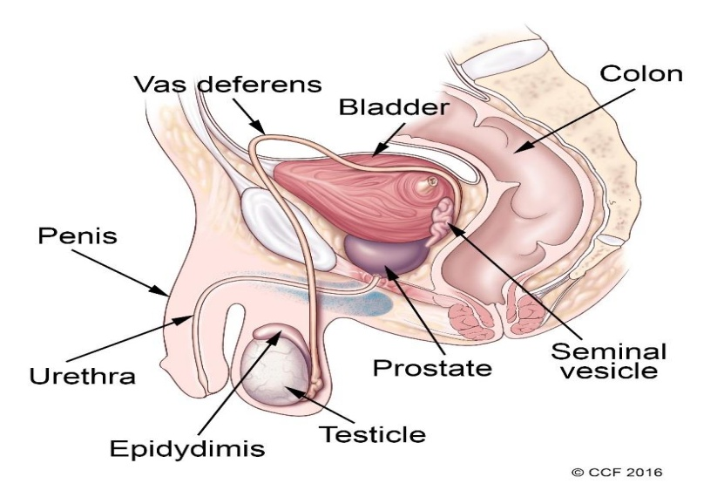

**Figure 2.1** The localization of prostate gland and other surrounded organs in male system (*Ward A. D. Crukley* *et al.*2012)

The region's prostate anatomy is similar to a cone in adults male. The main struction or zones of prostate was illustrated as Figure 2.2.) (Shah and Zhou 2019). Seventy percent of the total volume of the prostate gland is contained inside the cone region. The scoop is located in the middle of the prostate gland in mature males and accounts for 25 percent of the gland. The remaining 5% of the prostate is made up of the transition region, which is composed of two small bulging tissues that form a horseshoe-like shape around the front and side of the proximal urethra (Johnson *et al.* 2014).

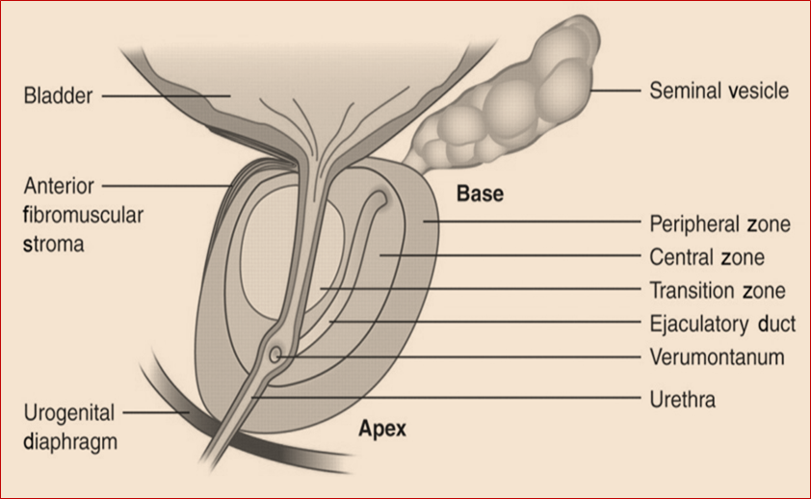

**Figure 2.2** Graphical shown the normal zonal description of prostatic anatomy illustrates in a sagittal view (Verma and Rajesh 2011)

Since the regions of the prostate may be histologically characterized, the distribution of many prostate illnesses can be logically mapped out. Only 10% of glandular tumors begin in the central region, whereas 70% of glandular tumors, also known as adenocarcinomas, originate in the peripheral zone. The transition region is home to 20% of glandular tumors, while the peripheral region is home to 20% of glandular tumors. Cancers of the prostate, also known as prostate adenocarcinomas, begin in the glandular tissues that make up the prostate gland (Thompson and Seay 1997; Figure 2.3).

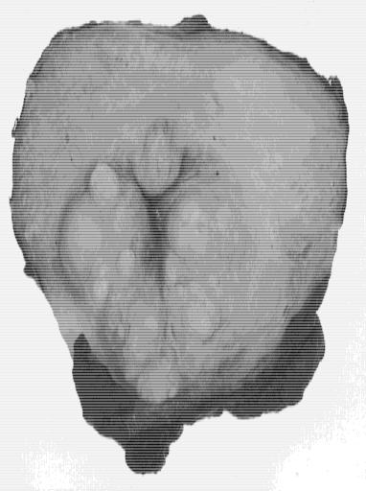

**Figure 2.3** A cross-section of the prostate at the verumontanum level clearly illustration the central, peripheral, and urethral swelling of BPH. The lateral and posterior parts of the prostate are not affected by the nodular process (Foster 2000)

## Prostate Cancer

Prostate cancer (PCa) is categorized as an adenocarcinoma, It begins whilst the cells of the prostate gland that secrete semen into abnormal cells (Tumor cells). The glandular tumor is the most common occur in the peripheral region in prostate gland. Initially, prostate cancer begin with small groups of cancer cells stay confined in the healthy prostate glands, While prostate cancer spread to the lymph system, bones, and other parts(Kyrianou 1994).

In addition to, factors for example, hereditary, diet, inflammation, way of life, infectious agents, and so forth are largely expected agitators for the advancement of prostate malignancy. These causal elements may cooperate or consecutively to start or advance the improvement of disease (Coffey 2001, American Cancer Society 2010).

During the previous three decades, PCa rates in UK, for instance, has been tripled from 33 cases per 100,000 man in 1975 to 97 cases per 100,000 men in 1997, this pattern does not show any sign of undo, the most currently statistics monitored during the previous decade (1998-2008) reveal a 49% increase in diagnoses in England alone. Similar patterns exist in the majority of the western world (Cancer Research UK 2010).

Prostate disorders are generally connected with maturing; as age is expanding, the probability of creating prostate issues is expanding as well, the dimensions of the prostate fluctuates with age, and the youthful prostate couldn't measure up to a more seasoned man. Anatomy is complicated, and the prostate isn't best, which may causes additionally problems in neighboring organs. At the same time, it eliminates the effects of urinary incontinence, impotence and the prostate’s inability to store and secrete fluids. This is because of the anatomical changes to hypertrophy that generally movement with age. Disease of prostate divide in to three sorts Pca , prostatitis and kindhearted prostatic hyperplasia (Macleod *et al.* 2010, Gonzales and Riboli 2010).

**Prostatitis:** Inflammation of the prostate gland's tissue is known as prostatitis. This is by far the most common genitourinary diagnosis in adult males between the ages of 18 and 50. Also, it is possible for injuries to lower ages. In many prostate inflammation cases may be lead to some signs and symptoms like ejaculation and aching urination (Collins *et al.* 1998).

**Benign prostatic hyperplasia**: **BPH** is a very common disease in a male up to 58 years old and rarely a impendence to life. It refers to an enlarged a transitional region in prostate as a result of the non malignant tumors of epithelial cells and stromal as a sequence to rise proliferation. Because of an enlarged prostate, Because enlarged in the prostate, the surrounding tissue layer prevents it from stretching, causing the prostate part of the urethra to be compressed. The transition region is the primary site for the development of benign prostatic hyperplasia, whilst the peripheral region is where the malignant tumors are situated (Zhong *et al.* 2015, Blennerhassett *et al.* 1966).

BPH causes to now are unknown, but it is believed that many potential factors contribute to BPH. Because, Benign prostatic tumors can't appear in the absence of androgen hormones and the application of additional androgens does not raise BPH symptoms. In particular, the dihydrotestosterone (DHT) hormone found in prostate and it derived from the testosterone, it may be play a important role in benign prostatic hyperplasia (Isaacs and Coffey 1989).

Until in older male, the DHT can still be produced in huge proportions and canbe stored in a professional state in the prostate. Benign prostate tumors is generally can treated with some drugs such as five α-reductase inhibitors that make to contract the prostate, then lead to slow its growth or eradicate through the urethra. (Schroder and Blom1989).

In a normal functioning of prostate, cells grow, divide, and die regularly. During differentiation process for the cells in malignant growth will lead to inorrectly aggregation for lymphocytic cells (Nagle *et al.* 1987), During that process, the cells divide uncontrollably and grow due to either the cells are not subject to their systemic death of cells or divide very quickly. In some instances, cancer cells were able to spread to neighboring organs like the bladder and seminal vesicles, and in more advanced cases, the disease could spread to other areas of the body (Coffey and Pienta1987).

### Etiology and Risk Factors For Prostate Cancer

In addition to using DRE for early identification of prostate cancer and performing an appropriate PSA and TRUS examination, beside physicians should be also think about predisposing elements in the evolution of this malignant disease(National Comprehensive Cancer Network 2004).

#### Age

The age has been noted already is the most important factor to the occurrence of prostate cancer. previous study proved that < 1% of prostate cancer has been showed in men under 50 years of age, 16% has been detected in men between 50 and 64 years old, while the residual 83% has been showed in men > 64 (Miller *et al.* 1992). Consequently, it is highly recommended to annual malignant tumour scans for 50 and more years old men . However, this Recommendation should be weighed against the affected individual's health and survival (Haggstrom 2013).

#### History Family

Recently, family history has been recognized as a significant danger factor for Pca. Around 20% of patients with prostate cancer have a family history of the disease, but it may develop not only due to genetics, but also due to similar exposure to certain environmental carcinogens and common lifestyle behaviors. (Carroll PR 2002). In a case study and evidence, it was found that 691 males with a first-degree relative who had prostate cancer were more likely to develop 31 malignant prostate cases than those who did not have a family history of Pca. This was contrasted to persons who did not have a family history of Pca. In addition, the likelihood of contracting the disease rises in tandem with the number of family members who have been afflicted, which results in a five- to elevenfold increase in the likelihood of prostate cancer in men who have two or three first-degree relatives (Steinberg *et al.* 1990). It turned out to be certain that the men with a family background of the diseaese must to go through recognition endeavors similar with their high-risk condition given the current 10% age risk of developing prostate (Shen *et al.* 2020).

#### Hormones

Interstitial cells, also known as Leydig cells, from the testicle are responsible for the production of the majority (> 95%) of the hormones that are necessary for the normal functioning of the prostate during puberty. The adrenal glands are responsible for the production of the remaining 5% of the hormones. The hormones play an important role in the normal functioning of the prostate during puberty. Synthesis of androgen hormones begins in the hypothalamus. Androgen hormones such as lutein hormone, follicle-stimulating hormone, and other hormones are synthesized by releasing the gondotropin-releasing hormones in the hypothalamus, which in turn serves to stimulate the pituitary gland to secret these hormones. (Figure 2.4) (Tucci *et al.*2009).

All methods of hormonal treatment of cancer metastasis are the final common pathway for reducing circulating testosterone. Symptoms of sexual dysfunction in male with an abnormally low level of testosterone include loss of desire for sex, difficulty achieving full erection, the need for prolonged stimulation to reach orgasm, low semen volume, and often reduction of the resulting pleasure during the foreplay of the penis and orgasm (Schover 1987).

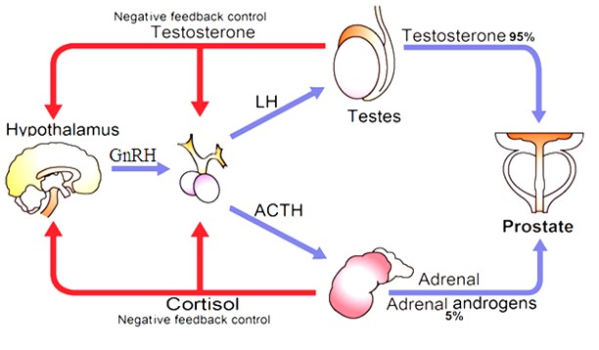

**Figure 2.4** Testosterone production under super hypothalamic and pituitary control (Abouhamraa H. 2013)

#### Race

Available data on this subject are inconsistent, though it appears that race has no relationship to poor prostate cancer outcomes. However,the critical question, is whether factors such as grade, stage, and other clinical criteria can be used to demonstrate black males' poor outcomes. This is accomplished by using data from a medical center that is equivalent to the one in question, which allows for the reduction of care disparities and the acquisition and explanation of specific clinical characteristics in greater detail. Even after accounting for clinical factors, black males have a higher risk of having prostate-specific antigen (PSA) repetition after radical prostatectomy in an environment with equal access. As a result, these findings supported the hypothesis that a black race is associated with aggressive prostate cancer(Gaines *et al.* 2014).

#### Diet

Although there have been some investigations into nutrients in the epidemiology of prostate cancer, little is currently known about their specific role. Overall, nutrients suggested from previous case and control studies with a possible role in prostate cancer had little effect on these data. No association was found between prostate cancer and lifestyle of eating, such as, consumption of meat, fish or milk. There was some evidence that men who consumed greater amounts of butter, margarine, and cheese had an inverse link with PCa (Severson *et al.* 1989).

### Classifying and Staging of Prostate Cancer

The pathologist and physicians depend on the Gleason Scoring System. The scoring system was found in 1966 by Gleason for the diagnosis the stage of the prostate cancer. The scoring system was updated in the last century in the years 1974 and 1977, respectively (Gleason 1992). The Gleason scoring system is separated the men's prostate cancer in five categorizations depending on the aggression. The aggression is categorized as a result of the morphological details that are shown on the needle-biopsy or samples get from the section of the prostate gland. According to the Gleason Grading system, there are five stages of aggression starting from level one until level five where level one is the minimum and level five is the maximum (Catalona 1982, Figure 2.5.)**.**

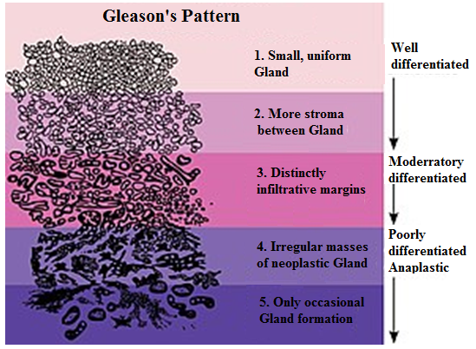

**Figure 2.5** Gleason grades characteristics system(Arvaniti*et al.* 2018)

From Figure 2.5, it has been found that there are clear differences observed in gland structure between spots annotated by various Gleason pattern. The benign spots in the prostate gland showed that contained to a good configuration outer layer of basophils, these revealed no evidence of cytological atypia (Arvaniti *et al.* 2018). The histological assessment of human tissues - based on the optical estimation based on microscopic examination of non-trivial cellular and morphological patterns is time-consuming and often suffers from restricted reproducibility. Therefor PCa in particular, it can be very difficult to identify Gleason patterns 3 and 4 related medium severity unequivocally(Arvaniti *et al.* 2018, Fuchs and Buhman 2011).

* In the Gleason 3 patches, the prostate glands are variable, but therewith round and well created.
* In Gleason 4 patches, it is noted compact glands, which are small and irregular, In addition an implicit gametophyte.
* In Gleason 5 stains, it found mostly no gland formation and solid sheets of the tumor.

### **Prostate Cancer Diagnosis**

Pca diagnosis depends upon asymmetry in the prostate gland that has shown by many pathways such as digital rectal examination , biopsy and prostate cancer level. DRE is a performed by urologist uses to check tangible changes When a relative enlargement of the prostate gland occurs (Selly *et al.* 1997). Another constraint is that most tumors happen in zones that are not reachable by DRE. The Transrectal Ultra sonography (TRUS), computerized tomography (CT) and magnetic resonance imaging (MRI) may be used for the clinical diagnosis of prostate cancer. The imaging has extended from the portrayal of cutting edge or metastatic cancers to involve marking of a tumor inside and outside the prostate, including anatomical and logical anatomy that provides basic primary information (Cupp and Oesterling 1993).

A strong need remains for an effective methodology of not only detecting but providing an accurate prognosis for PCa. Although the yearly estimate of PCa does not need to start until the age of 50 in most men only but checking at an early ageemay be justified in men at high risk (Moskalik 2001).

#### **Physician Diagnosis**

Over the past century, physicists have focused on continuous innovation in terms for imaging techniques that help radiologists to development of the diagnosis techniques of prostate cancer and other kinds of cancers (Downer *et al.* 2017). However, human diagnosis still suffers from faulty disclosure or explanations distortions during clinical decisions. There are two main reasons cause of these errors (Hambrock *et al.* 2013). First, be aware of restrictions, such as limited human visual perception, fatigue, or distraction. Another reason is the complexity of clinical cases, which can be caused by things like unbalanced data (normal cases are more prevalent than cancerous cases, and normal cases are entangled with cancerous structures).

##### Digital rectal examination (DRE)

It is the traditional method for determining the presence of malignant disease in the prostate gland, and it is still recommended by the American Cancer Society as a yearly evaluation in men aged 40 years or older. The abbreviation "DRE" refers to the "Digital Rectal Examination" for the diagnosis of prostate cancer (Goodman *et al.* 1995, Figure 2.6).

DRE for diagnosis the prostate cancer depends on determining the size of the prostate, its consistency, nodularity and asymmetry. It has been concluded that DRE is beneficial, an investigator proved the survival rates for 5 and 10 years were similar to those for identical control groups. Men who were diagnosed with prostate cancer after the first year of examination had a higher rate of clinically localized illness than men who were found during the initial examination. This was the case regardless of when the disease was discovered (Thompson *et al.* 1987).

However, DRE has ability to reveal prostate cancer at an early phase restricted to organs in asymptomatic men was investigated. As previously stated, the stage of disease increased in nearly half in a men whose primary prognosis for topical prostate cancer was clinically determined by DRE following total prostatectomy. However, these remaining men who have prostate cancer still have a disease that is organ-specific, making them possible candidates for treatment. In addition, prior studies that suggested a favorable benefit of DRE screening have been questioned for their lack of randomization and lead time bias. These criticisms have been leveled against these research (Jenson *et al.* 1960). In addition, it is not possible to answer the question of whether or not DRE detects mostly clinically significant tumors without first conducting a randomized, long-term, controlled trial. However, the fact that it can detect some cases of possibly treatable prostate cancer, in addition to its user-friendliness, low cost, and absence of any negative side effects, ensures that it will continue to be utilized (Gilbertsen 1971).

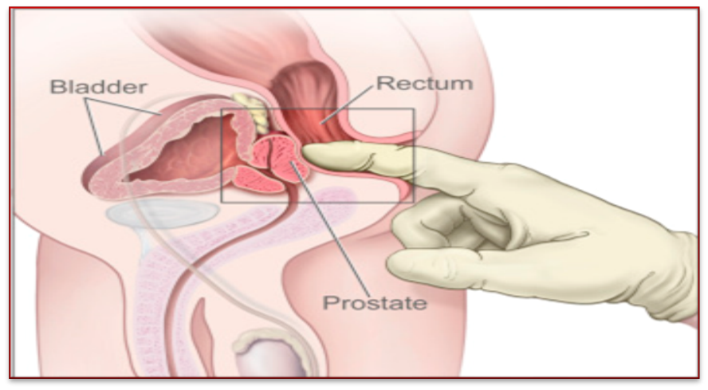

**Figure 2.6** Digital rectal examination (DRE) is a normal piece of prostate cancer (PCa) screening and gives significant prognostic data (Okotie *et al.* 2017)

##### Imaging Methods

The Image Method (IM) allows a high-resolution dynamic contrast with quantitative and quantitative perfusion estimates and capillary surface and extra-vascular extracellular space (Vos *et al.* 2007).

Functional imaging methods such as MR have improved dynamic contrast of materials MRI. Multi-parameter MRI demonstrated values in detection, localization, and separation (Kitajima *et al.* 2010). Diffusion weighted imaging, which evaluates the restriction of free proton movement, has become more prominent in prostate imaging, not only for detection and localisation but also for determining the degree of lesion aggressiveness (Verma *et al.* 2010). The apparent spread coefficient (ADC) values generated from the weighted images allow for more objective microtissue environment characterization. However, despite being quantitative, the analysis of prostate cancer on multi-parameter MR images is a challenge, requiring advanced skill and being subject to observer variation (Lim *et al.* 2009).

Computer aided diagnostic (CAD) techniques have been developed for radiological evaluation of various malignant tumors, such as breast cancer, lung cancer, and colorectal cancer. CAD appears to be especially beneficial for inexperienced radiologists, as it appears to improve their ability to detect tumors (Figure 1.7., de Hoop *et al.* 2010).

##### Prostate Ultrasound

Ultrasound of the prostate can be performed by scanning through the abdomen, perineum, transurethral or rectal. Trans rectal scanning provides the best image quality due to the prostate's close proximity and patient acceptance. Prostatic trans rectal imaging has become a routine and ultrasound scaling procedure in urology clinics today. Additionally, ultrasound guidance of a puncture biopsy has become a widely used needle (Gratzke *et al.* 2015).

Although specificity and sensitivity have not been as prominent as they might be, still it is disputed if compacted lesions on the Trans rectal ultrasound can be used to diagnose malignancy. Depending on the size, location, and specification of the transducer, the appearance of the malignant lesions may vary on the image (Giesen *et al.* 1995). On the other hand, it is important to note that not all of the lesions shown on an image are malignant. A comparison of the symmetry and regularity of the left and right lobes, in addition to the echo, may provide important information that can be used to distinguish between benign tissues and cancerous tumors (Hill *et al.* 1991). However, transrectal ultrasonography has several drawbacks due to the fact that image interpretation is dependent on the patient (Melchior and Brawer 1996). Additionally, the interpretation is constrained by the limitations inherent in human visual perception. Ultrasound can also be used to assess prostate disease infections (Doble and Carter 1989).

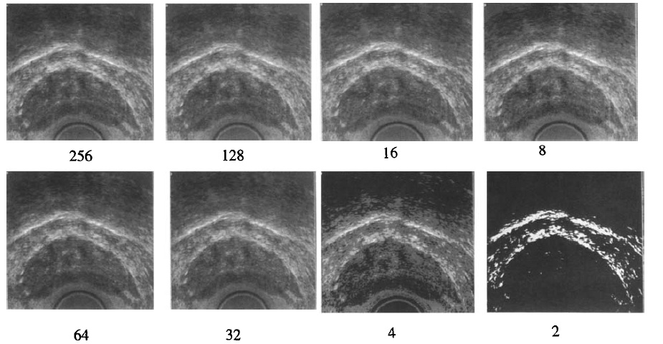

**Figure 2.7** Ultrasound pictures of prostate at exclusive grey ranges. unique image with 265 grey values turned into used to get photos with reduced wide variety of gray (Aarnink *et al.* 1998)

#### Clinical Diagnosis of Laboratory

The three most common methods of treatment are radical prostatectomy cancer, final pelvic radiotherapy and different hormones, each cause having varying degrees of impaired organic sex. Of course, these treatments also harm fertility. But fortunately the vast majority of men have prostate cancer when they get older. Urologists must remain vigilant for a man who may be married to a younger woman. Over the years, many men have in keeping cold. But they were not seen this option before treating cancer. Because the doctor assumed that the patient was too older to be concerned about fertility (Walsh and Donker 1982).

##### PSA

The Prostate-specific antigen (PSA) offers a quick and cost-effective way to screen illnesses person (male) for a possible PCa with a single blood test. In many countries, the PSA examination is offering as a standard protocol for all illnesses person (male) over 50 years old (American Cancer Society 2010).

**Definition**

In many wealthy nations, PSA testing of males without symptomatic physical examination is becoming increasingly prevalent. This increased usage of the PSA test led to an increase in the incidence of prostate cancer that began in the 1990s and is still evident today (Walter *et al.* 2006).

The primary care setting is where the majority of PSA screenings get their start. Despite the fact that other aspects, such as the practice of urologists, local guidelines, user requirements, a man's social network, and the media all play a part in determining the frequency of PSA testing, general practitioners continue to play a pivotal role in determining the population's testing levels and patterns. Thus, increasing understanding of PSA test triggers in asymptomatic men is critical, even more so if evidence-based practice in this area is possible (Evans *et al.* 2007, Drummond *et al.* 2008).

**PSA in PCa diagnosis**

PSA is utilized both to assist in the diagnosis of prostate cancer as well as to monitor the results of its therapy. PSA levels that are higher than the current biopsy threshold can be caused by a number of non-cancerous illnesses, including inflammation and benign prostatic hyperplasia (BPH), however these conditions are extremely uncommon. Inflammation and BPH are just two examples (Ruckle *et al.* 1994). To aid in detection, the overall PSA speed (tPSAv) is suggested as a predictor. Numerous studies have confirmed that increased tPSA speeds are associated with an increased risk of developing prostate cancer. Numerous reports indicated that a rapid increase in PSA prior to treatment was indicative of aggressive disease (Hanks *et al.* 1996).

PSA concentrations are expressed in nanograms per milliliter (ng/mL). Although most physicians consider a PSA level of less than 4 ng/mL to be normal, some physicians believe anything greater than 2.5 is abnormal (American Cancer Society 2018).

**Factors Affecting Serum PSA Level**

PSA is the primary product of prostate secretion. The mean PSA concentration in the seminalpplasma is 0.39-3 g/L (Wang *et al.* 1998). The PSA molecule is a glycoprotein that contains 240 amino acids. The molecular weight of PSA is 34 kDa. The PSA gene is located on the XIX chromosome, near the pancreatic and glandular kallikrein (hK1 and hK2). PSA synthesis is affected by testosterone, adrenal androgen and dihydrotestosterone (DHT) (Wang *et al.* 1981). The average PSA concentration in prostatic tissues is 15 mg per gram of tissue. However, the expression of PSA is the highest in the epithelial cells of BPH, mild in normal and inferior epithelial cells in PCa cells (Billis *et al.* 2007).

##### Testosterone Hormone

Testosterone is a steroid hormone whose levels can be used to diagnose hypogonadism; elevated testosterone levels are associated with a variety of diseases, including prostate cancer. Spermatogenic potential and phallus development are thought to be profoundly influenced by testosterone levels in the newborn period. Pseudo puberty is characterized by a dramatic rise in testosterone levels. After the third decade of life, longitudinal studies indicate that testosterone levels in healthy men begin to decline by approximately 3.2 to 3.5ng/dL per year (Harman *et al.*2001, Zmuda *et al.* 1997). It is widely believed that testosterone plays a pivotal function in the neonatal period in establishing the potential for spermatogenesis and the maturation of the phallus. Testosterone levels rapidly increase during puberty. After the third decade of life, longitudinal studies indicate that testosterone levels in healthy men begin to decline by approximately 3.2 to 3.5ng/dL per year (Wright *et al.* 1996). Due to testosterone's effect on prostate cell growth, it also nourishes prostate cancer cells and is required for the tumor mass to continue growing. As a consequence of this, it was found that an increase in testosterone levels will occur concurrently with the expansion of the prostate tissue mass that was brought on by the growth of the tumor. The evaluation of a patient's testosterone levels is therefore thought to be a good way to determine whether or not the patient has prostate cancer, as well as the size of the disease if it is present (Bostwick *et al.* 1999).

##### FSH

FSH comprises two polypeptides (alpha and beta). FSH is part of the glycoprotein hormone family and resembles members of his family such as LH, thyroid-stimulating hormone, and chorionic gonadotropin in structure. There are 96 amino acids in the alpha subunit of these hormones, while the beta subunit varies in size. Participation in the biology activity is only available to the heterodimer. The FSH-β subunit contains 111 amino acids, and is the biological work and receptor interaction that account for the biological activities of FSH (Robboy 2009, Figure 2.8).

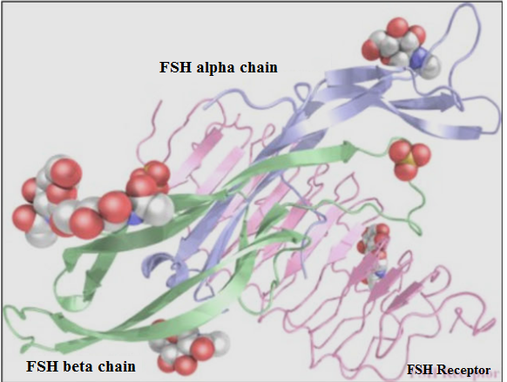

**Figure 2.8** The form of FSH-alpha and beta-receiver follicle stimulating hormone (FSH)

##### Growth Differentiation Factor-15

GDF-15 is robustly expressed in wide different types of human cancers such as PCA. However, its role in the pathophysiology of cancer to now remains mysterious. The relationship between the expression of GDF-15 and the phase of the tumor or cancers outcome is very useful, maybe GDF-15 an important biomarker for detection of prostate cancer in future (Vanňhara *et al.* 2012).

Consequently, the suppression of some groups of autoimmune cellular immune systems may be the primary role of development of GDF-15 and development of cancer. Recognized the primary GDF-15 as a factor meddles with macrophage activation. The role of GDF-15 in fetal evolution unresolved (Böttner *et al.* 1999).

**Definition and secretion**

The placenta and prostate both contain GDF-15 in a high ratio, but GDF-15 is less concentrated in the other organs such as the heart, pancreas, liver, and colon. Additionally, tissue injury, hypoxia, and inflammation responses to cytokines release macrophages, smooth muscle vascular cells, muscle cells, adipose cells, and endothelial cells. When GDF-15 is present in the bloodstream, it functions as a functional endocrine gland (Ding*et al.* 2009). Serum GDF-15 concentrations are associated with a variety of different types of tumors, implying the importance of GDF-15 measurement in cancer diagnosis and management. An analysis of total serum levels of GDF-15 demonstrated an apparent estimated ability to such as PCa mortality and disease outcomes although there are many molecular shapes of GDF-15, which justify further future studies to choose GDF-15 as a clinical biomarker for PCa. In general, GDF-15 analysis may provide a robust sorting method For suspected patients (Frank*et al.* 2008).

**GDF-15 in Prostate Cancer**

GDF-15 plays a pivotal part in the onset and progression of cardiovascular disorders like heart failure, coronary artery disease, atrial fibrillation, diabetes, cancer, and cognitive impairment. These conditions are all linked to cardiovascular disease. The higher the concentrations of GDF-15, the higher the risk of death from prostate cancer and other types of diseases such as cardiovascular and non-cardiovascular diseases. The expression of GDF-15 is elevated in a number of different malignancies, including prostate cancer, breast cancer, colon cancer, and pancreatic cancer. GDF-15 expression is also up in pancreatic cancer (Lindahl 2013, Wallentin *et al.* 2014).

Increased knowledge information of the signal routs induced by GDF-15 in the cancers cells produced or received will support to an understanding of the changes that make up the complex elements within the tumor micro-environment. Each GDF-15 protein has two parts, with properties and tumor inhibitors for both. Also, the cellular and histological effects of GDF-15 signals have been demonstrated in distinct experiment conditions, almost certainly, GDF15 is a functioning and significant part in creating PCa instead of onlooker instigated stress. Therefore, introducing GDF-15 in clinical students may be make to supply new possibilities to best understand the evolution of cancer and may be enhance diagnostic or treatment (Daniels *et al.* 2011).

##### Role of GDF-15 in Pca

According to investigation data, there was little genetic variation in the GDF-15. Polymorphisms in individual nucleotides were not associated with PCa. The wild type function GDF-15 can be distinguished in the advanced PCa. The probability of the tumor evolution In the living tissue to the early stages of development are (Vaňhara *et al.* 2012):-

* An uncontrolled regeneration.
* A cellular reprogramming,
* Or a regression.

GDF-15 is expressed in the division of epithelium caused by urogenital sinuses and sprouts, then GDF-15 ratio decrease when progress cancer to reach the lobes of the prostate. GDF-15 is then reactivated during sexual maturation, and its expression is associated with differentiation signs. The information from the development of foetal and early postnatal indicate a distinct double function of GDF-15 in regulates the proliferation of urogenital sinus epithelial cells and their differentiation in the late stage of the formation of prostate lobular structure. According to the recorded information of the cancer, demonstrated clear differences in GDF-15 expression about (Noorali *et al.* 2007):-

- Advancement prostate.

- Prostatic hypergenesis.

- Intraepithelial neoplasms in prostate.

This is in stark contrast to the expression of GDF-15 in normal tissues (epithelial), where there are two distinct peaks. Reproducing in sprouts and segments, grown prostate recognition, it is accompanied by a lack of recognition signs in transgenic tissues that appear the development of an hyperplasia to prostate intrae-pithelialneoplasias epithelial (Kasper *et al.* 1998, Figure 2.9.).



**Figure 2.9** GDF-15 plays a critical role in a variety of disease states. In Pca, cardiovascular, other cancers, and chronic diseases (Banerjee 2015)

Compared with the parental PC3, the resistance to docetaxel after chemotherapy increased the GDF-15 ratio in PC3 cells. An identical trend was noted in serum and plasma of Pca patients with docetaxel-resistant. Patient survival rate has a significant impact (Wang *et al.* 2012).

The GDF-15 is not significant for the normal development In mammals; Result Nevertheless, it may play a role in the fetal-maternal reaction in humans and may focus light on immune refusal in the uterus. Also there is growing proof of GDF15 being involved a regeneration in some tissue or reaction to various stress conditions. Severe impacts by GDF-15 frequently copy those saw by TGF-Generic, yet there are contrasts in reactions of the chose individual. It is particularly critical to explain the intracellular signs that range from the development of receptors to the connecting accomplices that moderate the impacts of GDF-15 (Costa *et al.* 2010).

Increased recorded data about the GDF-15 signaling pathways in cells produced or received contributes to an understanding of the events in the tumors micro-environment. Each GDF-15 protein has two parts, with properties and tumor inhibitors for both. it is high probably that GDF-15 proteinsis an important in developing PCa rather than bystander-induced stress. Therefore, studying GDF-15 in clinical discussions will give new data for understanding the progression of cancer.(Chen *et al.* 2007, Figure 2.10.).

##### Growth/differentiation factor-15: prostate cancer suppressor or promoter? | Prostate Cancer and Prostatic Diseases

**Figure 2.10** The role of GDF15 clear shown in the PCa stages (Vaňhara *et al.* 2012)

* + - 1. Prostate Biopsy

Today, the only final way to detect and confirm prostate cancer is by prostate biopsies. The current clinical scale is the action of prostate biopsies under the control of transrectal 2D ultrasound (TRUS). The US probe is equipped with a needle guide for transrectal prostate access. The guide aligns the needle path with the level of the American image of the end, making it possible to vision the path on the picture to monitor the position of the needle (Ahmed *et al.* 2007). However, cancer in its early and middle stages is frequently isoechogenic; as a result, it is not visible in US pictures. As a result, it is vital to obtain a sample of the gland in a systematic manner in order to diagnose cancer at these stages. The standard procedure calls for the collection of 10–12 cores and nearly takes into account the fact that the majority of tumors, around 70%, grow within the gland itself, particularly in the peripheral region (Andriole *et al.* 2007, Figure 2.11.).

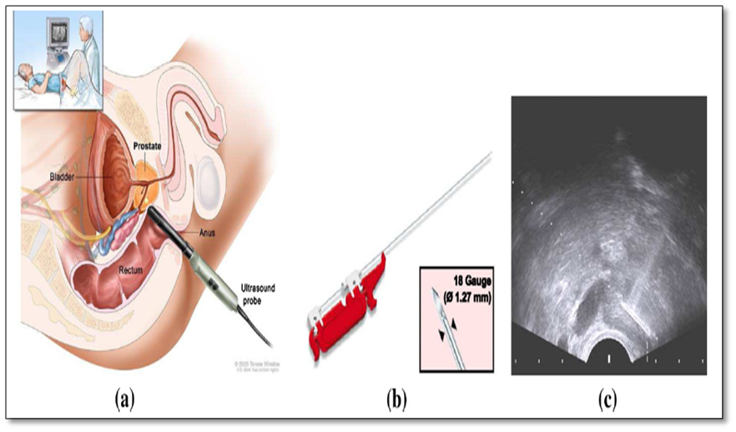

**Figure 2.11** Directed 2D-TRUS prostate biopsy during decubitus the patient is in dorsal or lateral with local anesthesia. Be entered the TRUS 2D probe into the rectum of patient to place a needle. The strictly attached needle guide ensures that the hole path is located in the American plane. (B) Shows a pistol measuring 18 diameter (1.27 mm diameter). (C) Shows a two-dimensional TRUS image.

# MATERIAL AND METHOD

## Ethical Approval

December 2019 to November 2020, the subject were selected from Anbar teaching hospital, Anbar Cancer center and Haditha general hospital. Questionnaires were filled by participants and to get the agreement to participants in this study to collect the information of patients groups.

### Design of Study

The study was take the analytical cross- sectional designed. The samples collected at the beginning of the study were 140 patients depending on the data of the study but 70 patients were selected after making sure of the preliminary analyzes in order service of researches aim. Blood samples were collected from control and patients group in the morning at 08:00 a.m - 01:00 p.m. Using a disposable syringe, the blood was withdrawn from the vein ( 5 ml ). The samples were put into disposable tubes with a gel that facilitated serum separation. Blood keep in the gel tubes allowed to clot at 37º C approximately at ten - fifteen minutes and then centerifuged at 2000 RPM for five - ten mintues then the serum was stored at ( -20º C) untile analysis (Prostate Specific antigen, C-reactive protein, Growth differentiation factor-15 (GDF-15), Total Testosterone hormone and Follicle stimulating hormone.

* + 1. **Subject**

The subjects of the study divided into two groups. All subjects are male and range in age from 35 - 90 year. The study was based one 100 Samples.

**Patient group:** Consist from 70 patient, these 70 people diagnosed with prostate cancer, All of them are of the gender of men, with ages ranging from 40 to 90 years. PSA values of most patients > 4 ng/ml in order service of researchers aim.

**Control group:** Consist from 30 healthy male with age range (35 - 90 years). The PSA values of most patients are < 4 ng/ml.

* + 1. **Exclusion criteria**:

1. Any patient suffering from Urinary Tract Infection (UTI) that will lead to increase a PSA levels.
2. Any patient who had sexual intercourse or ejaculation in a recent period therefore consider abstaining from sexual activities that may result in ejaculation for 24 hours before the test.
3. Any procedure that causes temporary bruising or trauma to the groin can have an effect on PSA levels.
4. Any patient with cardiovascular disease (CVD) which affecting in increase GDF-15 levels.
   * 1. **Inclusion criteria :**

All patient have got Prostate cancer (PCa).

# **Instruments Used in the Laboratory Analysis**

**Table 3.1** Apparatuses that are used and the companies supplied them and their origin

|  |  |  |  |
| --- | --- | --- | --- |
| **Apparatus** | **SN** | **Company** | **Origin** |
| Elisa ELx800 | 257381 | BioTek | U S A |
| Cobas c 311 Automated Chemistry Analyzer | 19R0-09 | Roche | Germany |
| Centrifuge C- 12000 | 6M 1810968 | Xinkang | China |
| Water bath | L513.0977 | Memmert | Germany |
| Refrigerator | 100269 | Bosch | Germany |
| Pipette | YE5E507726 YE5A491999 YE5E506188 | Dragon | China |

### 

### BioTek Elisa ELx800

#### Overview

This Elisa is intended for use in clinical, biotechnology, and pharmaceutical laboratories. It is a good solution for microplate-based biological assays due to its compact design and overall footprint. When used independently, the Elisa ELx800 on-board software supports a wide variety of qualitative and quantitative applications. The reader's optical characteristics were excellent, with a dynamic range of up to 3.000 absorbance units in some read modes. The wavelength range is 400–750 nm. The term "ultraviolet" refers to devices with wavelengths ranging from 340 nm to 750 nm. With its massive curve fitting, cutoff calculation, data transformation, and validation capabilities, the onboard information discount outperforms many computer software applications. The BioTek Elisa ELx800 interfaces with Diagnostic Automation Data Analysis Software to enhance data analysis and reporting flexibility.

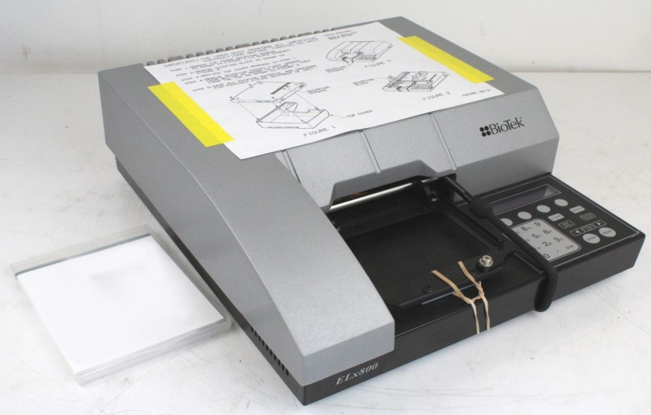

**Figure 3.1** BioTek Elisa ELx800

#### Calibration Work and Result Reading

Biotek Elisa xl 800 fully automated therefore we insert calibration for kits in maps of instrument. Some kits continent four or five or more calibrations depending on each kits. Then insert standard in maps then choose numbers of sample then press on start for reading the results.

* + 1. Roche Cobas c 311 Automated Chemistry Analyzer

#### Overview

Roche Diagnostics' cobas C311 analyzer is a fully automated, software-controlled clinical chemistry analyzer. It is intended for both quantitative and qualitative in vitro determinations, utilizing a broad range of analytical tests. The Cobas C311 analyzer employs serum/plasma for photometric assays and ion-selective electrode measurements.

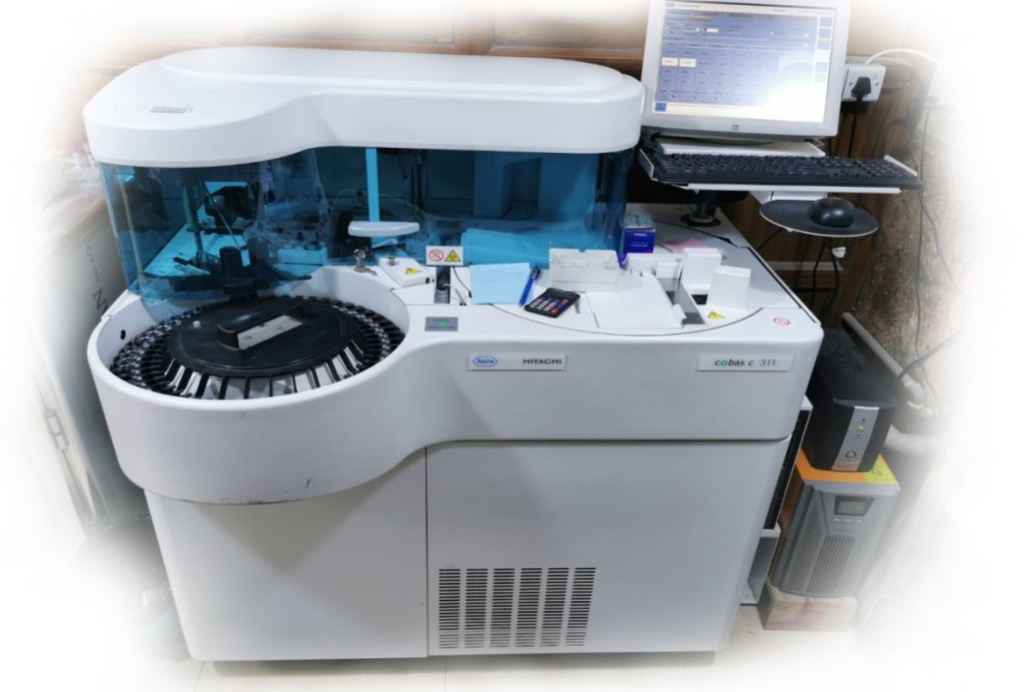

**Figure 3.2** Roche Cobas c 311 Automated Chemistry Analyzer

The Cobas c 311 is a Clinical Chemistry analyzer that operates independently. Utilizing a system that is adaptable allows for the consolidation of both routine and specialized workloads in the field of chemistry. On-board testing capabilities include 45 tests, with a maximum throughput of 480 executed in one hour. The analyzer is used to evaluate a variety of bodily fluids, including serum, plasma, urine, cerebrospinal fluid (CSF), hemolysate, and whole blood..

#### Specifications

**Table 3.2** Roche Cobas c 311 automated chemistry analyzer specification

|  |  |
| --- | --- |
| System | Clinical Chemistry and Homogeneous Immunology full automated, random access analyzer (HIA). |
| Expected production yield | Up to 300 samples/hr |
| Throughput of test | 300 photometry tests per hour  480 tests per hour for only ISE tests |
| Channel count Reagent | On the ISE module, there are 42 cassette  slots and three channels. |
| Sample types | Slots for serum,6plasma, urine, cerebrospinal fluid, and3whole blood (HbA1c only).) |
| Volume of Sample | 1.0 to 35 μl in 0.1 μl steps |
| Dilution | 3 to 121 times, diluent 100 μl |
| Detection of sample clots | Available |
| Smallest quantity of material to be tested | 700 μl3Primary tubes  100 μl3sample cup  50 μl3micro cup |
| Calibrator/QC Input | On the sample disk, bar coded |
| Sample data base | 1. utine / STAT samples |

#### Calibration work and Result reading

The calibration procedure and read samples in cobas C 311 very is easily because of is cobas c 311 full automatic, The instrument only passed the serial number for solution through the red right light that read the bar code for this kit.Then put the calibration and QC in patient positions on the outer row with the barcodes facing out. The sample was placed for reading its values it in suitable position, then from instrument monitor it choose the tests for this sample, then put start for reading.

### Centrifuge C- 12000 (6M 1810968)

In this study, it has been used the centrifuge with 5000 RPM/min of Chinese origin. After collecting the blood, separated it in the device with a speed of 3000 spins for five minutes.

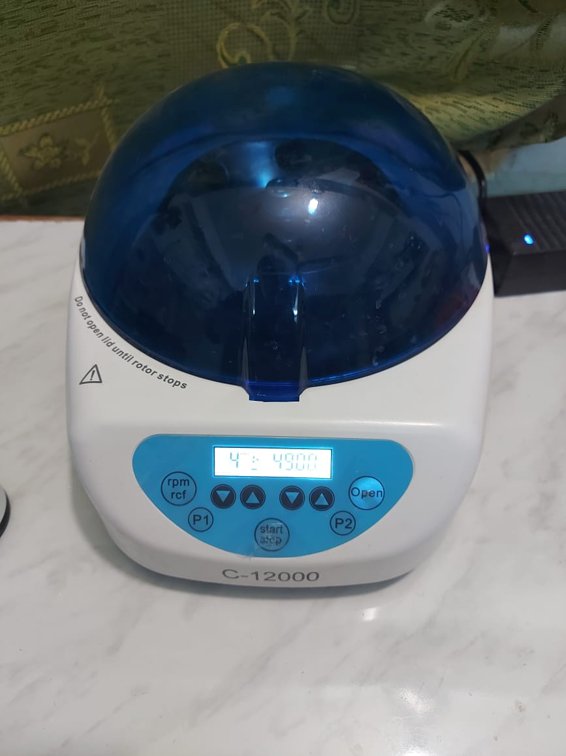

**Figure 3.3** Centrifuge C- 12000

### Memmert Water Bath (WNE 22) (L513.0977)

Memmert water baths are recommended for makes heating tasks in the standard laboratory. It is made from erosion,-resistant stainless steel and it characterized double protection against harmful over-heating. Memmert WNB water baths offer state-of-the-art control technology, accurate heat control, and monitoring, and advanced safety protection.

## Biochemical Kits

**Table 3.3** Materials and Kits that used

|  |  |  |  |
| --- | --- | --- | --- |
| **Apparatus** | **Ref.** | **Company** | **Origin** |
| Prostate Specific Antigen (PSA) kit | 52030 | Human Diagnostica mbH | Germany |
| Growth Differentiation Factor 15 (GDF15) kit | H0150F038 | MyBioSource | USA |
| C reactive protein (CRP) kit | 0004956842190c501V11.0 | Roche Diagnostics GmbH | Germany |
| Testosterone Hor. kit | S010 | VEDALAB | France |
| Follicle stimulating Hormone (FSH) kit | 100269 | Monobid | USA |

### 

### Prostate Specific Antigen

PSA, or prostate-specific antigen, is a protein produced by both normal and malignant cells of the prostate gland in men. The PSA test determines the PSA level in a man's blood. PSA levels in the blood are frequently elevated in men with prostate cancer. A blood sample (which must be serum-separated) is sent to a laboratory for analysis in this test. Typically, the results are expressed as nanograms of PSA per milliliter of blood (ng/mL). (Ilic *et al.* 2018).

#### PSA principle

The human PSA ELISA kit is intended for professional use. The ELISA for direct antigen utilizes highly specific monoclonal anti-PSA antibodies bound to microliter wells on the surface, which are covalently linked to the enzyme through an enzyme-coupled immunosorbent assay (ELISA). The first incubation step involves mixing the specimens, calibrators or controls, and antibody-enzyme conjugate to form the sandwich complex on the well surfaces. Excess conjugate and unbound antigens are washed out at the end of the incubation. When TMB/Substrate is added (step 2), a blue color develops that changes to yellow upon reaction termination. The color's intensity is proportional to the PSA concentration in the specimen.

#### Reagents and Contents

**Table 3.4** Materials provided and storage for PSA hormones kits

|  |  |  |
| --- | --- | --- |
| Abbreviation | Reagent | Quantity |
| MIC | Microwell Assay plate 12*8 wells | 1 |
| CAL | Calibrators (A:white, B:yellow, C:green, D:red, E:blue, F:black) | 1 vial of 6×2.0 ml |
| CON | Antibody-Enzyme Conjugate(white cap) | 1 vial of 13 ml |
| WS20X | Wash soluthion (white cap) | 1 vial of 50 ml |
| SUB | Substrate Reagent (black cap) | 1 vial of 13 ml |
| STOP | Stop solution (red cap) | 1 vial of 15 ml |
| Adhesive strip | | 1 |

#### Preparation of Reagent

Before use put all reagents in room with temperature (15 - 25ºc). but reagents that not use should be stored temperature (2 - 8ºc). While, working wash solution are prepared by dilution [WS20X] ( 1+19) with fresh deionized water, e.g. 50 ml from [WS20X] + 950 ml =1000 ml. Stability up to 60 days at 15 - 25ºc.

#### Wash Procedure

**Washe one**: Remove strips on plates, then aspirate off the contents in wells, add WASH after 30 sec. aspirate off content and repeat washing 4 times.

**Wash two**: If there are automatic washers only fill and prime with (WASH). Subsequently, five times wash strips.

**Wash three**: After washing, take off the remaining liquid by tapping the plate upside down on papers.

#### Procedure of PSA (REF 52030)

**Table 3.5** Procedure of PSA

|  |  |  |  |  |
| --- | --- | --- | --- | --- |
| Reagents and specimens should be at room temperature before use. Before use, all samples and kits reagents should be set at room temperature | | | | |
| Step one | Wells [μl] | | | |
|  | D2 Calibrator(A1) | | | Specimen(E2) |
| Calibrators (CAL) | 25 | | | …. |
| Samples and Controls; in duplicate | ….. | | | 25 |
| Antibody-Enzyme Conjugate (CON) | 100 | | | 100 |
| Mix and cover wells with Adhesive Strip | | | | |
| Incubat eat 20 to 25°C for 30 | | | | |
| Wash 5 times as (W one(W1) – W three(W3) | | | | |
| (WASH) | | 300 | 300 | |
| Step 2 | | | | |
| Substrate Reagent (SUB) | | 100 | 100 | |
| Incubat eat 20 to 25°C for 15 | | | | |
| Stop and mix carefully | | 100 | 100 | |
| As soon as possible or within 10 minutes after reaction termination, determine the absorbance at 450 nm. | | | | |

### 

### Human GDF15

It belongs to the transforming growth factor beta proteins superfamily and is a member of that family. When normal conditions are present, the majority of organs express GDF-15 at low levels; however, after damage to organs such as the liver, kidney, heart, and lungs, GDF-15 becomes uncontrolled and begins to accumulate at high levels. resides in a variety of mammalian tissues, is a component of the transforming growth factor (TGF-) superfamily, and belongs to the TGF- superfamily. It is a distant relative of the TGF-superfamily. The expression of this gene is strictly controlled and is regularly activated in response to various forms of cellular stress. It has been demonstrated that GDF-15 is an important prognostic factor in patients suffering from a wide range of disorders, including cancer and heart disease.

#### Principle

The technology used in this kit, sandwich enzyme-linked immune sorbent assay. Every one of the 96 wells had an antibody already applied to it, and the biotin-conjugated antibody was utilized as the indicator antibody. After that, the samples, the standards, and the biotin-conjugated detection antibody were added to the wells on the plates, and then they were rinsed with wash solution. Then, after added HRP-Streptavidin to wells, unbound conjugates were washed away with wash solution. TMB substrate also was used to visualize HRP enzymatic reaction. The blue color was the product after added HRp that stimulated by TMB, then color changed into yellow color after added stop solution. Read the optical density (O.D.) absorbance at wavelength 450 nm in a microplate reader, and then calculated the concentration of target.

#### Kit Components



**Figure 3.4** Materials provided and storage for GDF-15 kits

### CRP (0004956842190c501V11.0)

The CRP test looks at the amount of CRP in the blood. C-reactive protein is a protein made by the liver, which measures the amount of inflammation in the body. In response to inflammation, it is released into the bloodstream. Inflammation is the body's response to injury or infection; it helps to protect tissues.

A high CRP level in the blood is indicative of inflammation. A number of different conditions can cause it, from infection to cancer. Having a high CRP level may indicate an increase in the risk of heart attack because of the presence of inflammation in the arteries of the heart.

#### Principle

The immune turbidimetric assay was performed with a particle enhanced turbidimetric assay. Of latex particles coated with monoclonal anti-CRP antibodies, human CRP agglutinates. Turbidimetry is used to quantify the aggregates.

#### Working Solutions

Reagent 1: bufferywith bovinerserum albumin; preservatives.

Reagent 2 : Latex particles covered with antiCRP (mouse) in glycine buffer; immunoglobulins (mouse) ; preservatives.

#### Procedure

By Cobas C111 systems automatically calculate the results and the analytic concentration of each sample.

### Testosterone Hormone

The level of testosterone in the blood can be used to diagnose and monitor conditions such as prostate cancer, which is associated with high levels of the hormone. Testes are producing about 95% of testosterone(Diagnostic Automation Inc. 2001). Testosterone is essential for the continued growth of the tumor mass because it stimulates the growth of prostate cells, which includes cancer cells. Therefore, it was concluded that rising testosterone levels would accompany the expansion of prostate tissue mass brought on by the tumor. Thus, if a patient is found to have an elevated level of testosterone, it can be assumed that a tumor is present and may indicate the tumor's size. (Bostwick D *et al.* 1999).

#### Principle of Assay

Testosterone Elisa works on the principle of competitive binding between Testosterone in the test specimen and the Testosterone – HRP conjugate in order to detect a constant amount of anti-Testosterone antibodies. The amount of Testosterone left in the standard, sample, or control serum is permitted to vary over the incubation period, and HRP-labeled Testosterone competes with the endogenous Testosterone for a defined number of binding sites of the particular Testosterone antibody.

With time, the amount of immunologically attached Testosterone peroxidase conjugate to a well will decrease as the concentration of Testosterone peroxidase conjugate is washed away and the wells are washed. Subsequently, a TMB Reagent solution is added and allowed to incubate for 20 minutes at room temperature. This results in the development of blue color, which changes to yellow, and the absorbance at 450 nm is measured spectrophotometrically.

Enzyme activity controls the intensity of the color, and testosterone concentration is inversely related to the intensity of the color. Absorbance is measured spectrophotometrically at 450 nm.

#### Specimen Collection

To avoid hemolysis, serum samples should be prepared from whole blood obtained using acceptable medical techniques. Only undiluted serum samples could be assayed. The specimens can be stored at +2ºC to +8ºC. If screening is performed within 24 hours, or they may be stored at -20 ° c temperature in a deep freezer. Steer clear of repeated freeze/thaw cycles.

Do not use contaminated, hyperlipaemic or hyperhaemolysed sera. Do not use plasma sample.

### FSH

Follicle-stimulating hormone, or FSH, is one of the hormones that is critical to the development of pubertal characteristics as well as the operation of the ovaries in women and the testes in men. This was one of the major tests that we examined for our study. This hormone encourages the development of several ovarian follicles in females before to the ovulation process, which involves the release of a single egg from a single follicle. In addition to this, it enhances the production of the hormone oestradiol. Your pituitary gland, a small gland located beneath the brain, produces FSH. It is important in the development and functioning of sexual organs. FSH regulates the menstrual cycle in women and stimulates the growth of eggs in the ovaries.

#### Principle

An immunoenzymometric assay requires antibodies (enzyme and immobilized) with high affinity and specificity, the ability to recognize several epitopes, a large supply of native antigen, and excellent dilutions of the antigen. During the test, immobilization occurs at the surface of a microplate well due to the interaction between streptavidin-coated wells and exogenously inserted biotinylated monoclonal anti-FSH antibody. This interaction is caused by the biotinylation of the monoclonal anti-FSH antibody. When a monoclonal biotinylated antibody, an enzyme-labeled antibody, and a serum that contains the native antigen are combined, there is a reaction that takes place between the native antigen and the antibodies without any competition or steric hindrance. This results in the creation of a soluble sandwich equation.

Simultaneously, the complex is deposited in the well via a highly specific reaction between streptavidin and biotinylated antibody. To separate bound antibody from unbound antigen, decantation or aspiration can be used. When an antibody-bound enzyme fraction is separated, the enzyme activity is directly proportional to the concentration of the native antigen. This is the case even though the concentration of the native antigen is not known. A dosage response curve can be created from multiple different serum references that have known antigen values. Using this curve, it is possible to determine the antigen concentration of a serum sample whose value is unknown.

* 1. **Statistical Analysis**

The Statistical Analysis System- Spss (2012) and GraphPad prism version7 programs were utilized to determine the impact of distinct factors on study parameters. Comparing the significance of the differences between groups using the T. test. Pearson's correlation was used to determine the association between studied biomarkers. The statistical importance level was set as P value of less than 0.05. Descriptive statistics consist of mean, standard deviation (SD), T-test was calculated for each parameter.

# RESULTS AND DISCUSSION

## Preamble of Results

Patients were recruited from the Department of Oncology of AL-Ramadi Teaching Hospital and Haditha General Hospital of Al_Anbar - IRAQ. A total of 100 male patients were recruited from December 2019 to November 2020. All patients received after clinically and laboratory diagnoses. Patients was 70 person while the control groups 30 subject.

**Table 4.1** Comparison of Clinical characteristic between patients and control in Age, BMI

|  |  |  |
| --- | --- | --- |
| Parameters | Mean ± SD | |
| Age (year) | BMI (kg/m2) |
| Patients group | 64.45 ±10.97 | 24.93 ±4.03 |
| Control group | 59.33 ±8.01 | 28.49 ±4.04 |
| T-test | 4.413 * | 1.747 ** |
| P-value | 0.0233 | 0.0001 |
| * (P≤0.05), ** (P≤0.01). | | |

* 1. **Age**

In the studies was results patients and controls for Age (64.4 ± 10.9 year; 49.3 ± 8.02 year) respectively, This results was a statistically significant (*P 0.011) at P < 0.05, as shown in Table 4.1 (Figure 4.1). The study concluded that prostate cancer gradually increased with age. In previous studies, Age is considered to be the biggest risk factor for prostate cancer. Understandably, this disease has become one of the biggest public health problems (Syrigos*et al.* 2005). This result is also in agreement with our study.

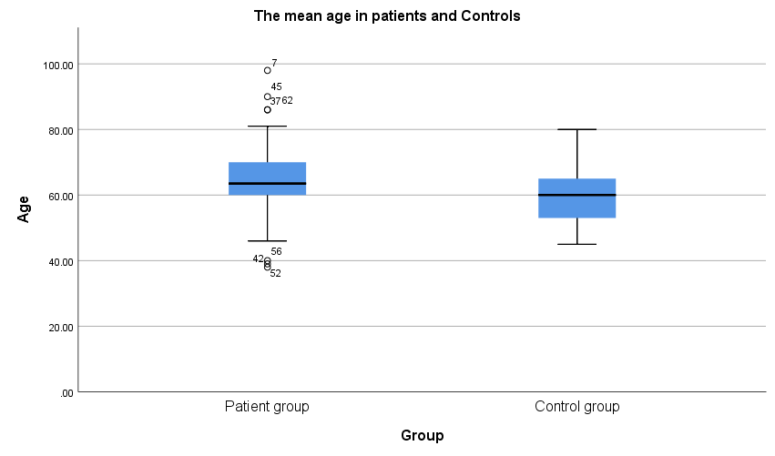

**Figure 4.1** A chart showing the relationship between the means patient group and control group given as percentage in Age

* 1. **BMI with Prostate Cancer**

In the weight was patients and controls results (24.93 ±4.03 kg/m2; 28.49 ±4.04 kg/m2) respectively, this results was highly significant statistical ( *P 0.0001 ) at P < 0.05, as shown in Table 4.1, Figure 4.2. Obesity is a risk factor for the development of aggressive prostate cancer, according to the majority of published studies (Choi*et al.* 2020). Some previous studies revealed after following up to 15 year for obese people that baseline obesity was associated with prostate volume and with the rate of change in PSA (Wallner *et al.* 2011). While other studies provide opposite results regarding local or overall prostate cancer risk (Gong *et al.* 2006). It is possible that the inverse association between obesity and a diagnosis of prostate cancer is at least partially due to detection bias, which is caused by large prostate sizes and hemodilution in obese men. This bias may explain why obesity is associated with a lower risk of being diagnosed with prostate cancer. This bias may explain why obese men have a lower risk of being diagnosed with prostate cancer (Wallner *et al.* 2011).

As well, Dickerman *et al.* 2017 supported our research. Weight loss and obesity were found to be associated with an increased risk of prostate cancer. According to the findings of Dickerman and colleagues, there is a correlation between weight gain over a long period of time and an increased risk of mortality from prostate cancer (2017).

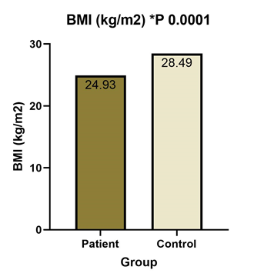

**Figure 4.2** The percentage difference in BMI levels between the patient and control groups.

## GDF15

In our study, serum GDF15 levels were significantly higher in the patient group than in the control group. The mean of GDF15 (mg/dl) was has a significant difference between groups, the results was (53.8 ± 50.8 mg/dl; 33.4 ± 19.3 mg/dl, respectively) ( *P 0.0352) at P < 0.05, as shown in Table 4.2 and Figure 4.3. GDF-15 concentrations have frequently been found to be elevated during the progression of various types of cancer, including gastric, ovarian, prostate, and breast cancers (Bauskin *et al.* 2006, Baek *et al.* 2009). In spite of the fact that the GDF-15 expression profile has been adequately described in a wide variety of cancers, a comprehensive investigation into its specific role in the development of prostate tumors is still required. Our study supported with presented studies. The presented data indicated that serum GDF15 levels were significantly higher in patients with metastasized cancer (Pca) who had a rapid disease progression (Winand *et al.* 2014). Welsh et al. discovered that metastatic prostate cancer patients had significantly higher serum GDF15 levels than normal controls. (Welsh *et al.* 2003 ). Another prior study found that metastatic prostate cancer expressed less GDF15 than main prostate cancer when gene expression data was compared from over 1,000 samples of primary prostate cancer and 200 samples of metastatic prostate cancer. GDF15 in the primary tumor lower levels are associated with prostate cancer patients (Zhang*et al.* 2019 ).

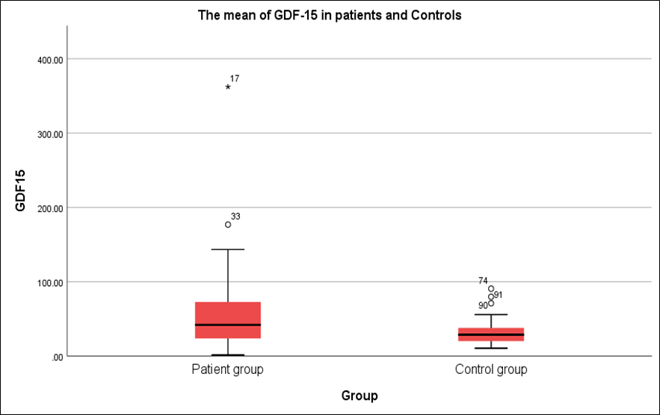

**Figure 4.3** The percentage difference in GDF-15 levels between the patient and control groups.

**Table 4.2** Comparison between patients and control in C.R.P, PSA and GDF15

|  |  |  |  |
| --- | --- | --- | --- |
| Parameters | Mean ± SD | | |
| S.C.R.P (nmol/L ) | S. PSA (ng/ml ) | S.GDF15 (mg/dl) |
| Patients Group | 92.57 ±79.30 | 38.92 ±33.21 | 53.85 ±50.88 |
| Control Group | 12.96 ±30.95 | 2.19 ±5.78 | 33.35 ±19.27 |
| T-test | 29.72 ** | 12.107 ** | 19.041 * |
| P. value | 0.0001 | 0.0001 | 0.0352 |
| * (P≤0.05), ** (P≤0.01). | | | |

## PSA

The PSA results of patients and controls were (38.9 ± 33.1 ng/ml; 2.19 ± 5.78 ng/ml , respectively) this results was a significant statistical ( *P 0.0001 ) at P < 0.05, as shown in table 4.2 (figure 4.4). Other findings from a major multicenter study showed that the total serum PSA use for prostate biopsy is greater than 4 ng/mL (Catalona *et al.* 1994). While serum PSA is a sensitive indicator of prostate cancer early detection, its specificity is limited by elevated levels in benign prostate disease (Oesterling *et al.* 1991). These studies supported our study. In another study, PSA levels decreased in prostate cancer (Catarinicchia and Crawford 2016). PSA concentration in some patient’s have come down due to receive some drugs such as abiraterone and degarelix and these treatment will reduces the production of androgens in the body that can promote the growth of a prostate gland tumor. Suggesting the influence of both testosterone and FSH on PSA levels (Catarinicchia *et al.* 2016).

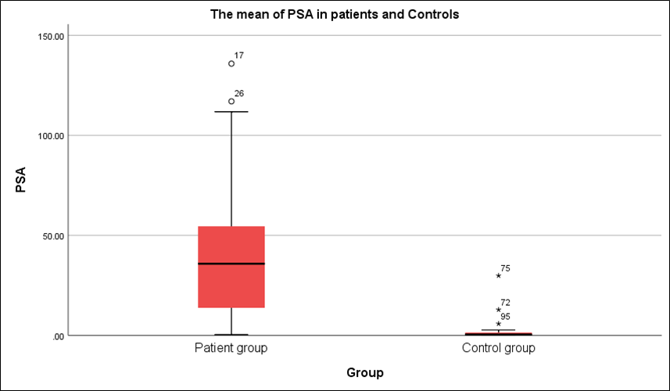

**Figure 4.4** The percentage difference in PSA levels between the patient and control groups.

## Serum CRP

The CRP results of patient and control were (92.6 ±79.3 nmol/L; 12.9 ±30.9 nmol/L) respectively. The results was a significant statistical (* P 0.001) at P. value <0.05, as displayed in Table 4.2 and Figure 4.5. Elevated serum CRP levels before treatment in PCa patients are closely related to bad prognosis (Wu *et al.* 2021). CRP levels decreased in prostate cancer patients that received treatment (Margel *et al.* 2020). CRP is a readily measurable biomarker that has the potential to detection the progress of the patient's condition deterioration or improvement (Prins *et al.* 2012).

As well as in our study showed a highly positive correlation between CRP with duration of disease (r=0.421***, P 0.002 respectively), as shown in Table 4.4 by used Pearson Correlation Analysis. This shows that there is a close relationship between CRP concentration and progression of disease in PCa patient. In some of the previous studies, CRP levels have been shown to be related to worse PCa patient outcomes (Beer *et al.* 2008).

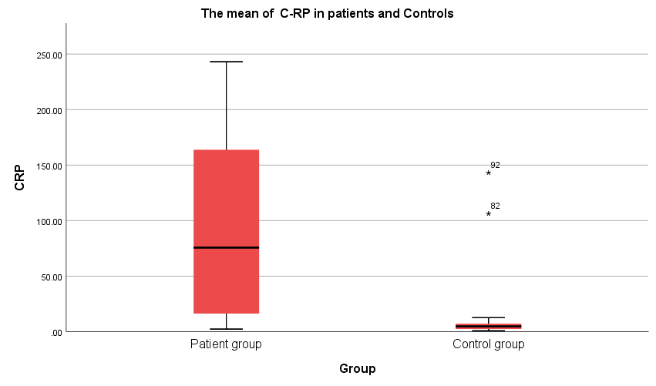

**Figure 4.5** The percentage difference in CRP levels between the patient and control groups.

## Serum Testosterone and Serum FSH with Prostate Cancer

The testosterone results of patients and controls were (5.72 ± 3.63 ng/ml; 4.37 ±2.28 ng/ml) respectively. The results were a non-significant statistical (* P 0.064 ) at P value < 0.05, as displayed in Table 4.3 and Figure 4.6. The studies are consistent with the report which reported that serum testosterone has not related with the incidence of prostate cancer (Chen *et al.* 2003). However, some studies contradicted our findings that high TT serum levels are associated with high-risk disease in PCa patients. Endogenous TT should be considered as a biological marker for assessing EAU PCA risk classes (Tafuri *et al.* 2020). Internal prostatic milieu levels are not accurately reflected by serum testosterone levels (Claps *et al.* 2018). On the other hand, if testosterone levels are to be considered in the etiology of prostate cancer, they should be measured and interpreted chronically over a period of years using multiple measurements (Loughlin 2016).

While the FSH results was in patients and controls (4.79 ± 5.47 mIU/ml; 2.89 ±3.40 mIU/ml) respectively, this results was a non-significant statistical (* P 0.082) at P. value < 0.05, as displayed in Table 4.3 and Figure 4.7. Previously, researchers have discovered that Follicle Stimulating Hormone (FSH) is an important component in the natural history for progression of PCa (Catarinicchia and Crawford 2016). The result shown don’t supported our study. Because, FSH concentration may be related to tumor size, revealing that there is a correlation before treatment. Most of the PCa patients in this study had undergone to different treatment methods, one of these methods used is medication which originally work to reduce some hormones that help in the growth of cancer cells may be the cause of this noticeable decrease in FSH and Testosterone hormone. Catarinicchia *et al.* (2016) revealed in one of the experiment worked that some medication such as abiraterone and degarelix lead to decrease levels of FSH and Testosterone in PCa patient (Catarinicchia *et al.* 2016). Whereas a recent study established that postoperative FSH levels were significantly lower. Also, FSH levels decreased after radical prostatectomy (Choi *et al.* 2020). However, additional research is required to fully understand the differences in FSH concentration between patients who have received treatment and those who have not.

**Table 4.3** Comparison between patients and control in Hormones level

|  |  |  |
| --- | --- | --- |
| Parameters | Mean ± SD | |
| S. Testosterone (ng/ml ) | S. FSH (mIU/ml) |
| Patients Group | 5.72 ±3.63 | 4.79 ±5.47 |
| Control Group | 4.37 ±2.28 | 2.89 ±3.40 |
| T-test | 1.427 NS | 2.146 NS |
| P-value | 0.0641 | 0.0820 |
| NS: Non-Significant. | | |

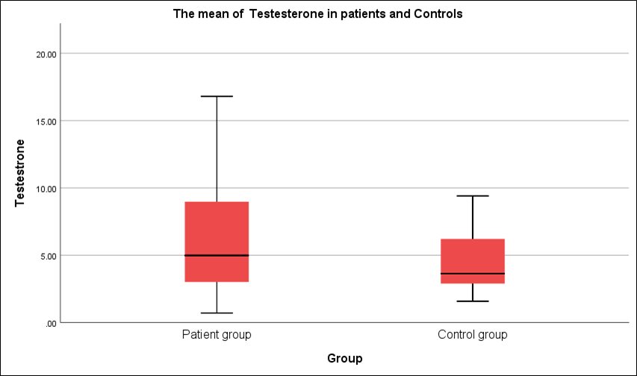

**Figure 4.6** The percentage difference in Testosterone levels between the patient group and healthy groups

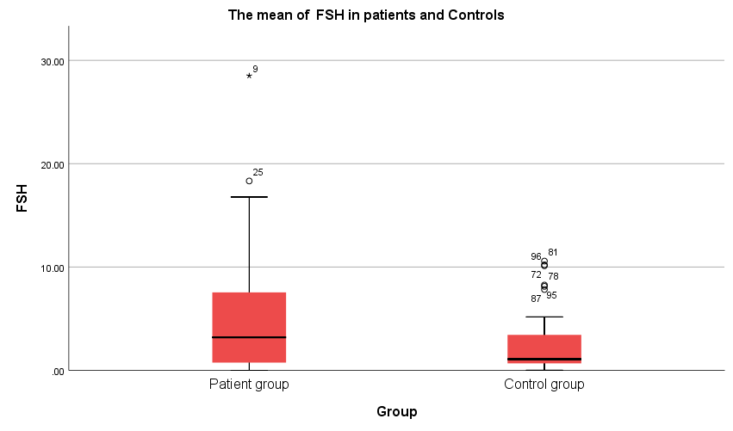

**Figure 4.7** The percentage difference in FSH levels between the patient group and healthy groups.

## Pearson Correlation Analysis

### Correlation between Studied Parameters

There was a linearly significant positive correlation between PSA and GDF15, as demonstrated by the data in Table 4.4 (r = 0.30**, P 0.002 respectively). Also, there was high correlation of PSA and FSH (r = 0.20, P 0.047 respectively), and there was a linear positive correlation between CRP and PSA (r = 0.22 *, P. value 0.023 respectively). While was negative correlation between GDF15 with CRP, Testosterone and FSH. Also, was negative correlation between PSA with Testosterone and FSH.

**Table 4.4** Correlation between Studied Parameters in all Case of Prostate Cancer

|  |  |  |
| --- | --- | --- |
| Parameters | Correlation coefficient-r | P-value |
| S. CRP & PSA | 0.22 * | 0.023 |
| S. CRP & GDF15 | 0.14 NS | 0.160 |
| PSA & GDF15 | 0.30 ** | 0.002 |
| PSA & S. Testosterone | 0.10 NS | 0.314 |
| PSA & S. FSH | 0.20 * | 0.047 |
| GDF15 & S. Testosterone | 0.06 NS | 0.527 |
| GDF15 & S. FSH | -0.07 NS | 0.507 |
| Duration of disease & S. CRP | 0.421*** | 0.002 |
| * (P≤0.05), ** (P≤0.01), NS: Non-Significant. | | |

# CONCLUSIONS

1. In this study have conclusion that men with raises of GDF-15 have a risk come to be capture prostatic diseases.Therefore, GDF-15 is a very important biomarker for diagnosis of prostate cancer and also very important for revelate a disease progression.
2. The values for serum PSA in Pca patients were elevated. Also results in the study indicated that serum Psa values is used as an non specific in the early diagnosis of prostate cancer. As well, there was to shown a direct positive correlation between PSA serum levels with GDF-15 in patients. It observed reduction in FSH and Testosterone hormones levels in Pca.
3. All men in the wide world are at risk of having prostate cancer. The thing that raises the odds of having prostate cancer the most is age .
4. The levels of CRP in a patient with PCa increased significantly, especially as the disease duration advanced. As well, there was to shown direct positive correlation between serum CRP levels with duration of disease.
5. For the BMI in this study was explained that fatness considered a risk factor for prostate cancer.
6. The prostate diseases are easily evaluated by used the PSA, GDF-15 and CRP test and Age.
   1. **Recomendation**
7. We obtained elevated levels of GDF-15 and PSA in serum in prostate cancer patients even after taking the treatment. Therefore, we recommend a qualitative study of these parameters by dividing samples into groups before and after treatment.
8. To fully understand the variation in FSH concentration between treated and untreated patients, further research is required.
9. Study more samples of prostate cancer aiming to give more data about increase and decrease levels in some parameters such as Testosterone.

# REFERENCES

Abouhamraa, H. (2013). Effect of Eurycomalongifolia (Tongkat Ali) on the prostate cancer cell line LNCaP.‏

Adela, R., & Banerjee, S. K. (2015). GDF-15 as a target and biomarker for diabetes and cardiovascular diseases: a translational prospective. *Journal of diabetes research*, *2015*.‏

Ahmed, H. U., Pendse, D., Illing, R., Allen, C., van der Meulen, J. H., & Emberton, M. (2007). Will focal therapy become a standard of care for men with localized prostate cancer?. *Nature clinical practice Oncology*, *4*(11), 632-642.‏

American Cancer Society, Screening Tests for Prostate Cancer, 2018.

American Cancer Society (2010). Cancer Prevention and Early Detection Facts and Figures. Atlanta: American Cancer Society.

Andriole, G. L., Bullock, T. L., Belani, J. S., Traxel, E., Yan, Y., Bostwick, D. G., & Humphrey, P. A. (2007). Is there a better way to biopsy the prostate? Prospects for a novel transrectal systematic biopsy approach. *Urology*, *70*(6), S22-S26.‏

Arvaniti, E., Fricker, K. S., Moret, M., Rupp, N., Hermanns, T., Fankhauser, C., ... &Claassen, M. (2018). Automated Gleason grading of prostate cancer tissue microarrays via deep learning. *Scientific reports*, *8*(1), 1-11.‏

Baek KE, Yoon SR, Kim JT, Kim KS, Kang SH, Yang Y et al. Upregulation and secretion of macrophage inhibitory cytokine-1 (MIC-1) in gastric cancers. Clin Chim Acta 2009; 401: 128 -- 133.

Bassett, J. K., Severi, G., Baglietto, L., MacInnis, R. J., Hoang, H. N., Hopper, J. L., ... & Giles, G. G. (2012). Weight change and prostate cancer incidence and mortality. International journal of cancer, 131(7), 1711-1719.

Baumann, M., Mozer, P., Daanen, V., &Troccaz, J. (2012). Prostate biopsy tracking with deformation estimation. *Medical image analysis*, *16*(3), 562-576.‏

Bauskin AR, Brown DA, Kuffner T, Johnen H, Luo XW, Hunter M et al. Role of macrophage inhibitory cytokine-1 in tumorigenesis and diagnosis of cancer. Cancer Res 2006; 66: 4983 -- 4986.

Beer TM, Lalani AS, Lee S, Mori M, Eilers KM, et al. C‑reactive protein as a prognostic marker for men with androgen‑independent prostate cancer: results from the ASCENT trial. Cancer 2008; 112: 2377–83.

Beilin, J., Harewood, L., Frydenberg, M., Mameghan, H., Martyres, R. F., Farish, S. J., ... &Zajac, J. D. (2001). A case–control study of the androgen receptor gene CAG repeat polymorphism in Australian prostate carcinoma subjects. *Cancer*, *92*(4), 941-949.‏

Billis, A., Meirelles, L. R., Magna, L. A., Baracat, J., Prando, A., & Ferreira, U. (2007). Extent of prostatic atrophy in needle biopsies and serum PSA levels: is there an association?. *Urology*, *69*(5), 927-930.‏

Blennerhassett, J. B., & Vickery Jr, A. L. (1966). Carcinoma of the prostate gland. An anatomical study of tumor location. *Cancer*, *19*(7), 980-984.‏

Bostwick, D. G., MacLennan, G. T., Larson, T. R., & Schaumburg, R. (1999). *Prostate cancer: What every man--and his family--needs to know*. Villard Books.‏

Böttner, M., Laaff, M., Schechinger, B., Rappold, G., Unsicker, K., &Suter-Crazzolara, C. (1999). Characterization of the rat, mouse, and human genes of growth/differentiation factor-15/macrophage inhibiting cytokine-1 (GDF-15/MIC-1). *Gene*, *237*(1), 105-111.‏

Cancer Research UK (2010). Prostate Cancer: Mapping patterns of prevalence cross the United Kingdom. CRUK Publications, London.

Carroll PR, Grossfeld GD, editors. Prostate cancer. Hamilton, London: Decker Inc.; 2002.

Catalona WJ, Richie JP, Ahmann FR, et al: Comparison of digital rectal examination and serum prostate specific antigen in the early detection of prostate cancer: Results of a multicenter clinical trial of 6,630 men. J Urol 151:1283-1290, 1994

Catalona, W. J. (1982). Grading and staging of prostate cancer.‏

Catarinicchia, S., & Crawford, E. D. (2016). The Role of FSH in Prostate Cancer: A Case Report. Urology case reports, 7, 23-25.

Chen C, Weiss NS, Stanczyk FZ, et al. Endogenous sex hormones and prostate cancer risk: a case-control study nested within the Carotene and Retinol Efficacy Trial. Cancer Epidemiol Biomarkers Prev 2003;12:1410 – 6.

Chen, S. J., Karan, D., Johansson, S. L., Lin, F. F., Zeckser, J., Singh, A. P., ... & Lin, M. F. (2007). Prostate‐derived factor as a paracrine and autocrine factor for the proliferation of androgen receptor‐positive human prostate cancer cells. *The Prostate*, *67*(5), 557-571.‏

Choi, Jin Bong, et al. "Does increased body mass index lead to elevated prostate cancer risk? It depends on waist circumference." BMC cancer 20.1 (2020): 1-8.

Choi, Se Young, et al. "Luteinizing Hormone Levels Relate to the Unfavorable Pathology of Prostate Cancer." Journal of clinical medicine 9.5 (2020): 1281.‏

Claps, Mélanie, et al. "Testosterone levels and prostate cancer prognosis: systematic review and meta-analysis." Clinical genitourinary cancer 16.3 (2018): 165-175.

Coffey, D. S. (2001). Similarities of prostate and breast cancer: evolution, diet, and estrogens. *Urology*, *57*(4), 31-38.‏

Coffey, D. S., &Pienta, K. J. (1987). New concepts in studying the control of normal and cancer growth of the prostate. *Progress in clinical and biological research*, *239*, 1.‏

Collins, M. M., Stafford, R. S., O'LEARY, M. P., & Barry, M. J. (1998). How common is prostatitis? A national survey of physician visits. *The Journal of urology*, *159*(4), 1224-1228.‏

Costa, V. L., Henrique, R., Danielsen, S. A., Duarte-Pereira, S., Eknaes, M., Skotheim, R. I., ... & Teixeira, M. R. (2010). Three epigenetic biomarkers, GDF15, TMEFF2, and VIM, accurately predict bladder cancer from DNA-based analyses of urine samples. *Clinical Cancer Research*, *16*(23), 5842-5851.

Crawford ED, Rove KO, Schally AV, et al. The role of the FSH system in the development and progression of prostate cancer. Am J Hematol Oncol. 12/ 2014;10(6):5e13.

Daniels, L. B., Clopton, P., Laughlin, G. A., Maisel, A. S., & Barrett-Connor, E. (2011). Growth-differentiation factor-15 is a robust, independent predictor of 11-year mortality risk in community-dwelling older adults: the Rancho Bernardo Study. *Circulation*, *123*(19), 2101-2110.

de Hoop, B., De Boo, D. W., Gietema, H. A., van Hoorn, F., Mearadji, B., Schijf, L., ... & Schaefer-Prokop, C. (2010). Computer-aided detection of lung cancer on chest radiographs: effect on observer performance. *Radiology*, *257*(2), 532-540.‏

Diagnostic Automation, Inc. (2010). Microwell ELISA prostatic acid phosphatase (PAP) enzyme immunoassay package insert. Product #4227Z.

Dickerman, B. A., Ahearn, T. U., Giovannucci, E., Stampfer, M. J., Nguyen, P. L., Mucci, L. A., & Wilson, K. M. (2017). Weight change, obesity and risk of prostate cancer progression among men with clinically localized prostate cancer. International journal of cancer, 141(5), 933-944.

Dickerman, B. A., Ahearn, T. U., Giovannucci, E., Stampfer, M. J., Nguyen, P. L., Mucci, L. A., & Wilson, K. M. (2017). Weight change, obesity and risk of prostate cancer progression among men with clinically localized prostate cancer. International journal of cancer, 141(5), 933-944.

Ding, Q., Mracek, T., Gonzalez-Muniesa, P., Kos, K., Wilding, J., Trayhurn, P., & Bing, C. (2009). Identification of macrophage inhibitory cytokine-1 in adipose tissue and its secretion as an adipokine by human adipocytes. *Endocrinology*, *150*(4), 1688-1696.‏

Doble, A., & Carter, S. S. (1989). Ultrasonographic findings in prostatitis. *The Urologic clinics of North America*, *16*(4), 763.‏

Downer, M. K., Allard, C. B., Preston, M. A., Gaziano, J. M., Stampfer, M. J., Mucci, L. A., & Batista, J. L. (2017). Regular aspirin use and the risk of lethal prostate cancer in the physicians’ health study. *European Urology*, *72*(5), 821-827.‏

Drummond, F. J., Sharp, L., & Comber, H. (2008). Major inter-laboratory variations in PSA testing practices: results from national surveys in Ireland in 2006 and 2007. *Irish journal of medical science*, *177*(4), 317.‏

Evans, R., Edwards, A. G., Elwyn, G., Watson, E., Grol, R., Brett, J., &Austoker, J. (2007). ‘It's a maybe test’: men's experiences of prostate specific antigen testing in primary care. *British Journal of General Practice*, *57*(537), 303-310.‏

Ferlay, J., Parkin, D. M., &Steliarova-Foucher, E. (2010). Estimates of cancer incidence and mortality in Europe in 2008. *European journal of cancer*, *46*(4), 765-781.‏

Frank, D., Kuhn, C., Brors, B., Hanselmann, C., Lüdde, M., Katus, H. A., & Frey, N. (2008). Gene expression pattern in biomechanically stretched cardiomyocytes: evidence for a stretch-specific gene program. *Hypertension*, *51*(2), 309-318.‏

Fuchs, T. J., &Buhmann, J. M. (2011). Computational pathology: Challenges and promises for tissue analysis. *Computerized Medical Imaging and Graphics*, *35*(7-8), 515-530.‏

Gaines, A. R., Turner, E. L., Moorman, P. G., Freedland, S. J., Keto, C. J., McPhail, M. E., ... &Hoyo, C. (2014). The association between race and prostate cancer risk on initial biopsy in an equal access, multiethnic cohort. *Cancer Causes & Control*, *25*(8), 1029-1035.‏

Giesen, R. J., Huynen, A. L., Aarnink, R. G., & de la Rosette, J. J. vdKaa C, Oosterhof GO, Debruyne FM, Wijkstra H (1995) Computer analysis of transrectal ultrasound images of the prostate for the detection of carcinoma: a prospective study in radical prostatectomy specimens. *J Uro1154*, 1397-1400.‏

Gilbertsen, V. A. (1971). Cancer of the prostate gland: results of early diagnosis and therapy undertaken for cure of the disease. *Jama*, *215*(1), 81-84.‏

Gleason, D. F. (1992). Histologic grading of prostate cancer: a perspective. *Human pathology*, *23*(3), 273-279.‏

Gong Z, Neuhouser ML, Goodman PJ, Albanes D, Chi C, Hsing AW, Lippman SM, Platz EA, Pollak MN, Thompson IM, et al. Obesity, diabetes, and risk of prostate cancer: results from the prostate cancer prevention trial. Cancer Epidemiol Biomarkers Prev. 2006;15(10):1977–83.

Gonzalez, C. A., &Riboli, E. (2010). Diet and cancer prevention: Contributions from the European Prospective Investigation into Cancer and Nutrition (EPIC) study. *European journal of cancer*, *46*(14), 2555-2562.‏

Goodman, H. S., Yellowitz, J. A., & Horowitz, A. M. (1995). Oral cancer prevention: the role of family practitioners. *Archives of Family Medicine*, *4*(7), 628.‏

Gratzke, C., Bachmann, A., Descazeaud, A., Drake, M. J., Madersbacher, S., Mamoulakis, C., ... &Gravas, S. (2015). EAU guidelines on the assessment of non-neurogenic male lower urinary tract symptoms including benign prostatic obstruction. *European urology*, *67*(6), 1099-1109.‏

Gray, R. E., Fitch, M., Phillips, C., Labrecque, M., & Fergus, K. (2000). Managing the impact of illness: The experiences of men with prostate cancer and their spouses. *Journal of Health Psychology*, *5*(4), 531-548.‏

Häggström, C. (2013). *Metabolic factors and risk of prostate, kidney, and bladder cancer* (Doctoral dissertation, UmeåUniversitet).‏

Hammerich, K. H., Ayala, G. E., & Wheeler, T. M. (2009). Anatomy of the prostate gland and surgical pathology of prostate cancer. Cambridge University, Cambridge, 1-10.‏

Hanks, G. E., Hanlon, A. L., Lee, W. R., Slivjak, A., &Schultheiss, T. E. (1996). Pretreatment prostate-specific antigen doubling times: clinical utility of this predictor of prostate cancer behavior. *International Journal of Radiation Oncology* Biology* Physics*, *34*(3), 549-553.‏

Harman SM, Metter EJ, Tobin JD, Pearson J, Blackman MR; Baltimore Longitudinal Study of Aging (2001) Longitudinal effects of aging on serum total and free testosterone levels in healthy men. Baltimore LongitudinalStudy of Aging. J Clin Endocrinol Metab 86: 724-731.

Hill, C. R., Bamber, J. C., Crawford, D. C., Lowe, H. J., & Webb, S. (1991). What might echography learn from image science?. *Ultrasound in medicine & biology*, *17*(6), 559-575.‏

Isaacs, J. T., & Coffey, D. S. (1989). Etiology and disease process of benign prostatic hyperplasia. *The Prostate*, *15*(S2), 33-50.‏

Jenson, C. B., Shahon, D. B., &Wangensteen, O. H. (1960). Evaluation of annual examinations in the detection of cancer: special reference to cancer of the gastrointestinal tract, prostate, breast, and female generative tract. *Jama*, *174*(14), 1783-1788.‏

Johnson, L. M., Turkbey, B., Figg, W. D., &Choyke, P. L. (2014). Multiparametric MRI in prostate cancer management. *Nature reviews Clinical oncology*, *11*(6), 346-353.‏

Kasper, S., Sheppard, P. C., Yan, Y., Pettigrew, N., Borowsky, A. D., Prins, G. S., ... &Matusik, R. J. (1998). Development, progression, and androgen-dependence of prostate tumors in probasin-large T antigen transgenic mice: a model for prostate cancer. *Laboratory investigation*, *78*(3), 319-334

Kitajima, K., Kaji, Y., Fukabori, Y., Yoshida, K. I., Suganuma, N., & Sugimura, K. (2010). Prostate cancer detection with 3 T MRI: comparison of diffusion‐weighted imaging and dynamic contrast‐enhanced MRI in combination with T2‐weighted imaging. *Journal of Magnetic Resonance Imaging: An Official Journal of the International Society for Magnetic Resonance in Medicine*, *31*(3), 625-631.‏

Kyprianou, N. (1994). Apoptosis: therapeutic significance in the treatment of androgen-dependent and androgen-independent prostate cancer. *World journal of urology*, *12*(6), 299-303.‏

Li, J., Yang, L., Qin, W., Zhang, G., Yuan, J., & Wang, F. (2013). Adaptive induction of growth differentiation factor 15 attenuates endothelial cell apoptosis in response to high glucose stimulus. *PloS one*, *8*(6), e65549.‏

Lim, H. K., Kim, J. K., Kim, K. A., & Cho, K. S. (2009). Prostate cancer: apparent diffusion coefficient map with T2-weighted images for detection—a multireader study. *Radiology*, *250*(1), 145-151.‏

Lindahl, B. (2013). The story of growth differentiation factor 15: another piece of the puzzle.‏

Loughlin, Kevin R. "The testosterone conundrum: the putative relationship between testosterone levels and prostate cancer." *Urologic Oncology: Seminars and Original Investigations*. Vol. 34. No. 11. Elsevier, 2016.‏

Macleod, D. J., Sharpe, R. M., Welsh, M., Fisken, M., Scott, H. M., Hutchison, G. R., ... & Van Den Driesche, S. (2010). Androgen action in the masculinization programming window and development of male reproductive organs. *International journal of andrology*, *33*(2), 279-287.

Maleki-Hajiagha, A., Razavi, M., Rezaeinejad, M., Sepidarkish, M., Mehri, A., Vesali, S., & Allameh, Z. (2019). Serum prostate-specific antigen level in women with polycystic ovary syndrome: a systematic review and meta- analysis. Hormone and Metabolic Research, 51(04), 230-242.

Margel, D., Ber, Y., Peer, A., Shavit-Grievink, L., Pinthus, J. H., Witberg, G., ... & Rosenbaum, E. (2020). Cardiac biomarkers in patients with prostate cancer and cardiovascular disease receiving gonadotrophin releasing hormone agonist vs antagonist. Prostate cancer and prostatic diseases, 1-9.

Mbey, P. M., Mukuku, O., Arung, W. K., Tengu, G. K., Amisi, N. L., Kyabu, V. K., ... & Tshilombo, F. K. (2020). Clinical, Histopathological, and Prognostic Characteristics of Patients with Prostate Cancer in Lubumbashi, Democratic Repub.

Melchior, S. W., & Brawer, M. K. (1996). Role of transrectal ultrasound and prostate biopsy. *Journal of clinical ultrasound*, *24*(8), 463-471.‏

Miller, B. A., Ries, L. G., Hankey, B. F., Kosary, C. L., & Edwards, B. K. (1992). Cancer statistics review: 1973-1989. *Bethesda, Md: National Cancer Institute*, 92-278.‏

Moskalik, A. P. (2001). Prostate cancer diagnosis and staging by sonography: Correlation of histopathologic measures with quantitative 3D Doppler ultrasound.‏

Nagle, R. B., Ahmann, F. R., McDaniel, K. M., Paquin, M. L., Clark, V. A., &Celniker, A. (1987). Cytokeratin characterization of human prostatic carcinoma and its derived cell lines. *Cancer research*, *47*(1), 281-286.‏

National Institute of Health and Care Excellence. (2014). Prostate cancer: diagnosis and treatment.‏

National Comprehensive Cancer Network. Prostate cancer early detection. Clinical practice guidelines in oncology. J Natl Compr Canc Netw. 2004 May;2(3):190-207.

Noorali, S., Kurita, T., Woolcock, B., De Algara, T. R., Lo, M., Paralkar, V., ... &Vielkind, J. (2007). Dynamics of expression of growth differentiation factor 15 in normal and PIN development in the mouse. *Differentiation*, *75*(4), 325-336.‏

Oesterling, Joseph E. "Prostate specific antigen: a critical assessment of the most useful tumor marker for adenocarcinoma of the prostate." The Journal of urology 145.5 (1991): 907-923.‏

Okotie OT, Roehl KA, Han M et al. Characteristics of prostate cancer detected by digital rectal examination only. Urology 2007;70:1117-1120.

Prins, Renee C., et al. "C-reactive protein as an adverse prognostic marker for men with castration-resistant prostate cancer (CRPC): confirmatory results." Urologic Oncology: Seminars and Original Investigations. Vol. 30. No. 1. Elsevier, 2012. Prostate cancer in the elderly. Anticancer research, 25(6C), 4527-4533.

Qi, H., Labrie, Y., Grenier, J., Fournier, A., Fillion, C., &Labrie, C. (2001). Androgens induce expression of SPAK, a STE20/SPS1-related kinase, in LNCaP human prostate cancer cells. *Molecular and cellular endocrinology*, *182*(2), 181-192.‏

Robboy, S. J. (2009). *Robboy's pathology of the female reproductive tract*. Elsevier Health Sciences.‏

Ruckle, H. C., Klee, G. G., &Oesterling, J. E. (1994, January). Prostate-specific antigen: critical issues for the practicing physician. In *Mayo Clinic Proceedings* (Vol. 69, No. 1, pp. 59-68). Elsevier.‏

Schover, L. R. (1987). Sexuality and fertility in urologic cancer patients. *Cancer*, *60*(S3), 553-558.‏

Schröder, F. H., &Blom, J. H. (1989). Natural history of benign prostatic hyperplasia (BPH). *The Prostate*, *15*(S2), 17-22.‏

Selley, S., Donovan, J., Faulkner, A., Coast, J., &Gillatt, D. (1997). Diagnosis, management and screening of early localised prostate cancer. In *Database of Abstracts of Reviews of Effects (DARE): Quality-assessed Reviews [Internet]*. Centre for Reviews and Dissemination (UK).‏

Severson, R. K., Nomura, A. M., Grove, J. S., &Stemmermann, G. N. (1989). A prospective study of demographics, diet, and prostate cancer among men of Japanese ancestry in Hawaii. *Cancer research*, *49*(7), 1857-1860.‏

Shah, R. B., & Zhou, M. (2019). *Prostate biopsy interpretation: an illustrated guide*. Springer.‏

Shen, Z., Zhou, L., Zhang, C., &Xu, J. (2020). Reduction of circular RNA Foxo3 promotes prostate cancer progression and chemoresistance to docetaxel. *Cancer letters*, *468*, 88-101.‏

Steinberg GD, Carter BS, Beaty TH, Childs B, Walsh PC. Family history and the risk of prostate cancer. Prostate. 1990;17(4):337-47.

SYRIGOS, K. N., KARAPANAGIOTOU, E., & HARRINGTON, K. J. (2005). Prostate cancer in the elderly. Anticancer research, 25(6C), 4527-4533.

Tafuri, A., Sebben, M., Shakir, A. et al. Endogenous testosterone mirrors prostate cancer aggressiveness: correlation between basal testosterone serum levels and prostate cancer European Urology Association clinical risk classes in a large cohort of Caucasian patients. Int Urol Nephrol 52, 1261–1269 (2020).

Tang J Wang, Harry G Rittenhouse, Robert L Wolfert, Charles M Lynne, Nancy L Brackett, 1998. PSA Concentrations in Seminal Plasma, Clinical Chemistry, 44 (4), 895–896.

Thompson, I. M., &Seay, T. M. (1997). Will current clinical trials answer the most important questions about prostate adenocarcinoma?. *Oncology (Williston Park, NY)*, *11*(8), 1109.‏

Thompson, I. M., Rounder, J. B., Teague, J. L., Peek, M., & Spence, C. R. (1987). Impact of routine screening for adenocarcinoma of the prostate on stage distribution. *The Journal of urology*, *137*(3), 424-426.‏

Tucci, M., Mosca, A., Lamanna, G., Porpiglia, F., Terzolo, M., Vana, F., ... &Torta, M. (2009). Prognostic significance of disordered calcium metabolism in hormone-refractory prostate cancer patients with metastatic bone disease. *Prostate cancer and prostatic diseases*, *12*(1), 94-99.‏

Vaňhara, P., Hampl, A., Kozubík, A., &Souček, K. (2012). Growth/differentiation factor-15: prostate cancer suppressor or promoter?. *Prostate cancer and prostatic diseases*, *15*(4), 320-328.‏

Verma, S., & Rajesh, A. (2011). A clinically relevant approach to imaging prostate cancer. *American Journal of Roentgenology*, *196*(3_supplement), S1-S10.

Verma, S., Rajesh, A., Morales, H., Lemen, L., Bills, G., Delworth, M., ... &Lamba, M. (2011). Assessment of aggressiveness of prostate cancer: correlation of apparent diffusion coefficient with histologic grade after radical prostatectomy. *American Journal of Roentgenology*, *196*(2), 374-381.‏

Vos, P. C., Hambrock, T., Fütterer, J. J., Hulsbergen-Van De Kaa, C. A., Barentsz, J., &Huisman, H. (2007, March). Effect of calibration on computerized analysis of prostate lesions using quantitative dynamic contrast-enhanced magnetic resonance imaging. In *Medical Imaging 2007: Computer-Aided Diagnosis*(Vol. 6514, p. 65140U). International Society for Optics and Photonics.‏

Wallentin, L., Hijazi, Z., Andersson, U., Alexander, J. H., De Caterina, R., Hanna, M., ... & Granger, C. B. (2014). Growth differentiation factor 15, a marker of oxidative stress and inflammation, for risk assessment in patients with atrial fibrillation: insights from the Apixaban for Reduction in Stroke and Other Thromboembolic Events in Atrial Fibrillation (ARISTOTLE) trial. *Circulation*, *130*(21), 1847-1858.‏

Wallner, Lauren P., et al. "The effects of body mass index on changes in prostate-specific antigen levels and prostate volume over 15 years of follow-up: implications for prostate cancer detection." Cancer Epidemiology and Prevention Biomarkers 20.3 (2011): 501-508.

Walsh, P. C., &Donker, P. J. (1982). Impotence following radical prostatectomy: insight into etiology and prevention. *The Journal of urology*, *128*(3), 492-497.

Walter, L. C., Bertenthal, D., Lindquist, K., &Konety, B. R. (2006). PSA screening among elderly men with limited life expectancies. *Jama*, *296*(19), 2336-2342.‏

Wang, M. C., Papsidero, L. D., Kuriyama, M., Valenzuela, L. A., Murphy, G. P., & Chu, T. M. (1981). Prostate antigen: a new potential marker for prostatic cancer. *The Prostate*, *2*(1), 89-96.‏

Wang, TJ, Rittenhouse, HG, Wolfert, RL, Lynne, CM & Brackett, NL 1998, ‘PSA concentrations in seminal plasma’, Clinical chemistry, vol. 44, no. 4, pp. 895–896.

Wang, X., Chrysovergis, K., Bienstock, R. J., Shim, M., &Eling, T. E. (2012). The H6D variant of NAG‐1/GDF15 inhibits prostate xenograft growth in vivo. *The Prostate*, *72*(6), 677-689.‏

Ward, A. D., Crukley, C., McKenzie, C. A., Montreuil, J., Gibson, E., Romagnoli, C., ... &Fenster, A. (2012). Prostate: registration of digital histopathologic images to in vivo MR images acquired by using endorectal receive coil. *Radiology*, *263*(3), 856-864.

Welsh JB, Sapinoso LM, Kern SG, Brown DA, Liu T, et al. (2003) Largescale delineation of secreted protein biomarkers overexpressed in cancer tissue and serum. Proceedings of the National Academy of Sciences of the United States of America 100: 3410-3415.

Winand, Franca Julia, et al. "GDF15 and hepcidin as prognostic factors in patients with prostate cancer." Journal of Molecular Biomarkers & Diagnosis 5.6 (2014):1.

Wright AS, Thomas LN, Douglas RC, Lazier CB, Rittmaster RS (1996)Relative potency of testosterone and dihydrotestosterone in preventing atrophy and apoptosis in the prostate of the castrated rat. J Clin Invest 98: 2558-2563.

Wu, Dongdong, et al. "Prognostic and clinical significance of modified glasgow prognostic score in pancreatic cancer: a meta-analysis of 4,629 patients." *Aging (Albany NY)* 13.1 (2021): 1410.‏

Zhang, W., Hu, C., Wang, X., Bai, S., Cao, S., Kobelski, M., ... & Zhan, Y. (2019). Role of GDF15 in methylseleninic acid-mediated inhibition of cell proliferation and induction of apoptosis in prostate cancer cells. PloS one, 14(9), e0222812.

Zhang, W., Hu, C., Wang, X., Bai, S., Cao, S., Kobelski, M., ... & Zhan, Y. (2019). Role of GDF15 in methylseleninic acid-mediated inhibition of cell proliferation and induction of apoptosis in prostate cancer cells. PloS one, 14(9), e0222812.

Zhong, X., Lin, J., Zhou, J., Xu, W., & Hong, Z. (2015). Anti-proliferative effects of qianliening capsules on prostatic hyperplasia in vitro and in vivo. *Molecular Medicine Reports*, *12*(2), 1699-1708.‏

Zmuda JM, Cauley JA, Kriska A, Glynn NW, Gutai JP, et al. (1997) Longitudinal relation between endogenous testosterone and cardiovascular disease risk factors in middleaged men. A 13-year follow-up of former Multiple Risk Factor Intervention Trial participants. Am J Epidemiol 146: 609-617.