**Lung Opacity Classification with Convolutional Neural Network**

***Yunus KÖKVER1, \**[](https://orcid.org/0000-0002-9864-2866)**

*1 Elmadağ Vocational School, Computer Technologies Department, Ankara University, Ankara, Turkey*

**Abstract**

On chest radiographs, the term of lung opacity refers to one or more areas where the normally darker lung appears more opaque or hazy. Lung opacity is usually benign and resolves spontaneously without complications in patients with short-term disease. In this study, a prediction process is performed by classifying chest x-ray images obtained from a public dataset with deep learning methods in order to help physicians in the diagnosis of the disease and to enable physicians to pay more attention to these areas before the disease passes to the pneumonia stage. The classical Convolutional Neural Network (CNN) model is preferred for the classification process. The CNN model is able to classify the dataset categorised as Normal and Lung Opacity with an accuracy rate of 92.93%.

**Keywords:** Lung Opacity, Deep Learning, CNN, Disease Classification

1. **Introduction**

Opacity represents any area on a chest radiograph that is whiter than it should be. The term of lung opacity on chest radiographs refers to one or more areas where the normally darker (air-filled) lung appears more opaque, hazy or cloudy [1]. Lung opacities are not homogeneous and do not have a clear center or clear boundaries. Therefore, it is difficult to separate them from the whole image and segment them properly. Lung opacity is generally benign and resolves spontaneously without any complications in patients [2–5].

Nowadays, artificial intelligence technologies have come of age with the development of deep learning methods, and as in many fields, it has become an area of interest for researchers in health technologies, where physicians can be used in the diagnosis of many diseases [6]. It is known that large datasets are highly effective in the success of deep learning studies [7].

In this study, the Convolutional Neural Network model, which is one of the deep learning techniques proven in the literature and frequently used in the biomedical field, is used to classify normal and lung opacity of images from a dataset.

In the second part of the study, literature studies, in the third part, materials and methods, in the fourth part, research findings related to this study are given, and in the last part, the results obtained within the scope of the study are shared.

1. **Related Studies**

Senan et al. used two deep learning models, ResNet-50 and AlexNet, to classify the images they collected from many sources. Each mesh was used to classify images with four classes (lung opacity, viral pneumonia, COVID-19 and normal) and two classes (normal and COVID-19) [8].

In another study, Li et al. proposed a model they named Cov-Net for the detection of radiological images with four classes (lung opacity, covid19, viral pneumonia and normal). The asymmetric convolution method was used for the correct determination of the classes [9].

Mergen et al. used deep learning methods to detect lung opacity. Multi-scale deep reinforcement learning technique was used to detect anatomical landmarks. [10].

Sirazitdinov et al., on the other hand, designed an ensemble model consisting of two CNNs, RetinaNet and Mask R-CNN, to automatically detect lung opacity and other pneumonias [11].

1. **Materials and Methods**
   1. **Dataset**

The dataset, which was compiled from various sources and public datasets, is used from the relevant link. All explanations about the dataset and labels can be downloaded from the related link (<https://github.com/turkfuat/covid19-multiclass>).

The available dataset is divided into training and testing subsets to develop and tune the classification algorithms. Then, data augmentation methods are applied to the images. Each dataset consists of two separate classes, Normal and Lung Opacity. In total, 22000 images are allocated for training data and 2431 images are allocated for testing data.

* 1. **Convolutional Neural Network (CNN) Model**

CNNs are a class of Deep Neural Networks that can recognise and classify certain features from pictures and are widely used to analyse visual images [12]. It has applications in video and image recognition, classification of image, segmentation of image, analysis of medical image, interfaces of brain-computer, processing of natural language, etc. [13–16].

Figure 1 represents the architecture of the classical CNN network model.

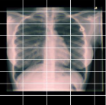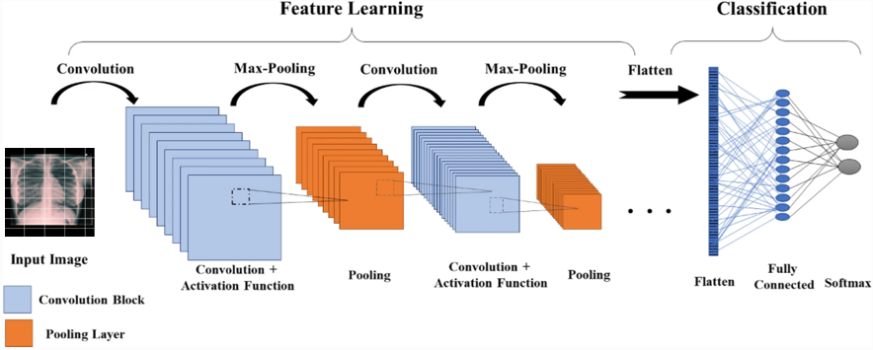

**Figure 1.** Architecture of Classical CNN network model

1. **Results and Discussion**

In this study, the classical CNN network model is designed as a deep learning model. Adam is used for the optimisation process and ReLU and Softmax functions are used for the activation function. The graph of training and validation loss values and training and validation accuracy values as a result of the algorithm is presented in Figure 2.

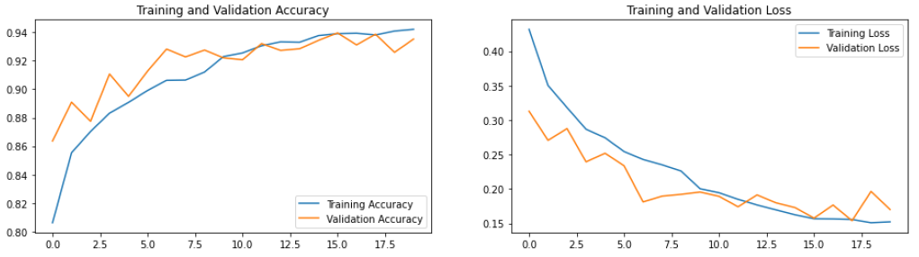

**Figure 2.** Accuracy and loss graph after training process

In the classification process consisting of two classes, an accuracy of 92.93% is obtained. Accuracy, Recall, Precision and F1 Score metrics are used for measure the performance of the algorithm.

The confusion matrix of the result values is presented in Figure 3 and the Precision, Recall and F1 Score values calculated according to this confusion matrix are presented in Table 1.

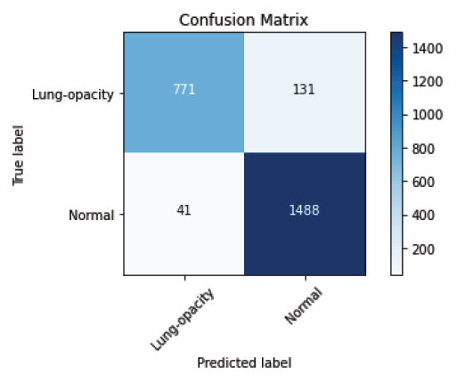

**Figure 3.** Confusion matrix according to the result of CNN model

**Table 1.** CNN architecture performance metrics

|  |  |  |  |
| --- | --- | --- | --- |
|  | **Precision** | **Recall** | **F1-Score** |
| **Lung-opacity** | 0.95 | 0.85 | 0.90 |
| **Normal** | 0.92 | 0.97 | 0.95 |
| **Accuracy(avg)** | 0.9293 | | |

1. **Conclusion**

In this study, convolutional neural network model, which is one of the deep learning methods, is applied on images consisting of lung opacity and normal categories using a publicly available dataset and the images are correctly classified with a success rate of 92.93%. CNN can be recommended instead of classical machine learning algorithms in the detection of lung opacity disease. Accuracy rates can be raised by increasing the number of epochs, making updates in the selection of hyperparameters and the design of the network structure. In future studies, it is planned to create an ensemble model by using more classifier models and to diagnose three-classes, four-classes and five-classes diseases.

**References**

[1] W. Herring, *Learning radiology: recognizing the basics*. Elsevier Health Sciences, 2019.

[2] Zahavi, G. What are lung opacities? Kaggle (2018). Available at: https://www.kaggle.com/zahaviguy/what-are-lung-opacities.

[3] J. J. Arenas-Jiménez, J. M. Plasencia-Martínez, and E. García-Garrigós, ‘When pneumonia is not COVID-19. Radiologia [Internet]. 2021; 63 (2): 180-92’. .

[4] W. Kim *et al.*, ‘Utility of a deep learning algorithm for detection of reticular opacity on chest radiography in patients with interstitial lung disease’, *Am. J. Roentgenol.*, vol. 218, no. 4, pp. 642–650, 2022.

[5] M. Zhu *et al.*, ‘A computerized tomography-based radiomic model for assessing the invasiveness of lung adenocarcinoma manifesting as ground-glass opacity nodules’, *Respir. Res.*, vol. 23, no. 1, pp. 1–11, 2022.

[6] H. M. Ünver, Y. Kökver, E. Duman, and O. A. Erdem, ‘Statistical edge detection and circular hough transform for Optic disk localization’, *Appl. Sci.*, 2019, doi: 10.3390/app9020350.

[7] F. Türk, M. Lüy, and N. Barışçı, ‘Kidney and renal tumor segmentation using a hybrid V-Net-Based model’, *Mathematics*, vol. 8, no. 10, p. 1772, 2020.

[8] E. M. Senan, A. Alzahrani, M. Y. Alzahrani, N. Alsharif, and T. H. H. Aldhyani, ‘Automated diagnosis of chest X-ray for early detection of COVID-19 disease’, *Comput. Math. Methods Med.*, vol. 2021, 2021.

[9] H. Li, N. Zeng, P. Wu, and K. Clawson, ‘Cov-Net: A computer-aided diagnosis method for recognizing COVID-19 from chest X-ray images via machine vision’, *Expert Syst. Appl.*, vol. 207, p. 118029, 2022.

[10] V. Mergen *et al.*, ‘Deep learning for automatic quantification of lung abnormalities in COVID-19 patients: First experience and correlation with clinical parameters’, *Eur. J. Radiol. Open*, vol. 7, p. 100272, 2020.

[11] I. Sirazitdinov, M. Kholiavchenko, T. Mustafaev, Y. Yixuan, R. Kuleev, and B. Ibragimov, ‘Deep neural network ensemble for pneumonia localization from a large-scale chest x-ray database’, *Comput. Electr. Eng.*, vol. 78, pp. 388–399, 2019.

[12] M. V Valueva, N. N. Nagornov, P. A. Lyakhov, G. V Valuev, and N. I. Chervyakov, ‘Application of the residue number system to reduce hardware costs of the convolutional neural network implementation’, *Math. Comput. Simul.*, vol. 177, pp. 232–243, 2020.

[13] A. Tsantekidis, N. Passalis, A. Tefas, J. Kanniainen, M. Gabbouj, and A. Iosifidis, ‘Forecasting stock prices from the limit order book using convolutional neural networks’, in *2017 IEEE 19th conference on business informatics (CBI)*, 2017, vol. 1, pp. 7–12.

[14] A. Van den Oord, S. Dieleman, and B. Schrauwen, ‘Deep content-based music recommendation’, *Adv. Neural Inf. Process. Syst.*, vol. 26, 2013.

[15] O. Avilov, S. Rimbert, A. Popov, and L. Bougrain, ‘Deep learning techniques to improve intraoperative awareness detection from electroencephalographic signals’, in *2020 42nd Annual International Conference of the IEEE Engineering in Medicine & Biology Society (EMBC)*, 2020, pp. 142–145.

[16] R. Collobert and J. Weston, ‘A unified architecture for natural language processing: Deep neural networks with multitask learning’, in *Proceedings of the 25th international conference on Machine learning*, 2008, pp. 160–167.