WATER and LIFE COUPLE
Zekâi Şen¹
Istanbul Medipol University, Engineering and Natural Sciences Faculty, Beykoz, 34815, Istanbul, Turkey. E-mail: zsen@medipol.edu.tr

Abstract: Water is the most precious survival existence of life for plants, animals and human in addition to their interactions. There cannot be sustainability without water and its by products in the nature, and therefore, its natural status must be cared for better future horizons without giving any harm through wastes, pollution and extravagant consumption. Any country needs further developments through expansion of socio-economic, industrial, energy, atmosphere and environmental aspect preservations, but at the heart of such developments water has the primary significance. It is well known that water is the source of life, but unfortunately its consumption is rather extravagant in many societies. The historical surveillance of water indicates its role in numerous of activities including philosophy, poetry, religion, culture, steam engines, transportation, hydro-electric energy, hydrogen energy, agriculture, food, etc. Unfortunately, recently human beings have put extra unwanted stress on water resources as a result of pollution, mismanagement, wastage loading, dangerous material dispersion, etc. Especially, present and future climate change and variability impacts are bound to affect water resources surface and sub-surface reservoirs if necessary precautions are not taken from now on through combat, mitigation and adaptation research studies and more significantly their implementations have priorities in any society for sustainable, safe and survival activities. Although, there are water related flood and drought nuisances, but at least by rational reasoning and scientific methodologies their dangers can be minimized. This article will expose different aspects of water for sustainable couple continuation of water and life.
Keywords: water, sustainability, life, climate change, pollution, risk, adaptation, society, energy
- Introduction
Since the cradle of the civilization water had the central role not only in any human activity but also in the plant and animal life sustenance. Fresh water resources have been the major social, political, military and recently industrial prerequisite in many aspects. Apart from the essential basic ingredients of many nutrients, human body and living organisms, water has energy, and hence, power distribution in many forms in nature. This force of water helped to expand both knowledge and human activities right from time immemorial, and therefore, the water structures have been prime targets in civil and international interactivities. Man cannot exist in this planet without the power of the water. In this paper, water power will be dealt with along two paths. On the one hand, actual and physical water power is essential in much industrial, navigation, electricity generation, machine running and on the other hand its social and political powers are emerging as the main concerns in the 21st century. This latter type of power is at the top of the hydro-political agenda internationally and within any country nationally. Available world fresh water resources depletion is not only due to population growth, but more significantly pollution, global climate change and greenhouse gas (GHG) emission effects. In the open literature, it is mentioned that there are water rich and poor countries in the world and especially if such countries are neighbors the sovereignty over the water rights might lead to power conflicts that eventually may lead to mutual interventions in the next century.
Different revolutions are rather frequent in human history, but unfortunately those related to water are overlooked even though their impacts are sustainable throughout the history. The first historical revolution includes agricultural activities, which have vitalized civilizations and commercial developments. This revolution was activated by individuals. The subsequent major water revolution became at the hand of states by management strategies, which took into consideration water savings, demand and supply adjustment. In the meantime hydraulic and water engineering started to take shape with practical applications leading to preliminary scientific principles. On the other hand, there are water crises, which might also be through among water revolutions including dry spells, droughts, wet periods and floods. Recent climate change discussions trigger presently such crises. Water resources are necessary and basic requirements prior to any other material for civilization and city settlements, where social, educational, economic, religious and technological developments take place. Water resources are limits for growth and prosperity. In the future another revolution is expected to occur, when the water can be disintegrated into hydrogen and oxygen, and hence, unlimited energy generation from the hydrogen coupled with the solar energy.
As Priscoli (1998) states “Just as water is life and we are predominantly water; water infrastructure is the precondition for civilization”. Whatever the availability of other raw materials for the survival of living organisms, water has the prime and top role in the sustenance of individual’s life and collectively society’s common actions, which are gathered under the umbrella of civilization. Civilization starts with the community life in villages, towns and especially in the big cities. Existence of water has become synonymous with the existence of life elsewhere whether in the earth or space. In Holy Books such as in the Qur’an there are verses whereby it is stated that all the living creatures are created from water. Ever since the creation of life man, animals and plants are dependent continuously on few precious commodities among which the water constitutes the primary importance. Other vital commodities such as food and oxygen are by products of water. Man's relationship with water has been vital, complex and varied from the earliest times. It is for this reason that the Holy Books include divine verses signifying the attachment of human life to water not in the usage sense only but more significantly that the living things are created from water. In fact, the life in essence is a product of water. Use of water power produces energy needed to run a society. Society’s first action to the problem of grossly uneven distribution of fresh water resources was to build large aqueducts and dams to balance fluctuations in river runoff over time and to transport water from surplus to deficit regions.
This dependence of man's life on water compelled him to choose his settlement locations at positions where water was easily available. Therefore, early settlements are invariably either along the rivers, next to lakes or springs all of which provide natural water resources. Accordingly, the first activities of man were basically related to water in search of food by means of irrigation, local live-stock rising, defense and communication. In the romantic past of the desert life, the shady oases of local agriculture and the routes of transportation across the arid region were located and controlled by the availability of water. In this manner, not only the goods but knowledge is distributed and expanded among different communities. Consequently, due to water related transportation routes as rivers, streams, creeks and on the land between water resources available points the communities were able to communicate with each other. This led to exchange of views and goods through commercial affairs. In the past, these routes become powerful communication networks and primary targets in any conflict or combat. Likewise, even today such intervention possibilities are still around the corner. Farther expansion of man's own environment gave rise to increase of demand on water. Consequently, the interference of human being on the natural occurrence and movement of water started by dams, dikes or levee's construction so as to augment or translate the available water storage with time. Specially, in the arid regions of the world due to high temperature and rare rainfall occurrences, every single drop of water had to be preserved. For this purpose, human being excavated surface depressions to save the rain water.
Later, human beings become acquainted with the groundwater storage and began to dig large diameter wells in order to reach the available groundwater reservoir (Şen, 1995). Groundwater is the main water resource in arid countries. Although there are social, economic, political, juridical impacts of the groundwater on man's life, these will not be touched upon herein. During the industrial revolution in the west, again as water power, steam power played very significant impact on the prosperity of the societies. Construction of high dams over the last 100 years pumped hydroelectric energy which is also derived from the physical power of the water that circulate along the natural hydrological cycle. Today, physical power of water is exploited at every occasion wherever such opportunities are available. However, at places where sufficient water is not available due to naturally unbalanced spatial and temporal distributions, transportation of water is thought at any cost. This makes water as a hydro-political matter and recently more than physical power, political power of water is in the world agenda. Water is at the way of becoming more precious than other energy power alternatives such as coal and oil. It is expected that in the 21st century, political water power will be debated more than its physical power which has been used throughout past centuries.

- Water and life
Life for all living things started with water and will continue with water. In the European Parliament's Water Policy Framework, water has been described as "not a commercial product, but a legacy to be seen and protected, to be defended and treated as a commercial product". Unlike all other natural resources and wealth, this heritage is a sustainable resource that has the opportunity to renew itself every year. Other natural resources (petroleum, minerals, gold, etc.) in the nature of wealth will undoubtedly be depleted one day depending on the available reserves and consumption amounts on earth. Fresh waters, which are in a continuous cycle (Hydrological Cycle) thanks to solar energy, will continue their existence depending on rainfall (Figure 1)

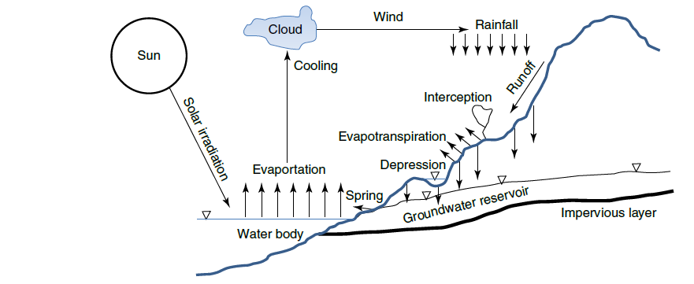

Figure 1 Hydrological cycle
Although the depletion of groundwater is due to rainfall, it is possible to degrade the aquifer structures, which are dams in the underground, by erroneous drilling constructions, by destroying the infiltration areas in various ways, especially by making them unusable by pollution.
Human beings, animals and plants are dependent on some gases, water, nutrients and solids that are available in nature rather abundantly, but in fine balance and measures and almost freely for their survival. Among these essential commodities, the most precious ones are the air in the atmosphere that living organisms breathe and the water that is available in the form of hydrosphere (Figure 2).
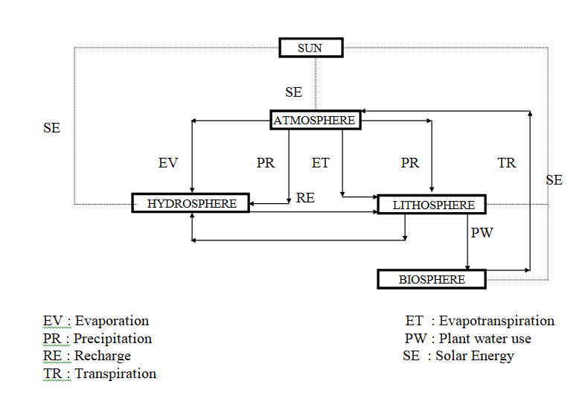

Figure 2 Various spheres and their environments
Unfortunately, during the last century these basic precious commodities for the survival of all creatures are polluted unilaterally by human beings only initially unconsciously at the cost of other creatures and nature, but recently for themselves also.
Although pollutants may originate from natural or man-made activities, the term pollution is often restricted to considerations of air and water quality as modified by human actions, particularly when pollutants are emitted from industrial, urban, commercial and nucleated areas at rates more than the natural diluting and self-purifying processes prevailing in the lower atmosphere, which is the main cause of climate change impacts. Pollution seems as a local problem with three distinctive geographical factors. First, the wealth of human beings defines the distribution of housing, industry, commercial centers and motor vehicle transportation between these centers. Such a system forms the major source of man-made pollution. The second agent that plays a significant role in the formation of pollution is a natural phenomenon in the atmosphere and hydrosphere which controls the local and temporal climatic weather and quality variations because of which the pollutants introduced into these spheres are either scattered in various directions or carried away by currents. The interaction between the pollution emissions and the spheres may well be modified by local relief factors. Finally, atmosphere, hydrosphere and lithosphere were created in harmonious balance and measures for the sustenance of biosphere where the living creatures’ survival. Hence, the equilibrium between these spheres and their harmony with the human beings in the center constitutes the environment and ecology.
Unfortunately, unlimited and uncontrolled technological developments affect the environment leading to various human health problems and spherical pollution. Accordingly, measures should be taken for reducing risks concerning environmental pollution and possible ecological imbalances. The various spheres and their interactions for human survival on the earth are shown in Figure 2. All these spheres and interactions are created by God in balance and proportional measurements in harmonious manners which are exposed to human for reflection, finding paths to reach God and for worldly scientific studies.
Even though the natural circulation within and among the spheres provides scavenging effects, continuous and long-term loading of atmosphere, hydrosphere and lithosphere have already given signals for undesirable and dangerous expectations in the future which might increase if the necessary precautions are not taken. For this purpose, more research activities are necessary to appreciate the natural events in the atmosphere; ozone depletion in the stratosphere; pollution in the lower troposphere and transboundary between the troposphere and hydro-lithosphere; energy, transport and industrial pollutants generation and their movement; effects of acid rain; waste water leakage into the surface, and especially ground water resources. It seems that success in these areas necessitates, at first glance, sound scientific basic research and its proper applications. To this end more extensive climatically, meteorological, hydrological and hydrogeological observation networks should be established for spatial and temporal monitoring of the uncontrollable variables. There should be ever greater cooperation in detecting and predicting atmospheric changes, and assessing consequential environmental and socioeconomic impacts, identifying dangerous pollution levels and greenhouse gases. It should be emphasized at these stages that from scientific and technological points of view, almost every effort has been done for keeping ecological balance and stopping environment degradation. A major question is whether the scientific approaches in their inhuman consequences towards environment with the lack of moral and faith are enough to restore the balance for sustainable ecology and clean environment?

- Philosophical and religious aspects of water
Human beings and nature are the two activists that have interactions starting from the early historical life and also after the birth. Philosophy can be defined as the fundamental nature of knowledge, reality, and existence, especially when considered as an academic discipline. Among the major philosophical topics are existence, ontology, metaphysics, epistemology and ethics. The first three subjects of philosophy have partial inclusions of water and its role in the human behavioral history. Philosophical thinking and judgments have started with the creation of man, but the first formal definition took place during the Old Greek period around 4-3 centuries B.C. For instance, Aristotle’s has considered the natural philosophy as combination of logic with observation to make general, causal claims. On the other hand, the philosophy by Avicenna (Ibn-i Sina) takes its form as the global environmental and ecological balance, monitoring and understanding of nature and universe as sub-spherical units such as atmosphere, lithosphere, hydrosphere and biosphere, which have meaningful explanations only explained with human beings and all other creatures at the center of the universe.
Since the creation, in the early periods of human existence on earth, all these environments had impacts on daily human life and survival but as the time passed away with the wisdom and intellectual ability granted to human beings by God, they started to obtain their fundamental needs such as food, shelter and clothing by exploiting natural sources in the nearby environments at reasonable rates.
Although materialistic advancements are trusted by the scientific and technological efforts, but spiritual, ethical, social, cultural and peace environments are not affected by these advancements and they need faith first in God and then in His creatures including nature and universe. Consequently, a right question about what the vehicles of unmaterialistic stability are, and hence, salvation? will have answers outside the scientific scope and technology whereby the faith, religion and ethical codes come into view. After all the corruptions ignited by the materialistic well-being and improvement, recently all over the world, there are visible shifts towards religious affairs more than ever and the main reason for this is the environmental and ecological deteriorations.
The whole realm of nature is a revelation of the will of God. The divine will be manifest in the creation of heavens and earth, the alternation of day and night, and in the variety of flora and fauna or in the hydrodynamic law which governs the interface between fresh and salt waters, and keeps them apart.
Philosopher Aristotle stated that “Everything has originated from water”, because he had the belief of unity, but this unity was a materialistic rational thinking based. On the other hand about one thousand years later it is a verse in Qur’an states that “Every live thing has been created from water.” The comparison of these statements indicates that the verse is more scientific. Today search for life in planets, for example, in Mars, is based on any trace of water or humidity as NASA continues their research for life existence or for human beings migration possibility to this planet.

- Socio-economic water features
The sanctity of water is recognized by societies. It has immersed social power to move people. The societies are deeply concerned with this power. Since, it has been the key driving force for sustenance and transportation of civilization. A very good example for such a case has appeared with the advent of steam engine leading to industrialized societies by using water power in the form of steam. Water constitutes socio-economic foundations of a society and environmental issues.
Fresh water is basic requirement of human being. It is the basic ingredient of food production, a moderator of economic growth and an essential social agent. As a source of incommensurable benefits to the planet and its people, it is also a vehicle of looming threads to human health and environment. In the next 30 years, more than 60 % of the world’s population is expected to face water related problems in large cities. Availability of limited fresh water resources places extra stress on the water related issues due to population growth and rising living standards which are the driving forces of the industry at large. The magnitude of stress on water varies widely across the world. This brings the concerned people to ponder upon the rational and more efficient use of available resources without extravagant wastage and according to suitable management and operation rules. Otherwise, the existing small scale issues arising from the water limitations might lead to political and economic crises. Unfortunately, today in the global world local political issues are becoming swiftly international conflicts, which pave ways to some other unconcerned nations to put their nose into such water related sensitive questions. According to World Meteorological Organization (1997) report about one-third of all low-income people live in areas of moderate to severe water stress. Also Najlis (1997) stated that two-thirds of low income people will face moderate to severe water stresses by 2025. In a river basin there are many water resources activities both on the surface and in the subsurface in the form of groundwater reservoirs. Increasing demands bring additional stresses on these resources. The local conflicts emerge between city municipalities. For example, Istanbul city in Turkey, as one of the world’s mage poles with more than 15 million populations presently tries to meet its water demand not from the water resources within the municipal boundaries, but transportation of water from nearby cities. In a way this presents a small scale water rights agreement between the cities, the large scale of which might occur between neighbor countries as trans-boundary water resources rights. There are different conflicts between the cities of the same country let along the possibilities of trans-boundary water rights. In order to offset the water demand, today in many cities of the world and especially in developing or oil rich countries, where the water scarcity prevails so to say “super-surface” water resources are being exploited by weather modification studies, i.e., by artificial rainfall generation procedures. Unfortunately, this approach is not yet well documented, but at the research stages. Hence, there are competitions for water resources with huge ramifications for water policy, particularly in countries with high water stresses especially in the Middle East, southwest United States and South Africa. As explained above, many such competitions will arise in the future not only concerning the quantity of water, but perhaps more significantly the quality of water with pollution frees preservation.
Not only the global population growth but social, environmental and industrial activities will escalate the risks of political conflicts over the limited and unevenly distributed water resources. Such tension and conflict possibilities make fresh water hence more social and international power than its physical power. In fact, physical power creates social power and therefore prior to any physical intervention on water resources social and political means must be debated with rightful understanding. A substantial portion of fresh water resources is contained in international drainage basins, basins shared by two or more nations. These basins make up nearly 50% of the earth’s land area, and 60% of the area of both Africa and Latin America (Gleick, 1993). Social and economic powers of water became more interesting especially that the international agreements are often either inadequate or lacking entirely in some parts of the world. In the future, it is most likely that political tensions over social and economic power of water might lead to tensions over shared rivers, lakes, aquifers and even clouds, if the artificial rainfall generation procedures become more efficient.
The water problems in a society will gather many specialists including politicians, environmentalists, commercial and trade interests, water scientists and technicians in addition to technocrats. However, these specialists are not sufficient to solve the problem, but they can present the possible deficiencies and lacking points. The overall and desirably holistically developed solutions will need to comprehend and deal with more complex issues including economics, financial support, social, environmental and legal issues. The following points must be kept in mind.
- Fresh water is a finite, vulnerable resource, essential to sustain life, development and environment,
- Water development and management should be based on a participatory approach, involving users, planners, and policy-makers at all levels,
- Women play a central part in the provision , management and safeguarding of water,
- Water has an economic value in all its competing uses and should be recognized as an economical good,
- Mobilizing financial resources is critical to effective water resources management.

- Climate and water
The natural atmospheric composition is subject to disturbance by anthropogenic activities, which loads atmosphere with unwanted greenhouse gas (GHG) emissions. The accumulation of GHGs, especially carbon dioxide and methane, in the troposphere (lower atmosphere) changes the chemical composition of the atmosphere on the one hand, and on the other changes the natural occurrences of meteorological variables including temperature, precipitation, solar irradiation, humidity all of which generates natural hazards on the surface of earth among which are the urban areas, coastal regions and internal low elevation lands. The nuisance of global warming and consequent climate change coupled with climate variability is seen as treats to human societal life in the future (IPCC, 2007, 2014). The first harmful impacts are bound to affect the water resources in general in the forms of meteorological, hydrological and agricultural droughts, floods, water stresses, and water scarcity. Land use and land cover are also one of the factors in this role, because in many parts of the world agricultural lands are converted to industrial, residential and factory areas, all of which reduce the vegetation cover, which is useful for GHG emission reduction. In addition to this also deforestration activities either by humans, fires and desire for agricultural area increments are among the triggering events. Unfortunately, materialistic deteriorations in the nearby atmo-, hydro-, bio- and geo-environments coupled with extravagance and luxurious standards of life gave ways to additional comfortability provided by the unprecedented technological developments abasing respects and regards in the traditional, social, religious and cultural lives. Consequently, demoralization in the society in addition to hollow ambitions and feelings without beneficial purposes started to flourish everywhere beyond limits. Parallel to this materialistic destruction in the environment, moral and ethical values also deteriorated with positivistic scientific evaluations void of faith. In the meantime, social ethical illnesses spread out in the society at the expense of innocent, sincere faiths and beliefs which are undeniable elements towards better standards of life. At times human beings found themselves in amidst of chaos and irreversible social, economic and especially environmental unrest and deteriorations. Of course, later it is understood that even the most advanced scientific techniques and technologies are insufficient to restore the genuine original aspects of the environment as they used to be naturally in the past. Furthermore, a new concept as “natural conservation without technological restoration and aid” started to spread within the social, scientific and administrational circles.
As a summary of the previous paragraph (Oki et al., 2003) proposed the skeleton of the previous paragraph explanation in Figure 3, which has been also modified by Şen (2015).
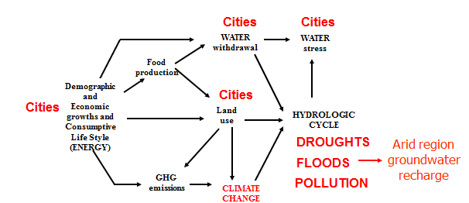

Figure 3 Climate change and hydrological cycle
T. Oki et al.,inValue of Water Research Report Series No.
12, A. Y. Hoekstra, Ed. (UNESCO-IHE, Delft, Netherlands,
2003), pp. 221–235

- Human engineering and water
The physical power of water arises along the hydrological cycle through which potential, kinetic and heat energy forms are converted from one to each other. Figure 4 shows energy powered hydrologic cycle with the inexhaustible energy source as sun. Solar radiation from the sun activates the free surface water for evaporation and in this manner the kinetic energy within the upper surface layer of the water leads to entrance of water molecules into the lower atmosphere as latent heat energy embedded particles.

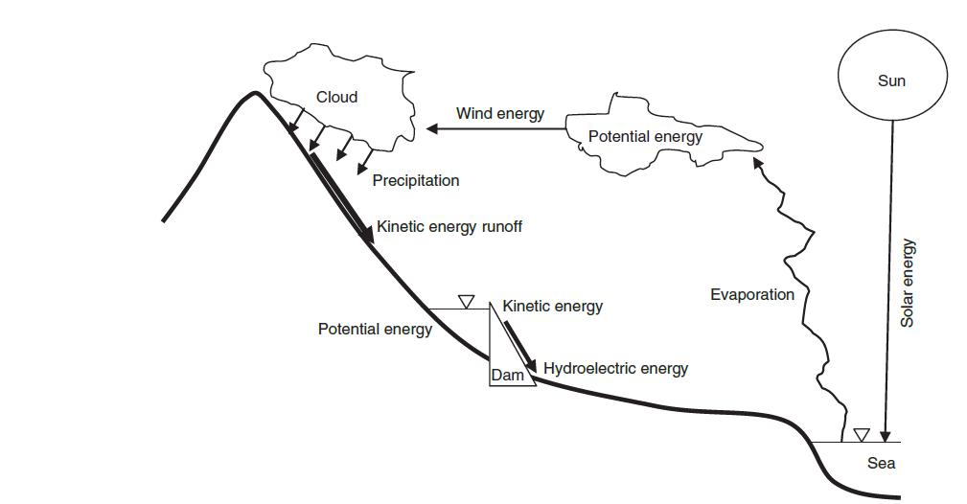

Figure 4 Energy powered hydrological cycle
Since the vertical temperature distribution has a decreasing trend upwards and according to thermo-dynamical laws heat flows from warm regions to cooler areas the particles that escape from the free water surface rises upward into the atmosphere. Such a rise cools down the water vapor and after some height these water vapor form clouds. In the clouds, water power is in the form of potential energy although within the cloud there are partial kinetic energy movements from the bottom of the cloud towards the ceiling. The clouds are transported towards inland by horizontal air movements in the form of winds and due to further rise along the mountain sides, or cyclone occurrences cooling within the clouds forms water drops which become heavier such that they become more than the gravitational force and hence start to fall downwards in the form of precipitation. The rainfall has maximum power as it reaches earth’s surface and consequently, it might cause soil erosion and consequent sediment transport. On the other hand, water at higher elevations has comparatively higher potential energy than lower lands and subsequently this potential energy is converted to kinetic energy in the rivers. It is this kinetic energy as water power turned water mills and haulage of water at a point from low to high elevations by water wheel through the centuries. Construction of big dams at any suitable cross-section along the river conserves this kinetic energy into accumulated potential energy. Hence, in any dam reservoir water power is ready for electric energy generation.

- Conclusions
In order to avoid the consumption of water as a precious commodity for future generations from now there must be social, intercity and international agreements for the use of water resources. Rather than the right for use, the right for equal sharing responsibilities with the contribution of all communities involved must the common goal. Unfortunately, limited fresh water resources are bound to be more limited and scarce with economic value in the future, if present rate of water quality deterioration mechanism such as environmental pollution, global climate change, CO₂ emission rate, and greenhouse gas (GHG) emission effects problems are not combated jointly all over the world. The overall water problems in the future are clear and appreciated by all communities and countries. However, the real problem is to try and solve these problems without creating any other problems of economic, political, military or other types. In other words, water problems must be confined within the water problems only with solutions. For this purpose the following guidance must be considered.
a) Data collection, dissemination and treatment procedures must be rendered to more efficient and internationally recognized standards by collaborations. Temporal and spatial distribution of water resources of any type must be assessed both on national and international levels,
b) The socio-economic and cultural weights of water must be emphasized because the importance of one or the other varies temporally and spatially depending on each nation,
c) Every society should have commonsense and should search for rightful solutions to water related problems especially within the next 50 years during which water conflict scenarios are expected to be fabricated even without any sound basis,
d) Water power of any type should serve societies on equitable rights with mutual understanding and scientific management programs.

8. References
Gleick, P.H. (1993). Water in Crisis. A Guide to the World’s Fresh Water Resources. Oxford University Press, 473 pp.
IPCC, 2007. Working group II contribution to the intergovernmental panel on climate change fourth assessment report climate change 2007: Climate change impacts, adaptation and vulnerability”, p. 9-10.
IPCC, 2014 Climate Change: Synthesis Report. An Assessment of Intergovernmental Panel on Climate Change, IPCC, Geneva, Switzerland, 2014, http://ipcc.ch/index.html.
Najlis, P. (1997). The role of fresh water in sustainable development. Proceedings of the First World Water Forum, Marrakesh, Morocco, Elsevier, 21-22.
Oki, T., Agata, Y., Kanae, S., Saruhashi T., and Musiake, K., (2003): Global Water Resources Assessment under Climatic Change in 2050 using TRIP. No. 280 in IAHS Publ., IAHS, 124–133.
Priscoli, J.D. (1998). Perspective on the problematic of water on the inauguration of Water Policy. Water Policy, Vol. 1, 1-7.
Şen, Z. (1995). Applied Hydrogeology for Engineers and Scientists, CRC Lewis Publishers, Baton Rouge, 425 pp.
Şen, Z., (2015. Applied Drought Modeling, Prediction And Mitigation.Elsevier Publication, 472 pp.
World Meteorological Organization and UN participating Agencies. (1997). Comprehensive assessment of fresh water resources of the world. Geneva.

