Planning Optimal Forest Road Network Using Unmanned Aerial Vehicle
(Eldivan Sample)
Turgay ÇÖLKUŞU^{1,*} , Ender BUĞDAY²
¹Institute of Natural and Applied Science, Çankırı Karatekin University, Çankırı, Turkey
²Faculty of Forestry, Çankırı Karatekin University, Çankırı, Turkey

Abstract
This study, using Unmanned Aerial Vehicle (UAV) for the existing forest road network on forest roads, which undertakes the basic infrastructure in the execution of various forestry activities, is used to determine and plan the forest road locations required for the optimal forest road network, such as drones, etc. This study was conducted to demonstrate the usability of featured technologies. In this study, a practical approach is presented in the use of databases that can be processed with the help of Geographic Information Systems (GIS) software to make evaluations about national forest road networks with the data obtained. Within the scope of the study, the current orthomosaic data was obtained by making flights from various heights with the drone (UAV) device of the forest assets within the borders of Çankırı Karatekin University Faculty of Forestry Eldivan Research and Application Forest (367 ha). With the advantageous analysis environment provided by better quality and sensitive data, a multi-database containing the data of the entire study area has been created. After the current state of the forest road network has been determined, the existing forest road network has been defined in the digital environment and the necessary locations to reach the optimal road network have been determined by the GIS software. By using the orthomosaic and high-resolution Digital Elevation (DEM) data produced within the scope of the study, the locations needed in accordance with the relevant communiqué of the General Directorate of Forestry (GDF) were included in the planning and alternative routes were revealed for the project design studies. By using the UAV device, practical and effective data can be obtained in a short time in practice and a suitable decision-making environment can be provided for decision makers. All the data produced as a result of this study are represented in a database that can be used by scientists and other interested participants.

Keywords: Unmanned aerial vehicle, forest road, planning, alternative route

- Introduction
In our country, the main infrastructure facility that serves to carry out forestry studies and various forestry plans is forest roads. It has an important place in the continuation of forestry activities throughout the year and without interruption [1]. In Turkey, road planning and construction works started in 1937 [1], but acceleration was seen in the early 1960s [2]. Forest road network planning studies in the world show a constant change until today with the rapidly developing and widespread technology [3]. In the period until today, there have been transformations with the effect of science and technology in terms of forest road network evaluation. In the past, studies carried out with traditional planning included various errors and deficiencies as they were not more detailed and clearer. This disadvantageous situation is on its way to an advantageous situation due to the use of computer software of Remote sensing (UA) techniques and Geographic Information Systems (GIS) approaches, and the increasing number of experts day by day. In planning and evaluation works that require time and expense, significant distances have been covered in terms of both time and costs, and an advantageous situation has been achieved.

Since detailed and sensitive evaluations are possible with the presence of clearer and higher quality information, the information obtained within the framework of the "Precision Forestry" approach can be beneficial in achieving the desired goal or objectives [4,5,6]. Along with the advantages of GIS software, it is possible to put forward more applicable strategies at every stage of the evaluation process. Obtaining quality information with modern and technological devices, processing this information with various software and contributing to the decision-making process; It means that it is an important support for planners, implementers or decision makers [7].
Planning, construction, maintenance and repair of forest roads in Turkey are carried out in accordance with the communiqué numbered 292 published by the General Directorate of Forestry (GDF) in 2008 [8]. According to this communiqué, forest roads are divided into main and secondary forest roads. Secondary forest roads are also classified in subgroups as A type and B type. Although B-type secondary forest roads are the most widely used forest roads among all forest roads, it can be said that the most important features of this type of forest roads are that they have very low geometric features and that they are obtained at a very low cost compared to other forest road types with higher standards [9]. The most important step after planning and revealing the alternative routes is to determine the route with the least inconsistency between the land characteristics and the plan among the alternative routes [10]. Here, in the evaluation of the optimum forest road network, it is essential to determine the existing forest road network and to make evaluations including this road network.

After examining the forest roads built and completed with the existing forest road network plan in terms of technique and forest transport, it is essential to try to reach the highest possible opening rate [11]. In our country, in the evaluation of forest roads, the current tulle is generally taken into consideration. The importance and innovative aspect of this study is the production of the Digital Terrain Model (SAM) using Unmanned Aerial Vehicle (UAV) and the evaluation of the optimal forest road network using this high-resolution data. In addition, this study also showed what kind of advantages the use of UAVs can provide in the evaluation of optimal forest road network.

One of the main objectives of the relevant department is the construction, maintenance and repair of roads that will enable the continuation of various forestry activities for the next years, while meeting the increasing need for wood raw materials by protecting the forest areas effectively and efficiently [1]. In this context, the final point of this study is to determine the optimal forest road network for each sub-unit and to contribute to our national forestry by making programs and plans for this. It is possible to provide a homogeneous application unity by spreading the planning and orientation works to be done from the center to sub-units in a hierarchical order. In order to realize this ideal, the approach produced in this study is an exemplary model in determining the optimal forest road networks in order to provide the desired conditions in terms of efficiency and where work and operations can be carried out from a single point. Through this model, all desired forest areas can be tested in terms of optimal forest road network criteria and a strong forestry management approach can be served by eliminating the weaknesses as a result of the detection of deficiencies.

The aim of this study is to plan the optimal forest road network and to plan the optimal forest road network by using Unmanned Aerial Vehicles (UAV) [12] on the forest roads, which serve as the basic infrastructure in the fulfillment of forestry activities, and drone etc. The aim is to demonstrate the applicability of specific technologies in such studies. The other purpose of this study is to provide a practical approach in the evaluation of forest road networks with the data to be obtained.

- Materials and Methods
The study area was carried out within the boundaries of the Central Anatolia Region, Çankırı Forest Directorate, Eldivan Forest Subdisrtict. It is located between 40°30'30"- 40°29'01" north latitudes and 33°25'49" - 33°27'09" east longitudes (Figure 1). The study was carried out on the existing forest road network located in Çankırı Karatekin University, Faculty of Forestry, Eldivan Research and Application Forest (RAF) covering an area of approximately 367 ha. A drone device was used to detect the existing forest road network in the study area. UAV-based high resolution orthomosaic data obtained by drone was processed using ArcGIS 10.3 TM [13] software and prepared to be used in the study area for optimum forest road network evaluation.

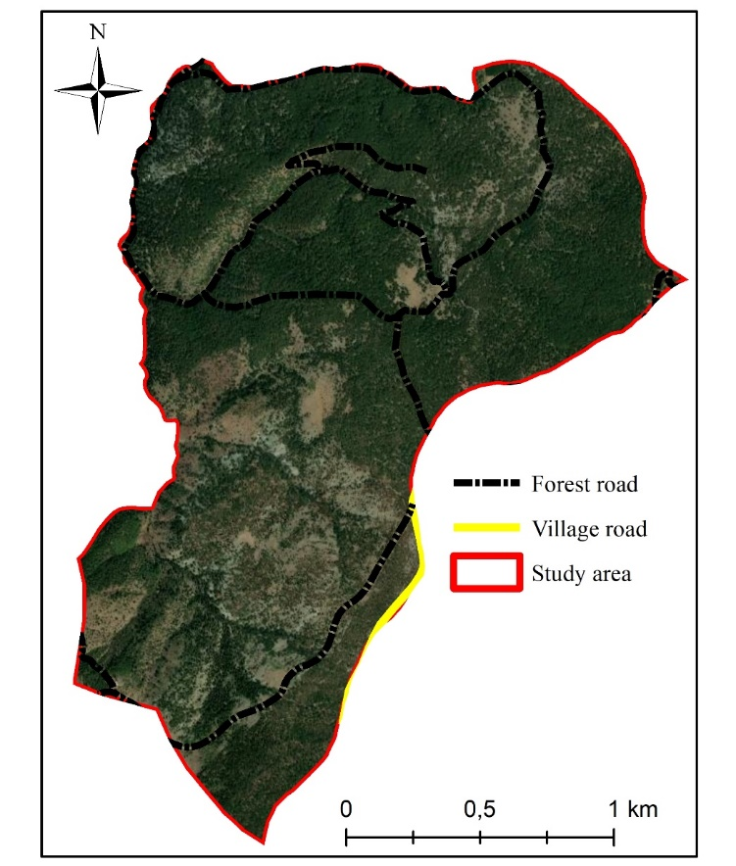
Figure 1. Location of the study area

Flights were carried out with drones from various heights on the road route. The flight path was determined by using professional photogrammetry and Pix4d software, which is widely preferred in the drone-mapping field, working in integration with the IOS loaded tablet. High resolution digital terrain model (SAM) data were obtained by using the raw data obtained from the flights using Pix4d software. The SAM data of this area were combined in a computer environment. As a last step, the existing road network of the study area was examined and the locations suitable for reaching the optimal road network were determined in order to maximize the commissioning rate in line with the objectives and targets, and the locations were expressed on the produced maps. The GNSS-RTK measuring device, which has an advanced and sensitive system, was used to obtain the precise coordinate data and heights of the ground control points for the ground verification after the flights made in the field, and for the coordinate validation of the measurement on the flight line. For the drone ground measurement validation, marking was made with spray paint and measurements were made with the GNSS-RTK device at random points in the study area.
3. Results and Discussion
Elevation, slope and aspect maps of the study area were obtained with ArcGIS 10.3 TM software. The lowest elevation of the study area is 1303 m, the highest elevation is 1685 m and the average height is 1520 m. The lowest slope of the study area is 0 degrees, the highest slope is 39.68 degrees, and the average slope is 15.13 degrees. When the slope of the study area is expressed as a percentage, these values are 0%, 82.96% and 27.03%, respectively. The dominant aspect of the study area is southwest (Figure 2).

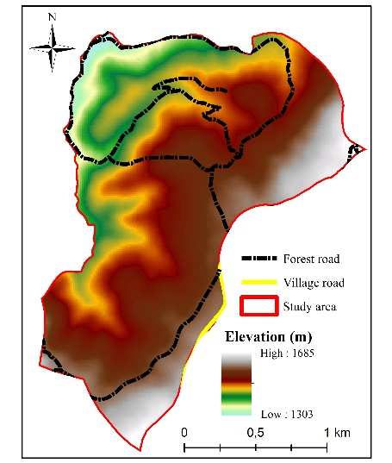 | 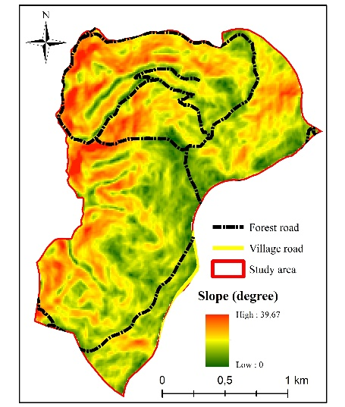 | 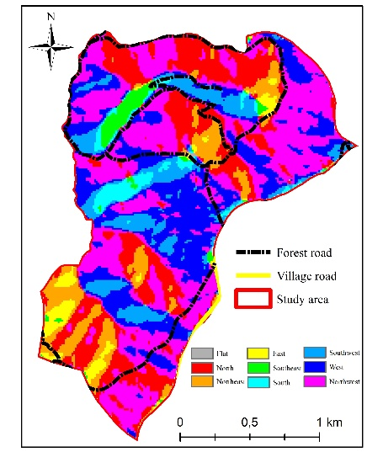
Figure 2. Study area Digital Elevation Model, slope and aspect maps

The total existing forest road length of the study area is 10531.9 meters (Figure 3). These forest roads are type B secondary forest roads. As stated in the "Forest Roads Planning, Construction and Maintenance" communiqué no. 292 of the General Directorate of Forestry (GDF), the geometric features of B-type secondary forest roads are designed as 4 m road width, 0.5 m shoulder widths on both sides, and a total width of 5 m.

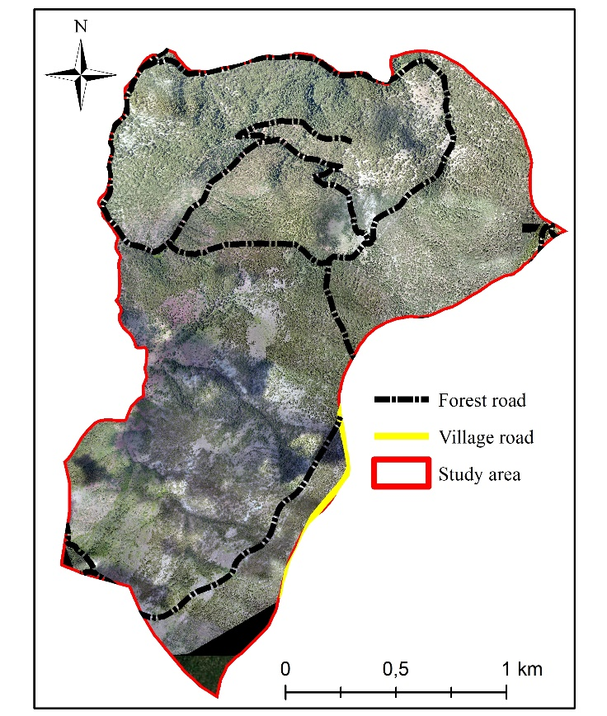
Figure 3. Existing forest road and village road locations in the study area

Road density and road spacing criteria are used in the optimal evaluation of forest roads. Accordingly, the road density formed by the existing 10531.9 m road in the study area is 28.9 m/ha. This value is appropriate as the GDF is above the usual target of 25 m/ha. However, in the future, it is foreseen that eliminating the need for roads in the middle-south part of the study area, which has no access, can provide significant advantages both in the transportation of forestry services and in firefighting. For this reason, the locations of alternative routes that can be created in case of any road need in the coming years are given in Figure 4, considering the slope criterion.

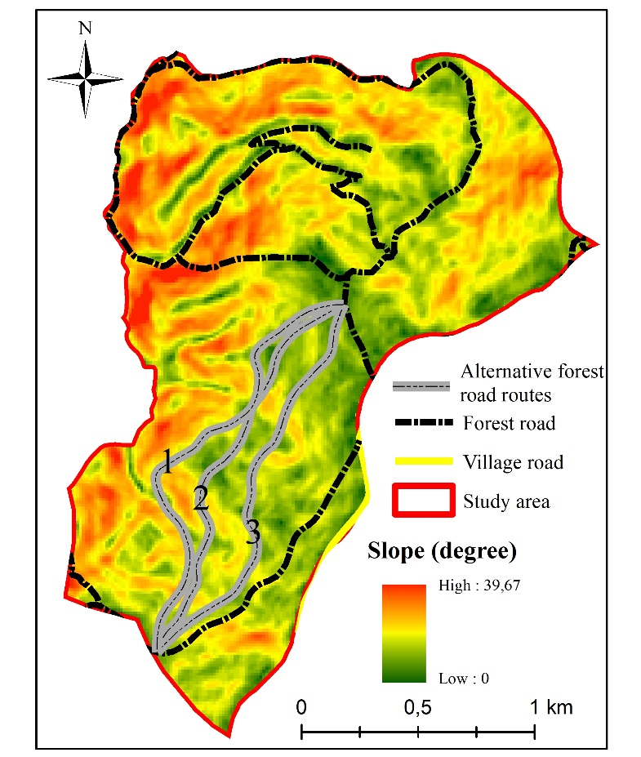
Figure 4. Alternative forest road routes

Three of the alternative routes obtained in this study are presented in Figure 4. Accordingly, alternative route number 1 is 2041.01 m long, route number 2 is 1815.90 m and alternative route number 3 is 1819.21 m long. By adding the alternative route number 1 to the existing forest road network plan, the road density is 34.26 m/ha, by adding the alternative route number 2 to the existing forest road network plan, the road density is 33.64 m/ha, and by adding the alternative route number 3 to the existing forest road network plan, the road density is It is calculated that it will be 33.65 m/ha. With this road density value, it is predicted that a suitable forest road network can be obtained for a healthier and more effective management of forestry works. The other criterion examined for the roads in the study area is the road spacing criterion. This criterion includes the distances of two different coded forest roads to each other. Regarding the road spacing values, the application in Turkey is as follows; It can be said that the road spacing is determined as 1000 m on the slopes with less than 250 m³/ha value in the forest, and 500 m on the slopes with more than 250 m³/ha value (Erdaş, 1997). According to this, it has been calculated that the road spacing on the roads in the north of the study area varies between 450 m and 850 m on average, but the road spacing value in the mid-south part of the study area has increased and reached approximately 1500 m. It has been determined that the road spacing value has decreased from 1500 m to 550 m and 700 m when the route number 1 is considered from the alternative routes. Any of the alternative routes mentioned in the study can be applied in order to carry out various maintenance works that can be done in the future in a more effective and healthy way.

4. Conclusion
When considered in the context of today's technology possibilities, not only quality information is produced, but also new perspectives can be gained in terms of efficiency with the use of modern devices and the direct transfer of current modeling approaches to the application. Since productivity is one of the most important parameters that directly contribute to the economic management of business and operations, a platform can be created for an economically efficient and ideal environment. Since this study creates a decision support system directly related to the application and practitioners, the database production and the results obtained from the project can be used by researchers and practitioners of the General Directorate of Forestry.

It has been determined in the comparison made after the data obtained from the drone device that there is a 736, 7 m long road located in the study area but not included in the current digital database. This road was added to the database and current forest road density calculations were carried out. The road density formed by the existing 10531.9 m road in the study area is 28.9 m/ha. As a result of this study, three alternative forest road routes were determined. With the implementation of any of these routes, it has been calculated that the forest road density will be around 33-34 m/ha. It is thought that any of these routes, which are important in meeting the road need of the middle-south part of the study area, which has no access in the coming years, will provide significant advantages in both forestry services and firefighting. By using the UAV device, practical and effective data can be obtained in a short time in practice and a suitable decision-making environment can be provided for decision makers. For this reason, it is thought that the use of such studies in areas of different sizes and characteristics in the future period is important in terms of both practice and literature.

Acknowledgment
This study, titled “Planning Optimal Forest Road Network Using Unmanned Aerial Vehicle (Eldivan Sample)” by Turgay ÇÖKUŞU, who was carried out in the Department of Forest Engineering, Graduate School of Natural and Applied Sciences at Çankırı Karatekin University, is derived from Master’s Thesis.

References

- Erdaş, O., (1986). Odun hammaddesi üretimi, bölmeden çıkarma ve taşıma safhalarında sistem seçimi. KTÜ Orman Fakültesi Dergisi. 9(1-2): 91-113.
- Seçkin, Ö. B. (1978). Orman yollarında drenaj. İstanbul Üniversitesi Orman Fakültesi Dergisi, 28(1), 149-165.
- Akay, A. E., & Sessions, J. (2005). Applying the decision support system, TRACER, to forest road design. Western Journal of Applied Forestry, 20(3), 184-191.
- Kellndorfer, J.M., Dobson, M.C., Vona, J.D., Clutter, M., (2003). Toward precision forestry: Plot-level parameter retrieval for slash pine plantations with JPL AIRSAR. IEEE Transactions on Geoscience and Remote Sensing, 41(7):1571-1582
- Gülci, N., Akay, A.E., Erdaş, O., Gülci, S., (2015). Forest operations planning by using RTK-GPS based digital elevation model. Journal of the Faculty of Forestry Istanbul University,65(2):59-68.
- Buğday, E. (2016). Ormancılıkta üretimin planlaması ve hassas ormancılık anlayışı. Anadolu Orman Araştırmaları Dergisi, 2(1-2), 54-57.
- Kangas, A., Gobakken, T., Puliti, S., Hauglin, M., Næsset, E., (2018). Value of airborne laser scanning and digital aerial photogrammetry data in forest decision making. Silva Fennica,52(1).19p. https://doi.org/10.14214/sf.9923.
- Anonim. (2008). 292 sayılı tebliğ: "Orman Yolları Planlaması, Yapımı ve Bakımı". Orman Genel Müdürlüğü, Ankara
- Erdaş, O. (1997). Orman Yolları-Cilt I. KTU Orman Fakültesi Yayınları, 187, 25.
- Demir, M., Hasdemir, M., (2005). Functional planning criterion of forest road network systems according to recent forestry development and suggestion in Turkey. American Journal Environmental Science, 1(1):22-28.
- Acar, H. H. (2011). Orman yol planlaması ve yol zemini üzerine bir araştırma. Pamukkale Üniversitesi Mühendislik Bilimleri Dergisi, 7(1), 125-130.
- Buğday, E. (2018). Capabilities of using UAVs in Forest Road Construction Activities. European Journal of Forest Engineering, 4(2), 56-62.
- ESRI, (2018). Spatial Analyst Toolbox. http://desktop.arcgis.com/en/arcmap/10.3/tools/spatial-analyst-toolbox/how-cut-fill-works.htm.

