**Numerical study of flow and heat transfer in a straight duct containing a circular region with a pair of fins**

***Selma AKÇAY1,[1]*[C:\Users\Abdullah\AppData\Local\Microsoft\Windows\INetCache\Content.Word\ORCID-iD_icon-16x16.gif](https://orcid.org/0000-0003-2654-0702)Nasser Abdoul-Halim Ismael2***

*1* Çankırı Karatekin University, Engineering Faculty, Department of Mechanical Engineering, Çankırı, Türkiye*

*2Çankırı Karatekin University, Undergraduate Student of Mechanical Engineering, Çankırı, Türkiye*

|  |
| --- |
| **Abstract**  This study numerically investigates flow and heat transfer characteristics in a straight duct containing a circular region with a pair of fins. Analyzes are carried out with ANSYS Fluent solver. The pressure-velocity connection is handled with the SIMPLE algorithm. There are adiabatic straight sections at the inlet and outlet of the duct. The duct structure contains a circular region near the inlet of the duct, and a pair of fins are installed within the circular region. The walls of the duct before and after the circular region are flat. The circular region and subsequent channel surfaces are kept at a constant temperature of Ts=350K. Nusselt number (Nu), thermal enhancement factor (TEF), pressure drop (𝛥P), friction factor (f), and performance factor (PF) are calculated for different Reynolds numbers (100 ≤ Re ≤ 800). The results of the study are given as a function of dimensionless numbers. The numerical study is compared with previous study results. To observe the effects of the circular region and the pair of fins on the flow and temperature fields, velocity and temperature contours are obtained, and the results are discussed. In addition, the study results are compared to the duct without fins and the straight duct. Numerical results show that the fins in the circular region increased the Nusselt number. However, the presence of fins causes a slight increase in pressure drop. |
| Keywords: Circular region, Fins, Straight duct, Heat transfer, Laminar flow, Thermal enhancement |

1. **Introduction**

Passive heat transfer enhancement methods are widely used in many heat transfer devices, especially heat exchangers [1, 2]. Wavy/corrugated channels are among the most used passive methods. These channels enhance the heat transfer performance by increasing the heat transfer surface area [3, 4]. To date, flow and heat transfer performance in wavy/corrugated channels with different wave profiles have been examined through numerical and experimental studies. The results of these studies have denoted that thermal performance and pressure drop in wavy/corrugated channels are higher than in straight channels [5-7]. Choudhary et al. [8] compared the flow and heat transfer of wavy and straight channels in a heat exchanger and declared that the heat transfer and pressure drop were higher in wavy channels than in straight channels. Ahmad et al. [9] numerically studied the heat transfer in triangular, sinusoidal, and rectangular corrugated mini ducts with different wave amplitudes, and they found that the heat transfer in the rectangular duct was improved by 22.19% at an amplitude ratio of 0.12. Ajeel et al. [10] experimentally and numerically investigated the flow and heat transfer in the circular and trapezoidal corrugated ducts and stated that the heat transfer increased by 3.1 times in the trapezoidal wave profile.

Another passive method is the addition of baffles, fins, and winglets into the duct. These modifications change the flow structure by directing the flow to certain regions. The addition of fins/winglets in different configurations into the duct enhances the flow and heat transfer [1, 7]. Akcay [5] numerically studied the nanofluid flow and heat transfer in a zigzag wavy channel with winglets and reported that the winglets added to the channel increased the heat transfer and the best thermohydraulic performance was found to be 2.12 at Re=400. Sun et al. [11] experimentally and numerically examined the heat transfer of multiple rectangular wings in a circular heat exchanger. Li and Gao [12] numerically examined the effects of delta-shaped baffles on heat transfer for different apex angles in a triangular wavy bottom wall. They showed that if the appropriate parameters are selected, the Nu can increase by 2.1 and 4.3 times. Naderifar et al. [13] numerically investigated the effects of wave number and fin height on the flow and heat transfer in a rectangular wavy duct with fins. They found that when the wave number is 2 and the fin height is 7.5, the best thermal improvement was achieved compared to the straight channel. Promvonge et al. [14] experimentally and numerically studied the flow and heat transfer of V-type wings. They reported that the wings can increase the heat transfer up to 3.8 times if appropriate parameters are used. Akcay and Akdag [15] numerically examined heat transfer in a circular channel with different baffle angles (θ=30º, 90º, 180º). They declared that the highest heat transfer and pressure drop were obtained at the 90º baffle angle. Feng et al. [16] numerically examined the flow and heat transfer in the triangular wavy duct with trapezoidal baffles declared that the heat transfer enhanced by 1.7 times compared to the straight duct, while the pressure drop increased by 3.5 times.

In this numerical study, more than one passive method was used together to further increase heat transfer. In the study, to reduce pressure loss, a large circular region was placed near the inlet of the duct; in this way, the number of waves was minimized, and the other walls of the duct were kept straight. The purpose of using fins is to direct the fluid to circular surfaces. In the study, the flow and thermal characteristics of the laminar steady flow were examined for different Reynolds numbers (100 ≤ Re ≤ 800) in a straight channel containing a circular region with a pair of fins. The results were compared with the straight duct.

1. **Materials and Methods**
   1. **Numerical model**

Figure 1 shows the geometry and mesh structure of the numerical model used in this study. The duct contains adiabatic straight sections with a length of L1 = 50 mm at the inlet and outlet. The height of the duct is H1 = 10 mm. At the duct inlet after the adiabatic section, there is a circular region with a length of L2 = 20 mm. After the circular region, there is a heated straight section with a length of L3 = 80 mm, which extends to the beginning of the adiabatic section at the duct outlet.

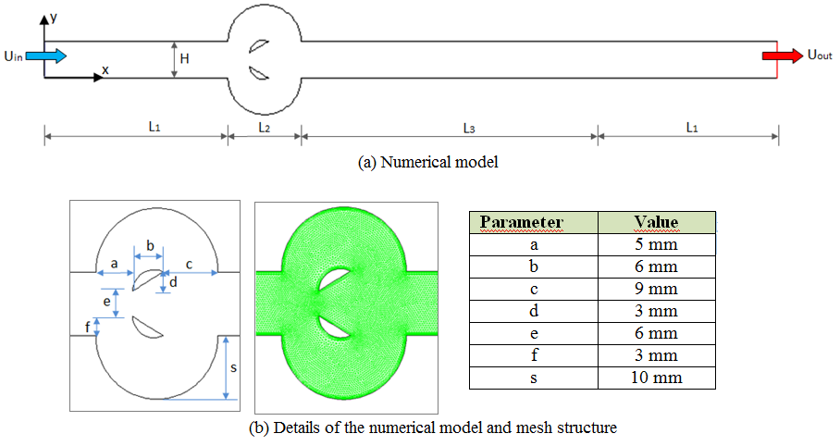

**Figure 1.** Geometry and mesh structure of the numerical model

* 1. **Governing equations**

In the numerical study, the fluid is considered single-phase, incompressible and Newtonian type. The flow field is 2d. The fluid flows in laminar and steady flow conditions. Viscous terms are neglected. Fluid properties are assumed to be constant. The effect of gravity and radiation are not taken into account. According to the these assumptions, governing equations are given below:

(1)

(2)

(3)

* 1. **Numerical method and boundary conditions**

The numerical study was carried out using the ANSYS Fluent solver. The laminar model was used as the flow model. Governing equations were discretized with the finite volume approach and the velocity-pressure relationship was solved with the SIMPLE algorithm. A value of 10-7 was set for all equations as the convergence criterion. For the mesh independence testing, Nusselt numbers were calculated for different element numbers. As a result of this calculations, it was decided that 41560, and 42660 element numbers are sufficient for the duct without fins, and the duct with fins, respectively.

Water was used as the working fluid. The fluid enters the duct at a uniform velocity (Uin) and temperature (To=300 K). In the study, Reynolds number varied in the range of 100≤Re≤800. The heated duct surfaces (L2 and L3) were kept constant at Tw=350 K. The non-slip wall condition was defined for the all surfaces. Straight sections at the inlet and outlet of the duct are adiabatic. The fins were assumed to be adiabatic and non-slip conditions.

* 1. **Data Reduction**

The Reynolds number (Re) is calculated by Equation (4):

$Re=\frac{ρUD_{h}}{μ}$ (4)

where, Dh is the hydraulic diameter, ρ is the density, μ is the dynamic viscosity, and U is the velocity.

The average Nusselt number (Nu) is obtained by Equation (5):

$Nu=\frac{hD_{h}}{k_{f}}$ (5)

where, kf and h are thermal conductivity coefficient and convective heat transfer coefficient, respectively.

The thermal enhancement factor (TEF) is described with Equation (6).

$TEF=\frac{{Nu}_{f}}{{Nu}_{o}}$ (6)

where, Nuf and Nuo represent the Nusselt numbers obtained in the duct with and the without fins, respectively.

The friction factor (f) is calculated in the duct is given by Equation (7):

$f=\frac{2ΔPD_{h}}{ρU^{2}L}$ (7)

Relative friction factor (ff/fo) is obtained by Equation (8):

$f_{rel}=\frac{f_{f}}{f_{o}}$ (8)

where, ff and fo are the average friction factors obtained in the channel with and without fins, respectively.

The performance factor (PF) is obtained by Equation (9):

$PF={{(Nu}_{f}/{Nu}_{o}){(f}_{f}/f_{o}) }^{-1/3}$ (9)

1. **Results and Discussion** 
   1. **Validation of the numerical results**

Numerical results obtained in this study were compared with the results of previous studies. Wang et al. [17] experimentally investigated flow and heat transfer behavior for the laminar flow of water in a straight channel. Figure 2 indicated the comparison of the results of numerical study with the results of Wang et al. [17].

**Figure 2.** Validation of the numerical study [17]

In numerical study, velocity and temperature contours were obtained to demonstrate the effects of duct geometry, fins, and Reynolds number on flow and heat transfer. In Figure 3a, velocity contours are indicated in ducts with and without fins for Re=100 and Re=800. Re and fins appear to affect the flow structure. The fins divided the flow into three main branches. The flow passing around the fins is directed towards the circular cavities and is provides better contact with the circular walls. Increasing the flow velocity increases the mass flow rate and inertia forces. Therefore, increasing the Reynolds number ensures a significant contribution to heat transfer. In Figure 3b, the temperature contours are exhibited in ducts with and without fins for Re=100 and Re=800. Reynolds number and fins affect the temperature contours. Increasing Reynolds number reduces the wall temperature in the duct. It is observed that the wall temperatures in the duct with fins are lower than in the duct without fins at Re=800.

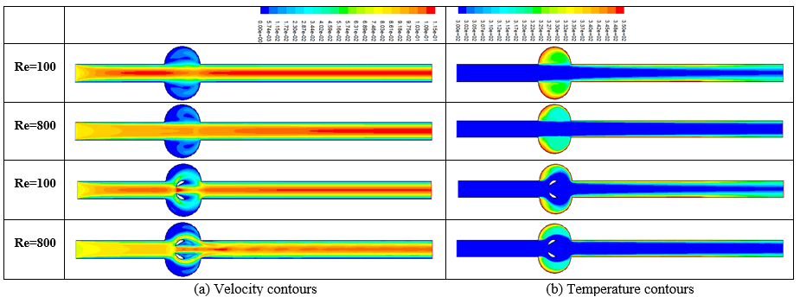

**Figure 3.** Velocity contours (a) and temperature contours (b) for Re=100 and Re=800

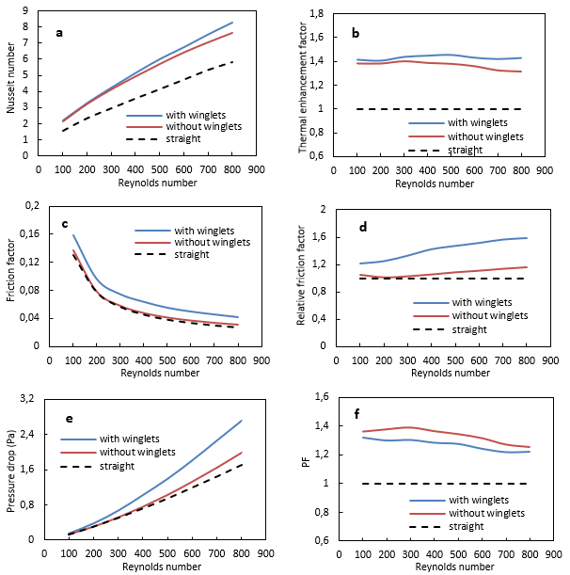

**Figure 4.** a-Nusselt number, b- Thermal enhancement, c- Friction factor, d- Relative friction factor, e-Pressure drop, f-Performance factorwith Reynolds number

Figure 4 shows the Nusselt number (a), thermal enhancement factor (b), friction factor (c), relative friction factor (d), pressure drop (Pa) (e), and performance factor (f) with Reynold number for all duct flows. In Figure 4a, the Nusselt number increases as the Reynolds number increases. The highest Nusselt number was obtained to be 8.30 at Re=800 in the duct with fins. In Figure 4b, thermal enhancement factor in the duct with and without fins was obtained to be higher than in the straight duct. The highest TEF was found to be 1.45 at Re=500 in the duct with fins. In Figure 4c, as the Reynolds number increases, the friction factor decreases for all duct flows. Friction factors in straight duct and duct without fins were found very close to each other. The friction factor in the duct with fins was found to be higher than in other ducts. In the duct without fins, the relative friction factor increased slightly with the Reynolds number, while the highest relative friction factor was obtained to be 1.58 at Re=800 in the duct with fins (Fig. 4d). The pressure drop increased with Reynolds number in all flow cases. The highest pressure loss was found to be 2.72 Pa in the duct with fins at Re = 800 (Fig. 4e). It was observed that the performance factors of the duct without and with fins were higher than the straight duct at all Reynolds numbers (Fig. 4f). The highest performance factor was obtained in the duct without fins. Because the pressure drop obtained in the duct without fins was found to be very close to the straight duct. The highest performance factor was obtained to be 1.39 at Re=300 in the duct without fins.

1. **Conclusion**

In this study were numerically analyzed flow and heat transfer in a straight duct containing a circular region with a pair of fins. Nusselt number (Nu), thermal enhancement factor (TEF), friction factor (f) and performance factor (PF) were calculated for different Reynolds numbers. To observe the effects of the circular region and fins on the flow and temperature fields, velocity and temperature contours in the duct were obtained at different Reynolds numbers. In addition, the study results were compared with the duct without fins and the straight channel. The important findings of the numerical study are given below:

* The fins in the circular region increased the heat transfer. However, the presence of fins causes a slight increase in pressure drop.
* The highest Nusselt number was obtained to be 8.30 at Re=800 in the duct with fins.
* The highest TEF was obtained to be 1.45 at Re=500 in the duct with fins.
* Friction factors in straight duct and duct without fins were obtained very close to each other.
* The friction factor in the duct with fins was found to be higher than in other flow cases.
* The highest relative friction factor was obtained to be 1.58 at Re=800 in the duct with fins.
* The highest pressure drop was found to be 2.72 Pa at Re=800 in the duct with fins.
* The highest PF was obtained to be 1.39 at Re=300 in the duct without fins.

**References**

1. Ajarostaghi SSM, Zaboli M, Javadi H, Badenes B, & Urchueguia JF. (2022). A review of recent passive heat transfer enhancement methods. *Energies,* 15, 986.
2. Alam T, & Kim MH. (2018). A comprehensive review on single phase heat transfer enhancement techniques in heat exchanger applications. *Renewable and Sustainable Energy Reviews*, 81, 813-839.
3. Kurtulmus N, & Sahin B. (2019). A review of hydrodynamics and heat transfer through corrugated channels. *International Communications in Heat and Mass Transfer*, 108, 104307.
4. Modi, AJ., & MK. Rathod. (2019). Comparative study of heat transfer enhancement and pressure drop for fin-and-circular tube compact heat exchangers with sinusoidal wavy and elliptical curved rectangular winglet vortex. *International Journal of Heat and Mass Transfer,* 141, 310-326.
5. Akçay S. (2023). Numerical analysis of hydraulic and thermal performance of Al2O3-water nanofluid in a zigzag channel with central winglets. *Gazi University Journal of Science*, 36 (1), 383-397.
6. Wang G, Qia C, Liu M, Li C, Yan Yu, & Liang L. (2019). Effect of corrugation pitch on thermo-hydraulic performance of nanofluids in corrugated tubes of heat exchanger system based on exergy efficiency. *Energy Conversion and Management*, 186, 51–65.
7. Nitturi LK, Kapu VK, Gugulothu R, Kaleru A, Vuyyuri V, & Farid A. (2023). Augmentation of heat transfer through passive techniques. *Heat Transfer,* <https://doi.org/10.1002/htj.22877>
8. Choudhary T, Sahu MK, Shende V, & Kumar A. (2022). Computational analysis of a heat transfer characteristic of a wavy and corrugated channel. *Material Today: Proceedings,* 56, 263-273.
9. Ahmad F, Mahmud S, Ehsan MM, & Salehin M. (2023). Numerical assessment of nanofluids in corrugated minichannels: Flow phenomenon and advanced thermo-hydrodynamic analysis. *Int. J. Thermofluids,* <https://doi.org/10.1016/j.ijft.2023.100449>.
10. Ajeel RK, Salim WI, Sopian K, Yusoff MZ, Hasnan K, Ibrahim A, & Al- Waeli AH. (2019). Turbulent convective heat transfer of silica oxide nanofluid through corrugated channels: an experimental and numerical study. *Int. J. Heat Mass Transf.,* 145, 118806.
11. Sun Z, Zhang K, Li W, Chen Q, & Zheng N. (2020). Investigations of the turbulent thermal-hydraulic performance in circular heat exchanger tubes with multiple rectangular winglet vortex generators. *Applied Thermal Engineering*, 168, 114838.
12. Li Z, & Gao Y. (2022). Numerical study of turbulent flow and heat transfer in cross-corrugated triangular ducts with delta-shaped baffles. *International Journal of Heat and Mass Transfer*, 108, 658-670.
13. Naderifar A, Nikian M, Javaherdeh K, & Borji M. (2022). Numerical investigation of the effect of fins on heat transfer enhancement of a laminar non-newtonian nanofluid flow through a corrugated channel. *J. Thermal Analysis and Calorimetry*, 147, 9779-9791.
14. Promvonge P, Promthaisong P, & Skullong S. (2020). Experimental and numerical heat transfer study of turbulent tube flow through discrete V-winglets. *International Journal of Heat and Mass Transfer*, 151, 119351.
15. Akcay S, & Akdag U, (2022). [Effect of baffle angles on flow and heat transfer in a circular duct with nanofluids](https://dergipark.org.tr/en/pub/iarej/issue/73888/1136354). *International Advanced Researches and Engineering Journal*, 6 (3), 176-185.
16. Feng C-N, Liang C-H, & Li Z-X. (2022). Friction factor and heat transfer evaluation of cross-corrugated triangular flow channels with trapezoidal baffles. *Energy & Buildings*, 257, 111816.
17. Wang G, Qia C, Liu M, Li C, Yan Yu, & Liang L. (2019). Effect of corrugation pitch on thermo-hydraulic performance of nanofluids in corrugated tubes of heat exchanger system based on exergy efficiency. *Energy Conversion and Management*, 186, 51–65.

1. * Corresponding author. *e-mail address: selmaakcay@karatekin.edu.tr*