**The Development Of Smart Lock Container Game for Slow Learner Children**

N. A. Moktar, NM. Kamaruddin, Z. Mohamad, N. Roslan, A. A. A. Wahid,

1norazlinaroslan@gmail.com, 2nmsarah87@gmail.com, [3zunuwanas@yahoo.co.uk](mailto:3zunuwanas@yahoo.co.uk), 4nuruliman.ahmadmoktar89@gmail.com[1], 5Amir40872@gmail.com

Department of Electrical Engineering, Polytechnic Sultan Salahuddin Abdul Aziz Shah, Selangor, Malaysia

**Abstract**

A slow learner is someone who takes longer than the average person to understand things or someone who needs multiple explanations before grasping a concept. Due to the pandemic of Covid19, children are often getting distracted while learning something at home because of the limits on how their parents can get their children to engage in learning at home. In order to overcome this problem, Smart Lock Container Game for Slow Learner Children is developed. This device is able to help slow learner children to learn and have fun solving problems at home. The project involves a game to be played in order to open a container that has been locked which consist of a processor such as Arduino Nano and HC-05 Bluetooth Module that has an interface for the game and the container. It is a new method that can help and encourage slow learner children to learn or gain interest in learning and also can boost their ability to think when solving the game to open the lock

**Keywords:** Slow learner, Arduino Nano, HC-05 Bluetooth Module, Assistive Technology

**Introduction**

A slow learner is someone who takes longer than the average person to understand things or someone who needs multiple explanations before grasping a concept and is not eligible for special education [1]. These individuals make up approximately 14.1% of the population, larger than the group of children with learning disabilities, intellectual disabilities, and autism combined [4]. According to Yusha'u, a slow child's measured intelligence ranges from 75% to 90% of that of an average child, and their learning rate is 4/5 to 9/10 of that of a normal child [16].

Slow learners' disabilities are not usually as visible as those of children who are blind, deaf, or physically disabled. Their inability to think and learn is tied to their impairment. As a result, they are less capable than other children to meet the normal demands of education and modern life. As adults, many of them will be absorbed into the community's life and will contribute meaningfully without bringing undue attention to themselves.

According to a study, multimedia courseware can aid students in their learning by attracting them, engaging them for longer periods of time, making them more independent and proactive in their learning, and increasing their self-motivation [16] such as Learning Book with Picture and Colour, Video-Assisted Learning and Game-Based Learning

1. **Literature Review**
   1. **. Slow Learner Children**

Slow learners are a category of children with learning disabilities (LD) who are unable to learn. They have mild cognitive problems and are unable to acquire something in the time allotted for it. Slow learners have limited cognitive capacity or a low intelligence quotient (IQ), information processing weaknesses, poor memory or short-term memory ability, lack of concentration with a short attention span, difficulty with abstract thinking leading to inability to express ideas, and attention problems [8].

A slow learner is a child who achieves developmental stages at a much slower rate than his peers. It is a common misconception that these children are incapable of learning or are simply 'dumb.' The truth is that each child develops and learns at his or her own pace. Some children are known to learn concepts and lessons quickly, while others are known to take their time. They can be broadly categorised into four group in terms of developmental, social, personal or educational [7].

* 1. **Characteristic Of Slow Learners**

Slow learners are hard to recognize because they don't stand out and can function normally in most contexts. They normally have normal physical dexterity, adequate memory and possess these qualities. Sometimes parents find it difficult to understand how their child can be a slow learner [12]

These children will display immature language patterns or speech problems, poor judgement, immature social behaviour, poor memory, difficulties understanding multiple steps in a task, and difficulties transferring information learned from one situation to another.

They do not set long term goals for themselves and have difficulty planning ahead. It occurs due to a lack of concentration. This weakness in what may be termed as long term memory hampers the educational progress of slow learners who need to go over the material more times before it is fixed in their mind, and more frequent revision is required to foil forgetting.

The reason for their poor memory is that they are slow to perceive and use possible associations. The efficiency of initial learning is important as well as actual retention and recall. These are all influenced by attitude, interest and emotional states.

* 1. **Assistive Technology (AT)**

Assistive technology (AT) or assistive device is any item, piece of equipment, software application, or product system that are designed, made, or adapted used to help people with disabilities increase, maintain, or improve their functional abilities. Based on certain factors parents should choose suitable assistive devices for their child to use to aid in the process of learning [13].

Although AT does not cure or eliminate learning disabilities, it can help a child reach her full potential by allowing her to focus on her strengths while avoiding areas of difficulty. A student who struggles with reading but has excellent listening skills, for example, might benefit from listening to audiobooks. Assistive technology can be low-tech, mid-tech or high-tech, so teachers and parents should become familiar with assistive technology and understand how it can be incorporated within their teaching to support an inclusive learning environment.

Low-tech AT refers to devices or equipment that do not require extensive training, may be less expensive, and do not have complex or mechanical features. Mid-tech AT may have some complex features, such as electronic or battery-operated components, and may require some training to use. Finally, high-tech AT is described as the most complex devices or equipment, which may include digital or electronic components and be computerized [13].

AT can address many types of learning difficulties. A student who has trouble writing can dictate a school report and have it converted to text using special software. A child who struggles with math can use a hand-held calculator to keep score while playing a game with a friend. There is a range of aids available to assist slow learner children with their learning, whether through traditional, technology-based, or hybrid techniques that combine traditional and technology-based methods.

* 1. **Suggestion On Types Of Game**
     1. **Puzzles**

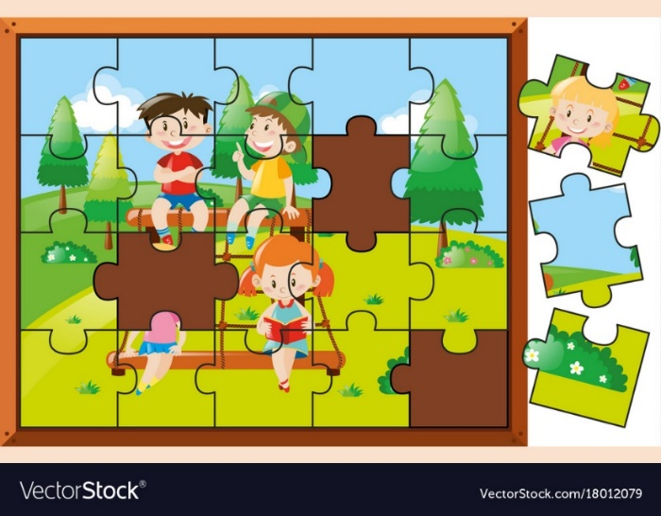

**Figure 1.** Kids Puzzles Game

Processing Speed is a measure of how quickly a child can complete a cognitive task. It describes how quickly a child receives information, processes it, and then acts on it. A child may struggle with one or more of these aspects of processing, and processing speed profiles vary because different children have different capacities in different areas [9]. Basic puzzles will keep children’s brains sharp and processing information quickly

* + 1. **Mathematic Game**



**Figure 2**. Mathematic Game

The slow learner has a fear of mathematics and a dislike for any computation or the type of analytical thinking [6]. This Mathematics game will help them to change their view of Mathematic which is fun to play and learn at the same time.

1. **Methodology**
   1. **HC-05 Bluetooth Module**

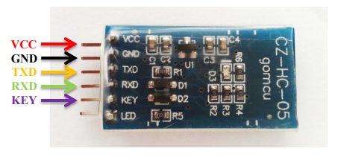

**Figure 3**. HC-05 Pin Definition

The HC-05 Bluetooth Module is a simple Bluetooth SPP (Serial Port Protocol) module that allows you to set up a transparent wireless serial connection. It communicates with the controller or PC via serial communication, which makes it simple to use. The HC-05 Bluetooth module allows you to choose between master and slave mode, which means it can neither receive nor transmit data [11].

* 1. **Arduino Nano**

The ATmega328P-based Arduino Nano is a small, complete, and breadboard-friendly board. It has the same connectivity and specifications as the Arduino Uno board but in a smaller form factor.

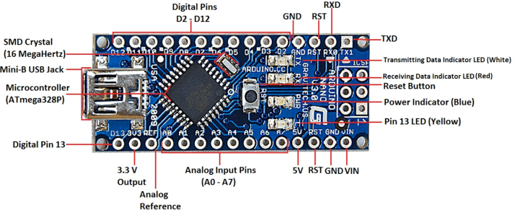

**Figure 4.** Arduino Nano with ATmega328 Processor

ATmega328 microcontroller on the Arduino Nano board 2.2 Software Engineering a software design used to operate the embedded Arduino microcontroller makes the E-M-D hardware functional. The Arduino Nano microcontroller, which has an ATmega328P processor, is programmed using the Arduino integrated development environment (IDE), which is an open-source IDE built primarily in Java and Processing for producing microcontroller sketches [1].

* 1. **Servo Motor SG-90**

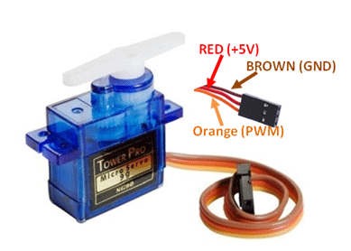

**Figure 4**. Servo Motor Pinout (Wires)

The SG90 Micro Servo Motor is a small and light server motor with high output power. The servo can spin 180 degrees (90 degrees in each direction) and functions in the same way as regular servos but in a smaller size. It's ideal for beginners who wish to move things without having to develop a motor controller with feedback and a gearbox, and it fits in compact spaces.

1. **Expected Result**

The expected result for the Smart Lock Container Games for Slow Learner Children device is that it can help and encourage slow learners to learn or gain interest in learning and can also improve their ability to think while completing games to unlock.

**Conclusion**

Slow learners have no trouble making connections, establishing themselves, and socialising in the domain of adaptive technology behaviour. The primary issue they face is a lack of educational development. When it comes to learning new things, slow learners will require more attention and practice than their peers. To help children stay focused and process information faster, audio-visual aids, graphics, displays, reference books, online material, and worksheets must be used, but they are not interactive enough for today's children.

**References**

1. Arduino. (2019). Arduino Nano. https://www.arduino.cc/
2. Bishara, Saied; Wubbena, Zane (2018). Active and traditional teaching, self-image, and motivation in learning math among pupils with learning disabilities. Cogent Education, 5(1), –. doi:10.1080/2331186x.2018.1436123
3. Dimitra, Kirstavridou & Kousaris, Konstantinos & Zafeiriou, Christina & Tzafilkou, Katerina. (2020). Types of Game-Based Learning in Education: A brief state of the art and the implementation in Greece. 3. 10.31757/euer.324.
4. du Plessis, S. (2021, November 11). What Is a Slow Learner? - Edublox Online Tutor. Edublox Online Tutor | Development, Reading, Writing, and Math Solutions. https://www.edubloxtutor.com/slow-learner/
5. Hassan, A., & Mahmud, M. (2015). Tablet technology and apps to enhance slow learners motivation in learning. Advanced Science Letters, 21(10), 3165–3169. https://doi.org/10.1166/asl.2015.6521
6. Hoffman, R. I. (1968). The Slow Learner— Changing His View of Math. NASSP Bulletin, 52(327), 86–97. https://doi.org/10.1177/019263656805232711
7. Khan, A. (2018, August 28). Dealing with A Slow Learning Child - Challenges and Tips to Help. FirstCry Parenting. https://parenting.firstcry.com/articles/dealing-with-a-slow-learner-child-challenges-and-tips-to-help/
8. Langston, A. (2020, December 10). Assistive Technology in Special Education. ViewSonic Library. https://www.viewsonic.com/library/education/assistive-technology-in-special-education/#Why_is_Assistive_Technology_Important
9. LearningWorks. (2020, November 20). Games and Activities That Improve Processing Speed. LearningWorks for Kids. https://learningworksforkids.com/2017/05/games-activities improve-processing-speed/
10. Puckett, Kathleen (2005). An Assistive Technology Toolkit. Computers in the Schools, 22(3-4), 107–117. doi:10.1300/J025v22n03_09
11. Robotic Solutions. (2015). HC-05 Bluetooth Module User’s Manual V1. 0. User Manual.
12. Ruhela, R. (2014). The Pain of the Slow Learners. Online International Interdisciplinary Research Journal, 4(4), 193–200.
13. Samantha Hearn and Maeghaen-Kaytlyn Flora Dr . Delar K . Singh , Mentor , Department of Childhood , Elementary , and Special Education. (2009). 21(2006), 2006.
14. Sanni, Shereefdeen & Olusuyi, Kehinde & MAhmud, Ismail. (2019). Design and Implementation of Home Appliance Energy Monitoring Device. 10.31258/ijeepse.2.2.1-6.
15. Tayade, A., Tayade, S., Chalak, A., & Srivastava, T. (2018). The impact of Video Assisted learning (VAL) on slow learners. International Journal of Biomedical and Advance Research, 9(1), 13–18.
16. Wan Ahmad, W. F., Md. Noordin, S., & Nor, N. S. (2013). Development of a multimedia courseware for slow learner children with reading difficulties: MyLINUS. Lecture Notes in Computer Science (Including Subseries Lecture Notes in Artificial Intelligence and Lecture Notes in Bioinformatics), 8237 LNCS, 371–382. https://doi.org/10.1007/978-3-319-02958-0_34

1. https://orcid.org/0000-0002-5653-0874