**MATHEMATICAL MODELING AND TIME SERIES ANALYSIS OF SHIP ELECTRICITY GENERATION PLANT CO2 EMISSIONS**

**Onur YÜKSEL1, Burak KÖSEOĞLU2**

1Dokuz Eylul University, Graduate School Of Natural And Applied Sciences, Buca, İzmir, Turkey.

2Dokuz Eylul University, Maritime Faculty, Maritime Transportation Engineering, Buca, İzmir, Turkey.

**ABSTRACT**

Carbon emission from internal combustion engines has been a crucial environmental issue that causes the greenhouse effect. In maritime transportation, diesel engines are the main propulsion plant and for electrical energy generation. Therefore, the enormous amount of ship movement causes the production of a great quantity of CO2. Usage of hydrocarbon fuels gives rise to CO2 generation, for that reason, strategies used to lower the CO2 emission involve fuel consumption reduction methods International Maritime Organization and European Commission fuel consumption records have been collecting from ships over 5000 gross tonnages to detect the impact of marine vessels on CO2 generation. Ship electrical system comprises mostly three diesel generators which produce CO2 generation and leads to air pollution both during the voyage and staying in the port. In this study, the simulation and mathematical model of the electrical power generation system of 50,000 DWT oil/chemical tanker were created using MATLAB software to detect CO2 production and fuel consumption caused by marine diesel generators of the ship. The model calculates the generator load distribution related to the electrical demand of the operation onboard and contains six modes of the ship operation that determine the electric demand from the generator plant. The simulation estimated the fuel consumption and CO2 emission production of the ship in one year using hourly position, port call, and operational data gained from the vessel. To predict the future fuel consumption and CO2 emission of the ship, we conducted a time series analysis using Auto-Regressive Integrated Moving Average (ARIMA) method. An iterative algorithm ensured the selection of the best model orders for the fuel consumption and CO2 emission production data sets. The ship produced 7273.829 metric tons of CO2 emission and consumed 2329.429 metric tons of marine diesel oil between 06.12.2019 and 10.03.2021 according to the outputs of the model. Results showed that ARIMA (3, 1, 2) is the best model and has a 98.263% of accuracy ratio for fuel consumption data. ARIMA (4, 1, 2) is the most suitable model for Carbon emission forecasting with an accuracy ratio of 97.716 %.

**Keywords**

Marine diesel generators, time series analysis, mathematical modeling, greenhouse gases.

**1. INTRODUCTION**

The increment of the global temperature has been a crucial and worrying issue currently that considers various sectors around the World. The phenomenon is directly related to greenhouse gases (GHG) produced by usage of fossil fuels for the energy generation (Mohammed et al., 2012). Researchers have been estimating the temperature rise of the Earth to be between 1 and 3.7 °C, which can vary with future GHG emission production (Anderson et al., 2016). Although fossil fuel usage is slightly reduced compared to previous years, fossil fuels still supply the World’s energy with 84% usage rate in 2019 (BP, 2020).

A major source of the GHG is global cargo transfer with commercial ships (Eyring et al., 2005). Shipping is more dominant to other forms of cargo transportation around the World. In fact, over 70% of global trade carried with maritime transportation so, its impact on air pollution and global warming is crucial (Sirimanne et al., 2019). Internal combustion engines are heat engines that can produce mechanical energy using the chemical energy of fossil fuel combustion. They can be used for propulsion of vehicles and electricity generation (Pulkrabek, 2004). One type of the internal combustion engines is diesel engines, and they are main propulsion plant and electricity generation plant on a ship (Nichols and Williams, 2009). As mentioned above, marine diesel generators are the electricity generation plant onboard. They comprise a set of a synchronous alternator for three-phase electricity production and a diesel engine as the prime mover of the alternator. Number of working marine diesel generators can vary depending on the operation and energy demand (McGeorge, 1998). The power generation plant is a continuous source of emission which contributes the air pollution significantly. Especially, during the cargo discharge operations in ports, ship electrical needs are amply high that leads to release many hazardous gases (Styhre et al., 2017).

The International Convention for the Prevention of Pollution from Ships (MARPOL) Annex 6 Prevention of Air Pollution from Ships regulates the air pollution from marine vessels. The convention sets a limit to CO2, SOx, NOx, particle matter (PM) emissions which lead to implementing the reduction technologies of these emissions onboard. However, reduction of CO2 emission has been a problem since their source is combustion of fossil fuels. To track the CO2 production from ships, International Maritime Organization (IMO) and European Commission collected fuel consumption data from ships over 5000 gross tonnages (IMO,2020; EC, 2020). Determination and prediction of CO2 emission from marine diesel engines become a priority to detect the current situation and future actions (Prpić-Oršić and Faltinsen, 2012).

Several studies have been conducted on calculation, prediction, and reduction of GHG from ships. Kesgin and Vardar (2001) calculated GHG from ships in Istanbul and Canakkale straits using AIS data. Cooper (2003) conducted a study that analyzes ships’ exhaust emission at berth. Emission measurements is the source of the data from main and auxiliary engines of six different ships. Miola and Ciuffo (2011) proposed an alternative approach to estimate GHG from ships and analyzed reliability of current methods. Prpić-Oršić and Faltinsen (2012) developed a method to predict ship speed loss and related CO2 emission for container ship on North Atlantic route. Winnes et al. (2015) calculated GHG emissions using AIS and ship technical data from ships, then analyzed reduction strategies of GHG emission from ships in port areas. They analyzed three different scenarios which are “Alternative Fuel”, “Ship Design” and “Operation”. They used the Port of Gothenburg as the case study. Tichavska and Tovar (2015) created a model based on AIS data and Ship Traffic Emission Assessment Model (STEAM). Their model has calculated emissions from cruise and ferries in Las Palmas Port. Styhre et al. (2017) developed a model that estimates GHG emissions from ship operations from different ports. They analyzed the various GHG reduction methods and their affects. Tichavska et al. (2019) analyzed the effect of the recent amendments on MARPOL Annex 6 in three different ports. They created a model based on STEAM and AIS data. Reis et al. (2019) developed and tested two feature-oriented model to predict ship CO2 emissions using an actual data set from a Ro-Pax ship. Wang et al. (2020) presented a system dynamics model that simulates ship CO2 emissions using the real-time data. The simulation has determined the relation between CO2 emissions speed, status, main and auxiliary engines of the ship. Carral et al. (2020) conducted an analysis that evaluates the impact of Panama Canal on GHG from ships. Liu and Duru (2020) proposed a probabilistic Bayesian estimation algorithm which forecasts ship emissions based on ship movements gathered from AIS data. Ammar and Seddiek (2020) presented a study that assesses the environmental and economic effects of emission reduction methods for container ships. The focus of these studies concentrates ports and ships, which work steady routes because of easier data acquisition.

This study aims to determine the fuel consumption and CO2 emissions from ship electricity generation plant. To calculate emissions, we constructed the mathematical simulation of the 50000 DWT oil tanker electrical system using MATLAB software. Port Call data, historical position data, ship electrical system technical specifications and operational data was obtained from the ship. A time series analysis provided future forecasts of the CO2 emissions. We constructed time series model using Python stats models and scikit-learn libraries, using data from 06/12/2019 to 10/03/2021.

**2. METHODOLOGY**

This section consists of ship electricity generation plant model, validation of the model and time series analysis of emission and fuel consumption data.

**2.1. Ship Electricity Generation Plant Model**

The section explains mathematical structure and formulas of the ship electric production plant model. The plant comprises three equivalent marine diesel generators. Synchronous generator equations are from Chapman, (2005) and Krause et al., (2002). Equation 1 describes the relationship between power and frequency. P is the power of the generator fnl is the no load frequency of the generator, fsys is system operation frequency and sp is slope of speed-power curve in MW/Hz.

|  |  |
| --- | --- |
| $$P=s_{p}(f_{nl}-f_{sys})$$ | (1) |

If two equivalent generators are working parallel in the system, the total power is equal to addition of each generator’s power. Equation 2 is the formula of the total power of the system.

|  |  |
| --- | --- |
| $$P_{tot}=P_{load}=P_{G1}+P_{G2}$$ | (2) |

In the mathematical simulation, look-up tables provided by the manufacturer of the engine provided brake specific fuel consumption data of the prime mover. The power and torque transmitted to the synchronous generator calculated using the stroke, the bore and the break mean effective pressure values also gathered from the manufacturer. Equation 3 to 8 (Pulkrabek, 2004) explains the calculation process of the power and torque of the diesel engine.

|  |  |
| --- | --- |
| $$V_{d}=π*\left(\frac{b^{2}}{4}\right)*s$$ | (3) |

$V_{d}$ is displacement volume, b is the bore of the piston and s is the stroke.

|  |  |
| --- | --- |
| $$P={(V}_{d}*n*bmep*N/1000)*η_{t}$$ | (4) |

P is the transmitted power, n is the number of the cylinders which is 6 for this engine, bmep is the brake mean effective pressure and N is the number of firing strokes which can be calculated with division of rpm to 120 for this engine and finally $η_{t}$ is the transmission efficiency.

The model uses the stoichiometric method to calculate CO2 emission produced by each generator has. In this method, Carbon content of the fuel and hourly fuel consumption data are necessary. Carbon content of marine diesel oil and marine gas oil is 0.875 (Acomi and Acomi, 2014). Manufacturer’s datasheet supplied fuel consumption data. The method relies on the chemical reaction equation of the formation of CO2. Equation 12. explains burning of one-kilogram fuel.

|  |  |
| --- | --- |
| $${C+O}_{2}→ {CO}_{2}+Q_{C}$$ | (5) |

C is the mass of the Carbon in the fuel and reaction energy produced QC. When we convert units of the equation to kilograms, that yields Equation 6. Equation 7 shows when the amount of the burnt C is “c” kg.

|  |  |
| --- | --- |
| $${1[kgC]+\frac{32}{12}[kg O}_{2}]→ {\frac{44}{12}[kgCO}_{2}]$$ | (6) |
| $${c[kgC]+\frac{32c}{12}[kg O}_{2}]→ {\frac{44c}{12}[kgCO}_{2}]$$ | (7) |

Finally, Equation 8 calculates the amount of CO2, when the hourly fuel consumption is Ch and the mass of the C is c because of the combustion. (Coşofreţ et. al., 2016).

|  |  |
| --- | --- |
| $$m_{{CO}_{2}}={\frac{44}{12}*C}_{h}*c [kg/h]$$ | (8) |

Manufacturer of the alternator supplies shop test result data which include load tests, governor tests, parallel running tests, open circuit and short-circuit tests. Manufacturer guides and manuals of the prime mover also provide the required data for the prime mover model. Electrical load analysis tests and data of the ship ensured operational load in kW parameter. There are six operational modes in the model, and the user can select each of them. In addition, the model enables to enter alternative load values as well. Table 2 shows the available operational modes, their loads, and operational currents.

Table 1. Operational modes used in the model.

|  |  |  |
| --- | --- | --- |
| **Operational Mode** | **Operational Load (kW)** | **Operational Current (A)** |
| Sea Gong | 850.6 | 1364.152 |
| Sea Gong with Tank Heating | 1195.7 | 1917.607 |
| At Port | 1122 | 1799.410 |
| At Cargo Handling | 1781.5 | 2857.085 |
| At Harbor | 571.3 | 916.224 |
| At Harbor with Tank Heating | 863 | 1384.038 |

Operational current is the required current, which is to be produced by the synchronous generators. According load and the current, the model makes a comparison with an active power of generators calculated in the synchronous generator section. This analogy determines the number of generators for the selected operational mode. According to the number of generators, the model includes to the operation the synchronous generators of the ship by order. The user can specify the order of generators, filling the generator sequence section. Using this section, the model fills a binary array if the generator is running its value 1, if not 0. Then, the algorithm checks the control array to calculate frequency, speed drop, slope of the power curve of the running generators. After that, again using the control array and number of generators data, the model computes system frequency, power, load, and current requirement of each generator. Then it determines brake specific fuel consumptions using the calculated load percentage of each generator, power of the prime mover, armature currents, internal generated voltages, line voltages, voltage regulation percentages, synchronous power output. The interpolation of manufacturer data ensures brake specific fuel consumption values for changing load conditions and the algorithm calculated synchronous machinery data using the equations given in this section. Brake specific fuel consumption yields the fuel consumption in kg per hour and carbon emissions produced by the generator, also in kg per hour.

**2.2 Model Validation**

The error rate can determine the performance of the model, and it is the comparison between the actual value and the calculated value by the model. The average error describes model performance metrics. Two model performance measurement methods become prominent among studies. These are root-mean-square error (RMSE) and mean absolute error (MAE). There are some studies that compare these two methods for model performance evaluation. According to results, MAE is more applicable metric compared RMSE for model error calculation and to evaluate the model validity, it gives more precise outcomes (Chai and Drexler, 2014; Willmott and Matsuura, 2005). Thus, MAE evaluated the validity and performing the ship electric system model in this study. Equation 9 shows the formula of the MAE (Willmott and Matsuura, 2005).

|  |  |
| --- | --- |
|  | (9) |

where, n is the total data number, $y_{c}$ is the calculated or predicted value and $y_{t}$ is the real or true value. MAE measures the difference between real and predicted value without direction considerations so, smaller MAE means better prediction performance (Chai and Drexler, 2014).

Some performance metrics that can provide to measure to the model validation. These performance criteria are real data got from the ship, and the mathematical model also calculated them. Thus, the comparison between calculated and real parameters measured the performance. The first metric is the analogy between measured and calculated line voltages of the synchronous generator. MAE of the line voltage calculation of the model is 0.000325. The error rate of the model line voltage prediction is successful according to error rate calculation. The next one is the benchmarking between calculated and measured output power of the synchronous generators. MAE of this analogy is 0.0035 which is small rate for this calculation. Another criterion is the analogy between the frequency from governor test results and the frequency calculated by the model for generator 1, 2 and 3. The frequency calculation for the generator 1 resulted with a MAE of 0.0034, for the generator 2 MAE is 0.0039 and for the generator 3 MAE is 0.004. The error rate is also in an acceptable range for this evaluation. The next metric illustrates the comparison between the power sharing of according to total system load taken from parallel running tests of each generator. The final criterion shows the frequency drop of the system depending to total system load. Parallel running test done by manufacturer, starts with stabilized system frequency which is 60 Hz. However, the model neglects the stabilization processes so, the error rate of the system frequency calculation could be higher. The error rate of the system frequency drop rate with the rising system power is 0.0099. The MAE of the power sharing calculation for generator 1 is 0.0168, for generator 2 is 0.0095 and for generator 3 is 0.0102 which are also reasonable error rates.

**2.3 Time Series Analysis**

Time series data are quantitative values formed with chronological time stamps. The time series analysis in this thesis used the data formed in the application. Time series analysis is a statistical approach that targets time series data or data with a trend (Kirchgässner and Wolters, 2007; Shumway and Stoffer, 2017).

     Stationary in the time series data means that statistical features of the data are not changing with time. If the data is nonstationary, it is recommended to apply an appropriate method which transforms the data to the stationary state. Plotting the time series and examination of statistical summary of the model can help detection of seasonality and stationary. In addition, Augmented Dickey-Fuller (ADF) test is an option to check if it is stationary or not. In ADF test, p-value can determine stationary of the model. If the p value is under 0.05, the data is stationary (Mills, 2019). In Auto-Regressive (AR) time series, past observations can find the current value. Equation 10 shows the AR(p) model description (Mills, 2019; Salvi, 2019).

|  |  |
| --- | --- |
| $$y_{t}= α_{1}*y_{t-1}+α_{2}*y_{t-2}+…+α_{p}*y_{t-p}+ϵ_{t}$$ | (10) |

where $y_{t}$ and $ϵ_{t}$ values represent lags and white noise, respectively. In Moving-Average (MA) model, linearly combined past errors can express the present data. Equation 11 describes the MA(q) model process (Salvi,2019).

|  |  |
| --- | --- |
| $$y_{t}= m_{1}*ϵ_{t-1}+m_{2}*ϵ_{t-2}+…+m_{p}*ϵ_{t-q}+ϵ_{t}$$ | (11) |

Combination of the AR(p) and M(q) models give the ARMA (p, q). Equation 12 is the formula that describes the ARMA (p, q) process (Mills, 2019; Salvi ,2019).

|  |  |
| --- | --- |
| $$y_{t}= {α_{1}*y_{t-1}+m}_{1}*ϵ_{t-1}+α_{2}*y_{t-2}+m_{2}*ϵ_{t-2}+…+{α_{p}*y_{t-p}+m}_{p}*ϵ_{t-q}+ϵ_{t}$$ | (12) |

To ensure the stationary differencing, the data is an applicable method. Auto regressive integrated moving average (ARIMA) models can apply the differencing automatically with the change of the parameter d, which is the non-seasonal differencing order (Brownlee, 2020).

Box-Jenkins method is a useful guide when selecting the right model for the data and building the model. It was introduced by George Box and Gwilyn Jenkins in 1970. The method assumes the time series can be forecasted with ARMA for stationary models. If the data does not perform well with the ARMA models, using an ARIMA model can fix the problem. Steps of the method can be listed as: (Box et. al., 2015; Brownlee, 2020).

* Identification
* Estimation
* Model Diagnostic Control
* Forecasting

The Akaike Information Criteria (AIC) and the Bayesian Information Criteria (BIC) supplies model order and type selection. Researchers commonly use this performance metrics in time series analysis. AIC and BIC determine the model quality with an estimation of the model error. Both metrics penalize complex models they select simple models with minimum error rate. The lower AIC and BIC show the better performance. Equation 13 and 14 are AIC and BIC formulas respectively (Fabozzi, et al., 2014).

|  |  |
| --- | --- |
| $$AIC= -2*logL(\hat{θ})+2*k$$ | (13) |

$θ$ model parameter vector, $L(\hat{θ})$ likelihood of the maximum model estimation, k is the number of predicted parameters in the model.

|  |  |
| --- | --- |
| $$BIC= -2*logL\left(\hat{θ}\right)+k*logn$$ | (14) |

where n is the number of observations and the other parameters are denoted same in AIC formula.

**3. RESULTS AND FINDINGS**

The model described above simulated the operation of marine diesel generators from 06.12.2019 to10.03.2020. Figure 1 illustrates the brake specific fuel consumption (kg/kWh) and fuel consumption (kg/h) of three generators. Figure 2 and Figure 3 illustrates the amount of carbon emission produced and fuel consumption according to the six operation modes explained above in the specified date range by the ship electric generation plant. Results reveal that ship electric system consumes the highest fuel rate and produces the highest carbon during the voyage. The operation modes “Sea Going”, and “Sea Going with Tank Heating” burnt 1469.111 metric tons of marine diesel oil, so the plant produced total 4587.18 metric tons carbon emission in these modes.

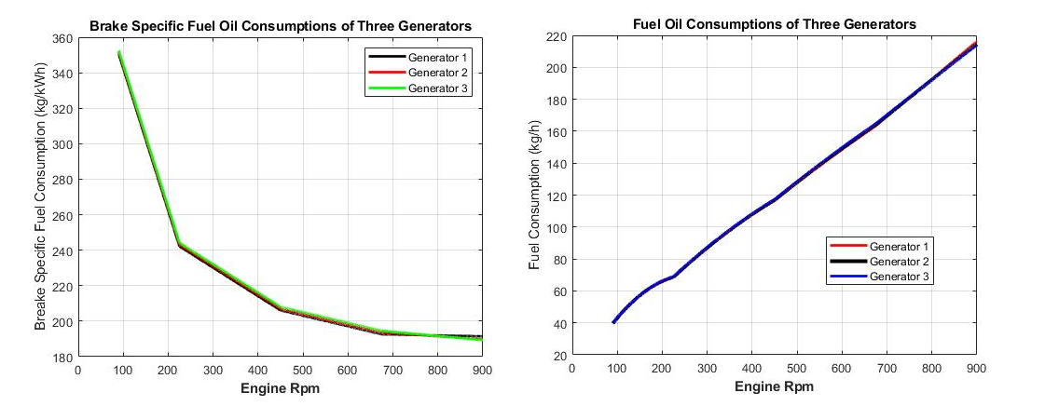

Figure 1 Fuel consumption of generators according to engine rpm.

Figure 2 Total carbon emission of generators according to operation modes.

Figure 3 Total fuel consumption of generators according to operation modes.

The plant consumption data converted to the Time series data in the app designed by authors. Figure 4 illustrates the total carbon emission produced by the plant, and Figure 5 shows the total fuel consumption. Both time series plots show the data are non-seasonal and the stationary. To ensure these assumptions, the ADF test applied to both data sets and their Table 2 shows the results at the. In the Table p-values for both C emission and fuel consumption data are below 0.05 and ADF statistics are also below zero. These results illustrate that the assumptions of stationary data were correct.

Table 2. Results of ADF tests on data.

|  |  |  |
| --- | --- | --- |
| **Data** | **p-value** | **ADF Statistics** |
| C Emission | 2.2703677538899416e-15 | -9.173348833133982 |
| Fuel Consumption | 2.2703677538899416e-15 | -9.179627964971871 |

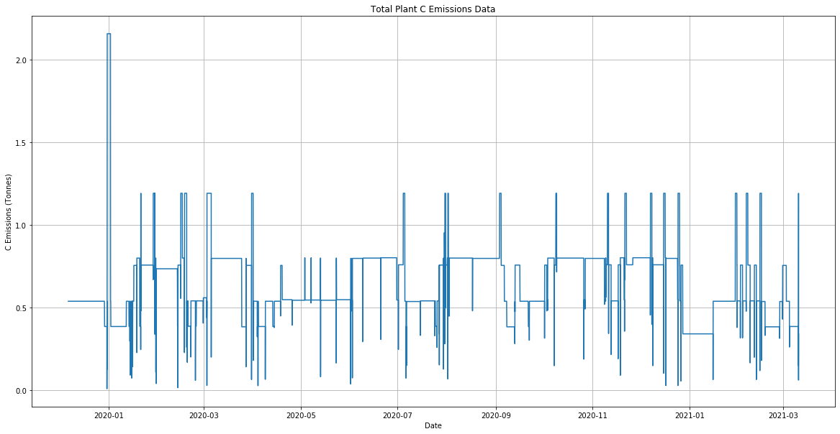

Figure 4. Time series data of total plant carbon emissions.

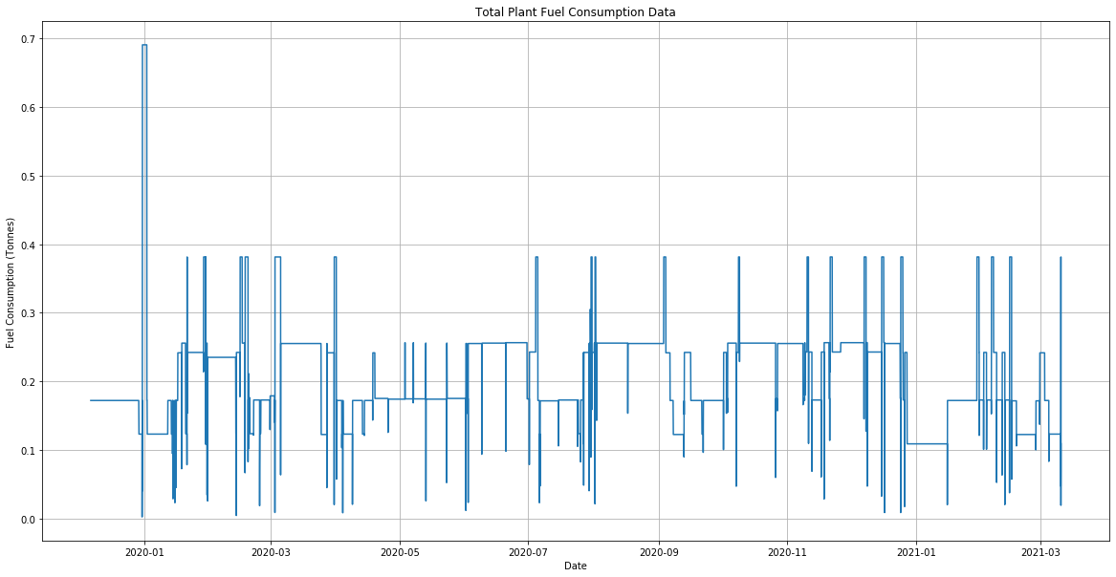

Figure 5. Time series data of total plant fuel consumption.

To detect right model orders for each data set, AIC and BIC calculated with an iterative algorithm. The algorithm tried every combination of p, q, d within the specified limits and the range for p and q was 1 to 5 and for d 1 to 3. Autocorrelation and partial autocorrelation plots determined these limits. The output of the algorithm suggested that ARIMA (3, 1, 2) and ARIMA (4, 1, 2) were the best model for fuel and carbon emission data, respectively. These models fitted to data sets separately, and their mean forecasts were compared to the actual data. Figures 11 and 12 illustrate mean predictions and actual values comparison plots for each data. MAE of predictions is 0.014933 for carbon emission data set and 0.003637 for the fuel consumption data set. The correctness of the model for carbon emission data set is 97.7167012% and for the fuel consumption data set 98.263512% which are notably satisfying validation metrics. The model predicts 26639.755368 metric tons of CO2 production and 6376.176724 metric tons of fuel consumption for 5 years.

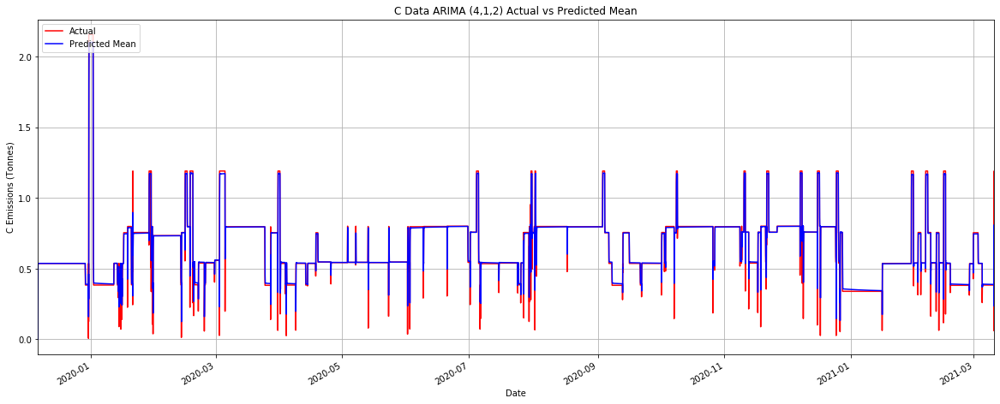

Figure 6. ARIMA (4, 1, 2) mean prediction vs actual values plot for carbon emission data.

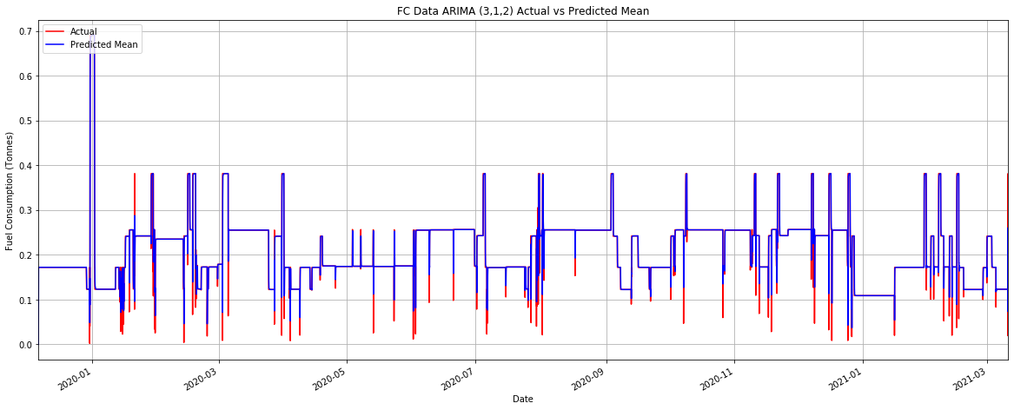

Figure 7. ARIMA (3, 1, 2) mean prediction vs actual values plot for fuel consumption data.

**4. CONCLUSIONS AND DISCUSSION**

The primary goal of the study was to calculate the fuel consumption and CO2 emissions from marine diesel generators. A mathematical simulation of parallel generator operation of a 50000 DWT oil tanker was modeled using MATLAB software. The modeled ship ensured the operational and technical data. A ship traffic tracking software that uses the Automatic Identification System (AIS) provided port calls and position data. The model calculates CO2 emissions and fuel consumption by taking different onboard operations into account. The model neglects sudden load changes during generator operations to calculate outputs, which is the major limitation of the model. Also, using the Port Call and position data, time-series data was formed for CO2 emissions and the fuel consumption calculation. We have carried time series analysis out using ARIMA (4, 1, 2) and ARIMA (3,1, 2) in the Python environment. These models supplied mean future forecasts.

The main outputs derived from the study are listed below:

* The generator plant fuel consumption and CO2 production are the highest during the voyage. During the “Sea Going” mode, there is only one generator is running. If the ship is loaded with a cargo that needs to be heated, “Sea Going with Tank Heating” mode is valid and two generators on moderate load are running during the voyage. Although generators are not loaded so much, the time of navigation for the ship is long which causes high fuel consumption compared to other operations. These operations are stable, and they are applicable candidates for a hybrid application on marine diesel generators.
* Harbor and port operations follow the sea-going operations. Port operations do not comprise discharge operations in this model. During port staying, two generators work on higher loads. At the harbor, one generator is running with a lower load. These operations can be stable as well. We can evaluate these operations in the hybrid application scenarios.
* Cargo handling operations last a short period compared to other operations. It requires working three generators in most times. We can see alterations on load more frequently in this operation.
* ARIMA model seems to a suitable model for these data set with a high correctness rate. The future forecasts show an extensive amount of CO2 production for a 5-year period. The future forecasts also can be a useful tool for a hybrid application.

Some recommended areas for future studies include the development of a more comprehensive mathematical model which considers sudden load changes, time series analysis with different methods, and hybridization of the marine electric production plant.

**5. REFERENCES**

Acomi, N., & Acomi, O. C. (2014). The influence of different types of marine fuel over the energy efficiency operational index. Energy Procedia, 59, 243-248.

Ammar, N. R., & Seddiek, I. S. (2020). An environmental and economic analysis of emission reduction strategies for container ships with emphasis on the improved energy efficiency indexes. Environmental Science and Pollution Research, 27(18), 23342-23355. <https://doi.org/10.1007/s11356-020-08861-7>

Anderson, T. R., Hawkins, E., & Jones, P. D. (2016). CO2, the greenhouse effect, and global warming: from the pioneering work of Arrhenius and Callendar to today's Earth System Models. Endeavour, 40(3), 178-187.

Box, G. E., Jenkins, G. M., Reinsel, G. C., & Ljung, G. M. (2015). Time series analysis: forecasting and control. John Wiley & Sons.

BP, (2020). Statistical Review of World Energy <https://www.bp.com/en/global/corporate/energy-economics/statistical-review-of-world-energy.html> Accessed in 07 April 2021

Brownlee, J. (2020). Introduction to time series forecasting with python: how to prepare data and develop models to predict the future. Machine Learning Mastery.

Carral, L., Fernández-Garrido, C., Vega, A., & Sabonge, R. (2020). Importance of the Panama Canal in the reduction of CO2 emissions from maritime transport. International Journal of Sustainable Transportation, 14(11), 819-832. <https://doi.org/10.1080/15568318.2019.1632994>

Chapman, S. (2005). Electric machinery fundamentals. Tata McGraw-Hill Education.

Chai, T., & Draxler, R. R. (2014). Root mean square error (RMSE) or mean absolute error (MAE)? Arguments against avoiding RMSE in the literature. Geoscientific model development, 7(3), 1247-1250.

Cooper, D. A. (2003). Exhaust emissions from ships at berth. Atmospheric Environment, 37(27), 3817-3830. <https://doi.org/10.1016/S1352-2310(03)00446-1>

Coşofreţ, D., Bunea, M., & Popa, C. (2016). The Computing Methods for CO2 Emissions in Maritime Transports. In International conference Knowledge-Based Organization (Vol. 22, No. 3, pp. 622-627). Sciendo.

EC, (2020), <https://ec.europa.eu/clima/news/commission-publishes-first-annual-eu-report-co2-emissions-maritime> transport_en#:~:text=Emissions%20reported%20by%2011%2C600%20ships,Agency's%20greenhouse%20gas%20emissions%20data. Accessed in 15 December 2020.

Eyring, V., Köhler, H. W., Van Aardenne, J., & Lauer, A. (2005). Emissions from international shipping: 1. The last 50 years. Journal of Geophysical Research: Atmospheres, 110(D17).

Fabozzi, F. J., Focardi, S. M., Rachev, S. T., & Arshanapalli, B. G. (2014). The basics of financial econometrics: Tools, concepts, and asset management applications. John Wiley & Sons.

IMO, (2020). <https://www.imo.org/en/OurWork/Environment/Pages/Air-Pollution.aspx> Accessed in 15 December 2020.

Kesgin, U., & Vardar, N. (2001). A study on exhaust gas emissions from ships in Turkish Straits. Atmospheric Environment, 35(10), 1863-1870. <https://doi.org/10.1016/S1352-2310(00)00487-8>

Kirchgässner, G., & Wolters, J. (2007). Introduction to modern time series analysis. Springer Science & Business Media.

Krause, P. C., Wasynczuk, O., Sudhoff, S. D., & Pekarek, S. (2002). Analysis of electric machinery and drive systems (Vol. 2). New York: IEEE press.

Liu, J., & Duru, O. (2020). Bayesian probabilistic forecasting for ship emissions. Atmospheric Environment, 231, 117540. <https://doi.org/10.1016/j.atmosenv.2020.117540>

McGeorge, H. David. Marine auxiliary machinery. Elsevier, 1998.

Mills, T. C. (2019). Applied Time Series Analysis: A Practical Guide to Modeling and Forecasting. Academic Press.

Miola, A., & Ciuffo, B. (2011). Estimating air emissions from ships: Meta-analysis of modelling approaches and available data sources. Atmospheric Environment, 45(13), 2242-2251. <https://doi.org/10.1016/j.atmosenv.2011.01.046>

Mohammed, Y. S., Mokhtar, A. S., Bashir, N., Abdullahi, U. U., Kaku, S. J., & Umar, U. (2012). A synopsis on the effects of anthropogenic greenhouse gases emissions from power generation and energy consumption. Int J Sci Res Publ, 2, 1-6.

Nichols, C. R., & Williams, R. G. (2009). Encyclopedia of marine science. Infobase Publishing.

Prpić-Oršić, J., & Faltinsen, O. M. (2012). Estimation of ship speed loss and associated CO2 emissions in a seaway. Ocean Engineering, 44, 1-10. https://doi.org/10.1016/j.oceaneng.2012.01.028

Pulkrabek, W. W. (2004). Engineering fundamentals of the internal combustion engine.

Reis, M. S., Rendall, R., Palumbo, B., Lepore, A., & Capezza, C. (2020). Predicting ships’ CO2 emissions using feature-oriented methods. Applied Stochastic Models in Business and Industry, 36(1), 110-123. <https://doi.org/10.1002/asmb.2477>

Salvi J., (2019), “Significance of ACF and PACF Plots In Time Series Analysis”, https://towardsdatascience.com/significance-of-acf-and-pacf-plots-in-time-series-analysis-2fa11a5d10a8 Accessed in 22 January 2021.

Shumway, R. H., & Stoffer, D. S. (2017). Time series analysis and its applications: with R examples. Springer.

Sirimanne, S. N., Hoffman, J., Juan, W., Asariotis, R., Assaf, M., Ayala, G., ... & Youssef, F. (2019). Review of maritime transport, 2019. tech. rep.

Styhre, L., Winnes, H., Black, J., Lee, J., & Le-Griffin, H. (2017). Greenhouse gas emissions from ships in ports – Case studies in four continents. Transportation Research Part D: Transport and Environment, 54, 212-224. <https://doi.org/10.1016/j.trd.2017.04.033>

Tichavska, M., & Tovar, B. (2015). Port-city exhaust emission model: An application to cruise and ferry operations in Las Palmas Port. Transportation Research Part A: Policy and Practice, 78, 347-360. <https://doi.org/10.1016/j.tra.2015.05.021>

Tichavska, M., Tovar, B., Gritsenko, D., Johansson, L., & Jalkanen, J. P. (2019). Air emissions from ships in port: Does regulation make a difference? Transport Policy, 75, 128-140. https://doi.org/10.1016/j.tranpol.2017.03.003

Wang, Z., Qin, C., Liu, C., & Zhang, W. (2020). System Dynamics Simulation of CO2 Emissions from Typical Route Ships. IOP Conference Series: Materials Science and Engineering, 740, 012199. <https://doi.org/10.1088/1757-899X/740/1/012199>

Willmott, C. J., & Matsuura, K. (2005). Advantages of the mean absolute error (MAE) over the root mean square error (RMSE) in assessing average model performance. Climate research, 30(1), 79-82.

Winnes, H., Styhre, L., & Fridell, E. (2015). Reducing GHG emissions from ships in port areas. Research in Transportation Business & Management, 17, 73-82. https://doi.org/10.1016/j.rtbm.2015.10.008