**AUTOMATIC ELECTRIC WALL MOUNTED HANGER RACK**

Mohd Fazrullah Bin Zakaria1*, Jane Daniela Mugan2,  
Alexandria George Empam3

1,2,3Department of Engineering, Politeknik Kuching Sarawak,

Km.22, Jalan Matang 93050 Kuching, Sarawak, Malaysia

**Abstract**

With the Automatic Electric Wall Mounted Hanger Rack, users will no longer face issues with limited space or reaching and pulling out the suspension manually. The inclusion of an automatic electric controller simplifies the operation of the hanger rack. Durability is a key consideration, and the project addresses this by utilizing high-quality stainless-steel materials. This choice of material minimizes the risk of corrosion, ensuring the longevity of the hanger rack. To provide uninterrupted functionality, each user will be supplied with a 12V battery. This backup power source ensures that the hanger rack can still be used during electrical trips or blackouts. The assembly process of the project involves three main parts: the frame part, body part, and mechanism part. Various processes such as cutting, grinding, welding, drilling, and painting are employed to fabricate the hanger rack. In conclusion, the Automatic Electric Wall Mounted Hanger Rack project presents an innovative solution for drying clothes in small spaces. It can support a maximum load of 20 kg and features a rivet nut joint mechanism for smooth movement. The retractable design maximizes space utilization, and the automatic electric controller enhances user convenience. With high-quality stainless-steel construction and battery backup, this project aims to provide a durable and reliable solution for drying clothes in Malaysia.

**Keywords**: Automatic hanger rack, innovation hanger rack, innovation

**JEL Classification:**

1. **Introduction**

Technology has significantly transformed our daily lives, revolutionizing various aspects and providing us with tools and services that simplify and enhance our routines. From multi-functional devices like smartphones and smartwatches to advanced home appliances, technology has made our lives simpler, faster, safer, and more enjoyable. One such everyday household item that has seen remarkable advancements is the clothes rack.

Traditionally, when doing laundry, homeowners would hang clothes to dry on a rope with two fixed points. This manual method of drying clothes is time-consuming and often presents challenges for homeowners. However, with the introduction of clothes racks, the drying process has become more efficient and convenient.

A clothes rack provides a designated space for freshly washed clothes to dry. These racks are typically constructed with a combination of ropes and poles. A laundry line, whether set up outdoors or indoors, offers a convenient solution for suspending clothes above ground level. Clothes racks are available in various materials such as wood, steel, aluminium, and plastic, catering to different preferences and needs. They come in different sizes and configurations, including large stationary outdoor racks, folding portable racks, and wall-mounted clothes racks. However, the conventional manual wall-mounted hanger rack commonly used by homeowners has its limitations. Users often encounter issues, such as incompatible attachment components, causing difficulties when trying to pull in and out the suspension. Additionally, the attachments may rust over time due to metal-to-metal rubbing, further hampering the functionality of the hanger rack. Insufficient space on the clothes rack to hang clothes is another common challenge faced by homeowners. This lack of space poses an inconvenience when attempting to hang freshly washed clothes. Moreover, many homeowners struggle to reach the suspension due to height limitations, often requiring assistance from others. To address these limitations, this research study focuses on a study of the "Automatic Electric Wall-Mounted Hanger Rack." This innovative solution aims to revolutionize the clothes drying process by utilizing a Linear Actuator mechanism powered by electricity. The proposed hanger rack will be automated, providing users with enhanced convenience during the drying process. By exploring the implementation of an Automatic Electric Wall-Mounted Hanger Rack, this research aims to investigate the potential benefits, usability, and impact of such a solution in improving the clothes drying experience for homeowners. The study will assess factors such as efficiency, space optimization, ease of use, and the overall user experience. Through this study, we seek to shed light on the advantages and challenges associated with the adoption of an automated, electric-powered wall-mounted hanger rack. The findings will contribute to the development of more advanced and user-friendly solutions, paving the way for more streamlined and hassle-free clothes drying process in modern households. The presentation will reveal questionnaire results indicating product acceptance.

The objective for the study is as follows: -

i. To fabricate an automatic wall-mounted hanger that use linear actuator.

ii. To increase the maximum load of the hanger that can be accommodate up to 20 kg of weight.

1. **Methodology**

The research methodology for the study of the Automatic Electric Wall Mounted Hanger Rack encompasses several key components. Firstly, the fabrication technique involves the utilization of four distinct methods to construct the hanger rack. These techniques encompass the cutting process, where various tools are employed to eliminate excess material and shape the hanger rack according to the desired geometry. The drilling process follows, utilizing a rotating drill bit to create circular holes in solid materials, facilitating the assembly of the hanger rack. To enhance the hanger rack's properties such as hardness and anti-corrosion, the painting process involves the application of metal spray onto the prepared surface, ensuring a quality finish. Finally, the grinding process employs an abrasive wheel to remove material from the hanger rack, enabling precise forms and fine finishes. Together, these methodologies provide a comprehensive approach to constructing the Automatic Electric Wall Mounted Hanger Rack, showcasing the importance of fabrication techniques in its development. Following the assembly of the automatic electric wall mounted hanger rack, the study conducted an experiment to assess its sturdiness and ability to withstand maximum weight. The objective was to enhance the hanger's weight capacity to accommodate loads of up to 20 kg.

**Table 1:** Experiment Setup Parameter

|  |  |
| --- | --- |
| Weight (Kg) | 5Kg, 10Kg, 15Kg, 20Kg |
| Observe parameter | Rack Bend/Break |

Product durability tests were conducted to assess its ability to withstand imposed loads. The study utilized a setup consisting of weights suspended on a rack. The experiment involved incrementally adding 5kg weights to the rack every 10 minutes, starting from 1 unit of 5kg weights, until reaching a total load of 20kg. The objective of testing the product's load-bearing capacity up to 20kg was successfully achieved, and further durability testing beyond this limit was not conducted.

1. **Result and Discussion**

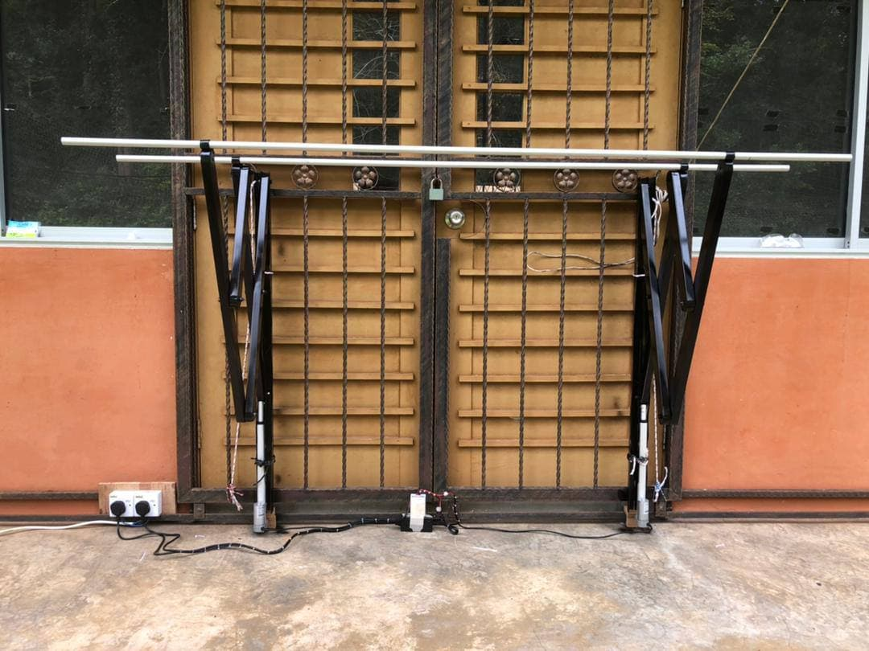 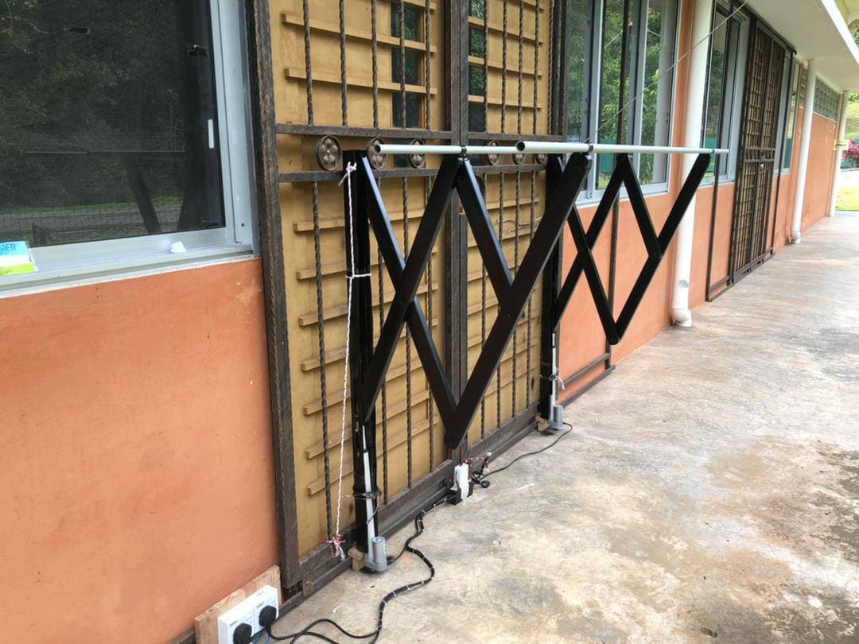

**Figure 1:** Final Product Automatic Electric Wall Mounted Hanger Rack

**Table 2:** Test Result

|  |  |  |
| --- | --- | --- |
| Test | Load(Kg) | Sturdiness |
|  | 5 | Pass |
|  | 10 | Pass |
|  | 15 | Pass |
|  | 20 | Pass |

Based on the additional information provided, a product durability test was conducted to assess the hanger rack's ability to withstand the applied load. The setup involves hanging a weight on a rack, and the experiment follows a specific procedure. The objective is to evaluate the load bearing capacity of the product up to 20 kg. The study used a systematic approach by incrementally adding 5 kg of weight to the rack every 10 minutes. It starts with 1 unit weighing 5 kg and continues to add weight until it reaches a total load of 20 kg. This step-by-step process allows evaluation of the performance and stiffness of hanger racks under increasing loads. The main objective of the test was successfully achieved, as the hanger rack demonstrated its ability to bear a specified load of 20 kg without failing or exhibiting significant issues. However, it is important to note that the durability test did not exceed this limit, meaning that the performance of the hanger rack under a load of more than 20 kg has not been evaluated. Considering these results, it can be concluded that the hanging rack has been tested and shown to have sufficient load-bearing capacity for weights up to 20 kg. Users can rely on hanging racks to safely support items in this weight range, making them an ideal solution for hanging and storing a variety of objects. However, it is important to consider other factors such as long-term durability, safety regulations and specific usage guidelines provided by the manufacturer when making a thorough assessment of the suitability of hanging racks for individual needs.

**Figure 2:** Testing with Wet Cloth (Weighed Accordingly)

**Table 3:** Material Costing

|  |  |  |  |  |
| --- | --- | --- | --- | --- |
| No | Component | Quantity | Retail Price | Overall Cost |
| 1 | Stainless Steel Rectange Hollow Galvanis | 2 Pcs | RM40.00 | RM80.00 |
| 2 | Aluminium Round Hollow Tube | 2 Pcs | RM6.00 | RM12.00 |
| 3 | Anchor Spray Paint (Black) | 2 Pcs | RM8.00 | RM16.00 |
| 4 | Bolt And Nut | 12 Sets | RM2.00 | RM24.00 |
| 5 | Self-Tapping Screw Philips Pan Round | 4 Pcs | RM0.20 | RM0.80 |
| 6 | Linear Actuator Control Switch Relay | 2 Unit | RM132.00 | RM264.00 |
| 7 | Wireless Remote Control Switch Relay | 1 Unit | RM7.50 | RM7.50 |
| 8 | Receiver Module | 1 Unit | RM13.20 | RM13.20 |
| 9 | Power Supply Adapter | 1 Unit | RM13.00 | RM13.00 |
| Total | | | | 430.50 |

In research projects, various items have been acquired for experimental or research purposes. The cost schedule provides item details along with corresponding quantities and prices. This project requires the following materials; First, two pieces of Galvanized Rectange Hollow Galvanized Stainless Steel were purchased at a cost of RM40.00 a piece, resulting in a total cost of RM80.00 for the two pieces. These stainless steel pieces may be used for their specific properties and characteristics in research. In addition, two pieces of Aluminum Round Hollow Tube have been obtained, each costing RM6.00. The total cost for the aluminum tube amounts to RM12.00. Aluminum tubes may be chosen because of their light weight and other related properties.In order to provide research materials, two cans of Anchor Spray Paint in Black were purchased, with each can costing RM8.00. The total cost for a can of spray paint is RM16.00. Spray paint may be used for surface treatment or color coding purposes. In terms of fasteners, twelve Bolt And Nut sets have been obtained at a cost of RM2.00 per set. The total cost of the bolt and nut set is RM24.00. These fasteners may be used to secure or join components together in a research project. For installation purposes, four pieces of Self Tapping Screw Philips Pan Round have been obtained, each costing RM0.20. The total cost for this screw is RM0.80. Screws may be used to securely fasten or attach components during the assembly process. Furthermore, research projects require certain electronic components. A Linear Actuator Control Switch Relay was purchased, at a cost of RM264.00 for one unit. These components may be used for precise control or automation purposes in research setups. To enable the functionality of the remote control device, a Wireless Remote Control Switch Relay is obtained at a cost of RM7.50 for one unit. These devices are allowed for remote operation or control of certain aspects of research experiments. In addition, the Receiver Module was purchased at a cost of RM13.20 for one unit. This module may be used to receive and process signals or data in a research system. Finally, the Power Supply Adapter was obtained at a cost of RM13.00 for one unit. A power supply adapter may be used to provide the electrical power required for the research setup. Overall, the cost table provides a breakdown of materials and components used in the research project, along with quantities with a total cost of RM430.50. These items have been carefully selected and obtained to support the objectives of the experiment and enable the successful implementation of the research.

1. **Conclusion**

In conclusion, the research project successfully achieved its objectives of fabricating an automatic wall-mounted hanger using a linear actuator as the driving mechanism. The implementation of the linear actuator technology enables the hanger to operate automatically, providing users with convenience and usability, especially in emergency situations and unpredictable weather conditions.

Furthermore, the project successfully increased the hanger's maximum load capacity to 20 kg through careful design and engineering. This enhancement ensures that the hanger can securely support heavier items. The research also focused on developing an improved working joint mechanism for the hanger, resulting in enhanced stability and reliability during everyday use. Additionally, a retractable design was incorporated into the automatic electric wall-mounted hanger to optimize space utilization. Users can conveniently retract the hanger when not in use, creating more available space in their living areas.

Overall, this research project offers an affordable alternative for individuals seeking a reliable and cost-effective drying hanger solution. By utilizing readily available linear actuators, users can fabricate the hanger at a significantly lower cost compared to commercially available options. In summary, the research project successfully achieved its objectives of developing an automatic wall-mounted hanger with a linear actuator mechanism. The hanger's increased load capacity, improved joint mechanism, and retractable design make it a practical and space-efficient solution for affordable and reliable drying hanger needs.

**References**

McLoughlin, J. A., Wang, L. C. C., & Beasley, W. A. (2008). Transforming the college through technology: A change of culture. Innovative Higher Education, 33, 99-109.

Atkinson, R. D., & Castro, D. (2008). Digital quality of life: Understanding the personal and social benefits of the information technology revolution. Available at SSRN 1278185.

Zulkiflee, M. A. B., Rahim, A. S. B., & Anuwar, N. A. D. B. (2020). Clothes Dryer Racks.

Stemp, M., Mischler, S., & Landolt, D. (2003). The effect of contact configuration on the tribocorrosion of stainless steel in reciprocating sliding under potentiostatic control. Corrosion Science, 45(3), 625-640.

Desai, N. C., Patel, S., & Desai, N. (2022). DESIGNING MULTIPURPOSE FURNITURE FOR LIVING ROOM OF SMALL HOUSES. International Journal of Early Childhood Special Education, 14(5).

Merchant, M. E. (1944). Basic mechanics of the metal-cutting process.

Williams, R. A. (1974). A study of the drilling process.

Shreir, L. L. (Ed.). (2013). Corrosion: corrosion control. Newnes.

Komanduri, R., Lucca, D. A., & Tani, Y. (1997). Technological advances in fine abrasive processes. CIRP annals, 46(2), 545-596.

Zhang, Y., Peng, Y., Sun, Z., & Yu, H. (2018). A novel stick–slip piezoelectric actuator based on a triangular compliant driving mechanism. IEEE Transactions on Industrial Electronics, 66(7), 5374-5382.