[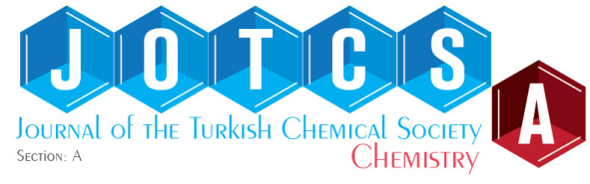](https://dergipark.org.tr/jotcsa) [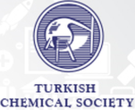](http://www.turchemsoc.org/)

**Investigating the Impact of Natural Dyes and Conservation Techniques on Optical Properties of Manuscript**

**Emel Akyol1#, Pınar Çakar Sevim1,2.**

1Yildiz Technical University, Chemical Engineering Department, Istanbul, Türkiye

2Manuscript Institution of Turkey, Istanbul, Türkiye

**Abstract**: Old manuscripts constitute a vital part of our cultural heritage, offering valuable insights into various historical issues and serving as essential resources for understanding the past. Unfortunately, the passage of time subjects these precious manuscripts to degradation caused by physical, chemical, biological factors, as well as the materials used in their creation such as paints and inks. In this study, Whatman filter papers were dyed with extracts from safflower (*Carthamus tinctorius* L.), buckthorn (*Rhamnus petiolaris* Boiss), turmeric (*Curcuma longa* L.), and onion peel (*Allium cepa* L.) plants, as well as cochineal insect (*Dactylopius coccus* Costa), which are reported to be used in coloring paper in manuscripts. Then, iron gall ink prepared according to the historical recipe was applied on it. To combat potential corrosion caused by the usage of iron gall ink, dyed papers underwent antioxidant and acid removal processes. These treatments were employed to retard the degradation process. Subsequently, a series of accelerated ageing experiments were carried out on model papers. At regular intervals, samples were taken and analyzed to track alterations in pH levels and optical characteristics throughout the ageing process. This study may provide information to helping conservators to evaluate the effectiveness of treatments.

**Keywords:** Cultural heritage, natural dyes, iron gall ink, conservation techniques, optical properties.

*Corresponding author’s E-mail: [eakyol@yildiz.edu.tr](mailto:eakyol@yildiz.edu.tr)

**1. INTRODUCTION**

Manuscripts are extremely important for preserving cultural heritage, as they contain a wealth of information and provide insights into the intricate dynamics of society, culture, and economy during their respective eras (1). These handwritten texts primarily use paper, a complex material mainly made up of cellulose, as well as other components such as lignin, hemicellulose, sizing materials, and impurities (2-3).

These artifacts, employing inks, pigments, and dyes for text, illuminations, and coloring, embody a diverse range of materials. However, over time, it begins to deteriorate by being affected by internal and external factors. Acid-catalyzed hydrolysis and oxidative degradation, notably, trigger cellulose depolymerization, compromising paper integrity (4-5).

In response, conservation scientists have devised chemical stabilization strategies. Antioxidant solutions counter transition metal-catalyzed oxidative degradation, and deacidification agents prevent glycosidic bond breakage (6-8).

To understand degradation, model samples are prepared. These serve to assess the impact of acidic components like iron gall ink and copper-based pigments on cellulose support and evaluate the effectiveness of preventive chemicals. Accelerated aging tests simulate long-term effects, estimating physico-chemical alterations. Monitoring and quantifying these changes provide insights into the aging processes of pure cellulose and cellulose with iron gall ink, as documented in scholarly literature. Zou, X. et al. (1994) investigated the changes in mechanical properties and degree of polymerization (DP) of model papers made of pure cellulose using tensile stress tests after accelerated aging. The high humidity level in the aging environment was reported to indicate an excess of water stoichiometrically, so the depolymerization of cellulose during aging could be considered a first-order reaction. Values of the function of the degree of polymerization as a function of the accelerated aging time were plotted and the glycosidic bond breakage constant was calculated (9). Conte, V. et al. (2008) emphasized that acid removal and antioxidant applications should be done together for the stabilization of papers containing iron gall ink. In the study, the effectiveness of imidazolium-based ionic liquids on papers containing iron gall ink was investigated after accelerated aging studies using pH, colorimetric, and viscosity measurements (10). Kolar, J. et al. (2008) compared alkylimidazolium bromides, calcium or magnesium phytate, and anhydrous solution of tetrabutylammonium bromide (TBABr) in the stabilization of iron gall ink, which has a corrosive nature on cellulose support, iron and acid. They calculated the degradation rate constants by viscosity measurements and determined the color changes by colorimetric measurements. It was stated that these two antioxidants are much more efficient than the others, and that they have an advantage over the disadvantages arising from the preparation of calcium phytate with water by being able to prepare their anhydrous solutions (11). Strlič, M. et al. (2010) performed DP and pH tests on documents with iron gall ink dated from the 18th and 19th centuries. They reached DP values by calculating the intrinsic viscosity from the Mark-Houwink-Sakurada equation, and calculated the DP at the instant t=400 when the ink line starts to break using the Ekenstam equation for linear polymers. They predicted the time required for the real samples to reach this value in terms of years (12). Zaccaron, S. (2014) investigated the changes in the degree of polymerization with accelerated aging to investigate the protective effect of gelatin in papers containing iron gall ink with gelatin sizing. They obtained the degrees of polymerization by determining both viscosity measurements and molecular size distribution (13). Couvrat Desvergnes, A. (2017) reported that interleaving papers were used to protect the illumination and miniatures in manuscripts and to prevent ink and pigment from smearing onto other pages. In the study, they examined interleaving papers, which vary in color from light yellow to bright fuchsia, found in seven manuscripts dating from the 18th to 19th centuries. In the analyzes using the HPLC (High-Pressure (Performance) Liquid Chromatography) system, they detected carthamin in addition to synthetic dyes. Based on this, they determined that the pink papers were dyed with safflower (Carthamus tinctorius L.), which contains carthamin (14). Ormancı and Bakiler (2021) provides an examination of the materials used in Turkish painting (15). Also, there are many studies in the literature on the extraction methods of natural dyes (16-17).

The study focused on the effect of Antioxidant and acid removal treatment on the colored paper. Color and pH measurements were performed on each sample before and after ageing for visual comparison between the control and treated samples. It is considered that this study will make an important contribution to both the literature and those working on the restoration of manuscripts within the framework of conservation science.

**2. EXPERIMENTAL SECTION**

In this investigation, model papers were subjected to dyeing using natural extracts derived from safflower, buckthorn, turmeric, onion peel plants, and cochineal insect. The chosen substrate for the paper was Whatman filter paper No. 1. The botanical specimens were acquired from the Spice Bazaar, while cochineal extract was obtained from a local supplier. A uniform application of iron gall ink was administered to the central region of the dyed papers. Subsequent to this, antioxidant treatment for papers featuring iron gall ink followed a previously established protocol (11). The non-aqueous antioxidant solution was concocted by dissolving (EMIMBr) 1-ethyl-3-methylimidazolium bromide in ethanol (Merck, 96%) at a concentration of 0.03 mol.L−1. Deacidification was executed using Bookkeeper®, applied via a sprayer. To evaluate the impact of acid removal and antioxidant applications, the model papers underwent accelerated aging within a Nüve ID 300 climatic chamber, maintained at 85 oC and 65% relative humidity, spanning a duration of up to 12 days. The nomenclature for each sample is succinctly outlined in Table 1. Detailed experimental procedures were reported previously (18-19). Color changes induced by aging were monitored using a Datacolor ELREPHO spectrophotometer, and the results were expressed in the CIEL*a*b* color space. Additionally, pH values on the surfaces of model papers were determined through the use of a flat electrode (Hanna HI 99171 pH meter).

**Table 1:** The nomenclature of all samples

|  |  |
| --- | --- |
| Designations | Samples |
| WP | Whatman No.1 filter paper |
| WP-T | Whatman paper treated with solutions |
| WP-D | Dyed Whatman paper |
| WP-DI | Ink on dyed Whatman paper |
| WP-DT | Dyed Whatman paper treated with solutions |
| WP-DIT | Ink on dyed Whatman paper treated with solutions |

**3. RESULTS AND DISCUSSION**

**3.1. Color Change with Ageing**

Papers and papers dyed with buckthorn, turmeric, safflower, cochineal and onion peel. Color measurements were carried out on the inks before and after aging. In order to examine the color changes caused by acid removal and antioxidant applications on paper and ink, treated and untreated samples were examined and the color change sizes were compared. To obtain the total color difference *ΔE* was used (20). ΔE formula is given by Equation (1).

*ΔE* = $\sqrt{{({∆L}^{'})}^{2}+{({∆a}^{'})}^{2}+{({∆b}^{'})}^{2}}$ (1)

where $∆L'$, $∆C'$ and $∆H^{'}$ are the CIELAB lightness, chroma and hue differences between the two samples in the color pair at viewing angle. The $a^{'}$ axis represents the green to red module with green in the negative direction and red in the positive direction. The $b^{'}$ axis represents the blue to yellow component with blue in the negative direction and yellow in the positive direction (21). Calculated ΔE for all samples before and after ageing.

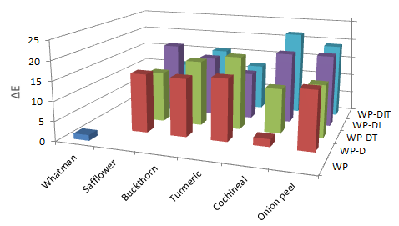

**Figure 1:** Total color change (ΔE) of the samples after accelerated ageing.

When the results obtained were evaluated, the least color change of 1.96 was observed in the cochineal dyed sample among the samples subjected to accelerated aging after dyeing. The biggest color change occurred on turmeric dyed paper with 15.79. With acid removal and antioxidant application after dyeing, the smallest color change occurred on paper dyed with cochineal at 1.15, while the highest color change occurred on paper dyed with buckthorn at 16.83. When the dyed samples with acid removal and antioxidant application were exposed to 12 days of accelerated aging, the least color change occurred in the cochineal dyed paper with 11.53, and the highest color change occurred in the turmeric dyed paper with 18.77. With aging, the L* value in all dyed papers decreased, meaning the lightness decreased. Among the dyed papers, the sample in which the lightness decreased the most after aging was the buckthorn dyed paper (*ΔL'*=4.90), and the sample in which the lightness decreased the least was the cochineal dyed paper (*ΔL'*=1.24). In papers with antioxidant and acid removal applications, lightness increased with aging in cochineal dyed paper and the *L'* value increased from 81.80 to 86.54. Among the treated samples, the sample whose lightness decreased the most with aging was turmeric dyed (*ΔL'*=7.15), and the sample whose lightness decreased the least was onion skin dyed paper (*ΔL'*=0.47). The color changes occurring in dyed papers are shown in Figure 1.

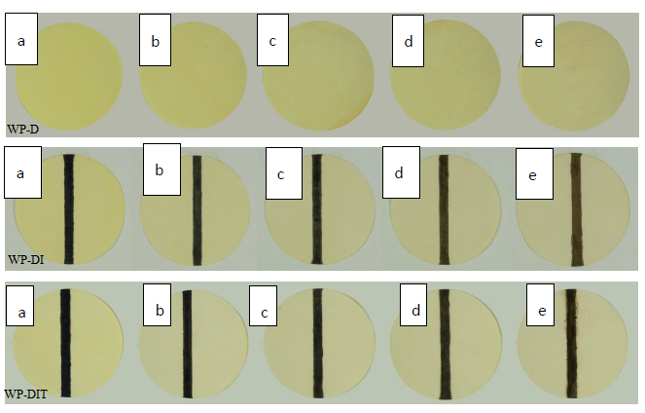

**Figure 2:** Color changes for safflower dyed paper during accelerated ageing.

Figure 2 illustrates the color change in paper dyed with safflower during accelerated aging (t=0, t=2, t=5, t=8, t=12 days of ageing from left to right, respectively). After acid removal and antioxidant applications were applied to the paper dyed with safflower, a total color change of 2.81 was experienced. The total color change (*ΔE*) observed after 12 days of accelerated aging on Whatman papers dyed with safflower and treated with acid removal and antioxidant treatments was calculated as 10.78. The decrease in the *L'* component with aging means that the patency decreases. The a*'* value has shifted from green to red. The *b'* value decreased and shifted from yellow to blue. The *ΔE* value in untreated paper dyed with safflower is 4.28 units higher than that in treated paper. The difference between dyed paper and treated and aged paper is 3.58. As in the untreated ink, in the ink with acid removal and antioxidant treatments, the *L'* component increased as the lightness increased with aging, the a*'* value shifted from green to red, and the *b'* value shifted from blue to yellow. The total color change in iron gall ink after processing is 8.84. With aging, the treated ink underwent a color change of 13.00, while the untreated ink underwent a color change of 18.25. The final *L'* value of treated ink is lower than that of untreated ink, meaning the clarity is less reduced. The difference between the ink of dyed paper and the ink of treated and aged paper is 12.34. Acid removal and antioxidant applications on the ink caused less color change compared to the untreated one.

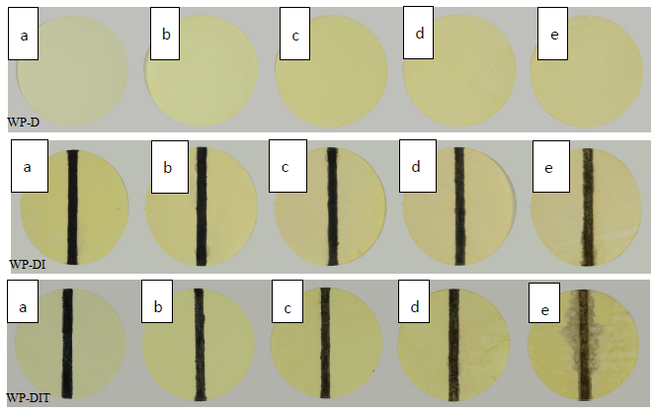

**Figure 3:** Color for buckthorn dyed paper during accelerated ageing.

Figure 3 shows the color change of paper dyed with buckthorn during accelerated aging. The total color change (*ΔE*) occurring in Whatman papers dyed with buckthorn after 12 days of accelerated aging was calculated as 14.82. The decrease in the *L'* value of the paper with aging indicates that the lightness decreases. While the a*'* value shifted from green to red, the *b'* value also increased and shifted from blue to yellow. After acid removal and antioxidant applications were applied to the paper dyed with buckthorn, a total color change of 16.77 was experienced. The total color change (*ΔE*) observed in these papers as a result of 12 days of accelerated aging was calculated as 14.82. The decrease in the *L'* component with aging means that the patency decreases. While the a*'* value shifted from green to red, the *b'* value decreased and shifted from yellow to blue. *ΔE* value of buckthorn dyed and untreated paper is 2.01 higher than that of treated paper. As seen, the total color change after deacidification and antioxidant applications is less than that of untreated. When ink was applied on papers dyed with buckthorn, the total color change (*ΔE*) occurring on the 12th day of aging was calculated as 15.61. As lightness increases with aging, the *L'* component increased, the a*'* value shifted from green to red, and the *b'* value shifted from blue to yellow. The total color change in iron gall ink after processing is 7.62. With aging, the treated ink underwent a color change of 17.15, while the untreated ink underwent a color change of 15.61. The difference between the ink of dyed paper and the ink of treated and aged paper is 11.60. Acid removal and antioxidant applications on the ink caused more color change compared to the untreated one.

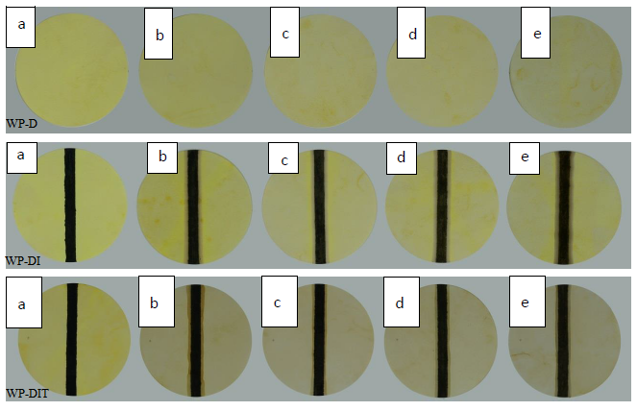

**Figure 4:** Color for turmeric dyed paper during accelerated ageing.

Figure 4 shows the color change of paper dyed with turmeric during accelerated aging. The total color change (*ΔE*) occurring on Whatman papers dyed with turmeric after 12 days of accelerated aging was calculated as 15.79. The decrease in the *L'* value of the paper with aging indicates that the lightness decreases. While the a*'* value shifted from green to red, the *b'* value decreased and shifted from yellow to blue. After acid removal and antioxidant applications were applied to the paper dyed with turmeric, a total color change of 8.96 was experienced. The total color change (*ΔE*) observed in these papers as a result of 12 days of accelerated aging was calculated as 18.77. The decrease in the *L'* component with aging means that the patency decreases. While the a*'* value shifted from green to red, the *b'* value decreased and shifted from yellow to blue. The *ΔE* value of paper dyed and treated with turmeric is 2.98 units higher than that of untreated paper. The total color change (*ΔE*) occurring on the 12th day of aging with the ink application on papers dyed with turmeric was calculated as 12.12. As lightness increases with aging, the *L'* component increased, the a*'* value shifted from green to red, and the *b'* value shifted from blue to yellow. The total color change in iron gall ink after processing is 1.28. With aging, the treated ink underwent a color change of 11.96, while the untreated ink underwent a color change of 12.12. The difference between the ink of dyed paper and the ink of treated and aged paper is 11.25. Acid removal and antioxidant applications on the ink caused less color change compared to the untreated one.

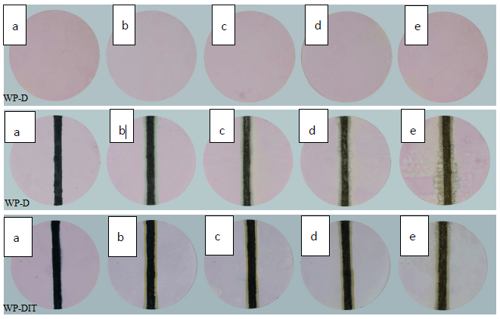

**Figure 5:** Color for cochineal dyed paper during accelerated ageing.

Figure 5 shows the color change of paper dyed with cochineal during accelerated aging. The total color change (*ΔE*) occurring in red-dyed Whatman papers after 12 days of accelerated aging was calculated as 1.96. The decrease in the *L'* value of the paper with aging indicates that the lightness decreases. While the a*'* value showed a slight shift from green to red, the *b'* value increased and shifted from blue to yellow. After acid removal and antioxidant applications were applied to the paper dyed with red, a total color change of 1.15 was experienced. The total color change (*ΔE*) observed in these papers as a result of 12 days of accelerated aging was calculated as 11.53. The increase in the *L'* component with aging means that the patency increases. The a*'* value decreased, shifting from red to green, and the *b'* value increased, shifting from blue to yellow. The *ΔE* value of red dyed and treated paper is 9.57 higher than that of untreated paper. The total color change (*ΔE*) occurring on the 12th day of aging with the ink application on red-dyed papers was calculated as 18.23. As lightness increases with aging, the *L'* component increased, the a*'* value shifted from green to red, and the *b'* value shifted from blue to yellow. The total color change in iron gall ink after processing is 3.06. With aging, the treated ink underwent a color change of 21.63, while the untreated ink underwent a color change of 18.23. The difference between the ink of dyed paper and the ink of treated and aged paper is 16.88. Acid removal and antioxidant applications on the ink caused more color change compared to the untreated one.

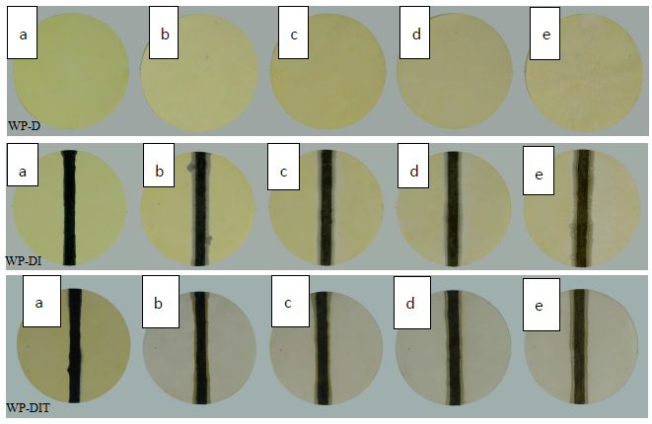

**Figure 6:** Color for onion peel dyed paper during accelerated ageing.

Figure 6 shows the color change of paper dyed with onion peel during accelerated aging. The total color change (*ΔE*) occurring on Whatman papers dyed with onion peel after 12 days of accelerated aging was calculated as 14.97. The decrease in the *L'* value of the paper with aging indicates that the lightness decreases. While , the a*'* value shifted from green to red, the *b'* value decreased and shifted from yellow to blue. After acid removal and antioxidant applications were applied to the paper dyed with onion peel, a total color change of 12.41 was experienced. The total color change (*ΔE*) observed in these papers as a result of 12 days of accelerated aging was calculated as 13.48. The slight decrease in the *L'* component with aging means that the patency decreases. The a*'* value increased, shifting from green to red, and the *b'* value decreased, shifting from yellow to blue. The *ΔE* value for paper dyed with onion peel is 1.49 higher than that for treated paper. The total color change (*ΔE*) occurring on the 12th day of aging with the ink application on papers dyed with onion peel was calculated as 18.38. As lightness increases with aging, the *L'* component increased, the a*'* value shifted from green to red, and the *b'* value shifted from blue to yellow. The decrease in the *L'* value of the paper with aging indicates that the lightness decreases. While the *a'* value shifted from green to red, the *b'* value decreased and shifted from yellow to blue. The total color change in iron gall ink after processing is 4.18. With aging, the treated ink underwent a color change of 19.01, while the untreated ink underwent a color change of 18.38. The difference between the ink of dyed paper and the ink of treated and aged paper is 16.88. Deacidification and antioxidant applications on the ink caused slightly more color change compared to the untreated one.

When the results obtained were evaluated, the least color change of 1.96 was observed in the cochineal dyed paper among the samples subjected to accelerated aging after dyeing. The biggest color change occurred on turmeric dyed paper with 15.79. With acid removal and antioxidant application after dyeing, the smallest color change occurred on paper dyed with cochineal at 1.15, while the largest color change occurred on paper dyed with buckthorn at 16.77. When the dyed samples with acid removal and antioxidant application were exposed to 12 days of accelerated aging, the least color change occurred in the cochineal dyed paper with 11.53, and the largest color change occurred in the turmeric dyed paper with 18.77. With aging, the *L'* value in all dyed papers decreased, meaning the lightness decreased. Among the dyed papers, the sample in which the lightness decreased the most after aging was the onion peel dyed paper (*ΔL'*=5.34), and the sample in which the lightness decreased the least was the cochineal dyed paper (*ΔL'*=1.24). In papers with antioxidant and acid removal applications, lightness increased with aging in cochineal dyed paper and the *L'* value increased from 81.80 to 86.54. Among the treated samples, the sample whose lightness increased the most with aging was safflower dyed paper (*ΔL'*=5.52), and the sample whose lightness decreased the least was onion skin dyed paper (*ΔL'*=0.47). When the inks on the painted samples are examined; After 12 days of accelerated aging, the least color change occurred in the ink of the turmeric dyed paper with 12.12, and the highest color change occurred in the ink of the paper dyed with onion peel, with 18.38. With acid removal and antioxidant application, the smallest color change occurred in the ink of turmeric dyed paper with 1.28, and the largest color change occurred in the ink of safflower dyed paper with 8.84. When the dyed samples with acid removal and antioxidant application were exposed to 12 days of accelerated aging, the least color change occurred in the ink of the safflower dyed paper with 10.78, and the largest color change occurred in the ink of the cochineal dyed paper with 21.63.

**2.2. pH Change with Ageing**

pH measurements taken from both the paper and ink parts of the dyed, ink-applied and antioxidant-acidification applied samples before and after aging were compared. The minimum change in pH value of Whatman paper, whose initial pH value is 7.10, decreases to 6.75 in dyeing with safflower extract, and the highest change occurs in dyeing with onion peel .extract, decreasing to 5.20. pH changes with dyeing are given in Figure 7.

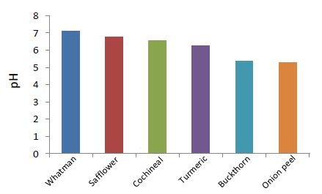

**Figure 7:** Plot of pH against accelerated ageing time for dyed Whatman paper (12thday)

The pH of Whatman paper increased to 8.29 after antioxidant and acid removal application, and after accelerated aging, this value was measured as 7.12. The highest pH value was measured on the paper dyed with onion peel for papers that were treated with antioxidants and acid removal after dyeing. After aging, it decreased to 6.67 and remained the highest pH value in its group (Figure 8).

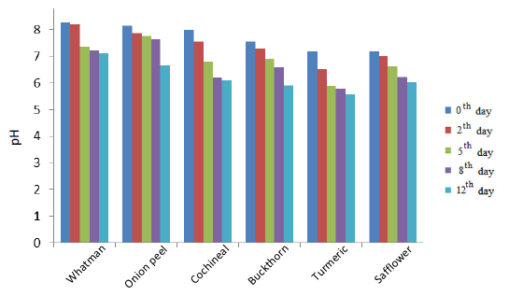

**Figure 8:** Plot of pH against accelerated ageing time for Dyed Whatman paper treated with solutions

In the pH measurements made in the ink part of the dyed papers, the pH of the ink part of the paper dyed with safflower was the highest with 5.18. With 12 days of accelerated aging, the highest ink pH was observed in paper dyed with safflower with a value of 4.04, and the lowest pH was observed in paper dyed with turmeric with a value of 1.74. The pH changes of the inks on dyed papers with aging are given in Figure 9.

In measurements taken from the ink part of dyed papers with antioxidant and acid removal applications, the highest pH before aging was measured as 6.25 in the ink of paper dyed with onion peel. The ink pH with the highest value after aging was measured as 4.91 in the paper dyed with safflower, and the lowest was measured as 2.03 in the paper dyed with turmeric (Figure 10). It was observed that the pH value decreased with accelerated aging in all samples examined, while deacidification and antioxidant applications improved the pH value in both paper and ink parts. After dyeing and aging Whatman paper, safflower gave the highest value at 5.29. With antioxidant and acid removal applications, the highest pH value after aging was measured as 6.67 in the paper dyed with onion peel.

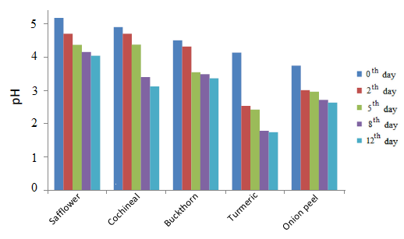

**Figure 9:** Plot of pH against accelerated ageing time for ink on dyed Whatman paper.

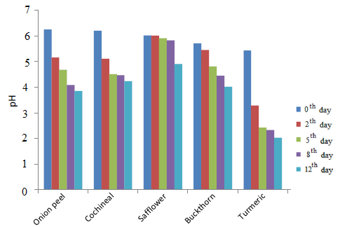

**Figure 10:** Plot of pH against accelerated ageing time for ink on dyed Whatman paper treated with solutions

In pH measurements made on the inks of dyed papers, the highest value after aging was observed in papers prepared with safflower, 4.04, and the lowest value was observed in papers prepared with turmeric, 1.74. By aging the inks of the samples treated with antioxidant and acid removal, the highest pH was measured as 4.91 in the one dyed with safflower, and the lowest pH was measured as 2.03 in the one dyed with turmeric.

**4. CONCLUSION**

In this study, it is aimed to examine the effect of antioxidant and deacidification treatments on manuscripts in the presence of natural dye and iron gall ink during aging. pH and color difference measurements were made to examine the effects of natural dyes and antioxidant and acid removal processes not only on the paper but also on the ink. There was a change in the *ΔE* values ​​of all samples with aging. The *ΔE* change in the ink of papers dyed with turmeric and for cochineal dyed paper with safflower and onion peel after aging is smaller than those treated with antioxidant and deacidification treatments. The *ΔE* occurring in paper and ink dyed with buckthorn, paper dyed with turmeric, paper dyed with cochineal and ink of paper dyed with onion peel is smaller compared to their treated samples. The *ΔE* difference between treated and untreated samples is relatively small, but *ΔE* is 1.96 with aging in for cochineal dyed papers, while *ΔE* is 11.53 in treated papers. Considering the view that the side effects of the processing of the works should be minimal, it has been observed that the combination of 1-ethyl-3-methylimidazolium bromide (EMIMBr) and Bookkeeper® is not suitable for real papers that have been colored using cochineal but have not been surface treated. The pH values ​​of all prepared samples decreased in both paper and paper parts after aging. It was determined that antioxidant and deacidification applications improved the pH value of the paper and ink parts of all samples.

**5. CONFLICT OF INTEREST**

No potential conflict of interest was reported by the authors.

**6. ACKNOWLEDGMENTS**

We appreciate the support of the Research Fund of the Yıldız Technical University with DOP Project: [2014-07-01-DOP03] for the accomplishment of this work.

**7. REFERENCES**

1. Andrews CM. On the preservation of historical manuscripts. The William and Mary Quarterly. 1944;1(2):123-137. <https://doi.org/10.2307/1921884>

2. Laguardia L, Vassallo E, Cappitelli F, Mesto E, Cremona A, Sorlini C, Bonizzoni G. Investigation of the effects of plasma treatments on biodeteriorated ancient paper. Applied Surface Science. 2005; 252(4): 1159-1166. <https://doi.org/10.1016/j.apsusc.2005.02.045>

3. Cirone M, Figoli A, Galiano F, La Russa MF, Macchia A, Mancuso R, Ricca M, Rovella N, Taverniti M, Ruffolo SA. Innovative methodologies for the conservation of cultural heritage against biodeterioration: A review. Coatings. 1986; 13(12): 1986.

<https://doi.org/10.3390/coatings13121986>

4. Souguir Z, Dupont AL, E. De la Rie ER. Formation of brown lines in paper: Characterization of cellulose degradation at the wet−dry interface. Biomacromolecules. 2008; 9(9): 2546-2552.

<https://doi.org/10.1021/bm8006067>

5. Suslick BA, Hemmer J, Groce BR, Stawiasz KJ, Geubelle PH, Malucelli G, Mariani A, Moore JS, Pojman JA, Sottos NR. Frontal polymerizations: From chemical perspectives to macroscopic properties and applications. Chemical Reviews. 2023; 123(6): 3237-3298.

<https://doi.org/10.1021/acs.chemrev.2c00686>

6. Bukovský V. The influence of light on ageing of newsprint paper. Restaurator. International Journal for the Preservation of Library and Archival Material. 2000; 21(2): 55-76. <https://doi.org/10.1515/REST>

7. Kaszonyi A, Izsák L, Králik M, Jablonsky M. Accelerated and natural aging of cellulose-based paper: Py-GC/MS method. Molecules. 2022; 27(9): 2855. <https://www.mdpi.com/1420-3049/27/9/2855>

8. Zervos S. Revising established tenets in paper conservation. Procedia - Social and Behavioral Sciences. 2013; 73(1): 35-42. <https://doi.org/10.1016/j.sbspro.2013.02.016>.

9. Zou X, Gurnagul N, Uesaka T, Bouchard J. Accelerated aging of papers of pure cellulose: Mechanism of cellulose degradation and paper embrittlement. Polymer Degradation and Stability. 1994; 43(1): 393-402.

10. Conte V, Ceres G, Mirruzzo V, Kolar J, Strlič M. Imidazolium-based ionic liquids for the efficient treatment of iron gall inked papers. ChemSusChem. 2008; 1(11): 921-926. <https://doi.org/10.1002/cssc.200800111>

11. Kolar J, Moţir A, Balaţic A, Strlič M, Ceres G, Conte V, Mirruzzo V, Steemers De Bruin G. New antioxidant treatments for transition metal containing inks adnd pigments. Restaurator. International Journal for the Preservation of Library and Archival Material. 2008; 29:184-198. <https://doi.org/10.1515/rest.2008.013>

12. Strlič M, Cséfalvayová L, Kolar J, Menart E, Kosek J, Barry C, Higgitt C, Cessar M. Non-destructive characterisation of iron gall ink drawings: Not such a galling problem. Talanta. 2010; 81(1-2):412-417. (2010).

13. Zaccaron S. The influence of sizing and iron-gall inks on the kinetics and degradation mechanism of cellulose in sealed vessel [PhD Thesis]. [Venedik]: University of Venice; 2014. <http://dspace.unive.it/handle/10579/4643?show=full>

14. Couvrat Desvergnes A Berghe IV. Dyestuff identification and significance of interleaves from moroccan manuscripts of dalā‟il al-khayrāt. Studies in Conservation. 2017; 63(4):236-250. <https://doi/full/10.1080/00393630.2017.1314585>

15. Ormancı Ö, Bakiler M. Complementary use of raman and µ-xrf spectroscopy for non-destructive characterization of an oil painting by Turkish painter İbrahim Çallı. Journal of the Turkish Chemical Society Section A: Chemistry. 2021; 8(2): 491-500.

<https://doi.org/10.18596/jotcsa.842525>

16. Önal A, Özbek O, Vanlioglu F, Teker AT, Boyraz D. Investigation of the dyeing properties of the colorant extracted from Juglans regia L. leaves on cellulosic and protein fabrics. Journal of the Turkish Chemical Society Section A: Chemistry. 2021; 8(2): 453–60.

<https://doi.org/10.18596/jotcsa.856975>

17. Periyasamy AP. Natural dyeing of cellulose fibers using syzygium cumini fruit extracts and a bio-mordant: A step toward sustainable dyeing. Sustainable Materials and Technologies. 2022; 33: e00472. <https://doi.org/10.1016/j.susmat.2022.e00472>

18. Akyol E, Sevim, PÇ. Dyes used for colouring manuscripts and their effect on cellulose degradation. Restaurator. International Journal for the Preservation of Library and Archival Material. 2023; 44(4) 345-360. <https://doi.org/10.1515/res-2023-0014>

19. Çakar P, Akyol E. The effects of natural dye and iron gall ink on degradation kinetics of cellulose by accelerated ageing. Studies in Conservation. 2022; 67(6): 381-388. <https://doi.org/10.1080/00393630.2021.1996090>

20. Moropoulou A, Zervos S, Mavrantonis P. Quality control and optimization of the conservation treatments applied to the material of the archives of the greek communist party. R Restaurator. International Journal for the Preservation of Library and Archival Material. 2001; 22(3): 146-163. <https://doi.org/10.1515/REST>

21. Lorusso S, Natali A, Matteucci C. Colorimetry applied to the field of cultural heritage: examples of study cases. Conservation Science in Cultural Heritage. 2002; 7(1): 187-220. <https://doi.org/10.6092/issn.1973-9494/1252>