**AUTOMATED GUIDED VEHICLE (AGV) LINE TRAINING KIT USING ARDUINO**

**Koh Foo Hin1, Firdaus Mohamed Sahid2, Choong Chee Guan3**

Politeknik Seberang Perai1,2 , Politeknik Tuanku Syed Sirajuddin,3

*Abstract*

Automated Guided Vehicle (AGV) has a mechanically built structure to transport items from one station to another station automatedly. It is one of the material handling equipment that are most often used in the industrial applications to move materials around a manufacturing facility or a warehouse. The system is completed through the written code structure programmed into the Arduino Nano microprocessor which acts as the machine controller. The design attached at the front section of the frame is the ultrasonic sensor which is used to detect an obstacle and send signal back to the microprocessor to stop the motor in a 50 cm range from the detected obstacle. Meanwhile, the design attached below the frame, at the front is two auto calibrating sensors which can cover the line detection of 1 cm to 3 cm wide, dark colour line. The sensors are built with five infrared (IR) transmitters and receivers. Lastly, the auto calibrating sensors detect the presence of a black line on the ground and send signal to the Arduino Nano microprocessor which in return send signals to the motor drivers which are installed to control the speed of the motor to drive the wheels through a chain and sprocket drive.

*Keywords: Automated Guided Vehicle, Material Handling, Arduino Nano, microprocessor*

**INTRODUCTION**

One of the various material handling systems used in industrial applications to move raw materials around a factory or warehouse is the automated guided vehicle (AGV), which considerably decreases the workload of human labourers and expedites the transportation process. A person is typically required to push or pull the trailer that transports the raw materials. However, manually pushing and dragging the trolley while it is loaded may have a significant impact on the workers' ergonomics, leading to conditions like Low-back Disorder (LBD). Work-related musculoskeletal disorders (MSDs) such as profession-related LBD are brought on by a combination of poor body mechanics, difficult movements, inappropriate lifting techniques, and bad posture.

The main objective of this project is to build an AGV that will ease the delivery of manufacturing materials/products from point A to point B without causing any harm to the operator. This project can be used by the material handling sector to make it easier to transfer materials and components, by small businesses who need to move large objects in a warehouse, and by TVET institutions that require materials and equipment to be delivered to them within the confined work areas.

**LITERATURE REVIEW**

Material handling in industrial systems is becoming significantly more efficient as a result of the ease brought on by freshly enhanced automated machine technology. One of the most widely utilised materials handling methods is the Automated Guided Vehicle System. It has emerged as one of the flourishing equipment categories in the material handling sector.

The AGV is a material handling system that is autonomously operated, according to Groover (2013). automated guided vehicles are self-moving cars that follow predetermined routes between distribution sites. The cars also use changeable batteries that can run for a long time before needing to be recharged (typically 8-16 hours). The chassis, batteries, electrical system, drive unit, steering mechanism, microprocessor, and work platform are the main building blocks of a typical AGV.

In comparison to earlier AGV systems, modern ones have many differences. Several modern AGVs have free range paths rather than fixed ones. This demonstrates how a software can programme the path of the vehicle and how it will be able to minimise relative change if new stations and even flows are introduced. In contrast to more recent AGV technology, which allows the vehicle to make decisions on its own, older AGV technology was controlled by central controllers. The AGV's adaptive, self-learning mechanism is the result of this technology (Le-Anh, 2004).

According to Groover (2000), AGV can be divided into the following three categories which are: (i) Driverless Train; (ii) Pallet Trucks; and (iii) Unit Load Carriers. An AGV serves as the towing vehicle in a driverless railway, which is made up of one or more trailers. It was the first kind of AGV to be made available and is still in use today. Moving heavy payloads across long distances in a warehouse or factory, with or without intermediate pickup and drop-off stations along the way, is a typical application. If the trains have more trailers, they will be a more efficient transportation method because they can move and carry more loads (Groover, 2000). Meanwhile, automated guided pallet trucks are used to move palletized loads along predetermined path routes. In the typical application, the AGV is backed into the loaded pallet by a human worker who steers the truck and uses its forks to elevate the load slightly. Unit load carrier is used to move unit loads from one station to another. They frequently have powered rollers, moving belts, automated lift platforms, or other systems incorporated into the vehicle deck for automatic loading and unloading of pallets.

**METHODOLOGY**

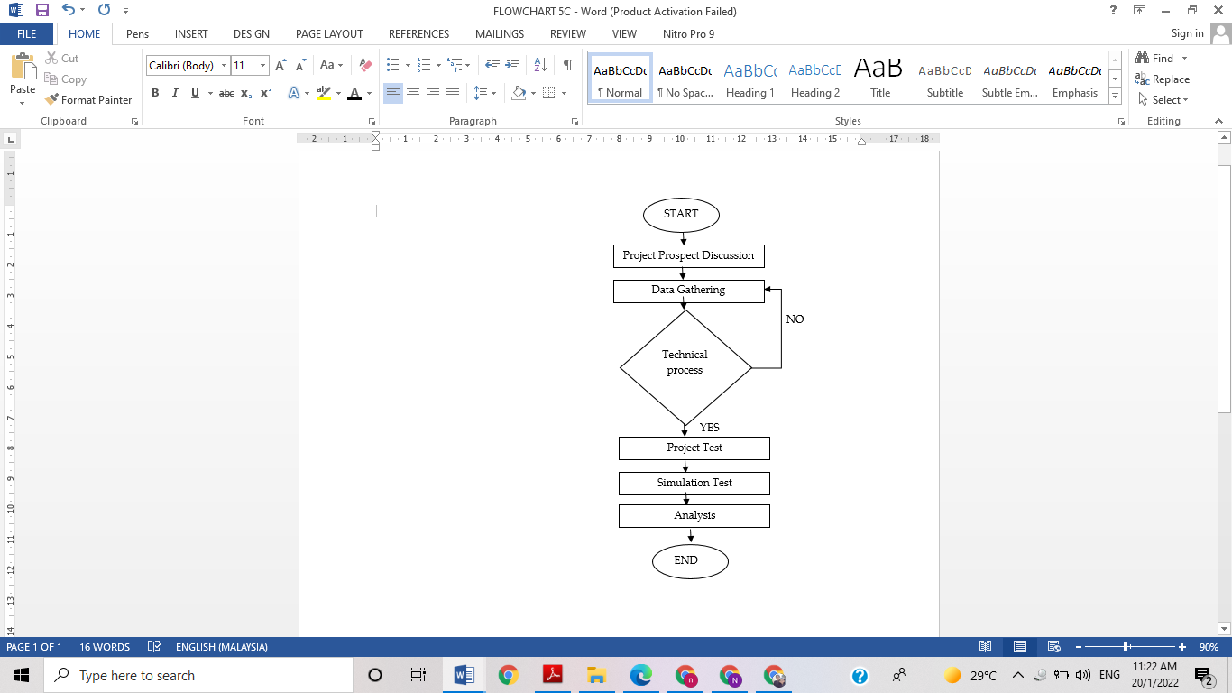To make this project a success, several steps need to be taken and followed to ensure that the project will be smooth and successful. If there is a problem, this flow chart should be referred again to assist before or during the project. Having this flow chart promotes a more organized and systematic use of time as it can follow all instructions promptly. This project was completed according to the flowchart and design process shown in Figure 1 and 2.

**Figure 2**: Design of project

**Figure 1**: Flowchart of project

In order to identify the black tape on the floor surface during testing, firstly program the Arduino microcontroller using the auto calibrating line sensor. After that, test the sensors to determine if each of the five IR could detect the black tape equally without causing the AGV to veer too far to one side while still maintaining a straight course. After that, program the Arduino to use the motor driver to decide and start the motor's movement and stopping speed. The ultrasonic sensor was then designed to alert the Arduino to stop the motor when it came within 50 cm of an impediment and to detect any obstacle outside of that range. The AGV was then tested, and data was gathered.

**FINDINGS AND DISCUSSIONS**

The purpose of obtaining results and data was to compare to see if the project will be beneficial for future commercial uses and to identify what needs to be improved for the further improvement of the product.

1. Ultrasonic sensor is able detect an obstacle and send signal back to the microprocessor and to motor driver to stop the motor in a 50 cm radius from the obstacle;
2. Auto calibrating line sensor was able to read the black line on the floor all the way until the end destination without stopping due to failure; and
3. Error in carrying load when battery was weak, indicated that the battery had to be fully charged before operation.

Following the completion of the fabrication process, the ability to tow a load, obstacle identification, and line testing or evaluation are carried out. The objectives are met if the AGV is able to pass each test, and vice versa. If any corrective action needs to be taken, the AGV is modified as well. The explanation includes recordings of the data collection and the outcomes.

**Line Following Testing**

The line following test is done to ensure that the auto calibrating line sensor functions as intended, and the robot was able to follow the laid-out line on the floor without encountering errors. Table 1 and 2 showed the data collection for line following test and distance travelled versus time taken. Each DC motor is controlled by two signals. The direction of the motor shaft's rotation changes when the polarity of the motor is changed. By adjusting the voltage being provided to the motor, the rotational speed can be changed. Chain drive was used to move the AGV because DC motors cannot provide enough torque to move it on their own.

**Table 1**: Data collection for line following test

|  |  |  |  |  |  |
| --- | --- | --- | --- | --- | --- |
| **IR 1** | **IR 2** | **IR 3** | **IR 4** | **IR 5** | **DIRECTION** |
| 0 | 0 | 0 | 0 | 0 | Left |
| 1 | 0 | 0 | 0 | 0 | Right |
| 1 | 1 | 0 | 0 | 0 | Right |
| 1 | 1 | 1 | 0 | 0 | Right |
| 1 | 1 | 1 | 1 | 0 | Right |
| 1 | 1 | 1 | 1 | 1 | Straight |
| 0 | 1 | 1 | 1 | 1 | Left |
| 0 | 1 | 1 | 1 | 0 | Straight |
| 0 | 1 | 1 | 0 | 0 | Right |
| 0 | 0 | 1 | 0 | 0 | Straight |

**Table 2**: Distance travelled vs Time taken

|  |  |  |
| --- | --- | --- |
| **LENGTH OF TAPE** | **TIME TAKEN** | **CONDITION (LOAD)** |
| 478 CM | 3 minutes 48 secs | 0 KG |
| 478 CM | 4 minutes 22 secs | 15 KG |

**Obstacle Avoidance Sensor Testing**

The obstacle avoidance sensor test is done to ensure that the ultrasonic sensor can identify the obstacle within range and return signal back to Arduino. The ultrasonic sensor identified the obstacle within 2-15 cm range and signals back to the Arduino to signal the motor driver to limit the current supply for the motor shaft to stop. Table 3 showed the data collection for obstacle avoidance test.

**Table 3**: Data collection for obstacle avoidance test

|  |  |
| --- | --- |
| **DISTANCE** | **MOTOR RESPONSE** |
| 110 cm | Run |
| 80 cm | Run |
| 64 cm | Run |
| 40 cm | Run |
| 35 cm | Stop |
| 20 cm | Stop |
| 18 cm | Stop |
| 2 cm | Stop |

**CONCLUSION**

One benefit of the training kit-automated line guided vehicle is its low cost of construction, which makes it affordable for small businesses to buy and operate as their warehouses and workshops. By removing the need to push and pull big goods and leaving the heavy lifting to the AGV itself, this product would minimise the rate of LBD and MSD diseases that occur in the material handling industry and other heavy lifting related industries alike. Additionally, the device's tiny form factor makes storage simple, especially while not in use. The device appears less impregnable when it is moving thanks to the brilliant grey colour, which is also evident to the user's eyes and those of any onlookers. In addition, the product has taller walls at each corner of the item placement area, preventing any things on the item storage bay from falling off during movement or in the event of an accident.

**REFERENCES**

Groover, M. P. (2000). Automation, Production Systems, and Computer Integrated Manufacturing. Prentice Hall International.

Groover, M. P. (2013). Principles of Modern Manufacturing. John Wiley & Sons, Inc.

Le-Anh, Tuan. (2004). A review of design and control of automated guided vehicle systems. [European Journal of Operational Research](https://www.researchgate.net/journal/European-Journal-of-Operational-Research-0377-2217) 171(1): 1-23.