**Internet Based Door Automation System**

***Çağatay ERSİN[[1]](#footnote-1), C:\Users\Abdullah\AppData\Local\Microsoft\Windows\INetCache\Content.Word\ORCID-iD_icon-16x16.gif, Mehmet GÜNEŞ2 C:\Users\Abdullah\AppData\Local\Microsoft\Windows\INetCache\Content.Word\ORCID-iD_icon-16x16.gif***

*1Vocational School, Department of Design Interior Design Program, Cankiri Karatekin University, Cankiri, Turkey*

*2Vocational School, Department of Electronic and Automation Mechatronics Program, Cankiri Karatekin University, Cankiri, Turkey*

|  |
| --- |
| **Abstract**  The internet of things (IoT) has become an application that is included in our daily lives thanks to rapidly developing technology. IoT has an important place in the development of internet-based smart home applications. In this study, it is aimed to control the exterior door of the apartment using a smartphone with the NodeMCU development card integrated into the door automaton systems at home. By connecting to the home network with the built-in Wi-Fi receiver on the development board, the automatic exterior door can be controlled via a single-channel relay with the software on the designed circuit board. The development card used in the smart home system was preferred because it was economical and open source. It is thought that the system can be designed by users using simple circuit elements and software code. |
| ***Keywords:*** *Internet of Things, IoT,**Door, Automation, NodeMCU* |

**1. Introduction**

With the increase and development of the speed and bandwidth of the Internet, the IOT (Internet of Things) market moves to a new point and continues to offer new ideas and opportunities [1]. IoT consists of web-enabled smart devices that can use sensors and communication hardware to collect, send and act on data. Thanks to a gateway, objects in the system enable the transfer and processing of this data via online storage service. The developing technology of the Internet allows all kinds of objects or devices to connect with it. IoT is the communication of addressable objects over the internet, built on standard communication protocols [2]. It was introduced in the AutoID laboratories of the Massachusetts Institute of Technology (MIT) in the early 1990s, and its first application, “Trojan Room Coffee Pot”, was developed in 1999. In the same year, the world's first internet-controlled device, the toaster, was designed. However, today the concept of IoT has taken its place at the center of the concepts of object, human and internet [3].

As the Internet of Things finds application with rapidly developing technologies, new generation urbanization brings more and new opportunities in business, life and many areas of our lives (smart factories, building energy management systems, e-health systems, precision agriculture, smart homes, etc.). reveals [4]. Nowadays, smart home systems and internet of things automations are increasing the number of users and continue to be integrated into our lives with the popularity they have achieved [5]. The main idea of Smart Home Technology is to introduce network devices and equipment at home for a better quality of life. Smart home allows the entire house to be automated, thus providing benefits to disabled individuals as well as a comfortable life. In the future, more innovations and developments are expected in the field of internet of things and smart home systems. These technologies will make significant contributions to areas such as energy efficiency, security, comfort and quality of life. Additionally, as these technologies become widespread, it will be inevitable for our homes to become smarter and make our lives easier [6].

Current door locking systems are all legacy ways of accessing the system via a traditional key, passcode pads or some RFID (Radio Frequency Identification) chip [7]. In this study, an automatic door-opening system that is integrated with in-home doorphones and works online is designed. With this system, the user will be able to open the exterior door of the apartment via mobile device while being away from the intercom. When the studies in the literature were examined, it was observed that similar studies had been conducted. However, in the circuit designed in this study, the door opening signal is sent by connecting the line given as output directly to the doorphone data line, without the need for any door lock or motor. In this way, the cost of the system was reduced and it was integrated into the ready-made system.

**2. Materials and Methods**

NodeMCU microcontroller was used as the controller in the system design. The main reason for using this microcontroller is that it can communicate with objects without the need for an additional module, thanks to the integrated Wi-Fi. Since the microcontroller operates with 5v DC voltage, a 7805 regulator was used to reduce the voltage coming from the doorphone to this voltage. Additionally, a 5v relay was preferred to open the automatic door.

**2.1. NodeMCU ESP32**

It is an open source, low-cost IoT platform. It can connect objects over the internet and enable them to transfer data using the Wi-Fi protocol. Later, 32-bit ESP32 MCU support was added. The relay that regulates AC power is managed by a NodeMCU. Relays are electrical switches used to protect electrical equipment. Typically relay modules use 5V/12V. Electrical devices are switched mechanically using electromagnets. The main function of relays is to manage high voltage and operate low voltage equipment. Since there is no direct contact between NodeMCU and the device, it is considered safe to use [8].

NodeMCU is an open source programmable electronic circuit. It is produced to realize internet of things applications economically. The programming language called “lua” is used to program the NodemCU circuit. Lua is a programming language written in C, generally designed for embedded systems and clients [9]. In addition, it can also be programmed with the Arduino IDE program [10]. The most important reason why this circuit is preferred is that it can connect to wireless networks and spread its own internet network, allowing other devices to connect.

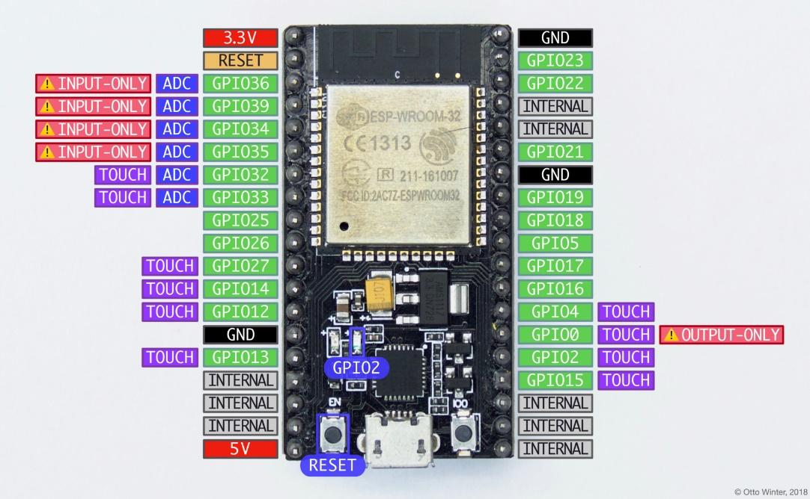

Figure 1. ESP32 Wifi Module.

The NodeMCU card, relay and 7805 voltage regulator circuit integrated on an example video call intercom system is shown in Figure 2. The +24v received via the doorphone was reduced to 5v, which the NodeMCU and relay could use, using a 7805 voltage regulator. The development board and relay were fed with this voltage obtained. GPIO pin 14 on the NodeMCU was used as an output and connected to the In1 input of the relay card. When the user logs in to the interface created on the web address and uses the open button, a signal is sent to the data entry on the intercom and the apartment entrance door is opened.

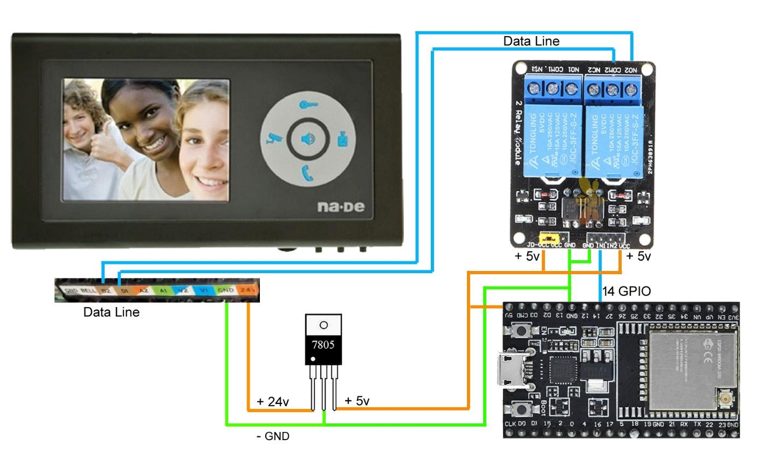

Figure 2. Circuit diagram.

**2.2. Circuit Software**

In this study, Arduino IDE program was used to upload software to the Esp32 microcontroller development board. The Esp32 plug-in was installed in the Arduino Ide program and the door automatic software shown in Figure 3 was written in C language.

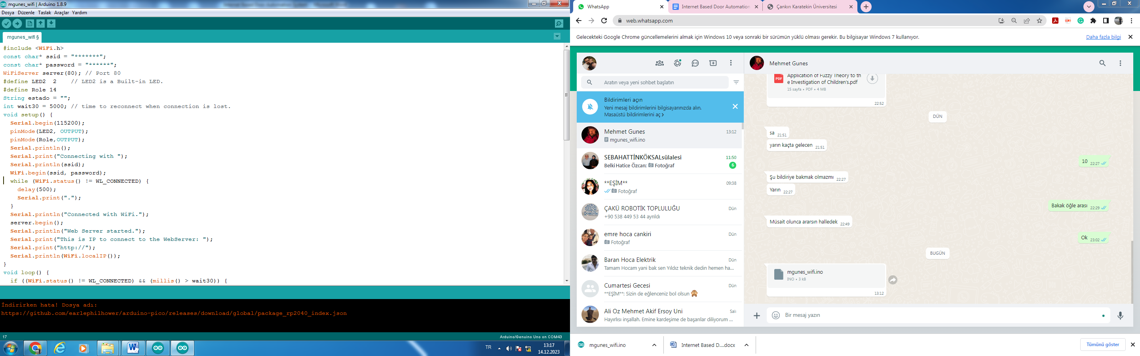 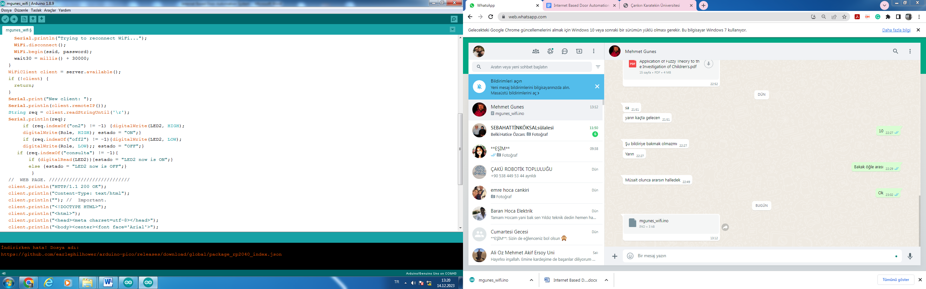

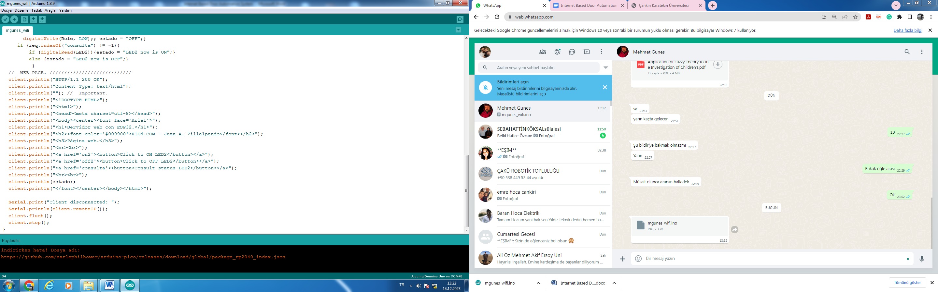

Figure 3. Door automatic codes.

In order for the door vending system, which is implemented in C language, to work on the internet, HTML codes have been added to the software and an opening button has been added. When the user accesses the internet address in a location away from the intercom and presses the button on the interface created with HTML codes, the door automatic will be activated and the door will open. The image of the interface created with HTML codes implemented in the Arduino IDE software is shown in Figure 4.

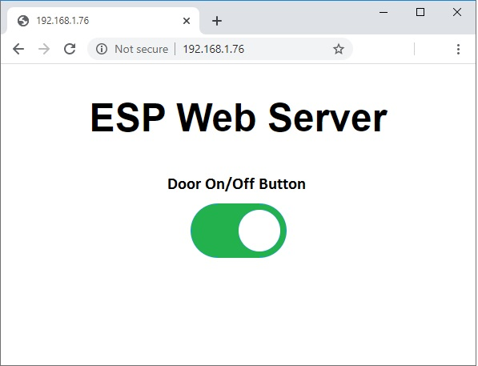

Figure 4. Interface created with HTML codes.

**3. Result**

The internet of things can be seen in examples where it is widely used in smart home systems, as in every aspect of our lives. With the system designed and implemented in this study, homeowners will be able to open the exterior doors of the building when they are not at home with the help of a smartphone and a simple interface. The user will also be able to operate the system remotely without going to the intercom when he is at home. The biggest advantage of the system is that it is designed with low-cost hardware. It can also be integrated into the intercom systems in the apartment. Video and audio features on the intercom can be added to similar studies by making the necessary software and coding on the system later.

**References**

1. Gupta, A. K., & Johari, R. IOT based Electrical Device Surveillance and Control System, 4th International Conference on Internet of Things: Smart Innovation and Usages (IoT-SIU), Ghaziabad, India, 2019, pp. 1-5
2. Bassi, A., & Horn, G. (2020). Internet of Things in 2020: A Roadmap for the Future*.* *European Commission: Information Society and Media,* *22*, 97-114.
3. Erdal, E., & Ergüzen, A. Nesnelerin İnterneti (IoT). (2020). *International Journal of Engineering Research and Development, 12*(3), 24-34.
4. Karakoç, E., & Çeken, C. (2021). Black hole attack prevention scheme using a blockchain-block approach in SDN-enabled WSN. *International Journal of Ad Hoc and Ubiquitous Computing,* *37*(1), 37-49.
5. İlkbahar, F., Ünal, Ş., Karakaya, A. T., & Eren, B. (2021). Akıllı Ev Sistemleri Üzerine Bir Model Önerisi*.* *AJIT-e: Academic Journal of Information Technology*. *12*(45), 90-105.
6. Alaçakal, İ., & Doğan, H. (2023). Nesnelerin İnterneti Tabanlı Akıllı Kapı Uygulaması. *Türk Bilim ve Mühendislik Dergisi,* *5(*1), 21-28.
7. Gupte, N. N., & Shelar, M. R. (2013). Smart door locking system. *International Journal of Engineering Research & Technology, 2*(11), 2214-2217.
8. Niranjana, R., Arvind, S., Vignesh, M., & Vishaal, S. Effectual Home Automation using ESP32 NodeMCU, 2022 International Conference on Automation, Computing and Renewable Systems (ICACRS), Pudukkottai, India, 2022, 1-5,
9. Oral, O., & Çakır, M. (2017). Nesnelerin interneti kavramı ve örnek bir prototipin oluşturulması. *Mehmet Akif Ersoy Üniversitesi Fen Bilimleri Enstitüsü Dergisi,* *8*(1), 172-177.
10. Kayaalp, K., & Özkorucuklu, S. (2015). Arduino Teknolojisi Kullanılarak Tarla İçin Radyasyon Kapı Kontrolü Tasarımı. *Uluslararası Teknolojik Bilimler Dergisi*, *7*(2), 39-47.

1. \* Corresponding author. *e-mail address: cagatayersin@karatekin.edu.tr* [↑](#footnote-ref-1)