**Solar chimney power systems as a renewable energy solution in Libya**

***Abrayik Abdulslam Abrayik ALFAKHAKHIRI 1,[[1]](#footnote-1)\*[C:\Users\Abdullah\AppData\Local\Microsoft\Windows\INetCache\Content.Word\ORCID-iD_icon-16x16.gif](https://orcid.org/0009-0003-9377-9825), Abdullah AKBULUT 2[C:\Users\Abdullah\AppData\Local\Microsoft\Windows\INetCache\Content.Word\ORCID-iD_icon-16x16.gif](https://orcid.org/0000-0002-6199-4083), Ethar Sulaiman Yaseen YASEEN3[C:\Users\Abdullah\AppData\Local\Microsoft\Windows\INetCache\Content.Word\ORCID-iD_icon-16x16.gif](https://orcid.org/0000-0002-5259-378X)***

*1 Institute of Graduate Studies, Department of Mechanical Engineering, Çankırı Karatıkin University, Çankırı, Türkyie*

*2 Institute of Graduate Studies, Department of Mechanical Engineering, Çankırı Karatıkin University, Çankırı, Türkyie*

*3 Institute of Graduate Studies, Department of Electrical and Electronics Engineering, Çankırı Karatıkin University, Çankırı, Türkyie*

|  |
| --- |
| **Abstract**  This study investigates the potential of Solar Chimney Power Systems (SCPS) as a sustainable energy solution for Libya. SCPS technology leverages solar energy to drive air through a tall chimney, generating electricity via turbines, making it an attractive option for regions with high solar irradiance. This research proposes a system design optimized for Libyan conditions, particularly in Derna-Al-Fataih, where climatic and solar characteristics are conducive to efficient operation. An economic analysis, reveals promising financial metrics, including an annual revenue of $290,138, a net profit of $240,138, and a payback period of 6.25 years, resulting in a 16.01% return on investment (ROI). These results suggest that SCPS technology could provide a reliable and profitable renewable energy source for Libya, contributing to energy diversification and sustainability. This study addresses existing gaps in SCPS research and offers recommendations for future work on hybrid systems and region-specific adaptations. |
| Keywords: Solar chimney, Renewable energy, Hybrid energy systems, Libya. |

1. **Introduction**

Solar Chimney Power Systems (SCPS), also known as Solar Aero-Electric Power Plants (SAEP), are innovative structures that convert solar energy into electrical power through the natural process of buoyancy-driven airflow. The system consists of three main components: a solar collector, a chimney, and a turbine. Sunlight heats the air trapped under a transparent collector, creating a greenhouse effect that increases the temperature of the air. The warmer air rises through the chimney, where it drives a turbine to generate electricity. This process uses a simple yet effective method to capture solar energy and convert it into a sustainable power source. The concept of the solar chimney was first introduced by Cabanyes [1], who envisioned using it to heat air within a building, with an attached wind blade for electricity generation. Since the 1970s, various countries, including Australia, the USA, and Canada, have registered patents to explore the potential of this technology [2]. The first operational prototype was constructed in Manzanares, Spain, between 1981 and 1982 by Schlaich and his team [3][4]. This pioneering project inspired additional proposals globally, including some notable large-scale initiatives. For instance, a 200 MW solar chimney was proposed for Mildura, Australia, featuring a 1000-meter chimney and a 7000-meter-diameter collector, with the capacity to power around 200,000 households [5][6]. In Rajasthan, India, a 100 MW plant was scheduled but later canceled due to political tensions between India and Pakistan [7]. Meanwhile, Spain saw a proposal for a 40 MW Ciudad Real Torre Solar project, which would include a 750-meter-high chimney and a 3.5 km² collector [8]. In Namibia, the "Green Tower" project planned a 1500-meter chimney integrated with agricultural greenhouses, generating 400 MW [9]. In China, a 1000-meter-high solar chimney was proposed in Shanghai, combining power generation with tourism potential [10]. Over time, researchers have examined various design enhancements and applications for solar chimney systems. Zhou et al. [10] provided an overview of the early experimental and theoretical research on solar chimneys up to 2010, discussing design variations like floating chimneys and sloped collectors. Chikere et al. [11] reviewed methods for enhancing SCPS performance, including the use of waste heat from flue gases to boost energy input. Zhai et al. [12] summarized applications of solar chimneys integrated into buildings, particularly on rooftops and walls, while Dhahri and Omeri [13] categorized research into project developments, numerical studies, and unconventional designs. Olorunfemi and Bamisile [14] focused on desert applications, with specific attention to northern Nigeria. Although these reviews provided valuable insights, they were often limited in scope, region-specific, or outdated. Figure 1 shows the visualization of solar chimney.

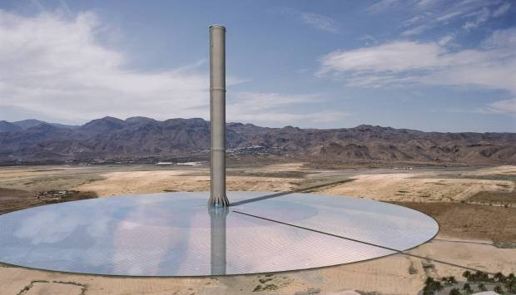

Figure 1. Solar chimney [15]

This study aims to address existing gaps by offering a design of solar chimney, focusing particularly on its potential applications in Libya. The desgin also includes an analysis of hybrid systems that integrate solar chimneys with other renewable energy sources, providing insights into optimizing these systems for improved efficiency tailored to Libyan conditions. Furthermore, we identify key research gaps and propose a roadmap for future studies, encouraging advancements in hybrid configurations, more precise simulation models, and exploration of solar chimney potential specifically adapted to Libya’s environment and energy needs.

1. **Materials and Methods**

**2.1 System overview**

For this mission focused on designing an efficient and durable solar chimney that optimizes both cost and performance, the selection of materials and corresponding parameters for the collector area, chimney structure, and insulation needs to carefully balance these factors. Figure 2 shows the general scheme of solar chimney.

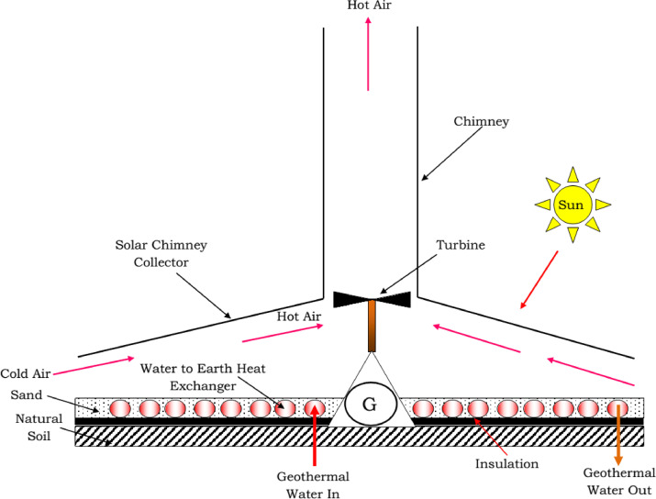

Figure 2. Scheme of solar chimney [16]

Solar chimney collector consists of a sloped, transparent structure designed to capture sunlight. This collector creates a greenhouse effect, trapping solar radiation and heating the air beneath it. As the air warms, it becomes less dense and rises toward the chimney. This heated airflow is crucial to driving the system, as it moves naturally toward the chimney due to the temperature-induced pressure difference.

At the center of the system, the chimney provides the primary pathway for the hot air, channeling it upward through the tall, vertical structure. The chimney height enhances the stack effect, which intensifies the upward flow of air by creating a stronger pressure gradient. Positioned at the base of the chimney is a turbine, which harnesses the kinetic energy of the rising hot air. As the air flows through, it drives the turbine, generating mechanical energy that is converted to electrical power via a generator.

**2.2 Proposed Location**

This study suggests Derna-Al-Fataih in Libya as a location for this study (Figure 3). Darna Al-Fataih, a district in the historic city of Darna, Libya, is distinguished by its favorable Mediterranean climate, characterized by hot, dry summers and mild, wet winters. With a population of approximately 100,000 [17] and over 3,200 hours of sunshine annually, the area is highly suitable for solar energy initiatives like Solar Chimney technology. This technology generates electricity by harnessing solar energy to create an updraft within a tall chimney, a process well-suited to the region’s sunny conditions.

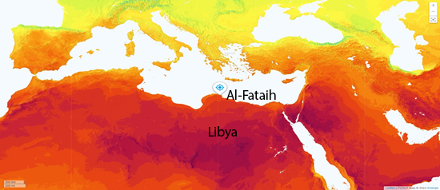

Figure 3. Map of the proposed location

As shown in Figure 4 easonal variations in the solar path are marked by distinct lines for the equinoxes, June solstice, and December solstice. During the summer solstice, the sun follows the highest path in the sky, giving the longest day and the most intense solar radiation. Conversely, during the winter solstice, the sun's lower path results in shorter days and reduced solar intensity.

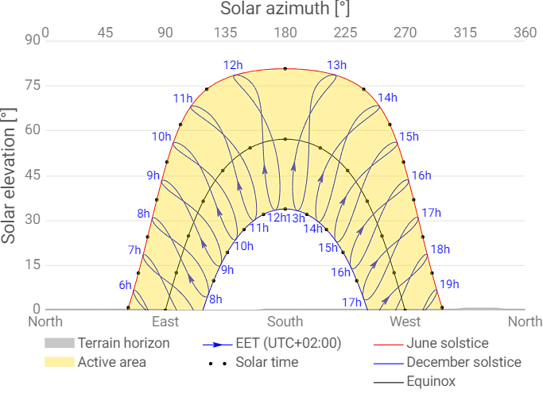

Figure 4. Elevation [°] and azimath [°] solar

The monthly average values of direct normal irradiation (DNI) in Libya offer critical insights for designing and evaluating the efficiency of hybrid solar and wind chimney power systems. Measured in kilowatt-hours per square meter (kWh/m²), DNI displays seasonal trends, with peak levels occurring in the summer and lower values in the winter. These seasonal fluctuations have a substantial effect on the design and operational efficiency of hybrid systems, making careful planning and optimization essential for achieving optimal performance.

**2.3 Economic analysis**

In this economic analysis, the profitability of the project is evaluated with an electricity price set at $60 per megawatt-hour (MWh). Key financial metricsn such as annual revenue, net profit, payback period, and return on investment (ROI) are calculated to assess the viability of the project. To determine the annual revenue, the total amount of electricity generated annually, 4,835.64 MWh, is multiplied by the fixed electricity price of $60 USD per MWh. This results in an annual revenue of $290,138 USD. This revenue forms the basis for further profitability calculations by providing a clear picture of the project's income potential. The net profit calculation involves subtracting the total operating costs from the annual revenue. With annual revenue at $290,138 USD and operating costs at $100,000 USD per year, the resulting net profit amounts to $240,138 USD per year. This value represents the actual income that the project is expected to generate annually after accounting for operating expenses. Next, the payback period is calculated to determine the time required to recover the initial investment of $1,500,000 USD through the annual net profit. By dividing the initial investment by the annual net profit, we find that the payback period is approximately 6.24 years. This metric is crucial as it indicates the timeframe within which the project will start to yield returns beyond the original capital expenditure. Finally, the ROI is computed to evaluate the project's profitability in percentage terms. By dividing the annual net profit by the initial investment and multiplying by 100, we arrive at an ROI of 16.1%. This ROI provides a straightforward indication of the financial efficiency of the investment, with a higher percentage reflecting a more attractive return relative to the initial expenditure. In summary, the economic analysis indicates that with an electricity price of $60/MWh, the project yields an annual revenue of $290,138 USD and a net profit of $240,138 USD. The payback period is approximately 6.24 years, and the ROI stands at 16.1%, suggesting a profitable and viable investment opportunity. These metrics collectively provide a comprehensive view of the project's economic potential and its capacity to generate sustained returns.

1. **Results and Discussion** 
   1. **Analysis of daily temperature and solar radiation variations**

Over a 365-day cycle, Earth’s orbit around the sun creates four distinct seasons, each marked by significant changes in temperature and solar radiation. Additionally, Earth’s rotation on its axis every 24 hours results in day and night, which affects ambient temperature and solar energy availability. In January, ambient temperatures and solar radiation levels are moderate, averaging 16.7°C and 362 W/m², respectively. These conditions support efficient solar panel operation, as temperatures are within the optimal range to avoid losses from excessive heat. Although January’s solar radiation is lower than in warmer months, its consistency and mild temperatures provide a stable energy generation base. February exhibits similar moderate conditions, with an average daytime temperature of 15.35°C and solar radiation of 301 W/m². While solar radiation is slightly lower than in January, it remains adequate for effective solar generation, with moderate temperatures sustaining system efficiency. In March, temperatures peak at midday, reaching 25°C, with solar radiation hitting a high of 510 W/m², also around midday. These midday peaks indicate the most productive time for solar energy generation, where both temperature and solar radiation align optimally. April sees a temperature increase, peaking at 28°C at midday, while solar radiation rises to 560 W/m². The alignment between peak solar radiation and temperature in April further optimizes energy generation around midday. May experiences significant increases in both temperature and solar radiation, enhancing solar productivity. Daytime temperatures average 29.4°C, ranging from 22°C in the morning to a midday peak of 34°C. Solar radiation averages 488.33 W/m², reaching 710 W/m² at midday, marking 10:00–14:00 as the prime period for energy collection due to sustained high radiation levels. June, marked by high temperatures and solar radiation, represents the onset of summer. Average temperatures are 33.88°C, beginning at 26°C and peaking at 39°C at midday. Solar radiation averages 600.83 W/m², reaching a peak of 860 W/m² at midday and staying high between 11:00 and 14:00. This combination of prolonged daylight and intense solar radiation makes June an exceptionally productive month for solar generation, even with minor efficiency losses from heat. Overall, the high temperatures and strong solar radiation in spring and early summer provide optimal conditions for hybrid solar chimney systems, with midday hours offering the most efficient energy collection due to the alignment of temperature and solar intensity. Figure 5 show the summarized of finding.

|  |  |
| --- | --- |
|  |  |
|  |  |
|  |  |

**Figure 5**. Analysis of daily temperature and solar radiation variations from January to July 2024

**3.2 Economic feasibility analysis of solar chimney power generation system**

In this study, an economic analysis for a Solar Chimney Power Generation System was conducted. The analysis focuses on essential financial metrics such as Annual Revenue, Net Profit, Payback Period, and Return on Investment (ROI), providing a comprehensive view of the project’s financial viability. These parameters offer insights into the project's potential to generate income, cover operational costs, repay its initial investment, and deliver returns to investors. The annual revenue of the system is derived by multiplying the total energy produced by the system with the electricity price, resulting in an annual revenue of $290,138. This value represents the total income generated each year through the sale of electricity produced by the solar chimney. The net profit, calculated by subtracting the annual operating expenses (OPEX) from the annual revenue, is $240,138. This net profit figure highlights the earnings available after operational costs are covered, serving as a primary indicator of the system's profitability. The payback period is calculated by dividing the initial investment by the net profit, yielding a result of 6.25 years (Table 1).

**Table 1.** Economic analysis conducted for a base electricity price of $60/MWh

|  |  |
| --- | --- |
| **PARAMETER** | **VALUE** |
| Annual Energy Production (Eannual) | 4,835.64 MWh/year |
| Annual Revenue | $290,138 |
| Initial Investment | $1,500,000 |
| Annual Net Profit | $240,138 |
| Payback Period | 6.25 years |
| Return on Investment (ROI) | 16.01% |

1. **Conclusion**

This study demonstrates the feasibility and potential benefits of implementing Solar Chimney Power Systems (SCPS) as a renewable energy source in Libya, particularly in regions like Derna-Al-Fataih with favorable solar and climatic conditions. These financial metrics underscore the system's ability to provide a steady income stream while recouping the initial investment within a reasonable timeframe, marking it as a viable alternative to conventional energy sources. This research not only fills a gap in region-specific renewable energy studies but also suggests that SCPS technology can contribute to Libya’s energy diversification and reduce dependency on fossil fuels. Additionally, the integration of SCPS with hybrid renewable systems, as proposed in this study, presents further avenues for enhancing efficiency and reliability, particularly in meeting Libya’s energy demands sustainably. Future studies are encouraged to explore advanced design optimizations, hybrid configurations, and precise simulation models to adapt solar chimney systems more effectively to Libya’s unique environmental and economic landscape.

**References**

1. Cabanyes, I. (1903). *Las chimeneas solares (Solar chimneys)*. *La Energía Eléctr*.
2. Lucier, R. E. (1981). System for converting solar heat to electrical energy. *Google Patents*.
3. Richards, R. (1982). Hot air starts to rise through Spain’s solar chimney. *Electrical Review*, *210*, 26–27.
4. Haaf, W., Friedrich, K., Mayr, G., & Schlaich, J. (1983). Solar chimneys (part I): principle and construction of the pilot plant in Manzanares. *International Journal of Solar Energy*, *2*, 3–20.
5. Nizetic, S., Ninic, N., & Klarin, B. (2008). Analysis and feasibility of implementing solar chimney power plants in the Mediterranean region. *Energy*, *33*, 1680–1690.
6. EnviroMission Limited. (2006). Technology: Technology overview. Retrieved from <http://www.enviromission.com.au>
7. Jiakuan, Y., Jin, L., & Po, X. (2003). A novel technology of solar chimney for power generation. *ACTA Energiae Solaris Sinica*, *24*, 570–573.
8. Sagasta, F. M. (2003). Torre solar de 750 metros de altura en Ciudad Real (España).
9. Cloete, R. (2008). Solar Tower sheds light on little-used technology. *Engineering News Online*. Retrieved from http://www.engineeringnews.co.za/article.php
10. Zhou, X., Wang, F., & Ochieng, R. M. (2010). A review of solar chimney power technology. *Renewable and Sustainable Energy Reviews*, *14*, 2315–2338.
11. Chikere, A. O., Al-Kayiem, H. H., & Karim, Z. A. A. (2011). Review on the enhancement techniques and introduction of an alternate enhancement technique of solar chimney power plant. *Journal of Applied Sciences*, *11*, 1877–1884.
12. Zhai, X. Q., Song, Z. P., & Wang, R. Z. (2011). A review for the applications of solar chimneys in buildings. *Renewable and Sustainable Energy Reviews*, *15*(8), 3757–3767.
13. Dhahri, A., & Omri, A. (2013). A review of solar chimney power generation technology. *International Journal of Engineering and Advanced Technology*, *2*.
14. Olusola Olorunfemi, & Bamisile. (2014). A review of solar chimney technology: Its application to desert-prone villages/regions in Northern Nigeria. *International Journal of Scientific and Engineering Research*, *5*, 1210–1216.
15. Saleh, M. J., Atallah, F. S., Sameer Algburi, & Ahmed, O. K. (2023). Enhancement methods of the performance of a solar chimney power plant: Review. Results in Engineering, 19, 101375–101375. https://doi.org/10.1016/j.rineng.2023.101375
16. Sharon, H. (2023). A detailed review on sole and hybrid solar chimney based sustainable ventilation, power generation, and potable water production systems. Energy Nexus, 10, 100184.
17. Motamedi, M. (2023, September 13). Why did Derna’s dams break when Storm Daniel hit Libya? Www.aljazeera.com. https://www.aljazeera.com/news/2023/9/13/why-did-dernas-dams-break-when-storm-daniel-hit-libya

1. \* Corresponding author. *e-mail address: 228117200@ogrenci.karatekin.edu.tr* [↑](#footnote-ref-1)