THE EFFECT OF MARULA OIL ON THE RELEASE OF MADECASSOSIDE
Gamze UYSAL^{1,}∗ , Emel AKYOL ²
Institute of Science and Engineering, Faculty of Chemical and Metallurgical Engineering, Chemical Engineering, Yıldız Technical University, Istanbul, Turkey
Institute of Science and Engineering, Faculty of Chemical and Metallurgical Engineering, Chemical Engineering, Yıldız Technical University, Istanbul, Turkey

Abstract
Specifically, the impact of natural oils on drug release in cream formulations was investigated through UV-Vis Spectrophotometry analysis. The aim of this study was to enhance the drug release from creams, a commonly employed transdermal drug delivery method, by formulating them with marula oil. Specifically, the impact of marula oil on drug release in cream formulations was investigated through UV-Vis Spectrophotometry analysis. The experimental findings clearly indicate that the inclusion of marula oil enhances the drug release in creams. To compare the release profiles, various kinetic models such as zero-order, first-order, Higuchi, and Korsmeyer Peppas were employed. The focus of this study centered on investigating the release of the active ingredient madecassoside, derived from the Centella asiatica plant. In conclusion, the inclusion of marula oil in cream formulations was found to increase drug release compared to the base formulation. Release performance in the formulations was observed for 120 minutes. In the cream formulation reinforced with marula oil, it provided 38% permeability by mass at the end of the 120th minute. This study highlights the potential of marula oil as an effective ingredient in transdermal drug delivery, particularly for enhancing the release of madecassoside in topical creams. Further research and optimization of formulations can lead to improved therapeutic outcomes and enhanced patient convenience.
Keywords: Topical Drug Delivery, Madecassoside, Kinetic model, Marula oil

- Introduction
Transdermal drug administration devices allow the medication to be applied to the skin without the need for a needle and manage the drug's blood flow, in contrast to routinely used methods like a hypodermic needle. [1,2] The medicine is loaded directly into instruments like patches, gels, creams, and microneedles for transdermal applications. For the medicine to penetrate the skin, several techniques have been tested and developed since antiquity. [3] Transdermal systems are gaining attention in research and development today because they provide a simple, painless, regulated, and efficient means of release. [4] These techniques have been utilized to create numerous medications, vitamins, and hormones that are used to treat several ailments. Patches are suitable for use throughout a range of time periods since they are made for continuous or intermittent drug administration. Contrarily, micron-sized drug delivery systems called microneedles were created by combining the benefits of patches and hypodermic needles. [5] It also distinguishes out because of its formulation, which is the most extensively used topical medicine in the cosmetics industry, and because of how simple it is to apply. With its composition employing several excipients, it helps the active component to go deeply into the stratum corneum while preventing direct skin penetration and regulating its blood flow. The stratum corneum, the skin's top layer, must first be penetrated by the medicine before it can reach the epidermis and dermis. [6,7] The drug's routes of transmission are crucial for efficient penetration. Three stages can be used to explain how the transmission via these techniques occurs. The drug's entry into the stratum corneum comes first. It also refers to the stratum corneum's permeation into the dermis and epidermis. [8,9] This leads to its resorption into the circulatory system as an outcome. Fick’s first law, which is a brief explanation of the transmission mechanism, states that therapeutic molecules must continue to work on the skin until the concentration gradient vanishes. [9] Drug penetration is evaluated using in vitro techniques. Franz diffusion cell, which offers several benefits, is an appropriate technique for lab experiments. [10,11]
The purpose of this study was to monitor and assess the controlled release of cream formulated with the active component madecassoside, marula oil, and other excipients by using Franz diffusion cell method. Madecassoside is widely recognized in the cosmetic industry for its beneficial properties, including soothing the skin, promoting healing, and combating signs of aging. [12]

- Materials and Methods
2.1 Materials
Chemicals that are used for the experiments are;
Table 1. Chemicals used in the experiment
RAW MATERIAL NAME | FUNCTION
Aqua (Water) | solvent
Cellulose Gum | gelling agent
Cetearyl Alcohol | emulsifier
Glyceryl Stearate SE | emulsifier
Pentylene Glycol | preservative
Glyceryl Caprylate/Caprate | preservative
Dimethyl Isosorbide | penetration enhancer
Madecassoside | active ingredient
Lactic acid | pH regulator
Marula Oil | natural oil

2.2 Methods
2.2.1 Preparation and formulation of cream
In Table 2., ingredients and their mass percentage in cream are given.
Table 2. Formulation
INGREDIENT | % W/W
Aqua (Water) | 67.29
Cellulose Gum | 0.2
Cetearyl Alcohol | 12
Glyceryl Stearate SE | 4
Pentylene Glycol | 2.5716
Glyceryl Caprylate/Caprate | 0.4284
Dimethyl Isosorbide | 3
Marula Oil | 10
Madecassoside | 0.5
Lactic Acid | 0.01

The cream consists of a water phase and an oil phase. The oil phase consisted of cetearyl alcohol, glyceryl stearate SE, dimethyl isosorbide, and marula oil. These ingredients were weighed according to their mass percentages and then heated to a temperature of 75-80 °C. Similarly, the water phase was prepared by mixing water and cellulose gum and heating them to the same temperature as the oil phase. Once both phases were heated, they were combined with suitable mixing rpm. The mixing rpm was gradually decreased, resulting in the formation of a creamy consistency. After completing the mixing stage, the cream was cooled to approximately 30°C. At this temperature, the active ingredient madecassoside and preservative is pentylene glycol and glyceryl caprylate/caprate used as a were added to the formulation. Finally, the pH of the cream was adjusted to 6.0 matching the pH of human skin, by incorporating lactic acid.
2.2.2 Drug Release experimentals
A cellulose acetate membrane with a 0.45 µm pore size and 47 mm diameter was select to fit the donor compartment of the Franz diffusion cell. This cellulose acetate membrane was used to simulate human skin. In order to replicate human blood, pH 7.4 buffer solution was placed in the receptor compartment of the Franz diffusion cell. The receptor compartment was covered with a manufactured cellulose acetate membrane. 1 gram of cream was applied to the membrane and donor compartment was placed above them. Then, Franz diffusion cell to simulate human body was placed into agitating hot water bath with a temperature of 36.8°C and shaken at 120 rpm. 1 ml of samples were collected into sample tubes and 2 ml of buffer solution is added to tube and diluted. Buffer solution is added instead of the sample taken at certain time intervals in the Franz diffusion cell. Sample collection is carried out at 10-minute intervals during the first hour and 20-minute intervals during the second hour. These collected samples were subsequently analyzed in the UV Spectrophotometer.

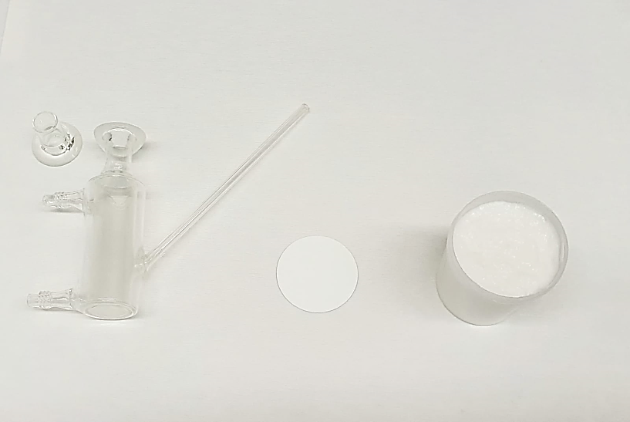

Figure 1. Franz diffusion cell and cream formulation

- Results and Discussion
In-vitro release studies use UV-vis spectroscopy to investigate the presence and amount of madecassoside active released from the cream.

Figure 2. Mass percentage – time graph of base formulation
Figure 2 shows the mass percentage-time graph for the base formulation. From the graph, it is evident that the base formulation exhibits an increasing trend up to 80 minutes. However, after 80 minutes, the graph levels off, indicating an interruption of drug release. Notably, there are sharp increases observed at the 30-minute and 50-minute marks on the graph. These points indicate notable spikes in the drug release rate during those specific time intervals.

Figure 3. Mass percentage – time graph of cream with marula oil

Figure 3 presents the mass percentage-time graph for the marula oil formulation. Based on the graph, there is a sligtly increase in drug release up to 80 minutes. However, after 80 minutes, there is a rapid increase in drug release. The graph continues to show an increasing trend beyond 120 minutes. It can be concluded that the cream containing marula oil exhibits its maximum transdermal penetration at 120 minutes. The duration of the experiment was set at 2 hours since topical creams are typically applied to the skin for this duration. In the Cream with marula oil formulation, 38% permeability by mass was achieved at the end of the 120th minute.
In this study, the obtained data were fitted to the widely recognized Korsmeyer-Peppas equation and zero order equation, which is an exponential equation frequently used to describe drug release behavior. Additionally, the release kinetics of Madecassoside during the permeability study using pH 7.4 phosphate buffer were evaluated using the zero-order, first order, and Higuchi equations. The results indicate that the Korsmeyer-Peppas and zero order release kinetic models exhibit the highest R² values for base and marula oil formulations respectively.

Tablo 3. Regression coefficients according to release kinetic models

Formulations | R² Values
 | Zero Order | First Order | Higuchi | Korsmeyer Peppas
Base | 0.8657 | 0.7058 | 0.9036 | 0.9235
Marula oil | 0.9744 | 0.8527 | 0.9233 | 0.9602

This formulas have Korsmeyer-Peppas ve zero order kinetics models. R² values is better indicate that drug release is a diffusion-controlled process. When the emissivity (n) parameter value of the Korsmeyer-Peppas model was examined, it performed non-fickian diffusion. For non-Fickian diffusion, mass and rate of penetration are directly proportional to time. In this case, the diffusion rate of the penetrant is faster than the chain mobility. This chain mobility causes the polymer to swell. This non-Fickian state occurs during the mobility of the penetrant and the polymer chain. It occurs as a combination of diffusion and erosion controlled release. The cream with marula oil formula has zero-order drug kinetic model. Zero-order drug delivery systems have the potential to overcome the issues facing immediate-release by releasing drug at a constant rate, there by maintaining drug concentrations within the therapeutic window for an extended period of time.

- Conclusion

In this study, topical drug delivery, which is one of transdermal drug delivery methods, was investigated. Various systems and formulations used in topical drug delivery are described. Creams, which are a highly frequent and simple approach for drug delivery systems, were preferred. The solvent, moisturizer, emulsifier, preservative, and active component in the cream are all listed in detail. To examine its release, the madecassoside component was chosen because of its numerous advantageous and functional features. To examine the effect of the release, marula oil was employed as a moisturizer, penetration enhancer, and gives different advantages to the skin in the field of cosmetics and alternative medicine. investigated. The cream formulations were analyzed using the Franz diffusion cell method, and the release rate was monitored using a UV spectrophotometer. The results showed that marula oil improved the release rate of the active component, suggesting its potential in enhancing drug delivery in topical applications.

References

[1] Alkilani, A. Z., McCrudden, M. T., & Donnelly, R. F. (2015). Transdermal Drug Delivery: Innovative Pharmaceutical Developments Based on Disruption of the Barrier Properties of the Stratum Corneum. Pharmaceutics, 7(4), 438–470.
[2] Agrahari, S., Sharma, A., Kumar, S., Sharma, A., & Sagar, M. K. (2019). Formulation and Development of Transdermal Patches of Piroxicam. Asian Journal of Pharmaceutical Research and Development, 7(3), 119–128.
[3] Benson, H. a. E. (2005). Transdermal Drug Delivery: Penetration Enhancement Techniques. Current Drug Delivery, 2(1), 23–33.
[4] Adepu, S., & Ramakrishna, S. (2021, September 29). Controlled Drug Delivery Systems: Current Status and Future Directions. Molecules, 26(19), 5905.
[5] Donnelly, R. F., Singh, T. R. R., & Woolfson, A. D. (2010). Microneedle-based drug delivery systems: Microfabrication, drug delivery, and safety. Drug Delivery, 17(4), 187– 207.
[6] Bartošová, L., & Bajgar, J. (2012). Transdermal Drug Delivery In Vitro Using Diffusion Cells. Current Medicinal Chemistry, 19(27), 4671–4677.
[7] Osseiran, S., Cruz, J. D., Jeong, D. H., Wang, H., Fthenakis, C. G., & Evans, C. L. (2018). Characterizing stratum corneum structure, barrier function, and chemical content of human skin with coherent Raman scattering imaging. Biomedical Optics Express, 9(12), 6425.
[8] Bhowmik, D. (2013). TOPICAL DRUG DELIVERY SYSTEM. ResearchGate.
[9] Alkilani, A. Z., McCrudden, M. T., & Donnelly, R. F. (2015). Transdermal Drug Delivery: Innovative Pharmaceutical Developments Based on Disruption of the Barrier Properties of the Stratum Corneum. Pharmaceutics, 7(4), 438–470.
[10] Salamanca, C. H., Barrera-Ocampo, A., Lasso, J. F., Camacho, N., & Yarce, C. J. (2018). Franz Diffusion Cell Approach for Pre-Formulation Characterisation of Ketoprofen Semi- 49 Solid Dosage Forms. Pharmaceutics, 10(3), 148.
[11] Ng, S. F., Rouse, J., Sanderson, F. D., Meidan, V. M., & Eccleston, G. (2010). Validation of a Static Franz Diffusion Cell System for In Vitro Permeation Studies. Aaps Pharmscitech, 11(3), 1432–1441.
[12] Guangtao Jia, Xiuyang Lu. (2008). Enrichment and purification of madecassoside and asiaticoside from Centella asiatica extracts with macroporous resins Journal of Chromatography A, 1193(1-2), 136-141.

* Corresponding author. e-mail address: .........@.....

