**CONSTRUCTING THE IMAGE OF SOLDIERS BY USING NEWSPAPER MEDIA**

1. **ABSTRACT**

*Sri Lanka is a country that has experienced gruesome chapters of an ethnic conflict for nearly three decades from 1983 to 2009. During the war time, military forces have played a key role by actively involving in the battlefield.  However, it was evident that during different phases of the war in Sri Lanka, the acceptance and the reputation for the armed forces, by the civil society, was subjected to a great extent of variation. Although protecting the country was their duty, criticisms directed against soldiers from both national and international spheres because of the civilians’ deaths and the military actions. In this context, there was an active attempt for the legitimation of the battle, and media was widely used as a platform for this process. Although a considerable number of literature and researches have been conducted to study about the war in Sri Lanka, lack of studies and literature regarding the soldiers is recognizable. Hence this study tried to fill that study gap, by focusing on how media was used to construct the image of the soldiers in the Sri Lankan context, during the war period. Therefore, the objective of this study was to critically investigate the role of newspapers in terms of constructing the identity of soldiers, during the wartime with special reference to the final phase of the war. This was based on a discourse analysis of the weekend Sinhala and English newspapers, using both the government and the private newspapers. This study revealed that, during different phases of the war, different identities have existed towards the soldiers and these identities have had both positive and negative impacts on their image with respect to their role on the battlefield. As part of this, it was evident that the media has uplifted soldiers' identity from less educated people to war heroes or ultimate protectors of the country. Furthermore, as another observed fact, the newspapers have widely highlighted and brought forward the humanitarian facet of these soldiers by using sentimental heart-catching pictures, words, and phrases during this war period. Therefore, it can be identified that the military media management project has successfully directed the public opinion as they were intended, ensuring that the role of soldiers is socially justified. However, this study was conducted based on the newspapers of only two official languages, out of the three main languages. This may lead to missed perspectives from the Tamil newspapers which may have conveyed other opinions about the soldiers and their actions, during these periods. Moreover, this research may open up the space to conduct further research by future researchers as well, concentrating on different perceptions of the military actions at different levels.*

*Key Words: war, soldiers, constructing image, war heroes, newspaper*

1. **INTRODUCTION  
   2.1 Go down in conflict history of Sri Lanka**

Warfare is a common condition experienced by almost every state in the world since time immemorial. According to sociologist Sigmund Freud, warfare arises as a persecution of the perpetrators (Baron,1983 cited in Jayatungala,2004:14). Thus war can be simply defined as an armed conflict between a society or any group, and it can also be seen as the ultimate outcome of various forms of violence and oppression.

Therefore, in this context when focusing on the history of war in Sri Lanka, it is possible to identify various forms of resistance based on the history of the war in Sri Lanka dating back to centuries and extending to the year 2009. The Mahavamsa (a book which contained the Sri Lankan history) bears written evidence to the major wars that have taken place in the country (Balasuriya,2011:02). As Uyangoda stated, “conflicts and wars were not alien to the country. It is identified as a result of the process of nation-building in the nation-state as well and in the state-building by forced and internal warfare, absorbing the language, religion or culture of the majority community” (Uyangoda,2011:49). Therefore, war can be the result of the forcible exercise of the aspirations of the majority in the nation state, towards the minority.

If we go down the war history of Sri Lanka, the ethnic conflict that has prevailed in the country for nearly three decades since 1983, can be described as a physical conflict that has arisen in the country in various forms and at various times. The claim of the socio-economic, political and cultural rights of the Tamil minority community has caused to the genesis of the war in this country. Actions like the introduction of the Citizenship Act, the Official Languages Act into the public administration of the country and not giving a proper representation ratio in the political arena, have predisposed to this conflict between the Sinhalese majority and the Tamil minority. The minority communities in the country have been severely affected over the years due to the exclusion and marginalization from the country's major socio-economic, political and cultural streams. Because of these types of injustice, Tamils started to demand and claim their rights. At first, they claimed their rights in a peaceful manner and subsequently formulated the organization called the Liberation Tigers of Tamil Eelam (L.T.T.E.). L.T.T.E. started to claim Ealama, (Name of the separate state that the L.T.T.E., claimed from the country to govern as a county, within the country) by using various kinds of human rights violations including bomb blasting’s, shootings, savage killings of innocent people, suicidal attacks etc. and became a dreadful experience to the entire Sri Lankan community regardless of the fact whether they belonged to the majority or the minority. The war officially began in Jaffna on 23rd of July, 1983, continued in four-phases until the 18 th May 2009.

Therefore, war in Sri Lanka can be considered as an undesired release of the long-standing pressure within the Tamil minority in an unfavourable, unacceptable manner, as the part of the Tamil representatives who formed L.T.T.E, demanded a separate control to the Tamil society. Here, the phases of the Sri Lankan war can be identified as follows,

Phase I - 1983 - 1989   
 Phase II - 1989- 1994   
 Phase III - 1994 - 2001  
 Phase IV - 2006 - 2009 (Balasooriya,2011).

The civil war which was taken place from 1983, caused to turn thousands of civilians into internally displaced and refugees. Sudden suicidal attacks and the terror emerged by these terrorist attacks, was affecting the entire country, despite the religion, ethnicity or any other differences, in a merciless way throughout the entire country. Due to these brutal murders, harassments and torture to the common civilians, especially to those who resided in boarder villages, the control of the terrorist crisis became a strong demand of the civil society. Since the beginning of the 20th century, the need of a lasting peace was the country’s top priority, as it had created a great deal of insecurity to the national security and the development of the country. In this context, in 2005 President Mahinda Rajapaksa, promised to end the war in his policy statement. The policy statement further pointed out the need of a lasting peace for this protracted war.

However, 2006 marked the beginning of the formal involvement of the government in the war by further organizing government forces for the war. After the number of ceasefires L.T.T.E. was unable to keep it as it is. Therefore, these types of involvements were proven to be useless in establishing peace in the country, since every time L.T.T.E. signed a ceasefire, LTTE would later start the bombings and violations to those agreements, taking maximum advantages of such times of negotiation. Because of this, government of Sri Lanka started the war on terror during the period of 2004 - 2009, especially after the incidence of the closure of the Mavilaru sluice by the LTTE, which deprived thousands of civilians from their access to water which is a major human need for the survival. Therefore, government initiated the humanitarian war to save those civilians who were crying for their survival throughout the country and especially for the safety and well-being of those who were in the affected areas of the country. After this humanitarian battle, the government lead their military forces for a series of humanitarian operations to rescue innocent civilians who were in the L.T.T.E. capture, as a human shield.

However, with the closure of the Mavilaru sluice gate, the humanitarian struggle launched by the government forces drew the attention of all Sri Lankans as well as the international community to Sri Lanka. The greatest challenge then faced by the Sri Lankan government was to obtain the legitimacy for the military action taken against the terrorism. Therefore, on 07th December 2006, President Mahinda Rajapaksa explained the government's stance on going to war in the Parliament. “Until the assassination attempt on our Army Commander at the Army Headquarters on the 25th of April, 142 of our soldiers were killed without any provocation. This was done by the L.T.T.E. without any provocation. We as a government and as a world community tolerated all these. We made maximum sacrifices for peace. Because I will tell you then not to worry, that I will meet Prabhakaran (the leader of the L.T.T.E.) face to face and solve this. It was the moment that the L.T.T.E. entered to our army headquarters and tried to assassinate the Army Commander, that for the first time we decided that this task could not be accomplished without answering in a language that L.T.T.E. could understand. Meanwhile, when the Mavilaru Reservoir was closed and thousands of acres of paddy fields were destroyed and people in the Eastern Province were about to die without drinking water, we rescued those people through a limited military operation” (National Peace Council,2010:623). In this background, talks were held in Geneva to resolve the issue through negotiation, but once again the talks had to be withdrawn because the L.T.T.E left the meetings. Therefore, Sri Lankan government had to take the military action to resolve the issues that affected the lives of the entire country.

In the presence of various criticisms from local and foreign organizations and individuals regarding the military intervention, government had to face the challenge of legitimizing their actions against L.T.TE. as L.T.T.E. was backed by some local and foreign organizations representing some Tamil community. In order to legitimize this, they carried out a comprehensive military media management campaign by using various media platforms. Here, the concept of military media management, based on a combination of two of the main concepts that are currently in focus today, namely 'media' and 'military conflict'. This concept highlighted the importance of the role of the media in war zones in times of war and the media coverage of any conflict would add new definitions to the war, legitimize it, and so on (Maltby,2010:04). However, in this process the press is among the main medium that was widely used during the war, to legitimize the war and build the identity of the war heroes in Sri Lanka.

**2.2 Soldiers**

Soldiers play a vital role in a war in any country, thus achieving war victories without their sacrifices is merely a dream. When considering the term, “a soldier”, by definition, a person who is engaged in military service and especially in the army can be identified as a soldier (Merriam Webster Dictionary). Being a soldier, he or she is bound to obey the official orders, which means all soldiers have a moral and legal obligation or duty to obey the lawful orders of the officers and leaders appointed over them. Other than this, they have a moral and legal obligation to work as a part of the team to accomplish all assigned tasks (Parker,2018). Since they are working on behalf of the state, they have official recognition and the power which were granted by the legal sources such as constitutions, acts, by laws etc.

Considering the Sri Lankan context, Army, Navy, Airforce, Police, Special Task Force (STF) and Sri Lanka Civil Security Force can be identified as legitimized army forces in terms of achieving above mentioned duties on behalf of the country. When considering the military history in Sri Lanka, among above mentioned forces, Sri Lanka Army was the oldest force which was established in 1949. More specifically, from 1949 -1983 the army troops of the country had the facet of a ceremonial army. There is no conscription in the recruitment process and it follows totally a volunteer based enrollment. Since 1983 government forces entered to the civil war with the Liberation Tigers of Tamil Eelam, known as the L.T.T.E. The L.T.T.E. was a militant group that was formulated in 1976. When comparing with the government forces, the main differences of the L.T.T.E. were, they do not have the government legitimacy as a legal militant group and also most of the times this militant group has practiced conscription in their recruitment process, especially when recruiting children and women as L.T.T.E. soldiers with their forced consent.

During wartime, military forces in Sri Lanka have played a key role in terms of protecting the country. It was evident that during different phases of the war the acceptance and the reputation for the forces have subjected to a great extent of variation. With the criticism of the military actions which came from the national and international civil society, launching the media campaign can be identified in terms of constructing the image of soldiers while emphasizing the humanitarian facet of the actions which were taken against the L.T.T.E.

**3.** **METHODOLOGY**

Although a considerable number of literature and researches have been conducted to study the war in Sri Lanka, the lack of studies and literature regarding the soldiers is recognizable. Hence, this study tried to fill the study gap, by focusing on how media was used to construct the image of the soldiers in the Sri Lankan context, during the war period with special reference to the final phase of the war. Therefore, the objectives of this study can be identified under two scopes. Firstly, to critically investigate the role of newspapers in terms of constructing the identity of soldiers, during the IV phase and Secondly, to investigate the techniques that newspapers used in terms of constructing the soldiers’ image in Sri Lanka.

This research was directed to address the key research problem, 'How did newspapers change the perceptions of the Sri Lankan society about the soldiers and built a new image around them during the final phase of the war?'. In order to investigate this broad question, a discourse analysis was used as the research methodology. This study was based on the selected weekend newspapers in the time period from May 2008 to December 2009. In this study, newspapers were selected according to the ownership and their medium. Based on that criteria, as state-owned newspapers, Silumina and Sunday Observer newspapers, and as the private-owned newspapers, Lankadeepa and Sunday Times newspapers were selected. Moreover, this study was conducted based on only Sinhala and English medium, by using Silumina and Lankadeepa as Sinhala newspapers and Sunday Observer and Sunday Times representing the English newspapers. Here the main reason to select these newspapers were those are the newspapers with the highest readers base according to the statistics (Kantar cited in Verite Research Strategies Analysis for Asia,2019).

1. **DISCUSSION**

The main finding of this study revealed that during the final phase of the war, newspapers have constructed a new image towards the soldiers, resulting better recognition from the Sri Lankan society. This novel image was a very positive image for the soldiers when compared to their images they were represented before. When considering newspapers before 2008, different identities of the soldiers have existed in society and in the field of media as well. For instance, under British colonial rule (before 1948), forces in Sri Lanka were exercised only as a ceremonial army. However, when they published the advertisements in the newspapers, especially in their enlistment notices, they tried to create a kind of a manly image towards the soldiers by symbolizing them to a lion with bravery. Furthermore, they highlighted that state has the ability to make them a man with a new personality with the state sponsorship.

Prior to the civil war in Sri Lanka (1948-1983), the media used various terms to call soldiers such as, ‘Yushmatha’ *(hqIau;d)*, ‘Soldaduwa’ *(fid,aod÷jd)* and ‘Hamudabataya’ *(yuqodNghd) (Dawasa, 1977)*. The meaning of these terms were merely soldiers, and through these advertisements, they tried to identify the army as, ‘our army’ and tried to convey this message to the society by using newspaper as the medium. With this, the media tried to create a kind of a collective identity towards the forces, giving the soldiers image/identity a sense of belongness to the nation. The main reason for this concept during this era, was the formulation of Sri Lankan forces, which formally occurred after the independence of Sri Lanka as a country. Focusing on the newspaper reporting styles, they have widely used black and white fonts along with cartoonish pictures most of the time, with a very simple structure to convey the message to the society during this period and newspapers in this era, were not paying special attention to highlight the soldiers from the common civilians in the country.

During the first phase of the war (1983-1987), media has used quite similar, simple terms to call soldiers such as, ‘Yudahamuda Sebala’ (hqo yuqod fin<d), ‘Hamuda Sebala’ (yuqod fin<d), ‘Hamuda Bataya’ (yuqod Nghd) with the meaning of just an ‘Army Soldier’. When reporting the news, they paid no special attention towards them or their role in the warfield. However, when analyzing the content of the newspapers during this period, a new identity articulation towards the soldiers can be identified. This articulation provided a kind of a positive and nationalist image towards soldiers by calling them the ‘Buddhist Army’, with the fact that most of the soldiers who voluntarily recruited represented the Sinhala, Buddhist community or the background. However, when it comes to the second phase of the civil war (1989-1994), media has articulated a kind of institutional and individual rank based identities towards soldiers such as private, lance corporal and corporal etc. Other than using the common terms ‘Yudahamuda Sebala’ (hqo yuqod fin<d), ‘Hamuda Sebala’ (yuqod fin<d), ‘Hamuda Bataya’ (yuqod Nghd) which meaning ‘soldier’, the media started to use the novel term ‘uniform bearers’ to address them in some of the newspapers. This can be identified as an attempt to create a different identity to soldiers, highlighting them from the civilian others.

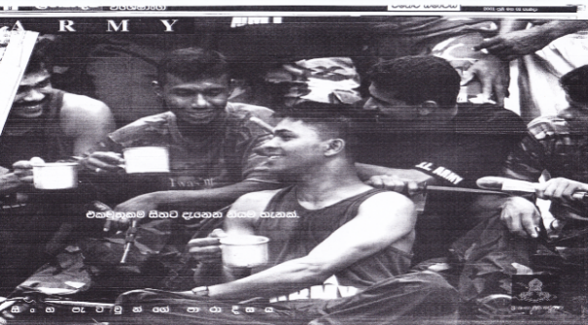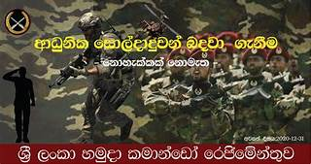**Picture: 01 and Picture 02: Enlistment advertisements to the forces**

Source: Lankadeepa, July 13, 2001 Source: Lankadeepa, November 05, 2000

During the period of 1994 - 2001, a clear difference can be identified in the news reporting style. In this era, media have created a new social image construction towards the soldiers. Other than the previously used terms and institutional identities, media tried to create a kind of heroic, manly identity towards the soldiers. In this period media created a kind of Rambo type, American army type heroic identity towards the Sri Lankan armed forces. When looking at the contents of the advertisements in this era (Picture 01 and 02), it is clear that they have used more realistic images of the soldiers with strong, confident personalities thus giving a new definition to the manliness, while highlighting the heroic figures from the well-trained armed forces.

Here the newspaper media have used various techniques to address soldiers, which were new to that time period. In here they used some attractive phrases that easily captured youth’s attention and their appreciation. Phrases such as ‘isxy megjqkaf.a mdrdoSih’ (Paradise of lions), ‘fkdyelalla fkdue;’ (Nothing is impossible) etc. were used to motivate the youths for their volunteer enrolments. Also, during this period media gave a considerable space to report the death and injuries on the battlefield in the social texts. Yet, in this era media has successfully highlighted and constructed the bravery of the soldiers by emphasizing their pictures with their great morals for the victory of the nation. Through these efforts, media created a kind of notion of war heroes during this era, when compared to the previous two phases of the Eelam war in Sri Lankan history.

However, when it comes to the final phase of the civil war, media’s contribution to constructing the soldier's image was increased in a drastic and a dramatic way. Newspapers used more colourful and realistic pictures with eye-catching phrases compared to the previous eras. More creatively influential phrases such as, ‘fuh Tfí ysig .kak ys; yod .kak’ (Make up your mind to head this) which implied the great honour a soldier carried in his position, and also the phrases such as ‘wms fjkqfjka wms’ (Together for all) which indicated that they, the soldiers stand for almost everyone in Sri Lanka. Because of the number of victorious battles, the media further uplifted the soldier's identity from a person who merely passed a grade 8 school qualification, which was a negative identity circulated for decades in the country, to the extremely positive, better honoured and recognized identity, by calling the soldiers as “the brave son of the mother Sri Lanka”, or ‘ùfrdaodr rKúrejd’ (bravery hero) or “gods on Sri Lanka who protect the country”. With this, media was able to socially uplift the soldiers' image in a positive manner by articulating them a new facet, while successfully organizing the public opinion of the society.

In the attempt of uplifting the soldiers’ image, newspapers have followed certain important strategies. To do so, the newspaper media has reserved considerable space to report war-related reports, news during this period in terms of constructing the soldiers’ image while legitimizing the military actions. When comparing with the newspapers before 2008, it is clear that the number of war-related news articles has considerably increased after 2008, providing the public with an in-depth understanding of the achievements and the sacrifices on the battlefield.

|  |  |  |  |
| --- | --- | --- | --- |
| Area | No. of News | | Total |
| Government Media | Private Media |
| History of the Sri Lankan Defense Forces | 56 | 138 | 194 |
| Operations launched by forces | 212 | 307 | 519 |
| Recruitment notices related to the Security Forces | 177 | 146 | 323 |
| Creative works related to the soldiers (poems, arts, essays, etc.) | 132 | 101 | 233 |
| Pass out parades, colours awarding ceremonies, funerals | 77 | 69 | 146 |
| Welfare of soldiers | 188 | 204 | 392 |
| Religious programs and ceremonies for war heroes | 158 | 121 | 279 |
| **Total** | **1000** | **1086** | **2086** |

**Table 01: News related to the soldiers**

Source: Study data

Study data in table 01 shows that the news related to the soldiers can be categorized under several themes (news published during the period of May 2008 to December 2009). According to the statistics in the chart, information related to the battles and missions done by forces, was the highest news field which was rapidly published during the study period. The 2nd highest is Welfare programmes for soldiers and the 3rd highest is recruitment advertisements to the triforces including Special Task Force. Therefore, considering these facts, we can assume that during this period, by uplifting the soldier’s identity and by socially constructing the image of the soldiers, may be the government tried to attract more of the skillful young crowd to the tri forces, due to the high demand of the military workforce during that time. Also by highlighting the welfare facilities such as donating houses, giving scholarships to the members from the military families, and other welfare facilities provided kind of attraction and motivation to join the forces. When considering these facts, it is clear that this type of social constructions could motivate people to join the armed forces for the call of their country.

|  |  |
| --- | --- |
| Type of Picture | No. of Pictures |
| Coloured Pictures | 1983 |
| Black and White Pictures | 441 |
| Cartoons (indirectly related) | 11 |
| **Total** | **2435** |

**Table 02: Number of picture usage**

Source: Study data

Table 02 shows the usage of the pictures, directly and indirectly, related to the forces during the study period. This implies that a considerable number of pictures were used in the newspapers in order to deliver the news related to the triforces during the study period.

Overall, it is clear that both government newspapers and private newspapers (Table 01), have done an equal job when constructing the image of the soldiers and in some aspects, the private newspapers were slightly ahead of the government media in their news allocations for the triforces. This shows that how the government has successfully utilized their political psychology project with military media management by using newspaper media as one of the mediums in terms of organizing public opinion of the society.

Another vital factor worthy of consideration is, utilization of newspaper media to bring forward the humanitarian facet of the soldiers during the final phase of the war. This further assisted in the construction of this new image and identity around the soldiers. To do so newspaper journalists have used a wide range of sentimental eye catchy pictures of the soldiers during the wartime, highlighting the fact that the service of the Sri Lankan armed forces go beyond the military mission and ensured the wellbeing of the general public despite their differences (Picture 03 and 04).

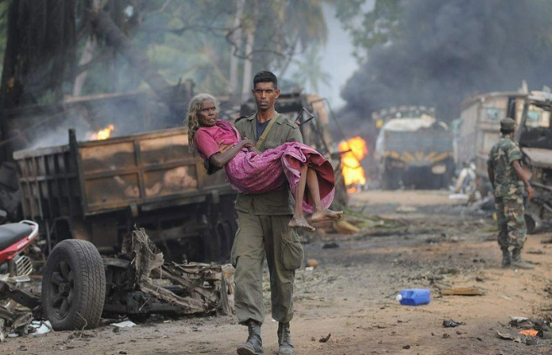**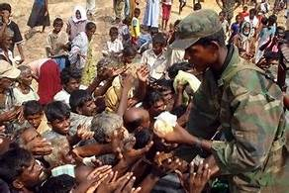Picture 03 and 04: Sentimental Pictures of the soldiers**

Source: weekend newspapers

With this new approach, newspapers have merged the boundaries of soldiers and civilians to a significant level, trying to highlight the inner human being within these patriotic soldiers. Therefore, this factor can be considered as one of the highest influential factors in this image constructing process as it allowed the readers or the civil society who read these newspapers to understand, trust these soldiers as their ultimate saviors, who come for their help when people are devastated.

Another strategic action that has taken to uplift soldiers’ identity is, the ‘wms fjkqfjka wms’ (Together for all) (Picture 05 and 06) programme. This project is a welfare project aimed to uplift the lives of the heroes in the triforces. Since this is a fundraising programme, newspaper media has dedicated a special space to publish the advertisements related to this project. This project further highlighted the humanitarian face of the soldiers and encouraged the general public to pay their gratitude to those who sacrificed their lives to protect all of us at the Warfield.

**Picture 05 and 06: Posters of the together for all project**

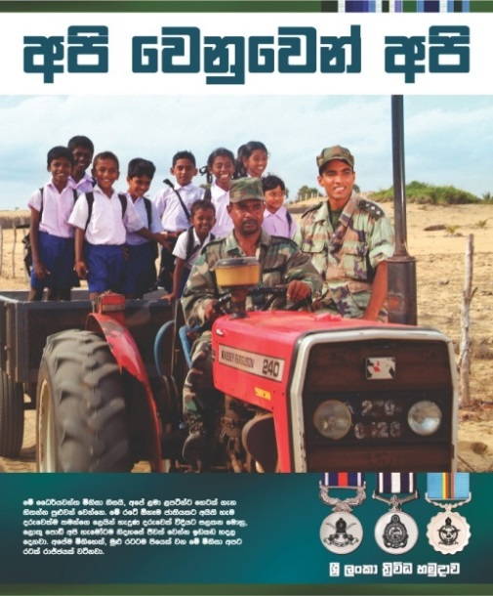

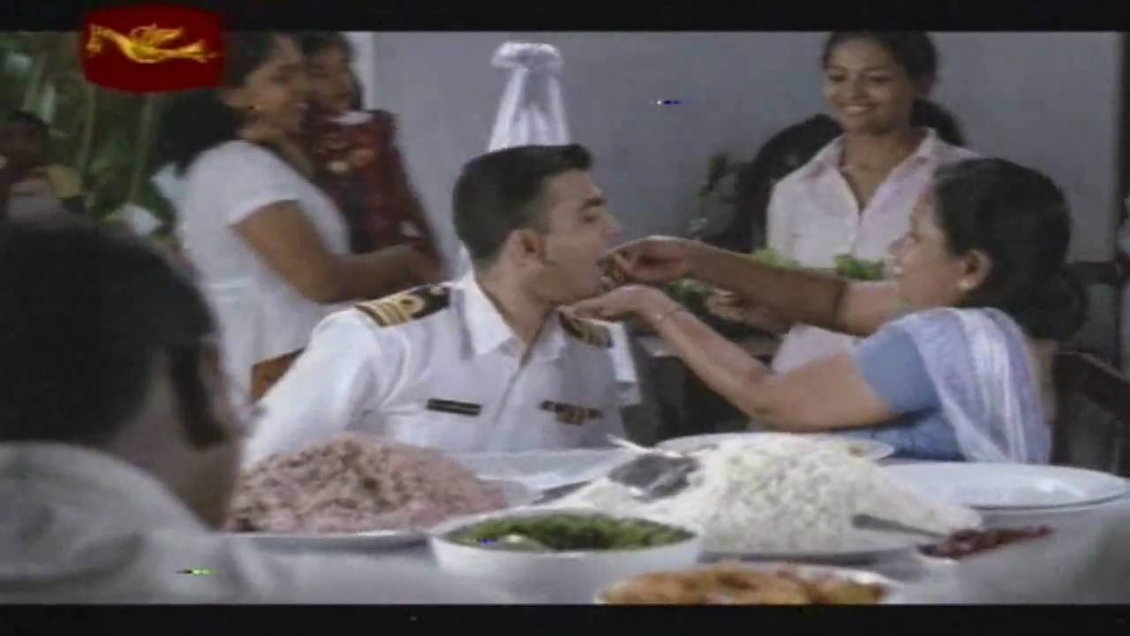

Source: TriAd,2017:189

Through this project, they tried to transmit the message to the society that the ‘soldiers are also people, who live with us’. Therefore, they used very sensitive captures in this project, by emphasizing soldiers as a son, as a brother, as a husband, as a father, as a friend and as a protector (Picture 05 and 06), utilizing all forms of media, attracting huge publicity towards the role of the soldiers in the battlefield and outside the battle. Therefore, as a result of this, society also started to look at the soldiers from a different angle than ever before.

It is significant that throughout this period the newspapers used various influential techniques when they report war-related news on a daily basis. Other than using sentimental pictures, newspaper journalists have used different writing techniques at different scales, such as usage of the attractive headings, subheadings, and also paying special attention to the soldiers' life stories etc. Through these write-ups they allowed the soldiers to share their memories about how they joined the military forces, memories of battle fires, difficulties etc.

*“The weather was getting worse day by day. The LTTE hoped that the army would cease   
 its operations as it could no longer withstand the situation. The courage of the soldiers   
 engaged in the operation was not insignificant ..... They did not give up the fight even   
 when they were wearing a wet uniform for days in the rain.” (Wijeweera,2009:04)*

Another fact is that these journalists’ have used eye catchy phrases to create sympathy and kindness towards members who represented the triforces acknowledging the fact that these soldiers are on a battlefield on behalf of the entire Sri Lankan nation.

*“Leading Task Force on Humanitarian Operations” - (Mihindukula,2009:12)*

*“The spread of humanity on the battlefield” - (Bandara,2009:04)*

When designing the page layout of the newspapers, they have reserved front pages, 3,5,7,9 pages, and small magazine type newspapers for war-related news reporting, in order to prioritize the war related news during this period. Moreover, they have used attractive fonts, font sizes, and background colours (especially blue, red, and green colour) to capture the readers' attention to that news and to the background stories of the great achievements of the soldiers.

Furthermore, journalists exercised the war news reporting methods as another technique to deliver accurate truthful news to their readers. This technique was started during the mid-2008 after the Wanni battlefire. In here journalists went to the front line on the battlefield along with the soldiers and did the live news reporting to their fan base. This also helped to uplift the image of the war heroes because these reporters revealed the actual struggles these soldiers faced on a daily basis, especially towards the end of the war.

Therefore, considering all these facts it is clear, how media have worked to construct the new image and identity towards soldiers during the final phase of the civil war in Sri Lanka. As Gorvett pointed out it is well known that our conscious decisions are routinely influenced by unconscious thought-processes, emotions, and prejudices (Gorvett,2015). Thereby it is clear that the media has influenced the readers by using their conscious habit of reading while unconsciously influencing the readers' mind by constructing a new kind of public opinion about war heroes, as they intended.

When considering these study findings, it shows that the media has the ability to construct public opinion of the society. This can be identified by paying attention to the scholars’ ideas related to this type of influencing. The media is directly involved in shaping the basic opinion as well as the specific views of the majority of the people (Weerasinghe,2005:158). The fact that the media has the potential to play a major and direct role in shaping public opinion, and thus to understand the relationship between newspapers and public opinion, can be seen as a factor in organizing the public opinion (William cited in Perera,2003:12). The service rendered by newspapers to society is extremely important. Because according to the Press Council, journalists have the ability to create true or false news, and thereby they have the potential to build public opinion, both positive and negative way (Press Councill,2002:61). All these prove that the media’s ability to create public opinion is possible and can be done as intended.

On the other hand, when considering the final phase of the war in Sri Lanka, it is a clear fact as Habermas pointed out media gave their active contribution to creating a new social image and a better identity towards war heroes by doing their media role. Because of the active role played by the newspaper media during the final phase of civil war especially after 2008, helped to create a positive public belief and image about the soldiers as “our guardian deities in Sri Lanka” during the studied timeframe. As McNair pointed out it is true that the press is a major vehicle for building political identity (MaNair,2011:91). Therefore, it is clear that the Sri Lankan government has successfully exercised their political communication project accordingly as they intended, during the final and the most critical war period. This in turn was very positive from the soldiers’ aspect, as their true sacrifices were publicly recognized and much appreciated.

1. **CONCLUSION**

To sum up the findings of the study, it is evident that the image of the soldiers has changed from time to time with the more influential reporting of the newspapers in Sri Lanka. When compared to the contribution of the government newspapers for this process, the private newspapers studied in this research, had a slightly higher allocation for the construction of the soldier’s image during this selected period. However, in the process of building a new face and identity for the Sri Lankan security forces during the time period of war on terror, the Sri Lankan press, either government or non-government, had a decisive impact on the opinion creating, although may or may not had the potential to completely transform public opinion in that regard. Because at that time newspaper distribution process also subjected to the barriers and because in some areas people who are with the lack of the literacy all caused to this.

Furthermore, because of the active role played by the media, it helped to construct the soldier's image in a positive manner while creating a collective identity to them like ‘our army’, ‘our children’ which helped to merge the boundaries between the civil society and the tri forces. This provided the soldiers with a better recognition as human beings who have dedicated their precious lives in a patriotic manner and their actions on behalf of every citizen of Sri Lanka, were publicly appreciated.

But when it comes to the post-war scenario, significant dynamics can be identified due to the war related criminal charges against some soldiers who were previously identified as war heroes. Other than this, in the post-war context, soldiers labor was used for the urban beautification projects in Sri Lanka, which was openly criticized. This caused a slight decrease in the identity of the soldiers as “War Heroes “and this impacted their image in a kind of a negative direction during the post-war period. Therefore, the image constructed by the newspaper and other media which was examined in this study, can be further examined considering this post war period.

As the limitations, this study was conducted based on limited newspapers within a limited time frame which may lead to either over or under representation of some of the information. Also, this study was conducted based on two official languages out of the three official languages in Sri Lanka. Therefore, there is an opportunity to miss the perception of the Tamil journalists towards the soldier’s image during the war period. Thus, these areas may open up space for future researchers with regard to these untouched aspects, providing further understanding of the use of newspaper media for the image construction of the soldiers.

**BIBLIOGRAPHY**

Dr Balasooriya, M., Jayawardhena, C., (Ed), (2011), P*rabhakaran's dream state - The Origin and   
 Destruction of the LTTE*, Colombo, Vijithayapa Publications

Goldsworthy, Haynes, Ian(Ed), (1999), *The Roman Army as a Community*, London: University   
 of London

Gorvett, Z. (2015), The Hidden Psychology of Voting, BBC Future. Retrieved form

<<https://www.bbc.com/future/article/20150506-the-dark-psychology-of-voting>>   
 [5th June 2021]

H[bermas, Jurgen](https://en.wikipedia.org/wiki/J%C3%BCrgen_Habermas) (1989), *The Structural Transformation of the Public Sphere: An Inquiry into a   
 Category of Bourgeois Society,* Massachusetts, The MIT Press

Dr Jayathunga, Ruwan M., (2004), *Psychological effects of war stress*, Colombo, Wijesooriya   
 Publications

Maltby, S., (2010), *Military Media Management*, London, Routledge

McNair, Brian,(2011), *An Introduction to Political Communication*, New York, Routledge   
 Taylor & Francis Group

Merriam Webster Dictionary,(2021), “Soldier”, (online), Retrieved form

<<http://www.merriam-webster.com/dictionary/soldier>>[ 05 June 2021]

National Peace Council of Sri Lanka, (2010), *Ethnic Issue in Sri Lanka Yesterday Today and Tomorrow,* Colombo, National Peace Council of Sri Lanka

Parker, Mike, (2018), What are the duties of a soldier in the army? Retrieved from

<<https://careertrend.com/facts-5002212-what-duties-soldier-army.html>> [5th June   
 2021]

Perera, K. S., (2003), *Newspaper Reader and Credibility*, Colombo, Godage Publications

Perera, Ranjith, (2013), *War Heroes Who Shattered Prabhakaran's Eelam Dream*, Nugegoda, Sarasavi Publications

Press Associations of Sri Lanka, (2002), Journalism Review - III, Colombo, Press Associations   
 of Sri Lanka

Security Forces Headquarters media unit, (2021), *Mavilaru Operation - 20 July 2006 to August   
 2006*, Retrieved from <[https://alt.army.lk/sfhqeast/content/mavilaru-operation-20-  
 july-2006-09-aug-2006](https://alt.army.lk/sfhqeast/content/mavilaru-operation-20-%20%20%20%20%20%20%20%20%20%20%20%20%20%20%20%20%20%20%20%20%20%20%20%20july-2006-09-aug-2006)> [17th June 2021]

Sri Lanka Commando Regiment, (2000), *Vacancies,* (Lankadeepa, 05 November, 2000)

Sri Lanka Army, (2001), *Vacancies,* (Lankadeepa, 13 July, 2001)

Triad, (2021), ‘Api Wenuwen Api’, (Online), Retrieved form <<http://triad.lk/>> [05 June 2021]

Uyangoda, Jayadeva., (2011), *Nation, Nationalism and the Nation State - Political Theory and   
 Practice*, Colombo, Social Scientists’ Association

Verite Research Strategies Analysis for Asia, (2019), *Print Market*, Retrieved from <[h](https://alt.army.lk/sfhqeast/content/mavilaru-operation-20-%20%20%20%20%20%20%20%20%20%20%20%20%20%20%20%20%20%20%20%20%20%20%20%20july-2006-09-aug-2006) http://sri-  
 lanka.mom-rsf.org/en/media/print/> [17th June 2021]

Weerasinghe, Tudor, (2007), *Critical Study of Media and Methodology in the Social Sciences of   
 Journalism,* Nugegoda, Sarasavi Publications

Wijeweera, (2009), *Countries not have the compulsory military services* (Lankadeepa, 14 June,   
 2009)