**A THESIS SUBMITTED TO**

**THE GRADUATE SCHOOL OF NATURAL AND APPLIED SCIENCES**

**OF ÇANKIRI KARATEKIN UNIVERSITY**

**STUDY OF THE CHANGES THAT OCCUR IN SOME BIOCHEMICAL VARIABLES AFTER CHOLECYSTECTOMY FOR PATIENTS IN AL-ANBAR GOVERNORATE/ IRAQ**

**IN PARTIAL FULFILLMENT OF THE REQUIREMENTS**

**FOR**

**THE DEGREE OF MASTER OF SCIENCE**

**IN**

**CHEMISTRY**

**BY**

**OMAR KHALID MUSTAFA AL-BAYATI**

**ÇANKIRI**

**2021**

STUDY OF THE CHANGES THAT OCCUR IN SOME BIOCHEMICAL VARIABLES AFTER CHOLECYSTECTOMY FOR PATIENTS IN AL-ANBAR GOVERNORATE/ IRAQ

By Omar Khalid Mustafa AL-BAYATI

June 2021

We certify that we have read this thesis and that in our opinion it is fully adequate, in scope and in quality, as a thesis for the degree of Master of Science

**Advisor :** Assoc. Prof. Dr. Hakan ÇOLAK

**Co-Advisor :** Assoc. Prof. Dr. Khalid F. AL-RAWI

**Examining Committee Member**

**Chairman :** Assoc. Prof. Dr. Hakan ÇOLAK

Chemistry

Çankırı Karatekin University

**Member :** Assoc. Prof. Dr. Şevki ADEM

Chemistry

Çankırı Karatekin University

**Member :** Asst. Prof. Dr. Ümit YIRTICI

Medical Laboratory

Kırıkkale University

**Approved for the Graduate School of Natural and Applied Sciences**

**Prof. Dr. İbrahim ÇİFTÇİ**

**Director of Graduate School**

**I hereby declare that all information in this document has been obtained and presented in accordance with academic rules and ethical conduct. I also declare that, as required by these rules and conduct, I have fully cited and referenced all material and results that are not original to this work.**

**Omar Khalid Mustafa ALBAYATI**

# ABSTRACT

STUDY OF THE CHANGES THAT OCCUR IN SOME BIOCHEMICAL VARIABLES AFTER CHOLECYSTECTOMY FOR PATIENTS IN AL-ANBAR GOVERNORATE /IRAQ

Omar Khalid Mustafa AL-BAYATI

Master of Science in Chemistry

Advisor: Assoc. Prof. Dr. Hakan ÇOLAK

Co-Advisor:Assoc. Prof. Dr. Khalid F. AL-RAWI

July 2021

The study included (90) Iraqi persons with age ranged from (20 - 70), that divided for two groups, group (1) control group consist of 30 healthy persons (males and females) and group (2) consist of 60 patient had a cholecystectomy, samples were obtained from Al-Ramadi teaching hospital and Haditha general hospital during the duration of October 2020 to March 2021, and measuring concentrations of TSB, ALT, AST, ALP, cholesterol, TG, LDL, HDL, VLDL, LDL, S. amylase, S. lipase, and CCK. Regarding the age of all participant the Mean ± SE of patient group was (45.47 ± 1.57) that is lower than the control group (50.53 ±1.73) with p- value 0.05 indicate a difference of statistical significant between the two group. The TSB mean level of patient group was 0.81 ± 0.02 that is statically different from mean level in control group (0.74 ± 0.01), with p-value 0.04. TG and VLDL result showed a statistical difference between patient and control group, p-value was 0.01 for both markers. Measuring CCK for both group indicate a statistical significant difference in between as p- value 0.008.

**2021, 69 pages**

**Keywords:** Cholecystectomy, Liver function test, Lipid profile, Amylase, Lipase and cholecystokinin

# ÖZET

AL-ANBAR VALİLİĞİ/ IRAK'TA HASTALAR İÇİN KOLESİSTEKTOMİ SONRASI BAZI BİYOKİMYASAL DEĞİŞKENLERDE MEYDANA GELEN DEĞİŞİKLİKLERİN İNCELENMESİ

Omar Khalid Mustafa AL-BAYATI

Kimya, Yüksek Lisans

Tez Danışman: Doç. Dr. Hakan ÇOLAK

Eş Danışman: Doç. Dr. Khalid F. AL-RAWI

Temmuz 2021

Bu çalışmada yaşları 20 - 70 arasında değişen toplam 90 Iraklı hasta ile çalışıldı. Kontrol grubu (1. Grup) sağlıklı 30 kadın ve erkek bireylerden oluşmaktadır. İkinci grup kolesistektomi hastası 60 bireyden oluşmaktadır. Örnekler, Ekim 2020-Mart 2021 tarihleri arasında Al-Ramadi eğitim hastanesi ve Haditha genel hastanesinde alındı. Bu örneklerde; TSB, ALT, AST, ALP, kolesterol, TG, LDL, HDL, VLDL, LDL, S. amilaz, S. lipaz ve CCK değerleri incelendi. Tüm katılımcıların yaşa bağlı olarak ortalama SE değeri 45,47 ± 1,57’dir ve kontrol grubundan daha düşüktür (50,53 ± 1,73). İki grup arasında istatistiksel olarak anlamlı bir fark bulundu (P-değeri 0,05). Hasta grubunun TSB ortalama düzeyi 0,81 ± 0,02 olup, P-değeri 0,04 ile kontrol grubundaki ortalama düzeyden (0,74 ± 0,01) istatistiki olarak farklıdır. TG ve VLDL sonuçları hasta ve kontrol grubu arasında istatistiksel olarak farklılık göstermiştir. Her iki grubun CCK ölçümleri için P-değeri 0,008’dir.

**2021, 69 sayfa**

**Anahtar Kelimeler:** Kolesistektomi, Karaciğer fonksiyon testi, Lipid profili, Amilaz, Lipaz ve kolesistokinin

# PREFACE AND ACKNOWLEDGEMENTS

I would like to thank my thesis advisor, Assoc. Prof. Dr. Hakan ÇOLAK, for his patience, guidance and understanding.

**Omar Khalid Mustafa ALBAYATI**

**Çankırı-2021**

# CONTENTS

ABSTRACT i

ÖZET ii

PREFACE AND ACKNOWLEDGEMENTS iii

CONTENTS iv

LIST OF ABBREVIATIONS vi

LIST OF FIGURES vii

LIST OF TABLES viii

1. INTRODUCTION 1

2. LITERATURE REVIEW 3

2.1 Anatomy of Biliary System 3

**2.1.1 The intra hepatic component 3**

**2.1.2 Extra hepatic biliary tract 4**

**2.1.3 The gallbladder 5**

**2.1.4 Arterial supply 6**

2.2 Disease of Gallbladder 6

**2.2.1 Acute calculous cholecystitis (ACC) 7**

**2.2.2 Gallstone 7**

2.3 Biochemical Diagnostic Marker of Liver Disease 11

2.3.1 Serum bilirubin 11

**2.3.2 Alanine amino transferase (ALT) 13**

**2.3.3 Aspartate amino transferase (AST) 14**

**2.3.4 Alkaline phosphatase (ALP) 15**

**2.3.5 Cholesterol 16**

**2.3.6 Triglyceride 17**

**2.3.7 Low density lipoprotein (LDL) 18**

**2.3.8 Very low density lipoprotein (VLDL) 19**

**2.3.9 High density lipoprotein (HDL) 20**

**2.3.10 Amylase 21**

**2.3.11 Lipase 22**

**2.3.12 Cholecystokinin CCK 23**

3. MATERIALS AND METHODS 25

**3.1 Study Design, Settings and Data Collection Time 25**

3.2 Instruments Used in My study 29

3.3 Biochemical Kits 29

3.4 Blood Sampling 29

3.5 Methods 29

**3.5.1 Calculation of body mass index (BMI) 29**

**3.5.2 Serum lipid profile assay 30**

**3.5.3 Liver function test assay 33**

**3.5.4 Measurement of Amylase 35**

**3.5.5 Measurement of lipase 36**

**3.5.6 Measurement of cholecystokinin 36**

3.6 Statistical Analysis 37

4. RESULTS AND DISCUSSION 38

4.1 Results 38

**4.1.1 Description of data 38**

**4.1.2 Compare between patient and control according to biochemical tests 39**

**4.1.3 Compare between patient and control group according to gender 41**

**4.1.4 Correlation between CCK and other markers 43**

4.2 Discussion 51

5. CONCLUSION AND RECOMMENDATION .56

REFERENCES 57

APPENDICES 68

CURRICULUM VITAE 69

# LIST OF ABBREVIATIONS

|  |  |
| --- | --- |
| ACC | Acute calculous cholecystitis |
| ALP | Alkaline phosphatase |
| ALT | Alanine amino transferase |
| AST | Aspartate amino transferase |
| CBD | Common bile duct |
| CCK | Cholecystokinin |
| CHD | Common hepatic duct |
| CHOL | Cholesterol |
| DM | Diabetes mellitus |
| GD | Gallstone disease |
| GOT | Glutamate oxaloacetate transaminase |
| GPT | Glutamate pyruvate transaminase |
| HDL | High density lipoprotein |
| HRT | Hormone replacement therapy |
| ICU | Intensive care unite |
| LDL | Low density lipoprotein |
| LFT | Liver function test |
| LHD | Left hepatic duct |
| RASD | Right anterior sectoral bile duct |
| RHD | Right hepatic duct |
| RPSD | Right posterior sectoral bile duct |
| TG | Triglyceride |
| TPN | Total parenteral nutrition |
| TSB | Total serum bilirubin |
| VLDL | Very low density lipoprotein |

# LIST OF FIGURES

Figure 2.1 The anatomy of biliary tree intra and extra-hepatic part 4

Figure 2.2 Gallbladder parts (Ellis 2011). 5

Figure 3.1 Elisa (Enzyme linked immusnorbent assay) 26

Figure 3.2 Laboratory FujiFilm corporation device 27

Figure 3.3 Genex laboratory device (SN - G: 001538) 28

Figure 4.1 Scattered blot diagram of CCK correlation and age 45

Figure 4.2 Scattered blot diagram of CCK correlation and TSB 45

Figure 4.3 Scattered blot diagram of CCK correlation and GOT 46

Figure 4.4 Diagram of a scattered blot showing the link between CCK and GOT 46

Figure 4.5 Diagram of a scattered blot showing the link between CCK and ALP 47

Figure 4.6 Diagram of a scattered blot showing the link between CCK and CHOL 47

Figure 4.7 Diagram of a scattered blot showing the link between CCK and TG 48

Figure 4.8 Scattered blot diagram of CCK correlation and HDL 48

Figure 4.9 Diagram of a scattered blot showing the link between CCK and LDL 49

Figure 4.10 Diagram of a scattered blot showing the link between CCK and lipase 49

Figure 4.11 Scattered blot diagram of CCK correlation and amylase 50

Figure 4.12 Scattered blot diagram of CCK correlation and lipase 50

# LIST OF TABLES

Table 3.1 Medıcal tools that used in this study 25

Table 3.2 Kits and chemicals 29

Table 4.1 Variables study groups, subgroup, frequency and percentage 38

Table 4.2 Mean level of studied biomarkers in both groups 40

Table 4.3 Compare between female patient and control group 42

Table 4.4 Compare between male patient and control group 43

Table 4.5 The Linear regression correlation between CCK and measured markers in all enrolled participant 44

# I**NTRODUCTION**

Gallstones are stone like structure made from the hardened deposition of the bile and formed mainly within the gallbladder but can be found also in common bile duct, the stones have various size, shape and composition. The disease is about a chronic frequency hepatobiliary disease, gallstone formation is cause mainly due to chemical imbalance in constituents of bile, impaired metabolism of bile acids, bilirubin and cholesterol leading to precipitation of one or more of the components (Njeze 2013), It is consisting of calcium bilirubinate, cholesterol monohydrate crystals, proteins and mucin gels. It can be classified their according to a chemical composition of their as (1) cholesterol stone (> 75% is cholesterol), (2) Pigment or black, and (3) Mixed stones that contains < 75% cholesterol with calcium and bilirubin salts in various concentration. About 75% of stones in western country is cholesterol gallstones, black pigment stones about 20%, and brown pigment stones just 5% (Portincasa *et al.* 2019).

Cholecystitis is an inflammation of the gallbladder because of presence of gallstone that develops over hours, the development of condition slowly will refer to chronic cholecystitis, and the symptoms include right upper quadrant pain with tenderness that probably associated with fever, vomiting and chills nausea (Yeo and Jung 2018).

The stone move near cystic duct opening and cause stagnation of flow bile, lead to the classic biliary colicky ache. If the blockage cystic duct continues for several hours, lead to the gallbladder wall inflammation (Cholecystitis). If gallstone moves further and cause occlusion, leading to abdominal pain and jaundice. Progressive fibrosis and loss of motor function of the gallbladder is result from the chronic gallstones disease (Lammert *et al.* 2016).

Bile stasis will trigger the release of liver enzymes, as the gallstones blocks fluid passage to the gallbladder irritated and swollen in gallbladder will develop that will transmit to nearby liver cell. Irritation of liver cell can progress to cell damage which will be seen as elevation in liver enzymes. Ultrasound is the main diagnostic tool to diagnosis gall stone disease after physical examination. The treatment of gallstones is mainly surgical, cholecystectomy.

The prevalence of gallstones in increase with age, in women higher than in men, in the developed countries 20% of adult will have (Portincasa *et al.* 2006). GD is common gastrointestinal disease, one of the most economic load medical conditions at the world (Bagaudinov *et al.* 2007). In the US over 14.2 million males and 6.3 million females with age's range of 20 – 74 suffering from. However, maximum case of gallstones is without symptoms, however 10% of them within five years will develop symptoms, and about 20% will have symptoms in period 20 years of diagnosing gallstones.

Cholecystectomy is the surgery treatment, which is best choice of acute cholecystitis patient, which can either laparoscopic procedure or open surgery. The assessment of biliary injuries before surgery is necessary that include biochemical testing of liver enzymes. Studies has been find that the liver function test LFT sensitivity in detecting obstructions in biliary flow that reach 90% (Ahmad 2011). Hepatocyte function can be estimated by the ratio of GOT to GPT. Common bile duct (CBD) stones are associated with an increase in serum transaminases, and ALP rises when the biliary system is blocked.

However, increased LFTs are commonly seen shortly after surgery, and it is transient that back to normal values without any intervention. Routine preoperative LFT testing has been shown to be a factor in determining whether a cholecystectomy can be performed laparoscopically or must be performed openly.

Aim of the study: The main study aims that exploring in whether or not there are changes occur on constructions and activity of some enzymes and lipids levels after the cholecystectomy for the patients in AL-Anbar governorate.

# LITERATURE REVIEW

2.1 Anatomy of Biliary System

Biliary tract that contain intra and extra-hepatic portion to drain bile. The bile is a digestive fluid, made and secreted by the liver cell to the small intestine aid in digestion. The transportation of the bile through series of bile ducts that branching to form the biliary tree.

* + 1. The intra hepatic component

Start with the small several channels called canaliculated collecting the bile produced by hepatocyte, then drain into intra-lobular bile duct that collect the bile from a hepatic lobule (Chehade *et al.* 2019).

The liver has right and left segments and lobes and inside each segment intra-lobular duct that united to from the main hepatic duct. The left lobe can be broken down into "superior" (Segment 2) and "inferior" (Segment 3) parts, one on each side of the umbilical fissure. The left hepatic duct (LHD) is formed by the union of the ducts from segments 2 and 3, and it is also the destination for the duct from segment 4. The LHD have length approximate to 1.7 cm and diameter is 3.0 mm ±1.08.

The right lobe of the liver is comprised of the anterior and posterior sections, with each of these parts being further subdivided into the superior and inferior segments. The right anterior sectorial bile duct, also known as the RASD, is responsible for draining segments 5 and 8, whereas the right posterior sectorial bile duct, also known as the RPSD, is responsible for draining segments 6 and 7. RPSD and RASD are joined forming right hepatic duct (RHD), which measure in length of 0.9 cm and diameter is 2.6 mm ±1.2 averagely. Right and left hepatic ducts are drained the caudate lobe (Segment 1) (Babu ve Sharma 2014).

* + 1. Extra hepatic biliary tract

The common bile duct is formed when the common hepatic duct (CHD) and the cystic duct unite at the hilar plate at the base of the liver (CBD). CHB has an average length of (1.0 - 7.5) cm and an average width of (4.0) mm. The average diameter of the cystic duct is 4.0 mm and its length is 3-4 cm.

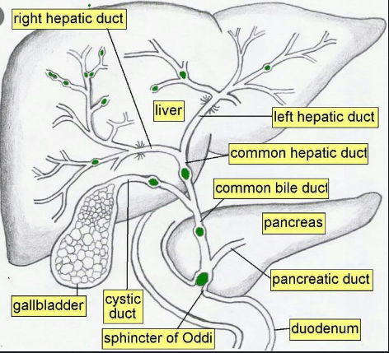

**Figure 2.1** The anatomy of biliary tree intra and extra-hepatic part (Washington et al. 2010)

The common bile duct (CBD) is 6.0 - 8.0cm long, divided into retro pancreatic, supra duodenal, intra duodenal segments, and retro duodenal. Along the course of CBD, in 83% of cases the CBD will be covered by a part of pancreatic tissue while 17% of patient the CBD is in retro pancreatic position (Skandalakis & Colborn 2004). The main pancreatic duct and CBD are joined to each other beside the middle of medial border of descending duodenum forming hepato pancreatic ampulla (Ampulla of vater) that opens in the main duodenal papilla 8 cm distally to pylorus that occur in 85% of cases, whereas 15% cases both ducts are opened separately or forming a V junction before opening. The sphincter of odd is an arranged as circular muscle fiber that surrounds the main pancreatic duct and terminal end of CBD and the ampulla (Castaing 2008), anatomy is presented in Figure 2.1.

* + 1. The gallbladder

Pear-shaped sac situated in the right hypochondrium area ling in fossa, its Measured about 7-10 cm length and 4 cm width. Gallbladder (Figure 2.2) is important in concentration and storing bile produced by hepatocyte with storage capacity 30 - 50mL, it entirely covered by the peritoneum, lying anteriorly to the duodenum first part (Jones *et al.* 2020). It divided into three parts:

• Fundus – which is the most distal part of the GB that is rounded in shape projecting in to the under surface of the liver.

• Body – forming the greatest part of the gallbladder which is also rounded in shape, lying between the liver postero-inferior part, and the duodenum superior part.

• Neck – which is the continuation of body with the cystic duct.

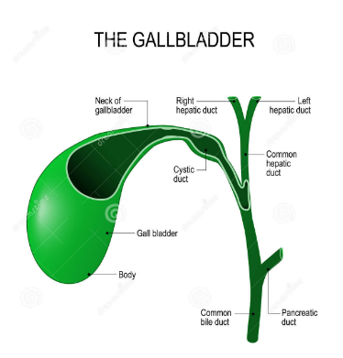

**Figure 2.2** Gallbladder parts (Ellis 2011).

* + 1. Arterial supply

The celiac trunk is main supplier of biliary tract that derived from the abdominal aorta at 12th thoracic vertebra level. The splenic artery, Common hepatic artery and left gastric artery all are braches from the celiac trunk and have a share in biliary tree supplement. The coeliac trunk gives rise to the left gastric artery, common hepatic artery and splenic artery.

The common hepatic artery gives blood supply to the liver to most part of the liver, While the "hepatic proper," "gastroduodenal," "cystic," and "posterior superior pancreaticoduodenal arteries" are all major arteries, the biliary tree's blood supply is primarily dependent on the network originate from subsidiary branches of greater vessels. Paracholedocal plexus, supplies the lateral and medial part of a biliary duct, the epicholedocal plexus give supply to the upper part of the duct. The arterial supply of the GB from cystic artery which is a branch of right hepatic artery (Babu ve Sharma 2014).

The venous drainage of the biliary tree follows the arterial arrangement, however, epicholedocal venous plexus drains into epicholedocal plexus. The gall bladder neck drain through the cystic veins that drain into the portal vein directly.

* 1. Disease of Gallbladder

Acute cholecystitis is gallbladder inflammation mainly blockage in cystic duct is a major cause, that treated mainly by surgery. The condition can be correlated with or without a gallstone as well as can be classified as acute or chronic (Burmeister *et al.* 2018). Bile stone are the main cause of cholecystitis disease.

A calculous cholecystitis is serious life threating condition in which gallbladder inflammation occur due to stasis of the bile from hypomotility increasing the intraluminal pressures in the cause inflammation, potential necrosis and the ischemia. Stasis of bile cause bacterial colonization that will develop to an infection of gallbladder. Continuity of ischemia, infection, or inflammation cause wall perforation occurs in about 10% cause sepsis and shock. The condition occurs in critically ill patient mostly ICU as well as DM (Kwatra *et al.* 2019).

Factors that trigger gallbladder dysfunction are many include total parenteral nutrition (TPN), long periods of fasting, and weight loss will increase the chance of acalculous cholecystitis. Patients in ICU or those who recover from major surgeries or serious illness as 1) Stroke, 2) MI, 3) Sepsis, 4) large burns, and 5) Extensive trauma can develop acalculous cholecystitis. Stasis cause growth of several pathogens (enteric bacteria) such as "*E. coli*, Klebsiella specie's, Proteus, Bacteroides, Enterococcus faecalis, and Pseudomonas” (Thampy *et al.* 2019).

### Acute calculous cholecystitis (ACC)

The Second source of the intra-abdominal infection (Sartelli *et al.* 2015), and biliary stones or cholelithiasis are the main cause of the condition in about 6.5% of males and 10.5% of females (Shaffer 2006). ACC is common complication of gallstone. The cause of ACC involves an infectious process or inflammatory in gallbladder wall, essentially because of presence of stone impacted in the cystic duct or in the infundibulum. The production of mucin gallbladder epithelial tissue and the insufflation in the wall will cause deficient in micro and macro circulatory perfusion which will be followed by sloughing in mucosal cells, edematous of the serosa, ischemia, venous and lymphatic congestion and necrosis changes in the wall that predispose to the diffuse peritonitis. The acute inflammation can be intricate by a secondary bacterial infection that transmits from the bile duct by the vascular system or portal lymphatic (Gomes *et al.* 2017).

### Gallstone

GD is a chronic hepatobiliary frequent disease considered as the higher common leading to GIT complain, and the common cause of cholecystitis in which an impairment in bile acids, bilirubin and cholesterol metabolism is occurring cause gallstones formation in the hepatic bile duct, gallbladder, or common bile duct (Belousov 2006).

* + - 1. Etiology

Three main mechanisms cause the formation of gallstones (Chong 2005).

* Cholesterol super-saturation: increase cholesterol excretion by the liver which is more than bile can dissolve lead to precipitate of excess cholesterol as crystals that trapped in the mucus with time grow to form stones and occlude the ducts.
* Excess bilirubin: over production of due to certain hematologic conditions in which excess breakdown of hemoglobin occur. The excess bilirubin participates for gallstone formation.
* Gallbladder hypomotility or impaired contractility: increase bile concentration and form gallstones.

However, a precipitating factor causes to increase the chance to develop the diseases, which are:

Age: Gallstone increase with age progression, with no differences between childhood and adolescence in rate of incidence (Poddar 2010). After age of 20 years, with each decade of life the rate of gallstone formation increases that can be detected of patient under 50 yrs. By 7% - 11%, and by 11% - 30% in those who are 60 - 70 years. This elevation is related to increase amount of cholesterol in the bile as well as increase age due to dyslipoproteinemia in which excess in cholesterol secretion into the bile with reduction in bile acids synthesis that related in reduction in cholesterol 7α-hydroxylase (CYP7A1) Enzyme activity (Li *et al.* 2013).

Gender: The female gender is more reliable for gall stone disease (Tareef *et al.* 2020), especially in the reproductive-aged which is 2 - 3 times more than in men, studies has been link that to the hormonal backgrounds that support by the fact that pregnancy is a risk for stone formation.

Elevation of estrogen levels is considered as a risk factor for increase excretion of cholesterol to the bile, in pregnancy, the level of estrogens is elevated to support fetus growth in uterus, more over due to graved uterus gallbladder evacuation function is impaired or defective cause bile sludge and gallstones (Al Samaraee and Bhattacharya 2019). Other condition rather than pregnancy includes Hormone replacement therapy (HRT) that consist of estrogen drug in post-menopausal females and the oral hormonal contraceptives may raise the risk of symptomatic GS (Reddy *et al.* 2020).

Genetic factors: some studied suggesting that the formation of GS probably genetically, and 2 - 4 times higher in persons whose have family history (Attili *et al.*2005), as well as environmental factors. Cholesterols transporter ABCG5/G8 are identified as a genetic mark of gall stone formation, or LITH gene in the humans. Patient who are Carriers for ABCG8 D19H polymorphisms or ABCG5 604Q are at danger of gallbladder disease independent of sex, age and BMI (Kuo *et al.* 2008). Other factors like high describe of 3-hydroxy-3-methylglutaryl-coenzyme-A-reductase that responsible for regulation of the synthesis of cholesterol in the body, have a role in GS. Genetic polymorphisms in apolipo-protein genes is always linked with changes in lipid profile and cause gallstone disease, studies found APOA1-75 G/A polymorphism is correlated with GS (Rebholz *et al.* 2018).

A mutation in the hepato-canalicular phosphatidylcholine transporters encoding genes causes lecithin secretion reduction into the bile.

Obesity: important risk factors of cholelithiasis, those conditions are linked with by elevated formation and secretion of cholesterol into bile. Moreover, weight fluctuation is associated with greater risk to develop GS. The beta3-adrenergic receptor (ADRB3) which is a Tran’s membrane receptor found mainly in fatty tissue that may be take part in the control of lipolysis process, expressed in gallbladder tissue and take part in gallbladder contraction, the ADRB3 Trp64Arg polymorphism is related to GD.

Diet: high cholesterol intake increases the bile level, while low-fiber diet delays the transit time of intestinal contents, promote the absorption of secondary bile acids promote GS. Carbohydrates increase the saturation of bile with cholesterol (Lee *et al.* 2018).

Liver and pancreatic diseases: GS is detected in 30% of liver cirrhosis patient, and viral hepatitis C are more at risk for GS formation. The GD incidence is increases in fatty hepatosis, DM that related to hypercholesterolemia (Arrese *et al.* 2018).

Drug: some drugs increase the GS formation include: "Estrogens, azathioprine, prednisolone, sandostatin, cyclosporine, nicotinic acid, clofibrate, and other drugs on long term use". Long-term corticosteroid used cause dyslipoproteinemia in which elevated plasma total cholesterol, TG and LDL-C is observed. The increased concentration of the total cholesterol induces alteration in bile acid/cholesterol values promoting GZS. Ceftriaxone causes transient biliary precipitation in children of age more than 12 months and the dose is over 2 g/d, for more than five days, approximately 40% of ceftriaxone is un-metabolized and secreted into bile (Azarkar *et al.* 2018).

#### Clinical presentations of gallstone disease

The most of patients whose have gallstones are asymptotic, that require no treatment. The symptomatic stones present mostly with frequent right-upper-quadrant or epigastric pain that is sharp in nature postprandial, with nausea and vomiting that extended from 30 min to several hours. A referred pain can see in those patients mainly between the shoulders or under the right shoulder (Boas’ sign) (Łącka *et al.* 2020).

The patient can be presented with secondary infection by intestinal microorganisms and acute cholecystitis. The gallbladder wall inflammation causes acute abdominal pain or biliary colic in the right upper quadrant, associated with leukocytosis, nausea, fever, and vomiting, in which needed a surgical intervention otherwise gangrene and perforation will occur (Fitzgerald *et al.* 2009).

If the gallstones lodged in the CBD (choledocholithiasis), cause obstruction of the duct and jaundice is presented in this case that due by a stone migration towards the CBD, or can be caused by compression of the CBD by a stone at the neck of the GB or in cystic duct (Mirrizi syndrome), acute pancreatitis can be triggered when a stone presented in CBD due to obstruction of the main pancreatic (Majidi *et al.* 2017).

#### The diagnosis of gallstone disease

Detailed history is required to diagnose GS, patient give history of frequent right-upper-quadrant or epigastric pain. During physical examination physician may notice presence of fever and tender right upper quadrant with or without Murphy's sign suggest cholecystitis. Regarding diagnostic approach three methods are used to diagnose GB disease, which are: the ultrasonography, nuclear scanning (cholescintigraphy), and oral cholecystography. Ultrasound is the general common method to discover GS with a specificity and sensitivity reach 90 - 95%, even small stone as 2 mm in diameter, the stone in CBD, and the thickening in gallbladder wall (Trotman *et al.* 1975).

In cholescintigraphy, is excellent method but limited in use, in which patients are injected with a small dose of radioactive material (diisopropyl iminodiacetic acid) or short-lived isotope technetium-99 m that secreted into the bile ducts providing functional information about GB shrink ability, as well as detection the obstruction of the duct, with low ability in providing anatomical information or identifying the cause of obstruction as gallstones. The Cholescintigraphy sensitivity and specificity reach the ultrasound accuracy which about 95% (Alhayo *et al.* 2020).

Computed tomography (CT) is useful in complicated acute calculus cholycystitis, as well as recognize other cause of colicky pain intra-abdominal diseases.

* 1. Biochemical Diagnostic Marker of Liver Disease

2.3.1 Serum bilirubin

Bilirubin is a yellow pigment formed endogenously in the reticuloendothelial system that consider a toxic metabolite and poor water soluble especially in neonate, it has two main sources, about 80% of bilirubin is a product of hemoglobin protein part metabolism of RBC by macrophage in the spleen red blood cells and the premature destructed erythroid cells at the bone marrow. Other source is product of heme-containing proteins turnover in muscles and liver include myoglobin, peroxidase, catalase, tryptophan pyrrolase and cytochromes (Hinds *et al.* 2018).

The produce bilirubin released to the circulation in unconjugated form bound to albumin (with affinity to albumin) in the circulation and transmitted to the liver, hepatic uptake of bilirubin by sinusoid through tow mechanisms: either passive diffusion or receptor-mediated endocytosis.

The unconjugated Bilirubin is converted to conjugated form that is glucuronic acid which soluble form product by the enzyme UDP-glucuronyl transferase, this process is very essential for the detoxification mechanisms of the human body. Mono and diglucuronides are the main production of conjugation where diglucuronide is the predominant (Yanagi *et al.* 2017).

Serum bilirubin measured using spectrophotometer when the molecule reacts with diazo reagents and cause a breakdown in the tetrapyrrole to two azodipyrroles. Unconjugated bilirubin is reacting slowly with the reagent in contrast to conjugated bilirubin that react fastly even in absence of accelerators, while addition of an accelerators like methanol accelerate the reaction and resulting value of total bilirubin. However, unconjugated bilirubin is calculated by poses the direct-reacting fraction from the total bilirubin.

Normal TSB is 2- 21μmol/L. unconjugated or the indirect bilirubin value is < 12μmol/L and the conjugated or the direct bilirubin value is < 8μmol/L.

Bilirubin elevation cause Jaundice that can see in the sclera, skin, and mucous membranes if reach to 40 μmol/L (Beckingham ve Ryder 2001). Elevated unconjugated bilirubin occur as a cause of increase bilirubin formation, a decrease in hepatic uptake or conjugation or both, genetic defect of UDP-glucuronyltransferase enzymes causing Gilbert\'s syndrome, Crigler-Najjar syndrome. Viral hepatitis, cause elevation in conjugated bilirubin due to hepatocellular damage, and the level of the increase is directly proportional with the degree of the histological injury.

Incomplete extra hepatic obstruction of the biliary duct will cause lower serum bilirubin value as will present in malignant obstruction of the common bile duct. During pregnancy the TSB is significantly lowered and a decrease in conjugated bilirubin was observed (Kapoor *et al.* 2018).

* + 1. Alanine amino transferase (ALT)

The ALT or GPT is an enzyme found in the heart, muscle, kidney and in the cytoplasm of the hepatocyte in higher concentration compared with other tissues of the body, have 496 amino acids and the half-life about 47 ± 10 hours, coded by ALT gene at the long arm of the chromosome 8 (Mason *et al.* 2018). ALT enzyme catalyzes the transamination reaction in which amino groups is transferred from L-alanine to α-ketoglutarate forming L-glutamate and pyruvate.

Hepatocyte contain ALT in a concentration higher than other tissue by 3000 times that explain the reason of significant elevation in serum ALT if liver injury has injured. The Normal ALT is 7–56 U/ L (Abro *et al.* 2018), ALT > than 500 U/L commonly seen in viral hepatitis, ischemic liver injury (shock liver) and toxin-induced liver damage. In liver injury both AST and ALT are elevated, but in compare to AST, ALT is more specific to hepatocellular diseases.

hepatitis C infection cause elevation in ALT level more than hepatitis A or B, Persistence of elevation more than six months after acute hepatitis indicate chronic hepatitis.

Alcohol intake cause ALT elevation that might be a time-and dose-dependent, in which Short-term and mild consumption will not cause significant elevation (Gunji *et al.* 2010). According to (Pratt and Kaplan 2000), who perfume a randomized controlled trial (RCT), and use the following drug: "morphine & acetaminophen, acetaminophen, hydromorphone & acetaminophen and oxycodone & acetaminophen", the odd ration of elevation in ALT level 2.57 - 3.08 in the compared with the placebo group after using those medications.

Statins which is cholesterol lowering agent cause mild ALT elevation that may be linked to decrease of cholesterol levels in the liver cells and co-morbid cases, instead of liver damage or dysfunction (Cohen *et al.* 2006). The levels of ALT are elevated in CBD stones and tend to decrease to near-normal values about 2 to 4 weeks after the cholecystectomy according to (Nathwani *et al.* 2005).

Presence of some physiological condition are associated with increase ALT in completely healthy person include: Extreme physical exertion, in a study on Thai boxers result showed that they have ALT level (2 - 2.25) times higher than the normal baseline value after the fight (Saengsirisuwan *et al.* 1998),that related to muscle injury during physical execration. As well as pregnancy period that should elevation in ALT level in completely healthy female.

* + 1. Aspartate amino transferase (AST)

AST or glutamic oxaloacetic transaminase that catalyzes transamination reaction, in urea cycle the reversible transfer of α-amino group between aspartate and glutamate is essential. It's found in two different iso-enzyme forms the mitochondrial and cytoplasmic form. It's contains 16 α-helices and a β-sheet, AST is found many tissue as liver, skeletal muscle, kidney but in the highest concentration be in the heart, compared with other tissues.

Normal serum AST is (0 – 35) U/L, extensive tissue necrosis causes mitochondrial AST elevation, almost 80% of AST activity in the liver is related to mitochondrial isoenzyme while the known AST activity is related to the cytosolic isoenzyme (Thapa and Walia 2007), and the mitochondrial AST to total AST activity ratio has a diagnostic importance.

AST elevations occur mainly in liver cirrhosis patient, as well as in symptomatic pregnant patient in hyperemesis gravidarum, pre-eclampsia, and help syndrome (Kongwattanakul *et al.* 2018).

* + 1. Alkaline phosphatase (ALP)

ALP is a type of glycoprotein that is attached to the plasma membrane and is a member of the family of dimeric enzymes. Its activities, which include the hydroxylation of monophosphate esters, are typically confined to the surface of the cell (Sharma *et al.* 2012). These enzymes, which are found in mammalian cells, are zinc-containing metalloenzymes and require magnesium and zinc ions as cofactors for their activity. The active site of these enzymes contains one Mg2+ and two Zn+2 ions. Bone, the proximal convoluted tubule of the kidney, the mucosal epithelia of the small intestine, the liver, and the placenta all contain the enzyme in question.

Liver, bone, and kidney alkaline phosphatases (L/B/KALP) are three of the four isozymes of ALPs that can be distinguished by their expression tissue, Intestinal alkaline phosphatase (IALP), placental alkaline phosphatase (PLALP or Regan isozyme) and germ cell ALP (GCALP or NAGAO isozyme).

Three important organs: the Liver, the Bone, and the Kidney In addition to skeletal, renal, and liver tissue, alkaline phosphatase is an isozyme that is unstable when exposed to heat. One genetic locus in the chromosome 1 short arm is responsible for its encoding. This locus is the only one. The Serum alkaline phosphatase levels are differing according to age, during childhood and puberty the serum level is high because of bone growth as well as development, after that tend to reduction between the 15 to 50 year, which is slightly higher in men (Lawrence and Steiner 2017).

The majority of circulating enzyme is attributed to liver and bone, with half-life of 7 days, with unknown site of metabolism, the purity is independent on the bile duct clearness or liver capacity. Liver disease is most common cause of enzyme elevation, as acute viral hepatitis that cause normal or moderately increase in serum level, granulomatous liver disease, infiltrative liver diseases, as abscesses, and amyloidosis may be cause elevation at the serum level. Four-fold raise than the normal level in 75% of the patients suffering from cholestasis, either intrahepatic or extrahepatic, that may persist in elevation up to 1 week after the resolve of obstruction. However, the degree of elevation can't distinguish site of obstruction or cause as the same elevation occur when biliary duct is obstructed because of cancer (pancreatic head adenocarcinoma, ampullary adenocarcinoma, or cholangiocarcinoma). Research state that increase synthesis of ALP is the cause their elevation rather than reduction in hepatobiliary excretion of the enzyme (Shamban *et al.* 2014).

Low of ALP is observed in pernicious anaemia hypothyroidism, congenital hypophosphatasia, and zinc deficiency (Ray *et al.* 2017).

In pregnancy as other liver enzymes ALP activity was higher than normal level in the 3rd trimester of asymptomatic normal pregnancy due to placental tissue production of ALP, in hyperemesis gravidarum case ALP may reach 21.5 U/L, in pre-eclampsia 14 U/L, and 15 U/L in HELLP syndrome (Wong *et al.* 2004). The determination of serum ALP values are different; the principle of estimation depends on if the enzyme has the ability to hydrolyze phosphate esters.

* + 1. Cholesterol

Cholesterol is a lipophilic molecule and forms a structural construction of the cell membranes and essential for formation vitamin D, bile acids and steroid hormones. Structurally Cholesterol is unsaturated alcohol made of 27 carbon compound with hydrocarbon tail, with presence of a central sterol nucleus made by four hydrocarbon rings, and a hydroxyl group. The lipophilic feature is related to the non-polarity of the hydrocarbon tail and the central ring which explain the reason of transport of CHO through the blood inside lipoprotein particles (HDL, IDL, LDL, VLDL, and chylomicrons) (Rahmati-Ahmadabad *et al.* 2019).

Lipoproteins are structures that made up of a lipid core (that is either cholesterol esters or triglycerides or both) and outer membrane of hydrophilic nature that is apolipoprotein, phospholipid, and free cholesterol. This structure facilitates lipophilic molecules to move around the body.

Cholesterol can be synthesizing by de novo, or get from the food. De Novo synthesis mainly occurs in hepatocyte cytoplasm that require endoplasmic reticulum system and in the intestines that form collectively 10% of the cholesterol amount in the body. The biosynthesis starts with condensation of 2 molecules of Acetyl-CoA to form acetoacetyl-CoA with addition of Acetyl-CoA 3rd molecule to acetoacetyl-CoA by action of 3-hydroxy-3-methyl glutaryl coenzyme A (HMG-CoA), the key regulatory enzyme in the smooth of Cholesterol formation that reduces HMG-CoA to mevalonate that essential fir synthesis of cholesterol (Stellaard and Lütjohann 2017).

Cholesterol is needed for formation major cellular component as well as formation all classes of: "glucocorticoids, steroid hormones, sex hormones, and mineralocorticoids" are derivatives of cholesterol. Elevation of cholesterol increase patient risk to develop many diseases as atherosclerosis, stroke, and metabolic syndrome, type 2 DM and other. The formation of gallstones is occurring if bile salt deficiency or increase cholesterol secretion to the bile.

Analysis of serum total cholesterol is usually performed through blood collection from venous puncture and use EDTA tube that require the patient to be fasting for 12hours. Cholesterol estimation occurs through direct measurement from serum, through Abell-Kendall (A-K) technique, in which Liebermann-Burchardt reaction after hydrolysis and extraction of cholesterol (Lee and Siddiqui 2019).

Hypercholesterolemia has many etiological factors that related mainly to genetic disorders, dietary factors, drugs, or it may be a secondary presentation to variety of diseases.

Three primary disorders causing hypercholesterolemia which are: (1) familial hypercholesterolemia, (2) polygenic hypercholesterolemia and (3) a variant of familial combined hyperlipidemia.

* + 1. Triglyceride

Is one of lipid form that is essential for human body component and used as a source of energy. Structurally, triglyceride is an ester derived from alcohol glycerol bind to three fatty acids. Two sources of human TG either dietary sources or de novo TG synthesis (Nordestgaard and Varbo 2014). Dietary source of TG is obtained from hydrolysis dietary fat by pancreatic lipase to form fatty acids in the small intestine and absorbed by the enterocyte to convert them into TG by the enzyme Acyl-CoA: diacylglycerol acyltransferase 2 (DGAT2) (Gluchowski *et al.* 2019) the formed TG will either hydrolysis to produce energy or stored in adipose tissue as lipid droplet.

The De novo lipogenesis formation take place in the liver, in which the sored fatty acids stored as TG are released from adipose tissue to be directly taken up by the liver. The liver synthesizes Apo lipoproteins needed to form VLDL and chylomicron that are spherical complexes structures composed of core lipids (TG and cholesterol) with surface apolipoproteins, free cholesterol and phospholipids (PL), to carried TG through circulation. Normal TG level is < 160 mg/dL or < 1.7 mmol/L, Hypertriglyceridemia can be classified into mild elevation when TG level 150 - 199 mg/dL, high elevation TG 200 - 499 mg/dL and very high elevation when TG > 500 mg/dL (Rygiel 2018). The disorder known as hypertriglyceridemia is caused by a combination of things, including genetic predisposition, an increase in production, and an impairment in the body's ability to eliminate triglyceride-rich lipoproteins.

Genetic causes or primary hypertriglyceridemia include syndromes which are familial combined hyperlipidemia familial hypertriglyceridemia, deficiency of apoprotein CII and familial dysbetalipoproteinemias and congenital deficiency of lipoprotein lipase. Secondary causes certain drugs usage " tamoxifen,thiazides, bile acid-binding resins, beta-blockers, oral estrogens, OCPs, anti-retroviral protease inhibitors, isotretinoin, corticosteroids, atypical antipsychotics, and immunosuppressive agents such as sirolimus" or increase dietary intake of saturated fatty acid containing food or medical condition as Obesity, Diabetes mellitus type 2, metabolic syndrome, hypothyroidism, and Cushing's syndrome. Medications that because HTG include. High TG level will increase patient risk factor to develop DM, metabolic syndrome, pancreatitis, cardiovascular disease and other condition (Packard *et al.* 2020).

* + 1. Low density lipoprotein (LDL)

The low density lipoprotein is a heterogeneous structure that considers a major carrier of cholesterol, the density of the lipoproteins is proportionated to the protein content. Each LDL particle composed of lipid core (polyunsaturated fatty and esterified and unesterified cholesterol molecules), surrounded by a shell of monolayer phospholipids and apolipoprotein B-100 that mediate the binding of LDL particles to specific cell-surface receptors (Winklhofer *et al.* 2017).

LDL is formed by removing triglyceride from VLDL remnant by hepatic triglyceride lipase and interacts with LDL receptor on the liver and most other tissues. The receptors have one chain glycoprotein with 839 amino acids long, as well as 320 residues N-terminal exoplasmic domain which is the binding site of LDL particles which help in clearing the circulation from LDL through recognition of the Apo B 100 and Apo E in LDL, chylomicron remnants, and IDL and uptake by endocytosis. LDL receptors on the liver surface determine plasma LDL levels, decrease in number of receptors because defect circulation clearance and build-up of lipid in circulation mainly arterial wall (Sabatine *et al.* 2018). High LDL level increases risk to diabetes, hypertension, hypertriglyceridemia and atherosclerosis.

LDL measurement obtained from fasting lipid panel, LDL cholesterol should be less than 130 mg/dL is considered abnormal (Bays *et al.* 2016). Commonly Friedewald calculation is used to estimate LDL in blood in which:

LDL-cholesterol = TC – HDL-C – triglycerides (VLDL)/5.

### Very low density lipoprotein **(VLDL)**

It’s one of the five lipoproteins that facilitate the transport of cholesterol and TG through the circulation, large size particle (30 - 60nm diameter), and density of 0.94 - 1.006 g/mL. Each particle has a single molecule of a larger apoB form, apoB100 as the major apolipoproteins that producing at a range about 15 mg/kg/day, with other apolipoproteins (apo E and apo Cs). VLDL produced by the liver and contains high triglyceride and the amount of presence TG will determine the rate formation of VLDL, the uptake triglycerides and cholesterol esters from the circulation by hepatocyte are carried in the endoplasmic reticulum to the newly synthesized Apo B-100. VLDL particles are transfer TG to the peripheral tissues (muscles and adipose tissue) in which VLDL is hydrolyzed by lipoprotein lipase LPL enzyme to intermitted density lipoprotein and fatty acids, the IDL particles are relatively rich in cholesterol ehich hydrolyzed by hepatic lipase leading and exchange the apolipoproteins to form LDL (Sundaram and Yao 2010).

In fasting state, the VLDL apoB-100 is transformed to LDL apoB-100 over about 5 hours, while in the fed state about 1/3 of VLDL apoB-100 is subtracted directly from the circulation and pull up by a specific liver receptor that links apo E. Normal VLDL should be less than 30 mg/dl, measuring VLDL reflect the serum TG, in which high TG is risk factor for many health condition as mentioned earlier. It requires the patient to be in fasting state to estimate VLDL accurately.

TG-rich lipoproteins (TGRL) as VLDL are considered a danger factor for cardiovascular disease (CVD) independent of low-density lipoprotein cholesterol (LDL-C) level, many of researchs found that VLDL and IDL are the most atherogenic TGRL particles that mainly related to cholesterol content.

Serum TG levels can't predict accurately the cholesterol content of VLDL and IDL particles, thus shifty is occur to VLDL- cholesterol measurement to be more accurate to estimate the risk (Prenner *et al.* 2014).

### **High density lipoprotein** **(HDL)**

HDL lipoprotein composed of heterogeneous group of particles with different size, density, electrophoretic, mobilityand apolipoprotein content. ApoA-I and ApoA-II are the major HDL apolipoprotein that required for normal HDL biosynthesis. Liver provide 70-80% of circulation HDL. ApoA-I is the major protein structure of HDL, synthesized in the intestine and the liver, in addition to ApoA-II is formed just in the liver apoAIV, apoB, apoCI and apoCII. HDL transports the excess cholesterol from the peripheral vessels to bring them back to the liver for disposal or to steroidogenic organs such as adrenals, ovary, and testes (Holzer *et al.* 2017).

HDL has a protective effect against CVD as antioxidative by inhibit formation of free radical in intimal wall, anti-inflammatory endothelial/ vasodilatory by inhibition the expression of adhesion molecules on cell surface, antithrombotic by increases the production of the nitric oxide (NO), enhance, and cytoprotective functions. HDL activate prostacyclin, as well as down regulation the synthesis of thrombin via the protein C pathway and blunting the activation of platelet (Mineo *et al.* 2006).

HDL transported to liver cells through scavenger receptor BI (SR-BI) to be metabolized into neutral sterol or bile acids then secreted, high term of SR-BI in hepatocytes enhance of HDL purity from plasma, experimental study show mutations in the SR-BI gene increase HDL-C. Normal HDL level is above 40 mg /dL.

* + 1. Amylase

Amylase is a digestive enzyme that has a molecular weight of 50–55 kDa and requires a physiological pH of between 6.7 and 7.0 in order to function properly. Calcium and chloride ions are essential for the activity of enzyme which has two isoforms that secreted either by the pancreatic tissue and salivary, the enzyme described first in the early 1800s. The small size facilitated the filtration through the glomeruli (Azzopardi *et al.* 2016).

The enzyme involves in hydrolyzing the glycosidic bonds in starch molecules, to be convert complicated carbs into simple sugars. The amylase has 3 classes: Alpha-, beta- and gamma-amylase. α form is found in human (Date *et al.* 2015).

S. amylase is strictly controlled in the body in which a balance between.the rate of formation and purity. Blood test or urine test can be used to measure amylase level, serum amylase range 30 - 110 U/L.

The serum level can be affected by some medication intake include: "antiretrovirals, morphine, aspirin and estrogen-containing medication". Serum amylase mostly used to diagnosis acute pancreatitis as raising serum amylase more than three times the upper limit of normal greatly support the acute pancreatitis diagnosis, but raising serum amylase is not specific for Pancreatitis due to presence of other condition cause elevation in serum level. Low levels of amylase are observed in DM, chronic pancreatitis, obesity, smoking and cystic fibrosis (Oh *et al.* 2017).

* + 1. Lipase

Lipase is a digestive enzyme that catalyzes that hydroxylation reaction of lipid breakdowns, its present in pancreatic secretions as well as stomach responsible for fat digestion and facilitated absorption.

Structurally lipase enzyme a 50 kDa protein contains two identical chains alpha and beta hydrolase folds, the protein inters into about 22% from alpha helices and 30% of the beta chain. Each chain consists of 2 domains, both of them are held together by hydrogen bonds, disulfide bonds and electrostatic interactions (salt bridges) (Pirahanchi *et al.* 2019). Activation of lipase enzyme by colipase which is a coenzyme that links to the C-terminal, non-activated domain for lipase. Colipase is protein produced and excreted by the pancreas and in an inactive form but activated by Trypsin before interacting with lipase.

Colipase binds, act by stabilizing the hydrophobic interaction with triglycerides that prevent the accumulation of amphiphiles in the duodenum surface inhibit pancreatic lipase from binding to its substrate (Moreno *et al.* 2020).

There are four main lipase varieties: Lipases in the liver reduce triglyceride levels and triglyceride retention in intermediate density lipoprotein (IDL), hormone-sensitive lipase in adipose tissue degrades triglycerides stored in adipocytes, lipoprotein lipase on the endothelial vascular surface degrades triglycerides in circulating chylomicrons and very low density lipoproteins, and pancreatic lipa (Waldmann and Parhofer 2019).

Normal range of lipase 28–100 IU/L. High serum lipase is strongly indicative of pancreatitis, however diagnosis should be depending on the results with 2 of the 3 criteria include acute epigastric pain that moving to the back, CT or MRI finding and increased s. amylase or lipase three times the upper normal limit of the serum lipase values. One of most common cause of pancreatitis is gallstones disease that cause obstruction of pancreatic enzyme follow and activation of those enzyme lead to degradation in pancreatic tissue and induce inflammation (Rompianesi *et al.* 2017).

* + 1. Cholecystokinin CCK

Cholecystokinin is a neuroendocrine peptide hormone belong to family of orderly peptides with well-saved C-terminal sequence, found in different forms (CCK-4, CCK-22, CCK-33, CCK-8 and CCK-58) synthesized by proximal small intestinal I‐cells in the mucosal epithelium and secrete in response to a meal consist of proteins and fat (Ma *et al.* 2013). GPR40 is a G-protein-coupled receptor expressed on I-cells surface stimulated by long-chain fatty acids (Aromatic L-amino acids such as phenylalanine and tryptophan) presence in intestine, the release is stimulated by a Ca2+-dependent mechanism mediated by the calcium-sensing receptor (CaSR) (Liou *et al.* 2011).

CCK is secreted in case to presence of food in the duodenum (mainly fats, proteins, and amino acids) and increase in Plasma levels of CCK from basal levels within a few minutes of food ingestion, and decline in the Plasma CCK directly food passes from the close small intestine, secretion of CCK is controlled by negative feedback from pancreatic proteases and bile acids. The hormone has short half-life and cleared the liver, normal CCK level ups to 80 pg/mL.

CCK has types of receptors, CCK-1 and 2 known as CCK-A (for alimentary) and CCK-B (for brain) which are G-protein-coupled receptor family. CCK1R are found in pancreatic acinar cells, chief and D cells of gastric mucosa, GB smooth muscles, and central and peripheral nervous systems selected parts while CCK2R/GR are presented in the stomach (in the parietal, chief, and ECL cell of gastric mucosa), central nervous system (CNS) and human pancreas.

CCK receptor presence in CNS regulate feeding behavior, Managing anxiety act as s Pain perception and important in Memory. CCK involve in Regulating the GI movement, gastric emptying by activating the CCK‐1R and the CCK‐2R signaling pathways, frustrations gastric acid excretion after the meal by controlling production of gastrin, enhances leptin secretion that inhibits secretion of basal gastric H+ after a meal (Konturek *et al.* 2001, Cao *et al.* 2016).

Other important function is to stimulate gallbladder contraction and the relaxation of the Sphincter of Oddi through CCK‐1 receptor (CCK‐1R) signaling cascade activation, as a result concentrated bile will be secreted to the small intestine that important for digestion and absorption of the fat, fat‐soluble vitamins and dietary cholesterol by forming the mixed micelles.

Experimental studies on animals showed that mice feeding with a lithogenic diet showed to decrease the expression of the CCK1 receptor in gallbladder (Xu *et al.* 2014). Cholecystokinin-1 receptor (CCK1) deletion in mice enhance the cholesterol gallstone formation (Wang *et al.* 2004). The genetic deletion of CCK peptide will cause gallbladder hypomotility, precipitation of solid cholesterol gallstones in experimental animals. Cholesterol-rich diets will reduce gallbladder contractility by reducing the intracellular Ca++ required for CCK-induced contractions.

# MATERIALS AND METHODS

* 1. Study Design Settings and Data Collection Time

The study included (90) Iraqi persons with age ranged from (20 – 70 years), that divided for two groups as following:

The control group 30, 60 patients having who underwent cholecystectomy surgery. Samples were obtained from Al-Ramadi teaching hospital and Haditha general hospital during the duration of October 2020 to March 2021.

* 1. **Instruments Used in My study**

The Instruments that used in this study are shown in Table 3.1.

**Table 3.1** Medıcal tools that used in this study

|  |  |  |
| --- | --- | --- |
| **Instrument** | | **Company** |
| 1 | Bio pipette (1-10) mL | Lab. net USA |
| 2 | Centrifuge | Kukosan Japan |
| 3 | Tips (blue, yellow) | AFCO, Jordan |
| 4 | Eppendorf tube (1.5mL) | Jet bio fil USA |
| 5 | Deep freezer | FROILABO France |
| 6 | Disposable syringes (5mL) | Medical jet (Syria) |
| 7 | Genex | Florida, USA |
| 8 | Spectrophotometer | APEL, Japan |
| 9 | FUJIFILM | Japan |
| 10 | Disposable test tubes (10mL) | Meheco, (China) |
| 11 | ELISA | BIOTEK, USA |
| 12 | Bio pipette (2-100) mL | Lab. net USA |

* + 1. **Elisa (enzyme linked immusnorbent assay)**

An antibody and a color change are both used in the enzyme-linked immunosorbent assay (ELISA), which is a type of test used to detect a chemical. As can be seen in Figure 3.1, the enzyme-linked immunosorbent assay (ELISA) is a popular type of "wet-lab" type analytic biochemistry assay that makes use of a solid-phase enzyme immunoassay (EIA) to detect the presence of a chemical, most commonly an antigen, in a liquid sample. The use of at least one antibody that has a specificity for a certain antigen is required in order to carry out an ELISA. The sample with an unknown amount of antigen is immobilized on a solid support (usually a polystyrene microtiter plate) either non-specifically (via adsorption to the surface) or specifically (via capture by another antibody specific to the same antigen, in a "sandwich" ELISA).

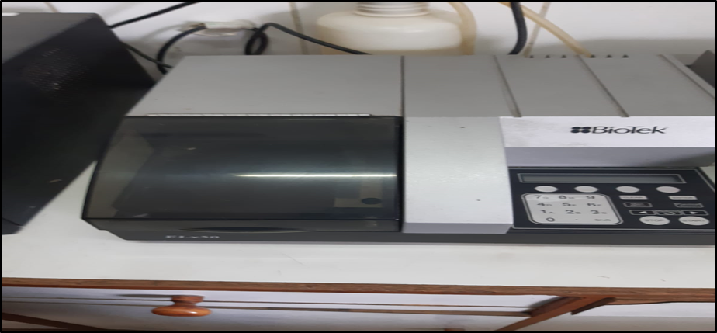

Figure 3. Elisa (Enzyme linked immusnorbent assay)

* + 1. **Laboratory fuji film corporation device**

In 1980, FUJI announced its layered film based FUJI DRI-CHEM (FDC) technology. The first product was an analyzer and a dry chemical slide used to spot a 6-microliter sample of whole blood and determine the glucose levels. To facilitate the use of whole blood samples, the slide was equipped with a unique spreading layer made of fabric. Several DRI-CHEM slides and analyzers, as well as a number of ancillary items, have been created since then to meet the expanding demands of emergency testing. To facilitate automatic spotting, for instance, specialized pipette tips—known as FUJI CLEAN TIPS—were developed. Avoiding the need to clean the tips means less chance of cross-contamination between the operator and the sample. See Figure 3.2.

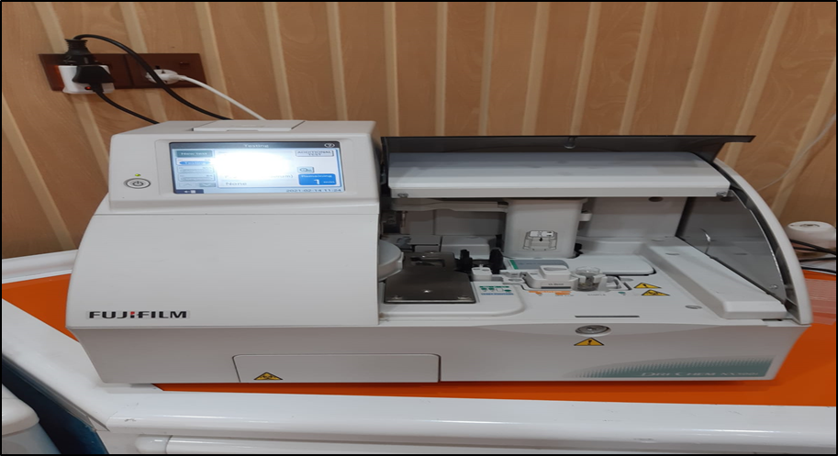

**Figure 3.4** Laboratory FujiFilm corporation device

* + 1. **Genex laboratory device (SN - G: 001538)**

**Specification**

Light Source: 6V 10W, halogen lamp of more than 2000 hours’ life time

Spectrometer: interference filter.

Wavelength: 340nm, 380nm, 405nm, 505nm, 546nm, 578nm, 620nm, and one wavelength free.

Stray light: ≤ 0.5% (absorbance ≥ 2.5)

Absorbance range: -0.214 ~ 3.000

Absorbance linearity: ±1%

Absorbance repeatability: ± 0.001

Absorbance resolution: 0.0001

Sampling system: pressure auto releasing pumps ensure the accuracy of suction volume

Test Method: End point, Fixed time, Kinetic, Factor, Muli-standards, Bichromatic, Dual wavelengths: -

Absorption volume: 200μL ~ 3000μL

Sample volume: 10μL ~ 50μL

Reagent: Open reagent

Display: LCD with high brightness

And, Figure 3.3 are shown the Genex laboratory device (SN - G: 001538)

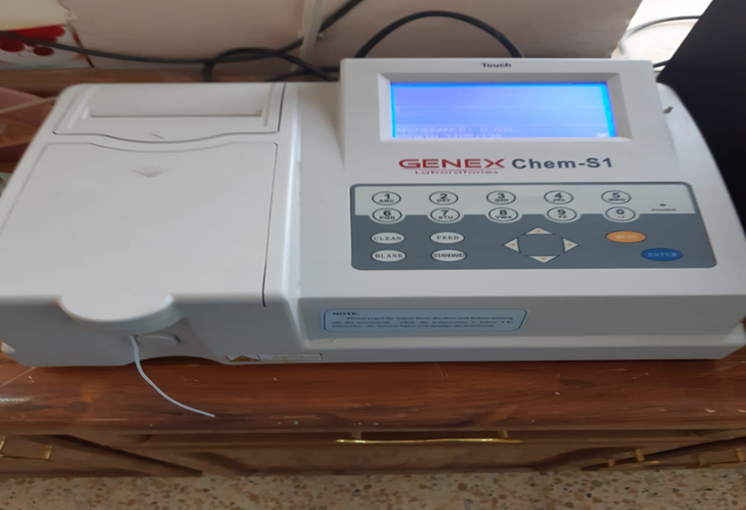

**Figure 2.5** Genex laboratory device (SN - G: 001538)

* 1. **Biochemical Kits**

The Kits and chemicals that used in study are shown in Table 3.2.

**Table 3.2** Kits and chemicals

|  |  |  |
| --- | --- | --- |
| **Kit** | | **Company** |
| 1 | Alkaline phosphatase kit | Beckman coulter USA |
| 2 | S GOT kit | Beckman coulter USA |
| 3 | S GPT kit | Beckman coulter USA |
| 4 | S Amylase kit | Beckman coulter USA |
| 5 | S Lipase kit | FUJIFILM Japan |
| 6 | HUMAN ELISA kit CCK | Sunlong Biotech Co. Ltd |
| 7 | HDL Cholesterol kit | Biolabo, France |
| 8 | Total Cholesterol kit | Biolabo, France |
| 9 | Triglyceride kit | Biolabo, France |
| 10 | TSB kit | Biolabo, France |

* 1. **Blood Sampling**

Five milliliter of blood were taken from each patient and control group at the fasting case, then immediately put into gel tube then centrifuge at 3000 rpm for 5 min. The resulting serum were separated and saved at (-20°C) until assay..

* 1. Methods

The following parameters, GOT, GPT, ALP, and lipid profile that include, include (cholesterol, triglyceride, HDL, LDL, and VLDL), amylase, lipase, and CCK.

* + 1. Calculation of body mass index (BMI)

Body Mass Index (BMI) which can be define as the weight in kilograms divided by the square of the height.

BMI = Weight (Kg)/ Height (m2)

BMI was classified into the following:

1. BMI less than 24.9 (normal weight).
2. Ranging from 25 to 29.9 (overweight).
3. More than 30 (obesity).
4. More than 35 (more bid obesity).
   * 1. Serum lipid profile assay

Using spectrophotometer device.

* + - 1. Measurement of serum total cholesterol (TC)

**Principle**

Utilizing a Bio Lab laboratory kit developed especially for the purpose of measuring total serum cholesterol, the determination is based on the enzymatic hydrolysis, as shown in the reaction that immediately follows the step of measuring total serum cholesterol.:

Cholesterol

Cholesterol esters + H2O Cholesterol + Fatty acid

Esterase

Cholesterol

Cholesterol + O2 Cholest – 4 – en – 3 – one + H2O2

Oxidase

Peroxidase

2H2O2 + Phenol + -Amino Phenazone 4H2O2 + Quinonimine

The amount of the former red dye quinonimide is proportional to the cholesterol concentration, the absorbance of quinonimine was read at 500 nm spectrophotometer.

**Normal Value:** < 200 mg/dL.

* + - 1. Measurement of serum triglyceride (TG)

**Principle**

The triglyceride is determined in serum by enzymatically hydrolyzed glycerol and fatty acids reaction according to the following equations: -

Lipoprotein Lipase

Triglycerides Glycerol + 3 Fatty acids

Glycerol kinase

Glycerol + ATP Glycerol – 3 - Phosphate + ADP

Mg +2

3 – Glycerol phosphate oxidase

Glycerol – 3 – Phosphate +O2 Dihydroxy aceton – P + H2O2

Peroxidase

H2O2 + 4 – Aminophenazone + P – cholorphenol Quinonimine + 4H2O

The quantity of red dye quinonimide that formed during the reaction is proportional to the concentration of the TG. The absorbance of quinonimine was read at 500nm spectrophotometer.

**Normal Value:** In women 35 - 135mg/dL, while in men 40-160mg/dL.

* + - 1. Measurement of serum high density lipoprotein cholesterol (HDL-C)

**Principle**

The following3 lipid carrying molecules low density lipoprotein (LDL), Very Low Density Lipoprotein (VLDL), and chylomicron fraction by addition of phosphotungstic acid (Contains magnesium chloride) at pH 6.2. Cause precipitation quantitatively after centrifugation the supernatant contains cholesterol concentration in the HDL fraction that used in determination by using cholesterol kit.

**Normal Value:** 40 – 60 mg/ dL.

* + - 1. Measurement of serum low density lipoprotein cholesterol (LDL – C)

**Principle**

Friedwad's method can be used to calculate the concentration of LDL cholesterol based on the total cholesterol and triglyceride levels, as well as the HDL cholesterol level, which can be measured numerically.:

LDL = Total cholesterol – HDL cholesterol – Triglyceride/5

Only at TG concentrations up to 5.32 mmol/L (or 400 mg/dL) can the formula be used correctly.

**Normal Value:** LDL-C value = 100 - 129 mg/dL.

* + - 1. Measurement of serum very low density lipoprotein (VLDL)

**Principle**

The VLDL concentration is calculated from one –fifth of the serum TG

$VLDL\frac{mmol}{L}=\frac{TG}{2.2}$, and $VLDL\frac{mg}{dL}=\frac{TG}{5}$

**Normal Value*:*** 5-40 mg/dL.

* + 1. Liver function test assay
       1. **Measurement of GOT or AST**

**Principle of assay**

Glutamate oxaloacetate transaminase (GOT) or Aspartate aminotransferase (AST) catalyzes the transaminase reaction of aspartate and α-oxoglutarate, to form L-glutamate and oxaloacetate. The oxaloacetate is reduced later on to L-malate by malate dehydrogenase, while the remaining NADH is .simultaneously converted to NAD+. The drop in absorbance due to the consumption of NADH is measured at 340 nm, and it is proportional to the amount of AST activity present in the sample. Estimation using Genex device.

AST

L-Aspartate + α-oxoglutarate L- Glutamate + Oxaloacetate MDH

Oxalacetate + NADH + H + L- Malate + NAD

**Normal values*:*** 5-40 U/L

* + - 1. Measurement of GPT or ALT

**Principle of Assay**

Glutamate pyruvate transaminase (ALT) transfers amino group from alanine molecule to α-oxoglutarate forming pyruvate and glutamate. The pyruvate enters a lactate and NAD+ the decrease in absorbance due to the consumption of NADH is measured at 340nm and is proportional to the ALT activity in the sample. Estimation using Genex device.

ALT

L-Alanine + α-Oxoglutarate L- Glutamate + Pyruvate

LD

Pyruvate + NADH + H + L- Lactate + NAD+

**Normal values**: 3 - 40 U/L

* + - 1. **Measurement of ALP**

**Principle of Assay**

Alkaline phosphate activity is determined through measuring conversion rate of p-nitro-phenylphosphate (pNPP) in the presence of -2amino -2- methyl-1- propanol (AMP) at pH 10.4 Estimation using Genex device.

ALP

pNPP + AMP pNP + AMP-PO4

Mg +2

The changing rate in absorbance due to the formation of pNPP measured bichromatically at 410/480nm and which is proportional directly to the ALP activity in the sample.

**Normal values:** 40-130 U\L

* + - 1. **Measurement of total serum bilirubin**

**Principle of assay**

A stabilized diazonium salt, 3.5-dichlorophenyldiazonium terafluoroborate (DPD) which is the total bilirubin reagent that reacts with bilirubin forming azobilirubin which absorbs at 570/ 660nm. Both surfactant and the caffeine are considered as eccelerators factors to the reaction. The absorbance at 570/660nm is proportional with the bilirubin concentration in the sample.

Caffeine

Bilirubun + DPD Azobilirubin

Surfactant

**Normal values:** 0.2 - 1.20 mg/dL.

* + 1. Measurement of Amylase

**Principle**

Simple and direct procedures to measure α-amylase activity through using insoluble substrate couples with dye amylose azure that cleaved by α-amylase to form soluble colored products. The color intensity is proportionate to the enzyme activity in the sample that measured at 595nm. Estimation using Genex device.

Amylase

5CNPG3 3 CNP + 2CNPG2 + 3 Maltotriose + 2 Glucose

CNP: Chloro-4-nitrophenol

CNP-G2: 2-chloro – 4 – nitrophenyl-a maltoside

**Normal values:** Serum, plasma 25 - 86 U/L, Urine < 470 U/L.

* + 1. Measurement of lipase

**Principles**

Lipase determination through the cleavage of a specific chromogenic lipase substrate which is emulsified in stabilized micro-particle. The substrate involves a conversion to 1.2-O-dilauryl-rac-glycerol and glutaric acid-6’-methylresorufinester using specific activators of pancreatic lipase as colipase, calcium ions and bile acide. The converted substrate decomposes spontaneously to glutaric acide and methylresorufin. The increase of absorbance at 580nm, due to methylresorufin formation, is proportional to the activity of lipase in the sample. The measurement using FUJI device.

**Normal value:** ≥ 38 U/L.

* + 1. **Measurement of cholecystokinin**

**Principle**

The assay involves a competitive inhibition enzyme immunoassay technique, using a monoclonal antibody (AB) specifically to CCK that pre-coated onto a microplate. The reaction occurs between a (labeled CCK) and (Unlabeled CCK) with a pre-coated CK. Avidin which is conjugated to Horseradish Peroxidase (HRP) is added to each microplate well and incubated.

The amount of CCK in the sample is inversely proportional to the amount of bound HRP conjugate that is present in the sample. Following the addition of the substrate solution, the amount of color that is formed has a relationship that is inversely proportional to the amount of CKK that was present in the sample. The calculation based on the ELISA.

**Normal value:** 4 – 200 pg/mL.

* 1. Statistical Analysis

The software program SPSS version 25.0 was utilized during every stage of the statistical study. For each of the numeric parameters, both the mean and the standard error were computed. The statistically significant difference between the groups was analyzed using the T test, which was conducted on independent samples. It is generally accepted that statistical significance can be inferred only when the 0.05 threshold for the P value is met or exceeded. The correlation coefficient was utilized in order to conduct an investigation into the nature of the connection that exists between the aforementioned factors. The information is laid up in the form of tables and figures.

# RESULTS AND DISCUSSION

# **Results**

### **Description of data**

The study is case-control study that enrolled 60 patients who were having gallstone disease and underwent cholecystectomy and 30 other healthy persons. The age of patient was divided into3 groups as the following, 20 - 30 years old (9 - 10.0%), 31 - 40 years old, (16 - 17.8%) and 41 -70 years old, (65 - 72.2%), in which can notice that most patient age are above 40 years old with mean (65 - 72.2%). 75.6% of the participant are females and 24.4% are males. The BMI of patient was calculated and the result was divided in 4 groups, (4 - 4.4%) have normal BMI, (0 - 44.4%) have overweight, (42 - 46.7%) have obesity, and (4 - 4.4%) have morbid obesity, as presented in Table 4.1.

**Table 4.1** Variables study groups, subgroup, frequency and percentage

|  |  |  |  |
| --- | --- | --- | --- |
|  | | **Frequency** | **Percent** |
| Group | Patient | 60 | 66.7% |
| Control | 30 | 33.3% |
| Age group | 20 – 30 years old | 9 | 10.0% |
| 31 - 40 years old | 16 | 17.8% |
| 41 - 70 years old | 65 | 72.2% |
| Gender | Female | 68 | 75.6% |
| Male | 22 | 24.4% |
| BMI groups | Normal | 4 | 4.4 % |
| over weight | 40 | 44.4 % |
| Obese | 42 | 46.7 % |
| morbid obesity | 4 | 4.4 % |
|  | Total | 90 | 100.0% |

### **Compare between patient and control according to biochemical tests**

The liver function of each participant was estimated using the measure of the following biomarkers: Total serum bilirubin (TSB), Aspartate transaminase (GOT), Alanine transaminase (GPT), Alkaline phosphatase (ALP), Cholesterol (CHOL), Triglyceride (TG), High density lipoprotein (HDL), Low density lipoprotein (LDL), Very low density lipoprotein (VLDL), Serum amylase, Lipase, and Cholecystokinin (CCK) for each group.

In order to evaluated the changes in these biomarkers between the two studied groups, the mean± SE of each biomarker of both group was calculated using independent t-test, as well as p-value and confidence interval, as presented in Table 4.2. Regarding the age of all participant the Mean ± SE of patient group was 45.47 ± 1.57 that is lower than the control group 50.53 ±1.73 with p- value 0.05 indicate a difference of statistical significant between the two group. The TSB mean level of patient group was 0.81 ± 0.02 that is statically different from mean level in control group 0.74 ± 0.01, with p-value 0.04. GOT, GPT, ALP, amylase and lipase mean level was not statistically significant differences between the group, as mean was 27.82 ± 0.88, 26.08 ± 1.54, 173.07 ± 13.44, 44.62 ± 1.93, and 37.38 ± 1.08 in patient group, respectively. The mean in control group was 25.97 ± 1.08, 23.53 ± 1.96, 156.27 ± 6.64, 42.47 ± 4.06, and 34.13 ± 2.19, respectively.

TG and VLDL result showed a statistical difference between patient and control group, p-value was 0.01 for both markers, mean level of TG 140.62 ± 5.33, and VLDL 28.12 ±1.06 in patient group which statistically lowered from control group as mean level of TG 174.07 ±15.04, and VLDL 34.84 ± 3.01 in control group.

HDL and LDL show non statistical significant difference between the two groups. Measuring CCK for both group indicate a statistical significant difference as p- value 0.008, the mean level of CCK in higher in patient group 59.68 ± 3.01 than in control 46.46 ± 3.21. Both group has insignificant statistical differences in BMI. See Table 4.2.

**Table 4.2** Mean level of studied biomarkers in both groups

|  |  |  |  |  |  |
| --- | --- | --- | --- | --- | --- |
| **Factors** | **Group** | **Mean ± S.E.** | **P -value** | **95% confidence interval** | |
| **Lower** | **Lower** |
| Age year | patient | 45.47 ± 1.57 | 0.050* | -10.12 | -0.007 |
| Control | 50.53 ± 1.73 |
| TSB | Patient | 0.81 ± 0.02 | 0.040* | 0.003 | 0.14 |
| Control | 0.74 ± 0.01 |
| GOT | Patient | 27.82 ± 0.88 | 0.20 | -1.05 | 4.75 |
| Control | 25.97 ± 1.08 |
| GPT | Patient | 26.08 ± 1.54 | 0.32 | -2.60 | 7.70 |
| Control | 23.53 ± 1.96 |
| ALP | Patient | 173.07 ± 13.44 | 0.39 | -22.21 | 55.81 |
| Control | 156.27 ± 6.64 |
| CHOL | Patient | 155.93 ± 2.41 | 0.80 | -10.12 | 7.85 |
| Control | 157.07 ± 4.20 |
| TG | Patient | 140.62 ± 5.33 | 0.01* | -59.28 | -7.61 |
| Control | 174.07 ± 15.04 |
| HDL | Patient | 46.95 ± 0.55 | 0.43 | -1.38 | 3.22 |
| Control | 46.03 ± 1.20 |
| LDL | Patient | 81.23 ± 2.39 | 0.39 | -4.94 | 12.54 |
| Control | 77.43 ± 3.98 |
| VLDL | Patient | 28.12 ± 1.06 | 0.01* | -11.89 | -1.54 |
| Control | 34.84 ± 3.01 |
| amylase | Patient | 44.62 ± 1.93 | 0.58 | -5.72 | 10.02 |
| Control | 42.47 ± 4.06 |
| Lipase | Patient | 37.38 ± 1.08 | 0.13 | -1.07 | 7.57 |
| Control | 34.13 ± 2.19 |
| CCK | Patient | 59.68 ± 3.01 | 0.008* | 3.61 | 22.82 |
| Control | 46.46 ± 3.21 |
| BMI | Patient | 29.77 ± 0.37 | 0.22 | -2.22 | 0.521 |
| Control | 30.63 ± 0.61 |

* P-valueiisssignificant if ≤ 0.05

### **Compare between patient and control group according to gender**

The study enrolled 68 females and 22 males, the participant were divided according to their gender into male group and female group that further divided into patient (46 females, 14 male) and control group (22 females, 8 males). Mean age of female participant in patient group 46.20 ± 1.80 is lower than in control group 51.23 ± 2.17, that statically insignificant differences, p-value 0.09. Mean TSB of female patient group (0.79 ± 0.012) is statically higher than in female mean TSB in control group (0.74 ± 0.01), p-value 0.02. Mean GPT level is lower in patient female group 23.91 ± 1.45than in female control group 24.68 ±2.58, p-value 0.78 indicate no-statistical significant differences. CCK mean level in female patient group higher 59.87 ± 3.52 than in control group 49.02 ± 3.97, that is statically insignificant as p-value 0.06. Regarding other liver enzymes, result showed that mean of GOT 28.37 ± 0.99, ALP 163.89 ± 7.61, CHOL 155.80 ± 2.82, TG 146.80 ± 6.04, HDL 47.09 ± 0.65, LDL 79.86 ± 2.74, VLDL 29.36 ± 1.20, amylase 43.28 ± 2.15, lipase 37.20 ± 1.19 and BMI 30.1 ± 0.36 in female patient group are statistically insignificant different from control female group as mean was 26.59 ± 1.18, 152.18 ± 7.92, 158.45 ± 5.00, 173.59 ± 19.56, 46.32 ± 1.52, 77.25 ± 4.87,34.76 ± 3.92, 39.77 ± 4.53, 32.82 ±2.79 and 30.88 ± 0.94.

**Table 4.3** Compare between female patient and control group

|  |  |  |  |  |  |  |
| --- | --- | --- | --- | --- | --- | --- |
| **Gender** | | **Group** | **Mean ± S.E.** | **P -value** | **95% confidence interval** | |
| **Lower** | **Upper** |
| Female | Age years | patient | 46.20 ± 1.80 | 0.09 | -11.03 | 0.97 |
| control | 51.23 ± 2.17 |
| TSB | patient | 0.79 ± 0.012 | 0.02* | 0.006 | 0.08 |
| control | 0.74 ± 0.01 |
| GOT | patient | 28.37 ± 0.99 | 0.28 | -1.52 | 5.08 |
| control | 26.59 ± 1.18 |
| GPT | patient | 23.91 ± 1.45 | 0.78 | -1.52 | 5.08 |
| control | 24.68 ±2.58 |
| ALP | patient | 163.89 ± 7.61 | 0.34 | -12.89 | 36.31 |
| control | 152.18 ± 7.92 |
| CHOL | patient | 155.80 ±2.82 | 0.62 | -13.34 | 8.04 |
| control | 158.45 ± 5.00 |
| TG | patient | 146.80 ± 6.04 | 0.09 | -58.78 | 5.21 |
| control | 173.59 ± 19.56 |
| HDL | patient | 47.09 ± 0.65 | 0.58 | -2.04 | 3.58 |
| control | 46.32 ± 1.52 |
| LDL | patient | 79.86 ± 2.74 | 0.61 | -7.76 | 12.97 |
| Control | 77.25 ± 4.87 |
| VLDL | Patient | 29.36 ±1.20 | 0.09 | -11.80 | 1.01 |
| Control | 34.76 ± 3.92 |
| amylase | Patient | 43.28 ± 2.15 | 0.42 | -5.29 | 12.3 |
| Control | 39.77 ± 4.53 |
| lipase | Patient | 37.20 ± 1.19 | 0.09 | -.77 | 9.53 |
| Control | 32.82 ±2.79 |
| CCK | Patient | 59.87 ± 3.52 | 0.06 | -0.73 | -22.4 |
| Control | 49.02 ± 3.97 |
| BMI | Patient | 30.1 ± 0.36 | 0.34 | -2.30 | 0.8 |
| Control | 30.88 ± 0.82 |

* P-value is significant if ≤ 0.05

Regarding male gender, GPT mean level was statistically significant higher in patient group (33.21 ± 4.17) than control group (20.38 ± 1.70), with p-value 0.03. TG and VLDL mean level was 120.29 ± 9.79, 24.05 ± 1.95 respectively, statically different from mean level in control group 175.38 ± 18.91, 35.07 ± 3.78, respectively. The CCK mean level was 59.06 ± 5.90 in patient group that is statistically higher than the mean of control group 39.42 ± 4.54. Other markers were not statically significant different between the two groups.

**Table 4.4** Compare between male patient and control group

|  |  |  |  |  |  |  |
| --- | --- | --- | --- | --- | --- | --- |
| **Gender** | | **group** | **Mean ± SE** | **p-value** | **95% confidence interval** | |
| **Lower** | **upper** |
| male | Age year | patient | 43.07 ± 3.30 | 0.26 | -15.62 | 4.51 |
| control | 48.63 ± 2.63 |
| TSB | patient | 0.91 ± 0.09 | 0.2 | -0.10 | 0.44 |
| control | 0.73 ± 0.01 |
| GOT | patient | 26.00 ± 1.87 | 0.57 | -4.69 | 8.19 |
| control | 24.25 ± 2.42 |
| GPT | patient | 33.21 ± 4.17 | 0.03* | -0.89 | 24.7 |
| control | 20.38 ± 1.70 |
| ALP | patient | 203.21 ± 52.57 | 0.62 | -112.08 | 183.51 |
| control | 167.50 ± 11.98 |
| CHOL | patient | 156.36 ± 4.73 | 0.72 | -15.02 | 21.23 |
| control | 153.25 ± 8.03 |
| TG | patient | 120.29 ± 9.79 | 0.009* | -95.12 | -15.05 |
| control | 175.38 ± 18.91 |
| HDL | patient | 46.50 ± 1.07 | 0.53 | -2.87 | 5.37 |
| control | 45.25 ± 1.84 |
| LDL | patient | 85.7 ± 4.86 | 0.36 | -9.72 | 26.47 |
| control | 77.92 ± 7.17 |
| VLDL | patient | 24.05 ± 1.95 | 0.009* | -19.02 | -3.01 |
| control | 35.07 ± 3.78 |
| amylase | patient | 49.00 ± 4.25 | 0.92 | -18.84 | 17.09 |
| control | 49.88 ± 8.72 |
| Lipase | patient | 38.0 ± 2.57 | 0.95 | -8.11 | 8.6 |
| Control | 37.75 ± 2.76 |
| CCK | Patient | 59.06 ± 5.90 | 0.03* | -1.72 | 37.54 |
| Control | 39.42 ± 4.54 |
| BMI | Patient | 28.64 ± 1.28 | 0.37 | -4.37 | 1.7 |
| Control | 29.9 ± 1.00 |

* P-value is significant if ≤ 0.05

* + 1. Correlation between CCK and other markers

Table 4.5 illustrates the link that can be found between CCK and the many other tested markers. The result showed non-statistical significant correlation between CCK and other markers. CCK and age (Figure 4.1) spearman correlation was -0.11 indicate a very weak negative non-significant correlation, p-value 0.28. The correlation coefficient of CCK and TSB (Figure 4.2) was 0.03 indicate a very weak positive non-significant correlation, p-value 0.75.

The correlation coefficient of CCK and GOT (Figure 4.3) was 0.06 indicate a very weak positive non-significant correlation, p-value 0.54, r of CCK and GPT (Figure 4.4) was -0.005 indicate a very weak negative non-significant correlation, p-value 0.96, of CCK and ALP (Figure 4.5) was 0.1 indicate a very weak positive non-significant correlation, p-value 0.33 of CCK and lipid profile marker CHOL (Figure 4.6) was 0.06, CCK and TG (Figure 4.7) was -0.11, HDL (Figure 4.8) was 0.13, LDL (Figure 4.9) was 0.07, and VLDL (Figure 4.10) was -0.11, with p-value of 0.54, 0.27, 0.19, 0.45, and 0.27, all indicate a non-significant very weak correlation. Both serum amylase and lipase show insignificant very weak correlation with CCK as r was 0.05 and 0.1 with p-value of 0.59 and 0.3, as shown in the figures (Figure 4.11, Figure 4.12).

**Table 4.5** The Linear regression correlation between CCK and measured markers in all enrolled participant

|  |  |  |
| --- | --- | --- |
|  | **CCK** | |
| **R** | **p-value** |
| Age | -0.11 | 0.28 |
| TSB | 0.03 | 0.75 |
| GOT | 0.06 | 0.54 |
| GPT | -0.005 | 0.96 |
| ALP | 0.10 | 0.33 |
| CHOL | 0.06 | 0.54 |
| TG | -0.11 | 0.27 |
| HDL | 0.13 | 0.19 |
| LDL | 0.07 | 0.45 |
| VLDL | -0.11 | 0.27 |
| Amylase | 0.05 | 0.59 |
| Lipase | 0.1 | 0.31 |

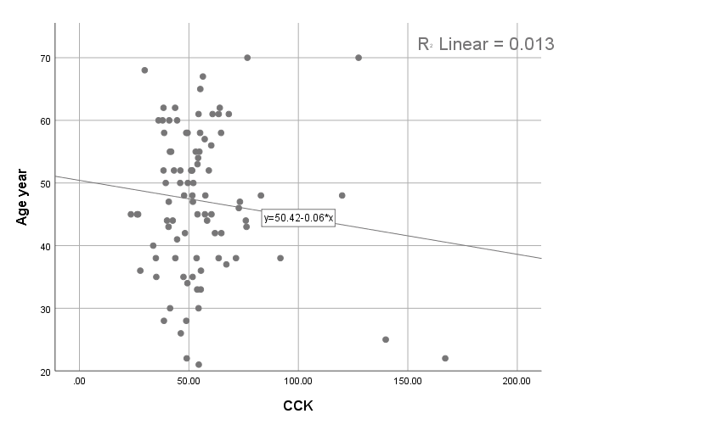

**Figure44.1** Scattered blot diagram of CCK correlation and age

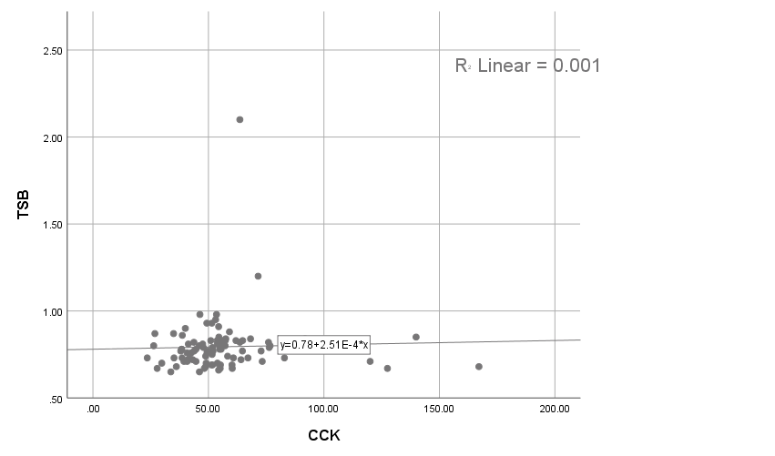

**Figure44.2** Scattered blot diagram of CCK correlation and TSB

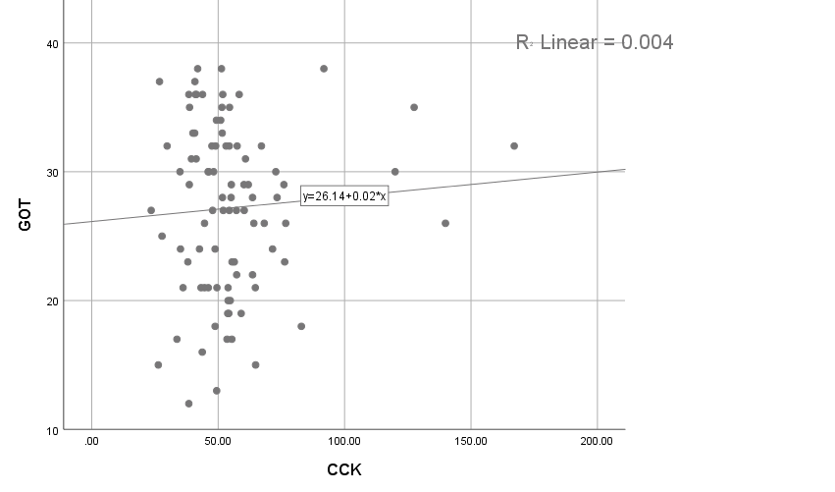

**Figure 4.3** Scattered blot diagram of CCK correlation and GOT

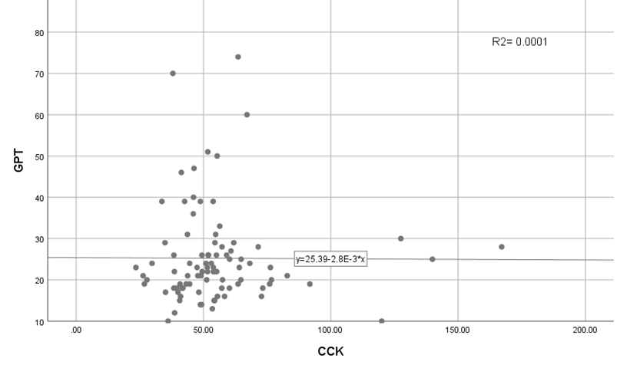

**Figure 4.4** Diagram of a scattered blot showing the link between CCK and GOT

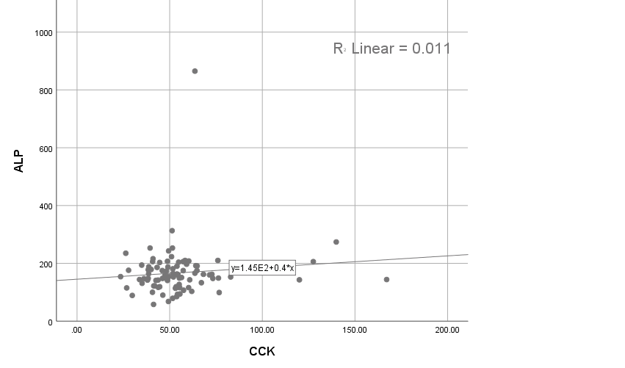

**Figure 4.5** Diagram of a scattered blot showing the link between CCK and ALP

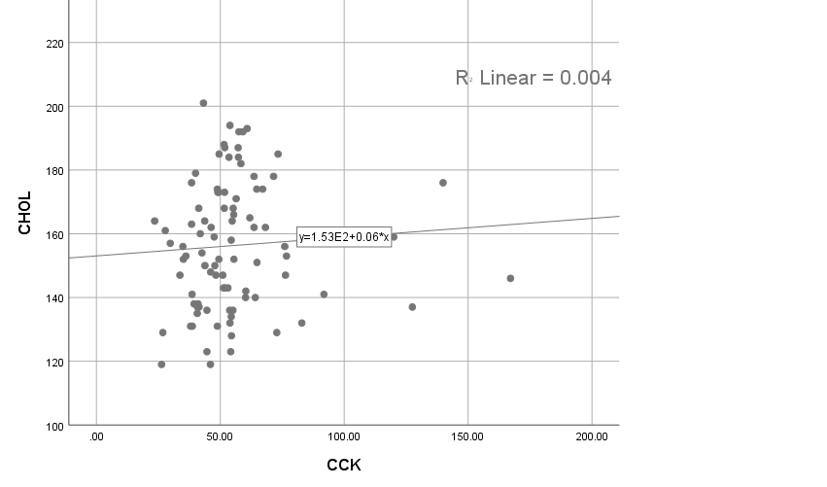

**Figure 4.6** Diagram of a scattered blot showing the link between CCK and CHOL

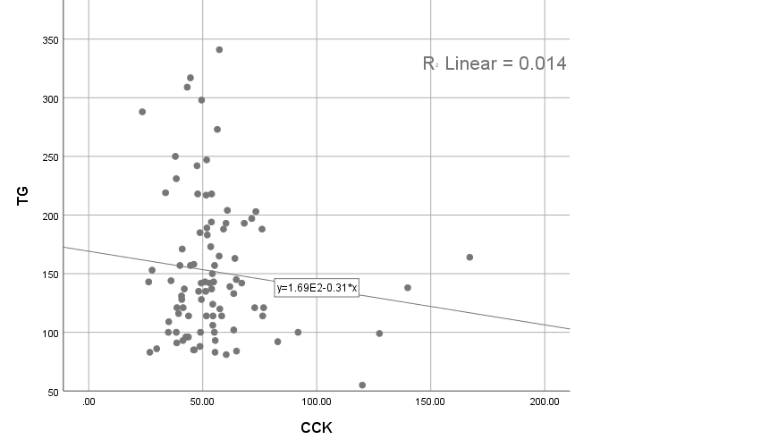

**Figure 4.7** Diagram of a scattered blot showing the link between CCK and TG

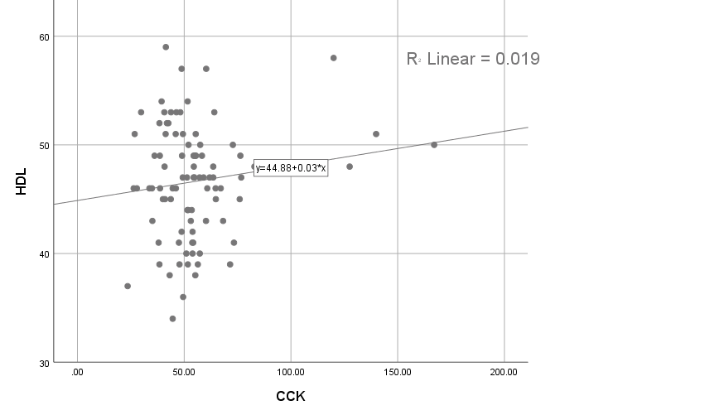

**Figure 4.8** Scattered blot diagram of CCK correlation and HDL

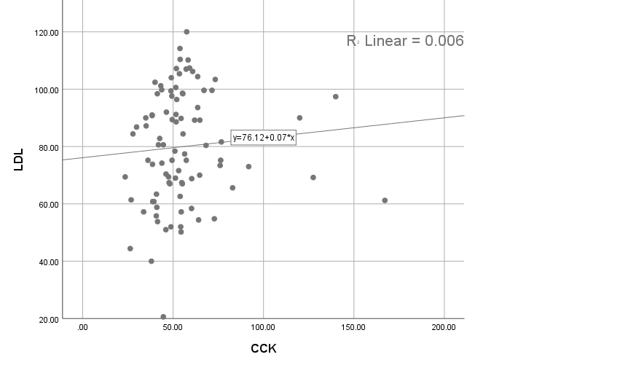

**Figure 4.9** Diagram of a scattered blot showing the link between CCK and LDL

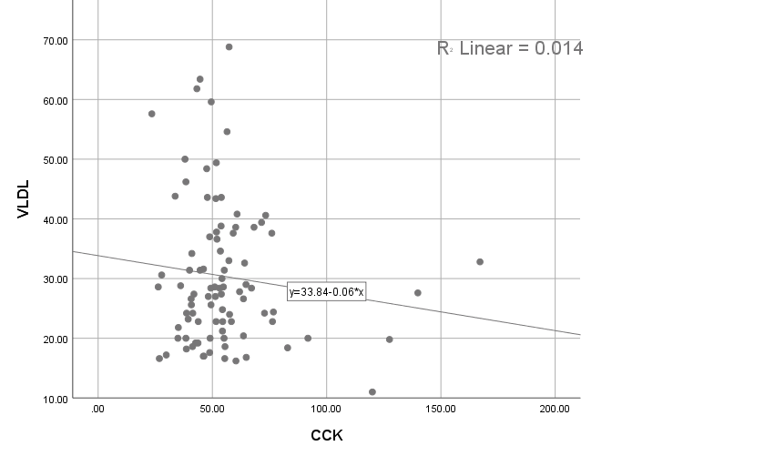

**Figure 4.10** Diagram of a scattered blot showing the link between CCK and VLDL

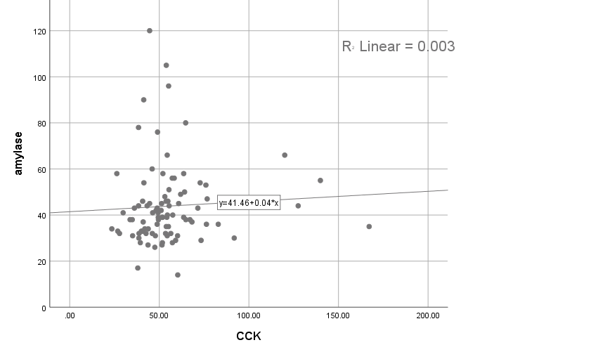

**Figure 4.11** Scattered blot diagram of CCK correlation and amylase

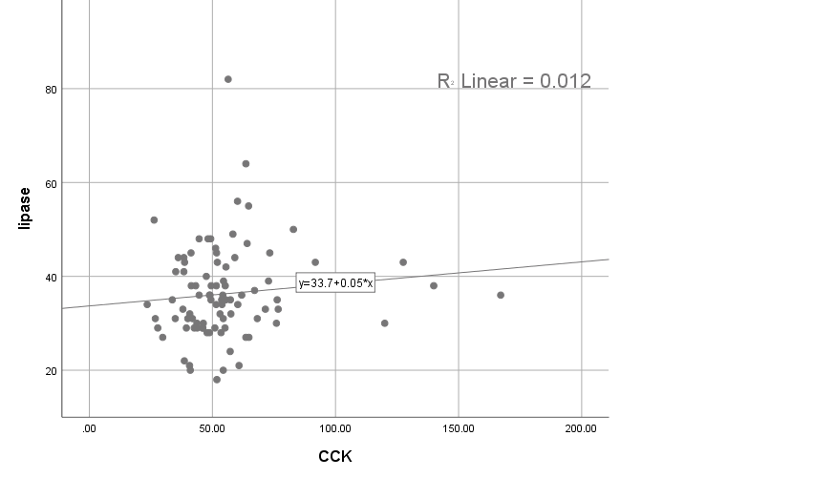

**Figure 4.12** Diagram of a scattered blot showing the link between CCK and lipase

## Discussion

The current study includes 90 participants, 60 of them are patient who underwent cholecystectomy surgery. The liver enzyme, lipid prolife, S. amylase, S. lipase and cholecystokinin patient and control.

Gallstone disease will induce liver damage due to the chronic obstruction of extra-hepatic bile duct and stagnation of bile or a frequented episodes of cholangitis that can develop to biliary cirrhosis. Prolong biliary blockage will cause change in other enzyme as lipid prolife, S. amylase, S. lipase and cholecystokinin.

Cholecystectomy surgery is most common treatment for gallstones disease, which is nowadays is laparoscopic cholecystectomy procedure. However, Cholecystectomy surgery carry some risk to patient by injury to biliary tree, biochemical testing of liver enzymes has been used to assess biliary duct injury.

In Table 3.1, the description of included data is presented. The study includes 68 women and 22 men, the compared ratio between females and males was 3:1 with various ages ranging from 20 - 70 divided into 3 group, mean of patient age was 45.47 ± 1.57 while mean age of control was 50.53 ± 1.73, most of the enrolled participant have high BMI (81.1%).

In (O Hamad and R Al-Luwaizi 2013) study that is prospective case control study included 74 cholecystitis patients to assess the effect of surgery on enzymes of the liver and serum bilirubin between two groups who have different procedures.

Mean of age of patient was 45.1 years with range of 22 - 76 years that is approach current study result, female: male ratio was 6:1 that is higher than current study. The agreement between both study can be explained as the following, many studies has been agreed that gallstone disease tend to be cluster in middle age female that support current study result (Sachdeva *et al.* 2011).

The result of mean of each measured biochemical markers is presented in Table 4.2. According to (Maleknia and Ebrahimi 2020) study that is a cross sectional study that involve 128 patients (109 females, 19 male) with mean age of 65.1 ± 14.6 years, and mean calculated BMI was 19.43 ± 2.19 kg/m2 (mean of BMI in patient of current study was 29.77 ± 0.37) who will have laparoscopic cholecystectomy to evaluate the pre and post-op result of TSB and liver enzymes. The demographic data of patient did not approach current study result.

The result of the study found that no statistical significant difference found between pre and post-op result of ALP, that agreed with current study regarding ALP, no change in ALP level post op from the healthy control group but the level of ALP in patient group was above the normal limit which can explain by ALP levels are consistent with the biliary tract injury, the number of sample was may have a role in inability to detect a significant difference.

The study found that TSB is higher in post-op patient which agreed with current study as TSB is higher in post-op patient than control, that can be explained by TSB is increase post-op but return to normal few days after surgery.

The GPT and GOT values were significantly different in between pre and post-op with agreed with current study which found no change in GPT or GOT level in post-op patient and no difference between patient and control, studies has been found that liver enzymes tent to return to their normal level few days after the operation.

The result of (Khare and Sahani 2018) study no significant change in TSB liver post-op. Measurement of lipid profile is important which give a clue to the cause of stone formation, hyperlipidemia is a triggering factor for stone formation, as stone composed of cholesterol. A prospective study carried on by (Menezes and Katamreddy 2019) the aimed to evaluate the lipid profile in cholecystectomy patient, the result showed that significant differences in the lipid profiles in post cholecystectomy patient in which the level of total cholesterol, low density lipoprotein (LDL) cholesterol, very low density lipoprotein (VLDL) cholesterol and triglycerides is decreased, increase in the high density lipoprotein (HDL) cholesterol.

In the current study, CHOL, LDL and HDL show no significant change from the control group that disagree with (Menezes and Katamreddy 2019). Study, however, the level CHOL, LDL and HDL the range value of the both groups were normal. The level of TG and VLDL show a significant decrease in post cholecystectomy patient group than control group.

A case control study done by (Gill and Gupta 2017) that aim to evaluate cholecystectomy on lipid profile in patients suffer from gallstones. study involves 50 patients had gallstones and 30 healthy that approach current study sample size, with BMI 27.45 and 25.66 kg/m2, respectively.

Result show a significant decrease in CHOL and TG with significant increase in HDL levels after surgery, and non-significant change in VLDL that inconstant with current study, while LDL levels were not statistically changed that is constant with current result.

Serum amylase is increased in gallstone disease due to induction of pancreatitis by stone blockage to biliary tree and not done routinely. The test is used to differentiate acute biliary pancreatitis, the current shows no significant change in S. amylase level in both patient and control. According to (Güngör *et al.* 2011) study S. amylase is higher value in the biliary pancreatitis patient with positive predictive value of 78.8%.

Lipase is another enzyme which used to diagnosis pancreatitis which tent to elevated extrahepatic gallstone disease, the current study found no significant change in post-op S. lipase in compare to control which is lie in the normal range value. No study has been found that evaluating S. lipase in post-op patient.

Cholecystokinin is important regulator for gallbladder contraction post meal, any disturbance in CCK secretion or function will promote gallstones formation. According to (McDonnell *et al.* 2002) study which is a case control study enrolled 67 participant divided into 3 groups, healthy control (15), symptomatic gallstones (27) and cholecystectomy patient (25), result showed that Fasting CCK levels have no statistical significant difference between the three groups, but in post cholecystectomy patients, meal-stimulated plasma show a significant elevation in compared to controls.

Those result are constant with current study result, as CCK level is statistically higher in post cholecystectomy patients in compare to control as p-value is 0.008.

In Table 4.3 the participant was divided according to their gender into female and male group that include patient and control, all the measured biomarkers were compared between patient and control groups in each gender separately from the other gender.

Result show no statistical significant changes in females between patient and control group regarding LFT which explained by returning of enzymes level to normal value soon after operation, GOT and GPT were in the normal range between patient and control, but ALP level was above the normal range in both groups.

Lipid profile level show no statistical significant changes in females between patient and control group and all the result of both groups fall in the normal range.

The same result for S. amylase, s. lipase and CCK show no statistical significant changes in females between patient and control group and all the result of both groups fall in the normal range.

Regarding male group (Table 4.4) that show the same insignificant changes between patient and control group, except in the result of GPT which is significantly higher in patient group but both of them lie in the normal range, TG and VLDL are significantly lower in patient in compare to control group, and CCK is significantly higher in patient group in compare to control. No study has been found that compare result of LFT, lipid prolife, S. amylase, S. lipase and cholecystokinin in post cholecystectomy patient to compare with current study result.

In Table 4.5 the correlation between CCK and other measured markers is presented, result show no significant correlation between CCK and any other measured markers.

No study has been found to compare current study result wit, as no study evaluate the correlation between CCK and LFT, lipid profile, S. amylase and S. lipase in cholecystectomy patient.

# CONCLUSION AND RECOMMENDATION

Measurement of liver enzymes, lipid profile, and other enzymes that are related to liver function or biliary tree is important to evaluate liver function and extent of damage caused by gallstone. Most of markers will return to their normal levels soon after the surgery if there is no sever damage to the biliary system and no development of post op complication.

The result showed non statistical significant correlation between CCK and other markers. The present study did include other tests with CCK that have not been studied previously.

## Recommendation

Study more samples of patients they did cholecystectomy in order to get best results. It is better to suggest that measuring the parameters before and after the operation and the measuring will be in fasting and random. At the future studies I suggest study if that correlations between cholecystectomy and vitamin D3 deficiency for the patients in AL Anbar Governorate.

# REFERENCES

Abro, M. U. R., Butt, A., Baqa, K., Waris, N., Khalid, M., & Fawwad, A. 2018. Association of serum liver enzyme Alanine Aminotransferase (ALT) in patients with type 2 diabetes. Pakistan journal of medical sciences, 34(4), 839.

Ahmad N. Z. 2011. Routine testing of liver function before and after elective laparoscopic cholecystectomy: is it necessary? JSLS: Journal of the Society of Laparoendoscopic Surgeons, 15(1), 65–69.

Al Samaraee, A. and Bhattacharya, V. 2019. Challenges encountered in the management of gall stones induced pancreatitis in pregnancy. International Journal of Surgery, 71, 72-78. ‏

Alhayo, S., Eslick, G. D., & Cox, M. R. 2020. Cholescintigraphy may have a role in selecting patients with biliary dyskinesia for cholecystectomy: a systematic review. ANZ Journal of Surgery, 90(9), 1647-1652

Arrese, M., Cortés, V., Barrera, F., & Nervi, F. 2018. Nonalcoholic fatty liver disease, cholesterol gallstones, and cholecystectomy: new insights on a complex relationship. Current opinion in gastroenterology, 34(2), 90-96

Attili, A. F., De Santis, A., Attili, F., Roda, E., Festi, D., & Carulli, N. 2005. Prevalence of gallstone disease in first-degree relatives of patients with cholelithiasis. World journal of gastroenterology: WJG, 11(41), 6508

Azarkar, G., Birjand, M. M., Ehsanbakhsh, A., Bijari, B., Abedini, M. R., & Ziaee, M. 2018. Ceftriaxone-associated nephrolithiasis and gallstone in adults. Drug, healthcare and patient safety, 10, 103

Azzopardi, E., Lloyd, C., Teixeira, S. R., Conlan, R. S., & Whitaker, I. S. 2016. Clinical applications of amylase: Novel perspectives. Surgery, 160(1), 26–37.

Babu, C. S. R., & Sharma, M. 2014. Biliary tract anatomy and its relationship with venous drainage. Journal of clinical and experimental hepatology, 4, S18-S26. ‏

Bagaudinov, K.G., Saidov, S.S., Garilevich, B.A., Zubkov, A.D., Abdulaev, R.A. and Ovakimian, G.S. 2007. Improvement of extracorporeal shockwave cholelithotripsy in the comprehensive treatment of cholelithiasis. Klinicheskaia meditsina, 85(10), 56-59.

Bays, H. E., Jones, P. H., Orringer, C. E., Brown, W. V., & Jacobson, T. A. 2016. National Lipid Association Annual Summary of Clinical Lipidology 2016. Journal of clinical lipidology, 10(1 Suppl), S1–S43.

Beckingham, I. J., & Ryder, S. D. 2001. Investigation of liver and biliary disease. Bmj, 322(7277), 33-36

Belousov Yu V. Pediatric Gastroenterology. Up-to-date guide. Moscow: Exma; 2006. p. 112.

Burmeister, G., Hinz, S. and Schafmayer, C. 2018. Die akute Cholezystitis. Zentralblatt für Chirurgie-Zeitschrift für Allgemeine, Viszeral-, Thorax-und Gefäßchirurgie, 143(04), pp.392-399.

Cao SG, Wu H, Cai ZZ. Dose-dependent effect of ghrelin on gastric emptying in rats and the related mechanism of action. Kaohsiung J Med Sci. 2016 Mar;32(3):113-7.

Castaing D. 2008. Surgical anatomy of the biliary tract. HPB: the official journal of the International Hepato Pancreato Biliary Association, 10(2), 72–76.

Chehade, M., Kakala, B., Sinclair, J. L., Pang, T., Al Asady, R., Richardson, A., Pleass, H., Lam, V., Johnston, E., Yuen, L., & Hollands, M. 2019. Intraoperative detection of aberrant biliary anatomy via intraoperative cholangiography during laparoscopic cholecystectomy. ANZ journal of surgery, 89(7-8), 889–894.

Chong, V. H. 2005. Iatrogenic biliary stone. Surgical technology international, 14, 147-155. ‏

Cohen, D. E., Anania, F. A., & Chalasani, N. 2006. An assessment of statin safety by hepatologists. The American journal of cardiology, 97(8), S77-S81. ‏

Date, K., Satoh, A., Iida, K., & Ogawa, H. 2015. Pancreatic α-amylase controls glucose assimilation by duodenal retrieval through N-glycan-specific binding, endocytosis, and degradation. Journal of Biological Chemistry, 290(28), 17439-17450. ‏

Ellis, H. 2011. Anatomy of the gallbladder and bile ducts. Surgery (Oxford), 29(12), 593-596. ‏

Fitzgerald, J.E.F., Fitzgerald, L.A., Maxwell‐Armstrong, C.A. and Brooks, A.J. 2009. Recurrent gallstone ileus: time to change our surgery. Journal of digestive diseases, 10(2), 149-151. ‏

Gill, G. S., & Gupta, K. 2017. Pre-and Post-operative comparative analysis of serum lipid profile in patients with cholelithiasis. International Journal of Applied and Basic Medical Research, 7(3), 186. ‏

Gluchowski, N.L., Gabriel, K.R., Chitraju, C., Bronson, R.T., Mejhert, N., Boland, S., Wang, K., Lai, Z.W., Farese Jr, R.V. and Walther, T.C. 2019. Hepatocyte Deletion of Triglyceride‐Synthesis Enzyme Acyl CoA: Diacylglycerol Acyltransferase 2 Reduces Steatosis Without Increasing Inflammation or Fibrosis in Mice. Hepatology, 70(6), 1972-1985.

Gomes, C.A., Junior, C.S., Di Saveiro, S., Sartelli, M., Kelly, M.D., Gomes, C.C., Gomes, F.C., Corrêa, L.D., Alves, C.B. and de Fádel Guimarães, S. 2017. Acute calculous cholecystitis: Review of current best practices. World journal of gastrointestinal surgery, 9(5), 118.

Güngör, B., Çağlayan, K., Polat, C., Şeren, D., Erzurumlu, K., & Malazgirt, Z. 2011. The predictivity of serum biochemical markers in acute biliary pancreatitis. International Scholarly Research Notices, 2011. ‏

Gunji, T., Matsuhashi, N., Sato, H., Iijima, K., Fujibayashi, K., Okumura, M., Sasabe, N. and Urabe, A. 2010. Risk factors for serum alanine aminotransferase elevation: A cross-sectional study of healthy adult males in Tokyo, Japan. Digestive and Liver Disease, 42(12), 882-887. ‏

Hinds Jr, T. D., & Stec, D. E. 2018. Bilirubin, a cardiometabolic signaling molecule. Hypertension, 72(4), 788-795. ‏

Holzer, M., Kern, S., Trieb, M., Trakaki, A., & Marsche, G. 2017. HDL structure and function is profoundly affected when stored frozen in the absence of cryoprotectants. Journal of lipid research, 58(11), 2220-2228.

Jones, M.W., Hannoodee, S. and Young, M. Anatomy, abdomen and pelvis, gallbladder. StatPearls. 2020. Available at: https://www.ncbi.nlm.nih.gov

Kapoor, R., Sharma, R. K., Hingora, O. M., Roy, A. K., Ahmed, F., & Sinha, N. 2018. Correlation of serum biochemical characteristics with its gallstone compositions. Journal of Biological Sciences and Medicine, 4(2), 9-18

Khare, N., & Sahani, I. S 2018. Evaluation of Serum Bilirubin Level Alterations in Patients Undergoing Cholecystectomy: An Observational Study.

Kongwattanakul, K., Saksiriwuttho, P., Chaiyarach, S., & Thepsuthammarat, K. 2018. Incidence, characteristics, maternal complications, and perinatal outcomes associated with preeclampsia with severe features and HELLP syndrome. International journal of women's health, 10, 371.

Konturek, J.W., Konturek, S.J., Kwiecień, N., Bielański, W., Pawlik, T., Rembiasz, K., Domschke, W. 2001. Leptin in the control of gastric secretion and gut hormones in humans infected with Helicobacter pylori. Scandinavian journal of gastroenterology, 36(11), 1148-1154.

Kuo, K. K., Shin, S. J., Chen, Z. C., Yang, Y. H., Yang, J. F., & Hsiao, P. J. 2008. Significant association of ABCG5 604Q and ABCG8 D19H polymorphisms with gallstone disease. British journal of surgery, 95(8), 1005-1011

Kwatra, N.S., Nurko, S., Stamoulis, C., Falone, A.E., Grant, F.D. and Treves, S.T. 2019. Chronic acalculous cholecystitis in children with biliary symptoms: Usefulness of hepatocholescintigraphy. Journal of pediatric gastroenterology and nutrition, 68(1), 68-73.

Łącka, M., Obłój, P., Spychalski, P., Łaski, D., Rostkowska, O., Wieszczy, P., & Kobiela, J. 2020. Clinical presentation and outcomes of cholecystectomy for acute cholecystitis in patients with diabetes-A matched pair analysis. A pilot study. Advances in Medical Sciences, 65(2), 409-414

Lammert, F., Gurusamy, K., Ko, C.W., Miquel, J.F., Méndez-Sánchez, N., Portincasa, P., Van Erpecum, K.J., Van Laarhoven, C.J. and Wang, D.Q.H. 2016. Gallstones. Nature reviews Disease primers, 2(1), 1-17. ‏

Lawrence, Y. A., & Steiner, J. M. 2017. Laboratory evaluation of the liver. Veterinary Clinics: Small Animal Practice, 47(3), 539-553.

Lee, E. J., Kim, M. H., Kim, Y. R., Park, J. W., & Park, W. J. 2018. Proteasome inhibition protects against diet-induced gallstone formation through modulation of cholesterol and bile acid homeostasis. international journal of molecular medicine, 41(3), 1715-1723. ‏

Lee, Y. and Siddiqui, W.J., 2019. Cholesterol Levels. StatPearls Publishing. ‏

Li, T., Francl, J.M., Boehme, S. and Chiang, J.Y., 2013. Regulation of cholesterol and bile acid homeostasis by the cholesterol 7α‐hydroxylase/steroid response element‐binding protein 2/microRNA‐33a axis in mice. Hepatology, 58(3), 1111-1121. ‏

Liou, A.P., Sei, Y., Zhao, X., Feng, J., Lu, X., Thomas, C., Pechhold, S., Raybould, H.E. and Wank, S.A. 2011. The extracellular calcium-sensing receptor is required for cholecystokinin secretion in response to L-phenylalanine in acutely isolated intestinal I cell. American Journal of Physiology-Gastrointestinal and Liver Physiology, 300(4), 538-546.

Ma, J., Dankulich-Nagrudny, L. and Lowe, G., 2013. Cholecystokinin: an excitatory modulator of mitral/tufted cells in the mouse olfactory bulb. PLoS One, 8(5), e64170.

Majidi, S., Golembioski, A., Wilson, S. L., & Thompson, E. C. 2017. Acute pancreatitis: etiology, pathology, diagnosis, and treatment. Southern medical journal, 110(11), 727-732

Maleknia, S. A., & Ebrahimi, N. 2020. Evaluation of Liver Function Tests and Serum Bilirubin Levels After Laparoscopic Cholecystectomy. Medical archives (Sarajevo, Bosnia and Herzegovina), 74(1), 24–27.

Mason-Osann, E., Dai, A., Floro, J., Lock, Y.J., Reiss, M., Gali, H., Matschulat, A., Labadorf, A. and Flynn, R.L. 2018. Identification of a novel gene fusion in ALT positive osteosarcoma. Oncotarget, 9(67), p.32868. ‏

McDonnell, C. O., Bailey, I., Stumpf, T., Walsh, T. N., & Johnson, C. D. 2002. The effect of cholecystectomy on plasma cholecystokinin. The American journal of gastroenterology, 97(9), 2189-2192.

Menezes, J. V. F., & Katamreddy, R. R. 2019. The effect of cholecystectomy on the lipid profile of patients with gallstone disease: a prospective study. International Surgery Journal, 6(11), 4112-4116.

Mineo, C., Deguchi, H., Griffin, J. H., & Shaul, P. W. 2006. Endothelial and antithrombotic actions of HDL. Circulation research, 98(11), 1352–1364.

Moreno-Córdova, E.N., Arvizu-Flores, A.A., Valenzuela-Soto, E.M., García-Orozco, K.D., Wall-Medrano, A., Alvarez-Parrilla, E., Ayala-Zavala, J.F., Domínguez-Avila, J.A. and González-Aguilar, G.A. 2020. Gallotannins are uncompetitive inhibitors of pancreatic lipase activity. Biophysical Chemistry, 264, 106409. ‏

Nathwani, R.A., Kumar, S.R., Reynolds, T.B. and Kaplowitz, N. 2005. Marked elevation in serum transaminases: an atypical presentation of choledocholithiasis. Official journal of the American College of Gastroenterology| ACG, 100(2), 295-298.

Njeze G. E. 2013. Gallstones. Nigerian journal of surgery: official publication of the Nigerian Surgical Research Society, 19(2), 49–55.

Nordestgaard, B. G., & Varbo, A. 2014. Triglycerides and cardiovascular disease. The Lancet, 384(9943), 626-635.

O Hamad, S., & R Al-Luwaizi, K. 2013. Changes of liver enzymes and serum bilirubin after laparoscopic cholecystectomy. Annals of the College of Medicine, Mosul, 39(2), 113-117.

Oh, H. C., Kwon, C. I., El Hajj, I. I., Easler, J. J., Watkins, J., Fogel, E. L., McHenry, L., Sherman, S., Zimmerman, M. K., & Lehman, G. A. 2017. Low Serum Pancreatic Amylase and Lipase Values Are Simple and Useful Predictors to Diagnose Chronic Pancreatitis. Gut and liver, 11(6), 878–883.

Packard, C. J., Boren, J., & Taskinen, M. R. 2020. Causes and consequences of hypertriglyceridemia. Frontiers in Endocrinology, 11.

Pirahanchi, Y., Anoruo, M. and Sharma, S. 2019. Biochemistry, lipoprotein lipase. ‏

Poddar, U. 2010. Gallstone disease in children. Indian pediatrics, 47(11), 945-953. ‏

Portincasa, P., Molina-Molina, E., Garruti, G., & Wang, D. Q. 2019. Critical Care Aspects of Gallstone Disease. Journal of critical care medicine (Universitatea de Medicina si Farmacie din Targu-Mures), 5(1), 6–18.

Portincasa, P., Moschetta, A., & Palasciano, G. 2006. Cholesterol gallstone disease. Lancet (London, England), 368(9531), 230–239.

Pratt, D.S. and Kaplan, M.M. 2000. Evaluation of abnormal liver-enzyme results in asymptomatic patients. New England Journal of Medicine, 342(17), 1266-1271.

Prenner, S. B., Mulvey, C. K., Ferguson, J. F., Rickels, M. R., Bhatt, A. B., & Reilly, M. P. 2014. Very low density lipoprotein cholesterol associates with coronary artery calcification in type 2 diabetes beyond circulating levels of triglycerides. Atherosclerosis, 236(2), 244–250.

Rahmati-Ahmadabad, S., Broom, D.R., Ghanbari-Niaki, A. and Shirvani, H. 2019. Effects of exercise on reverse cholesterol transport: A systemized narrative review of animal studies. Life sciences, 224, 139-148.

Ray, C. S., Singh, B., Jena, I., Behera, S., & Ray, S. 2017. Low alkaline phosphatase (ALP) in adult population an indicator of zinc (Zn) and magnesium (Mg) deficiency. Current Research in Nutrition and Food Science Journal, 5(3), 347-352.

Rebholz, C., Krawczyk, M., & Lammert, F. 2018. Genetics of gallstone disease. European journal of clinical investigation, 48(7), e12935. ‏

Reddy, Y. B., Kotla Balaraju, D., Srinivas, K., & Lalitha, K. 2020. Prevalence and management of cholelithiasis: A clinical study. International Journal of Surgery, 4(4), 08-10

Rompianesi, G., Hann, A., Komolafe, O., Pereira, S. P., Davidson, B. R., & Gurusamy, K. S. 2017. Serum amylase and lipase and urinary trypsinogen and amylase for diagnosis of acute pancreatitis. Cochrane Database of Systematic Reviews, (4). ‏

Rygiel K. 2018. Hypertriglyceridemia - Common Causes, Prevention and Treatment Strategies. Current cardiology reviews, 14(1), 67–76.

Sabatine, M. S., Wiviott, S. D., Im, K., Murphy, S. A., & Giugliano, R. P. 2018. Efficacy and safety of further lowering of low-density lipoprotein cholesterol in patients starting with very low levels: a meta-analysis. JAMA cardiology, 3(9), 823-828.

Sachdeva, S., Khan, Z., Ansari, M. A., Khalique, N., & Anees, A. 2011. Lifestyle and gallstone disease: scope for primary prevention. Indian journal of community medicine: official publication of Indian Association of Preventive & Social Medicine, 36(4), 263–267.

Saengsirisuwan, V., Phadungkij, S. and Pholpramool, C. 1998. Renal and liver functions and muscle injuries during training and after competition in Thai boxers. British journal of sports medicine, 32(4), 304-308.

Sartelli, M., Abu-Zidan, F.M., Catena, F., Griffiths, E.A., Di Saverio, S., Coimbra, R., Ordoñez, C.A., Leppaniemi, A., Fraga, G.P., Coccolini, F. and Agresta, F. 2015. Global validation of the WSES Sepsis Severity Score for patients with complicated intra-abdominal infections: a prospective multicentre study (WISS Study). World journal of emergency surgery, 10(1), 1-8.

Shaffer, E.A. 2006. Epidemiology of gallbladder stone disease. Best practice & research Clinical gastroenterology, 20(6), 981-996.

Shamban, L., Patel, B., & Williams, M. 2014. Significantly Elevated Liver Alkaline Phosphatase in Congestive Heart Failure. Gastroenterology research, 7(2), 64–68.

Sharma, U., Singh, S. K., Pal, D., Khajuria, R., Mandal, A. K., & Prasad, R. 2012. Implication of BBM lipid composition and fluidity in mitigated alkaline phosphatase activity in renal cell carcinoma. Molecular and cellular biochemistry, 369(1-2), 287–293.

Skandalakis, J. E., & Colborn, G. L. 2004. Skandalakis’ Surgical anatomy the embryologic and anatomic basis of modern surgery, PMP. McGraw-Hill distributor: Athens, Greece London.

Stellaard, F. and Lütjohann, D. 2017. The Interpretation of Cholesterol Balance Derived Synthesis Data and Surrogate Noncholesterol Serum Markers for Cholesterol Synthesis under Lipid Lowering Therapies. Cholesterol, 5046294.

Sundaram, M., & Yao, Z. 2010. Recent progress in understanding protein and lipid factors affecting hepatic VLDL assembly and secretion. Nutrition & metabolism, 7, 35.

Tareef, D., Bayan, A. B., Abdelrahman, E., & Moustafa, R. 2020. Non-typical gallstone ileus: case report. World Journal of Advanced Research and Reviews, 5(2), 100-104. ‏

Thampy, R., Khan, A., Zaki, I.H., Wei, W., Korivi, B.R., Staerkel, G. and Bathala, T.K. 2019. Acute acalculous cholecystitis in hospitalized patients with hematologic malignancies and prognostic importance of gallbladder ultrasound findings. Journal of Ultrasound in Medicine, 38(1), 51-61.

Thapa, B. R., & Walia, A. 2007. Liver function tests and their interpretation. Indian journal of pediatrics, 74(7), 663–671.

Trotman, B.W., Petrella, E.J., Soloway, R.D., Sanchez, H.M., Morris III, T.A. and Miller, W.T. 1975. Evaluation of radiographic lucency or opaqueness of gallstones as a means of identifying cholesterol or pigment stones: correlation of lucency or opaqueness with calcium and mineral. Gastroenterology, 68(6), 1563-1566.

Waldmann, E. and Parhofer, K.G. 2019. Apheresis for severe hypercholesterolaemia and elevated lipoprotein (a). Pathology, 51(2), 227-232.

Wang, D.Q.H., Schmitz, F., Kopin, A.S. and Carey, M.C. 2004. Targeted disruption of the murine cholecystokinin-1 receptor promotes intestinal cholesterol absorption and susceptibility to cholesterol cholelithiasis. The Journal of clinical investigation, 114(4), 521-528.

Washington, M.K., Tang, L.H., Berlin, J., Branton, P.A., Burgart, L.J., Carter, D.K., Compton, C.C., Fitzgibbons, P.L., Frankel, W.L., Jessup, J.M. and Kakar, S. 2010. Protocol for the examination of specimens from patients with neuroendocrine tumors (carcinoid tumors) of the small intestine and ampulla. Archives of pathology & laboratory medicine, 134(2), 181-186. ‏

Winklhofer-Roob, B. M., Faustmann, G., & Roob, J. M. 2017. Low-density lipoprotein oxidation biomarkers in human health and disease and effects of bioactive compounds. Free Radical Biology and Medicine, 111, 38-86.

Wong, H. Y., Tan, J. Y., & Lim, C. C. 2004. Abnormal liver function tests in the symptomatic pregnant patient: the local experience in Singapore. Annals of the Academy of Medicine, Singapore, 33(2), 204–208.

Xu, G.Q., Xu, C.F., Chen, H.T., Liu, S., Teng, X.D., Xu, G.Y. and Yu, C.H. 2014. Association of caveolin-3 and cholecystokinin A receptor with cholesterol gallstone disease in mice. World Journal of Gastroenterology: WJG, 20(28), p.9513.

Yanagi, T., Nakahara, S., & Maruo, Y. 2017. Bilirubin uridine diphosphate-glucuronosyltransferase polymorphism as a risk factor for prolonged hyperbilirubinemia in Japanese preterm infants. The Journal of pediatrics, 190, 159-162

Yeo, D. M., & Jung, S. E. 2018. Differentiation of acute cholecystitis from chronic cholecystitis: Determination of useful multidetector computed tomography findings. Medicine, 97(33).

# APPENDICES

**APPENDIX 1. Conformation for Cankiri Karatekin University**

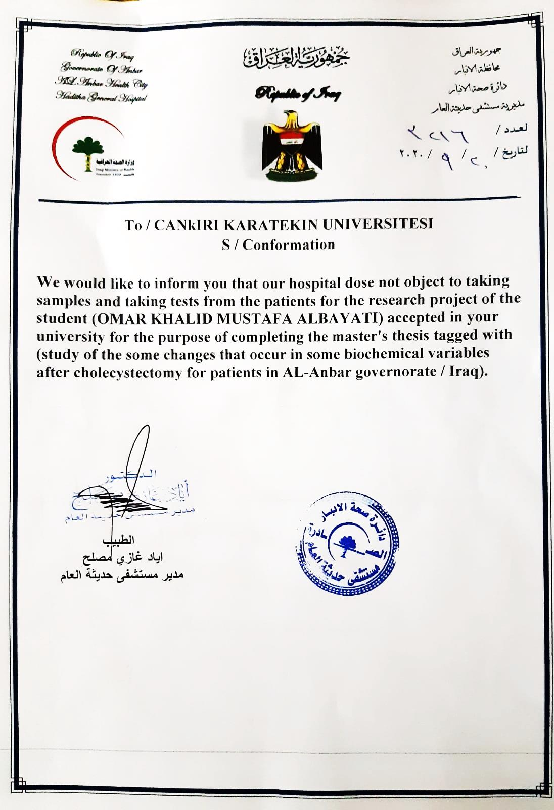

# CURRICULUM VITAE

|  |  |  |
| --- | --- | --- |
| Name and surname | : | Omar Khalid Mustafa ALBAYATI |
| Foreign language | : | Arabic/ English/ Turkish |

Educational Status

|  |  |  |
| --- | --- | --- |
| High School | : | Haditha. 1997 |
| BSc | : | Collage of Sciences (Chemistry) / Alanbar University. 2001 |
| MSc | : | Institute of Sciences (Chemistry) / Cankiri Karatekin  University. 2021 |