**Green chemicals to obtain reduced graphene oxide**

***Mahdı Mohamed DAHER 1, Mahad Ousleyeh ALI 1, Mücahit UĞUR1[C:\Users\Abdullah\AppData\Local\Microsoft\Windows\INetCache\Content.Word\ORCID-iD_icon-16x16.gif](https://orcid.org/0000-0002-3746-5683), Didar ÜÇÜNCÜOĞLU[C:\Users\Abdullah\AppData\Local\Microsoft\Windows\INetCache\Content.Word\ORCID-iD_icon-16x16.gif](https://orcid.org/0000-0002-2640-5976)2,***

***Haluk KORUCU1 [C:\Users\Abdullah\AppData\Local\Microsoft\Windows\INetCache\Content.Word\ORCID-iD_icon-16x16.gif](https://orcid.org/0000-0001-6763-3249)***

*1 Department of Chemical Engineering, Faculty of Engineering, Çankırı Karatekin University, Uluyazı, Çankırı 18100, Türkiye*

*2 Department of Food Engineering, Faculty of Engineering, Çankırı Karatekin University, Uluyazı, Çankırı 18100, Türkiye*

|  |
| --- |
| **Abstract**  To develop sustainable and environmentally friendly processes, researchers have focused on unhazardous compounds, such as reduced graphene oxide (rGO) instead of graphene oxide (GO). One of the synthesis methods is chemical reduction in which hydrazine and sodium boron hydride are intensively used. In this study, urea, glucose and sodium boron hydride were used during the chemical reduction method of GO as natural and green reducing compounds. The structural characterization, reduction performance, surface area measurements of rGO samples were determined with FTIR, SEM+EDS, and BET respectively to characterize the synthesis performance of rGO. According to the results obtained, SEM+EDS and BET surface area recovery results gave the best results with urea at 161.2% and 138.69%. FTIR analysis approved the prefered compounds were significantly effective to get rGO successfully. Overall outcomes of this research suggest urea performs better for the synthesis of rGO than sodium boron hydride and glucose. |
| Keywords: Graphene Oxide, Reduced Graphene Oxide, Hummers TOUR Method, Chemical reduction method |

1. **Introduction**

Graphene oxide (GO), a specific type of graphene, is defined by the presence of oxygen-containing functional groups such as carboxyl, epoxy, and hydroxyl. These groups keep GO hydrophilic, which increases its dispersibility in water and other organic solvents. Improved dispersibility is critical in applications such as drug delivery, where GO's high surface area and biocompatibility allow for successful drug loading and release. [1]. Furthermore, GO's functional groups provide active sites for additional chemical modifications, broadening its use in composite materials and sensor technologies [2]. One of GO's most powerful reducing agents is L Hydrazine, which is well-known for its ability to restore graphene's conjugated structure. Hydrazine reduction often produces high-quality reduced graphene oxide (rGO) with improved electrical conductivity. The main drawbacks of hydrazine are its severe toxicity and environmental concerns, which discourage large-scale and ecologically sensitive uses [3]. Other frequent reducing agents for GO include sodium borohydride (NaBH4). At low temperatures, it successfully decreases GO while being less harmful than hydrazine. Although the reduction is occasionally insufficient, leaving some oxygen-containing groups on the graphene lattice, NaBH4-reduced GO has good electrical properties [4]. The reduction of GO using urea and glucose presents a novel and sustainable method, notable for its ease of use and efficiency, which is attracting considerable interest. Because of its low cost and high organic component concentration, it makes it easier to heat out groups that contain oxygen. The technique yields rGO, exhibiting electrical and thermal properties remarkably like those of graphene. In contrast to conventional reducing agents such as hydrazine, the reduction process that employs urea and sugar presents advantages due to its reduced environmental impact and lower toxicity. In addition to being a promising green reductant for the manufacture of rGO, urea and sugar reduced graphene oxide demonstrate enhanced electrical conductivity and mechanical strength, making it a desirable material for a variety of technological applications [5]. This study utilized urea, glucose, and sodium boron hydride to create reduced graphene oxide using chemical reduction from graphene oxide, which was previously generated via the modified Hummers method. The objective of this study was to characterize the synthesis of reduced graphene oxide. For the characterisation investigation, structural analysis was conducted using FTIR, surface area was measured by BET, and the degree of reduction was assessed using SEM coupled with EDS. The evaluation of GO was conducted in relation to the quality criteria and metrics associated with urea, glucose, and sodium boron-reduced graphene oxide, focusing on the performance assessment of recovery rates and chemical properties.

1. **Materials and Methods**

This study focused on the production of graphene oxide by the Hummers technique from graphite and the characterisation of reduced graphene oxide produced through an environmentally friendly chemical reduction strategy. This study utilized glucose, urea, and sodium boron hydride, commonly referenced in the literature for comparative analysis, as reducing agents. All synthesized samples will be subjected to surface area analysis using the BET technique, the degree of reduction by SEM+EDS, and structure characterization by FTIR spectrum scanning. For graphene oxide synthesis by modified Hummers method from graphite, 10 g of graphite sample, and 30 g of KMnO4 were mixed with 100 mL of H2SO4 and 10 mL of H3PO4 at 5 ℃ for 24 h. The mixture was then mixed for another 6 h at the reaction temperature of 95 °C by adding 100 milliliters of distilled water. The mixture was allowed to cool down at the end of the reaction and 10 mL of H2O2 and 1 mL of HCl were added. Washing was performed using the decantation method until the pH was 3. GO synthesis was performed by subjecting the samples to centrifugation, washing, and drying steps at 60 °C. After 5 g of sodium borohydride, urea and glucose were added to the 2 g of GO samples obtained for three different experiments. 300 mL of distilled water was added at 80 °C. The experiments were carried out for a period of 24 h. At the end of the trials, each sample was washed with pure water by decantation method until it reached pH 7. Then, they were washed with ethyl alcohol and acetone for the last time and dried in a vacuum oven set to 70 °C. The quality standards established for the characterization of GO and rGO samples are listed in **Table 1**.

**Table 1.** Quality standards of the graphene oxide and reduced graphene oxide

|  |  |  |  |
| --- | --- | --- | --- |
| **Quality Criteria** | **Symbol** | **Purpose** | **Provided Information** |
| **1** | FTIR | Characatarizaton of the structure | Functional groups |
| **2** | SEM+EDS | Carbon/Oxygen ratio | Reduction degree |
| **3** | BET | Surface Area | Degree of porosity |

1. **Results and Discussion**

The improvement rates of reduced graphene oxide synthesis are given in **Table 2**. The best result in terms of reduction performance (C/O) and surface area was obtained in the reduced graphene oxide sample synthesized using urea with 161.2% and 138.69%, respectively. The reduction performance of glucose is almost the same as that of sodium boron hydride. The results obtained have shown that it has been found possible to use urea and glucose, which are environmentally friendly and low-cost compounds, instead of sodium boron hydride, which is a costly and toxic compound commonly used in the literature.

**Table 2** Recovery rates between graphene oxide and reduced graphene oxide samples

|  |  |  |  |  |  |  |  |
| --- | --- | --- | --- | --- | --- | --- | --- |
| **Answers** | **GO-Ref** | **rGO-Sodium Borhydre** | **rGO-Urea** | **rGO-Glicose** | **Recovery Rate**  **rGO- Sodium Borhydre (%)** | **Recovery Rate**  **rGO- Urea (%)** | **Recovery Rate**  **rGO- Glicose (%)** |
| BET (SA-m2/g) | 13,36 | 24,75 | **31,89** | 14,73 | 85,2\* | **138,69** | 10,25 |
| SEM+EDS (C/O) | 2,32 | 4,48 | **6,06** | 4,41 | 93,1 | **161,2** | 90 |

*Calculation of the % recovery rate of the experiment performed reference graphene oxide*

*Percentage change = (((New value/Old value)-1) \*100. \* was caltualated as ((24,75 / 13,36)-1\*100 =85,2(plus value means improvement)*

The produced graphene oxide samples FT-IR analysis model reveals that the vibration peak at 1721 cm-1 is C = O, whereas the vibration and deformation peaks of the O-H groups at 3391 cm-1 and 1410 cm-1 are C-O. The graphite structure does not have the C-O stress peak at 1221 cm-1, C-O stress peak at 1046 cm-1, and the C = C stress peak at 1680-1620 cm-1. On the other hand, it was discovered that sodium boron hydride had mostly vanished during the synthesis of reduced graphene oxide for urea and glucose, and the peaks created by graphene oxide synthesis began to resemble graphite when measured in cm-1.

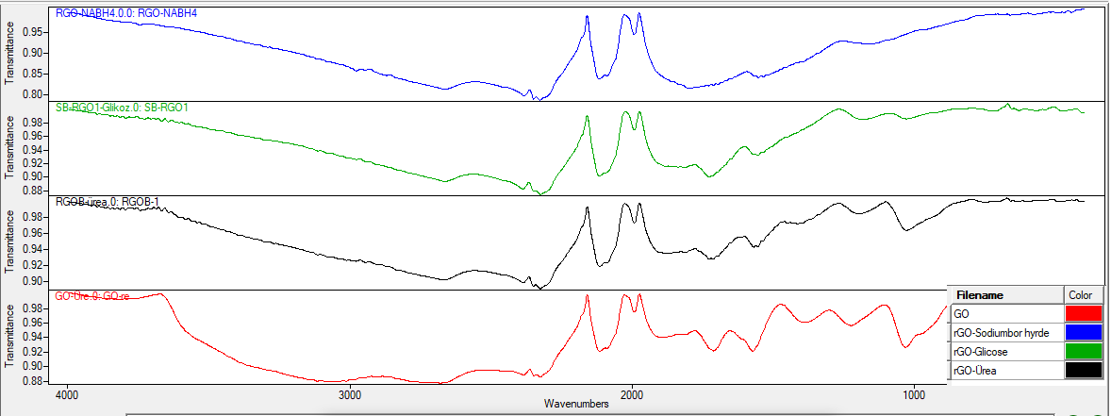

C=C

C=O

C-O-C

C-O

O-H

**Figure 1.** FTIR images of experimental samples

**Figure 1** shows that the produced GO samples' FT-IR analysis model reveals that the vibration peak at 1721 cm-1 is C = O, whereas the vibration and deformation peaks of the O-H groups at 3391 cm-1 and 1410 cm-1 are C-O. The graphite structure does not have the C-O stress peak at 1221 cm-1, C-O stress peak at 1046 cm-1, and the C = C stress peak at 1680-1620 cm-1 [6]. On the other hand, it was discovered that sodium boron hydride, urea, and glucose had mostly vanished GO structure during the synthesis of rGO, and the peaks created by GO synthesis began to resemble graphite.

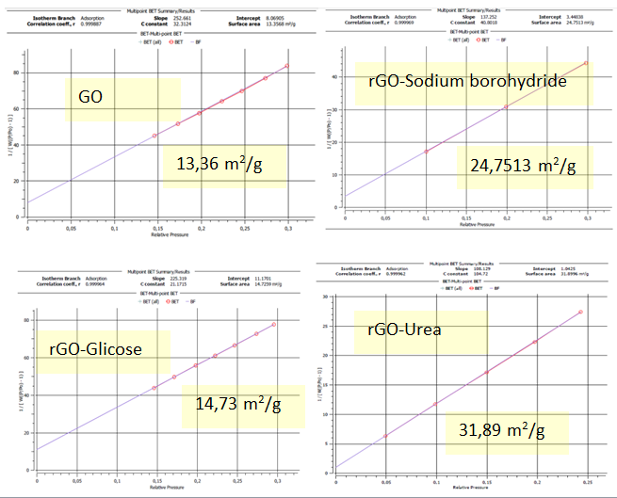

**Figure 2.** BET images of experimental samples

Multi-point BET surface area measurements of graphene oxide and reduced graphene oxide samples are given in **Figure 2**. Reduced graphene oxide samples are expected to have higher surface areas than graphene oxide. As expected, surface areas increased during the manufacture of reduced graphene oxide. Urine produced the best results, while glucose produced the lowest results. The huge surface area is due to the creation of a porous structure; however, contaminants in the structure may have prevented this increase by blocking the pores.

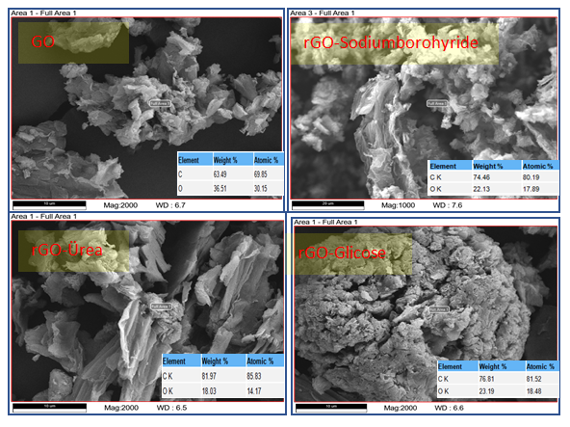

**Figure 3** SEM+EDS results of experimental samples

**Figure 3** shows the SEM images and EDS results. It has been discovered that urea has significantly better reduction performance than sodium boron hydride and glucose, while sodium boron hydride and glucose have similar reduction performance. This indicates that urea offers a more sustainable approach for the reduction of graphene oxide compared to the commonly utilized sodium boron hydride found in existing studies.

1. **Conclusion**

Reduction performance (C/O) was measured by SEM+EDS analysis and C/O atomic ratios were aimed to be large values because it was desired to reduce functional groups with oxygen content for reduction performance. According to the BET method, the surface area results have been analyzed and it is requested that the surface area values be high. As the surface area value increases, the porosity in the structure increases and provides an advantage in the adsorption ability of the material, mass transfer rate, and its use as a catalyst. In addition, the high surface area is an indicator of the formation of micro-pores and lamellar structures. The optimal outcomes for C/O and surface area recovery rates in reduced graphene oxide samples were achieved in the sample synthesized with urea, yielding 161.2% and 138.69%, respectively. The reducing efficacy of glucose is about equivalent to that of sodium borohydride. The findings indicate that environmentally benign and inexpensive molecules, urea and glucose, can substitute for sodium borohydride, a costly and poisonous substance commonly referenced in the literature.

**Acknowledgment**

The authors acknowledge that this research was supported financially by Çankırı Karatekin University, Scientific Research Project (MF081123B33). All experimental activities were carried out in the Research Laboratory of Çankırı Karatekin University. The author expresses gratitude to all sponsors for their valuable input.

**References**

[1] Korucu, H. (2025). Multi response optimization of synthesis of boron compounds by Dopting to graphene oxide in the Modified Hummers method. *Materials Science and Engineering: B, 311, 117839*.

[2] Toda, K., Furue, R., & Hayami, S. (2015). Recent progress in applications of graphene oxide for gas sensing: A review. *Analytica chimica acta, 878, 43-53.*

[3] Park, S., An, J., Potts, J. R., Velamakanni, A., Murali, S., & Ruoff, R. S. (2011). Hydrazine-reduction of graphite-and graphene oxide. *Carbon, 49(9), 3019-3023*

[4] Korucu, H. (2022). Evaluation of the performance on reduced graphene oxide synthesized using ascorbic acid and sodium borohydride: Experimental designs‐based multi‐response optimization application. *Journal of Molecular Structure, 1268, 133715.*

[5] De Silva, K. K. H., Huang, H. H., Joshi, R. K., & Yoshimura, M. (2017). Chemical reduction of graphene oxide using green reductants. *Carbon, 119, 190-199*.

[6] Alam, S. N., Sharma, N., & Kumar, L. (2017). Synthesis of graphene oxide (GO) by modified hummers method and its thermal reduction to obtain reduced graphene oxide (rGO). *Graphene, 6(1), 1-18.*