# ANALYSIS OF STRUCTURAL, ELECTRONIC, MECHANICAL AND THERMODYNAMIC PROPERTIES OF Ir3TiC COMPOUND USING DFT

***İlknur KARS DURUKAN1,[[1]](#footnote-1)\*[C:\Users\Abdullah\AppData\Local\Microsoft\Windows\INetCache\Content.Word\ORCID-iD_icon-16x16.gif](https://orcid.org/0000-0001-5697-0530), Yasemin ÖZTEKİN ÇİFTÇİ1[C:\Users\Abdullah\AppData\Local\Microsoft\Windows\INetCache\Content.Word\ORCID-iD_icon-16x16.gif](https://orcid.org/0000-0003-1796-0270)***

*1Science Faculty, Physics Department, Gazi University, Ankara, Turkey*

|  |
| --- |
| **Abstract**  Antiperovskite materials are a class of materials of great interest due to their unique physical, chemical and thermodynamic properties. These materials are electronically inverted perovskites and have emerged as a growing class of versatile materials, thus providing materials scientists with an effective and fruitful area of research. In our study, the compound Ir3TiC, an antiperovskite compound, was theoretically analysed. Our study is a purely theoretical study, no experimental parameters were used. The compound has Pm3m space group and has cubic structure. The structural, electronic, mechanical and thermodynamic properties of the compound were analysed by the DFT method using the first principles method. Firstly, the structural parameters were determined using geometrical optics. The lattice constant, Bulk modulus and the first derivative of the Bulk modulus were determined by fitting the Murnaghan equation. They were compared with the theoretical and experimental parameters available in the literature. Elastic constants were obtained by Stress-Strain method. The elastic constants were found to be structurally stable by determining their conformity with Born criteria. Young's modulus, Shear modulus, Bulk modulus, Paugh ratio, Caushy pressure and Poisson's ratio, anisotropy value, melting temperature, Debye temperature were obtained from elastic constants. Pugh ratio, Caushy pressure and Poisson's ratio indicated that the compound has a ductile structure. Electronic band structure calculations are important for understanding the physical properties of the crystal structure. By analysing the electronic properties, information such as the nature of the band gap and carrier density is obtained. Electronic band structure calculations showed that the compound is mechanical in nature. In addition, finally, parameters such as Bulk modulus, volume, Heat capacity were determined by detailed analysis of thermodynamic properties. |
| Keywords: Antiperovskite, ductile, thermodynamics |

1. **Introduction**

Perovskites, denoted as ABX3 materials, constitute a extensive group of crystalline substances renowned for their uncomplicated structure and captivating properties. This family of materials was named in honor of the Russian mineralogist L. A. Perovski in 1839[1].

Distinguished by their structural composition and coordination of constituent elements, perovskites manifest in various types, including simple perovskites like KMnF3 and SrTiO3, antiperovskites such as SbNCa3 and BiNCa3, inverse perovskites exemplified by (Eu3O)In and (Eu3O)Sn, double perovskites like SrLaVMoO6, and double antiperovskites represented by Na6FCl(SO4)2 [2]. The inverse counterparts, or antiperovskites (X3BA), are essentially electronically inverted derivatives of perovskites. In these structures, A is a cation positioned at (0, 0, 0), B (C, N) at (1/2, 1/2, 1/2), and the transition metal atom X resides at (0, 1/2, 1/2). Ideal antiperovskites exhibit a cubic structure with a Pm-3m space group [3].

Antiperovskite materials, particularly those with metallic characteristics, exhibit the potential for semiconductor and magnetic properties. The distinctive properties of these materials are contingent on their crystal structure and the specific elements they incorporate. Notably, certain constituents of antiperovskites, exemplified by LiGaO₂, may showcase exceptional conductive attributes.

These materials can be intentionally tailored for application in diverse electronic, magnetic, or optical contexts. Exploring the properties of antiperovskite materials through research contributes to advancements in the realms of materials science and nanotechnology.

In our study, the structural, elastic, electronic and thermodynamic properties of the Ir3TiC antiperovskite compound were studied theoretically using the DFT method. Detailed analysis of the material class, which has an important place in materials science, makes a great contribution to the literature.

1. **Materials and Methods**

All geometric optimization calculations were conducted utilizing the Density Functional Theory (DFT) method within the Vienna ab initio simulation package program (VASP) [4], [5]. The Perdew–Burke–Ernzerhof parameterization (PBE) was specifically employed for the exchange–correlation function, utilizing the generalized gradient approach (GGA). The calculations utilized a plane-wave basis set with an energy cut-off of 700 eV, and a 15 x 15 x 15 Monkhorst and Pack k-point grid in the Brillouin zone for the Ir3TiC compound.

The determination of mechanical properties employed the stress-strain method, facilitated by the implementation of IBRION = 6 commands in VASP 5.4. To explore the dependence of the thermodynamic properties of the Ir3TiC compound on pressure and temperature, a semi-harmonic Debye model approach was employed, utilizing the GIBBS code.

1. **Results and Discussion** 
   1. **Structural Properties**

Ir3TiC antiperovskite compound possess the ideal cubic structure with space group (Pm-3m), Ir ion occupying the corner positions, Ti at the body center and C at the face center of the cube. Their Wyckoff positions are Ir: 1a (0,0,0); Ti: 1b (1/2,1/2,1/2); C: 3c (1/2,1/2,0) respectively. Preceding any calculations, a geometric optimization was meticulously conducted to ascertain the most stable configuration of the CsCl crystal structure. The lattice constant of the compound was found to be 4.095 A and was determined to be compatible with the literature [1].

* 1. **Elastic Properties** Elastic properties play a crucial role in revealing the bonding characteristics among adjacent atoms, offering insights into a material's flexibility, hardness, and mechanical stability. In the case of the cubic Ir3TiC compound with a pm3m structure, the calculation of second-order elastic constants was carried out through the stress-strain method. Given its cubic structure, the Ir3TiC compound possesses three distinct elastic constants: C11, C12, and C44. These constants adhere to the Born criteria, ensuring the material's stability (C11 + C12 > 0, C44 > 0, and C11-C12 > 0)[6]. This analysis provides a comprehensive understanding of the compound's mechanical behavior and underscores its structural integrity.

**Table 1.** Calculated Elastic constants C11(GPa), C12(GPa) and C44(GPa), Bulk modulus (B, GPa), Young modulus (E, GPa), Poisson's ratio (**v**, GPa) of the Ir3TiC compound

|  |  |  |  |  |  |  |  |
| --- | --- | --- | --- | --- | --- | --- | --- |
| Material | C11 | C12 | C44 | B | G | E | v |
| Ir3TiC | 404.5 | 209 | 48.1 | 274.1 | 64.1 | 178.3 | 0.391 |
| ref [1] | 380.4 | 208 | 51.9 | 265.5 | 86.2 | 233.3 | 0.353 |

Table 1 showcases the mechanical properties derived from the elastic constants. The material exhibits elevated values for Bulk Modulus and Young's Modulus, suggesting a high resistance to volume and linear deformations, respectively. Simultaneously, the relatively low Shear Modulus implies a moderate resistance to shape distortion, classifying the compound as moderately hard. Notably, the Poisson's ratio exceeding 0.26 signifies ductility, indicating the material's ability to undergo significant deformation without compromising its structural integrity[7].

* 1. **Electronic Properties**

The nature of a material is revealed through its electronic properties, which in turn greatly influence the precision of its physical characteristics. To delve into the electronic structure and phase stability of Ir3TiC, Fig. 1 illustrates the energy band structure along the high symmetry direction (Γ-X-M-Γ-R), accompanied by the total electronic state density. The Fermi level is constantly set at 0 eV. The absence of any band gap at the Fermi level indicates that the compound has metallic character.

The changes in the partial DOS graphs of the Ir3TiC compound are seen in Figure 1. We can evaluate the given graph as Fermi level, valence band and conduction band. The biggest contribution to the Fermi level at zero comes from the Ir-d and Ti-d bands. The largest contribution to the valence band comes from Ir-d states, while the largest contribution to the conduction band comes from Ti-d states.

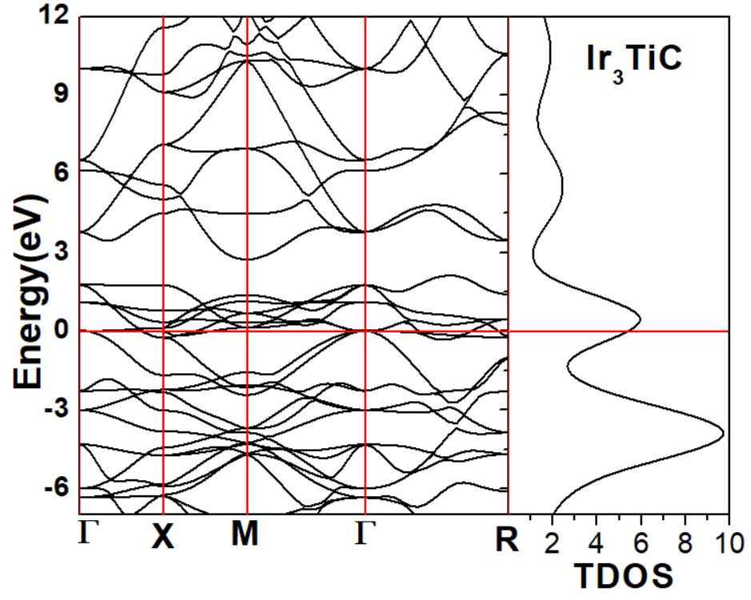

**Figure 1.** Electronic band structure and total density of Ir3TiC

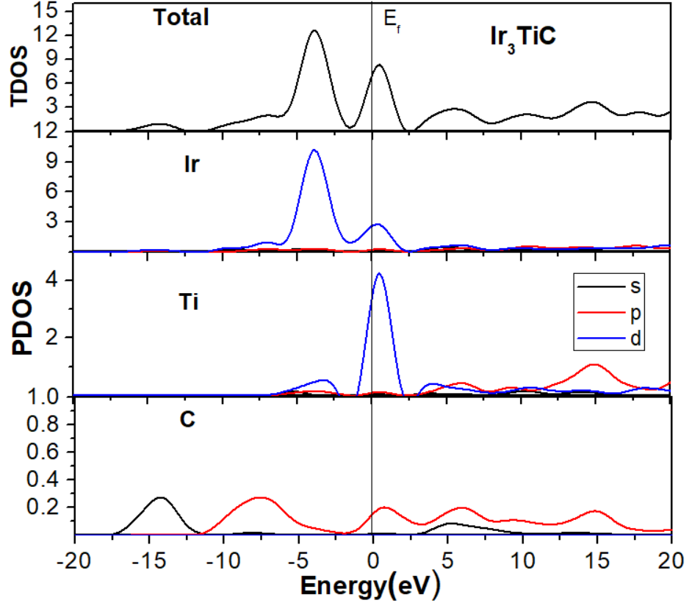

**Figure 2.** Partial density of states of Ir3TiC

The effects of the Ir3TiC compound on thermodynamic properties when exposed to high temperature and high pressure were investigated. Thermal properties were calculated with the Gibbs code half-harmonic Debye model [8]. Thermodynamic properties were analyzed in the temperature range of 0–1000 K and the pressure range of 0–50 GPa.

The effect of pressure and temperature on volume change was investigated in Fig.3. When the pressure is kept constant, the volume decreases as the temperature increases. When the temperature is kept constant, the volume decreases as the pressure increases. The effect of pressure is greater in the compound.

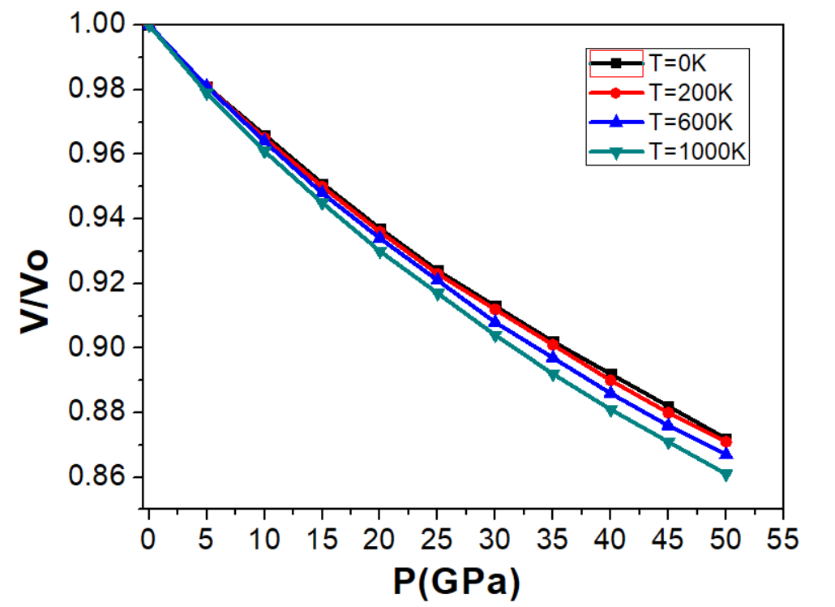

**Figure 3.** The variations of V/V0 with pressure at different temperature for Ir3TiC

The change of bulk modulus against pressure and temperature is examined in Figure 4. When the pressure is kept constant, the bulk modulus decreases as the temperature increases. Bulk modulus increases as the pressure increases when the temperature is kept constant. The effect of pressure is greater in the compound. The results show that the studied compound is compressible.

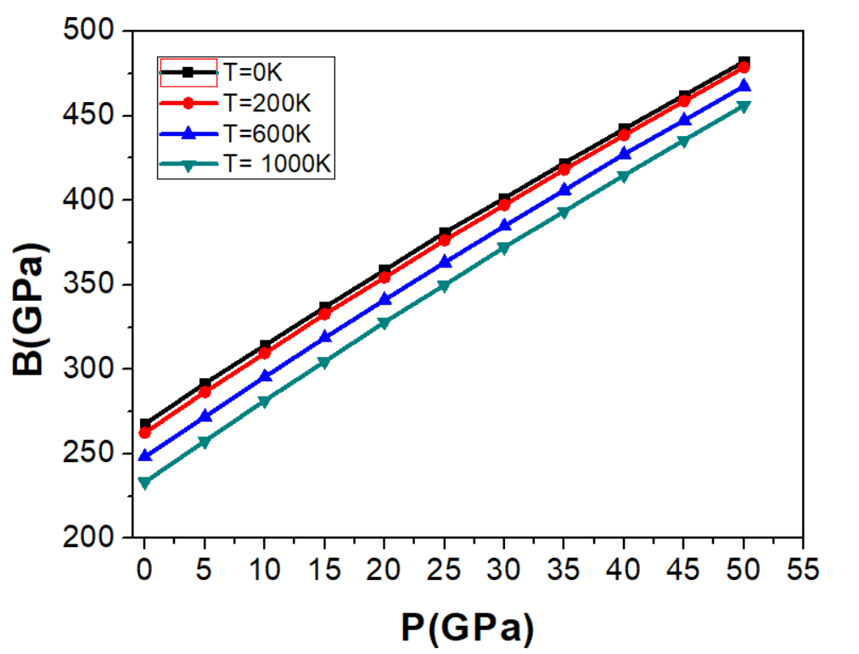

**Figure 4.** The variations of Bulk modulus with pressure at different temperature for Ir3TiC

The Debye temperature, denoted as θD, serves as a key indicator of diverse physical properties in solids, encompassing elastic constants, specific heat, and melting temperature [9]. Figure 5 illustrates the Debye temperature values and their correlation with temperature. As temperature rises at a constant pressure, Debye temperatures decrease, whereas they ascend with increasing pressure at a constant temperature. Notably, the impact of pressure on the Debye temperature surpasses that of temperature, underscoring its predominant role in shaping the material's characteristics.

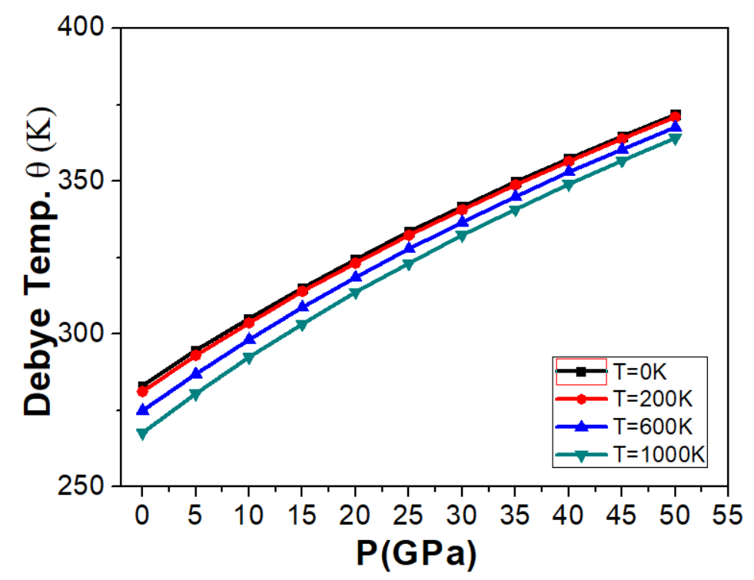

**Figure 5.** The variations of Debye temperature with pressure at different temperature for Ir3TiC

Figure 6 illustrates the correlation between temperature and pressure concerning heat capacities (Cv). The Cv values exhibit a rapid increase with rising temperature, particularly up to 300 K, following a proportional relationship with T^3[10]. Beyond 300 K, the rate of increase gradually diminishes, reaching a stabilization point that aligns with the Petit and Dulong limit[11], a characteristic shared by many high-temperature solids[12]. For the compound, the calculated heat capacity values at 900 K and 0 GPa stand at 124.16 J/mol·K.

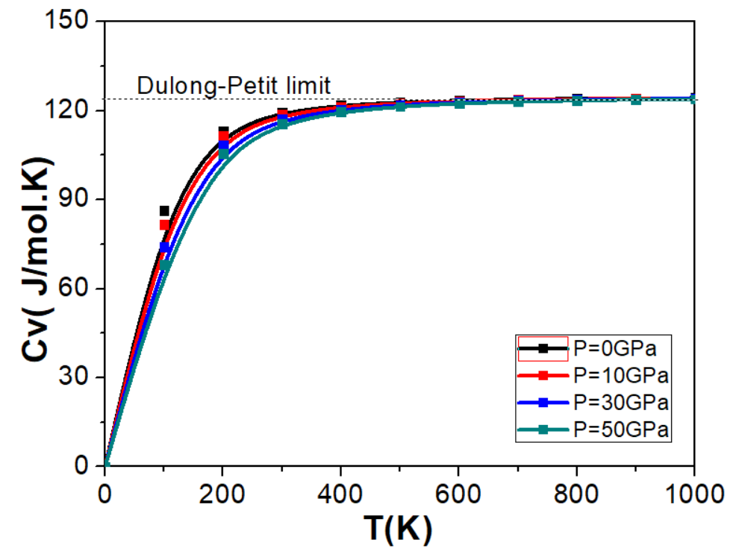

**Figure 6.** The variations of Cv with temperature at different pressure for Ir3TiC

1. **Conclusion**

First principles calculations were performed using the GGA approach to study the structural, elastic, electronic and thermodynamic properties of Ir3TiC. It was determined that the compound was structurally stable. The compound has a ductile structure and showed metallic properties. Thermodynamic properties at high temperature and pressure values were evaluated in detail.

**References**

[1] Bannikov, V. V., Shein, I. R., & Suetin, D. V. (2017). Structural, elastic and electronic properties of Ir-based carbides-antiperovskites Ir3MC (M = Ti, Zr, Nb and Ta) as predicted from first-principles calculations, *Computational Condensed Matter*, *11*, 60–68.

[2] Rasul, M. N., Mehmood, M., Hussain, A., Rafiq, M. A., Iqbal, F., Khan, M. A., & Manzoor, A. (2022). Investigation of the Physical Properties of XCRh3 (X = Ti, V, Cr, Mn, Fe, Ni, Cu, Zn, Zr, Nb, Mo, Tc, Ru, Pd, Ag) Inverse Perovskites from First Principles, *Journal of Electronic Materials*, *51*, 5880–5896.

[3] Bannikov, V. V., Shein, I. R. Anionic state of platinum-group metal atoms in a series of ternary and quarternary compounds. *Computational Condensed Matter*, *22*, e00441.

[4] Mehmood, N., Ahmad, R., & Murtaza, G.(2017). Ab Initio Investigations of Structural, Elastic, Mechanical, Electronic, Magnetic, and Optical Properties of Half-Heusler Compounds RhCrZ (Z = Si, Ge), *Journal of Superconductivity and Novel Magnetism*, *30*, 2481–2488.

[5] Kresse, G., Hafner, J. (1993). Ab initio molecular dynamics for liquid metals, *Physical Review B*, *47*, 558–561.

[6] Mouhat, F., Coudert, F. X. (2014). Necessary and sufficient elastic stability conditions in various crystal systems,” *Physical Review B - Condensed Matter and Materials Physics*, *90*, 4–7.

[7] Zeng, X., Peng, R., Yu, Y., Hu, Z., Wen Y., & Song, L.(2018). Pressure effect on elastic constants and related properties of Ti3Al intermetallic compound: A first-principles study, *Materials*, *11*, 10.

[8] Blanco, M. A., Francisco, E., & Luaña, V. (2004). GIBBS: Isothermal-isobaric thermodynamics of solids from energy curves using a quasi-harmonic Debye model, *Computer Physics Communications*, *158*, 57–72.

[9] Sahnoun, O., Bouhani-Benziane, H., Sahnoun, M., Driz, M., & Daul, C. (2018). Ab initio study of structural, electronic and thermodynamic properties of tungstate double perovskites Ba2MWO6 (M = Mg, Ni, Zn), *Computational Materials Science*, *77*, 316–321.

[10] Durukan, I. K., Ciftci, Y. O. (2021). Ab-initio study on physical properties of intermetallic LiPb compound, *Journal of Computational Science*, *54*, 101428.

[11] Sefir, Y. ,Terkhi, S., Zitouni, Z., Bekhti Siad, A., Seddik, T., Benani, M. A., Lantri, T., & Bentata, S. (2021). Structural, electronic, magnetic and thermodynamic properties of the new multifunctional half-Heusler alloy CoTcSn: Half-metallic and ferromagnetic behaviour, *Pramana - Journal of Physics*, *95*, 2.

[12] Touia, A., Benkhaled, M , Khobzaoui, C., & Fodil, M. (2021). Optical and Thermodynamic Properties of Half-Heusler Compound TaIrSn: Using Modified Becke-Johnson (mBJ), *Journal of Superconductivity and Novel Magnetism*, *34,* 2865–2877.

1. \* Corresponding author. *e-mail address: ilknurdurukan.@gazi.edu.tr* [↑](#footnote-ref-1)