**Tyrosinase inhibitory capacity of extracts obtained from different branches of endemic *Centaurea* (*C. paphlagonica* and *C. cankiriense*) plants from the same region**

***Zeyad Adil HAMEED*\**1[C:\Users\Abdullah\AppData\Local\Microsoft\Windows\INetCache\Content.Word\ORCID-iD_icon-16x16.gif](https://orcid.org/0000-xxxx-xxxx-xxxx)****,* ***Ali Rıza TÜFEKÇİ2[C:\Users\Abdullah\AppData\Local\Microsoft\Windows\INetCache\Content.Word\ORCID-iD_icon-16x16.gif](https://orcid.org/0000-xxxx-xxxx-xxxx), Şevki ADEM3[C:\Users\Abdullah\AppData\Local\Microsoft\Windows\INetCache\Content.Word\ORCID-iD_icon-16x16.gif](https://orcid.org/0000-xxxx-xxxx-xxxx)***

**1*Faculty of Science, Department of Chemistry, Cankiri Karatekin University, Cankiri, Turkey***

**2*Faculty of Science, Department of Chemistry, Cankiri Karatekin University, Cankiri, Turkey***

**3*Faculty of Science, Department of Chemistry, Cankiri Karatekin University, Cankiri, Turkey***

|  |
| --- |
| **Abstract**  In recent years, a lot of resources have been devoted to research for the treatment of disorders caused by this enzyme, especially on the discovery and use of herbal products. This study aims to demonstrate the antithyrosinase effects of the extracts of two endemic plant species from the *Centaurea* family from the same region by targeting the inhibition of the tyrosinase enzyme, which also causes skin cancer by increasing melanin synthesis. Inhibitory activity values of methanol:chloroform extracts of *Centaurea paphlagonica* and *Centaurea cankiriense* plant samples against tyrosinase enzyme were investigated. The samples examined were found to have IC50 values in the concentration range of 180.51-1359.13 μg/ml. In the light of the findings obtained, it was observed that *C. paphlagonica* extracts had the highest activity and had more inhibitory effect, and that changing the extraction method affected the activity very much. The high activity of some extracts of our plant samples against tyrosinase enzyme, albeit selectively, is a promising factor for future research. |
| ***Keywords:*** *Centaurea paphlagonica*, *Centaurea cankiriense*, Tyrosinase, Enzyme activity, Endemic |

1. **Introduction**

Plants hold a prominent position as fundamental sources of food worldwide. Naturally, occupying this primary role exposes them to numerous external threats. Similar to all living organisms, plants engage in interactions with various diseases and pests. These detrimental entities adversely affect plants by directly feeding on them, laying eggs, establishing hosts, and instigating various disease factors [1].From ancient times to the present, the use of plants for therapeutic purposes is based on their inherent therapeutic properties. This has directed scientists to acknowledge the effectiveness of traditional medical treatments and integrate them into modern therapeutic practices. Treatment methods have evolved with the progress of technology and the development of new techniques and devices. Scientists have even begun to adopt a complementary approach to evaluate natural and herbal products as a whole, combining them with conventional practices. In recent years, there has been a global increase in demand for natural solutions in the treatment and prevention of diseases [2]. The pursuit of alternative medicine, attracting scientists in many countries, has increased, similar to in our country. Beyond the methods offered by modern medicine, many patients are turning towards eco-friendly herbal remedies that are natural, harmless, cost-effective, and easily accessible, with minimal side effects [3].

*Centaurea* genus belongs to the Asteraceae family and includes approximately 500 resilient, herbaceous plants that can be annual, biennial, or perennial. It is widely distributed globally, particularly across various regions of Asia, Europe, and North America [4]. In Turkey, the Centaurea genus is represented by 179 species, with 111 of them exhibiting endemic characteristics, resulting in an endemism rate of 61%, as presented in the most recent record [5]. This endemism rate distinguishes the *Centaurea* genus as the third most prominent genus hosting endemic species in the Turkish flora. This rate suggests that Turkey serves as the genetic center for these plants. Many species belonging to this genus are utilized in traditional folk medicine.

Some *Centaurea* plant species have been used for the treatment of some diseases by the people since ancient times. For this reason, recently, an intensive study has been carried out or planned to reveal the biological potentials of the subspecies belonging to this genus, which have not been revealed or missing. In addition to revealing the characteristic active compounds of these species, it is stated that they can be used in all fields of pharmacology by isolating valuable chemical compounds that cause activity power [6]. The aim of this study was to determine the inhibition potential of extracts obtained from different parts of *C. paphlagonica* and *C. cankiriense* plants on tyrosinase enzyme. This study is the first in terms of the inhibition of these two plant species on tyrosinase enzyme so far.

1. **Materials and Methods**

**2.1. Plant materials**

*Centaurea paphlagonica* and *Centaurea cankiriense* are distributed in the same area. These two plant species were collected from Kalfat, Orta district, Çankırı province in July-August 2017. Species identifications of the plant species were made by Dr. Selçuk Tuğrul Koruklu, lecturer at Ankara University, Faculty of Science, Department of Biology, and the plant samples were stored in Ankara University herbarium.

**2.2. Preparation of extracts**

*Centaurea* plant samples were collected from the central district of Çankırı province of Turkey during the flowering period. The collected plants were first separated into root, stem-leaf and flower parts and dried. Each dried plant branch was disintegrated separately in liquid nitrogen. The finely crushed plant branches were first extracted with hexane and then with methanol/chloroform (1:1) solvent (**Fig.1**). The solvents of the extracts were removed in a rotary evaporator and stored at +4 degrees until the activity studies [7, 8, 9]. Hexane extracts were not included in the study because they were not soluble. The study continued with methanol/chloroform extracts.

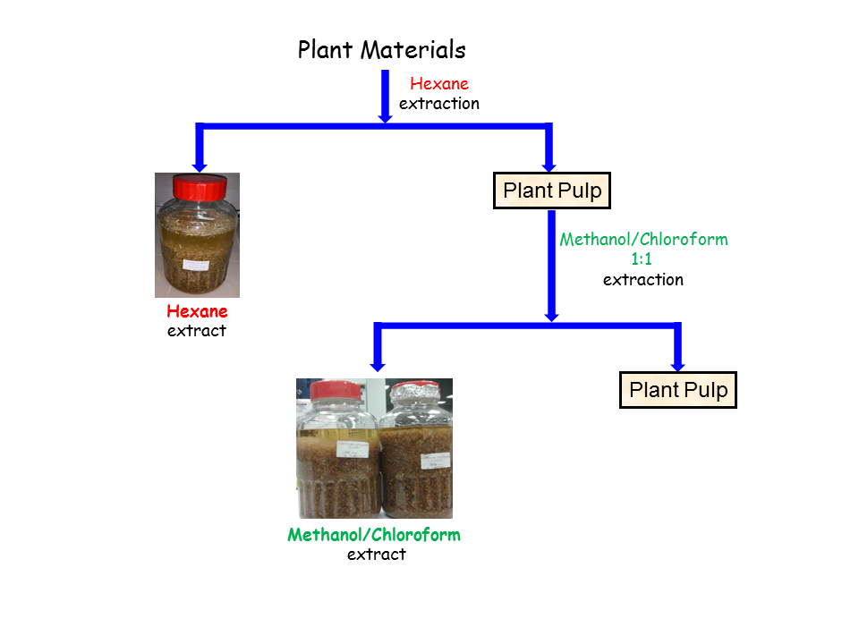

**Fig. 1** Methods of obtaining extracts from plants

**2.3. Tyrosinase enzymes activities**

The inhibitory activity of the extracts against tyrosinase enzyme in vitro was performed according to the renewed dopachrome method with minor modifications in the method used by Sarıkurkcu et al.[10, 11]. According to this method, the extracts were previously dissolved 1:1 with DMSO solvent and stock extract solutions were prepared. 25 μL of the stock solutions were taken and 40 μL of tyrosinase solution and 100 μL of sodium phosphate buffer (pH 6.8) were added and mixed. The mixture was incubated at 25°C for 15 minutes. To the final mixture, 40 μL L-DOPA was added and the mixture was incubated again at 25°C for 10 minutes. Absorbance measurements were performed at 492 nm. Scutellarin compound was used for in vitro tyrosinase enzyme activity assays.

**3. Results and Discussion**

*C. paphlagonica ve C. cankirien*se bitkilerinin farklı dokularının metanol/kloroform (1:1) ekstrelerinin tirozinaz enzimine karşı inhibe edici etkileri belirlenmiştir (Table 1).

**Table 1**. IC50 values of *C. cankiriense* and *C. paphlagonica* extracts on tyrosinase enzyme

|  |  |
| --- | --- |
| Extracts Code | Tyrosinase  IC50 (µg/ml) |
| AT-1 (*Centaurea cankiriense*-Flower) | 1359.11 |
| AT-2 (*Centaurea cankiriense*-Steam/Leaf) | 980.05 |
| AT-3 (*Centaurea cankiriense*-Root) | 1000.63 |
| AT-4 (*Centaurea paphlagonica*-Flower) | 180.51 |
| AT-5 (*Centaurea paphlagonica-*Steam/Leaf) | 202.15 |
| AT-6 (*Centaurea paphlagonica*-Root) | 770.17 |

Table 1 shows that the IC50 value of AT-1 coded methanol/chloroform extracts of *C. cankiriense* plant inhibiting tyrosinase enzyme was found as 1359.11 μg/ml. This value shows that the extract activates the tyrosinase enzyme. Likewise, AT-3 extract activated the tyrosinase enzyme with an IC50 value of 100.63 μg/ml. According to Table 1, it was observed that the AT-4 extract of *C. paphlagonica* has a very high inhibitory effect among the extracts of both plant groups with an IC50 value of 180.5 µg/ml. From the Table 1, it was revealed that AT-5 extract had an inhibition value close to AT-4 with an IC50 value of 202.15 µg/ml under in vitro conditions. AT-6 extract was found to have less inhibition effect than these two extracts. Since there were no studies on these two species, when tyrosinase activity studies on similar species were examined, it was determined in the literature that *C. fenzlii* plant has high inhibition [12, 13, 14]. In a study conducted by Kısa et al. in 2024, they examined the inhibition effect of the methanol extract of *C. cadmea* subsp. *pontica* against 10 enzymes including tyrosinase enzyme. They found a high activity result of 46.02 mg/ml IC50 value against all enzymes, especially against Urease and Tyrosinase enzyme [15].

The enzyme tyrosinase is one of the most important enzymes for the regular functioning of the living body and health. With the increase in global warming in the world, the continuous exposure to harmful UV rays makes it important for the tyrosinase enzyme to make positive contributions to the living system. In this respect, it is an enzyme that catalyzes the production of melanin pigment that helps prevent UV light. Excessive secretion or production of tyrosinase enzyme can cause hyperpigmentation and neurodegenerative diseases such as Parkinson's disease for living organisms and especially for humans. Naturally derived inhibitors of the tyrosinase enzyme can be used in the treatment of most skin cancers as well as dermatologic diseases associated with melanin deposition [16, 17].

Today, changing living conditions and eating habits increase the risk of developing chronic and degenerative diseases. Efforts to minimize this problem are one of the focal points of the scientific world. In this context, the biological activities exhibited by plants are recognized as an important resource in the development of new drug and food formulations. According to the results of our study, methanol/chloroform extracts of *Centaurea* *cankiriense* and especially *Centaurea paphlagonica* showed high enzyme inhibitory effects. Nowadays, it is important to identify safe and effective functional agents and in this context, the natural components of *Centaurea* species can be considered as a potential source. The activities and tyrosinase enzyme properties of these plants hold special promise for further studies and for the treatment of many diseases caused by aging and UV radiation.

**Acknowledgment**

In this study, the financial support was provided by University of Çankırı Karatekin.

**Conflict of Interest**

The article authors declare that there is no conflict of interest between them

**Author’s Contributions**

The authors declare that they have contributed equally to the article

**References**

[1] Karakaş, M. (2018). Önemli bazı bitkisel insektisitler. *Turkish Journal of Scientific Reviews*, *11*(2): 32-37.

[2] Boutemak, K., Safta, B., & Ayachi, N. (2015). Study of the anti-ınflammatory activity of flavonic extract of *Globularia alypum* L. *Acta Physica Polonica A*, *128*(2B).

[3] Begaa, S., Messaoudi, M., & Benarfa, A. (2021). Statistical approach and neutron activation analysis for determining essential and toxic elements in two kinds of Algerian *Artemisia* plant. *Biological Trace Element Research*, *199*(6), 2399-2405.

[4]. Clapman, A., Tutin, T., Warburg, W. (1952). The flora of the British Isles. Cambridge University Press, Cambridge, UK. 1952.

[5]. Davis, P.H. (1965). Flora of Turkey and the east Aegean islands:Edinburgh University Press.

[6] Reyhan, A., Küpeli, E., & Ergun, F. (2004). The biological activity of *Centaurea* L. species. *Gazi University Journal of Science*, *17*(4): 149-164.

[7] Gecibesler, I.H., Demirtas, I., Behcet, L., & Tufekci, A.R. (2017). Two new flavonoids and other phytochemicals from endemic *Phryna ortegioides* (Fish. & CA mey.) pax & k. hoffm and their antioxidant potentials. *Records of Natural Products*, *11*(3): 290-298.

[8] Köksal, E., Ulutaş, Y., Şimşek, S., Bayraktar, T., Altay, A., Çatır, M., Demirtaş, İ., Tüfekçi, A.R., Kandemir, A., Alp, C., Alemdar, M.A., & Akşit, H. (2021). Isolation, characterization and antiproliferative activity of secondary metabolites from *Tanacetum alyssifolium* (Bornm.) grierson. *Records of Natural Products*, 15(2).

[9] Tüfekçi, A.R., Akşit, H., Gül, F.,, & Demirtaş, İ. (2018). Determination of phenolic profile of *Cirsium arvense* (L.) Scop. subsp. *vestitum* (Wimmer et Grab.) Petrak Plant. *Eurasian Journal of Biological and Chemical Sciences*, *1*(2): 33-36.

[10] Sarikurkcu, C., Kirkan, B., Ozer, M.S., Ceylan, O., Atilgan, N., Cengiz, M., & Tepe, B. (2018). Chemical characterization and biological activity of *Onosma gigantea* extracts. *Industrial Crops and Products*, *115*, 323-329.

[11] Tüfekçi, A.R., Akşit, H., Şimşek, S., Karakoç, Ö.C., Adem, Ş., Hameed, Z.A., Atalar, M.N., & Topkara, A.R. (2023). Evaluation of insecticidal and enzyme activity potentials of essential oils and extracts of *Chenopodium botrys* against storage products pests. *Bulletin of Biotechnology*, *4*(1): 7-12.

[12] Yirtici, Ü. (2019). *Centaurea fenzlii* reichardt özütünün antioksidan özellikleri ve enzim inhibisyon etkisinin belirlenmesi. *Bitlis Eren Üniversitesi Fen Bilimleri Dergisi*, *8*(1): 66-73.

[13] Zengin G., Bulut G., Mollica A., Nancy Picot-Allain C.M., Mahomoodally M.F. 2018. In vitro and in silico evaluation of *Centaurea saligna* (K.Koch) Wagenitz-An endemic folk medicinal plant. *Comput Biol Chem*, *73*: 120-126.

[14] Zengin, G., Zheleva-Dimitrova, D., Gevrenova, R., Nedialkov, P., Mocan, A., Ciric, A., Glamoclija, J., Sokovic, M., Aktumsek, A., Mahomoodally, M.F. (2018). Identification of phenolic components via LC-MS analysis and biological activities of two *Centaurea* species: *C. drabifolia* subsp. *drabifolia* and *C. lycopifolia*. *Journal Pharm Biomed Anal*, *149*: 436-441.

[15] Kısa, D., Çelik, A., & İmamoğlu, R. (2024).Assessment of inhibitory ability against medicinally important enzymes with *in vitro* and ,n silico studies: phenolic content of endemic *Centaurea cadmea* subsp. pontica. *Kahramanmaraş Sütçü İmam Üniversitesi Tarım ve Doğa Dergisi*, *27*(1): 14-25.

[16] Aghraz A., Goncalves S., Rodriguez-Solana R., Dra L.A., Di Stefano V., Dugo G., Cicero N., Larhsini M., Markouk M., Romano A. 2018. Antioxidant activity and enzymes inhibitory properties of several extracts from two Moroccan Asteraceae species. *South African Journal of Botany*, *118*: 58-64.

[17] Fatullayev, H., Paşayeva, L., Celik, I., İnce, U., & Tugay, O. (2023). Phytochemical composition, in vitro antimicrobial, antioxidant, and enzyme inhibition activities, and in silico molecular docking and dynamics simulations of *Centaurea lycaonica*: A Computational and Experimental Approach. *ACS Omega*, 25(8): 22854-22865.