**ÇANKIRI KARATEKİN UNIVERSITY**

**SCIENCE INSTITUTE**

**MASTER'S THESIS**



**MENOPAUSAL HORMONES DISTRURBANCE IN YOUNG AND ELDER BREAST CANCER PATIENTS IN IRAQ**

**AHMED ABDULAMEER HUSSIEN**

**Supervisors**

**Prof. Dr. Ayşe Şahin YAĞLIOĞLU**

**BIOCHEMISTRY /CHEMISTRY DEPARTMENT**

**ÇANKIRI**

**2021**

**All rights reserved**

**THESIS APPROVAL**

The thesis study titled **"MENOPAUSAL HORMONES DISTRURBANCE IN YOUNG AND ELDER BREAST CANCER PATIENTS IN IRAQ"** prepared by **AHMED ABDULAMEER HUSSIEN** .../.../2021 was unanimously accepted as a **MASTER THESIS** in Çankırı Karatekin University Institute of Science, **Department of Biochemistry.**

**Supervisors:** Prof. Dr. Ayşe ŞAHİN YAĞLIOĞLU

**Co-Supervisor**: Assisstant Prof. Maha Elttayef Jasım

Jury Members: Dr. ……………………………….

………………. Universty, ………. Department

Jury Members: Dr. ……………………………….

………………. Universty, ………. Department

Jury Members: Dr. ……………………………….

………………. Universty, ………. Department

**I confirm the above result**

Pro. Dr. Ibrahim ÇİFTÇİ

Institute director

**... /... / 2021**

**Checked**

**DECLARATION OF CONFORMITY TO ETHICAL PRINCIPLES AND RULES**

The thesis that I have prepared according to the Graduate Education and Examination Regulation of Çankırı Karatekin University Institute of Science and Technology is an original study that belongs to me. I have acted in accordance with the scientific ethical principles and rules in all stages of my study, including preparation, data collection, analysis and presentation of information, that I did not get the innovations and results contained in the thesis from elsewhere, that I cited the works I used in the thesis duly as a source, I declare that I have not given another scientific committee for academic purposes and titles and that this study has been scanned with the "Scientific Plagiarism Detection Program" used by Çankırı Karatekin University and that it does not contain "plagiarism". I declare that I agree to all moral and legal consequences that will arise in the event that a situation contrary to this statement I have made regarding my work is detected. I would like to request that the necessary action be taken in accordance with the related articles of Çankırı Karatekin University Graduate School of Natural and Applied Sciences. (31 / May / 2021).

AHMED ABDULAMEER HUSSIEN

(Signature)

# ÖZET

Yüksek Lisans Tezi

Irak'ta Genç ve Yaşlı Meme Kanseri Hastalarında Menopoz Hormonları Rahatsızlığı

Ahmed Abdulameer HUSSIEN

Çankırı Karatekin Üniversitesi

Fen Bilimleri Enstitüsü

Kimya Anabilim Dalı

Danışman: Prof. Dr. Ayşe ŞAHİN YAĞLIOĞLU

Assisstant Prof. Maha Elttayef Jasım (Eş Danışman)

Meme kanseri (BC), meme hücrelerinden bazılarının kontrolsüz olarak çoğalması nedeniyle ortaya çıkan bir hastalıktır. Bu nedenle, bu çalışma da meme kanserinin erken teşhisi amaçlanmıştır. Bu amaca yönelik bazı kimyasal testler yapılmıştır. Araştırmaya 26-66 yaş aralığındaki 130 kadın dahil edilmiştir. Bu kadınlar hasta grubu ve kontrol grubu olarak bilinen iki gruba ayrıldı. Grup A, kontrol grubu 65 sağlıklı kadın, grup B ise 65 meme kanserine yakalanmış kadını temsil etmektedir. Antropometrik testler yaş, BMI ve ağırlık gibi bazı parametrelerin bir fonksiyonu olarak yapılmıştır.

Buna ek olarak, FSH, E2, Testosteron, Progesteron, Kan Üre ve S. Kreatinin gibi diğer bazı önemli kimyasal testler de gerçekleştirilmiştir; Sonuçlar incelendiğide, FSH, Testosteron, Progesteron, ALP, Hb testleri için istatistiksel İstatistiksel analizin sonuçlarında gözlenen önemli farklılıklar, meme kanserinin erken teşhisinde, bu testlerin kimyasal belirteçler olarak kullanılabileceğini desteklemektedir. Bununla birlikte, Got, Gpt, Kan üre ve kreatinin gibi diğer bazı testler için önemli bir istatistiksel farklılık tespit edilememiştir.

**2021, 91 sayfa**

**ANAHTAR KELİMELER**: Meme Kanseri, Kadın, Antropometrik

# ABSTRACT

Master Thesis

Menopausal Hormones Distrurbance In Young And Elder Breast Cancer Patients In Iraq

Ahmed Abdulameer HUSSIEN

Çankırı Karatekin University

Graduate School of Natural andApplied Sciences

Biochemistry /Chemistry department

Supervisors: Prof. Dr. Ayşe ŞAHİN YAĞLIOĞLU

Assisstant Prof. Maha Elttayef Jasım (Co-Supervisor)

Breast cancer (BC) is a disease that breast cells grow out of control. Therefor, the early detection of breast cancer disease was the main aim of this study. In this study, several significant chemical tests have been done according to the aim of study. The study included 130 woman at the age range between 26 - 66 years old. These women were divided in two groups known as patient group and control group. The control group included 65 healthy woman (group A), while group B included 65 patient suffered from breast cancer disease. Anthropometric tests were performed as a function of some parameters such as; age, BMI, and weight. In addition preformed some other significant chemical tests were also performed such as; FSH, E2, Testosterone, Progesterone, Blood Urea, and S. Creatinine. In our results, there was a statistical significance for the FSH, Testosterone, Progesterone, ALP, Hb tests. The results of statistical analysis refer to significant differences and can be used as chemical markers to early diagnoses for women that suffering from the breast cancer disease. While there were no significant differences for some other tests such as; Got, Gpt, Blood urea, and creatinine.

**2021, 91 pages**

**KEY WORDS:** Breast cancer, Women, Anthropometric

# ACKNOWLEDGEMENTS

I would like to thank all the people who helped me make this work possible.

To My supervisor Prof. Dr. Ayşe ŞAHİN YAĞLIOĞLU and second supervisor Dr. Maha Lateef Jasem for their guidance and assistance;

To Dr. Ali abbas for his support and always being available to help;

To the oncology department at Tikrit General Hospital for the time and effort they spent to provide me with datas;

To my mother for her support and encouragement;

To my brothers and sisters for their support;

To my wife for always believing in me, and for your thoughts and concern;

To my friends, for always being there. Especially my friend Saif who supported me in doing this work;

thank you so much.

AHMED ABDULAMEER HUSSIEN

ÇANKIRI, May 2021

# TABLE OF CONTENTS

# page

**ÖZET iv**

**ABSTRACT v**

**ACKNOWLEDGEMENTS vi**

**TABLE OF CONTENTS vii**

**LIST OF FIGURES x**

**LIST OF TABLES……………………………………………………………….….xi**

**ABBREVIATION…………………………………………………………………..xii**

**1. INTRODUCTION AND AIM 1**

**1. LITERATURE REVIEW 3**

**2.1 Woman Reproductive System and Menopause 3**

**2.1.1 Woman Reproduction System 4**

**2.1.2 Menopause 4**

**2.1.2.1 Menopause Symptoms 4**

**2.1.2.1.1 Heat Giveaways 5**

**2.1.2.1.2 Sleep Disturbances 5**

**2.1.2.1.3 Vaginal Dryness 5**

**2.1.2.1.4 Effect on the Urinary System 6**

**2.1.2.1.5 Joint pain 6**

**2.1.2.1.6 Breast pain 6**

**2.1.2.1.7 Migraine 6**

**2.1.2.1.8 Depression 7**

**2.1.2.1.9 Osteoporosis 7**

**2.1.2.1.10 Cardiovascular Diseases 7**

**2.1.2.1.11 Body Structure 8**

**2.1.2.1.12 Skin Changes 8**

**2.1.2.1.13 Balance 8**

**2.1.2.2 Premenopausal 8**

**2.1.2.3 The Menopause 9**

**2.1.2.4 Postmenopausal 9**

**2.1.2.5 Menopause Age and Affecting Factors 9**

**2.1.2.6 Younger Women and Menopause 10**

**2.1.2.7 Reproductive System Changes 11**

**2.1.2.8 The Health Problems That Link with the Menopause 12**

**2.2 Cancer 13**

**2.2.1 Breast Cancer 15**

**2.2.1.1 Types of Breast Cancer 15**

**2.2.2 Breast Cancer Epidemiology 16**

**2.2.3 Anatomical Structure of the Breast 17**

**2.2.4 Breast Cancer Risk Factors 18**

**2.2.5 Symptoms of Breast Cancer 19**

**2.2.6 Screening and Early Diagnosis in Breast Cancer 20**

**2.2.7 Breast Cancer Treatment And Menopause 23**

**2.2.8 Effects of Breast Cancer Treatments on Fertility 23**

**2.3 Hormones 24**

**2.3.1 Hormonal İmbalances 25**

**2.3.2 Symptoms of Hormonal Imbalance In Women 25**

**2.3.3 Causes of Hormonal Imbalances 26**

**2.3.4 Causes Unique to Women 27**

**2.3.5 Hormone Production and Menopause 27**

**2.3.6 Hormonal Treatments For Menopausal Symptoms 28**

**2.3.7 Non-Hormonal Treatments For Menopausal Symptoms 29**

**2.4 Diagnosis of Menopausal and Cancer Lab 30**

**2.5 Progesterone 30**

**2.6 Estrogen 32**

**2.6.1 E2 Hormone Analysis Results 33**

**2.7 Follicle Stimulating Hormone (FSH) 34**

**2.7.1 High Level of FSH in Women 35**

**2.7.2 Low Level of FSH 35**

**2.8 Testosterone 36**

**3 MATERIAL AND METHODS 38**

**3.1 Material 38**

**3.1.1 Equipment and Apparatuses used in the study 38**

**3.1.2 Semi Automated Biochemistry Analayzer (BA_88A) 39**

**3.1.3 Chemiluminescence immunoassay analyzer (CL-900i) 39**

**3.1.4 Complete Blood Analayzer (BC- 30S) 40**

**3.2 Sample Collection 41**

**3.3 Biochemstiry Kits 42**

**3.3.1 Estimation of Progesterone (PROG) : Catalog N: PROG 111 42**

**3.3.1.1 Principle 42**

**3.3.2 Follicle-Stimulating Hormone (FSH): Catalg No . fsh 111 42**

**3.3.2.1 Principle 43**

**3.3.3 Estimation of Estradiol (E2) : catalog No. E2111 43**

**3.3.3.1 Principle 43**

**3.3.4 Estimation of Testosterone (TESTO) Catalog NO. TESTO 111 43**

**3.3.4.1 Principle 44**

**3.3.5 Estimation of CREATININE:Lot number: 51009003 44**

**3.3.5.1 Principle 44**

**3.3.5.2 Reagent Composition 44**

**3.3.6 Estimation of SGOT: Lot number: 11408007 45**

**3.3.6.1 Principle 46**

**3.3.6.2 Reagent Composition 46**

**3.3.7 Estimation of SGPT: Lot number: 11409006 47**

**3.3.7.1 Principle 47**

**3.3.7.2 Reagent Composition 48**

**3.3.8 Estimation of UREA Lot Number: 1156015 48**

**3.3.8.1 Principle 49**

**3.3.8.2 Reagent Composition 49**

**3.3.9 Estimation of Alkaline Phosphatase (AL-P): Lot number: 11401003 50**

**3.4 Statical Anaylysis 51**

**4 RESULTS AND DISCUSSION 52**

**4.1 Breast Cancer Analysis 52**

**4.1.1 Age with Breast Cancer 52**

**4.1.2 Anthropometric Measurements with Cancer 53**

**4.1.3 Follicle-Stimulating Hormone (FSH), Estradiol (E2), Testosterone and Progesterone 56**

**4.1.4 Blood Urea and S. Creatinine 60**

**4.1.5 Glutamic-Oxaloacetate Transaminase (GOT), Glutamic-Pyruvic Transaminase (GPT) and Alkaline-Phosphatase(ALP) 63**

**4.1.6 White Blood Cells (WBC), Paked Cell Volume (PCV) and Hemoglubin (HB) with Breast Cancer 66**

**5 CONCLUSIONS AND RECOMMENDATION 69**

**5.1 Conclusion 69**

**1.2. Recommendations 74**

**REFERENCES 75**

# LIST OF FIGURES

**Figure 1.1** The structural formula for estrogen hormone................................................ 2

**Figure 1.2** Structure of human FSH in complex with human FSHR ED........................ 2

**Figure 2.1** Breast Cancer Stage .................................................................................... 16

**Figure 2.2** Reconstructions in a mastectomy nipple ..................................................... 18

**Figure 2.3** Core needle biopsy ..................................................................................... 21

**Figure 2.4** Breast MRI .................................................................................................. 22

**Figure 2.5** This sequence of chemical compounds demonstrates Marker's route to developing synthetic progesterone ............................................................. 31

**Figure 2.6** Including estrone (E(1)), estradiol (E(2)), and estriol (E(3)) ...................... 32

**Figure 2.7** Structure of Follicle Stimulating Hormone (FSH) ………………………. 34

**Figure 2.8** Chemical structure of (A) Testosterone, (B) Testosterone cypionate, and (C) Testosterone propionate ............................................................................. 37

**Figure 3.1** Semi Automated Biochemistry Analayzer....................................................39

**Figure 3.2** Chemiluminescence immunoassay analyzer……………………………….40

**Figure 3.3** Complete Blood Analayzer...........................................................................41

**Figure 4.1** ThePercentage of Age levels in patients and control group ....................... 53

**Figure 4.2** The Percentage of Length levels in patients and control group .................. 54

**Figure 4.3** The Percentage of Weight levels in patients and control group .................. 55

**Figure 4.4** The percentage of FSH levels in patients and control group …………….. 57

**Figure 4.5** The percentage of E2 levels in patients and control group ........................ 58

**Figure 4.6** The Percentage of levels of Testosterone in patients and in control group 59

**Figure 4.7** The percentage of levels of progestrone in patients and control group ...... 60

**Figure 4.8** The Percentage of levels of Urea in patients and in control group .............. 61

**Figure 4.9** The percentage of S. creatine levels in patients and control group ………. 62

**Figure 4.10** The percentage of S. GOT levels in patients and control group................ 64

**Figure 4.11** The percentage of S.GPT levels in patients and control group.................. 65

**Figure 4.12** The Percentage of ALP levels in patients and in the control group........... 66

**LIST OF TABLES Page**

**Table 3.1** Equipment and Apparatuses 38

**Table 3.2** Laboratory procedure 45

**Table 3.3** Laboratory procedure………………………………………………….…….49

**Table 4. 1** Age in Patients and Control grop.................................................................. 52

**Table 4.2** Height in Patients and Control group 54

**Table 4.3** Weight in Patients and Control group 55

**Table 4.4** FSH in patients and control group 56

**Table 4.5** E2 in patients and control group 57

**Table 4.6** Testosterone in Patients and Control group 58

**Table 4.7** Progesterone in patients and control group 59

**Table 4.8** Blood Urea in Patients and Control group 61

**Table 4.9** S. Creatinine in Patients and Control group 62

**Table 4.10** GOT in patients and control group 63

**Table 4.11** GPT in Patients and Control group 64

**Table 4.12** ALP in Patients and Control group 65

**Table 4.13** WBC in patients and control group 67

**Table 4.14** PCV in patients and control group 67

**Table 4.15** Hb in patients and control group 68

**Table 5.1** Table exlpain the values between normal persons and patients with B.C......71

**ABBREVİATİON**

- Minus

% Percent

% Percent

/ Divide

+ Plus

° Degree

µg mili gram

1. Iodide

Kg Kilo Gram

m² Square meters

ml milli litter

mm milimetre

ng Nano gram

ºC Degrees Celsius

OH Phenolic Hydroxyl

TGA Thermogravimetric analysis

# INTRODUCTION AND AIM

Breast cancer disease consider one of the foremost common kinds of cancer that female suffered from, and also the second leading reason for death, caused by cancer (Kelsey *et al.* 1993). Breast carcinoma could be a sickness that specifically affects girls, however, it should additionally have an effect on men, albeit at a far lower rate (Ramakrishna N. *et al.* 2018). Advances in screening and treatment have considerably improved survival rates since 1989, awareness of symptoms. In addition, those wishing to screen for ways to reduce the risk of disease have suggested that cercarcinoma may have a similar effect on men. Doctors have recently created nice progress within the areas of early detection and treatment of carcinoma, reducing the number of deaths caused by the sickness. Previously, screening for carcinoma meant an entire extirpation. Today, these operations are performed solely in rare cases, as there's a large variety of treatments out there (Hartmann *et al.* 1999).

Menopause in women refers to many indicators, as it represents the time during which a woman's body naturally moves to menopause, so menopause signals the end of a woman's ability to pregnant and give birth. Menopause is also called the menopausal transition (Palacios *et al.* 2010, Najjar 2019). Hormonal causes caused by various disorders of the endocrine system, over time, damage the functioning of the ovary. As a result, the ovarian function is partial and produces only the estrogen hormone, or it does not work at all and does not produce ovarian hormones (Kapoor *et al.* 2005).

The FSH hormone is responsible in women for the development of follicles in the ovaries (an important stage for the development of fertilized mature eggs) and important for the development of healthy sperm cells in men. The abbreviation (LH) refers to the Luteinizing Hormone, this hormone considered significantly for women even for men, it is known as gonadotropin, and for women, it affects the ovaries (Malini *et al.* 2018). This test looks for an antigen called CA-125 found in the serum of some cancer cells. This sign is mainly positive in people with ovarian cancer, but it may also be positive in women who do not have any malignant tumors at all. It can also be obtained in this test a false positive result in women before menopause, more than is possible in women after menopause. Therefore, a cancerous tumor should never be diagnosed based on the result of this test alone, see Figure 1.1 And Figure 1.2 (Nustad *et al.* 2002).

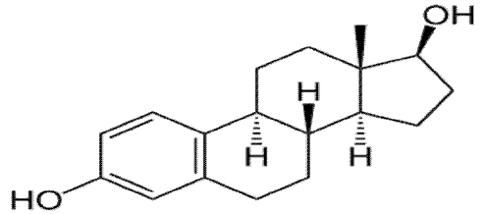

**Figure 1.1** The structural formula for estrogen hormone (Mohebzadeh *et al.* 2013)

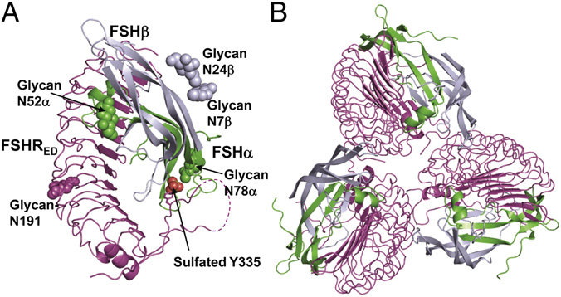

**Figure 1.2** Human FSH structure in complex with human FSHR ED(Jiang X. *et al.* 2012)

The current study's primary objective is to assess hormone levels, liver function tests, kidney function tests, and hematological parameters (WBC, PCV, and HB) in young and old women (pre- and postmenopausal) with breast cancer in Salah-Aldin City.

# LITERATURE REVIEW

## Woman Reproductive System and Menopause

The female reproductive system in humans is important because it is responsible for the function of reproduction and the continuity of reproduction, as it consists of the internal and external genital organs. The female reproductive system at birth is immature, but it develops as a function of time until it matures at puberty, and at puberty in childbearing age it is able to produce gametes and carry the fetus until the completion of childbirth. The internal reproductive organs in the uterus, fallopian tubes, and ovaries comprise the female reproductive system. Female reproductive systems have a need. Ovaries contain egg cells referred to as ova or oocytes. The ova are then transported to the fallopian tube, where they can be fertilized by the sperm (Reynolds *et al.* 2002, Ghosh M. *et al.* 2014).

The fertilized ova travel during the reproductive age after that to the uterus, then the lining of the uterus thickens when these ova enter the uterine region, where there is a possibility that the fertilized ova implant and continues to grow inside the uterine lining, which has become thick. Another possibility is that the implantation is not completed, In this scenario, the uterine lining sheds during menstruation. Throughout this time span, the female reproductive system releases female sex hormones that help sustain the reproductive cycle's length (Hall J. E. 2015, Tehrani F. R. *et al.* 2009).

After a female crosses the reproductive stage, the ability of The female reproductive system gradually ceases producing female hormones that regulate the reproductive cycle. A individual is believed to be in menopause one year after her menstrual period has ceased (Reynolds *et al.* 1992).

### Woman Reproduction System

Puberty is a term that represents the duratıon of biological transition that occurs in a woman's body from adolescence through adulthood. It is a period of our growth that is marked by a rise in gonadotrophin levels, the appearance of secondary sexual characteristics, and, most significantly, the attainment of reproductive ability. It is a critical stage of both men and women's lives, without which we fail to successfully reproduce a species (Colvin and Abdullatif 2013).

### Menopause

The woman's menopause after crossing the reproduction age means "pre-menopause" which refers to the time of natural transition to menopause, it means for the female to the end of the reproductive years. another term is called Menopause is also refers to the menopausal transition (Palacios *et al.* 2010, Najjar 2019).

Menopause in women signals the end of their ability to reproduce and the end of their ability to conceive. And menopause refers to the stopping of the menstrual cycle. Menopause occurs in a generation near the age of fifty and brings with it symptoms and things that are some annoying. The question of what is menopause is beginning to take place in the minds for many women who are older. However, answering the question of what does menopause mean may not be enough to correctly understand the menopause process, It is considered one of the distinctive periods during a woman's normal life (Alpaslan 2018, Attar 2019).

#### Menopause Symptoms

Menopause brings with it signs and symptoms for women And initially, it is difficult for the signs and symptoms to ignore. The section below, were given some of significant information about the menopause and period.

##### Heat Giveaways

Thermal flushes are the most common symptom of menopause, 80% of women experience heat flushes, 30% of them go for a diagnosis and receive treatment. In some women, heat waves appear around the time of the menstrual cycle (as they were during the last fertility period). Heat flushes appear initially as heat in the upper chest and face and spread throughout the body (Hickey *et al.* 2017). The heatwave lasts 2 - 4 minutes. This condition is accompanied by sweating, heart palpitations, sometimes tremors and feeling anxious. Donations of heat may occur several times daily, at night hours, and in difficult cases, they may occur every hour. 80% of women suffer from this phenomenon for 4 - 5 years. 10% of women experience heat flushes even after the age of 70 (Politi *et al.* 2008, Gawad *et al.* 2014).

##### Sleep Disturbances

In menopausal women, hot flashes at night are common and can cause sleep disturbances. However, even in the absence of hot flashes, 32 to 40% of menopausal women complain of sleep disturbances (Politi *et al.* 2008, Najjar 2019).

##### Vaginal Dryness

The vaginal colour shifts from reddish to pale, and pubic hair disappears.low estrogen levels affect the mucous membrane that covers the vagina and urethra, and makes it very thin, to the point of vaginal atrophy. when the concentration of estrogen is changed, The vaginal colour varies from reddish to pale.another change included pubic hair fades as a function of time and probably leads to the elasticity of the vagina is damaged, and so on. Possible treatments for prevent pain, infections and worsening of sagging vaginal walls include topical estrogen ointment, suppositories, or pills (Politi *et al.* 2008, Najjar 2019).

##### Effect on the Urinary System

The presenting symptomsin menopausal women such as, Burning during urination, decreased feeling of bladder filling, decreased urine flow, incontinence, and an increased incidence of urinary tract infections show (Politi *et al.* 2008, Gawad *et al.* 2014).

##### Joint pain

50 - 60% of women complain of joint pain especially,women who are overweight and who are depressed. It is not known whether joint pain is directly related to a decrease in the level of estrogen, although hormone therapy leads to improvement (Politi *et al.* 2008, Gawad *et al.* 2014).

##### Breast pain

At the beginning of menopause, women experience pain and hypersensitivity in the breasts, as a result of changes in estrogen levels. Menopause is associated with acute hormonal changes, with levels of female hormones (estrogen and progesterone), which affect breast congestion. The pain usually appears in both breasts. When the pain is on one side, it is advised to examine to deny the presence of breast cancer. In each case, comprehensive periodic breast exams are recommended using ultrasound (ultrasound and mammography) (Politi *et al.* 2008, Gawad *et al.* 2014, Najjar 2019).

##### Migraine

20% of women who have had menstrual-related migraines in their youth suffer from exacerbation in menopause for women. Migraines occur due to severe hormonal changes in estrogen levels. In every case of new pain, it is recommended that you seek advice from a neurologist. A distinction should be made between migraine attacks and other headaches. Migraine pain is characterized by preliminary signs such as, pain on one side, with visual disturbances and photosensitivity (Politi *et al.* 2008, Gawad *et al.* 2014).

##### Depression

There is an increase in the number of women who suffer from menopause depression. Depression worsens in the morning and decreases in the evening. Menopause increases twice the risk of depression in women without a history of mental illness, compared to the fertility period. Women who have previously experienced depression, such as postpartum depression, acute premenstrual syndrome, and also women after ovarian surgery (surgical menopause) are at risk of developing menopause depression. Sleep disorders, concentration disorders, appetite disorders, and low libido are characteristic symptoms of a woman's menopause and depression (Politi *et al.*2008, Gawad *et al.* 2014).

##### Osteoporosis

In the first two years of menopause, a significant decrease in bone density occurs. It is important to have a bone density test at the age of 40 and at the beginning of menopause for comparison and treatment (Politi *et al.* 2008, Gawad *et al.* 2014).

##### Cardiovascular Diseases

Estrogen deficiency alters the structure of blood fats. Generally, bad cholesterol (LDL) levels increase when healthy cholesterol (HDL) levels decrease marginally. Women are more likely than men of the same generation to have artery disorder and heart attack (Politi *et al.* 2008, Gawad *et al.* 2014).

##### Body Structure

Women who do not receive hormone replacement therapy gain about 20% more weight than their fertile age. Another characteristic phenomenon of menopause is the loss of muscle mass (Politi *et al.* 2008, Gawad *et al.* 2014).

##### Skin Changes

Collagen tissue damage occurs in the skin and bone. Low collagen in the skin causes wrinkling of the skin (Politi *et al.* 2008, Gawad *et al.* 2014).

##### Balance

Because of the low level of estrogen, some women suffer from an imbalance and increased risk of falls and fractures (Politi *et al.* 2008, Gawad *et al.* 2014).

#### Premenopausal

Perimenopause is the stage in which the body releases fewer hormones that control the menstrual cycle, or what is known as menstruation, which is estrogen and progesterone. Perimenopause is defined as “around menopause” and refers to the menopause transition stage. Begins three to five years before menstruation, and continues for a year after the last menstruation, signs and symptoms of menopause may begin to appear at this stage. Premenopause happen when there are no complications associated with menopause or perimenopause (Palacios *et al.* 2010, Najjar 2019). When the woman still has periods (whether they’re regular or not), it means she is in the years of reproduction. Although certain hormonal variations can exist, there are no visible changes in the woman's body. Perimenopause, the female starts to experience some of the menopause symptoms (for instance, changes in the regulation of the period cycle, sometimes there is the probability of happening hot flashes, another probability is mood swings or sleep disturbances) (Bener *et al.* 2014, Martin *et al.* 2016).

#### The Menopause

The menopause stage: menstruation stops completely, and this cessation lasted for a whole year, and here childbearing is no longer possible.

#### Postmenopausal

Menopause determines the end of menstrual cycles. Begins after one year from the date of the last menstruation, menstruation will not happen after that, and at this stage the risk of some health problems such as osteoporosis, and cardiovascular diseases increases. Diagnosis or reaching menopause is most likely after 12 months without a menstrual period. Most of the time menopause occurs in women during the period of 40 - 50 years, and most likely the average age is 51 years. Menopause is a normal biological process that occurs during a woman's life, but is accompanied by some abnormal physical symptoms (Ghazal 2013, Greendale *et al.* 1999).

There are many treatments that women can take to change the lifestyle to hormonal therapy. Hormonal treatment when taken by women has benefits and disadvantages depending on many criteria, as there is a possibility of some of the following symptoms such as a decrease in fractures or osteoporosis, as well as a decrease in the incidence of cardiovascular disease. There is a risk of developing or increasing the risk of breast cancer (Grodstein *et al.* 1997).

#### Menopause Age and Affecting Factors

Menopause in women is in their forties, characterized by many symptoms that differ from one person to another, the most important of these symptoms are: decreased fertility rate as a result of ovarian activity, irregular menstrual periods. There is no complete agreement on the factors that influence menopause (Blümel J. E. *et al.* 2006). But there are many studies and investigations that have shown some factors that are likely to have an effect, for example, the genetic factor, age at the occurrence of the first menstruation and its regularity, the age of the pregnancy, and the number of pregnancies may also have an effect, regular oral treatment using contraceptives, It is possible that BMI also have an effect, some habits such as smoking or alcoholism, physical activity, unilateral ovarian removal, blood lead levels, and concentrations, socioeconomic status, educational level (Ceylan *et al.* 2015).

There are many hormonal and biochemical changes that occur during the period in a woman's body during the reproductive age, and these changes in most women have different symptoms (Abdollahi A. A. *et al. 2013*). It can sometimes have negative effects on the quality of life for women (Ceylan *et al.* 2015, Akdeniz N. *et al.* 2009).

These symptoms may include, for example, morbidity and subsequent mortality, risks of developing cardiovascular disease, and sometimes the symptoms are osteoporosis. All of these symptoms are higher for women with early menopause, all of these symptoms may be caused by high levels and concentrations of the estrogen hormone (Gold *et al.* 2001).

#### Younger Women and Menopause

Young adults are now receiving increased attention, as evidence suggests that younger women suffer more mental dysfunction and have a poorer standard of life (QOL) after a breast cancer diagnosis than older women. Others who have young children still face survival issues; the majority of women dread having children, and even more so when confronted with a life-threatening illness. Together with the absence of menstruation, it consists in the cessation of pregnancy, the sudden initiation of vasomotor symptoms, and the long-term consequences of premature ovarian degeneration; There are frequently subsequent complications, such as concurrent childbirth and recurrence. Additional questions regarding the physical presence and sexuality of the topic. Employment preservation; the failure to shift jobs for the best, the fear associated with the prospect of losing a job owing to insurance (Avis *et al.* 2005). Numerous investigators and research established that younger people account for nearly 25% of all breast cancer disease cases as opposed to older women (their ages more than 50 years old). Breast cancer is a condition that mainly impacts people in their forties and fifties. However, recent years have shown a rise in the absolute number of young people diagnosed with breast cancer due to overpopulation of this age demographic. Over the last decade, the breast cancer mortality rate has slowly declined, with the greatest improvements occurring in younger people, owing primarily to the increased use of adjuvant treatment. As a result, this rising population of breast cancer survivors warrants recognition (Ganz *et al.* 2003).

#### Reproductive System Changes

All biological changes happen through the puberty are assosiated, directly or indirectly, to the stimulation of a sexual steroid. Many of the modifications that occur are physiological in nature. Among these are some of the most noticeable secondary sexual traits. Adult acne and body odor, for ınstance, are direct consequences of stimulation and ıncreased secretion of the apocrine and sebaceous glands, Respectively. The pregnancy period is one of the most difficult periods that a woman goes through, as many physiological changes happen to her, and it is considered natural changes that occur in the woman's body and always accompany the growth of the fetus, and these changes occur in the heart, blood vessels, blood, weight and also in the reproductive system of women, especially because during pregnancy the menstrual cycle stops The production of the hormones estrogen and progesterone increases, there are many facets of changes in the reproductive system during pregnancy, sometimes in the form of many and dense vaginal secretions, so the woman feels sticky secretions coming out from the cervix, which is normal during pregnancy, but it sometimes turns into a disease and here the secretions will be very profuse and dense Where the mother is infected with bacterial infections, for example, or other diseases (Skovorodin *et al.* 2020, Bordini and Rosenfield 2011).

#### The Health Problems That Link with the Menopause

In women after passing the childbearing stage, the estrogen concentration is very low. These low levels lead to health problems that occur naturally as a function of age. Below are examples of common health problems that most often occur during the postmenopausal years:

* **Heart disease**: Women before reaching the age of fifty-five years are less likely to have heart disease than men. Numerous studies and investigations have proven that estrogen helps keep blood vessels open and relaxed, and contributes to a balance between good and bad cholesterol. In the absence of estrogen, cholesterol begins to build upon the walls of the arteries leading to the heart (Schmidt C. W. 2017, Deeks A. A. 2003). By the time they reach the age of 70, women have nearly as many risks of developing heart disease as men at this age.
* Stroke: After the age of fifty-five, the probability of stroke is doubled in women. Low estrogen levels in women contribute to cholesterol buildup on the walls of the arteries leading to the brain (Becker 2005).
* **Osteoporosis**: The lack of estrogen in women leads to the loss of bone mass, and it is more quickly before menopause, which makes women during this stage vulnerable to osteoporosis and weakness, which makes them break easily. Some recent investigations and studies have shown that women who suffer from severe hot flashes and night sweats are more likely to lose bone (susceptible to hip fractures), especially when menopause approaches (Crandall *et al.* 2015).
* **Lead poisoning**: Lead is stored in the human body in various ways in the bones. After menopause in women, the stage of osteoporosis begins to collapse more quickly, so the likelihood of lead concentration in the blood increases in women (the concentration of lead in the blood increases by 30% when compared to the stage of childbearing). An increase in the level of lead in the blood leads to some symptoms such as: high blood pressure, hardening of the arteries, a change in kidney function, the possibility of dementia, affects the ability of memory, the ability to think (Jackson *et al.* 2010).
* **Urinary incontinence**. Several studies and investigations have proven that half of the postmenopausal women have difficulty retaining urine. One of the symptoms of low estrogen levels in postmenopausal women is irritation of the urethra (Shifren *et al.* 2014).

## Cancer

Cancer is a disease that is spread all over the world and is increasing very quickly, with the right intervention at the right time (although the type of cancer differs or where it occurs) (Khalil *et al.* 2019, McKinney *et al.* 2020).

Cancer is described broadly as a disorder that affects the fundamental building blocks of the human body (the cell). The natural human body regenerates cells on a continuous basis, whether through the development period or after injury (renewing dead cells, or treating damaged cells). This mechanism is governed by distinct genes, which are disrupted during the cancer period (there is a slight chance that these damaged genes are from one of the parents). In general, cells develop and reproduce in an ordered fashion in the human body, however defective genes may cause the basic unit of the human body to act abnormally during development or reproduction (Jones *et al.* 1999, Khalil *et al.* 2019). A tumor may be benign (i.e., noncancerous) or malignant (cancerous) (cancer). (Note that benign tumors should not spread to other areas of the body outside their natural range) (Hiyama *et al.* 1997).

When the tumor grows (which may lead to the formation of cancer) for the first time, it occurs only in the place of its spread, in the absence of treatment at the appropriate time and place, the tumor spreads to the neighboring tissues, in this case the tumor is called "colloidal carcinoma" (Freimuth *et al.* 1989, Jones *et al.* 1999).

For this reason, Cancer patients must undergo a lengthy and complex procedure at the location of the tumor and within a defined time frame (this service must be implemented by medical institutions). These organizations have experienced and specialized personnel, a breadth of medical expertise, cutting-edge medical technology, cutting-edge medical practices, and infrastructure networks that facilitate collaboration between experts. As a result, cancer patients must undergo a lengthy and complex treatment phase. Health institutions provide the most critical assistance to cancer patients. Cancer care facilities must include experienced and trained personnel, a breadth of medical expertise, cutting-edge technologies, advanced medical practices, and infrastructure networks that facilitate collaboration between experts (Freimuth *et al.* 1989, Jones *et al.* 1999).

Cancers that are more often seen include:

* oral cavity cancer and lung cancer.
* Brain tumors.
* Cancer of the skin.
* Cancer of the throat (larynx).
* Cancer of the liver.
* Tumors in the bone.
* Colon cancer.
* The term "lymphoma" refers to a form of cancer.
* Cancer of the breast.
* Cancer of the bladder.
* Cancer of the stomach.
* Pancreatic cancer.
* Oncology and hematology in children.
* Cancer of the prostate.
* Cancer of the endometrium (uterus)
* Cervical cancer of the uterus.
* Cancer of the thyroid.
* Ovarian cancer (Glinsky *et al.* 2005, Hoadley *et al.* 2018).

### Breast Cancer

Breast cancer is a malignant tumor that develops in some areas of the breast cells (in the glands that produce milk or in the pathways that transport milk from the glands to the nipple). The lump can form in the fatty or fibrous connective tissue inside the breast. Breast cancer is a term that refers to a category of cancers, lesions, or abnormal modifications (uncontrollably) that arise in a woman's breast tissue and result in the appearance of a lump (American Cancer Society 2019).

Breasts are composed of fat, connective tissue, and thousands of lobules, tiny glands that provide milk for breastfeeding during the postpartum period. Breast cancer's main signs, as established by the majority of recent trials and investigations, are the appearance of dense breast tissue or a lump in the breast or armpit (Luciani *et al.* 2013, Kelsey *et al.* 1993).

#### Types of Breast Cancer

As shown in Figure 2.1, breast cancer is divided into two types: "invasive" and "non-invasive" or localized. Invasive cancer develops as a tumor extends from the breast ducts or glands to other parts of the breast, while tumors of non-invasive cancer may not migrate from the initial tissues or cells (Forrest *et al.* 1996).

* **Ductal carcinoma in situ:** The abbreviation (DCIS ) refers to ductal carcinoma, it occurs in situ, and is a non-invasive condition, in which case the tumor cells or cancer cells remain contained inside the ducts of the breast which have not spread to the adjacent breast tissue.
* **Lobular carcinoma in situ.**The abbreviation (LCIS) refers to Lobular carcinoma in situ, it is kind of cancer that grows in the milk-producing glands female breast. Like DCIS, the cancer cells haven’t invaded the surrounding tissue.
* **Invasive ductal carcinoma.** The abbreviation (IDC) refers It is the most prevalent form of cancer in a woman's body, according to Invasive ductal carcinoma.It originates in the breast milk ducts, and after its occurrence it spreads rapidly to the adjacent tissues in the breast and then to ot her neighboring organs and tissues.
* **Invasive lobular carcinoma.**Invasive lobular carcinoma (ILC) that occurs in a woman's breast develops during the reproductive stage, where it begins in the form of breast lobules, after this stage it quickly spreads to the surrounding tissues (Li *et al.* 2005, Weigelt *et al.* 2010).

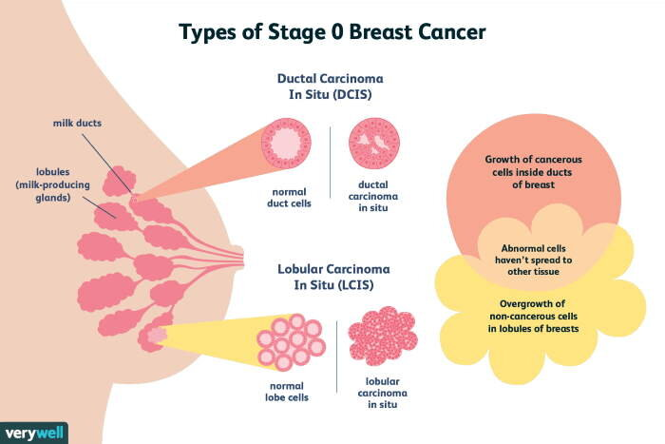

**Figure 2.1** Breast Cancer Stage (avialable at: https:// images. app. goo. gl/ay QXgf KeWhFisV Wa7)

### Breast Cancer Epidemiology

Breast cancer is important because of the possibility of common risk factors, and these common factors are between the first and second stages of the primary stages (for instance, the history recorded data of the family assosiated with the breast cancer disease), While it appears that other risk factors can be unique in the second primary stage (such as radiotherapy). Understanding epidemiology in the study of breast cancer in women should aid in determining women who are at a greater risk of contracting the disease and reducing uncertainty associated with the presence of other variables such as environmental, hereditary, and hormonal factors (Chen *et al.* 1999).

### Anatomical Structure of the Breast

Numerous research and investigators on the anatomical composition of the breast characterize radial "lobes" that are most likely identical in size to an orange fragment or to the same apple. The initial research in favor of this suggestion is rarely quoted, and astley cooper has given evidence to the contrary. Cooper pumped blocks of various shades into the human duct structures of dying breastfeeding women's breasts. Specific air duct systems have been anatomized, and it has been determined that they vary significantly in size and can be positioned above or below one another, rather than following a strict radial configuration. Cooper bears a striking resemblance to their shared mating with tree roots**.** (King *et al.* 2005). See Figure 2.2.

Breast duct injection trials can be jeopardized by spills, blockages, and contamination from severed limbs, as well as the difficulties of injecting each duct device individually. It seems improbable that the small-caliber 'Type B' channels mentioned by are readily injectable. Breast duct injection trials can be jeopardized by spills, blockages, and contamination from severed limbs, as well as the difficulties of injecting each duct device individually. It seems improbable that the small-caliber 'Type B' channels mentioned by are readily injectable. (Going and Mohun 2006). In subgross studies, the repercussions of the airway system can be tracked wherever they go, and patiently all the ducts and their branches can be visualized in a complete breast cancer (Rochman *et al.* 2009).

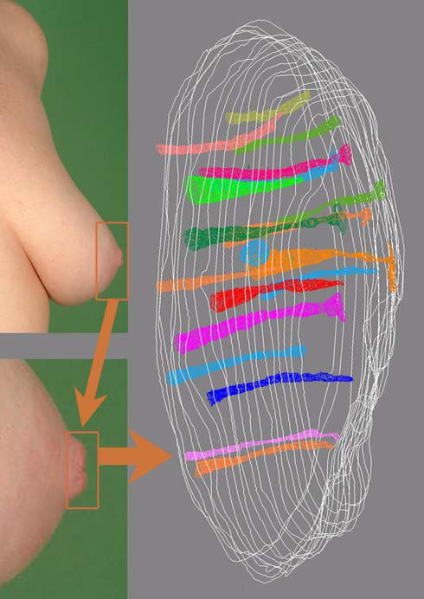

**Figure 2.2** Reconstructions in a mastectomy nipple (Going and Mohun 2006)

Some channels clearly reach the surface of the skin, but others are not identifiable. This may either be the result of clogging of the lumen by keratin, or the channels (ducts) may not really open at the surface of the nipple (Going and Mohun 2006).

### Breast Cancer Risk Factors

Epidemiological evidence indicates relatıons between breast cancer risk factor through oncopathology in both genetıc and non genetıc. many of the breast cancer susceptibility sites in the genome also show differences in associations by expression of hormone receptors. Although equivalent obesity and premenopausal obesity are correlated with a lower average rate of breast cancer, there is little evidence that these conditions are associated with a decreased risk of developing breast cancer (Yang *et al.* 2011).

Studies and investigations into the causes of an increase in the incidence of breast cancer in women in the majority of the world indicate the importance of identifying risk factors associated with the disease's occurrence, since it was discovered that between 20% and 30% of breast cancer cases diagnosed are related to the occurrence of various factors, the most significant of which was age (over 40 years) (Bucholc *et al.* 2001).

The preceding causes summarize the findings of epidemiological, genetic, and clinical research in this region. Both risk factors may be classified into two categories or classes. The first risk factors are age, size, ethnicity, and the genetic structure of the female mammary gland. External conditions are risk factors for the second category. Both variables are associated with lifestyle choices, nutrition, and long-term medical attention. It must be stressed, however, that after thorough research and examinations,it is difficult to explain the etiology unequivocally (Kaminska *et al.* 2015).

### Symptoms of Breast Cancer

Breast cancer has no effects because the tumor is tiny enough to be quickly handled, which is why it is recommended that people in their fertile years have routine early examinations. A painless lump is the most prominent physical symptom of breast cancer in women. When a mass becomes sore, it has migrated to the lymph nodes in the armpits. Skin swelling, thickening, or redness are less frequent signs and symptoms. Changes in the nipple, such as spontaneous discharge (especially when bloody), crusting, or retraction (American Cancer Society 2019).

**Other symptoms include:-**

* Pain in the armpits or breasts that does not change with the menstrual cycle.
* Breast redness and transformation of orange color.
* The appearance of a rash around or on one of the nipples.
* Empty nipple discharge and may contain blood.
* Inverted or inverted nipple.
* Change in breast size or shape.
* Exfoliation or flaking of the skin on the breast or nipple.
* Most of the lumps that appear in the breast of a woman in the reproductive stage are not indicative of the occurrence of cancer, but any changes must be examined and treated by a specialist doctor directly when they appear or are noticed (Luciani *et al.* 2013, Kelsey *et al.* 1993).

### Screening and Early Diagnosis in Breast Cancer

There are many medical tests for women to diagnose and detect breast cancer:

* **Routine monitoring**. For breast cancer recurrence with tumor markers (carcinoembryonic antigen [CEA], CA 15-3 and CA 27.29) (Molina *et al.* 1999, Molina *et al.* 1998).
  + **Breast Exam**. The specialist doctor will examine women of childbearing age both of the breasts and the lymph nodes in the armpit, to note and detect any lumps or other abnormalities affecting the breast and adjacent tissues.
  + **Mammogram**. Mammography of women is done by means of x-rays to detect and diagnose breast cancer. Where abnormalities are detected on a mammogram, the doctor may recommend a diagnostic mammogram to further evaluate the abnormality (Stavros 2004, Kelly *et al.* 2010).
  + **Breast Ultrasound.** Ultrasound machines in addition to screening off a woman's breasts, are used to create explanatory pictures of the human body. A fresh breast lump is evaluated using ultrasound to assess if it is a stable mass or a fluid-filled cyst (Seidman *et al.* 1982, Shapiro *et al.* 1982). If the indicator is negative, a core needle biopsy is used to remove a tissue sample using a large, hollow thread of the suspicious area. Here, the form is then sent to a specialized laboratory for examination and final decision determination (Mayoclinic 2016), see Figure 2.3.

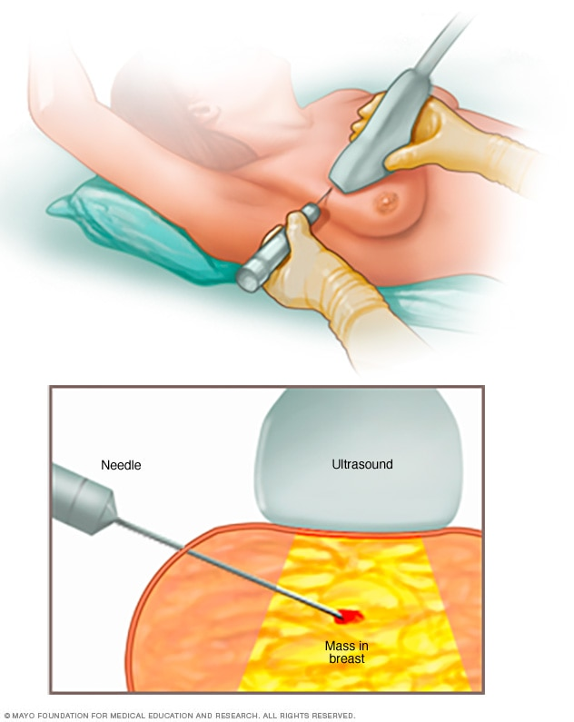

**Figure 2.3** Core needle biopsy (Mayoclinic 2016)

* **Removing a sample of breast cells for testing (biopsy)**

The most sophisticated type of breast biopsy is minimally invasive; this method is conducted with the aid of suction and involves certain modifications to breast biopsy procedures and implementations, however it enables assured biopsy of breast lesions under both ultrasound (US) and stereotaxic orientation. Breast biopsy is the principal and most accurate way of diagnosing breast cancer in women who are pregnant. During a biopsy, the surgeon extracts a sample from the desired region using a needle led by X-rays. Following the model's capture, a tiny metalmark is implanted inside the breast to allow easy identification of the region during subsequent imaging studies. Biopsy samples are submitted to a laboratory for examination and definitive determination of cancerous cells, which may include those involved in breast cancer, the grade of the cancer, and the involvement of hormone receptors or other receptors (Parker *et al.* 1997).

* **Breast Magnetic Resonance İmaging (MRI)**

A state-of-the-art MRI machine uses magnets and radio waves to map the interior of the breast and surrounding tissue. Upon diagnosis, the specialist recommends the use of this breast imaging technique with an injection of a dye. Magnetic resonance imaging does not use ionizing radiation imaging for illustration of the breast area, and this technique is considered harmless despite the frequent use, unlike other types of imaging tests like X-ray and related techniques (Kuhl *et al.* 2014). See Figure 2.4.

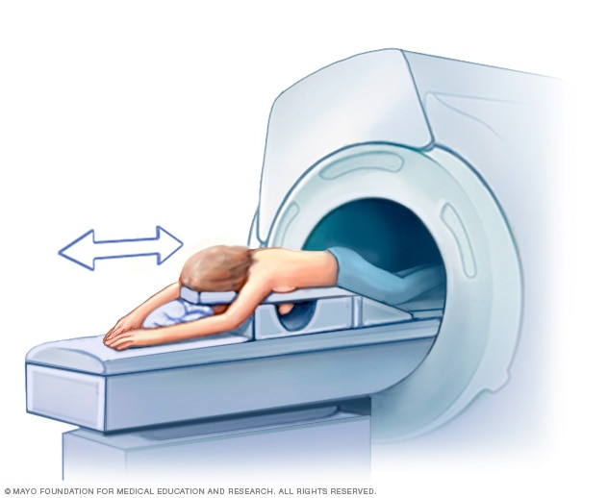

**Figure 2.4** Breast MRI (Mayoclinic 2016)

When viewing a woman's breast and neighboring tissues with magnetic resonance imaging, physicians prescribe that the female lay on her stomach on a padded scanner table. Where the breast blends into a cavity in the table, this cavity incorporates a magnetic signal transmission and reception device. The table is slid into the MRI machine's wide gap (Mayoclinic 2016).

The following testing and treatments are prescribed by physicians and clinicians for determining the stage of breast cancer in women during the childbearing stage:

* Blood tests, such as a full blood count.
* a mammogram on the other breast to test for symptoms of cancer.
* and a breast magnetic resonance imaging (MRI).
* Scan of the bones.
* CT (computed tomography) check.
* Check with positron emission tomography (PET) (Ramsey *et al.* 2015).

### Breast Cancer Treatment And Menopause

There are some guidelines from the North American Menopause Society (NAMS). For instance, women can relax and engage in just moderate physical activity, while maintaining a healthy attitude and using an over-the-counter therapy such as dietary isoflavones, black cohosh, or vitamin E. Progestogens, venlafaxine, paroxetine, fluoxetine, or gabapentin are both prescribed above for women who have questions or restrictions about estrogen-containing therapies. Doctors and specialists advocate for women's decision-making, balancing risks and advantages, and avoiding unscientific concerns regarding care choices. Regardless of the coping approach used, care should be reassessed routinely and consistently, since menopausal symptoms can resolve on their own without the use of prescription medications (NAMS 2004).

### Effects of Breast Cancer Treatments on Fertility

Numerous surveys and investigations have established that approximately 20% of women with breast cancer are diagnosed and identified after reaching fertile age (age fifty), while approximately 9% are diagnosed and detected before childbearing age. Antibiotics are known to be detrimental to chemotherapy with alkylating agents such as cyclophosphamide, although it is likely that the addition of taxanes to anthracycline-based chemotherapy increases gonadotoxicity. Menopause is expected to occur in about 55% of women under the age of 40 and 90% of women over the age of 40 after two years of chemotherapy with cyclophosphamide, anthracycline, and taxanes (Ewertzand Jensen 2011).

Since ovarian stimulation for women during childbearing with gonadotropins increases the concentration of estrogen in the blood, so traditional For women with breast cancer, fertility therapy using ovarian stimulation procedures is prohibited and limited. Although a current therapy combining letrozole and FSH could be safe in the short term, it may take many trials in the long term. While it is currently nascent, other choices involve ovarian tissue cryopreservation. According to the ASCO recommendations, oncologists and therapists have a duty to advise women who are pregnant or planning a pregnancy that care may result in irreversible infertility and to address fertility preservation steps. (Shuster *et al.* 2010).

## Hormones

The endocrine system secretes chemical messengers called hormones, and these hormones function as communication between cells. These hormones are the chemical messengers throughout the human body, and they travel to tissues or organs durıng the bloodstream. They run slowly, over time, and have an effect on a variety of mechanisms, including growth and development, metabolism (how the body converts food into energy), sexual activity, reproduction, and mood. (Güneş *et al.* 2013, Yeşilkaya 2008).

Tissues producing hormones are examined in 3 groups:-

* Endocrine organs: The pituitary, pineal gland, thyroid gland, parathyroid glands and adrenal glands are in this group.
* Endocrine cell groups: Langerhans islets in the pancreas, lutein cells in the ovary, corpus luteum cells and endocrine interstitial cells, Leydig cells in the testis and chorion epithelium in the placenta.
* Single cells with endocrine function: They are the only cells located in epithelium or lamina propria in some organs such as intestines. These cells synthesize peptides (Güneş *et al.* 2013, Yeşilkaya 2008).

### Hormonal İmbalances

Hormones affect the body with the majority of its organs and organs, it is very necessary to work with its exact amount in the body, and any imbalance in the balance of hormones in the body will lead to the consequences and symptoms felt by the patient. Hormones are chemical carriers in the body, which are produced in the endocrine system and transported with the bloodstream to the tissues and organs to inform them of their functions.It helps the body to control and regulate major processes in it, such as metabolism and reproduction.Hormonal imbalance occurs when the body increases or decreases the production of aspecific hormone. While no matter how little difference is in terms of the amount of hormone production required, it may have a great effect on the body (Dahlgren *et al.* 2012, Bak *et al.*  1992).

It is worth noting that hormone levels fluctuate in the body throughout the life time, depending on the stages of growth. Symptoms of hormonal imbalance Because hormones have such a significant impact on so many different organs and systems in the body, and because they play such a key part in overall health, the symptoms of hormonal imbalance can vary quite a little. Hormonal imbalance in children occurs in the stages of growth towards adulthood, while it can also occur in more advanced stages of human life (Dahlgren *et al.* 2012, Bak *et al.* 1992).

### Symptoms of Hormonal Imbalance In Women

Natural hormones in women change during different stages of their lives, thus they are at risk of hormonal imbalance. And the symptoms of hormonal imbalance that distinguish women:-

* Irregular menstrual periods, menstruation stops or repeats.
* An excessive amount of hair in some regions, such as on the chin or other parts of the body.
* Thinning and falling out of hair.
* Weight gain or difficulty losing it.
* Skin signs.
* Vaginal dryness.
* Vaginal atrophy.
* Night sweats.
* Blackening and darkening of the skin (Seth *et al.* 2013, Nahleh *et al.* 2011).

### Causes of Hormonal Imbalances

The reasons for the imbalance of hormones in the human body are due to many causes or several criteria, the causes or criteria differ according to the different hormones or the affected glands. Some of the most common causes of hormone imbalance are as follows::-

* Diabetes
* hypothyroidism, or underactive thyroid
* hyperthyroidism, or overactive thyroid
* Hypogonadism
* Cushing syndrome
* Thyroiditis
* hyperfunctioning thyroid nodules
* hormone therapy
* tumors (benign or cancerous)
* congenital adrenal hyperplasia
* eating disorders
* Medications
* Stress
* adrenal insufficiency
* pituitary tumor
* Injury or trauma
* Cancer treatments (Kumar *et al.* 2015, American Academy 2012).

### Causes Unique to Women

There is a good chance that the hormone balance in women's reproductive systems is related to the reason why women have hormonal imbalances. Here are some common causes recorded and proven in several previous studies:-

* Menopause.
* Pregnancy.
* Breastfeeding.
* PCOS.
* premature menopause.
* hormone drugs like birth control pills.
* primary ovarian insufficiency (Adrenal disorders 2017, Nguyen *et al.* 2016).

### Hormone Production and Menopause

According to what was previously said, hormones are the transporters in the body that move via the bloodstream, as they issue commands to all body structures, such as initiating, terminating, accelerating, or slowing physical and chemical functions and processes. The female body's ovaries produce the hormones estrogen and progesterone. Estrogen and progesterone regulate the female reproductive system, including menstruation and fertility. Women are born with all of their ova. The ova was contained in the ovaries' follicles. Menopause results in a reduction in the amount of ovarian follicles and a decrease in the ovarian response to the other reproductive hormones luteinizing hormone (LH) and follicle-stimulating hormone (FSH). FSH and LH can no longer regulate estrogen, progesterone, and testosterone as the ovaries mature and contain less hormones. These inescapable increases in hormone concentration and the normal reduction in estrogen levels associated with menopause may have a long-term detrimental effect on health (Schwenkhagen 2007).

### Hormonal Treatments For Menopausal Symptoms

Specialized physicians and therapists recommend hormone replacement therapy (HRT) to be taken by women after they have passed through the reproductive phase (the menopause phase) (Bonnier *et al.* 1998). In the female menopause stage, doctors do not recommend the use of any medical treatment. There are, however, treatments available that can help alleviate indications and symptoms, as well as prevent or control chronic illnesses that may be brought on by aging. (Menopause Guidelines 2006). It may include treatments:-

* Hormone replacement therapy. When it comes to alleviating the symptoms of menopausal hot flashes in females, treatment with estrogen hormone is the most successful option. After studying the personal medical history of the patient as well as the family, the doctor will likely recommend the use of estrogen hormone at the lowest dose, with less time to relieve symptoms in women during this stage. The hormone estrogen plays a key role in preventing bone loss. There are some studies that have proven that long-term hormone therapy may lead to risks of cardiovascular cancer and breast cancer, but starting hormones around the time of menopause has benefits for some women (North American 2012).
* Vaginal estrogen. It is possible to inject estrogen straight into the vagina. Tablets or rings containing vaginal estrogen are typically worn in order to provide relief from vaginal dryness for the longest amount of time possible. This treatment merely causes a negligible amount of the estrogen hormone to be released into the vaginal tissue, where it is then taken up by those tissues. This topical treatment can help relieve vaginal dryness in addition to that it plays an important role in relieving some symptoms of the urinary system in women during different stages.
* Low-dose antidepressants. There is a chance that antidepressant therapies belonging to a family of pharmaceuticals known as selective serotonin reuptake inhibitors (SSRIs) can lower the number of hot flashes that women experience during menopause. This treatment is prescribed for women who are unable to take estrogen due to health reasons, this treatment is prescribed for women who require antidepressants for the treatment of mood disorder during different stages of life, and this treatment is prescribed for women in situations where doctors recommend a low dose of this treatment to manage hot flashes.
* Gabapentin (Neurontin, Gralise, others). Some studies and investigations have proven that this group of drugs is used to treat seizures, reduce some of the purposes of hot flashes, it is useful for women who cannot use estrogen therapy, it is also useful for treating hot flashes at night.Clonidine (Catapres, Kapvay, others). Clonidine, a pill or patch typically used to treat high blood pressure, might provide some relief from hot flashes.
* Medicines to aid in the prevention or treatment of osteoporosis. Doctors provide recommendations for osteoporosis prevention and treatment depending on medical needs. These drugs are critical in preventing bone deterioration and fractures. Vitamin D supplements can be prescribed by the doctor to help support the bones (Menopause Guidelines 2006, North American 2012).

### Non-Hormonal Treatments For Menopausal Symptoms

Many women prefer to use non-hormonal medications or prescription drugs to relieve or reduce the symptoms of hot flashes and night sweats during menopause. Some women prefer to use non-hormonal medications or prescription drugs for vaginal dryness. Non-hormonal treatments for vasomotor symptoms may accompany some side effects or warnings (Woyka 2017) for example :

* Many studies and investigations of these drugs involved females who were treated for breast cancer. The treatment was with an anti-estrogen (tamoxifen). It's possible that the outcomes of these protocols won't work for some of the women. The findings of clinical trials with hot flushes need to be read with caution due to the fact that the so-called placebo effect can be greater than fifty percent and can last for more than three months..
* The long-term safety of treatments using black cohosh, soybeans, and red clover is unreliable and the results are unknown, especially for women with hormone-dependent cancers. Basically, these studies and investigations prove that there is no benefit or little benefit of these products in treating hot flashes.
* Unlike hormonal preparations, doctors recommend using TGA clonidine only to treat flashes (Hickey *et al.* 2017).

## Diagnosis of Menopausal and Cancer Lab

Certain blood tests for follicle-stimulating hormone (FSH), estrogen, and thyroid-stimulating hormone (TSH) in women result in a rise in FSH levels, while others may result in a decline in estrogen levels when the woman enters menopause. Low TSH levels (a result of an underactive thyroid gland) contribute to the development of some effects, including those linked with menopause. Sensitivity, accuracy, optimistic predictive value, and menopausal studies with serum CA125, ultrasound, and menopausal symptoms all contribute to a useful panel of measures for diagnosing ovarian cancer (Tingulstad *et al.* 1996). The Food and Drug Administration (FDA) of the United States has approved some preliminary blood measures for determining whether an individual will begin menopause. The anti-molar hormone (AMH) level in the blood is determined by this examination.AMH produced in a woman's ovaries is responsible for the maturation and release of eggs (ovulation). Levels of this hormone decrease in some cases, such as the approaching menopause, so AMH levels are one of several indicators that determine the stage of a woman's approach to menopause (Chong *et al.* 2012, Beaver *et al.* 2015).

### Progesterone

The human placenta's job is to produce the steroid hormone progesterone, which is needed for the pregnancy to continue normally (Tuckey 2005). Progesterone is synthesized in the ovaries and also in the placenta and adrenal gland. Following ovulation, the corpus luteum secretes the hormone progesterone, which is essential for preparing the endometrium to accept the fertilized egg by raising its thickness and developing special proteins for the fertilized egg's nourishment. This hormone's concentration reduces through breastfeeding. This hormone is critical in females since it regulates the menstrual cycle, stimulates sexual appetite, and leads to the development of the glands responsible for generating milk in the breast during pregnancy. However, the estrogen hormone reduces ovulation during pregnancy (Mulac-Jericevic *et al.* 2000, Siregar 2009). According to one research performed on postmenopausal females, glandular estrogen and progesterone receptors is substantially more abundant than estrogen and progesterone receptors. Additionally, proliferating endometrial polyps expressed substantially more progesterone receptors in the glandular epithelium than in the stroma (Gul *et al.* 2010). Men often have a trace amount of this drug, as progesterone aids in the development of semen.see Figure 2.5 ( Mulac-Jericevic *et al.* 2000, Siregar 2009).

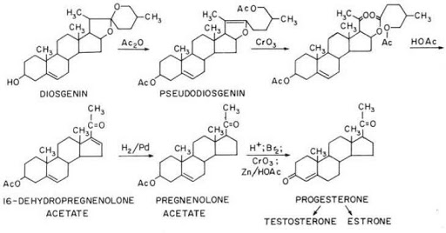

**Figure 2.5** This sequence of chemical compounds demonstrates Marker's route to developing synthetic progesterone (Stephen 2010)

### Estrogen

The most important natural source for it is ovarian and adrenal cortex, and cells in the testicle and placenta. These hormones or compounds are considered steroid compounds, but the manufactured forms are not. The hormone estrogen plays an essential role during the different stages of human life. The production of the three types of estrogen is not equal during the different stages of human life. The three types of estrogen hormone affect the lives of human beings (men and women) equally. The term E2 has been abbreviated by Estradiol, which is one of the estrogen hormones, mainly produced by the ovaries. Estradiol plays an important role in the development of the female reproductive system, as it is a key hormone for the development of the uterus, and my duct valop, vagina, and breast, as it is found in a small percentage in men. Estradiol analysis is one of the types of blood tests that help to detect some health problems, and it is worth noting that no special measures need to be taken before performing the analysis. Estrogen plays an essential role and an important function in a person (including men and women as well), and this hormone may stop being produced in a woman's body in some cases, for example, after menopause, or after a radical hysterectomy, as illustrated in Figure 2.6 (Thomas *et al.* 1997).

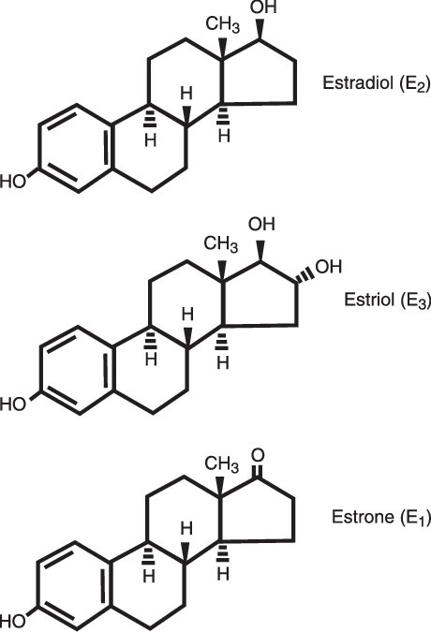

**Figure 2.6** Including estrone (E(1)), estradiol (E(2)), and estriol (E(3)) (Watson *et al.* 2008)

In humans, estradiol is an estrogenic steroid. Female ovaries are responsible for estradiol development. Luteinizing hormone (LH) and follicle-stimulating hormone (FSH) are critical hormones involved in the human body's development of sexual steroids. The luteinizing hormone activates the development of progesterone and androgens by the peri-follicular cells. Androgens diffuse through the basement membrane to the granule cell sheet, where they are denatured into estrogens, primarily estradiol, through the action of FSH. In comparison to the testicle, the ovary exhibits cyclic activity. Hormone secretion differs according to menstrual cycle level. LH receptors (LH-R) are present exclusively on cancer cells in a growing follicle, while FSH receptors (FSHR) are found on granule cells (Hall *et al.* 2005).

### E2 Hormone Analysis Results

Interpretation of the results of the hormone estradiol analysis depends on a number of different factors such as age, gender, and health status of the person. The following is a description of some of the natural proportions of the hormone in a number of cases:

* Females in fertility:
  + Between 30-400 picograms per ml.
  + Females in menopause: between 0-30 pg per ml.
  + During pregnancy, estradiol levels increase during pregnancy due to the hormone secretion from the placenta.

Ovulation period: Estradiol hormone levels are at their highest normal levels during ovulation.

* + PMS: Estradiol levels are at their lowest normal levels during this period.
* Male: between 10-50 picograms per ml (Hilal *et al.* 2001, Elmlinger *et al.* 2002).

### Follicle Stimulating Hormone (FSH)

Follicle Stimulating Hormone (FSH) is one of the diabetic reproductive hormones of alpha and beta units, as it works to regulate the work of the gonads in men and women, and this hormone is secreted from the anterior pituitary gland, in response to the release of the hypothalamus of the releasing hormone reproductive glands (GnRH) (Dierich *et al.* 1998). In fact, there is a FSH hormone in the body of both men and women, but its function varies between them, as this hormone regulates the menstrual cycle, and the production of eggs in the ovaries in women, but in men it regulates the production of sperm, and it should be noted that levels of This hormone remains stable in the body of a man, while it differs in a woman, according to the different stage of the menstrual cycle, so that it is the highest possible before the ovulation period, see Figure 2.7(Mayorga *et al.* 2000).

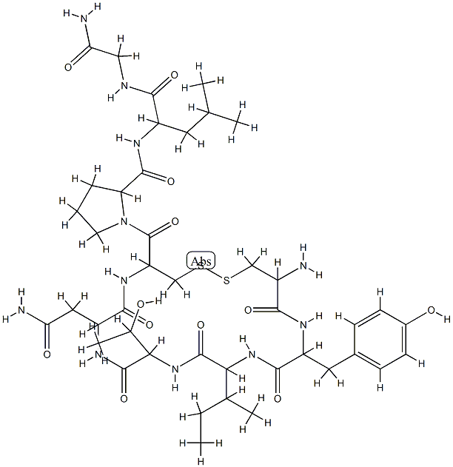

**Figure 2.7** Structure of Follicle Stimulating Hormone (FSH) (Mayorga *et al.* 2000)

### High Level of FSH in Women

The high level of FSH in women is due to many reasons, including the following:-

* Reaching menopause.
* Premature ovarian failure or loss of function.
* Gonadal dysgenesis. Turner syndrome, a condition that represents a defect of female chromosomes.
* Polycystic Ovary Syndrome, in which case ovarian cysts are formed as a result of a disturbance in the level of hormones in the body.
* Systemic lupus erythematosus.
* Swyer syndrome.
* Aging, with age, the production of high-quality eggs decreases, and this in itself affects a woman's fertility ( Gürbüz *et al.* 2004).

### Low Level of FSH

The low level of FSH is due to many reasons, among which we mention the following:

* Hypogonadism
* Exposure to stress
* Women lose their ability to produce eggs
* The man lost his ability to produce sperm
* The presence of a tumor affects the brain's ability to control FSH production.
* Kallmann syndrome
* Hyperprolactinemia
* The use of treatments that affect the function of the gonads
* The presence of dysfunction in the pituitary and hypothalamus, as these glands

represent the centers of hormone control in the brain (Van der Meer *et al.* 1994).

### Testosterone

Testosterone is generated in three forms in women of childbearing age: by the ovaries, the adrenal glands, and by peripheral androgen conversion to testosterone. 25% of testosterone is produced by the ovaries and each adrenal gland, while 50% is produced by peripheral androgen androstenedione conversion to testosterone. Testosterone is 99 percent attached to proteins in the circulatory system, including sex hormone-binding globulin (SHBG) (Hubayter and Simon 2008).

When women reach menopause, their adrenal glands release less androgen, resulting in a gradual decrease in the testosterone level in the blood through the peripheral shunt. Postmenopausal women's ovaries starting secreting testosterone prior to menopause. However, it produces less androstenedione, resulting in a 50% reduction in androstenedione levels. Then, through constant ovarian testosterone development, blood testosterone levels decline due to reduced androstenone production by the adrenal glands, glands, and ovaries, as well as the peripheral shunt part (Palomba *et al.* 2015).

As a result, many parameters affect the testosterone concentration in the female body, for example, increasing the age of a woman from this important parameter, in women the testosterone concentration in the fifth decade is 50% less than the concentration in the third decade. Whereas in the case of bilateral oophorectomy (that is, menopause caused by surgery), it leads to a sudden decrease in the concentration of the hormone testosterone in the female body (by about 50%), see Figure 2.8 (Maric-Bilkan, 2017).

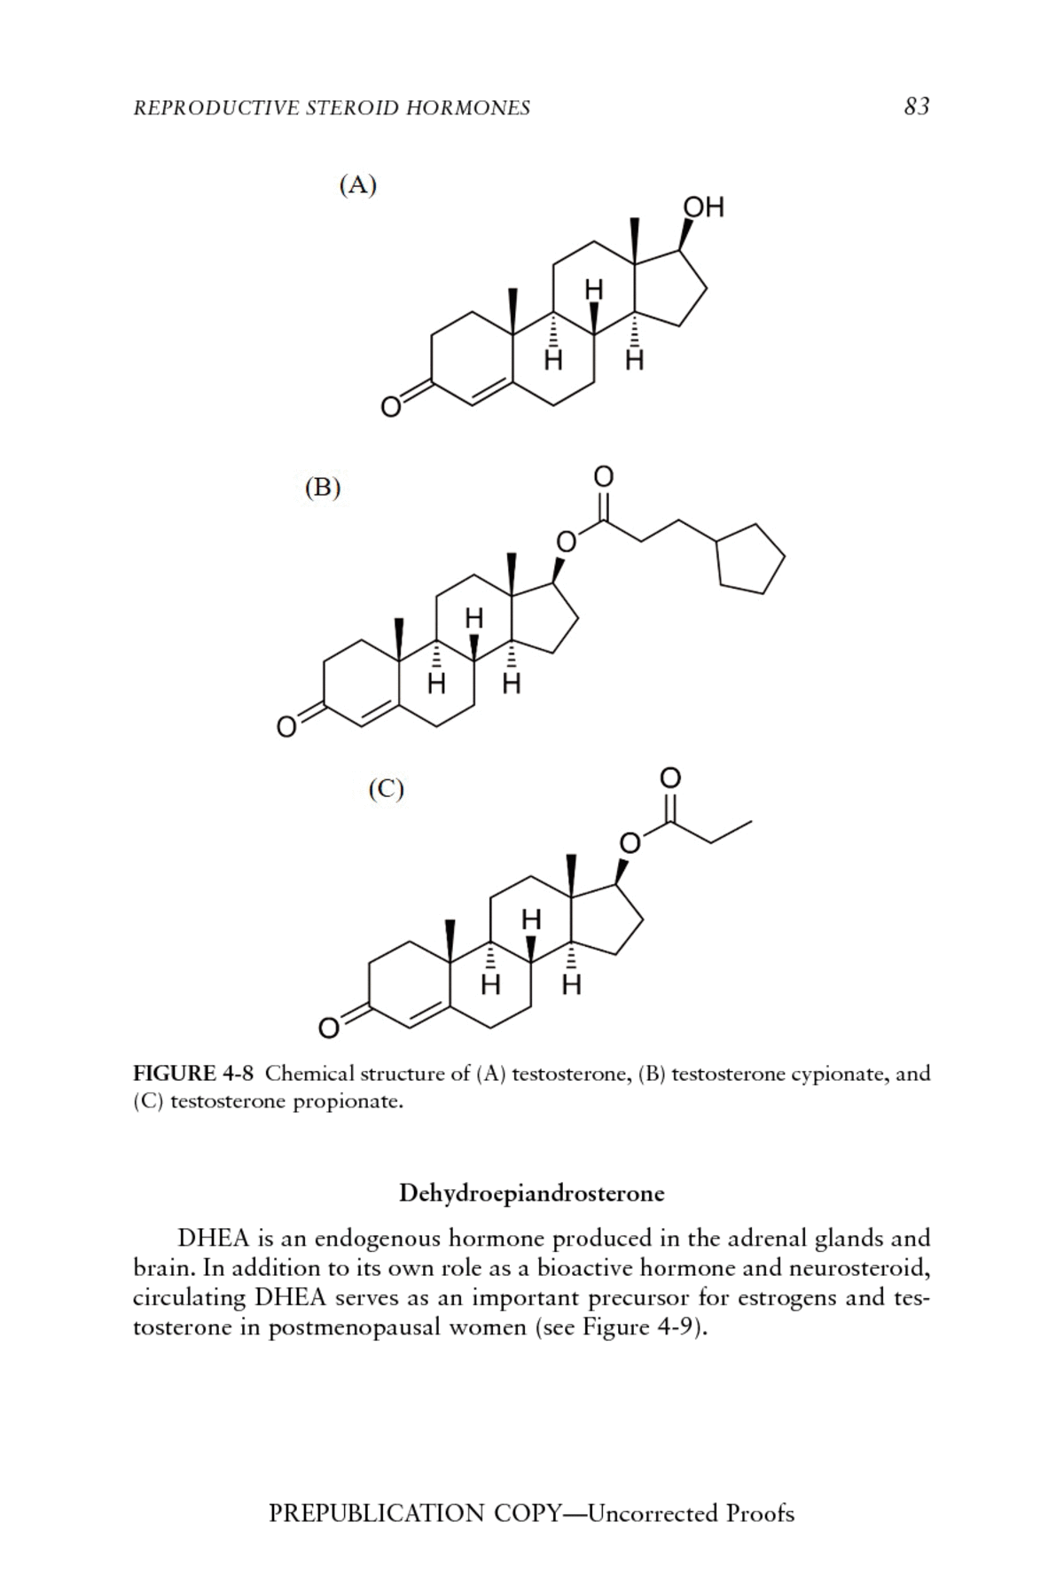

**Figure 2.8** Chemical structure of (A) Testosterone, (B) Testosterone cypionate, and (C) Testosterone propionate (Maric-Bilkan 2017)

# MATERIAL AND METHODS

## Material

### Equipment and Apparatuses used in the study

**Table 3.1** Equipment and Apparatuses

|  |  |  |  |
| --- | --- | --- | --- |
| **Equipment and Apparatus** | **Company** | **Country** | |
| Semi auto spectrophotometer | Mindray | | China |
| Chemiluminesence immunoassay CL_900i | Mindray | | China |
| Centrifuge PLC Series | Gemmy Industrial Corp. | | Taiwan |
| Hematology auto-anaylzer | Mindray | | china |
| Freezer | Hicool | | China |
| Micropipettes (different size) | Eppendorf | | Germany |
| Refrigerator | Concord | | Lebanon |
| Water bath | HUMAN | | Germany |
| Water Distillator | GFL | | Germany |
| Conical Flasks 1L, 500ml, 250ml | Germany | | Germany |
| Disposable Syringes | China | | China |
| Serum Separator Gel Tubes (Clot Activator with Gel) | South Korea | | South Korea |
| Plain Tubes | AFCO | | Jordan |
| Tips (Different size) | AFCO | | Jordan |

### Semi Automated Biochemistry Analayzer (BA_88A)

This type of device has the capacity to perform many tests, for example, tests on whole blood, serum, plasma, cerebrospinal fluid, in addition to the analysis of urine samples. Semi Automated Biochemistry Analayzer device is an analysis system that is programmed for manual applications, designed for a wide variety of diagnostic uses, veterinary uses, research, and investigative analysis in the laboratory. The principle of this device uses a type of chain reaction, the result of these reactions leads to changing the color of the chosen samples.

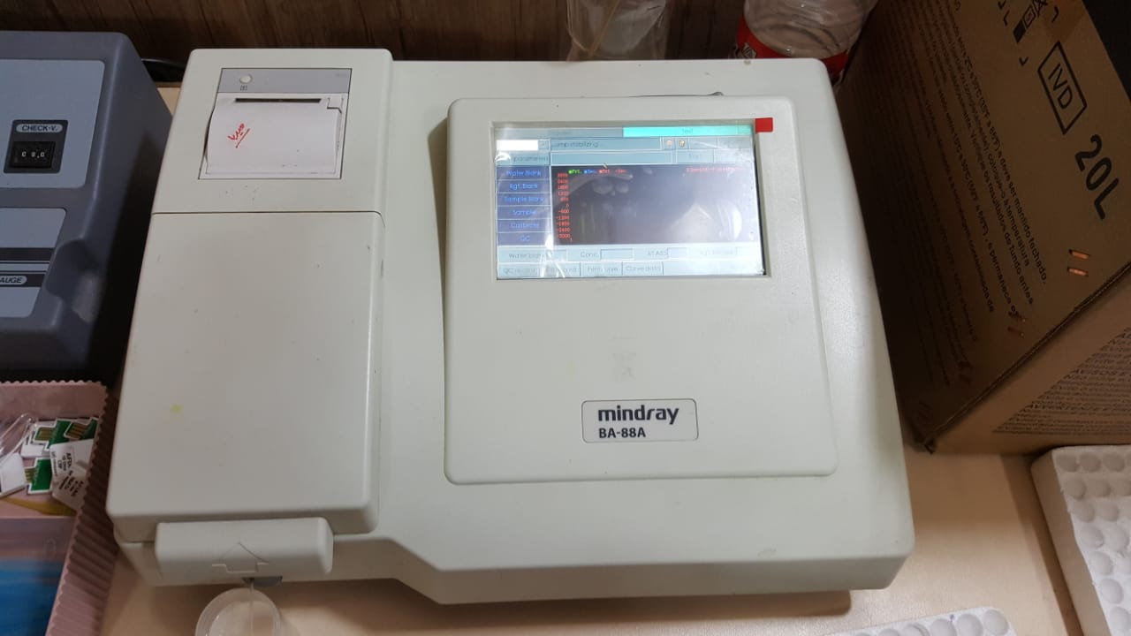

**Figure 3.4** Semi Automated Biochemistry Analayzer

### Chemiluminescence immunoassay analyzer (CL-900i)

The Automated Biochemistry Analyzer System is one of the smallest fully automated immunoassay analyzers used in most developed countries in the world. This system (CL-900i) is characterized by the following things: large capacity, rapid display of the test result, the use of compact models. These characteristics make this system strike an ideal balance between size and immunoassay test performance. This system takes 50 samples for example, it has the capacity of 180 tests in one hour, the results are accurate and fast.

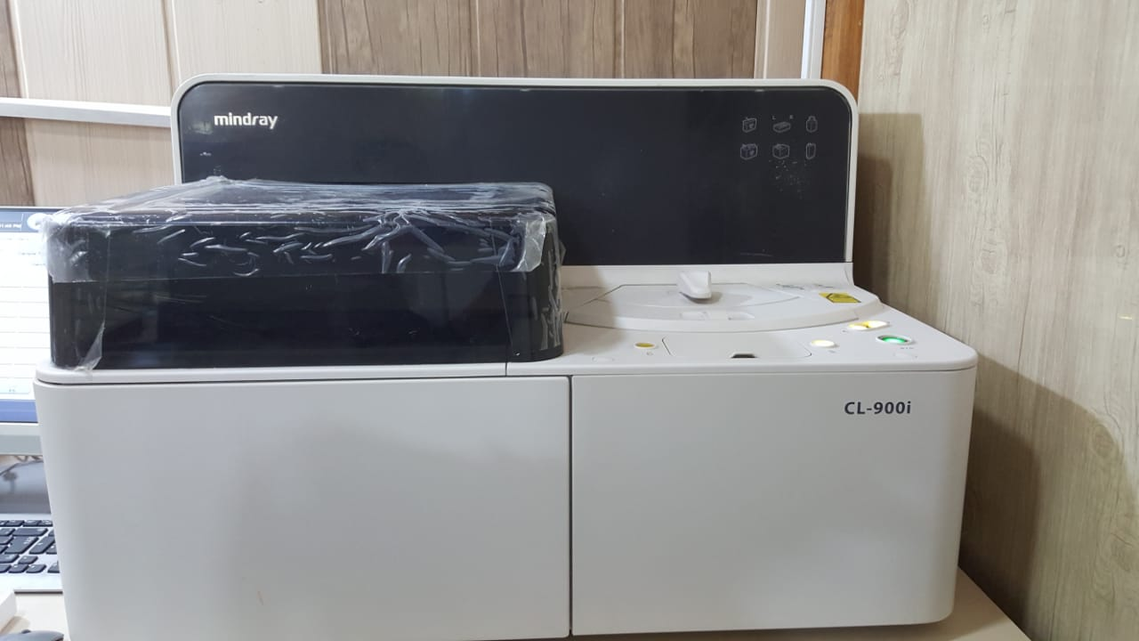

**Figure 3.5** Chemiluminescence immunoassay analyzer

### Complete Blood Analayzer (BC- 30S)

This system uses basic laboratory equipment or an automatic hematology analyzer, this system has many sequential functions, for example: counting the number of cells, collecting information about their size, in addition to its information structure, determining the hemoglobin level in the patient's blood model, calculating the red blood cell indicators about By means of measurements of red blood cells in addition to measuring the level of hemoglobin in the chosen form, rapid analysis of complete blood samples quickly for a complete blood count (CBC). Measurement results include the following: RBC, WBC, platelet count, hemoglobin concentration, hematocrit, erythrocyte indices, and leukocyte difference.

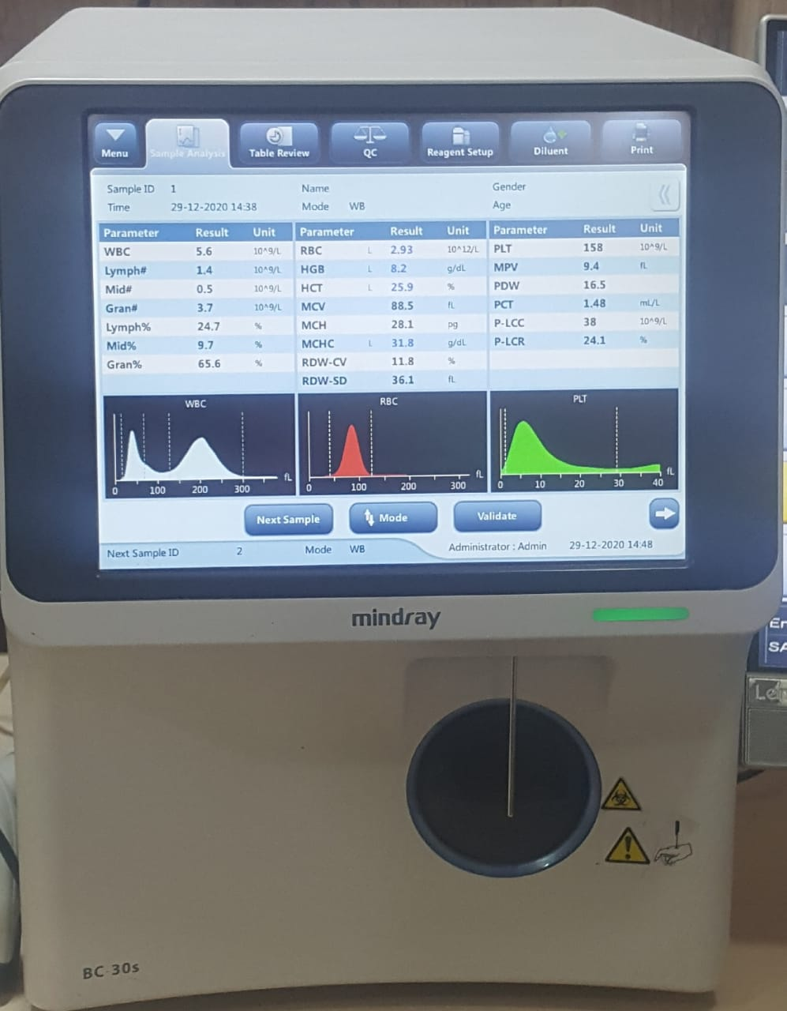

**Figure 3.6** Complete Blood Analayzer

## Sample Collection

A total of (130) clinical samples of whole blood were collected from patients admitted at Salah Al-Din General Hospital and the Oncology Center of Salah Al-Din during the period from 1/8/2020 to 15/11/2020. Whole Blood were taking from patients and divided into two parts. The first part collected into EDAT tubes for testing complete blood tests which included white blood cells (WBC), packed cell volume (PCV) and Haemoglobin (HB). The second part collected into gel-tubes and separated by Centrifuge to obtain the serum which is required for doing tests like hormones and other bio-chemical tests which included in this work.

## Biochemstiry Kits

### Estimation of Progesterone (PROG) : Catalog N: PROG 111

Progesterone is a steroid hormone and the precursor of primary importance in ovulation, fertility, pregnancy, and menopause. The preliminary metabolite of progesterone is 17a-hydroxy progesterone. The dominant metabolite is pregnanediol in the liver. Progesterone is transported mainly through binding to albumin, and to a lesser extent binding to Corticosteroid binding globulin (CBG) or sex hormone binding globulin (SHBG).

#### Principle

Progesterone present in the Sample competes with procesterone aikaline phosphatase conjugate for binding with anti-progesterone antibody. The progesterone concentration can be determined via a calibration curve. The work was done according to do is found in the kit method.

### Follicle-Stimulating Hormone (FSH): Catalg No . fsh 111

Human follicle stimulating horrnone (FSH) is a glycoprotein of approcimately 30,000 daltons that is consisted of two noncovalently assoclated subunlts designated A and B. The function of FSH in both males and females is to facilitate the develo pment and maintenance of the gonadal tissues. In mern, it promotes the functional maturity of seminiferous tubules and spermatogenesis

#### Principle

After the substrate solution has been introduced to the reaction vessel, it is subjected to the activity of anti-FSH. The concentration of FSH can be calculated with the help of a calibration curve. The job was carried out in accordance with the procedures stated in the kit method.

### Estimation of Estradiol (E2) : catalog No. E2111

Estradiol (17ß-estradiol, 1,3,5 -Estratrien-3,178- diol), the biologically most active estrogen, is a steroid hormone with a molecular mass of 272.3 Daltons . Most of estradiol is bound to protein, only 1-3% of estradiol is free.

#### Principle

The reaction vessel receives estradiol-alkaline phosphatase conjugate. A built-in photomultiplier measures the chemiluminescent reaction as RLUs. Kit technique work was done.

### Estimation of Testosterone (TESTO) Catalog NO. TESTO 111

Testosterone is a steroid hormone involved inmany bodily processes, including reproductive physiology Testosterone is secreted by testis in men, regulated by luteinlzing hormone (LH). It's the main androgen relevant with the development of secondary sex characteristics in men Testosterone could be transformed to 17-8-estradiol by aromatase.

#### Principle

This step involves adding the substrate solution to the reaction vessel. Testosterone-alkaline phosphatase is the enzyme responsible for this reaction. A portion of the immunocomplex conjugate is kept on the microparticle. The resulting chemically generated reaction appears through measurıng the (RLUS) by a photomultiplier integrated into the system. The (RLUS) term refers to Relative Light Units of thıs kind of device.The work was done according to do is found in the kit method.

### Estimation of **CREATININE**:Lot number: 51009003

Creatinine is a waste product from the natural wear and tear that the body's muscles are exposed to during the life cycle of a normal person. A normal person has a specific concentration of creatinine in the bloodstream (creatinine at Mayo Clinic). Additionally, creatinine could be a product of the breakdown of creatine phosphate from muscle and protein metabolism. Released at a constant rate by the body (depending on muscle mass) (Lewis S. M. *et al.* 2013).

#### **Principle**

Creatinine reacts with picric acid, the product of this type of reaction is a colored compound in addition to alkaline creatinine spools. The characteristics of this reaction and its properties are proportional to the level of creatinine in the chosen sample.

#### Reagent Composition

**R1**: **Creatinine Base Reagent (**Sodium hydroxide 300 mmol/L and Sodium phosphate 25 mmol/L)

**R2: Creatinine** (Picric acid 8.73 mmol/ L and Surfactant)

**Procedure:**

1. **Reagent Preparation**

* Mix one volume of Reagent 1 with Reagent 2. This working reagent.
* Creatinine standard is ready to use

1. **Laboratory Procedure**:
2. Bring reagents and samples to room temperature.
3. Pipette into a cuvette.
4. Mix and read the optical density (T) 60 second after the sample or standard addition.

**Table 3.2** Laboratory procedure

|  |  |  |
| --- | --- | --- |
| **TUBES** | **Standard** | **Test** |
| Working reagent | 1000 μl | 1000 μl |
| Cal. Standard | 100 μl |  |
| Sample | - | 100 μl |

**Calculations:**

(T2 – T1) of sample

* Creatinine Conc. (mg/dL) =X 2

(T2 – T1) of standard

### Estimation of SGOT: Lot number: 11408007

The SGOT examination is a blood test that is used to determine a person's liver profile. It quantifies one of two liver enzymes named serum glutamic-oxaloacetic transaminase; this enzyme is now often referred to as AST, or aspartate aminotransferase. The SGOT (or AST) examination determines the amount of liver enzyme in the blood. SGOT is used to determine the extent of liver injury or illness. As liver cells are weakened, SGOT escapes into the bloodstream, resulting in an increase in the blood volume of this enzyme. Additionally, SGOT is present in several organs in the body, including the kidneys, muscles, heart, and brain. If one or more of these areas is impaired, SGOT levels can be elevated above average. For example, its level in the blood rises during a heart attack or as a result of muscle injury (Taylor and Vadgama 1992, Kzar *et al.* 2020).

#### Principle

The amino group is transferred from L-aspartate to -ketoglutarate by aspartate aminotransferase (AST), resulting in oxaloacetate and L-glutamate. MDH catalyzes the degradation of oxaloacetate while simultaneously oxidizing NADH+ to NAD. The pace at which the absorbance at 340 nm decreases is directly proportional to the AST operation. Lactate dehydrogenase (LDH) is applied to the reaction to avoid interference from endogenous pyruvate found in serum.

Kinetic determination of Aspartate Aminotransferase (AST) based upon the followingreaction.

AST

L- Asparate + alpha - ketoglutarate Oxaloacetate + L-Glutamate.

MDH

Oxaloacetate + NADH + H+ L- Malate + NAD+

* AST: Aspartate aminotransferase.
* MDH: Malate dehydrogenase.

#### **Reagent Composition**

R1: SGOT ) Tris Buffer (pH 7.8) 88 mmol/L and L-Aspartate 260 mmol/L)

R2: SGOT (alpha - ketoglutarate 12 mmol/L and NADH 0.24 mmol/L)

**Procedure:**

* Take 100 μL (0.1 mL) of sample and add it to 1000 μl (1 mL) of working reagent.
* Mix and incubate at 37 °C for 1 minute.
* Measure the change in absorbance per minute ($∆$ OD/min) during 3 minutes.

**High Linearity Procedure**

* Mix and incubate at for 1 minutes 37 °C.
* Read the change in absorbance per 20 sec, during 1 minute.

**Calculation:**

SGOT activity (U/L) = (( $∆$ OD/min) x 1745.

### Estimation of SGPT: Lot number: 11409006

The GPT is a liver-specific enzyme. ALT is an abbreviation for alanine transaminase. When damaged liver cells are released into the bloodstream, they emit ALT. A GPT examination is used to determine the concentration of GPT in the blood. Increased GPT levels in the blood may signify a liver problem long before you have symptoms of liver disease such as jaundice, a yellowing of the skin and eyes. A blood test for GPT (ALT) can aid in the early detection of liver disease (Tietz and Ash 1995).

#### Principle

GPT (ALT) catalyzes the transition of amino groups from pyruvate and glutamate to L-Alanine and -Ketoglutarate. Pyruvate was converted to NAD. The rate of oxidation of NADH to NAD is quantified as a decrease in absorbance proportional to the sample's SGPT (ALT) behavior.

The following reaction is used to determine the kinetics of Aspartate Aminotransferase (ALT).

ALT

L- Alanine + alpha - ketoglutarate Pyruvate + L-Glutamate.

LDH

Pyruvate+ NADH + H+ L- Lactate + NAD+

* ALT: Alanine aminotransferase.
* LDH: Lactate dehydrogenase.

#### **Reagent Composition**

R1: SGPT (Tris Buffer (pH 7.8) 110 mmol/ L and L-Alanine 600 mmol/L)

R2: SGOT (alpha -ketoglutarate 16 mmol/L and NADH 0.24 mmol/L)

**Procedure:**

* Take 100 μL(0.1mL) of sample and add it to 1000 μL(1 mL) of working reagent.
* Mix and incubate at 37 °C for 1 minute.
* Measure the change in absorbance per minute ($∆$ OD/min) during 3 minutes.

**High Linearity Procedure**

* Mix and incubate at for 1 minutes 37 °C.
* Read the change in absorbance per 20 sec, during 1 minute.

**Calculation:**

SGPT activity (U/L) = ( $∆$ OD/min) x 1745

### Estimation of UREA Lot Number: 1156015

Urea, commonly known as carbamide, is the carbonic acid diamide. It has the formula H2NCONH2. Urea is a critical component of fertilizers and feed supplements, as well as a raw ingredient in the production of plastics and pharmaceuticals. It is a colorless crystalline material that melts at 132.7 degrees Celsius (271 degrees Fahrenheit) and decomposes prior to boiling (Young 2001, Flanagin and Metzger 2011).

Urea is a critical component of animals' nitrogen-containing compound metabolism and is the only nitrogen-containing element in their urine. It is a colorless, odorless solid that is extremely water soluble and virtually non-toxic. It is neither acidic nor alkaline when dissolved in water. It is used by the body in a variety of processes, most specifically nitrogen excretion. It is synthesized by the liver during the urea cycle by mixing two ammonia (NH3) molecules with a carbon dioxide (CO2) molecule. Urea is a common source of nitrogen (N) in fertilizers and a critical raw material for the chemical industry. (Schupp 2018).

#### **Principle**

This step involves adding the substrate solution to the reaction vessel. Testosterone-alkaline phosphatase is the enzyme responsible for this reaction. A portion of the immunocomplex conjugate is kept on the microparticle.

Urease

Urea + H2O 2 NH3 + CO2 Nitroprusside

NH4+ + Salycilate + NaClO Indophenol + NaCl

OH-

**CALCULATIONS:**

A Sample

X C Standard  = mg/dL urea

A Standard

**Note:**

* A Sample  = Absorbance sample
* A Standard = Absorbance standard
* C Standard = concentration standard = 50 mg/dL (8.3 mmol/L)

### Estimation of Alkaline Phosphatase (AL-P): Lot number: 11401003

The enzyme alkaline phosphatase (ALP) is present in a variety of tissues in the body. ALP is mostly derived from the liver of stable adults' blood tests, with the majority of the remaining ALP derived from the bones (skeleton). The most frequent causes of elevated ALP levels in the blood include liver dysfunction, bile duct obstruction, gallbladder disease, and bone disorders. This procedure determines the concentration of ALP in the blood. The alkaline phosphatase (ALP) test is used to aid in the diagnosis of liver failure or bone disorders. When the liver is weakened, elevated levels of AL-P are released into the blood (Taylor and Vadgama 1992).

#### Principle

Alkaline phosphatase (ALP) catalyzes the hydrolysis of 4-nitrophenylphosphate (4-NPP) to yield free 4-nitrophenol and inorganic phosphate, with the alkaline buffer serving as a phosphate-group acceptor.

The rate of formation of 4-nitrophenol, which is proportional to the behavior of ALP present in the sample, is controlled kinetically at 405 nm.

ALP

Para-nitrophenyl phosphate + H2O p-nitrophenol+Inorgnicphosphate.

#### Reagent Composition

**R1**: alkaline phosphatase (125 mmol/L Diethanolamine Buffer (pH 10.2) and 0.625 mmol/L Magnesium Chloride)

**R2:** alkaline phosphatase (50 mmol/L P-Nitrophenyl phosphate)

**Procedure:**

* Take 20μL (0.02mL) of sample and add it to 1000 μL (1mL) of working reagent.
* Mix and incubate at 37 °C for 1 minute.
* Measure the change in absorbance per minute ($∆$ OD/min) during 3 minutes.

**Calculation:**

SAL-P activity (U/L) = ( $∆$ OD/min.) x 275

## Statical Anaylysis

All results were interpreted descriptively using the Statistical Package for the Social Sciences (SPSS) program (SPSS Inc., Chicago, IL, USA) version 25.0. All variables were represented as mean standard deviation (SD). The one-way ANOVA test was used to assess the importance of variations within classes. Pearson correlation research was used to validate the relationships between variables. Significant was described as a P-value less than P 0.05.

1. RESULTS AND DISCUSSION
   1. Breast Cancer Analysis

Breast cancer is a condition in which the cells of the breast develop uncontrollably. A breast is composed of three major structural components: lobules, ducts, and connective tissue. Breast cancer comes in a variety of forms. Breast cancer has the potential to spread beyond the breast through blood and lymph vessels. The type of breast cancer is determined from which cells in the breast become cancerous (Harbeck *et al.* 2019).

This thesis analyzed 130 individuals ranging in age from 26 to 66 years. The control group consisted of 65 individuals (Group A), while Group B consisted of 65 patients with breast cancer diseases.

### **Age with Breast Cancer**

The results of have been showed that a significantly in young according to the mean age of the Control group and patients (22.5 ± 2.59; 34.6 ± 5.02 year) respectively, In same time, results have been showed there were a significant differences in elder age between control group and patients group, as shown in Table 4.1 and Figure 4.1, which was (46.4 ± 5.48; 59.8 ± 10.7 year) respectively.

**Table 4.1** Age in Patients and Control grop

|  |  |  |  |
| --- | --- | --- | --- |
| Variable | Groups | Mean ± SD | Sig. |
| (Youth) | (Control) | 22.5 ± 2.59 | 0.011 |
| (Patient) | 34.6 ± 5.02 | 0.032 |
| (Adult) | (Control) | 46.4 ± 5.48 | 0.040 |
| (Patient) | 59.8 ± 10.7 | 0.011 |

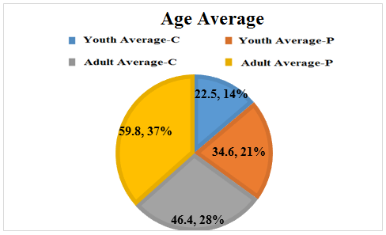

**Figure 4.1** ThePercentage of Age levels in patients and control group

### **Anthropometric Measurements with Cancer**

Anthropometric scales are a set of quantitative measurements of muscle, bone, and adipose tissue that are used to determine the body's composition. There are some components of anthropometry. These components include height, weight, body mass index (BMI), circumferences of the body (waist, hip, and limbs), and skinfold thickness (Casadei *et al.* 2020). The studies including the two element, height and weight. In same studies as demonstrated in Table 4.2 and Figure 4.2, the mean of height (CM) in young was has a significant difference between patients group (165.6 ± 19.6) as compare to the control groups (167.8 ± 2.94), while there was statistic a significant difference between patients (166.6 ± 3.63) and controls (170.9 ± 6.37) group in Elderly.

**Table 4.2** Height in Patients and Control group

|  |  |  |  |
| --- | --- | --- | --- |
| Variable | Groups | Mean ± SD | Sig. |
| (Youth) | (Control) | 167.8 ± 2.94 | 0.001 |
| (Patient) | 165.6 ± 19.6 | 0.001 |
| (Elderly) | (Control) | 170.9 ± 6.37 | 0.001 |
| (Patient) | 166.6 ± 3.63 | 0.001 |

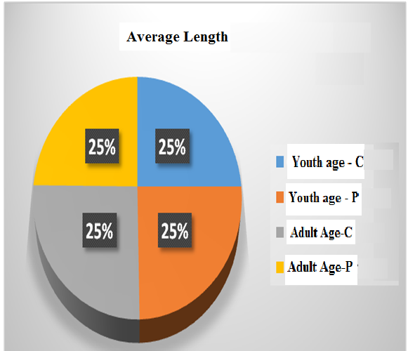

**Figure 4.2** The Percentage of Length levels in patients and control group

Also the mean of Weight (Kg) was has a significant difference between patients (71.2 ± 8.78) and controls (71.4 ± 3.35) group in Young and ın elderly was significant difference between patients (80.3 ± 13.3) and controls (73.3 ± 5.53) group, as shown in Table 4.3 and Figure 4.3.

**Table 4.3** Weight in Patients and Control group

|  |  |  |  |
| --- | --- | --- | --- |
| Variable | Groups | Mean ± SD | Sig. |
| (Youth) | (Control) | 71.4 ± 3.35 | 0.001 |
| (Patient) | 71.2 ± 8.78 | 0.002 |
| (Adult) | (Control) | 73.3 ± 5.53 | 0.001 |
| (Patient) | 80.3 ± 13.3 | 0.003 |

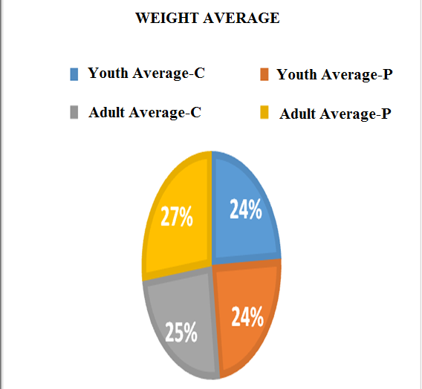

**Figure 4.3** The Percentage of Weight levels in patients and control group

### **Follicle-Stimulating Hormone (FSH), Estradiol (E2), Testosterone and Progesterone**

The results have been displayed in Table 4.4 and Figure 4.4 that the mean of FSH (mIU/mL) in young has a significant difference between patients group (59.6 ± 29.3) as compare to the control groups (16.3 ± 11.4). There are importantly in patients with breast cancer (BC) while there wasn't a significant difference between patients and controls group in elderly.

Also the mean of E2 (pg/mL) displayed a non-significant difference between patients and controls group in elderly and young, the results was (Yp, 95.7 ± 66.4, Yc,116.7 ± 45.3; Ap,72.7 ± 7.48, Ac,68.2 ± 18.9) as displayed in Table 4.5 and Figure 4.5.

Also the mean of testosterone (ng/ml) in patients and controls group was (Yp, 0.55 ± 0.27, Yc,0.70 ± 0.20; Ap,0.57 ± 0.20, Ac,0.57 ± 0.23), which showed a significant difference in elderly and Young with breast cancers, as shown in the Table 4.6 and Figure 6.6.

Also, as displayed in Table 4.7 and Figure 4.7, the mean of Progesterone (ng/mL) in young was has a significant difference between patients group (2.05 ± 2.03) as compare to the control groups (0.92 ± 0.33). There are importantly in patients with breast cancer (BC) while there wasn't a significant difference between patients and controls group in elderly.

**Table 4.4** FSH in patients and control group

|  |  |  |  |
| --- | --- | --- | --- |
| Variable | Groups | Mean ± SD | Sig. |
| (Youth) | (Control) | 16.3 ± 11.4 | 0.001 |
| (Patient) | 59.6 ± 29.3 | 0.001 |
| (Adult) | (Control) | 56.6 ± 29.4 | 0.001 |
| (Patient) | 66.6 ± 47.3 | 0.001 |

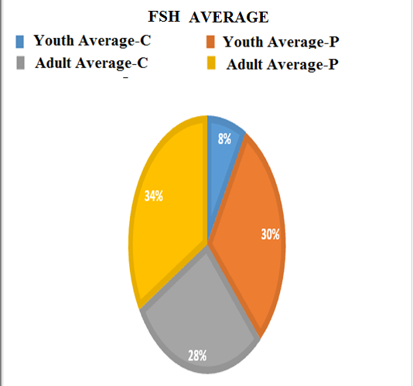

**Figure 4.4** The percentage of FSH levels in patients and control group

**Table 4.5** E2 in patients and control group

|  |  |  |  |
| --- | --- | --- | --- |
| Variable | Groups | Mean ± SD | Sig. |
| (Youth) | (Control) | 116.7 ± 45.3 | 0.062 |
| (Patient) | 95.7 ± 66.4 | 0.062 |
| (Adult) | (Control) | 68.2 ± 18.9 | 0.050 |
| (Patient) | 72.7 ± 7.48 | 0.050 |

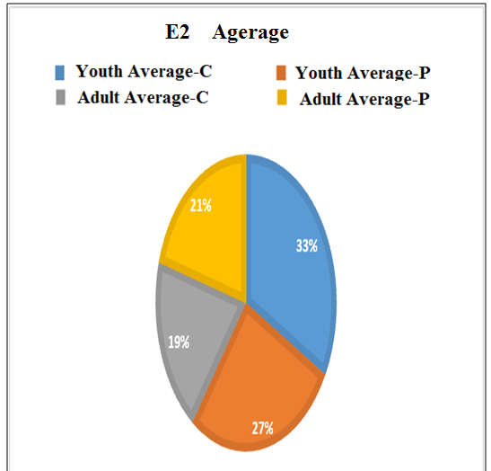

**Figure 4.5** The percentage of E2 levels in patients and control group

**Table 4.6** Testosterone in Patients and Control group

|  |  |  |  |
| --- | --- | --- | --- |
| Variable | Groups | Mean ± SD | Sig. |
| (Youth) | (Control) | 0.70 ± 0.20 | 0.02 |
| (Patient) | 0.55 ± 0.27 | 0.017 |
| (Adult) | (Control) | 0.57 ± 0.23 | 0.01 |
| (Patient) | 0.57 ± 0.20 | 0.01 |

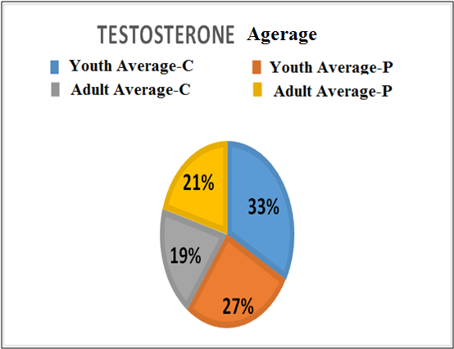

**Figure 4.6** The Percentage of levels of Testosterone in patients and in the control group

**Table 4.7** Progesterone in patients and control group

|  |  |  |  |
| --- | --- | --- | --- |
| Variable | Groups | Mean ± SD | Sig. |
| (Youth) | (Control) | 0.92 ± 0.33 | 0.001 |
| (Patient) | 2.05 ± 2.03 | 0.001 |
| (Adult) | (Control) | 0.80 ± 0.21 | 0.001 |
| (Patient) | 1.17 ± 0.54 | 0.001 |

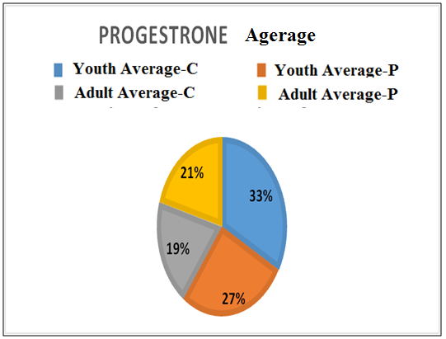

**Figure 4.7** The percentage of levels of progestrone in patients and control group

### **Blood Urea and S. Creatinine**

Also the mean of Blood Urea (mg/dl) have been showed a non-significant difference between patients and controls group in elderly and young, the results was (Yp, 30.4 ± 6.22, Yc, 29.3 ± 3.93; Ap, 36.2 ± 10.6, Ac, 34.1 ± 5.10) as shown in Table 4.8 and Figure 4.8.

Also the mean of S. Creatinine (mg/dl) in patients and controls group was (Yp, 0.64 ± 0.11, Yc, 0.62 ± 0.08; Ap, 0.76 ± 0.17, Ac, 0.72 ± 0.14), which showed a non-significant difference in elderly and Young with breast cancers, as shown in the Table 4.9 and Figure 4.9.

**Table 4.8** Blood Urea in Patients and Control group

|  |  |  |  |
| --- | --- | --- | --- |
| Variable | Groups | Mean ± SD | Sig. |
| (Youth) | (Control) | 29.3 ± 3.93 | 0.08 |
| (Patient) | 30.4 ± 6.22 | 0.08 |
| (Adult) | (Control) | 34.1 ± 5.10 | 0.08 |
| (Patient) | 36.2 ± 10.6 | 0.08 |

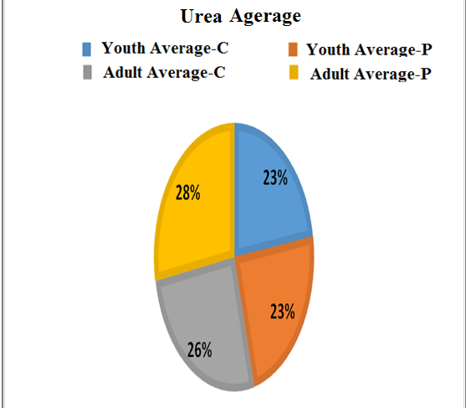

**Figure 4.8** The Percentage of levels of Urea in patients and in control group

**Table 4.9** S. Creatinine in Patients and Control group

|  |  |  |  |
| --- | --- | --- | --- |
| Variable | Groups | Mean ± SD | Sig. |
| (Youth) | (Control) | 0.62 ± 0.08 | 0.071 |
| (Patient) | 0.64 ± 0.11 | 0.071 |
| (Adult) | (Control) | 0.72 ± 0.14 | 0.071 |
| (Patient) | 0.76 ± 0.17 | 0.071 |

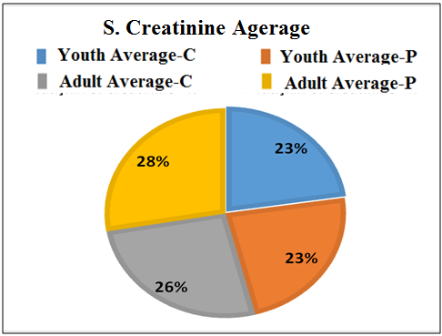

**Figure 4.9** The percentage of S. creatine levels in patients and control group

### **Glutamic-Oxaloacetate Transaminase (GOT), Glutamic-Pyruvic Transaminase (GPT) and Alkaline-Phosphatase(ALP)**

The results have been showed in Table 4.10 and Figure 4.10 the mean of S. GOT (U/l) in young was has a non-significant difference between patients group (18.9 ± 5.53) as compare to the control groups (18.2 ± 2.28). There are importantly in patients with breast cancer (BC) while there wasn't a significant difference between patients (18.1 ± 5.93) and controls (21.1 ± 5.73) group in elderly. On the other hand, the mean of S. GPT (U/l) was has a non-significant difference between patients and controls group in young. While was little a significant difference in elderly and the results was (Yp, 16.3 ± 6.17, Yc, 15.5 ± 2.11; Ap, 17.2 ± 5.46, Ac, 19.8 ± 5.03) as shown in Table 4.11 and Figure 4.11.

Also, the results showed the mean of ALP (U/l) in patients and controls group at Young and Elderly was (Yp, 169.5 ± 58.6, Yc, 132.2 ± 19.4; Ap, 187.9 ± 65.4, Ac, 150.8 ± 39.5) respectively, which demonstrated a statistically significant distinction between the patients and controls in the Young and Elderly breast cancer groups, as can be shown in Table 4.12 and Figure 4.12 respectively..

**Table 4.10** GOT in patients and control group

|  |  |  |  |
| --- | --- | --- | --- |
| Variable | Groups | Mean ± SD | Sig. |
| (Youth) | (Control) | 18.2 ± 2.28 | 0.059 |
| (Patient) | 18.9 ± 5.53 | 0.059 |
| (Adult) | (Control) | 21.1 ± 5.73 | 0.059 |
| (Patient) | 18.1 ± 5.93 | 0.059 |

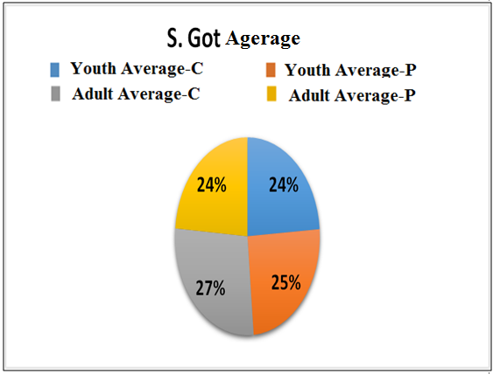

**Figure 4.10** The percentage of S. GOT levels in patients and control group

**Table 4.11** GPT in Patients and Control group

|  |  |  |  |
| --- | --- | --- | --- |
| Variable | Groups | Mean ± SD | Sig. |
| (Youth) | (Control) | 15.5 ± 2.11 | 0.081 |
| (patient) | 16.3 ± 6.17 | 0.081 |
| (Adult) | (Control) | 19.8 ± 5.03 | 0.081 |
| (Patient) | 17.2 ± 5.46 | 0.081 |

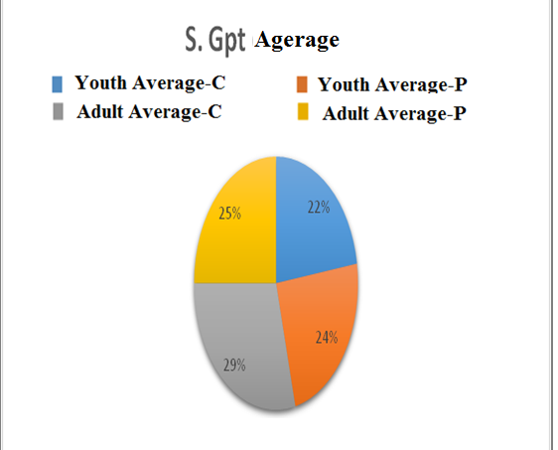

**Figure 4.11** The percentage of S.GPT levels in patients and control group

**Table 4.12** ALP in Patients and Control group

|  |  |  |  |
| --- | --- | --- | --- |
| Variable | Groups | Mean ± SD | Sig. |
| (Youth) | (Control) | 132.2 ± 19.4 | 0.001 |
| (Patient) | 169.5 ± 58.6 | 0.001 |
| (Adult) | (Control) | 150.8 ± 39.5 | 0.001 |
| (Patient) | 187.9 ± 65.4 | 0.001 |

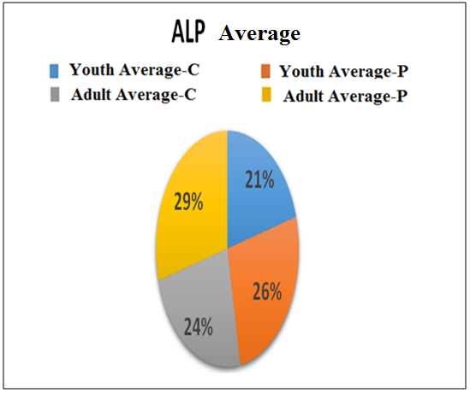

**Figure 4.12** The Percentage of ALP levels in patients and in the control group

### **White Blood Cells (WBC), Paked Cell Volume (PCV) and Hemoglubin (HB) with Breast Cancer**

The results showed in Table 4.13 the mean of WBC (10ꝰ/l) in Young was has a non-significant difference between patients group (5.87 ± 1.41) as compare to the control groups (6.30 ±1.0), while also, there wasn't a significant difference between patients and controls group in Elderly. Also, the mean of PCV (%) in Young and Elderly patients exhibited a significant difference from that of the control group., the results was (Yp, 32.9 ± 4.7, Yc, 40.4 ± 0.61; Ap, 35.4 ± 2.98, Ac, 40.8 ± 0.86) as shown in Table 4.14.

Also the mean of Hb (g/dl) in patients and controls group was (Yp, 10.3 ± 4.25, Yc, 12.5 ± 0.40; Ap, 9.2 ± 0.95, Ac, 12.8 ± 0.49), which showed a significant difference but it is little statistically significant in Elderly and Young with breast cancers, as shown in the Table 4.15 and Fıgure 4.15.

**Table 4.13** WBC in patients and control group

|  |  |  |  |
| --- | --- | --- | --- |
| Variable | Groups | Mean ± SD | Sig. |
| (Youth) | (Control) | 6.30 ± 1.0 | 0.053 |
| (Patient) | 5.87 ± 1.41 | 0.053 |
| ((Adult) | (Control) | 9.65 ± 1.17 | 0.057 |
| (Patient) | 5.90 ± 1.72 | 0.054 |

**Table 4.14** PCV in patients and control group

|  |  |  |  |
| --- | --- | --- | --- |
| Variable | Groups | Mean ± SD | Sig. |
| (Youth) | (Control) | 40.4 ± 0.61 | 0.001 |
| (Patient) | 32.9 ± 4.7 | 0.001 |
| (Adult) | (Control) | 40.8 ± 0.86 | 0.031 |
| (Patient) | 35.4 ± 2.98 | 0.031 |

**Table 4.15** Hb in patients and control group

|  |  |  |  |
| --- | --- | --- | --- |
| Variable | Groups | Mean ± SD | Sig. |
| (Youth) | (Control) | 12.5 ± 0.40 | 0.001 |
| (Patient) | 10.3 ± 4.25 | 0.001 |
| (Adult) | (Control) | 12.8 ± 0.49 | 0.001 |
| (Patient) | 9.2 ± 0.95 | 0.001 |

# 

# CONCLUSIONS AND RECOMMENDATION

## Conclusion

* + - 1. In the Young and Elderly populations, there was a significant difference in the mean of Age and Higher speech between patients and controls. Tallness, regardless of when it was reached, was correlated with an elevated risk of breast cancer detection at both young (50 years) and older ages, with an adult height of 68 cm or higher raising risks by about 50% to 80% relative to statures shorter than 62 cm (Brinton *et al.* 1992), and this research coincides with ours, as weight was a major difference between patients and controls. Weight loss can serve as a biomarker for the diagnosis of breast cancer. After the age of 18, women who gained almost 20 pounds had a 15% greater risk of breast cancer compared to women who gained little or no weight (Eliassen *et al.* 2006), which is compatible with our results. Increased body mass indices based on early adulthood weights were also associated with a decrease in danger (Brinton *et al.* 1992); this study corroborates our results.
      2. Although the mean of FSH expression differed significantly between patients and controls in the Young and Elderly, the mean of E2 expression did not vary significantly between patients and controls in breast cancer patients in the Young and Elderly and was unrelated to disease occurrence. The E2 levels of women with breast cancer were impaired (Bighin C. *et al.* 2010), and this study contradicts my observations, since the majority of patients were post-surgery and taking tamoxifen, an anti-esterogen that results in a decrease in the amount of esterogen. This explains why E2 was a consistent value in my study. The mean Testosterone and Progesterone levels are slightly different across young and elderly breast cancer patients and control groups. FSH and testosterone levels were shown to be significantly higher in patients with breast cancer diagnosis in another study (Kyvernitakis I. *et al.* 2015), correlating with our results.
      3. In the Young and in Elderly populations, the mean blood urea and S. Creatinine concentrations did not differ substantially between patients and controls. There were no clinically significant differences in blood urea nitrogen or creatinine levels between the two groups (Malya F. U. *et al.* 2018), which corroborates our results.
      4. The mean of Got expression was slightly different between the Young and the Elderly, but not between breast cancer patients and non-breast cancer patients. Aspartate aminotransferase (AST or SGOT), alanine aminotransferase (ALT or SGPT), and alanine aminotransferase (ALP) amounts were found to be inside the normal reference range (Swapna V. S. *et al.* 2018), correlating with our results. ALP expression was slightly different between the youth and the old, and was consistent with the activity of breast cancer disease.
      5. There was a major gap in the mean of PCV and Hb expression between patients and controls in the Young and Elderly, but not in WBC.Due to the WBC in certain patients, their immune level drops immediately after the first dose and lasts for a period of seven days. Additionally, the majority of patients were receiving immune injections called Filgrastim, also known as Neupogen, when their immunity level decreased, which explained the usual WBC findings in my study. The research discovered that when cancer patients were linked to standard control groups, there was a substantial decrease in HB, PCV, RBC, and WBC levels and a significant increase (P 0.05) in HB, PCV, RBC, and WBC levels (Alsaadi, J. H. H. *et al.* 2009).

**Table 5.2** Table exlpain the values between normal persons and patients with B.C

|  |  |  |  |  |  |  |
| --- | --- | --- | --- | --- | --- | --- |
| parameter | Younth | | Adult | | Referange rage | Patient value |
| Control | Patient | Control | Patient |
| Age | 22.5 ± 2.59 | 34.6 ± 5.02 | 46.4 ± 5.48 | 59.8 ± 10.7 | Normal | Increased |
| Height | 167.8 ± 2.94 | 165.6 ± 19.6 | 170.9 ± 6.37 | 166.6 ± 3.63 | Normal | Increased |
| Weight | 71.4 ± 3.35 | 71.2 ± 8.78 | 73.3 ± 5.53 | 80.3 ± 13.3 | Normal | Increased |
| FSH | 16.3 ± 11.4 | 59.6 ± 29.3 | 56.6 ± 29.4 | 66.6 ± 47.3 | post menopause (25.8__ 134.8)  mIU/mL  pre menopause (3.5__ 12.5) mIU/mL | Increased |
| E2 | 116.7 ± 45.3 | 95.7 ± 66.4 | 68.2 ± 18.9 | 72.7 ± 7.48 | post menopause (< 25__ 84) pg/mL  pre menopause (20__ 138) pg/mL | Normal |
| Testosterone | 0.70 ± 0.20 | 0.55 ± 0.27 | 0.57 ± 0.23 | 0.57 ± 0.20 | post menopause (0.2 __ 1.2) ng/m  pre menopause (0.2__ 1.2)) ng/m | Increased |
| Progesterone | 0.92 ± 0.33 | 2.05 ± 2.03 | 0.80 ± 0.21 | 1.17 ± 0.54 | post menopause (< 1.05) ng/mL  pre menopause (0.2 __ 1.6) ng/mL | Increased |
| Blood urea | 29.3 ± 3.93 | 30.4 ± 6.22 | 34.1 ± 5.10 | 36.2 ± 10.6 | 20 _ 45 mg /L | Normal |
| S. Creatinine | 0.62 ± 0.08 | 0.64 ± 0.11 | 0.72 ± 0.14 | 0.76 ± 0.17 | 0.6 _ 1.2 mg/L | Normal |
| GOT | 18.2 ± 2.28 | 18.9 ± 5.53 | 21.1 ± 5.73 | 18.1 ± 5.93 | up to 46 U/L | Normal |
| GPT | 15.5 ± 2.11 | 16.3 ± 6.17 | 19.8 ± 5.03 | 17.2 ± 5.46 | up to 49 U/L | Normal |
| ALP | 132.2 ± 19.4 | 169.5 ± 58.6 | 150.8 ± 39.5 | 187.9 ± 65.4 | 64 _ 306 U/L | Increased |
| WBC | 6.30 ± 1.0 | 5.87 ± 1.41 | 9.65 ± 1.17 | 5.90 ± 1.72 | 4.0 _ 10.0 | Normal |
| PCV | 40.4 ± 0.61 | 32.9 ± 4.7 | 40.8 ± 0.86 | 35.4 ± 2.98 | 37.0 _ 45.0 | Decreased |
| Hb | 12.5 ± 0.40 | 10.3 ± 4.25 | 12.8 ± 0.49 | 9.2 ± 0.95 | 11.0_ 13.0 g/dL | Decreased |

## Recommendations

* Based on the results we reached in this study, recommend increasing the number of samples taken.
* The study should also be divided into more groups, and the division should be based on age.
* We recommend specifying the type of treatment, the immediate date of the treatment, and which treatment protocol the patient used.
* We recommend adding some chemical tests to the study and preferring some enzymes that can be used in the future as a treatment method for the disease.

**REFERENCES**

Abdollahi, A.A., Qorbani, M., Asayesh, H., Rezapour, A., Noroozi, M., Mansourian, M., Soleimani, M.A. and Ansari, H., 2013. The menopausal age and associated factors in Gorgan, Iran. *Medical journal of the Islamic Republic of Iran*, *27*(2), p.50.

Adrenal disorders (2017). hormone.org/diseases-and-conditions/adrenal.

Akdeniz, N., Akpolat, V., Kale, A., Erdemoglu, M., Kuyumcuoglu, U. and Celik, Y., 2009. Risk factors for postmenopausal osteoporosis: anthropometric measurements, age, age at menopause and the time elapsed after menopause onset. *Gynecological endocrinology*, *25*(2), pp.125-129.

Alpaslan, M. (2018). Menopoz Semptomlarının Günlük Yaşam Aktivitelerine Etkisi (Master's thesis, Sağlık Bilimleri Enstitüsü).

Alsaadi, J. H. H., &Younus, B. M. (2009). Study of Some Biochemical and Blood Parameters as Screening Markers for Breast Cancer Patients before Adjuvant Therapy in ThiQar Government-Southern Iraq.

American Academy of Dermatology. (2012). Hormonal factors key to understanding acne in women.

American Cancer Society (2019). Breast cancer facts & figures 2019–2020. Am. Cancer Soc, 1-44.

Attar R., 2019. <http://www.yeditepehastanesi.com.tr/menopoz-nedir-menopoz-yasi-ne-zaman-baslar-menopoz-belirtileri-nelerdir>.

Avis, N. E., Crawford, S., & Manuel, J. (2005). Quality of life among younger women with breast cancer. *Journal of Clinical Oncology*, *23*(15), 3322-3330.‏

Bak, C. W., Seok, H. H., Song, S. H., Kim, E. S., Her, Y. S., & Yoon, T. K. (2012). Hormonal imbalances and psychological scars left behind in infertile men. Journal of andrology, 33(2), 181-189.

Beaver, J. A., Amiri-Kordestani, L., Charlab, R., Chen, W., Palmby, T., Tilley, A., ...&Crich, J. (2015). FDA approval: palbociclib for the treatment of postmenopausal patients with estrogen receptor–positive, HER2-negative metastatic breast cancer. Clinical Cancer Research, 21(21), 4760-4766.

Becker, R.C. (2005). Heart attack and stroke prevention in women(link is external). Circulation; 112: e273–e275.

Bener, A., &Falah, A. (2014).A measurement-specific quality-of-life satisfaction during premenopause, perimenopause and postmenopause in Arabian Qatari women.Journal of mid-life health, 5(3), 126.

Bighin, C., Lunardi, G., Del Mastro, L., Marroni, P., Taveggia, P., Levaggi, A., ...&Pronzato, P. (2010). Estronesulphate, FSH, and testosterone levels in two male breast cancer patients treated with aromatase inhibitors. The oncologist, 15(12), 1270.

Blümel, J.E., Chedraui, P., Calle, A., Bocanera, R., Depiano, E., Figueroa-Casas, P., Gonzalez, C., Martino, M., Royer, M., Zuñiga, C. and Dulon, A., 2006. Age at menopause in Latin America. *Menopause*, *13*(4), pp.706-712.

Bonnier, P., Bessenay, F., Sasco, A. J., Beedassy, B., Lejeune, C., Romain, S., ...& Martin, P. M. (1998). Impact of menopausal hormone‐replacement therapy on clinical and laboratory characteristics of breast cancer. International journal of cancer, 79(3), 278-282.‏

Bordini, B., & Rosenfield, R. L. (2011). Normal pubertal development. *Pediatrics in review*, *32*(6), 223.‏

Brambilla, D. J., &McKinlay, S. M. (1989). A prospective study of factors affecting age at menopause.Journal of clinical epidemiology, 42(11), 1031-1039.

Brewster, M. E., Bartruff, M. S. M., Anderson, W. R., Druzgala, P. J., Bodor, N., & Pop, E. (1994).Effect of molecular manipulation on the estrogenic activity of a brain-targeting estradiol chemical delivery system.Journal of medicinal chemistry, 37(24), 4237-4244.

Brinton, L. A., & Swanson, C. A. (1992). Height and weight at various ages and risk of breast cancer. Annals of epidemiology, 2(5), 597-609.

Bucholc, M., Łepecka-Klusek, C., Pilewska, A., & Kanadys, K. (2001). Ryzyko zachorowania na raka piersi w opinii kobiet. *Ginekol Pol*, *72*, 1460-1456.‏

Casadei, K., & Kiel, J. (2020). Anthropometric Measurement. In StatPearls [Internet]. StatPearls Publishing.

Ceylan, B., &Özerdoğan, N. (2015).Factors affecting age of onset of menopause and determination of quality of life in menopause.Turkish Journal of Obstetrics and Gynecology, 12(1), 43.

Chen, Y., Thompson, W., Semenciw, R., & Mao, Y. (1999). Epidemiology of contralateral breast cancer. *Cancer Epidemiology and Prevention Biomarkers*, *8*(10), 855-861.‏

Chong, Y. H., Campbell, A. J., Farrand, S., & McLennan, I. S. (2012). Anti-Müllerian hormone level in older women: detection of granulosa cell tumor recurrence. International Journal of Gynecologic Cancer, 22(9).

Colvin, C. W., & Abdullatif, H. (2013). Anatomy of female puberty: The clinical relevance of developmental changes in the reproductive system. *Clinical anatomy*, *26*(1), 115-129.‏

Crandall, C., Aragaki, A., Cauley, J., Manson, J., LeBlanc, E., Wallace, R., et al. (2015). Associations of Menopausal Vasomotor Symptoms with Fracture Incidence(link is external). Journal of Clinical Endocrinology and Metabolism; 100(2): 524–534.

Dahlgren, E., Johansson, S., Lindstedt, G., Knutsson, F., Odén, A., Janson, P. O., ...& Lundberg, P. A. (1992). Women with polycystic ovary syndrome wedge resected in 1956 to 1965: a long-term follow-up focusing on natural history and circulating hormones. Fertility and sterility, 57(3), 505-513.

Deeks, A.A., 2003. Psychological aspects of menopause management. *Best Practice & Research Clinical Endocrinology & Metabolism*, *17*(1), pp.17-31.

Dierich, A., Sairam, M. R., Monaco, L., Fimia, G. M., Gansmuller, A., LeMeur, M., &Sassone-Corsi, P. (1998). Impairing follicle-stimulating hormone (FSH) signaling in vivo: targeted disruption of the FSH receptor leads to aberrant gametogenesis and hormonal imbalance. Proceedings of the National Academy of Sciences, 95(23), 13612-13617.

Eliassen AH, Colditz GA, Rosner B, et al. Adult weight change and risk of postmenopausal breast cancer. JAMA. 296(2):193-201, 2006.

Elmlinger, M. W., Kühnel, W., & Ranke, M. B. (2002). Reference ranges for serum concentrations of lutropin (LH), follitropin (FSH), estradiol (E2), prolactin, progesterone, sex hormone-binding globulin (SHBG), dehydroepiandrosterone sulfate (DHEAS), cortisol and ferritin in neonates, children and young adults. Clinical Chemistry and Laboratory Medicine (CCLM), 40(11), 1151-1160.

Ewertz, M., & Jensen, A. B. (2011). Late effects of breast cancer treatment and potentials for rehabilitation. *Acta Oncologica*, *50*(2), 187-193.‏

Flanagin, A. J., & Metzger, M. J. (2011). From Encyclopaedia Britannica to Wikipedia: Generational differences in the perceived credibility of online encyclopedia information. *Information, Communication & Society*, *14*(3), 355-374.‏

Forrest, A. P., Stewart, H. J., Everington, D., Prescott, R. J., McArdle, C. S., Harnett, A. N., ... & Group, S. C. T. B. (1996). Randomised controlled trial of conservation therapy for breast cancer: 6-year analysis of the Scottish trial. The Lancet, 348(9029), 708-713.

Freimuth, V. S., Stein, J. A., & Kean, T. J. (1989).Searching for health information: The cancer information service model.University of Pennsylvania Press.

Ganz, P. A., Greendale, G. A., Petersen, L., Kahn, B., & Bower, J. E. (2003). Breast cancer in younger women: reproductive and late health effects of treatment. *Journal of Clinical Oncology*, *21*(22), 4184-4193.‏

Gawad, S. F., & Mohamed, H. S. E. (2014). Menopausal Symptoms and Its Relationship with Quality of Life among Women in Lower and Upper Egypt = Symptoms Associated with Menopause and its Relationship with Quality of Life for Women in Upper Egypt and Delta. Zagazig Nursing Journal, 395 (3589), 1-20.

Ghazal, Mary Mal Allah. (2013). An analytical study of some variables in the nutritional patterns in women during menopause. International Journal for Sciences and Technology, 143 (1729), 1-26.

Ghosh, M., Rodriguez-Garcia, M. and Wira, C.R., 2014. The immune system in menopause: pros and cons of hormone therapy. *The Journal of steroid biochemistry and molecular biology*, *142*, pp.171-175.

Glinsky, G. V., Berezovska, O., & Glinskii, A. B. (2005). Microarray analysis identifies a death-from-cancer signature predicting therapy failure in patients with multiple types of cancer. The Journal of clinical investigation, 115(6), 1503-1521.

Going, J. J., & Mohun, T. J. (2006). Human breast duct anatomy, the ‘sick lobe’hypothesis and intraductal approaches to breast cancer. *Breast cancer research and treatment*, *97*(3), 285-291.‏

Going, J.J. and Mohun, T.J., 2006. Human breast duct anatomy, the ‘sick lobe’hypothesis and intraductal approaches to breast cancer. *Breast cancer research and treatment*, *97*(3), pp.285-291.

Gold, E. B., Bromberger, J., Crawford, S., Samuels, S., Greendale, G. A., Harlow, S. D., &Skurnick, J. (2001). Factors associated with age at natural menopause in a multiethnic sample of midlife women. American journal of epidemiology, 153(9), 865-874.

Goodman, N., Cobin, R., Ginzburg, S., Katz, I., &Woode, D. (2011).American Association of Clinical Endocrinologists medical guidelines for clinical practice for the diagnosis and treatment of menopause. Endocrine Practice, 17(Supplement 6), 1-25.

Greendale, G. A., Lee, N. P., &Arriola, E. R. (1999).The menopause. The Lancet, 353(9152), 571-580.

Grodstein, F., Stampfer, M. J., Colditz, G. A., Willett, W. C., Manson, J. E., Joffe, M., ... &Hennekens, C. H. (1997). Postmenopausal hormone therapy and mortality. New England Journal of Medicine, 336(25), 1769-1776.

Gul, A., Ugur, M., Iskender, C., Zulfikaroglu, E., & Ozaksit, G. (2010). Immunohistochemical expression of estrogen and progesterone receptors in endometrial polyps and its relationship to clinical parameters. Archives of gynecology and obstetrics, 281(3), 479-483.

GÜNEŞ, M. H., & DEMİR, S. (2013). Endokrinsistemkonusununaltışapkalıdüşünmetekniğiyleanlatılmasınınöğrencibaşarısıüzerineetkisi. Journal of Turkish Science Education, 10(2), 101-115.

Gürbüz, B., Yalti, S., Ozden, S., &Ficicioglu, C. (2004).High basal estradiol level and FSH/LH ratio in unexplained recurrent pregnancy loss.Archives of gynecology and obstetrics, 270(1), 37-39.

Hall, G., & Phillips, T. J. (2005). Estrogen and skin: the effects of estrogen, menopause, and hormone replacement therapy on the skin. Journal of the American Academy of Dermatology, 53(4), 555-568.

Hall, J.E., 2015. Endocrinology of the menopause. *Endocrinology and Metabolism Clinics*, *44*(3), pp.485-496.

Harbeck, N., Penault-Llorca, F., Cortes, J., Gnant, M., Houssami, N., Poortmans, P., ...& Cardoso, F. (2019). Breast cancer (Primer). Nature Reviews: Disease Primers.

Hartmann, L. C., Schaid, D. J., Woods, J. E., Crotty, T. P., Myers, J. L., Arnold, P. G., ... & Frost, M. H. (1999). Efficacy of bilateral prophylactic mastectomy in women with a family history of breast cancer. New England Journal of Medicine, 340(2), 77-84.

Hickey, M., Szabo, R. A., & Hunter, M. S. (2017). Non-hormonal treatments for menopausal symptoms.bmj, 359.

Hickey, M., Szabo, R. A., & Hunter, M. S. (2017). Non-hormonal treatments for menopausal symptoms.bmj, 359.

Hilal, G., Massicotte, F., Martel‐Pelletier, J., Fernandes, J. C., Pelletier, J. P., &Lajeunesse, D. (2001). Endogenous prostaglandin E2 and insulin‐like growth factor 1 can modulate the levels of parathyroid hormone receptor in human osteoarthritic osteoblasts. Journal of Bone and Mineral Research, 16(4), 713-721.

Hiyama, E., Kodama, T., Shinbara, K., Iwao, T., Itoh, M., Hiyama, K., ...& Yokoyama, T. (1997). Telomerase activity is detected in pancreatic cancer but not in benign tumors. Cancer research, 57(2), 326-331.

Hoadley, K. A., Yau, C., Hinoue, T., Wolf, D. M., Lazar, A. J., Drill, E., ... & Cope, L. (2018). Cell-of-origin patterns dominate the molecular classification of 10,000 tumors from 33 types of cancer. Cell, 173(2), 291-304.

Hubayter, Z., & Simon, J. A. (2008). Testosterone therapy for sexual dysfunction in postmenopausal women. *Climacteric*, *11*(3), 181-191.‏

images. app. goo. gl/ay QXgf KeWhFisV Wa7

Jackson, L.W., Cromer, B.A., Panneerselvamm, A. (2010). Association between bone turnover, micronutrient intake, and blood lead levels in pre-and postmenopausal women, NHANES 1999–2002. Environmental Health Perspectives; 118(11): 1590–1596.

Jiang, X., Liu, H., Chen, X., Chen, P. H., Fischer, D., Sriraman, V., ...& He, X. (2012). Structure of follicle-stimulating hormone in complex with the entire ectodomain of its receptor. Proceedings of the National Academy of Sciences, 109(31), 12491-12496.

Jones, R., Pearson, J., McGregor, S., Cawsey, A. J., Barrett, A., Craig, N., ...& McEwen, J. (1999). Randomised trial of personalised computer based information for cancer patients. Bmj, 319(7219), 1241-1247.

Kamińska, M., Ciszewski, T., Łopacka-Szatan, K., Miotła, P., & Starosławska, E. (2015). Breast cancer risk factors. *Przeglad menopauzalny= Menopause review*, *14*(3), 196.‏

Kapoor, D., & Jones, T. H. (2005).Smoking and hormones in health and endocrine disorders.European journal of endocrinology, 152(4), 491-499.

Kelly, K. M., Dean, J., Comulada, W. S., & Lee, S. J. (2010).Breast cancer detection using automated whole breast ultrasound and mammography in radiographically dense breasts.European radiology, 20(3), 734-742.

Kelsey, J. L., Gammon, M. D., & John, E. M. (1993). Reproductive factors and breast cancer.Epidemiologic reviews, 15(1), 36.

Khalil, S., Hatch, L., Price, C. R., Palakurty, S. H., Simoneit, E., Radisic, A., ... & Gonzalez, E. (2019). Addressing breast cancer screening disparities among uninsured and insured patients: A student-run free clinic initiative. Journal of community health, 1-5.

King, B. L., Love, S. M., Rochman, S., & Kim, J. A. (2005). The fourth international symposium on the intraductal approach to breast cancer, Santa Barbara, California, 10–13 March 2005.‏

Kuhl, C. K., Schrading, S., Strobel, K., Schild, H. H., Hilgers, R. D., &Bieling, H. B. (2014). Abbreviated breast magnetic resonance imaging (MRI): first postcontrast subtracted images and maximum-intensity projection—a novel approach to breast cancer screening with MRI. Journal of Clinical Oncology, 32(22), 2304-2310.

Kumar, A., Ali, M., Rahman, S. M., Iqubal, A. M., Anand, G., Niraj, P. K., ...& Kumar, R. (2015). Ground water arsenic poisoning in “TilakRaiKaHatta” village of Buxar district, Bihar, India causing severe health hazards and hormonal imbalance. J Environ Anal Toxicol, 5(4), 1-7.

Kyvernitakis, I., Albert, U. S., Kalder, M., Winarno, A. S., Hars, O., &Hadji, P. (2015). Effect of anastrozole on hormone levels in postmenopausal women with early breast cancer. Climacteric, 18(1), 63-68.

Kzar, H. H., Al-Gazally, M. E., & Wtwt, M. A. (2020). Association of Body Mass Index and Age with Positive Receptors Expression and Metastasis Status Subtypes in Iraqi Women with Breast Cancer. *International Journal of Psychosocial Rehabilitation*, *24*(01).‏

Lewis, S. M. (2007). *Lewis's Medical-surgical Nursing: Assessment and Management of Clinical Problems*. Elsevier Australia.‏

Li, C. I., Uribe, D. J., &Daling, J. R. (2005).Clinical characteristics of different histologic types of breast cancer.British journal of cancer, 93(9), 1046-1052.

Livolsi, V. A., &Perzin, K. H. (1977). Malignant mixed tumors arising in salivary glands. I. Carcinomas arising in benign mixed tumors: a clinicopathologic study. Cancer, 39(5), 2209-2230.

Luciani, S., Cabanes, A., Prieto-Lara, E., &Gawryszewski, V. (2013). Cervical and female breast cancers in the Americas: current situation and opportunities for action. Bulletin of the world health organization, 91, 640-649.

Malini, N. A., & George, K. R. (2018). Evaluation of different ranges of LH: FSH ratios in polycystic ovarian syndrome (PCOS)–Clinical based case control study. General and comparative endocrinology, 260, 51-57.

Malya, F. U., Kadioglu, H., Hasbahceci, M., Dolay, K., Guzel, M., &Ersoy, Y. E. (2018). The correlation between breast cancer and urinary iodine excretion levels. Journal of International Medical Research, 46(2), 687-692.

Maric-Bilkan, C. (2017). Sex differences in micro-and macro-vascular complications of diabetes mellitus. *Clinical Science*, *131*(9), 833-846.‏

Martin, V. T., Pavlovic, J., Fanning, K. M., Buse, D. C., Reed, M. L., & Lipton, R. B. (2016).Perimenopause and menopause are associated with high frequency headache in women with migraine: results of the American migraine prevalence and prevention study. Headache: The Journal of Head and Face Pain, 56(2), 292-305.

Mayoclinic 2016. https://www.mayoclinic.org/diseases-conditions/breast-cancer/diagnosis-treatment/drc-20352475.

Mayorga, M. P., Gromoll, J., Behre, H. M., Gassner, C., Nieschlag, E., &Simoni, M. (2000). Ovarian response to follicle-stimulating hormone (FSH) stimulation depends on the FSH receptor genotype. The Journal of Clinical Endocrinology & Metabolism, 85(9), 3365-3369.

McKinney, S. M., Sieniek, M., Godbole, V., Godwin, J., Antropova, N., Ashrafian, H., ... & Shetty, S. (2020). International evaluation of an AI system for breast cancer screening. Nature, 577(7788), 89-94.

Menopause Guidelines Revision Task Force, A. A. C. E. (2006).American Association of Clinical Endocrinologists medical guidelines for clinical practice for the diagnosis and treatment of menopause. Endocrine Practice, 12(3), 315-337.

Mohebzadeh, T., Taghizadeh, M. M., Takdastan, A., &Dehghani, M. (2013).Comparing the performance of wastewater treatment using activated sludge and aerated lagoons processes in the removal efficiency of estradiol hormones.Jundishapur J Health Sci, 5(3), 149-156.

Molina R, Jo J, Filella X, et al. c-erbB-2 oncoprotein, CEA, and CA 15.3 in patients with breast cancer: Prognostic value. Breast Cancer Res Treat. 1998;51:109–119.

Molina R, Jo J, Filella X, et al. C-erbB-2, CEA and CA 15.3 serum levels in the early diagnosis of recurrence of breast cancer patients. Anticancer Res. 1999;19:2551–2555.

Mulac-Jericevic, B., Mullinax, R. A., DeMayo, F. J., Lydon, J. P., &Conneely, O. M. (2000). Subgroup of reproductive functions of progesterone mediated by progesterone receptor-B isoform. Science, 289(5485), 1751-1754.

Nahleh, Z. (2011). Breast cancer, obesity and hormonal imbalance: a worrisome trend. Expert review of anticancer therapy, 11(6), 817-819.

Nguyen, T. C., Obermeier, C., Friedt, W., Abrams, S. R., &Snowdon, R. J. (2016). Disruption of germination and seedling development in Brassica napus by mutations causing severe seed hormonal imbalance.Frontiers in plant science, 7, 322.

North American Menopause Society. (2004). Treatment of menopause-associated vasomotor symptoms: position statement of the North American Menopause Society. *Menopause (New York, NY)*, *11*(1), 11.‏

North American Menopause Society. (2012). The 2012 hormone therapy position statement of the North American Menopause Society. Menopause (New York, NY), 19(3), 257.

Nustad, K., Lebedin, Y., Lloyd, K. O., Shigemasa, K., De Bruijn, H. W. A., Jansson, B., ... & O’Brien, T. J. (2002). Epitopes on CA 125 from cervical mucus and ascites fluid and characterization of six new antibodies. Tumor Biology, 23(5), 303-314.

Palacios, S., Henderson, V. W., Siseles, N., Tan, D., &Villaseca, P. (2010). Age of menopause and impact of climacteric symptoms by geographical region. Climacteric, 13(5), 419-428.

Palomba, S., De Wilde, M. A., Falbo, A., Koster, M. P., La Sala, G. B., & Fauser, B. C. (2015). Pregnancy complications in women with polycystic ovary syndrome. *Human reproduction update*, *21*(5), 575-592.‏

Parker, S. H., & Klaus, A. J. (1997).Performing a breast biopsy with a directional, vacuum-assisted biopsy instrument.Radiographics, 17(5), 1233-1252.

Politi, M. C., Schleinitz, M. D., & Col, N. F. (2008).Revisiting the duration of vasomotor symptoms of menopause: a meta-analysis.Journal of general internal medicine, 23(9), 1507-1513.

Ramakrishna, N., Temin, S., Chandarlapaty, S., Crews, J.R., Davidson, N.E., Esteva, F.J., Giordano, S.H., Kirshner, J.J., Krop, I.E., Levinson, J. and Modi, S., 2018. Recommendations on disease management for patients with advanced human epidermal growth factor receptor 2-positive breast cancer and brain metastases: ASCO clinical practice guideline update. *J Clin Oncol*, *36*(27), pp.2804-2807.

Ramsey, S. D., Henry, N. L., Gralow, J. R., Mirick, D. K., Barlow, W., Etzioni, R., ... &Veenstra, D. L. (2015). Tumor marker usage and medical care costs among older early-stage breast cancer survivors. Journal of Clinical Oncology, 33(2), 149.

RazanNajjar2019., / Director of the Department of Medicine and Health at Web Medicinehttps: //www.webteb.com/articles .

Reynolds, L. P., Grazul‐Bilska, A. T., &Redmer, D. A. (2002). Angiogenesis in the female reproductive organs: pathological implications. International journal of experimental pathology, 83(4), 151-164.

Reynolds, L. P., Killilea, S. D., &Redmer, D. A. (1992).Angiogenesis in the female reproductive system.The FASEB journal, 6(3), 886-892.

Rochman, S., Mills, D., Kim, J., Kuerer, H., & Love, S. (2009, December). State of the Science and the Intraductal Approach for Breast Cancer: Proceedings Summary of The Sixth International Symposium on the Intraductal Approach To Breast Cancer Santa Monica, California, 19–21 February 2009. In *BMC proceedings* (Vol. 3, No. S5, p. I1). BioMed Central.‏

Schmidt, C.W., 2017. Age at menopause: do chemical exposures play a role?.

Schupp, T. (2018). Derivation of indoor air guidance values for volatile organic compounds (VOC) emitted from polyurethane flexible foam: VOC with repeated dose toxicity data. *EXCLI journal*, *17*, 784.‏

Schwenkhagen, A. (2007). Hormonal changes in menopause and implications on sexual health. The journal of sexual medicine, 4, 220-226.

Seidman H, Stellman SD, Mushinski MH (1982) A different perspective on breast cancer risk factors: some implications of the nonattributable risk. CA Cancer J Clin 32:301–313.

Seth, B., Arora, S., & Singh, R. (2013). Association of obesity with hormonal imbalance in infertility: a cross-sectional study in north Indian women. Indian Journal of Clinical Biochemistry, 28(4), 342-347.

Shapiro S, Venet W, Strax P, Venet L, Roeser R (1982) Ten to 14-year effect of screening on breast cancer mortality. J Natl Cancer Inst 69:349–355.

Shifren, J.L., Gass, M.L.S., for the NAMS Recommendations for Clinical Care of Midlife Women Working Group. (2014). The North American Menopause Society Recommendations for Clinical Care of Midlife Women(link is external). Menopause; 21(10): 1038–1062.

Shuster, L. T., Rhodes, D. J., Gostout, B. S., Grossardt, B. R., & Rocca, W. A. (2010). Premature menopause or early menopause: long-term health consequences. *Maturitas*, *65*(2), 161-166.‏

Siregar, T. N. (2009). Profilhormon estrogen danprogesteronpadasiklusberahikambinglokal. Jurnal Kedokteran Hewan, 3(2), 240-247.

Skovorodin, E., Mustafin, R., Bogoliuk, S., Bazekin, G., & Gimranov, V. (2020). Clinical and structural changes in reproductive organs and endocrine glands of sterile cows. Veterinary world, 13(4), 774.

Stavros, A. T. (2004). Breast ultrasound.Lippincott Williams & Wilkins.

Stephen T., 2010.http://pabook2.libraries.psu.edu/palitmap/Prog.html .

Swapna, V. S., Sudhakar, V., &Javerappa, D. (2018). Study of liver function tests in breast carcinoma patients before and after chemotherapy. International Journal of Biotechnology and Biochemistry, 14(3), 177-184.

Taylor, A. J., & Vadgama, P. (1992). Analytical reviews in clinical biochemistry: the estimation of urea. *Annals of clinical biochemistry*, *29*(3), 245-264.‏

Tehrani, F.R., Solaymani-Dodaran, M. and Azizi, F., 2009. A single test of antimüllerian hormone in late reproductive-aged women is a good predictor of menopause. *Menopause*, *16*(4), pp.797-802.

Thomas, H. V., Reeves, G. K., & Key, T. J. (1997). Endogenous estrogen and postmenopausal breast cancer: a quantitative review. Cancer Causes & Control, 8(6), 922.

Tietz, N. W., & Ash, K. O. (1995). Clinical Guide to Laboratory Tests. *Clinical Chemistry*, *41*(10), 1548-1548.‏

Tingulstad, S., Hagen, B., Skjeldestad, F. E., Onsrud, M., Kiserud, T., Halvorsen, T., &Nustad, K. (1996). Evaluation of a risk of malignancy index based on serum CA125, ultrasound findings and menopausal status in the pre‐operative diagnosis of pelvic masses. BJOG: An International Journal of Obstetrics &Gynaecology, 103(8), 826-831.‏

Tuckey, R. C. (2005). Progesterone synthesis by the human placenta. Placenta, 26(4), 273-281.

Van der Meer, M., Hompes, P. G. A., Scheele, F., Schoute, E., Veersema, S., &Schoemaker, J. (1994). Endocrinology: Follicle stimulating hormone (FSH) dynamics of low dose step-up ovulation induction with FSH in patients with polycystic ovary syndrome. Human Reproduction, 9(9), 1612-1617.

Watson, C. S., Jeng, Y. J., &Kochukov, M. Y. (2008).Nongenomic actions of estradiol compared with estrone and estriol in pituitary tumor cell signaling and proliferation. The FASEB Journal, 22(9), 3328-3336.

Weigelt, B., Geyer, F. C., & Reis-Filho, J. S. (2010). Histological types of breast cancer: how special are they?.Molecular oncology, 4(3), 192-208.

Woyka, J. (2017). Consensus statement for non-hormonal-based treatments for menopausal symptoms. Post Reproductive Health, 23(2), 71-75.

Yang, X. R., Chang-Claude, J., Goode, E. L., Couch, F. J., Nevanlinna, H., Milne, R. L., ... & Fasching, P. A. (2011). Associations of breast cancer risk factors with tumor subtypes: a pooled analysis from the Breast Cancer Association Consortium studies. *Journal of the National Cancer Institute*, *103*(3), 250-263.‏

Yeşilkaya, E. (2008). Endokrinbozucular.

Young, D. S. (2001). Effects of disease on Clinical Lab. *Tests, 4th ed AACC*.‏