**Fabrication and Characterization of Molybdenum Doped ZnO Nanorods via Ultrasonic Spray Pyrolysis**

***Hakan ÇOLAK1,2\*[C:\Users\Abdullah\AppData\Local\Microsoft\Windows\INetCache\Content.Word\ORCID-iD_icon-16x16.gif](https://orcid.org/0000-0001-5338-1749)***

*1ScienceFaculty, Chemistry Department, Çankırı Karatekin University, Çankırı, Türkiye*

*2* *Central Research Laboratory (ÇANKAM), Çankırı Karatekin University, Çankırı, Türkiye*

|  |
| --- |
| **Abstract**  Molybdenum metal doped ZnO nanorods were fabricated on a glass substrate via ultrasonic spray pyrolysis technique. The doping concentrations were in the range of 1 and 10 mol %. The crystallographic properties of the resulting ZnO samples were analyzed by the x-ray diffraction (XRD) method. According to the XRD analysis, it was determined that the lattice structure of the samples belonged to the hexagonal (wurtzite) unit cell. According to the XRD peaks it was understood that the crystals grow in the c-axis (002) direction. The morphological characteristics of the obtained thin films were analyzed by scanning electron microscopy (SEM). The presence of Mo ions in the samples was confirmed via energy dispersive x-ray spectroscopy (EDX) analysis. The optical transmittances of the samples were measured by ultraviolet / visible spectrophotometer (UV/VIS) at a wavelength of 300-1000 nm. It was observed that the produced films had high optical transparency. |
| Keywords: 1D nanostructure, ZnO, Metal doping, Ultrasonic spray pyrolysis method. |

1. **Introduction**

One of the most important problems in our world is meeting the need for environmentally friendly and sustainable energy. One of the best approaches to solving this important problem is to obtain electrical energy from solar energy. Photovoltaic (PV) solar cells are best practices for converting solar energy into electrical energy. Optoelectronic devices in systems with technological and industrial application areas, especially photovoltaic cells, generally require the use of a transparent electrode. For this purpose, n-type transparent conductive oxide (TCO) semiconductors with high optical transmittance and electrical conductivity and high chemical and thermal stability are preferred [1]. Tin-doped indium oxide (ITO) and fluorine-doped tin oxide (FTO) are the most known and preferred TCO materials. However, ITO has some disadvantages such as low stability, toxicity, limited indium sources, as well as high cost. On the other hand, the use of indium-free FTO films is more limited due to the low conductivity and chemical stability of this material compared to ITO. Other than these, zinc oxide (ZnO)-based materials, which can be produced more economically and easily, have attracted attention recently. ZnO is chemically and thermally stable, as well as suitable for use in optoelectronic devices [2]. ZnO is a semiconductor material with a wide band gap (3.37 eV) and large exciton binding energy (60 meV) at room temperature. Many technological application areas are foreseen for ZnO materials with their structural, optical, and piezoelectric properties. Recently, the investigation of 1D nanostructures has been one of the most interesting topics in physics, chemistry, and materials science. These structures offer new opportunities for designing new generation, high-efficiency solar cells, especially with large surface areas. As seen in the figure below, compared to thin films with nanoparticles, 1D nanostructures perform electron transfer more efficiently in a single-axis direction [3]. However, these properties are not stable as atmospheric oxygen is adsorbed onto the ZnO surface, and there is a decrease in conductivity. It is necessary the impurity doping to stabilize ZnO and to further develop its properties [4]. The doping process happens in the form of the displacement of the ions of the doping element with Zn2+ ions which are in the unit cell of the ZnO. When ions that have higher valance than Zn2+ enter the unit cell, there is an increase in electron concentration in the ZnO crystal lattice and, as a result, an increase in electrical conductivity [5].

In the present study, with the motivation that optical transmittance and high electrical conductivity are important for TCO materials, molybdenum (Mo)-doped ZnO NRs were produced via an ultrasonic spray pyrolysis system. Mo is a group VI-B element, and the valence state is 5s1 4d5. Therefore, Mo is thought to be a suitable dopant for ZnO.

1. **Materials and Methods**

**2.1. Producing the samples**

Production of ZnO nanorod structures on glass substrate was carried out in two steps. In the first step, ZnO seed layer was produced on the cleaned glass substrate with an ultrasonic spray pyrolysis system (USP, HO-TH-04, HOLMARC, India). The produced seed layer acts as nucleation in the growth of nanorod structures. At this stage, the stock solution with a concentration of 0.5 M was used as the coating solution. The stock solution was prepared by dissolving Zn(CH3COO)2.2H2O (Sigma-Aldrich, 99-102 %) in 2-methoxyethanol (Sigma-Aldrich, ≥ 99.3 %). Monoethanolamine (MEA, Merck, ≥ 99.5%) was added to the solution as a stabilizer (molar ratio of Zn2+/MEA was 1:1). The USP process parameters used for seed layer production are listed in table 1. In the second step, undoped and Mo-doped ZnO nanorod structures were produced on ZnO seeded glass substrates by the USP technique. For the production of undoped ZnO nanorod structures, 0.1 M Zn(NO3)2.6H2O (Sigma-Aldrich, ≥ 99.0 %) aqueous solution was prepared, and hexamethylenetetramine (HMT, Sigma-Aldrich, ≥ 99.5 %) was added into the solution as a stabilizer (molar ratio of Zn2+/HMT was 1:1). For the production of Mo-doped ZnO nanorod structures, 0.5 M Zn(NO3)2.6H2O aqueous solution was prepared, and MoCl5 (Sigma-Aldrich, ≥ 99.9 %) was added to this solution at stoichiometric ratios of 1-10 mol %. The USP process parameters used in the production of undoped and Mo-doped ZnO nanorods are given in table 1.

**Table 1.** The USP process parameters for ZnO nanorod structures production.

|  |  |  |  |
| --- | --- | --- | --- |
| Parameters | Produced Samples | | |
| ZnO seed layer | Undoped ZnO nanostructures | Mo-doped ZnO nanorod structures |
| Distance between nozzle and substrate (cm): | 15 | 15 | 25 |
| Spraying precursor volume (mL): | 15 | 10 | 50 |
| Spraying speed (mL/min): | 5 | 5 | 1 |
| Substrate temperature (°C): | 500 | 400 | 475 |

**2.2. Characterizations**

The samples were characterized structurally and morphologically by an x-ray diffractometer system (Bruker AXS D8), a field emission scanning electron microscope with EDX (Zeiss, EVO LS 10).

**3. Results and Discussion**

**3.1. Structural analysis**

Figure 1 exhibits the XRD patterns of the produced samples. All the patterns were indexed in the type of wurtzite (hexagonal) unit cell. The XRD results were found to be in good agreement with JCPDS card No. 36-1451 corresponding to hexagonal ZnO. The (002) diffraction peaks indicate the c-axis orientation of hexagonal ZnO. Any impurity peak was not observed.

The XRD patterns of some samples are shown in figure 2. The results indicated that all ZnO samples have a wurtzite (hexagonal) structure. Any impurity peak was not observed in the patterns due to niobium metal, niobium/other oxides, or any zinc niobium phase, exhibiting that the as-synthesized samples have single phase. The Nb5+ ions were understood to have substituted the Zn2+ site without changing the hexagonal structure. But, from the patterns of 10 mol %, the Nb5+ ions have difficulty in entering the ZnO lattice. The undoped and Nb-doped ZnO structures have single crystalline (1D) structure owing to have single peak (002). The very strong (002) peak indicates that the c-axis is the fastest growth direction, and the film has rod shape structure.

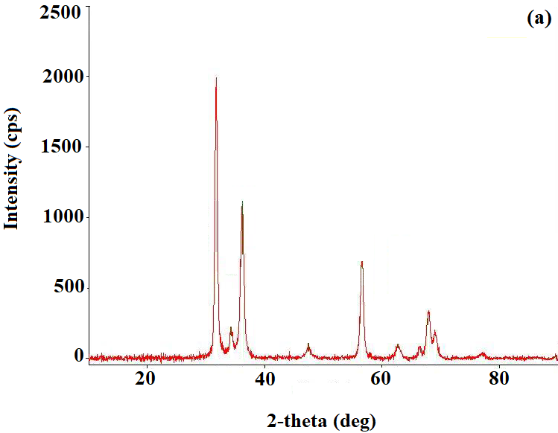 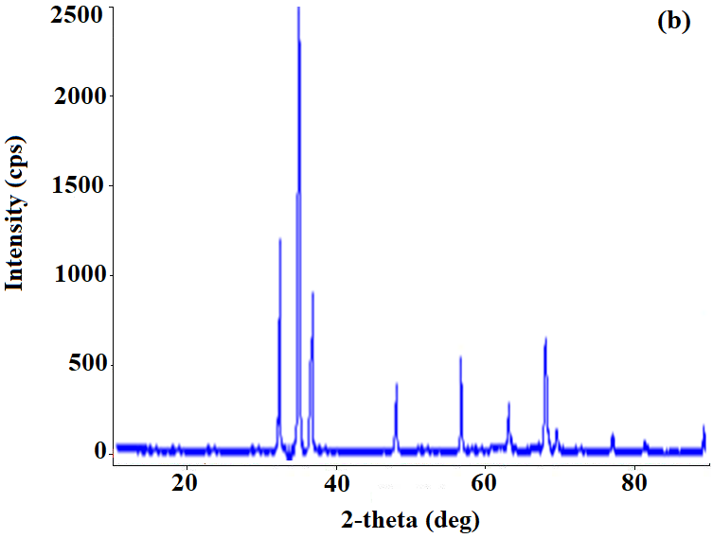

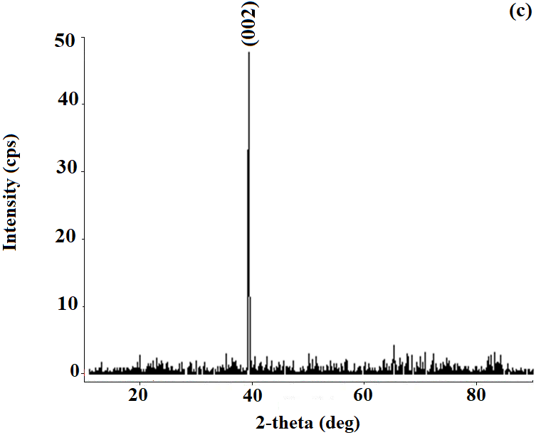 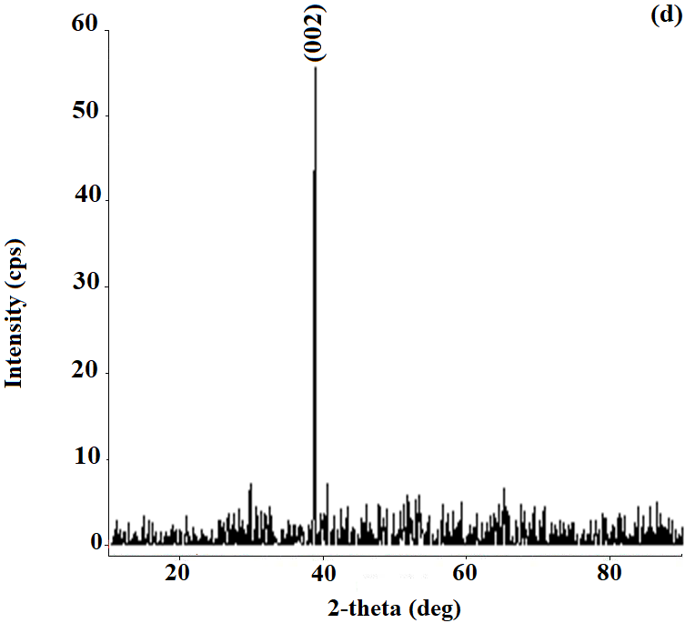

**Figure 1**. XRD patterns of the samples: (a) ZnO seed layer, (b) undoped ZnO nanorod structures, (c) 1 mol % Mo-doped ZnO nanorod structures, (d) 10 mol % Mo-doped ZnO nanorod structures.

**3.2. Morphological and compositional analysis**

Figure 2 shows the FE-SEM micrographs of produced samples. All the samples have homogeneous distribution. The more homogeneous the seed layer is, the more homogeneous the structures of the nanorods produced are understood from the micrographs. On the other hand, it is seen that the rod-shaped nanoparticles are very close to each other and there is almost no space between them, that is, they have a very dense structure. The nanorod diameters were measured at approximately 90 nm. The EDX spectra shown in figure 3 confirm that the molybdenum metal enters into the ZnO crystal lattice.

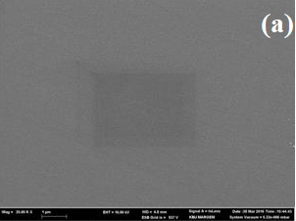 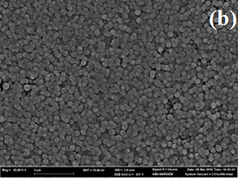

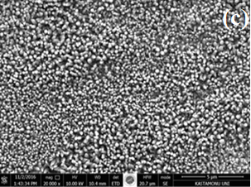 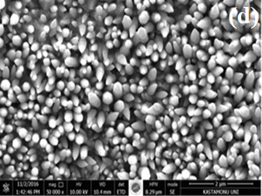

**Figure 2.** FE-SEM micrographs of the produced samples: (a) ZnO seed layer, (b) undoped ZnO nanorod structure, (c) and (d) 10 mol % Mo-doped ZnO nanostructures.

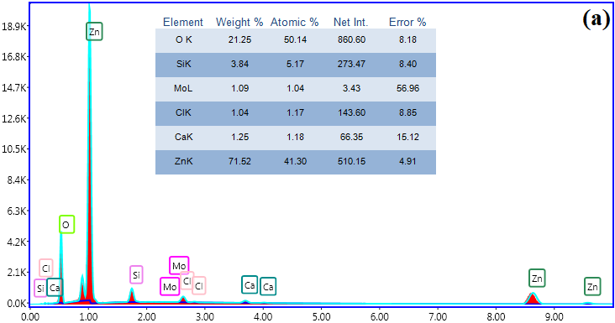 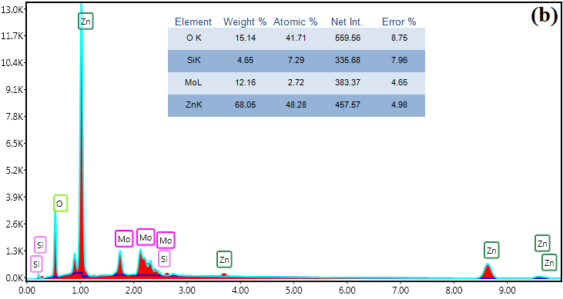

**Figure 3.** EDX spectra of the ZnO nanorod structures: (a) 1 mol % Mo doped, (b) 10 mol % Mo-doped.

**Acknowledgment**

This research was financially supported by Çankırı Karatekin University Scientific Research Projects Coordinatorship (ÇAKÜ BAP), Project No. FF031114B05.

**References**

1. Sohn, S., & Kim, H. M. (2011). Organic light emitting diode- material, process and devices, Chapter 9: Transparent conductive oxide (TCO) films for organic light emissive devices (OLEDs). *InTech Publication, Korea South*, 233-274.
2. Liao, Y., Zhou X., Xie X., & Yu Q. (2013). The effects of solvents on the highly oriented ZnO films prepared using sol–gel method. *Journal of Materials Science: Materials in Electronics*, 24, 4427-4432.
3. Rajeswari Yogamalar, N., & Chandra Bose A. (2013). Synthesis, dopant study and device fabrication of zinc oxide nanostructures. *Progress in Nanotechnology and Nanomaterials*, 2 (1), 1-20.
4. Çolak, H., & Türkoğlu, O. (2012). Studies on structural and electrical properties of copper-doped zinc oxide powders prepared by a solid state method at high temperatures. *Materials at High Temperatures*, 29, 344–350.
5. Kumari, V., Kumar, V., Malik, B. P., Mehra, R. M., Mohan, D., & Mohan, D. (2012). Nonlinear optical properties of erbium doped zinc oxide (EZO) thin films. *Optics Communications*, 285, 2182–2188.