**Detection of 4-methyl imidazole in dark soft drinks (cola)**

SALWAN SUFYAN IBRAHIM and Prof. Dr. VOLKAN EYÜPOĞLU

ÇANKIRI KARATEKİN ÜNİVERSİTESİ/ FEN BİLİMLERİ ENSTİTÜSÜ

salwanibrahim@yahoo.com

**Abstract**

The coloring agent caramel is used in a variety of popular drinks like beers, dark soft drinks another food product. The manufacturing process of these drinks and food product can expose consumers to 4-methylimidazole (4-MEI), and its possible carcinogen (1).

Although a standardized categorization for 4-methylimidazole (4-methylimidazole) has not yet been determined, there are a number of issues regarding the substance's toxicity to humans. (2)

the goal of the current study is to determining the 4-methylimidazole levels in soft drinks (Cola) from the local market in IRAQ/Baghdad 2023, fifty soft drink samples(cola) in total were gathered and examined HPLC technique, 20% of samples contain high concentration of (4-methylimidazole) above (250ppm) and its higher than the permissible limits,4-methylimidazole is not a genotoxic carcinogen, according to many Genotoxicity research. Consequently. (3)

***key words: 4-methylimidazole, cola, dark soft drinks, HPLC***

**1. Introduction**:

In the United States America, soft drinks are commonly consumed. A frequent component of many soft beverages, including as iced teas, colas, and root beers is a shade of caramel, which is made with ammonium compounds. When these compounds are used to make caramel color, 4-methylimidazole (4-MEI) may develop (Moon JK and Shibamoto T, 2011). Concerns over the usage rich caramel hue types three and four that may reveal users to 4-MEI and up the danger they face of cancer have been raised in recent years due to evidence that 4-MEI is carcinogenic, Using two-year feeding studies, The National Toxicology Program in United States America (NTP) evaluated 4-MEI's carcinogenicity in both sexes of rats in 2007. The other researches results showed concerning the presence of cancer-causing substances in female rats, there was conflicting evidence. predicated on an association between an increase in leukemia in exposed female rats as opposed to controls, and "clear evidence of carcinogenic activity in male and female mice." Male rats showed no signs of carcinogenicity (National Toxicology Program 2007). The International Agency for Research of tumor designated 4-MEI as Group 2B, or “possibly carcinogenic to humans,” based on the NTP research. This classification indicates that there is enough evidence of carcinogenicity in experimental animals even though there is a lack of available human data. Toxic Enforcement and Safe Drinking Water Act of 1986, or proposition 65 , California identified 4-MEI as a carcinogen in 2011 (Office of Environmental Health Hazard Assessment 2011). If using a product that includes a substance that has been classified as a carcinogen in accordance with Proposition 65 will expose the user to more of the chemical level of danger lower than that which is not statistically significant (N.S.R.L), which is 28.9 μg/day for 4-methyl imidazole, The NSRL is a typical daily exposure throughout a person's lifespan linked to a cancer risk of 1 in 100,000., After 4-MEI was included in light of Proposition 65, major soft drink producers declared they could cut back the amount of 4-MEI in their goods that were sold in the United States. Although investigations of 4-MEI in foods and beverages have been published, and the usage of caramel color types III and IV is still under inspection (Aubrey, 2013), earlier works that were research have not evaluated 4-MEI exposure or the related cancer risk and burden. In order to fill this important vacuum throughout the research, we evaluated the cancer risk and/or burden linked to exposure to 4-MEI by carrying out a market evaluation research beverages that were sweetened with caramel. (Consumer Reports (2014) Caramel Color).

A common natural colorant in wine, food, beverages, and spices is caramel. Almost all caramel is produced via an operation that produces 2- and 4-methylimidazole byproducts and is catalyzed by ammonia or ammonium bisulfite. The World Health Organization International Agency for Research on Cancer has categorized these compounds as "probable carcinogenic to humans" (Grosse etal. 2011). These substances have been demonstrated to cause cancer when tested in animals (Program 2007, 2004). The maximum Acceptable Daily Intake for 4-methylimidazole in class 2, class 3, and class 4 caramel is 201 mg/kg body weight per day, as determined by the World Health Organization's Expert Committee on Food Additives and the Joint Food and Agriculture Organization of the United Nations. Class III caramels must include fewer than 200 mg/kg of 4-methylimidazole, and class IV caramels must contain less than 250 mg/kg, according to EU regulations. China's national standards state that caramel made with ammonia, ammonium bisulfite, or the simple method can include up to 0.02% of 4-methylimidazole (Peng *et al*., 2001). Imidazole is not allowed to be added to cigarettes since it causes severe skin and mucous membrane irritation and reactions in humans. A common starting point for creating tastes and casings that enhance the color and quality of tobacco is caramel. Therefore, in order to guarantee the safety of soft drink products, it is imperative to quickly and precisely ascertain the 4-methylimidazole, 2-methylimizazole, and imidazole concentrations in soft drink additives. (Alwarthan, Fattah, and Zahran 1992), gas chromatography (Guo et al. 2005), high performance liquid chromatography (Wilks, Johnson, and Shingler 1977), gas chromatography-mass spectrometry (Charlton and Jones 2007), and liquid chromatography tandem mass spectrometry (Schlee *et al.,* 2013) are techniques that have been reported for the determination of 4-methylimidazole. On the other hand, the high performance liquid chromatograph (HPLC) has a special technical advantage because of its high polarity and relatively high boiling points.

the aim of the current study is to determining the 4-methylimidazole levels in the soft drinks (Cola) from the local market in IRAQ/Baghdad 2023.

**2.Material and Methods:**

**2-1.Prepare samples**:

50 samples of soft drinks (cola) were collected from the local markets in BAGHDAD/ IRAQ 2023 all samples were stored at room temperature and dark dry place.

In the laboratories of the Ministry of Science and Technology/IRAQ, a test was carried out to detect 4-Methylimidazole.

Extraction and detection of 4-methyl imidazole using high-performance liquid chromatography (HPLC).

4-Methlimidozole was extracted using the following steps, as outlined by the scientist (Tae Rang Kim,2013) 10ml of soft drink sample was combined with 50ml of acetonitrile solvent, then the mixture was shaken for thirty seconds. The organic layer of acetonitrile was then removed, and the sample was refrigerated until the analysis was done. Food items were found to have 4-methylimidazole. (Tae Rang Kim *et al.,*2013).

The test utilized a high-performance chromatography (HPLC) model SHIMADZO, which was developed in JAPAN. The following parameters were used: a carrier phase consisting of (methanol, acetonitrile, distilled water at a ratio of 70-25-5) was used, with a flow rate of 1 ml/minute; a C18-ODS column (25 cm * 406 mm) was used to filter the compound; a UV detector with a wavelength of (220 nm) was employed to detect the substance; the presence of the substance in the samples was diagnosed by relying on the retention time, and the concentration was determined using the following equation.

**2-2. Reagents:**

Methanol (99%), 4-MEI (98%), acetonitrile (99%), deionized water.

A Shimadzu HPLC system (Shimadzu, Japan) with a diode array detector and oven, a degasser solvent, an auto sampler with a 2 ml lope, and a pump system was utilized to detect 4-MEI in soft drink products. RECIPE-Chemicals (Munich, Germany) provided the guard column, extraction column (SPEcolumn), and two columns for analysis equipped wi0th protective cartridges (ClinPrep). The mobile phase flow rate was 2.0 mL/min, the oven was set to 40°C, and the detection range was 190–370 nm. Solvents from RECIPE-Chemicals were used to produce the separation: ClinRep, SPE-Washing solution for TOX.IS; ClinRep, mobile phase solvent A; ClinRep, mobile phase solvent B; and ClinRep, mobile phase solvent AB. 44 minutes was the run time in total. The 4-MEI retention time under the aforementioned circumstances was 21.8 minutes. Standard and spiked 4-MEI chromatograms as well as chromatograms of soft drink samples that are both positive and negative.

**3.Results and discussion:**

Fifty samples of soft drinks (cola) were collected from local markets in Baghdad/Iraq then doing extraction process according to the scientific literature, then inject all soft drink samples in HPLC technique and analyzed it.

A peak with a retention time of 2.20 min was observed in the data, indicating that the standard substance 4-Methylimidazole was injected according to the well-established parameters to assess its retention time. Fig (1)

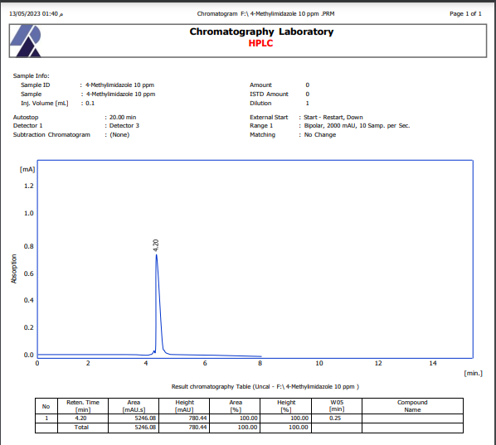

**Figure (1) Chromatographic analysis of standard 4-methylimidazole by HPLC**

The results show that the soft drinks have several peaks (2.36, 4.25, 5.61) min then we do comparing the retention time with the standard substance, the results shows that the soft drinks contained 4-methylimidazole as in the fig (2).

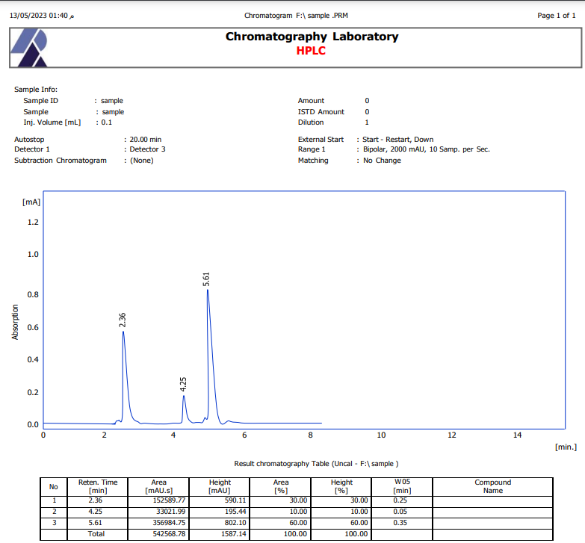

**Figure (2) Chromatographic analysis of soft drinks samples 4-imidazole by HPLC**

The results showed that all seven up samples (15 samples) are not contained 4 methyl imidazole, and the analyzed of the other 15 samples of cola showed that 4 samples contained 4 methyl imidazole and another 11 samples cola not have any concentration of it, four cola samples have (250-300) mg/kg, and that not suitable for human consumption because these samples containing imidazole above permissible limits according to Europe United which said Caramel-colored substance of all types was considered safe in the Europe United and the legally permitted concentration of MEI-4 in caramel coloring was 250 mg/kg. (European Food Safety Authority, 2004).

Schlee and co-authors (2013) reported that the average consumption of soft drinks is 224 g/day in men and 505 g/day in teenagers (14-18 years old). Using the same exposure assumptions, and based on the results presented in the present study for soft drinks, a rough estimation of the maximum daily 4-MEI intake for an adult in Greece is around 107 µg/day with a mean daily intake of 50.3 µg/day (according to the mean detected concentrations of 4-MEI in soft drinks, while for a Greek teenager the maximum daily intake is 241 µg/day with a mean daily intake of 113 µg/day. Our results are in agreement with the 2011 re-evaluation of the European Food Safety Authority, which concluded that in Europe the human exposure to 4-MEI was far below the threshold level of NOAEL (EFSA, 2011). Nevertheless, these values exceed the value of 29 µg/day set by the California Environmental Protection Agency (CEPA). Leading soft drink manufacturers in the United States of America (U.S.A.) announced that they would lower 4-MEI concentrations in products sold there (Smith et al., 2015). Based on the above controversial classifications and statements, the European Commission should initiate relevant procedures in order to conclude a harmonized classification for 4-MEI regarding all health hazards, including carcinogenicity and mutagenicity. In such a way, the human health hazard it would be legally clarified and any concerns to consumers and the scientific community derived from different approaches in Europe and the USA would be soothed.

**4.Conclusion:**

Making sure that 4-methylimidazole (4-MeI) is present in soft drinks is an important step in maintaining consumer safety and meeting regulatory requirements. Given that other studies have linked high exposure to 4-MeI with an increased risk of cancer in laboratory animals, this study set out to quantify the quantities of 4-MeI in soft beverages with an eye toward its perhaps health implications, All of the soft drinks (cola) examined contained 4-methylimidazole with concentrations that were either within or beyond the limits set by regulators. This emphasizes the importance of the beverage industry's regulatory requirements and the necessity for ongoing monitoring of consumer health.

The research also highlighted the significance of improving production procedures to reduce 4-MeI generation, especially those that use caramel coloring. Furthermore, it recommended establishing quality control procedures to guarantee that soft drinks adhere to predetermined safety standards.

These results highlight the need for regulatory bodies to place stringent limitations on 4-MeI concentrations in soft drinks and for producers to actively work towards reducing this component's presence in their products. To ensure the safety of soft drink consumers, additional studies should investigate potential substitute components or manufacturing processes that reduce the creation of 4-MeI. It is our responsibility as customers to learn about the regulations governing soft drinks and to make educated decisions when purchasing these beverages.

**References:**

* Alwarthan, A., S. A. Fattah, and N. M. Zahran. 1992. Spectrophotometric determination of cephalexin in dosage forms with imidazole reagent. Talanta 39 (6): 703–07. doi:10.1016/0039-9140(92)80085-r
* Aubrey A (2013) Coke Changed Caramel Color To Avoid Cancer Warning; Pepsi In Transition. Available
* Charlton, A. J., and A. Jones. 2007. Determination of imidazole and triazole fungicide residues in honeybees using gas chromatography–mass spectrometry. Journal of Chromatography A 1141 (1): 117–22. doi:10.1016/j.chroma.2006.11.107
* Consumer Reports (2014) Caramel Color: The Health Risk That May Be in Your Soda.
* EFSA Panel on Food Additives and Nutrient Sources added to Food (ANS), 2011. Re-evaluation of caramel colours (E 150 a,b,c,d) as food additives. European Food Safety Authority (EFSA), Parma, Italy. EFSA Journal 9(3), 2011
* European Food Safety Authority (2004) Scientific opinion on the re-evaluation of caramel colours (E 150 a,b,c,d) as food additives. EFSA Panel on Food Additives and Nutrient Sources added to Food (ANS).
* Grosse, Y., R. Baan, B. Secretan-Lauby, F. El Ghissassi, V. Bouvard, L. Benbrahim-Tallaa, N. Guha, F. Islami, L. Galichet, and K. Straif. 2011. Carcinogenicity of chemicals in industrial and consumer products, food contaminants and flavourings, and water chlorination byproducts. The Lancet Oncology 12 (4): 328–29. doi:10.1016/s1470-2045(11)70088-2.
* Guo, X. l., M. Chen, S. Zhang, and J. Hu. 2005. Determination of 4-methylimidazole in caramel color by capillary gas chromatography.
* Moon JK, Shibamoto T (2011) Formation of Carcinogenic 4(5)-Methylimidazole in Maillard Reaction Systems. J Agr Food Chem 59: 615–618.
* National Toxicology Program (2007) NTP Technical Report on the Toxicology and Carcinogenesis Studies of 4-Methylimidazole (CAS No. 822–36–6) in F344/N Rats and B6C3F1 Mice (Feed Studies).
* Office of Environmental Health Hazard Assessment (2011) No Significant Risk Level (NSRL) for the Proposition 65 Carcinogen 4-Methylimidazole.
* Peng, G., J. Tan, Z. Jiufang, X. Huo, Y. Zhang, and T. Ye. 2001. Food additives-caramel (Sulfite ammonia caramel, ammonia caramel, plain caramel). National Standard of the People’s Republic of China. (GB8817): 468–75.
* Program, N. T. 2004. Toxicology and carcinogenesis studies of 2-methylimidazole (Cas No. 639- 98-1) in F344/N rats and B6C3F1 mice (feed studies). National Toxicology Program technical report series (516): 292.
* Program, N. T. 2007. Toxicology and carcinogenesis studies of 4-methylimidazole (Cas No. 822- 36-6) in F344/N rats and B6C3F1 mice (feed studies). National Toxicology Program technical report series (535): 274.
* Schlee, C., Markova, M., Schrank, J., Laplagne, F., Schneider. R., Lachenmeier, D.W., 2013.Determination of 2-methylimidazole, 4-methylimidazole and 2-acetyl-4-(1,2,3,4- tetrahydroxybutyl)imidazole in caramel colours and cola using LC/MS/MS. J. Chromatogr. B 927, 223– 226.
* Smith, T.J., Wolfson, J.A., Jiao, D., Crupain, M.J., Rangan, U., Sapkota, A., Bleich, S.N., Nachman, K.E., 2015. Caramel Color in Soft Drinks and Exposure to 4-Methylimidazole: A Quantitative Risk Assessment. PLoS One, Feb 18;10(2):e0118138. doi: 10.1371/journal.pone.0118138.
* Tae-Kyung Kim , Yun-Sang Choi (2017) . Quality Characteristics of Tteokgalbi with Black Rice
* Wilks, R. A., M. W. Johnson, and A. J. Shingler. 1977. An improved method for the determination of 4-methylimidazole in caramel color. Journal of Agricultural and Food Chemistry 25 (3): 605–08. doi:10.1021/jf60211a058