**Investigation of thermal enhancement in a wavy channel with circular cylinders**

***Selma AKÇAY1,[1]*[C:\Users\Abdullah\AppData\Local\Microsoft\Windows\INetCache\Content.Word\ORCID-iD_icon-16x16.gif](https://orcid.org/0000-0003-2654-0702)Nijat SADIGOV2***

*1* Çankırı Karatekin University, Engineering Faculty, Department of Mechanical Engineering, Çankırı, Türkiye*

*2Çankırı Karatekin University, Undergraduate Student of Mechanical Engineering, Çankırı, Türkiye*

|  |
| --- |
| **Abstract**  The present study numerically investigates the flow and thermal enhancement in a circular wavy channel with different positions of circular cylinders. Solutions are conducted using ANSYS Fluent program with standard k-ε turbulence model. The pressure-velocity relation is handled with the SIMPLE algorithm. In the study, three different channel flows are examined: Channel 0 (without cylinder), Channel 1 (with one circular cylinder), and Channel 2 (with two circular cylinder). There are adiabatic flat parts at the inlet and outlet of the channel. The circular wavy surfaces of the channel are kept at a constant temperature of Ts=340K. The working fluid is air. Nusselt number (Nu), pressure drop (𝛥P), friction factor (f), and thermal enhancement factor (TEF) are found for different Reynolds numbers (2000 ≤ Re ≤ 8000). The numerical work is compared with previous study results. To observe the effects of the circular wavy channel and the circular cylinders on the flow and temperature fields, the velocity and temperature contours are obtained, and the results are discussed. In addition, the study results are compared to the flat channel. Numerical results show that the circular wavy channel increased the Nusselt number. However, the presence of circular cylinders causes a slight increase in friction factor. The highest heat transfer is found as Nu = 11.62 in Channel 1 at Re = 8000. The highest-pressure drop is obtained to be ΔP= 20.05 Pa in Channel 1 at Re=8000. |
| Keywords: Circular wavy channel, Circular cylinder, Pressure drop, Termal enhancement, Turbulent flow |

1. **Introduction**

Wavy channels have been commonly used in many thermal systems for a long time. These channels have more heat transfer area than flat channels. Therefore, higher thermal enhancement is achieved by increasing the heat transfer surface area. These channels are used in many engineering fields such as heating and cooling applications [1, 2]. Many researchers experimentally and numerically investigated the flow and heat transfer behavior of wavy channels with different wave geometries. The results of these studies demonstrated that wavy channels provide higher thermal enhancement than flat channels. However, it was declared an increase in pumping power in these channels [2-4].

Choudhary et al. [5] investigated the flow and heat transfer of wavy and flat channels in a heat exchanger and reported that the heat transfer and pressure drop were higher in wavy channels than in flat channels. Ajeel et al. [6] conducted an experimental and numerical study to investigate the heat transfer in the circular and trapezoidal corrugated ducts and declared that the heat transfer enhanced by 3.1 times in the trapezoidal channel. In their numerical study, Akdag et al. [7] investigated the heat transfer under pulsating flow in sinusoidal wavy and reported that heat transfer enhanced in wavy ducts with increasing friction factor. The results of Salami et al. [8] indicated that the maximum heat transfer was obtained in the trapezoidal wavy duct, while the highest performance factor was found in the sinusoidal wavy duct. Shahsavar et al. [9] examined the flow and thermal characteristics of nanofluid flow in different waveforms (triangular, sinusoidal, and trapezoidal), and declared that heat transfer in the sinusoidal profile was improved more than other ducts.

The addition of baffles, winglets, or cylinders in different modifications into the channel increases the heat transfer [10, 11]. Promvonge et al. [12] experimentally and numerically studied the flow and heat transfer of V-type wings. They reported that the wings can increase the heat transfer up to 3.8 times if appropriate parameters are used. Akcay [13] numerically studied the flow and heat transfer in a zigzag wavy channel with winglets and found that the winglets added to the channel increased the heat transfer. Naderifar et al. [14] numerically investigated the effects of wave number and fin height on the flow and heat transfer in a rectangular wavy duct with fins. They indicated that when the wave number was 2 and the fin height was 7.5, the best heat transfer was achieved compared to the flat duct. Feng et al. [15] numerically investigated the flow and thermal performance in the triangular wavy duct with trapezoidal baffles declared that the heat transfer increased by 1.7 times compared to the flat duct, while the pressure drop increased by 3.5 times. Akcay and Akdag [16] numerically examined heat transfer in a circular channel with different baffle angles (θ=30º, 90º, 180º). They found that the highest thermal enhancement and friction factor were obtained at the 90º baffle angle. Akcay [17] numerically investigated the heat transfer at different Re in a semicircular wavy duct with vertical baffles. It was reported that flow and heat transfer were highly influenced by duct geometry and baffles. Togun et al. [18] conducted a numerical work investigating heat transfer in a circular wavy duct for varying modifications of ribs at 10000 ≤ Re ≤ 25000. They indicated that Nusselt number increased with Reynolds number in the wavy duct.

As can be seen from the above works, the wavy channels greatly enhance thermal performance with an increase in pumping power. The fact that there are too many parameters to be examined such as geometries of wavy channels and vortex generators, modifications of vortex generators in channel and fluid properties have led to an increase in studies. The main purpose of these studies is to enhance heat transfer without an important increase in pumping power. Therefore, this study investigates the flow and thermal enhancement in a circular wavy channel with different positions of circular cylinders. The results were compared with the flat channel.

1. **Materials and Methods**
   1. **Numerical model**

Figure 1 indicates the geometries of the wavy channel used in this work. There are adiabatic straight parts with a length of L1 = 200 mm at the inlet and outlet of the channel. The heights of the channel are H = 40 mm. There is a circular wavy channel part with a length of L2 = 400 mm. The circular wavy channel section (L2) is heated. Circular cylinders are placed inside the wavy channel. The circular wavy channel without cylinders is called Channel 0. In the case of Channel 1, there is one circular cylinder in the channel center inside each wavy section. In the case of Channel 2, there are two circular cylinders inside each circular section. The diameter of the cylinders is 6 mm. Geometric dimensions of the wavy channels and circular cylinders are given in Figure 1.

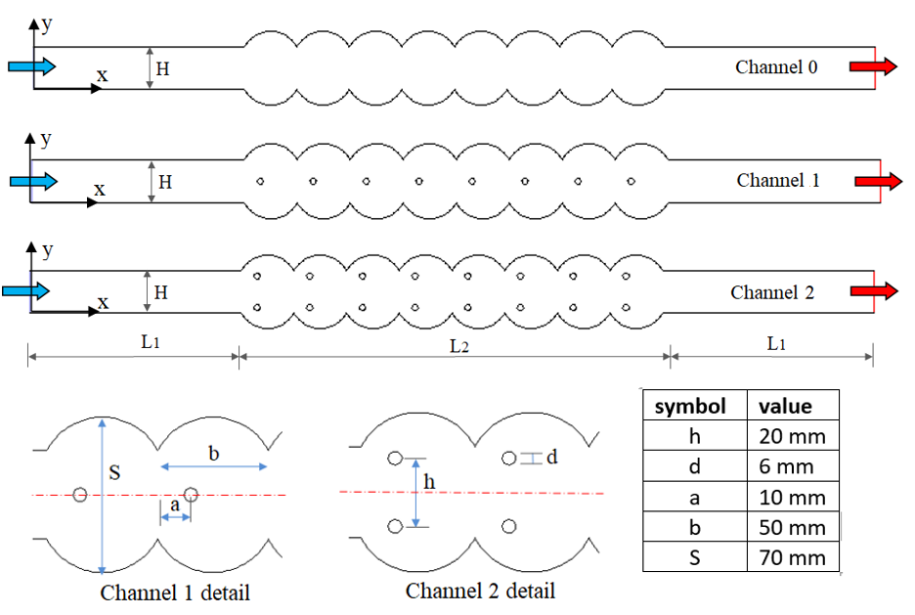

**Figure 1.** Geometries of the numerical model (with details)

* 1. **Governing equations**

In the numerical study, the flow field is 2d. The fluid is considered single-phase, incompressible and Newtonian type. The fluid flows in turbulent regime and steady case. Viscous terms are ignored. Fluid properties are constant. The effect of gravity and radiation are neglected. The governing equations are given below:

$\frac{∂}{∂x_{i}}\left(ρ{\overline{u}}_{i}\right)=0$ (1)

$\frac{∂}{∂t}\left(ρ{\overline{u}}_{i}\right)+\frac{∂}{∂x_{j}}\left(ρ{\overline{u}}_{i}{\overline{u}}_{j}\right)=-\frac{∂\overline{p}}{∂x_{i}}+\frac{∂}{∂x_{j}}\left[\left(μ+μ_{t}\right)\left(\frac{∂{\overline{u}}_{i}}{∂x_{j}}+\frac{∂{\overline{u}}_{j}}{∂x_{i}}\right)\right]-ρ\overline{u_{i}^{'}u_{j}^{'}}$ (2)

$\frac{∂}{∂t}\left(ρc\overline{T}\right)+\frac{∂}{∂x_{j}}\left(ρ{\overline{u}}_{i}\overline{T}\right)=\frac{∂}{∂x_{j}}\left[\left(Γ+Γ_{t}\right)\left(\frac{∂\overline{T}}{∂x_{j}}\right)\right]$ (3)

$-ρ\overline{u_{i}^{'}u_{j}^{'}}=(μ_{t})\left(\frac{∂u_{i}}{∂x_{j}}+\frac{∂u_{j}}{∂x_{i}}\right)$ (4)

$\frac{∂}{∂t}\left(ρk\right)+\frac{∂}{∂x_{i}}\left(ρk{\overline{u}}_{i}\right)=\frac{∂}{∂x_{j}}\left[\left(μ+\frac{μ_{t}}{σ_{k}}\right)\frac{∂k}{∂x_{j}}\right]+G_{k}-ρε$ (5)

$\frac{∂}{∂t}\left(ρε\right)+\frac{∂}{∂x_{i}}\left(ρε{\overline{u}}_{i}\right)=\frac{∂}{∂x_{j}}\left[\left(μ+\frac{μ_{t}}{σ_{ε}}\right)\frac{∂ε}{∂x_{j}}\right]+C_{1ε}\frac{ε}{k}G_{k}-C_{2ε}ρ\frac{ε^{2}}{k}$ (6)

In this study, the flow and heat transfer in a circular wavy channel with different positions of the circular cylinders were studied at different Reynolds numbers (2000 ≤ Re ≤ 8000).

* 1. **Numerical method and boundary conditions**

The numerical study was conducted by the ANSYS Fluent solver. The standard k- ε turbulence model was used as the flow model. Governing equations were discretized with the finite volume approach and the velocity-pressure relationship was solved with the SIMPLE algorithm. A value of 10-7 was set for all equations as the convergence criterion. For the mesh independence testing, the Nusselt numbers were calculated for different element numbers. As a result of this calculations, it was decided that 64344, 64508 and 64106 element numbers are sufficient for the Channel 0, Channel 1 and Channel 2, respectively.

The working fluid is air. The air enters the channel at a constant velocity (U) and temperature (To=300 K). In the study, Reynolds number varied in the range of 2000≤Re≤8000. The heated circular wavy surfaces (L2) were kept constant at Ts=340 K. The non-slip wall condition was defined for the all surfaces. Straight parts at the inlet and outlet of the channel are adiabatic. The circular cylinders were assumed to be adiabatic and non-slip conditions.

* 1. **Mathematical Model**

The Reynolds number (Re) is calculated by Equation (7):

$Re=\frac{ρUD_{h}}{μ}$ (7)

where, Dh is the hydraulic diameter, ρ is the density, μ is the dynamic viscosity, and U is the mean velocity.

The average Nusselt number (Nu) is obtained by Equation (8):

$Nu=\frac{hD_{h}}{k_{f}}$ (8)

where, kf and h are thermal conductivity and convective heat transfer coefficient, respectively.

The relative Nusselt number (Nurel) is described with Equation (9).

${Nu}_{rel}=\frac{{Nu}_{w}}{{Nu}_{o}}$ (9)

where, Nuw shows the Nusselt number obtained in the circular wavy channel with/without circular cylinders, and Nuo shows the Nusselt number obtained in the flat channel flow.

The friction factor (f) is found in the channel is given by Equation (10):

$f=\frac{2ΔPD_{h}}{ρU^{2}L}$ (10)

Relative friction factor (fw/fo) is calculated by Equation (11):

$f_{rel}=\frac{f_{w}}{f_{o}}$ (11)

where, fw is the friction factor obtained in the circular wavy channel with/without circular cylinders, and fo shows the friction factor obtained in the flat channel flow.

The thermal enhancement factor (TEF) is given by Equation (12):

$PF={{(Nu}_{w}/{Nu}_{o}){(f}_{w}/f_{o}) }^{-1/3}$ (12)

**Results and Discussion**

* 1. **Validation of the numerical results**

The numerical results obtained in this work were validated with the results of previous studies. Brodniansk’a and Kot’smid [19] experimentally and numerically investigated flow and heat transfer for the turbulent flow of air in a flat channel. Fig. 2 indicates the comparison of the results of this study with Brodniansk’a and Kot’smid [19].

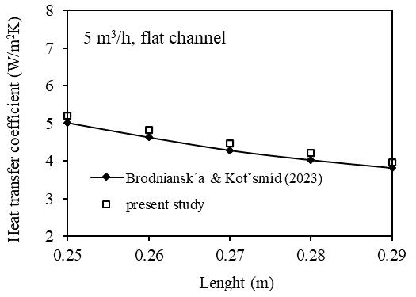

**Figure 2.** Validation of the numerical study [19]

In this study, the velocity and temperature fields were presented to indicate the effects of wavy channel geometry, circular cylinders, and Reynolds number on flow and heat transfer. In Figure 3, the velocity contours (a) and temperature fields (b) are indicated in wavy channels with/without circular cylinders for Re=2000. The positions of the circular cylinders in the wavy channel were considerably changed the flow and thermal fields. In the case of Channel 1, the cylinders appeared to direct the fluid into circular cavities. In the case of Channel 2, while the main flow passes between both cylinders, a very small part of it flows over the cylinders (Fig 3a). Therefore, in the case of Channel 2, the temperature of the circular wavy surfaces is higher than the other channels (Fig 3b).

|  |  |
| --- | --- |
|  |  |
|  |  |
|  |  |
|  |  |
| 1. Velocity contours | 1. Temperature contours |

**Figure 3.** Velocity contours (a) and temperature contours (b) at Re=2000 for all channel flows

In Fig. 4, velocity contours (a) and temperature fields (b) are showed in wavy channels with/without circular cylinders for Re=8000. The Reynolds number significantly affected the flow and temperature fields. Increasing the Re increased the flow velocity in the channel, which caused an increase in inertial forces and turbulence effects in the channel. Therefore, in Fig. 4b, the temperature gradient in the channel is seen to be lower than in Fig. 3b. As the Reynolds number increased, the temperature of the wavy surfaces decreased considerably.

|  |  |
| --- | --- |
|  |  |
|  |  |
|  |  |
|  |  |
| 1. Velocity contours | 1. Temperature contours |

**Figure 4.** Velocity contours (a) and temperature contours (b) at Re=8000 for all channel flows

Figure 5 shows the Nusselt number (a), pressure drop (Pa) (b), friction factor (c), and thermal enhancement factor (d) with Reynold number for all channel flows. In Fig. 5a, the Nusselt number increases as the Reynolds number increases. The highest heat transfer was found to be Nu=11.62 at Re=8000 in the Channel 1. In Fig. 5b, the pressure drop increased with Reynolds number in all flow cases. The pressure drop in the wavy channel without cylinders was found to be close to the flat channel. The highest pressure drop was obtained to be ΔP = 20.05 Pa in the Channel 1 at Re = 8000. In Fig. 5c, as the Reynolds number increases, the friction factor decreases for all channel cases. Friction factors in the flat channel and the wavy channel without cylinders were obtained very close to each other. The highest friction factor was obtained in Channel 1. In Fig. 5d, the flat channel is considered as reference for thermal enhancement factor. In the Channel 0, TEF was found above the reference value for all Reynolds numbers. In the Channel 1, TEF was found to be above the reference value at low Re values. As Re increases, the TEF value falls below the reference value. Because the pressure drop increases with increasing Re. In the Channel 2, TEF values for all Re were found below the reference value. Because the heat transfer achieved in Channel 2 is much lower than the other channels. The highest TEF was obtained to be 1.16 at Re=6000 in the Channel 0.

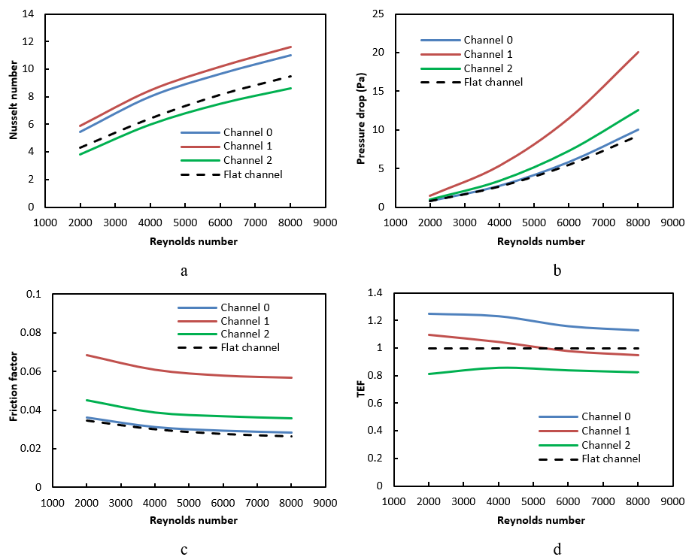

**Figure 5.** a-Nusselt number, b- Pressure drop, c- Friction factor, d-Thermal enhancement factorwith Reynolds number

1. **Conclusion**

In present work were numerically investigated the flow and thermal enhancement factor in a circular wavy channel with different positions of circular cylinders. Nusselt number (Nu), pressure drop (Pa), friction factor (f) and thermal enhancement factor (TEF) were obtained in three different channel for turbulent flow. Images of the velocity and temperature contours in the channels were obtained at different Reynolds numbers. In addition, the numerical results were compared with the flat channel. The circular wavy channel increased the heat transfer relative to flat channel. However, wavy channel causes a slight increase in pressure drop. The highest Nusselt number was found to be 11.62 at Re=8000 in the Channel 1 case. The highest pressure drop was obtained to be 20.05 Pa at Re=8000 in the Channel 1. Friction factors in flat channel and circular wavy channel without cylinder were found very close to each other. The highest TEF was found to be 1.16 at Re=6000 in the Channel 0.

**References**

1. Ajarostaghi SSM, Zaboli M, Javadi H, Badenes B, & Urchueguia JF. (2022). A review of recent passive heat transfer enhancement methods. *Energies,* 15, 986.
2. Kurtulmus N, & Sahin B. (2019). A review of hydrodynamics and heat transfer through corrugated channels. *International Communications in Heat and Mass Transfer*, 108, 104307.
3. Nitturi LK, Kapu VK, Gugulothu R, Kaleru A, Vuyyuri V, & Farid A. (2023). Augmentation of heat transfer through passive techniques. *Heat Transfer,* <https://doi.org/10.1002/htj.22877>
4. Alfellag M A, Ahmed H E, Jehad M G, Farhan A A. (2022). The hydrothermal performance enhancement techniques of corrugated channels: A review. *Journal of Thermal Analysis and Calorimetry*, 147, 10177-10206.
5. Choudhary T, Sahu MK, Shende V, & Kumar A. (2022). Computational analysis of a heat transfer characteristic of a wavy and corrugated channel. *Material Today: Proceedings,* 56, 263-273.
6. Ajeel RK, Salim WI, Sopian K, Yusoff MZ, Hasnan K, Ibrahim A, & Al- Waeli AH. (2019). Turbulent convective heat transfer of silica oxide nanofluid through corrugated channels: an experimental and numerical study. *Int. J. Heat Mass Transf.,* 145, 118806.
7. Akdag U, Akcay S, Demiral D. (2014). Heat transfer enhancement with laminar pulsating nanofluid flow in a wavy channel. *International Communications in Heat and Mass Transfer*, 59, 17–23.
8. Salami M, Khoshvaght-Aliabadi M, Feizabadi A. (2019). Investigation of corrugated channel performance with different wave shapes. *Journal of Thermal Analysis and Calorimetry*, 138, 3159-3174.
9. Shahsavar S S, Alimohammadi I, Askari B, Ali H M. (2021). Numerical investigation of the effect of corrugation profile on the hydrothermal characteristics and entropy generation behavior of laminar forced convection of non-Newtonian water/CMC-CuO nanofluid flow inside a wavy channel. *Int. Commun. Heat Mass Trans.* 121, 105117.
10. Li Z, & Gao Y. (2022). Numerical study of turbulent flow and heat transfer in cross-corrugated triangular ducts with delta-shaped baffles. *International Journal of Heat and Mass Transfer*, 108, 658-670.
11. Sun Z, Zhang K, Li W, Chen Q, & Zheng N. (2020). Investigations of the turbulent thermal-hydraulic performance in circular heat exchanger tubes with multiple rectangular winglet vortex generators. *Applied Thermal Engineering*, 168, 114838.
12. Promvonge P, Promthaisong P, & Skullong S. (2020). Experimental and numerical heat transfer study of turbulent tube flow through discrete V-winglets. *International Journal of Heat and Mass Transfer*, 151, 119351.
13. Akçay S. (2023). Numerical analysis of hydraulic and thermal performance of Al2O3-water nanofluid in a zigzag channel with central winglets. *Gazi University Journal of Science*, 36 (1), 383-397.
14. Naderifar A, Nikian M, Javaherdeh K, & Borji M. (2022). Numerical investigation of the effect of fins on heat transfer enhancement of a laminar non-newtonian nanofluid flow through a corrugated channel. *J. Thermal Analysis and Calorimetry*, 147, 9779-9791.
15. Feng C-N, Liang C-H, & Li Z-X. (2022). Friction factor and heat transfer evaluation of cross-corrugated triangular flow channels with trapezoidal baffles. *Energy & Buildings*, 257, 111816.
16. Akcay S, & Akdag U. (2022). [Effect of baffle angles on flow and heat transfer in a circular duct with nanofluids](https://dergipark.org.tr/en/pub/iarej/issue/73888/1136354). *International Advanced Researches and Engineering Journal*, 6 (3), 176-185.
17. Akcay S. (2023). Heat transfer analysis of pulsating nanofluid flow in a semicircular wavy channel with baffles. Sādhanā, 48: 57.
18. Togun H, Homod R Z, Yaseen Z M, Abed A M, Dhabab J M, Ibrahem R K, Dhahbi S, Rashidi M M, Ahmadi G, Yaïci W, Mahdi J M. (2022). Efficient heat transfer augmentation in channels with semicircle ribs and hybrid Al2O3-Cu/water nanofluids. *Nanomaterials*, 12(15), 2720.
19. Brodniansk´a Z & Kotˇsmíd S. (2023). Heat transfer enhancement in the novel wavy shaped heat exchanger channel with cylindrical vortex generators. *Applied Thermal Engineering*, 220, 119720.

1. * Corresponding author. *e-mail address: selmaakcay@karatekin.edu.tr*