**The Investigation of Oven and Vacuum Oven Drying Kinetics and Mathematical Modelling of Golden Berries**

***Ekin KIPÇAK1,\*[C:\Users\Abdullah\AppData\Local\Microsoft\Windows\INetCache\Content.Word\ORCID-iD_icon-16x16.gif](https://orcid.org/0000-xxxx-xxxx-xxxx)***

*1Faculty of Chemical and Metallurgical Engineering, Department of Chemical Engineering, Yıldız Technical University, Istanbul, Turkey*

|  |
| --- |
| **Abstract**  Golden berry (*Physalis peruviana*) is a fruit that is natively cultivated in the Andean region. Due to its significant nutritional and functional properties, golden berry has been gradually attracting worldwide attention. It’s characterized by a high content of vitamins, minerals, carotenoids and polyphenols. Due to its significant antioxidant properties, it’s widely used for the treatment of various diseases and nutritional support. Nevertheless, golden berry is a rapidly perishable fruit, a property of which hinders its desired commercialization. The requirement for extensive preservation highlights drying: one of the most widely preferred preservation techniques. Although there are numerous studies regarding the antioxidant properties of golden berries, investigation on their drying characteristics is still scarce. Hence, in this study, oven and vacuum oven drying of golden berries were performed at 60, 70 and 80°C. Throughout the experiments, the drying kinetic parameters of effective moisture diffusivity (Deff) and activation energy (Ea) were investigated. Moreover, mathematical modelling of the drying data was established with the most known modelling equations presented in literature. The experimental studies revealed that the drying times decreased with increasing drying temperature and with vacuum addition. The highest and lowest drying times were encountered as 480 minutes in oven drying at 60°C, and 195 minutes in vacuum oven drying at 80°C, respectively. Deff values were calculated between 1.95×10-10-3.80×10-10 m2/s and 2.20×10-10-5.45×10-10 m2/s for oven and vacuum oven drying, respectively. Ea values, on the other hand, were found as 32.81 kJ/mol for oven drying and 44.30 kJ/mol for vacuum oven drying. Fourteen mathematical models were applied to the drying curve data and most of them were seen to yield satisfactory results. However, Midilli & Kucuk model was seen to provide the best fit for both oven and vacuum oven drying, with R2 values between 0.999799-0.999957 and 0.999648-0.999998, respectively. |
| Keywords: Drying Kinetics, Golden Berry, Mathematical Modelling, Oven Drying, Vacuum Oven Drying |

1. **Introduction**

Golden berry (*Physalis peruviana*), also called cape gooseberry, is an exotic fruit that is natively cultivated in the Andean region of the world [1, 2]. It is covered by a yellow peel and is protected through a surrounding dry parchment-like husk, named as calyx, which serves as a protective shield againsts adverse climatic conditions, birds and insects [3-5]. It is a functional food that attracts particular attention due its nutritional composition and content of bioactive components. Golden berries contain substantial amount of vitamins (especially Vitamin A, Vitamin C, Vitamin K and Vitamin B complexes), minerals, fibers, ascorbic acid, polyphenols and carotenoids [2-5]. It is widely used in the field of medicine for the remedy of various diseases, due to its anti-parasitic, anti-infectious and diuretic properties [3]. It was reported that golden berries are used in the treatment of cancer, hypertension, asthma, ulcer, hepatitis, dermatitis, malaria and rheumatism [6, 7]. The high levels of Vitamin K, which is responsible for protein synthesis in charge of blood clotting and bone metabolism, reduce the risk of heart diseases and occurrence of cancer [7]. Due to its fructose content, golden berry is also recommended for diabetics [5, 7].

Considering all of the aforementioned desirable nutritional and functional properties, golden berry is gradually becoming a fruit of particular interest to the food industry. Nevertheless, golden berry is a rapidly perishable fruit, a property of which hinders its desired commercialization. Consequently, this phenomenon necessitates the investigation of efficient methods for the extensive preservation of golden berries. One of these preservation methods is drying. The main objective of food drying is to preserve foods and to increase their shelf lives, by decreasing their moisture contents in order to inhibit the activities of microorganisms. Moreover, transport and storage costs are reduced, since the use of refrigeration systems is not necessary. There are many conventional methods employed for the drying of fruits; however among these methods, oven drying offers the easiest and simplest and application. Furthermore, it provides a more homogeneous, hygienic and rapid drying than the other conventional methods. In some studies, oven drying is assisted with the use of vacuum. Vacuum assistance protects fruits against oxidation, while simultaneously preserving their nutritional values, texture, taste and color [8-11].

In this study, oven and vacuum oven drying of golden berries was investigated. Although there are numerous articles regarding the antioxidant properties of golden berries present in the literature, investigation on their drying characteristics is still very scarce. This being the motivation of the present research, golden berry drying experiments were performed at 60, 70 and 80°C. Moreover, drying kinetic parameters including the effective moisture diffusivities and activation energies were calculated. Fourteen mathematical models present in the literature were applied to the drying curve data. The results obtained for drying with and without the assistance of vacuum were comparatively evaluated.

1. **Materials and Methods**

**2.1. Sample preparation**

Golden berries used in the experiments, cultivated in Mersin province of Turkey, were bought from a local supermarket in İstanbul, on October 2021. Similar sized golden berries were selected for the experiments with approximate radii of 2 cm. Before the experiments, the golden berries were horizontally divided into two pieces for the investigation of thin layer diffusion process. In each experiment, 10 g of golden berry samples were used, which were equivalent to two or three golden berries for each run. Prior to drying, the initial moisture content of the golden berries was determined by AOAC method [12], using a KH-45 hot air drying oven (Kenton, Guangzhou, China) at 105°C for 2 hours. In this regard, the initial moisture content of the golden berries was determined as 74.93% on wet basis, and 2.989 kg of water/kg dry matter.

**2.2. Drying methods**

In this study, two different drying methods were used for the drying of golden berries, which were oven drying and vacuum oven drying. In oven drying, Nüve EV-018 model oven (Nüve, Ankara, Turkey) was used. In vacuum-oven drying, on the other hand, the same oven was used with KNF N022AN.18 model vacuum pump (KNF, Freiburg, Germany). The pressure inside the oven was measured as 0.3 atm during the experiments. In order to calculate the kinetic parameters, the experiments were performed at three different temperatures that were 60˚C, 70˚C and 80˚C. During the drying process, the golden berries were weighed by a Radwag AS 220.R2 digital balance (Radwag, Radom, Poland) in every 15 minutes. When the weights of the golden berries were reduced to approximately %5 of the moisture content, the drying process was stopped.

**2.3. Drying kinetics**

In order to calculate the kinetic parameters, the moisture content (M) as kg water/kg dry matter, the drying rate (DR) as kg water/(kg dry matter × min) and the moisture ratio (MR) as dimensionless were calculated by using Equations (1), (2) and (3), respectively [13-15]:

$M= \frac{m_{w}}{m_{d}}$ (1)

$DR=\frac{M_{t+dt}-M_{t}}{dt}$ (2)

$MR= \frac{M_{t}-M_{e}}{M_{0}-M_{e}}$ (3)

In the aforementioned equations mw represents the water content of the golden berries in kg, md is their dry matter content in kg, t is the drying time in minutes and Mt+dt is the amount of moisture during the time t+dt in kg water/kg dry matter. M0, Mt and Me represent the amount of initial moisture, moisture at any time t and moisture at equilibrium, respectively. Since the moisture levels at equilibrium are very low compared to the initial and instantaneous moisture values, Me is neglected in the calculations [8, 16].

To describe moisture diffusion in food drying, which usually occurs during the falling rate period, Fick’s second law of diffusion is used [17]. In the present study, in order to peform the analytical solution of this equation, several assumptions were made, which are presented as follows:

* The shrinkage of the golden berries was neglected,
* The diffusion coefficient was accepted as constant,
* The mass transfer was assumed to occur symmetrically with respect to the center, only by diffusion.

Taking into account the foresaid assumptions, the analytical solution of Fick’s second law for a thin layer with a thickness of 2 L is calculated with respect to Equation (4):

$MR=\frac{8}{π^{2}}\sum_{n=1}^{∞}{\frac{1}{{(2n+1)}^{2}}}exp\left(-\frac{{{{(2n+1)}^{2}π}^{2}D}_{eff}×t}{{4L}^{2}}\right)$ (4)

In Equation (4) n is a positive integer, Deff is the effective moisture diffusivity in m2/s, t is the time in seconds and L is the half of the sample thickness in meters. For elongated drying times, n is assumed as 1 [13, 14]. Thus, Equation (4) can be simplified to Equation (5) as presented below:

$\ln\left(MR\right)=\ln\left(\frac{8}{π^{2}}\right)-\left(π^{2}\frac{D_{eff}×t}{{4L}^{2}}\right)$ (5)

By using Equation (5), Deff can be calculated from the slope of ln(MR) versus t plot. Once Deff is calculated, its relation with temperature can be expressed by Arrhenius equation, which is presented in Equation (6) [18]:

$D_{eff}=D_{o}exp\left(-\frac{E_{a}}{R\left(T+273.15\right)}\right)$ (6)

In the aforementioned equation D0 is the pre-exponential factor in m2/s, Ea is the activation energy in kJ/mol, R is the universal gas constant in kJ/(mol × K) and T is the drying temperature in °C. The activation energy, Ea, can be calculated from the slope of Deff versus 1/T plot.

**2.4. Mathematical modelling of the drying process**

For the mathematical modelling of the drying of golden berries, fourteen abundantly used mathematical models present in the literature were investigated. These mathematical drying models applied to the experimental data were Aghbaslo et al., Alibas, Henderson & Pabis, Jena et al., Lewis, Logarithmic, Midilli & Kucuk, Page, Parabolic, Peleg, Two-Term Exponential, Verma et al., Wang & Singh and Weibull models. In the modelling process, Statistica 6.0 software (Statsoft Inc., Tulsa, OK) was used for the nonlinear regressions based on Levenberg-Marquardt procedure and parameters. During the testing of the mathematical models, the coefficient of determination (R2), reduced chi-square (χ2) and root mean square error (RMSE) were calculated for the experimental and predicted MR values, the formulas of which are given in various studies in literature [19-21]. The best model to describe the drying of golden berries was selected as the model giving the highest R2, lowest 𝜒2 and lowest RMSE values [8].

**3. Results and Discussion**

**3.1. The drying and drying rate curves**

Figure 1 and Figure 2 present the drying curves and the drying rate curves of oven drying and vacuum oven drying of golden berries, respectively. Considering Figure 1 first, it is seen that the drying times and the final moisture contents decreased with increasing temperature. Moreover, the drying times were observed to be shorter for vacuum oven drying. Similar results were obtained in literature studies [18]. During the experiments made with oven drying, the drying times were found as 285, 300 and 480 minutes for drying temperatures of 80°C, 70°C and 60°C, respectively. On the other hand, these times reduced to 195, 285 and 435 minutes for the same drying temperatures during vacuum oven drying. From the moisture content point of view, vacuum oven drying yielded similar results. The initial moisture content of the golden berry samples, which was 2.989 kg water/kg dry matter, reduced to 0.156, 0.208 and 0.291 kg water/kg dry matter for oven drying at 80°C, 70°C and 60°C, respectively. For vacuum oven drying, the final moisture contents were calculated as 0.154, 0.204 and 0.269 kg water/kg dry matter for the same drying temperatures.

For both of the drying methods, the rising-rate periods and falling-rate periods were observed as seen from Figure 2. In the oven drying, the rising rate periods were obtained from the initial moisture content of 2.989 kg water/kg dry matter to 2.782, 2.798 and 2.861 kg water/kg dry matter for the drying temperatures of 80, 70 and 60°C, respectively. Then the falling-rate periods were encountered until the final moisture contents. For the vacuum oven drying, the rising rate periods were obtained again from the initial moisture content of 2.989 kg water/kg dry matter to 2.744, 2.799 and 2.827 kg water/kg dry matter for the drying temperatures of 80, 70 and 60°C, respectively.

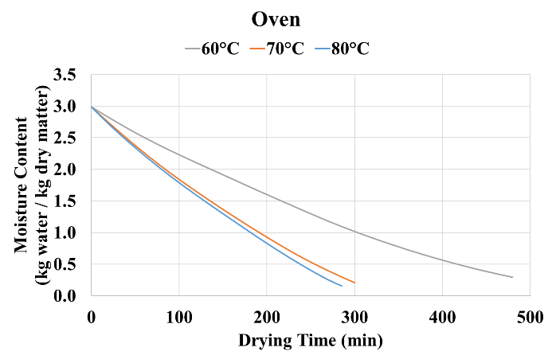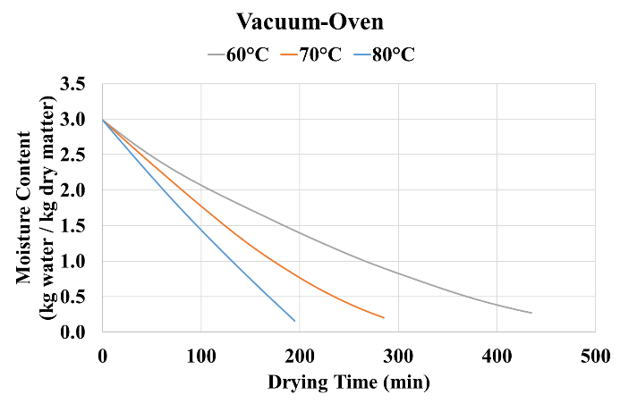

**Figure 1.** The oven and vacuum oven drying curves of golden berries.

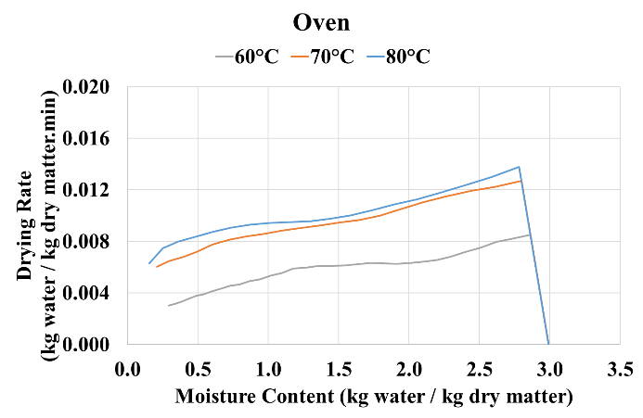**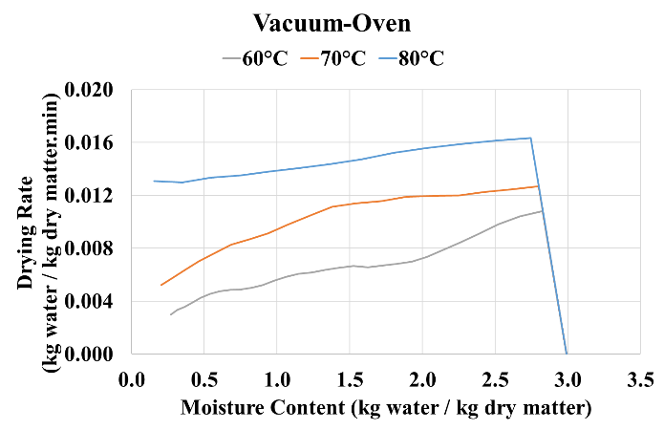**

**Figure 2.** The oven and vacuum oven drying rate curves of golden berries.

**3.2. Drying kinetics: Effective moisture diffusivity and activation energy results**

For each drying temperature and drying method, Deff values were calculated from the slope of the ln(MR) versus drying time plots, which are presented in Figure 3. The effective moisture diffusivities obtained for each method and for each drying temperature are presented in Figure 4a. As it can be seen from Figure 4a, Deff values calculated for vacuum oven drying are greater than those for oven drying, due to the lower drying times obtained in the presence of vacuum. In oven drying, Deff values were found as 1.95×10-10, 3.37×10-10 and 3.80×10-10 m2/s, for drying temperatures of 60, 70 and 80°C respectively. On the contrary, in vacuum oven drying, Deff values were found as 2.20×10-10, 3.72×10-10 and 5.45×10-10 m2/s, during the experiments performed at 60, 70 and 80°C respectively.

Furthermore, in order to calculate the activation energy for the drying processes, Deff values shown in Figure 4a were employed. The plots of ln(Deff) versus 1/T are presented in Figure 4b. From the slopes of the foresaid ln(Deff) versus 1/T plots, the values of Ea were calculated by multiplying the slope with the universal gas constant (R = 8.314×10-3 kJ/mol×K). Accordingly, the activation energies were found as 32.81 and 44.30 kJ/mol, for oven drying and vacuum oven drying, respectively. Since the assistance of vacuum increased the Deff values, the activation energy was also observed to increase during vacuum oven drying.

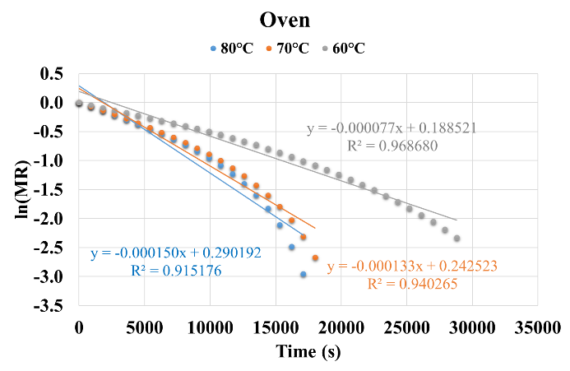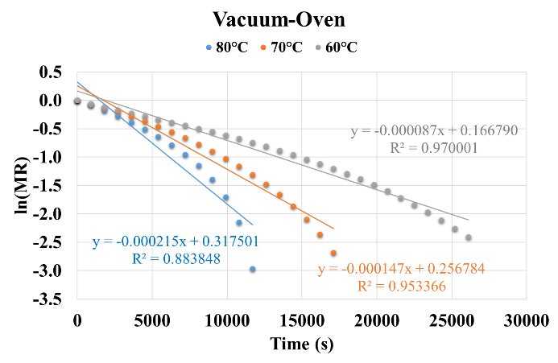

**Figure 3.** ln(MR) versus drying time plots for oven and vacuum oven drying.

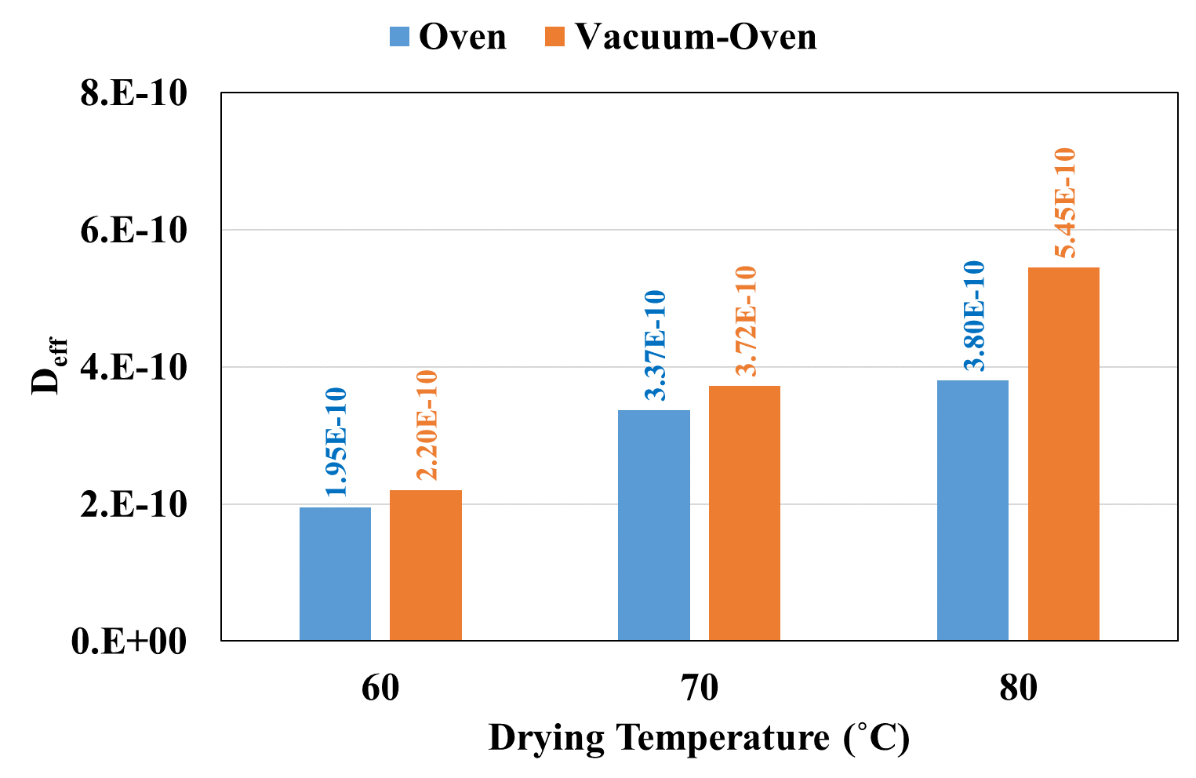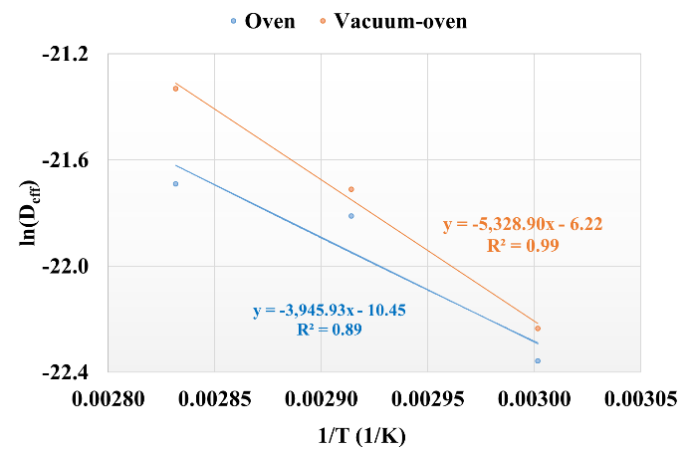

1. **(b)**

**Figure 4.** **a)** Deff values calculated for each drying temperature and drying method. **b)** The plot of Deff versus 1/T.

**3.3. Mathematical modelling results**

For the mathematical modelling of the drying of golden berries, fourteen mathematical models present in the literature were investigated. Regarding the model parameters and the statistical evaluation results (R2 > 0.998), the models that provided the best fit for oven and vacuum oven drying are presented in Table 1. Among the fourteen mathematical models that were tested five models, namely Aghbashlo et al., Logarithmic, Midilli & Kucuk, Parabolic and Wang & Singh models, gave R2 values higher than 0.998. For oven drying, the maximum R2 (between 0.999799 and 0.999957), along with the minimum χ2 (between 0.000004 and 0.000017) and RMSE (between 0.001879 and 0.003807) values were obtained from the model of Midilli & Kucuk. This model provided the best results for vacuum oven drying as well. Considering Midilli & Kucuk model, for vacuum oven drying of golden berries, R2 values were between 0.999648 and 0.999998. χ2 and RMSE values, on the other hand, were less than 0.000001-0.000029 and 0.000378-0.005089, respectively.

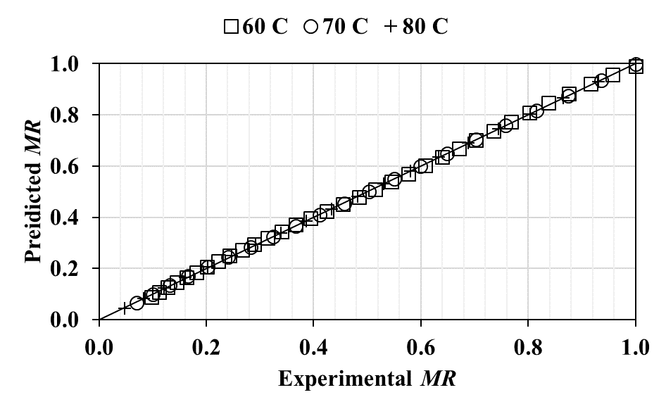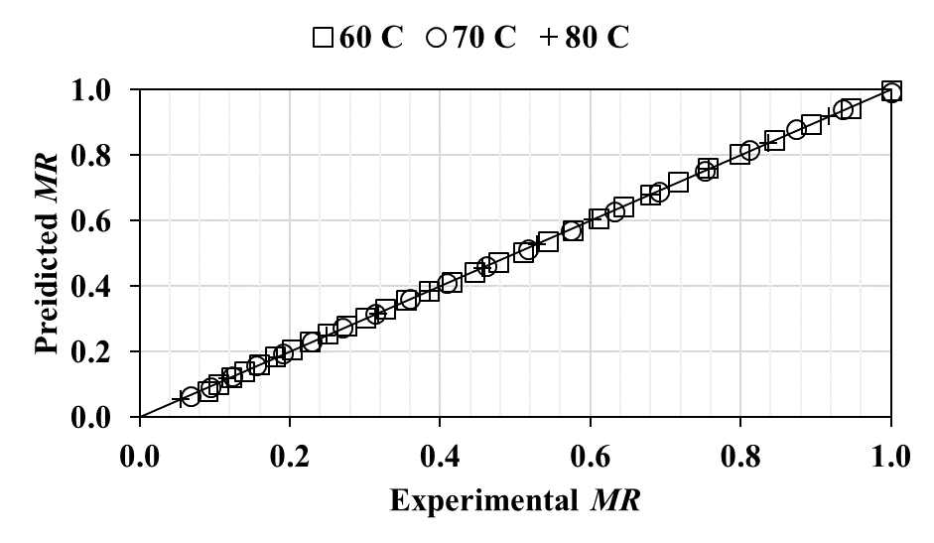

**(a) (b)**

**Figure 5.** The plot of experimental MR versus predicted MR for Midilli & Kucuk model, in a) oven drying and b) vacuum oven drying.

The comparison of the experimental and predicted MR results obtained from the mathematical model of Midilli & Kucuk is presented in Figure 5a for oven drying and in Figure 5b for vacuum oven drying. Regarding the figures, as all of the data lied on the 45° line, it can be concluded that the fitted Midilli & Kucuk model can be excellently used to represent the experimental drying data.

**Table 1.** Drying model constants and statistical parameters for oven drying and vacuum oven drying of golden berries.

|  |  |  |  |  |  |  |  |
| --- | --- | --- | --- | --- | --- | --- | --- |
|  |  | **Oven Drying** | | | **Vacuum Oven Drying** | | |
| **Model** | **Parameter** | **60°C** | **70°C** | **80°C** | **60°C** | **70°C** | **80°C** |
| **Aghbashlo et al.** | k1 | 0.003198 | 0.003936 | 0.004039 | 0.002559 | 0.004231 | 0.005051 |
| k2 | -0.000897 | -0.001724 | -0.001959 | -0.000965 | -0.001907 | -0.003148 |
| R2 | 0.998865 | 0.999198 | 0.998328 | 0.999698 | 0.999977 | 0.998922 |
| χ2 | 0.000088 | 0.000070 | 0.000153 | 0.000024 | 0.000002 | 0.000108 |
| RMSE | 0.009057 | 0.007984 | 0.011738 | 0.004718 | 0.001380 | 0.009629 |
| **Logarithmic** | a | 1.434928 | 1.904526 | 2.20549 | 1.660257 | 1.735105 | 3.73481 |
| k | 0.002295 | 0.002245 | 0.00197 | 0.001669 | 0.002824 | 0.00150 |
| c | -0.444364 | -0.905562 | -1.21137 | -0.659638 | -0.722035 | -2.73423 |
| R2 | 0.999770 | 0.999957 | 0.999908 | 0.999597 | 0.999322 | 0.999997 |
| χ2 | 0.000019 | 0.000004 | 0.000009 | 0.000033 | 0.000067 | <0.000001 |
| RMSE | 0.004081 | 0.001843 | 0.002755 | 0.005446 | 0.007559 | 0.000465 |
| **Midilli & Kucuk** | a | 0.997277 | 0.999061 | 0.999956 | 0.990199 | 0.993081 | 1.000129 |
| k | 0.003482 | 0.003167 | 0.003877 | 0.001446 | 0.001754 | 0.002966 |
| n | 0.962940 | 1.013221 | 0.946609 | 1.099835 | 1.197080 | 1.019046 |
| b | -0.000499 | -0.000980 | -0.001396 | -0.000386 | -0.000540 | -0.002428 |
| R2 | 0.999799 | 0.999948 | 0.999957 | 0.999648 | 0.999852 | 0.999998 |
| χ2 | 0.000017 | 0.000005 | 0.000004 | 0.000029 | 0.000016 | <0.000001 |
| RMSE | 0.003807 | 0.002036 | 0.001879 | 0.005089 | 0.003535 | 0.000378 |
| **Parabolic** | a | 0.983405 | 0.995936 | 0.991677 | 0.997178 | 1.010471 | 1.000051 |
| b | -0.003067 | -0.004130 | -0.004228 | -0.002657 | -0.004715 | -0.005555 |
| c | 0.000002 | 0.000003 | 0.000003 | 0.000002 | 0.000005 | 0.000004 |
| R2 | 0.999617 | 0.999943 | 0.999856 | 0.999783 | 0.999665 | 0.999996 |
| χ2 | 0.000031 | 0.000005 | 0.000014 | 0.000018 | 0.000033 | <0.000001 |
| RMSE | 0.005259 | 0.002122 | 0.003443 | 0.003999 | 0.005311 | 0.000555 |
| **Wang & Singh** | a | -0.003217 | -0.004183 | -0.004342 | -0.002680 | -0.004572 | -0.005554 |
| b | 0.000003 | 0.000004 | 0.000004 | 0.000002 | 0.000004 | 0.000004 |
| R2 | 0.999135 | 0.999916 | 0.999743 | 0.999769 | 0.999490 | 0.999996 |
| χ2 | 0.000067 | 0.000007 | 0.000024 | 0.000018 | 0.000048 | <0.000001 |
| RMSE | 0.007907 | 0.002591 | 0.004604 | 0.004122 | 0.006557 | 0.000556 |

**4. Conclusion**

In this study, oven and vacuum oven drying of golden berries was investigated, at drying temperatures of 60, 70 and 80˚C. It was observed that the increase in drying temperature and the assistance of vacuum caused shorter drying times. The duration of drying was between 285-480 minutes for oven drying and between 195-435 minutes for vacuum oven drying, respectively. Taking into account the drying rate curves, for both drying methods, a rapid rising-rate period followed by a falling-rate period was observed. Considering the drying kinetic parameters, the effective moisture diffusivities calculated for oven drying were between 1.95×10-10 and 3.80×10-10 m2/s; and for vacuum oven drying were between 2.20×10-10 and 5.45×10-10 m2/s. Calculations regarding the activation energy, on the other hand, unveiled 32.81 and 44.30 kJ/mol for oven and vacuum oven drying, respectively. Furthermore, fourteen mathematical models were fitted and tested to respresent the drying curve data. Among the tested models Aghbashlo et al., Logarithmic, Parabolic and Wang & Singh models yielded very good fits, having R2 greater than 0.998. For both oven and vacuum oven drying, Midilli & Kucuk model was found to yield the best fit among the employed models.

**References**

1. Etzbach, L., Meinert, M., Faber, T., Klein, C., Schieber, A., & Weber, F. (2020). Effects of carrier agents on powder properties, stability of carotenoids, and encapsulation efficiency of goldenberry (*Physalis peruviana* L.) powder produced by co-current spray drying. *Current Research in Food Science*, 3, 73-81.
2. Junqueira, J. R. J., Correa, J. L. G., de Oliveira, H. M., Avelar, R. I. S., & Pio, L. A. S. (2017). Convective drying of cape gooseberry fruits: Effect of pretreatments on kinetics and quality parameters. *LWT – Food Science and Technology*, 82, 404-410.
3. Bravo, K., & Osorio, E. (2016). Characterization of polyphenol oxidase from cape gooseberry (*Physalis peruviana* L.) fruit. *Food Chemistry*, 197, 185-190.
4. Lopez, J., Vega-Galvez, A., Torres, M. J., Lemus-Mondaca, R., Quispe-Fuentes, I., & Di Scala, K. (2013). Effect of dehydration temperature on physico-chemical properties and antioxidant capacity of goldenberry (*Physalis peruviana* L.). *Chilean Journal of Agricultural Research*, 73(3), 293-300.
5. Nawirska-Olszanska, A., Stepien, B., Biesiada, A., Kolniak-Ostek, J., & Oziemblowski, M. (2017). Rheological, chemical and physical characteristics of golden berry (*Physalis peruviana* L.) after convective and microwave drying. *Foods*, 6, 60.
6. Karacabey, E. (2016). Evaluation of two fitting methods for thin-layer drying of cape gooseberry fruits. *Brazilian Archives of Biology and Technology*, 59, e160470.
7. Ramadan, M. F., (2011). Bioactive phytochemicals, nutritional value, and functional properties of cape gooseberry (*Physalis peruviana*): An overview. *Food Research International*, 44, 1830-1836.
8. Calín-Sánchez, A., Figiel, A., Wojdylo, A., Szaryez, M. & Car­bonell-Barrachina, A. A. (2014). Drying of garlic slices using convective pre-drying and vacuum-microwave finishing drying: Kinetics, energy consumption, and qual­ity studies. *Food and Bioprocess Technology*, 7, 398-408.
9. Kaleta, A. & Górnicki, K. (2010). Some remarks on evaluation of drying models of red beet particles. *Energy Conversion and Management*, 51(12), 2967-2978.
10. Guiné, R. P. (2018). The drying of foods and its effect on the physical-chemical, sensorial and nutritional properties. *International Journal of Food Engineering*, 4(2), 93-100.
11. Pan, Z., Khir, R., Godfrey, L. D., Lewis, R., Thompson J. R., & Salim A. (2008). Feasibility of simultaneous rough rice drying and disinfestations by infrared radiation heating and rice milling quality. Journal of Food Engineering, 84(3), 469-479.
12. AOAC (Association of Official Analytical Chemists). (1995). Official Methods of Analysis of AOAC International, 16th ed., AOAC International, Rockville, MD.
13. Ismail, O. & Kocabay, O. G. (2018). Infrared and microwave drying of rainbow trout: drying kinetics and modelling. *Turkish Journal of Fisheries aand Aquatic Sciences*, 18, 259-266.
14. Doymaz, I., Kipcak, A. S. & Piskin, S. (2015). Microwave drying of green bean (Phaseolus vulgaris) slices: drying kinetics and physical quality. *Czech Journal of Food Sciences*, 33, 367-376.
15. Baslar, M., Kılıçlı, M., Toker, O. S., Sağdıç, O. & Arici, M. (2014). Ultrasonic vacuum drying technique as a novel process for shortening the drying period for beef and chicken meats. *Innovative Food Science and Emerging Technologies*, 26, 182-190.
16. Chayjan, R. A. & Shadidi, B. (2014). Modeling high-moisture Faba bean drying in fixed and semi-fluidized bed conditions. *Journal of Food Processing and Preservation*, 38: 200-211.
17. Crank, J. (1975). The Mathematics of Diffusion. London, UK: Oxford University Press.
18. Ozyalcin, Z. O. & Kipcak, A. S. (2022). The ultrasound effect on the drying characteristics of loligo vulgaris by the methods of oven and vacuum-oven. *Journal of Aquatic Food Product Technology*, 31(2), 187-199.
19. Zhu, A. (2018). The convective hot air drying of lactuca sative slices. *International Journal of Green Energy*, 15, 201-207.
20. Alibas, I. (2014). Microwave, air and combined microwave-air drying of grape leaves (Vitis vinifera L.) and the determination of some quality parameters. *International Journal of Food Engineering*, 10, 69-88.
21. Vega-Galvez, A., Puente-Diaz, L., Lemus-Mondaca, R., Miranda, M. & Torres, M. J. (2014). Mathematical modelling of thin-layer drying kinetics of cape gooseberry (Physalis peruviana L.). *Journal of Food Processing and Preservation*, 38: 728-736.