Mechanical Properties of Hydrothermally Grown Carbon Reinforced Polypropylene Composites
Nurettin ELTUĞRAL
¹ Engineering Faculty, Medical Engineering Department, Karabuk University, Karabük, Türkiye
Abstract
This study reports mechanical properties of composites produced by adding certain amounts (10, 15 and 20 wt%) of hydrothermall grown carbon spheres (HTCs) into polypropylene (PP) were investigated. Composites were prepared by means of melt-mixing method. The effect of HTC amounts was also investigated. Scanning electron microscopy (SEM) was employed to study morphological and structural properties of the obtained composites. Thermal stabilities of the composites were studied by thermogravimetric analsysis under nitrogen atmosphere. Mechanical properties of the composited were evaluated by means of tensile tests. Although, PP/HTC composites yielded lower tensile strength compared to pristine PP, they showed improved performance as the HTC content increased, their performance increase as more HTC was added. Addition of HTC caused a remarkable reduction in elongation of PP. Thermal stabilities of the composites were found to be higher than that of pristine PP. MFI values of the composites were shown to increase as more HTC added. This study could be assessed as a means of useful data for future applications of HTC as potential filler in polymer science and technology.

Keywords: Hydrothermal carbon, polypropyle, melt-mixing, composite, mechanical properties.

- Introduction
Polypropylene (PP) as being a thermoplastic polymer, has very useful properties such as low density, easy processability, low cost, resonable mechanical strength heat distortion temperature, transparency, flame resistance, dimentional stability and high impact strength [1–3]. These properties widen its application in many areas including automotive, medical, construction and packaging industries [4]. PP is also a very promising material which serves as a useful matrix for reinforcing to produce composites with improved mechanical properties to enlarge its applications [5–7]. Reinfrocements are used to tune and improve mainly physical and mechanical properties of plastics. In general, their inclusions led to increase the mechanical performance of polymer composites.
Carbon-based reinforcements (CBRs) including carbon nanotubes (CNTs), graphene, graphite, carbon fibers and carbon black have been considered in a number of prospective applications due to their excellent properties such as low mass density and improved mechanical properties [8–10]. Therefore, CBRs have been the subject of a large number of studies to illustrate their potential as reinforcers for polymer matrix. Their intrinsic properties and morphologies may play an important role in determining the ultimate properties of polymer composites. For instance, Juan Li prepared PP composites reinforced with multiwalled CNTs and their hydroxyl-modified ones [11]. An increase in tensile strength, bending strength, and impact strength was observered as CNT concentration increases. A further improvement in those properties resulted in with addition of hydroxyl-modified CNTs. However, elongation at break is reported to decrease upon addition of multiwalled CNTs and hydroxyl-modified multiwalled CNTs as well. Similarly, Yang et al. studied the mechanical properties of PP/CNTs composites (0.5-2 wt%) nanocomposites in the presence of maleic anhydride (0.6 wt%) [12]. Again, an enhancement in tensile strength, toughness and Young’s modulus was observed. However, there appears to be some major issues that limit the mechanical properties of the resulting composite. For instance, strong tendency of the carbon nanotubes to form bundles even at low loadings such as 1 wt% which in turn may cause reduction in hardness and crystallinity while improved tensile strength is attained at higher filler loadings [3,11,13]. In a recent study, J. Wang et al. introduced graphene nanoplates into PP by melt compounding method and then self-reinforced polymer composites were produced by film stacking technique [14]. It was reported that graphene-reinforced PP composites exhibited an improvement in mechanical properties. Similar findings were reported also in other research studies [10,15]. In some cases, post chemical procedures are necessary to modify graphene into graphene oxide form to improve compatibility. Mechanical properties of PP-based composites fabricated by introducing carbon fibers or carbon black as the reinforcement were also reported in the literature [16,17].
Hydrothermal carbons (HTCs) can be considered as another set of CBRs which can be produced under mild conditions [18–21] whereas methods for the synthesis of other CBRs need challenging procedures. In most cases HTCs can be fabricated in the form of microspheres [22]. HTCs have several advantages over the afformentioned CBRs, i.e. (1) they can be prepared at mild conditions in water at low temperatures (180-220 °C) under autogenic pressures from different types of biomass; (2) HTCs production is very simple, and since the reaction medium is water, the process is pronounced to be environmentally friendly; (3) production cost is cheap in comparison with other processess for the preparation of other CBRs. HTCs have been extensively studied for their potential in energy and environment [23] due to these advantages. To the best of our knowledge, effect of HTCs as a reinforcement material on the mechanical properties of PP has not been studied in literature. This study aims to postulate the processability and mechanical performance of PP/HTC. In this regard, first of all, HTCs were produced from glucose precursor, and PP/HTC composites at different compositions (10, 15, and 20 wt%) were fabricated by melt blending method. Surface characteristics of the produced HTCs as well as the morphology of PP/HTC composites were investigated using scanning electron microscopy (SEM). Mechanical properties of the obtained composites were evaluated by tensile test, melt flow index (MFI) test, thermogravimetric analysis (TGA).

- Materials and Methods
2.1. Materials
Polypropylene used in this research study was obtained from Borealis, Belgium under the trade name of BP 335 SA. This injection-grade homopolymer has a density of 0.905 g cm⁻³ according to supplier. HTC synthesis was carried out using D(+)-glucose (Merck) as a precursor. Ultra pure water was used throughout the experiments.
2.2. Preparation of HTCs
Synthesis of HTCs was produced from glucose as the feedstock. HTC experiments were carried out in a Teflon-lined stainless steel autoclave. Accordingly, in each set, 1.5 g of glucose was dissolved in 20 mL of ultrapure water and transferred in to the autoclave. Then, it was placed into a pre-heated oven at 200 °C and kept at that temperature for 24 h. HTC conversion occurs almost within 24 h which was reported by one of our previous study [21] . After the conversion was complete, the autoclave was taken out of the oven and cooled down to ambient temperature. The resulting product was filtered off and solid residue was washed with ultrapure water several times and the recovered solid product (HTCs) were dried at 105 °C for 3 h.
2.3. Preparation of PP/HTC composites
PP pellets and HTC powder were placed at 100˚C for 2 hours to eliminate the moisture prior processing. Composite samples were produced via melt-blending technique by the help of lab-scale counter rotating twin screw micro-compounder (MC 15 HT, Xplore Instruments, Netherlands). The process parameters used in compounding including screw rate, mixing temperature and mixing time summerized in Table 1. The compositions of HTC in PP matrix were 10, 15 and 20 weight percent. Fabricated composite samples were shaped via compression molding using lab-scale hydraulic hot-press device (AtsFaar, Italy) and mold with the thikness of 1.5 mm. The dog-bone shape casts were used to obtain test specimen with dimensions of 70×6.0×1.5 mm³ according to ASTM 638-M 91a standard.
Table 1. Processing parameters applied during fabrication of PP and PP/HTC composites
Parameters | Specification | Unit
Mixing Temperature | 200 | ˚C
Mixing Time | 5 | min
Screw Speed | 100 | rpm
Compression Temperature | 200 | ˚C
Compression Pressure | 10 | bar
Holding Time | 2 | min

2.4. Characterization methods
Tensile test measurements of composites were done by universal tensile test device (Lloyd LR30K, England) using load cell with 5 kN and crosshead speed of 5 cm min⁻¹ testing parameters. Tensile strength, percentage strain and tensile modulus values were recorded as an average of at least five samples or each composite. TGA tests were carried out using STA 7300 thermogravimetric analyzer (Hitachi, Japan). During TGA analysis, heating range of 25-600 ºC and heating rate of 10°C min-1 under argon atmosphere. MFI measurements were conducted by MFI measurement equipment (Coesfeld Meltfixer LT, Germany) using standard specified load of 2.16 kg at temperature of 200 °C. MFI values were recorded as an average value of at least ten samples for each composite. Fracture surface of composites and morphological properties of HTCs were examined using field emission-scanning electron microscope (FESEM) (Carl Zeiss Ultra Plus Gemini, Germany). All the samples were coated with a layer of gold deposited by sputtering under vacuum prior to the analysis. Wear test was applied in accordance with ASTM G133 standard in UTS Tribometer T10 test device with 5 N load, 10 mm stroke and total sliding distance 20 m back and forth. Wear volume and specific wear rate were calculated with the formulas given in equations 1 and 2, respectively.
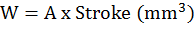 (1)
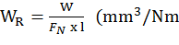 (2)
Where, W is wear volume in mm³, A is wear surface area in mm², W_{R} is specific wear rate, FN is applied load in Newtons, and I is total slide distance in meters.

- Results and Discussion
3.1. Characterization of HTCs

Figure 1 show morphologies of HTCs. The formed HTCs by hydrothermal method were confirmed to be accumulated in the form of hard spheres with an average size of 0.67 ± 0.06 µm.
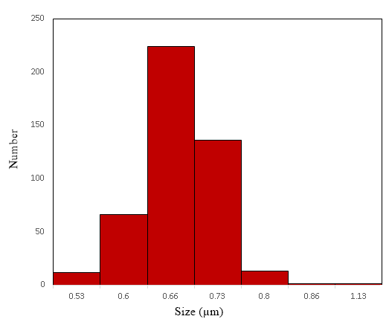
Figure 1. SEM image of prepared HTCs and their particle size distribution histogram.
3.2. Mechanical Properties of PP/HTC composites
Table 2 shows the tensile properties of the PP and its composites. Although, PP/HTC composites yielded lower tensile strength compared to pristine PP, they showed improved performance as the HTC content increased, their performance increase as more HTC was added. Addition of HTC increased Young’s modulus up to about 46%. Improvements in the Young’s modulus favours the rigidity of the polymer which could be attributed to brittle behaviour of the samples which in turn results in a large reduction of elongation as compared to pure PP. Elongation at break was observed to decrease gradually with the increase of HTC content. Movement of polymer chain is supposed to be restricted by the HTCs which leads to a decrease in the this property [16]. However, composites which contain 15 and 20% HTC revealed almost close values in elongation at break.
Table 2. Tensile properties of the PP and its composites.
Samples | Tensile Strength (MPa) | Elongation at break (%) | Young’s modulus (MPa)
PP | 20.7 ± 0.4 | 24.4 ± 2.1 | 293.7 ± 8.3
PP/10 HTC | 11.8 ± 1.1 | 8.2 ± 0.1 | 310.5 ± 6.6
PP/15 HTC | 12.9 ± 0.3 | 6.3 ± 0.3 | 381.5 ± 4.6
PP/20 HTC | 14.3 ±0.1 | 6.1 ± 0.1 | 427.6 ± 4.9

3.3 MFI measurements
MFI parameter provides an insight for viscosity and processibility of polymers. MFI values of PP and PP/HTC composites are given in Figure 2. HTC addition at lower loading ratios caused a decrease in MFI values of the PP/HTC composites. This effect is almost compensated by 15% HTC loading compared to pristine PP and after that, a slight increase in MFI was obtained for 20% HTC loading which is comparable to that of PP itself. These results suggest that HTC reinforcers seem to have no significant problems during the processing or manufacturing of the PP/HTC composites even at higher HTC concentrations [24,25].
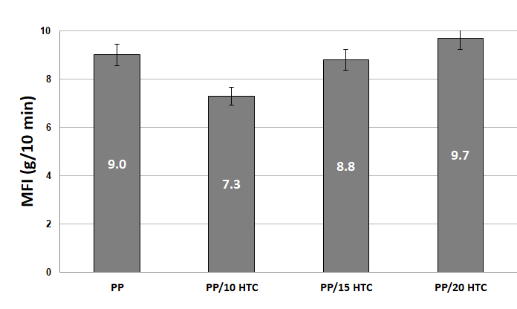
Figure 2. Melt flow index results of the PP and PP/HTC composites.
3.3. Morphological characterization of PP/HTC composites
SEM analysis of the fracture surface of the composites was employed to investigate the dispersion of HTCs in the PP matrix. Figure 3 shows the SEM micrographs of PP/HTC composites with varying weight percentages of the HTCs. SEM micrographs indicate that HTC spheres are well dispersed throughout the PP phase. For 20% HTC loading, the HTCs appear in the form of aggregates to some extent. Nevertheless, they are observed to be covered by the PP matrix. SEM surveys represent a good interfacial adhesion with the spherical HTCs. This can be attributed to compatibility of HTCs with the PP matrix due to increased surface area of the HTCs.
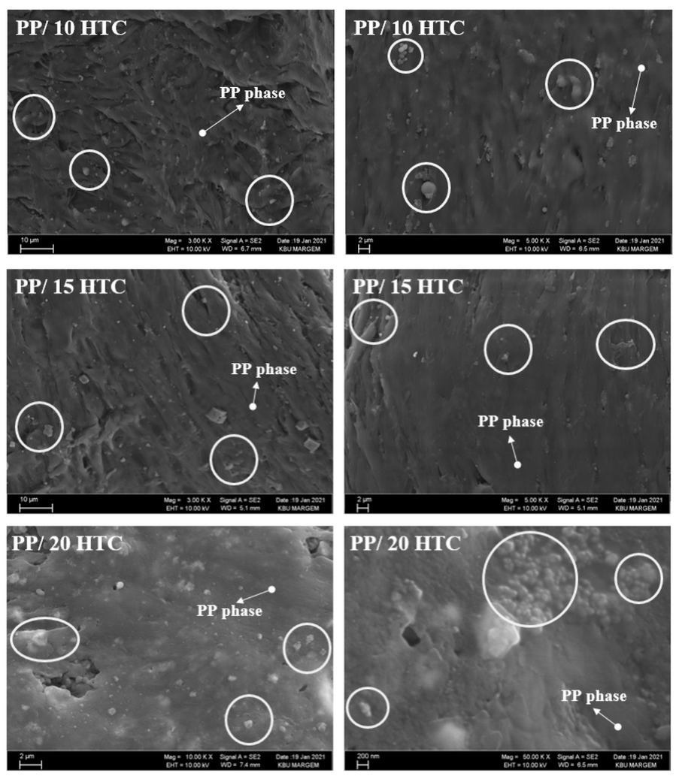
Figure 3. SEM micrographs of the composites with varying weight fractions of the HTC.
3.4. Thermal characteristics
Figure 4 shows the melting behavior of the PP and its composites with varying HTC concentrations. It was observed that the initial decomposition temperature increases as the HTC content increases. The weight loss for pristine PP starts at about 330 °C. Our findings agrees the litereture as well [2]. The onset degredation behaviour of composites including 10 – 20 wt% HTC has a very similar melting profile. They almost start to decompose around 370 °C. Our results depicts no significant changes in thermal decomposition of the composites however, thermal stability increases compared to pristine PP.
Figure 4. TGA analysis of pristine PP and of its composites at different loadings of HTC.
3.5. Wear properties of the PP/HTC composites
Table 4 shows the wear properties values of PP and PP/HTC composites. As the specific wear rate increases, wear resistance decreases [26]. Specific wear rates were shown to decrese as HTC content increased in the composite. Therefore, wear resistance increases as the composite is reinforced with increasing amount of HTC. Among the composites, the specific wear rate of the composite containing 20% HTC showed the best improvement (30%).
Samples | Stroke (mm) |  | Surface area of wear (A) (mm²) | Volume of wear (W) (mm³) |  | Specific wear rate (W_{R}) (mm³/Nm)
PP | 10 | 0.001 |  |  | 0.1 |  | 0.4
PP/%10HTC | 10 | 0.006 |  |  | 0.06 |  | 0.24
PP/%15HTC | 10 | 0.005 |  |  | 0.05 |  | 0.2
PP/%20HTC | 10 | 0.003 |  |  | 0.03 |  | 0.12

Table 3. Wear properties of PP and its composites

- Conclusion
In this work, hydrothermally grown carbons were considered as reinforcers to investigate mechanical properties of PP/HTC composites. The interfacial adhesion between reinforcers and a polymer matrix influence the mechanical properties of the overall composite. Alternatively, a novel approach based on incorporation of HTCs into PP matrix has been developed to improve mechanical, thermal and wear strength of the resulting composite. The results showed that HTC loading lowers the tensile strength with respect to pristine PP however, as the HTC content increases tensile strength of the resulting composites increases as well. Addition of 20% HTC causes some agglomeration. Addition of more HTC increases the wear resistance. Thermal stability of the composites has improved with respect to PP itself, however there was no significant change among the composites having different amount of HTC loadings. This study presents insightful information about possible potential application of HTCs in the polymer composite technology.
Acknowledgements
The author acknowledges the funding (grant no. KBÜBAP-21-DS-049) from Karabük University.

References
[1] Shubhra QTH, Alam AKMM, Quaiyyum MA. Mechanical properties of polypropylene composites: A review. J Thermoplast Compos Mater 2013;26:362–91. https://doi.org/10.1177/0892705711428659.
[2] Mertens AJ, Senthilvelan S. Mechanical and tribological properties of carbon nanotube reinforced polypropylene composites. Proc Inst Mech Eng Part L J Mater Des Appl 2018;232:669–80. https://doi.org/10.1177/1464420716642620.
[3] Yunus R, Zahari NH, Salleh MAM, Ibrahim NA. Mechanical properties of carbon fiber-reinforced polypropylene composites. Key Eng Mater 2011;471–472:652–7. https://doi.org/10.4028/www.scientific.net/KEM.471-472.652.
[4] Kanbur Y, Tayfun Ü. Polipropilen/Huntit Kompozitlerinin Mekanik, Fiziksel ve Morfolojik Özellikleri. SAÜ Fen Bilim Enstitüsü Derg 2017;21:1–1. https://doi.org/10.16984/saufenbilder.281035.
[5] Menyhárd A, Varga J. The effect of compatibilizers on the crystallisation, melting and polymorphic composition of β-nucleated isotactic polypropylene and polyamide 6 blends. Eur Polym J 2006;42:3257–68. https://doi.org/10.1016/J.EURPOLYMJ.2006.09.003.
[6] Martínez-Colunga JG, Sánchez-Valdés S, Ramos-Devalle LF, Muñoz-Jiménez L, Ramírez-Vargas E, Ibarra-Alonso MC, et al. Simultaneous polypropylene functionalization and nanoclay dispersion in PP/Clay nanocomposites using ultrasound. J Appl Polym Sci 2014;131:1–8. https://doi.org/10.1002/app.40631.
[7] Barkoula NM, Alcock B, Cabrera NO, Peijs T. Flame-Retardancy Properties of Intumescent Ammonium Poly(Phosphate) and Mineral Filler Magnesium Hydroxide in Combination with Graphene. Polym Polym Compos 2008;16:101–13. https://doi.org/10.1002/pc.
[8] Papageorgiou DG, Li Z, Liu M, Kinloch IA, Young RJ. Mechanisms of mechanical reinforcement by graphene and carbon nanotubes in polymer nanocomposites. Nanoscale 2020;12:2228–67. https://doi.org/10.1039/c9nr06952f.
[9] Rao CNR, Sood AK, Subrahmanyam KS, Govindaraj A. Graphene: The New Two-Dimensional Nanomaterial n.d. https://doi.org/10.1002/anie.200901678.
[10] Galpaya D, Wang M, Liu M, Motta N, Waclawik E, Yan C. Recent Advances in Fabrication and Characterization of Graphene-Polymer Nanocomposites. Graphene 2012;01:30–49. https://doi.org/10.4236/graphene.2012.12005.
[11] Li J. Multiwalled Carbon Nanotubes Reinforced Polypropylene Composite Material. J Nanomater 2017;2017. https://doi.org/10.1155/2017/2171356.
[12] Yang BX, Shi JH, Pramoda KP, Goh SH. Enhancement of the mechanical properties of polypropylene using polypropylene-grafted multiwalled carbon nanotubes. Compos Sci Technol 2008;68:2490–7. https://doi.org/10.1016/J.COMPSCITECH.2008.05.001.
[13] Moniruzzaman M, Winey KI. Polymer Nanocomposites Containing Carbon Nanotubes. Macromolecules 2006;39:5194–205. https://doi.org/10.1021/ma060733p.
[14] Wang J, Song F, Ding Y, Shao M. The incorporation of graphene to enhance mechanical properties of polypropylene self-reinforced polymer composites. Mater Des 2020;195:109073. https://doi.org/10.1016/j.matdes.2020.109073.
[15] Huang CL, Lou CW, Liu CF, Huang CH, Song XM, Lin JH. Polypropylene/graphene and polypropylene/carbon fiber conductive composites: Mechanical, crystallization and electromagnetic properties. Appl Sci 2015;5:1196–210. https://doi.org/10.3390/app5041196.
[16] Pérez-Rocha D, Morales-Cepeda AB, Navarro-Pardo F, Lozano-Ramírez T, Lafleur PG. Carbon Fiber Composites of Pure Polypropylene and Maleated Polypropylene Blends Obtained from Injection and Compression Moulding. Int J Polym Sci 2015;2015. https://doi.org/10.1155/2015/493206.
[17] Kanbur Y, Küçükyavuz Z. Electrical and mechanical properties of polypropylene/carbon black composites. J Reinf Plast Compos 2009;28:2251–60. https://doi.org/10.1177/0731684408092378.
[18] Bai CX, Shen F, Qi XH. Preparation of porous carbon directly from hydrothermal carbonization of fructose and phloroglucinol for adsorption of tetracycline. Chinese Chem Lett 2017;28:960–2. https://doi.org/10.1016/j.cclet.2016.12.026.
[19] Hu B, Wang K, Wu L, Yu SH, Antonietti M, Titirici MM. Engineering carbon materials from the hydrothermal carbonization process of biomass. Adv Mater 2010;22:813–28. https://doi.org/10.1002/adma.200902812.
[20] Wei L, Sevilla M, Fuertes AB, Mokaya R, Yushin G. Hydrothermal carbonization of abundant renewable natural organic chemicals for high-performance supercapacitor electrodes. Adv Energy Mater 2011;1:356–61. https://doi.org/10.1002/aenm.201100019.
[21] Simsir H, Eltugral N, Karagoz S. Hydrothermal carbonization for the preparation of hydrochars from glucose, cellulose, chitin, chitosan and wood chips via low-temperature and their characterization. Bioresour Technol 2017;246. https://doi.org/10.1016/j.biortech.2017.07.018.
[22] Mi Y, Hu W, Dan Y, Liu Y. Synthesis of carbon micro-spheres by a glucose hydrothermal method. Mater Lett 2008;62:1194–6. https://doi.org/10.1016/j.matlet.2007.08.011.
[23] Maniscalco MP, Volpe M, Messineo A. Hydrothermal carbonization as a valuable tool for energy and environmental applications: A review. Energies 2020;13. https://doi.org/10.3390/en13164098.
[24] Ahmed SA, Tirkes S, Tayfun U. Reinforcing effect of polyurethane sizing on properties of acrylonitrile–butadiene–styrene composites involving short carbon fiber. SN Appl Sci 2020;2:1–9. https://doi.org/10.1007/s42452-020-03809-5.
[25] Türk DA, Brenni F, Zogg M, Meboldt M. Mechanical characterization of 3D printed polymers for fiber reinforced polymers processing. Mater Des 2017;118:256–65. https://doi.org/10.1016/J.MATDES.2017.01.050.
[26] Karabeyoğlu SS, Ekşi O, Feratoğlu K. Eriyik yığma modelleme ile imal edilen PLA-Cu kompozitlerinin farklı sıcaklık şartları altında aşınma karakteristikleri. Balıkesir Üniversitesi Fen Bilim Enstitüsü Derg 2021;23:358–65. https://doi.org/10.25092/baunfbed.854829.

