

****

**PROCEEDINGS OF IKSTC 2023 2ed KARATEKIN SCIENCE AND TECHNOLOGY CONFERENCE**

**21-22 DECEMBER 2023, Çankırı, Türkiye**

**Molecular Docking and ADMET Studies of Podophyllotoxin Derivatives targeting Ribosomal Protein (RPL27A) in Triple Negative Breast Cancer**

***FATMA SAAD MOHAMED BELHAJ 1,[[1]](#footnote-1)\* [C:\Users\Abdullah\AppData\Local\Microsoft\Windows\INetCache\Content.Word\ORCID-iD_icon-16x16.gif](https://orcid.org/xxxx-xxxx-xxxx-xxxx), Şevki ADEM2 [C:\Users\Abdullah\AppData\Local\Microsoft\Windows\INetCache\Content.Word\ORCID-iD_icon-16x16.gif](https://orcid.org/xxxx-xxxx-xxxx-xxxx)***

*1 Natural and Applied Sciences, Science Faculty, Çankırı Karatekin University, Çankırı, Türkiye/Libya*

*2 Natural and Applied Sciences, Science Faculty, Çankırı Karatekin University, Çankırı, Türkiye*

|  |
| --- |
| **Abstract**  Breast cancer is the most prevalent cancer in women worldwide, and Triple-negative breast cancer (TNBC) accounts for ∼20% of all its cases. This study aimed to investigate the possible interaction potentials of podophyllotoxin derivatives with RPL27A target as an important therapeutic option that used in silico molecular techniques. Podophyllotoxin derivatives are found to have beneficial health effects in treating Cancer. An effort has been made to virtually screen podophyllotoxin derivative inhibitors by molecular docking in the current studies. The best binding score that has been resulted from the molecular docking analysis was by a Teniposide ligand with RPL27A target which is -9.1 kcal/mol , in addition to the lowest binding energies that were by Dihydrotaiwanin C, tetrahydrojusticidin B, Cleistantoxin, and Etop ligands with the same target , which are (-8.0, -7.1, -7.6, and -9.0 kcal/mol respectively) .This study reveals that these podophyllotoxin molecules can be developed as a novel multi-target RPs target inhibitors with greater potential and low toxicity. |
| ***Keywords:*** *Triple Negative Breast Cancer ( TNBC), Ribosomal protein ( RPL27A), Podophyllotoxine derivatives, molecular docking, ADMET studies.* |

1. **Introduction**

The management of triple- negative breast cancer represents a challenge due to its worse prognosis, heterogeneity and lack of targeted hormone therapy. [1,2] But Interestingly, TNBC is sensitive to drugs related to gene expression. Recent studies have linked mutations in ribosomal protein genes expression with poor prognosis, highlighting ribosome-targeted therapy as a promising approach for treating patients with cancer. [3-5] Fortunately, TNBC has strongly associated with specific ribosomal protein gene that is considered as a potential diagnostic and prognostic biomarker and potentially novel therapeutic target for TNBC. It is RPL27A which plays an important functional role in carcinogenesis in TNBC patients. [6] one of the drugs related to gene expression is podophyllotoxin and its derivatives which could not only inhibit the migration and invasion of triple-negative breast cancer but also affect the cell cycle and induce apoptosis. [7-9]

This study aimed to initiate a new direction for exploring the effect of podophyllotoxin and its derivatives as an anti-TNBC compound by in silico approach. Moreover, it provides theoretical support for further exploration of podophyllotoxin drugs as a vital part of the drug discovery method in cancer research field.

**2.Materials and Methods**

Five podophyllotoxin derivatives were selected and used as ligands to find the binding affinities with RPL27A target. The 3D structure of the RP (PDB ID: 8HTC) was selected as protein target that retrieved from the Protein Data Bank (PDB) (http://www.rcsb. org/) in PDB format. It is refined by preparing the protein for docking study by using Biovia Discovery Studio Visualizer (Biovia, 2021) and saved as PDB format. This processed protein structure is converted to the PDBQT file by selecting make macromolecule using the PyRx tool.

The 3D structure of the podophyllotoxin derivatives was obtained from the PubChem database (<https://pubchem.ncbi.nlm.nih.gov>), and then prepared by open babel in PyRx which minimized their energies and converted them into PDBQT formats for molecular docking analysis. The grid box parameter was set and adjusted for maximum binding affinity. The molecular docking study was carried out by using the Autodock PyRx docking tool. Best-predicted poses were screened to study the interaction of prepared ligands with target receptors.

The toxicity behavior of the selected podophyllotoxin derivatives was studied by ADMET parameters in the human body. The admetSAR prediction tool was used (http://lmmd.ecust.edu.cn:8000) to study ADMET parameters.

**3.Results and Discussion**

**3.1. Molecular docking studies**

RPL27A is targeted by the five podophyllotoxin derivatives predicted from previous studies’ in silico screening data. AutoDock Vina in PyRx software, with an inbuilt docking algorithm, was employed for the purpose. The predicted free binding energy and hydrogen bonding were strongly focused on docking analysis. The values of docking binding energy and the interaction among the active site residues of the target receptor with podophyllotoxin derivatives are reported in Table 1.

**Table 1.** The Binding energy of different podophyllotoxin derivatives against the RPL27A target.

|  |  |  |  |
| --- | --- | --- | --- |
| no | **Ligand name** | **PubchemID** | **RPL27A** |
| 1 | **ETOP** | 5284558 | -9.0 |
| 2 | **Cleistantoxin** | 71452884 | -7.6 |
| 3 | **TetrahydrojusticidinB** | 54758663 | -7.1 |
| 4 | **Dihydrotaiwanin C** | 163076341 | -8.0 |
| 5 | **Teniposide** | 452548 | **-9.1** |

The binding affinity scores of all the formed ligand-protein complexes were compared with each other, one of them showed the lowest binding energy values that was by a Teniposide ligand with RPL27A target which is -9.1 kcal/mol, in addition to the lowest binding energy values of Dihydrotaiwanin C, tetrahydrojusticidin B, Cleistantoxin, and Etop ligands which are (-8.0, -7.1, -7.6, and -9.0 kcal/mol sequentially).

This comparative computational docking analyses gives insight into the efficacy of the podophyllotoxin derivatives over clinically approved reference drug molecules.

**3.2 The docking analysis**

The docking analysis was carried out using Discovery Studio (Biovia, 2021) for the best docked pose which was represented in Figure 1. Tenoposide docked well with the target binding pocket of RPL27A with the binding energy of -9.1 kcal/mol determines the ability of Teniposide to inhibit RPs.The podophyllotoxin derivative Teniposide stability in the binding site of RPL27A receptor is also recognized by common amino acids residue forming interactions like conventional hydrogen bond, hydrophobic interaction, Pi Sigma, Carbon-Hydrogen bond, and van der Walls interactions. The conventional hydrogen bonds with the amino acids at a distance of 4.90 Å, 4.61 Å, 3.94 Å ,3.96 Å, and 3.74 Å are interrelated with the high binding affinity of Tenoposide with RPL27A. The high binding affinity of Teniposide with the RP target may be due to the bond length distance between amino acid residues.

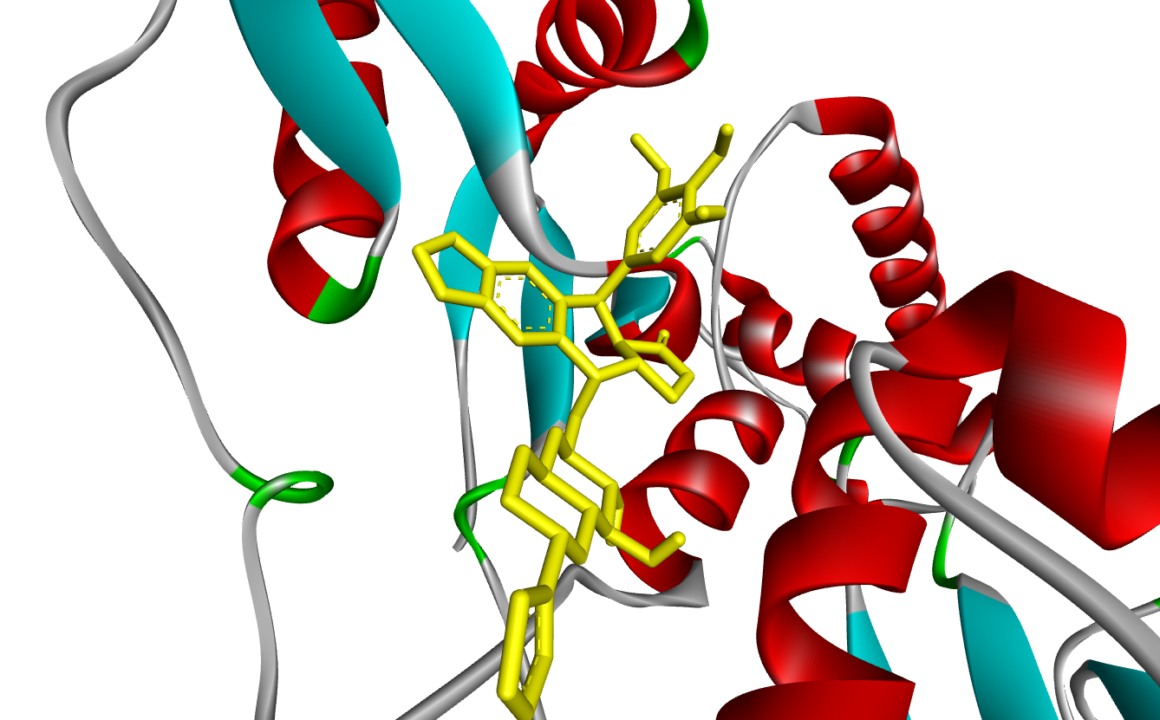 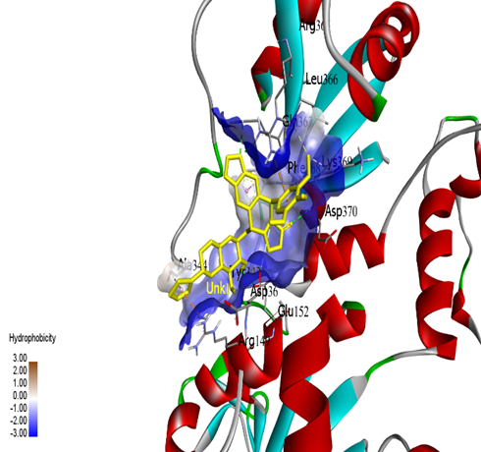

1. (b)

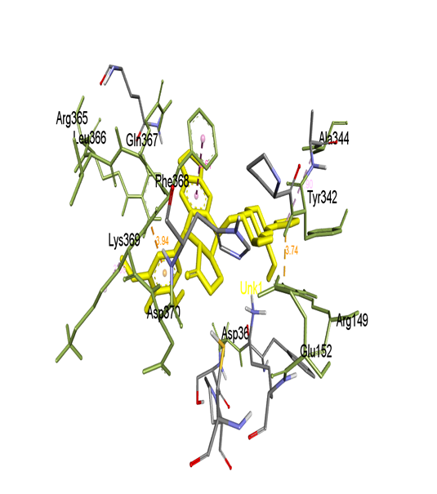 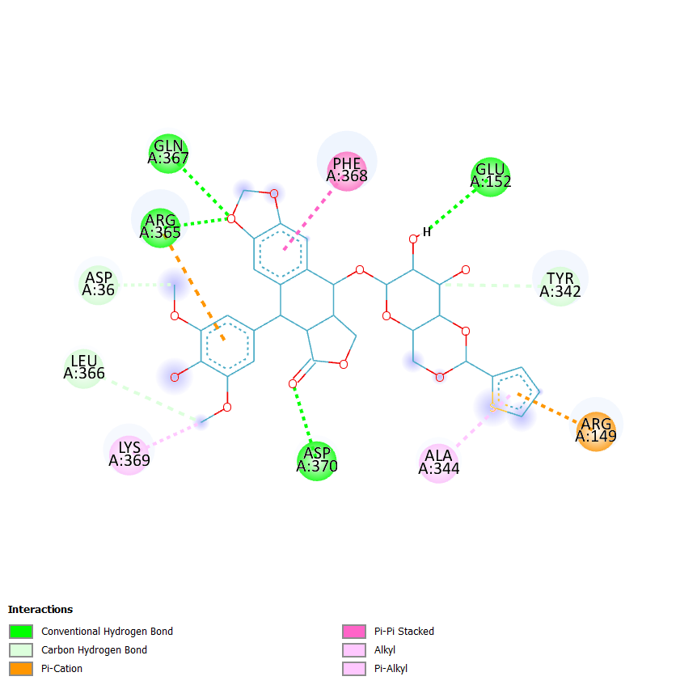

(c) (d)

**Figure 1.** Docked poses of RPL27A (8BGH) with Teniposide (452548): (a) Teniposide docked to RPL27A (b) Hydrophobicity surface at the active binding site of RPL27A with Teniposde; (c) 3D stick diagram of surrounding RPL27A amino acids with Teniposide; (d) 2D view of surrounding RPL27A amino acids with Teniposide.

The reported docking results found that Teniposide exhibits the best binding interaction among the five podophyllotoxin derivatives as a common inhibitor for the RPL27A receptor. The lead compound was then assessed for ADME studies.

**3.3 ADMET evaluation studies**

Docking analyses showed Teniposide as the common inhibitor for RPL27A target. Teniposide was checked for the ADMET profile using admetSAR software. The admetSAR results were shown in Table 2. Teniposide may be capable of passing through BBB and able to absorb by intestine with probability score of 0.830. In addition, Teniposide is an inhibitor of P-glycoprotein with probability score of 0.53. Teniposide was an inhibitor of some CYP enzymes, two important biomarkers assessing the Teniposide’s potential effects on the liver and renal functions accordingly, with probability score > 0.62. Drug toxicity is a great concern to the medical world. The toxicity prediction also indicated that Teniposde is a non-carcinogenic, and non- toxic to the body organs. Acute oral toxicity category-3 considered Teniposide is nontoxic for oral toxicity with a probability score of 0.74. Teniposide showed higher solubility with a log S value of -3.19, which affects Teniposide’s movement from the site of administration into the blood.

**Table 2.** Predicted ADMET profile of Teniposide.

|  |  |  |
| --- | --- | --- |
| **ADMET** | **results** | **probability** |
| HIA | HIA+ | 0.8302 |
| Caco 2 | Caco 2- | 0.8551 |
| BBB | BBB - | 0.8000 |
| P-gp substrate | Substrate | 0.8292 |
| P-gp Inhibitor | inhibitor | 0.5362 |
| Plasma protein binding | 1.071 100% |  |
| CYP IP (inhibitory promiscuity) | low | 0.9121 |
| Renal clearance | 10% of total body clearance |  |
| hERG (Human ether-a-go-go-related gene)  a prediction of arrhythmias | Weak Inhibitor | 0.4338 |
| Carcinogen | Non-Carcinogen | 0.9700 |
| Biodegradation | Not ready biodegradable | 0.7750 |
| Acute oral toxicity | III | 0.7416 |
| Aqueous solubility (logS) | -3.199 |  |

**4. Conclusion**

Finally, based on the current computational study and obtained results, it can be predicted that the selected podophyllotoxin derivative drugs have shown potential inhibitory activity with TNBC specific target. Furthermore, this study could provide a new framework for discovering future solutions to the absence of targeted therapy problem for this aggressive type of breast cancer.

**Acknowledgement**

In this study, the scientific support was provided by my supervisor prof.Dr.Shevki Adem who was the sincere and kind mentor during my phD study, so a big thank for him, and thanks alot for Çankırı Karatekin University that gave me this great chance to participate in this conference . I would also like to thank all the supporters due to their precious contributions.

**References**

[1] Sylvia Annabel Dass , Kim Liu Tan , Rehasri Selva Rajan , Noor Fatmawati Mokhtar , Elis Rosliza Mohd Adzmi , Wan Faiziah Wan Abdul Rahman , Tengku Ahmad, Damitri Al-Astani Tengku Din, and Venugopal Balakrishnan. (2021). *Triple Negative Breast Cancer: A Review of Present and Future Diagnostic Modalities. Medicina journal*, 57- 62.

[2] Yun Li, Huajun Zhang, Yulia Merkher, Lin Chen, Na Liu, Sergey Leonov & Yongheng Chen. (2022). *Recent advances in therapeutic strategies for triple-negative breast cancer. Journal of Hematology & Oncology*, 33k Accesses, 87 Citations, 12 Altmetric, 15-121.

[3] Dolezal, J.M., Dash, A.P. and Prochownik, E.V. (2018) *Diagnostic and prognostic implications of ribosomal protein transcript expression patterns in human cancers*. *BMC Cancer* 18- 275.

[4] Lijuan Jiao, Yuzhe Liu, Xi-Yong Yu, Xiangbin Pan, Yu Zhang, Junchu Tu, Yao-Hua Song & Yangxin Li. (2023). *Ribosome biogenesis in disease: new players and therapeutic targets. Signal Transduction and Targeted Therapy*, 11k Accesses, 19 Citations, 11 Altmetric, 8-15.

[5] Elhamamsy1, Brandon J. Metge1, Heba A. Alsheikh1, Lalita A. Shevde1,2, and Rajeev S. Samant.(2022). *Ribosome Biogenesis: A Central Player in Cancer Metastasis and Therapeutic Resistance. Cancer Research journal* 82 (13): 2344-2353.

[6] Alkhatabi, H. A., McLornan, D. P., Kulasekararaj, A. G., Malik, F., Seidl, T., Darling, D., et al. (2016). *RPL27A is a target of miR-595 and may contribute to the myelodysplastic phenotype through ribosomal dysgenesis. Oncotarget* 7, 47875-47890.

[7]. Zhang W., Liu C., Li J., Liu R., Zhuang J., Feng F., et al. (2020). *Target analysis and mechanism of podophyllotoxin in the treatment of triple-negative breast cancer. Front. Pharmacol*. 11:1211.

[8] Hua-yang Fan, † Zhuo-li Zhu, Hong-chun Xian, Hao-fan Wang, Bing-jun Chen, Ya-Jie Tang, Ya-ling Tang, and Xin-hua Liang. (2021). Insight into the Molecular Mechanism of Podophyllotoxin Derivatives as Anticancer Drugs. *Front. Pharmacol*.75-90.

[9] Li, Y., Chen, M., Yao, B., Lu, X., Zhang, X., He, P., et al. (2019). *Transferrin receptor-targeted redox/pH-sensitive podophyllotoxin prodrug micelles for multidrug-resistant breast cancer therapy. J. Mater. Chem*. B. 7 (38), 5814–5824.

1. [↑](#footnote-ref-1)