**Separation of rhodium from simulated rhodium plating solutions with imidazolium derivative ionic liquids**

***Aboubakar Ibrahim MOHAMED******, Meryem NiluferYARASIR, Volkan EYUPOGLU 1[C:\Users\Abdullah\AppData\Local\Microsoft\Windows\INetCache\Content.Word\ORCID-iD_icon-16x16.gif](https://orcid.org/0000-xxxx-xxxx-xxxx), Ahmet YARTASI 2[C:\Users\Abdullah\AppData\Local\Microsoft\Windows\INetCache\Content.Word\ORCID-iD_icon-16x16.gif](https://orcid.org/0000-xxxx-xxxx-xxxx)***

*1 Department of Chemistry, Faculty of Science, Çankırı Karatekin University, Uluyazı, Çankırı 18100, Turkey*

*2 Department of Chemical Engineering, Faculty of Engineering, Çankırı Karatekin University, Uluyazı, Çankırı 18100, Turkey*

|  |
| --- |
| Abstract  Separation of rhodium Rh(III) ions from an acidic solution containing HCl by solvent extraction method was optimized by using 1-octyl-3-methyl imidazolium bromide (MOIMBr) and 1-decyl-3-methyl imidazolium bromide (MDIMBr) salts as extractants. In addition, parameters such as HCl concentration, ionic liquid concentration, extraction time and phase ratio, which affect the recovery of Rh(III), were optimized experimentally. At the end of the experimental process, the parameters of the extraction steps of Rh(III) were tested under optimum conditions and the selectivity of the process was tested in the presence of metal ions (Pt, Au, Cu, Ni, Fe) that can be found together with rhodium in the ore or industry, and the selectivity was found to be quite high. |
| **Keywords**: Rhodium, ionic liquid, Extraction method, Imidazolium bromide |

1. **Introduction**

Recently, there has been an increasing demand for platinum group metals (Ruthenium, Rhodium, Platinum, Palladium, Osmium and Iridium). Because of their excellent physical and chemical properties, they are widely used in electronic devices, chemical and oil refining industries, catalysis, glass industries and pharmaceutical industries, etc. Rhodium is one of the most expensive platinum metals and indispensable for automotive catalytic converters [1]. Although several sophisticated techniques are used for the determination of traces and ultra-traces, the rhodium amounts, the spectrometric technique still has the advantage of simplicity and low operating costs, but suffers from matrix effects. For this reason, the removal of Rh (III) from the synthetically prepared acidic solutions with chlorine from the aqueous solution medium to the organic phase (extraction) using the solvent extraction technique and the selective recovery of the Rh (III) taken into the organic phase into the aqueous solution medium by the stripping process has been achieved. For this purpose, an OS-based recovery process was developed by using asymmetric imidazolium salts (MDIMBr MOIMBr) synthesized within the scope of the study we concluded [2]. A solvent extraction process has been developed in which we can perform the selective extraction of Rh (III) by optimizing the aqueous phase and organic phase conditions that will affect the recovery.

Positive and highly efficient results were obtained in the studies of rhodium extraction and separation of asymmetric imidazolium bromide salts by solvent extraction technique. In this study, a new dimension has been added to the use of imidazolium bromide-based ionic liquids for extraction purposes.

1. **Materials and Methods**

Synthesized asymmetric imidazolium bromide salts were optimized by liquid liquid solvent extraction method for Rh (III) extraction from HCl solution medium. The chemicals used are chloroform, diethylether, toluene, dimethyl formamide (DMF), Hexane, N-methyl imidazole, n-octyl bromide, n-decylbromide, HCl, NaOH, KOH, Na2CO3, Na2SO3, NaCl, Fe, Ni, Cu, Pt, Au, Rh AAS standard solutions Sigma-Aldrich (USA) and Merck. Inch. (Germany) and used directly without any preliminary purification.

**2.1 Synthesis of asymmetric imidazolium bromide salts**

1-alkyl-3-methyl imidazolium bromide salts/ionic liquids were synthesized in accordance with the literature by a one-step method. 0.1 mole (8.2 grams) of N-methyl imidazole was placed in a 100 mL conical tube and dissolved in approximately 20 mL of toluene. 0.1 mol (1 equivalent) of alkyl bromide was added to it. Stirring was continued at room temperature. Within 1 hour, salt formation was observed as turbidity first. Then the turbidity darkened and after 2-3 hours the mixing was complete. The reaction mixture was allowed to settle and the salt formed was allowed to settle to the bottom. Excess solvent was removed by decanting. The remaining reaction mixture was washed 3 times with mixing with hexane (10 mL). After each washing, hexane was decanted and removed from the environment. After the last washing, the reaction mixture, which was mixed with diethyl ether and washed and the solvent was decanted, was applied vacuum to remove the solvent from the salt-attached part. The purity of the obtained salt was checked by TLC (thin layer chromatography). Cleaning was continued until a single spot was observed for each item. The reaction scheme is given in Figure 1.



**Figure 1**. Synthesis of methyl imidazole derivative asymmetric ionic liquids (imidazolium salts).

## 2.2. Solvent extraction procedure

In the solvent extraction (SE) process, organic phase (ionic liquid phase), feed phase HCl medium (Rh(III) and stripping phase basic solutions were used. Solvent extraction process was carried out at room temperature and in a test cell similar to Figure 2. With the prepared feed solution The organic phase containing ionic liquids was filled into the cell and mixed with the help of a magnetic stirrer, and after a certain period of time for the phases to be agitated with each other, it was waited for phase separation.Then, the sample taken from the aqueous phase was diluted and analyzed by ICP-MS and thus the Rh(III) phase in the aqueous phase was analyzed. Quantitative analysis of) was carried out. The reverse of this procedure for extraction was carried out on the basis of re-removing rhodium from the rhodium-saturated organic phase into the aqueous phase by means of stripping reagents for stripping. It was diluted with HNO3 solution.

Lid

Aqueous phase including rhodium

Organic phase including imidazolium salts

İmidazolyum bromür tuzu içeren organik faz

Magnetic stirrer

1200 PPM

**Figure 2**. Representative figure of the extraction setup.

**3. Results and Discussion**

## 3.1. Synthesis and Molecular Characterization of Asymmetric Imidazolium Salts

In the study, the synthesis of asymmetric imidazolium bromide salts was carried out. Their molecular characterizations were performed using ATR-FTIR spectroscopy.

MOIMBr and the FT-IR spectrum of the compound are given in Figure 3. ATR-FTIR peaks seen in the figures were observed as 1161 cm-, 1663 cm-, 2925 cm- and 3450 cm- and were determined by marking the functional groups corresponding to the peaks on the spectrum. If it is MDIMBr, the ATR-FTIR spectrum of the compound is given in Figure 4. The FT-IR peaks seen in the figures were observed as 1162 cm-, 1660 cm-, 2923 cm- and 3347 cm- and the functional groups corresponding to the peaks on the spectrum were determined by marking them.

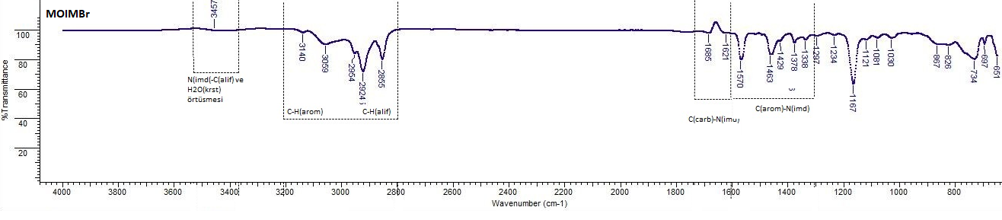

**Figure 3**. ATR-FTIR spectrum of MOIMBr

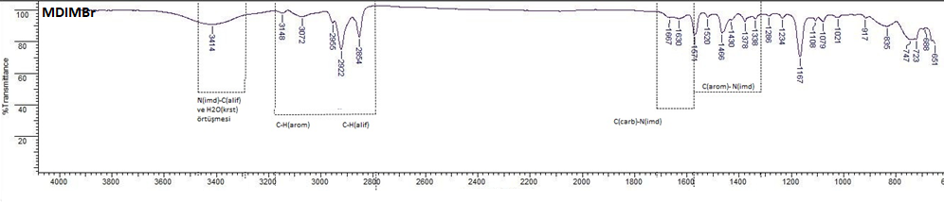

**Figure 4.** ATR-FTIR spectrum of MDIMBr

## 3.2. Rh(III) Separation Studies by Solvent Extraction

### 3.2.1. Determination of optimum Rh(III) recovery conditions

In current study, the effective aqueous phase and organic phase conditions (Time, HCl concentaration, NaCl concentarion, phase ratio and imidazolium salts concentations) were investigated experimentally. So, the optimum recovery conditions have been determined as below;

HCl concentration = 0,01 mol/L

NaCl concentration = 0,3 mol/L

Time: 5 min.

Phase Ratio (Vorg/Vaq): 4/2

Imidazolium Salt Concentration: 0,1 mol/L

### 3.2.2. Rh(III) recovery and separation in optimum conditions

### 3.2.2.1. Effect of different metal ions on Rh (III) extraction under optimum conditions

Another experimental parameter to determine the effectiveness of the optimized process is to perform Rh(III) extraction in the presence of different ions under optimum extraction conditions. For this purpose, Rh(III) extraction from initial solutions prepared with Cu, Au, Pt, Ni, Fe metals, where rhodium is generally found together in nature and for industrial purposes, was investigated and the results are given in Figure 5. In parallel, the separation factors, which are a measure of the separability of Rh(III) from other metals, are given in Table 1. Accordingly, it was determined that rhodium was extracted with high yield and especially high separation factors against Ni, Cu, Fe and Au in the presence of other metal ions, and its separation factor was relatively lower against Pt.

**Tablo 1.** Effect of foreign ion on Rh(III) extraction under optimum conditions

|  |  |  |
| --- | --- | --- |
| **Distribution Coefficients D (Corg/Csu)** | | |
|  | MDIMBr-Rh(III) | MOIMBr-Rh(III) |
| Rh | 6,56 | 5,89 |
| Pt | 0,66 | 0,54 |
| Cu | 0,29 | 0,21 |
| Fe | 0,40 | 0,23 |
| Au | 0,26 | 0,17 |
| Ni | 0,02 | 0,02 |
| **Separation Factors SF (β)** | | |
| SF | MDIMBr-Rh(III) | MOIMBr-Rh(III) |
| βRh/Pt | 10,01 | 10,84 |
| βRh/Cu | 22,55 | 27,46 |
| βRh/Fe | 16,26 | 25,49 |
| βRh/Au | 24,81 | 35,58 |
| βRh/Ni | 324,80 | 291,38 |

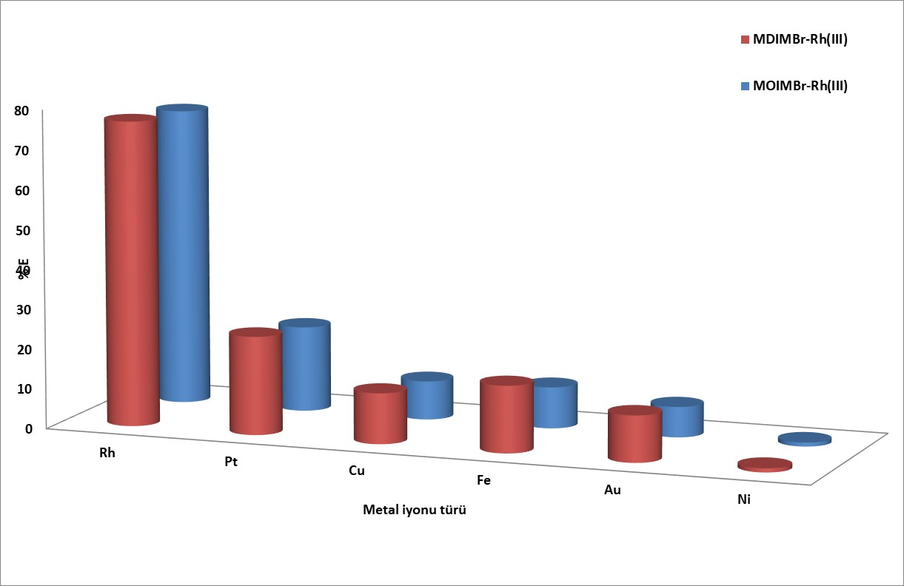

**Figure 5**. Effect of different metal ions on Rh(III) extraction under optimum conditions

**4. Conclusion**

In this study, Rh(III) recovery with newly synthesized asymmetrical imidazolium bromide salts has been achieved by the traditional solvent-solvent extraction method. In the recovery conditions, we have reached max separation factors values against nickel ions with the longer alkyl chain including imidazolium bromide salts.

**5. Acknowledgement**

All experimental studies were performed in Cankiri Karatekin University chemistry department laboratories and its instrumental facilities. The study also supported by Cankiri Karatekin Universitiy Scientific Research Project Commission ennumbered as FF060515B25.

**References**

1. Diamantatos, A. (1981). *A Solvent-Extraction Scheme for the Determination of Platinum, Palladium, Rhodium, Iridium and Gold in Platiniferous Materials.* Analytica Chimica Acta, 131(Nov), 53-62.
2. Zhu, L., Liu, Y., Chen, J., & Liu, W. (2011). Extraction of scandium(III) using ionic liquids functionalized solvent impregnated resins. *Journal of Applied Polymer Science, 120*(6), 3284-3290. Doi: 10.1002/app.33501