**RECYCLING FOUNDRY WASTE INTO MASONRY BRICKS**

**Yap Tek Hong 1, Mazrul Hisyam bin Mat Ali 2, Choong Chee Guan 3**

Politeknik Tuanku Syed Sirajuddin 1,2,3

*Abstract*

Recycling foundry waste into masonry bricks is a project that aimed to produce high mechanical compressive properties and to reduce the cost of the production of the building bricks. Nowadays, foundry waste of CO2 sand is abundant because after used the foundry waste CO2 sand, the factory or the others party will just throw away them into the disposal site. In addition, the use of foundry waste CO2 sand can help to reduce the cost of production of building bricks and utilize residual waste aware garbage, most of is highly regard by some. With the success of this project, foundry waste CO2 sand can be used to produce a composition of a new brick ornaments.

*Keywords: Recycling; Foundry Waste, Sand, Bricks*

**INTRODUCTION**

Solid waste management has become one of the global environmental issues, as there is continuous increase in industrial by-products and waste materials (Collins & Ciesielski, 1994). Utilizing trash and by-products has emerged as a desirable disposal option due to a scarcity of land filling space and its rising cost. One such industrial by-product that can be used in a variety of purposes, including the production of building materials, is waste foundry sand. The advantageous use of these by-products in building materials lowers the cost of the raw materials and aids in solving the disposal issue. Foundry waste consists of many products such as used-foundry sand, slag, ash, refractory, coagulant, baghouse dust, pattern shop waste, and debris (Basar & Aksoy, 2012). The leachate obtained from the CO2 foundry waste sand contains hazardous compound that effects the environment. So, it is important to know the characteristics of leachate obtained from waste foundry sand.

Foundry sand is the one of foundry waste. Malaysia is using foundry to manufacturing sector because it very simple to use and cheaper than the others way in making product. The foundry sand was disposed by incineration process and directly contributing to the environmental pollution. In this research, the purpose is to change the waste foundry sand with the original sand to make a cement brick. From that, it can help Malaysia to decrease the discharge of the waste. Current use of cement brick in the growing economic situation got more request from many companies in development. The production of cement brick by industry also increased based on increasing the usage of cement brick. Addition in waste of foundry sand can reduce the absorption and porosity in structure.

The purpose we make this research on brick is to reduce environment foundry waste pollution on CO2 sand, and to investigate the mechanical performance of bending compressive strength and water absorption towards foundry waste green masonry bricks. The first step in this project is to prepare the waste sand. Next, the moulding process will be used. Bricks should have standard characteristics if they are to be used in construction. The standard imperial size for brick is 210 mm long x 100 mm wide x 65 mm height with a mass of 2.8 kg per piece according to [ISO 9001:2008](http://www.iso.org/) of [SIRIM.](http://www.sirim.my/) The last process is drying and firing. The project can be completed using these 4 processes. Once the masonry bricks are produced, the project will study on the mechanical performance of foundry waste green masonry bricks reinforced composite.

This project was completed according to the process flow under Section Methodology. Among the objectives of this project are:

1. To produce composite from foundry waste with Portland cement;
2. To determine the mechanical performance of foundry waste green masonry bricks reinforced composite;
3. To study the optimum compression of foundry waste through differences compositions between silica sand, foundry waste and Portland cement; and
4. To study the compressive, flexure strength and water absorption of difference composition of foundry waste green masonry bricks.

**LITERATURE REVIEW**

Foundry waste green masonry bricks industry is one of the sectors that can be developed commercially in several tropical countries located especially in Malaysia. Both of our neighbouring countries, such as Thailand and Indonesia, has been producing the foundry waste for quite a long time with Indonesia has the dominant world share. Clay brick is frequently utilised in Malaysia's construction sector. Small, rectangular clay blocks that have been baked are known as bricks. The composition of the clay used to make bricks varies from place to place. Bricks are used for a variety of purposes, including construction, paving, floor construction, and aesthetic purposes (Borchelt, Danforth, & Hunsicker, 2006).

**Classification Specification of Bricks**

Based on their characteristics after manufacture, bricks fall into a specific classification. Although most bricks can be produced to have all the needed properties, some properties may be constrained by the production process, durability rating, or appearance classification chosen by the user (ASTM C185-15a, 2021). There are several classifications used in each standard. Grade, class, kind, application, and use are a few examples of classifications. These categories can be made based on a variety of factors, such as exposure or use conditions, appearance-related items, performance-related physical qualities, dimension, and distortion tolerances, chippage, and void area.

**Table 1**: Classifications Specification of Brick

|  |  |  |  |  |
| --- | --- | --- | --- | --- |
|  | **Classification** | | | |
|  | **Durability** | **Appearance** | **Void Area** | **Use** |
| **ASTM Specification** | | | | |
| **C 62**  **Building Brick** | Grade | None | None | None |
| **C 216**  **Facing Brick** | Grade | Type | None | None |
| **C 652**  **Hollow Brick** | Grade | Type | None | None |
| **C 1088**  **Thin Veneer Brick** | Grade | Type | None | None |
| **C 902**  **Pedestrian and Light Traffic Paving Brick** | Class and Type | Application | None | Type |
| **C 1272**  **Heavy Vehicular Paving Brick** | Type | Application | None | Type |
| **C 126**  **Ceramic Glazed Facing Brick** | None | Grade and Type | None | None |
| **C 1405**  **Single Fired Glazed Brick** | Class | Grade and Type | Division | None |
| **CSA (Canadian Standards Association) Specification** | | | | |
| **A82**  **Fired Masonry Brick**  **Made from Clay or Shale** | Grade | Type | None1 | None |

**Foundry Waste**

In order to create moulds for ferrous (iron and steel) and nonferrous (copper, aluminium, and brass) metal castings, foundry sand is largely composed of clean, consistently sized, high-quality silica sand or lake sand. Despite being clean before usage, some sands may contain contaminants after casting. Approximately 95% of the foundry sand used for castings comes from the ferrous (iron and steel) industries. The main producers of foundry sand are the automotive sector and the companies that supply its components.

The sand-casting technology is the most widely utilised casting method in the foundry sector. Majority of sand cast moulds used for ferrous castings are made of green sand. Green sand consists of high-quality silica sand, about 10 percent bentonite clay (as the binder), 2 to 5 percent water and about 5 percent sea coal (a carbonaceous mould additive to improve casting finish). What additives and sand grade are used depends on the type of metal being cast. Upwards of 90% of the moulding materials utilised in the process are made of green sand (American Foundrymen's Society, 1991).

**METHODOLOGY**

The process of making foundry waste green masonry bricks is by using silica sand, foundry waste (CO2 sand), Portland cement and water by mixing the material and letting it dry for a few days according to the test age. The average grain size for silica sand and foundry waste (CO2 sand) was calculated (ISO R565). Foundry waste green masonry bricks are specified for building brick. So, the mechanical testing equivalent to the ASTM C 62 is the compressive and flexural tests. In addition, the sample will undergo rate absorption of water for the mixing procedures field.

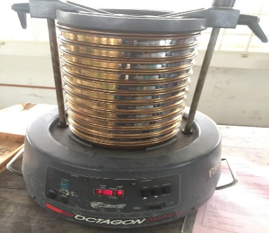

**Figure 1**: Sieve analysis of sand

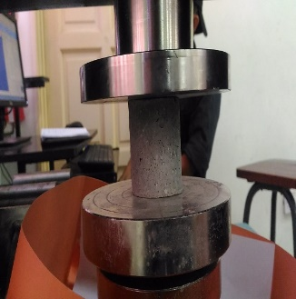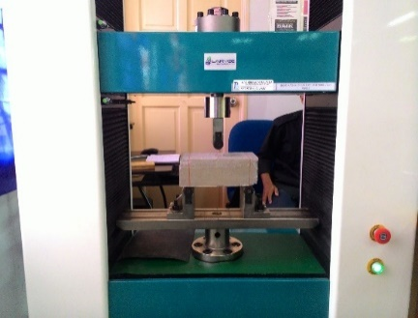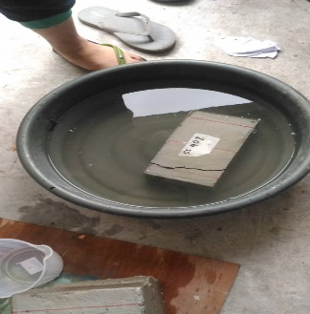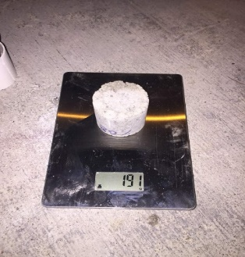

1. (b) (c) (d)

**Figure 2**: Testing process (a) Compression test, (b) Flexural test, (c) Water absorption test, and (d) Density test

This project was completed according to the design process flow shown in Figure 1.

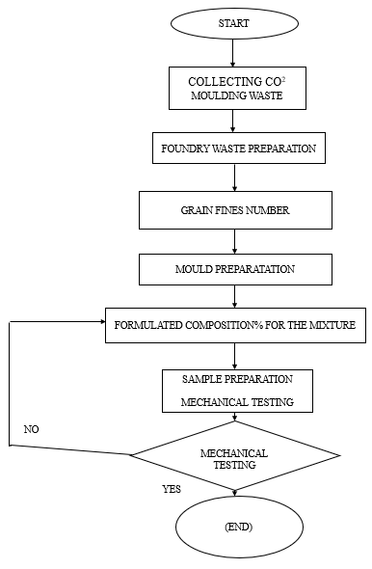

**Figure 3**: Design process flow

This finalized prototype was completed according to the different views as shown in Figure 2:-

**Figure 4**: Sample of Masonry bricks

Mechanical testing consists of: -

**Table 2**: Mechanical Testing

|  |  |
| --- | --- |
| Test | Purpose |
| Compressive | The static compressive strength characteristics of materials, goods, and components are evaluated using compression tests, which are widely used for this purpose. The ultimate compression strength, yield strength, deflection, and modulus are all properties that our compression test equipment measures. |
| Flexure | A flexure test is most frequently used to assess flexural strength and modulus. The highest stress at the outermost fibre on either the compression side or the tension side of the specimen is what is referred to as flexural strength. The slope of the stress vs. strain deflection curve serves as the basis for calculating the flexural modulus. These two numbers can be used to assess the sample material's resistance to bending or flexure forces. |
| Water Absorption | The cold-water absorption test is used to determine how much water a brick can hold. Water absorption and the watertightness of walls do not directly correlate. The brick producer uses the results of water absorption testing to ensure quality. To ascertain its weight, the specimen is cooled to room temperature. Immerse the fully dry specimen in clean water for 24 hours at a temperature of 27+2°C. After removing the specimen from the water and wiping off any remaining water with a wet cloth, weigh the specimen. |
| Density | A fundamental characteristic of matter known as density is the mass of an object per unit volume. The object with higher density will weigh more than the similarly shaped object with lower density if two objects have the same volume but different densities. Knowing an object's density can be a useful tool for figuring out the composition of a sample of unknown material. |

**FINDINGS AND DISCUSSIONS**

**Result of Average Grain Size**

From the ISO metric sieving analysis of sand silica sand and foundry waste (CO2 sand), the average grain size were obtained from the Sieve Shaker (OCTAGON 2000 DIGITAL). The average grain size for foundry waste grain was 176.76 μm while the average saiz number for silica sand grain was 410.67 μm.

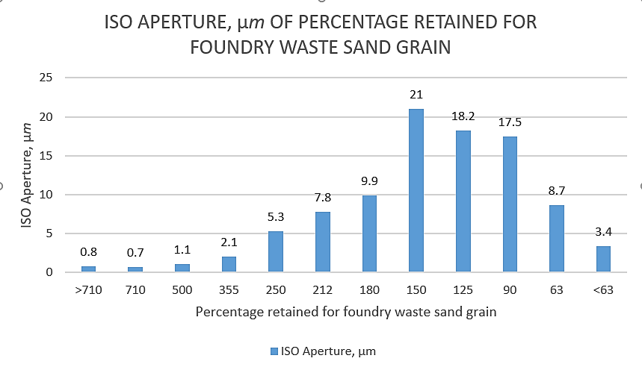

**Figure 5**: Percentage retained for foundry waste sand grain

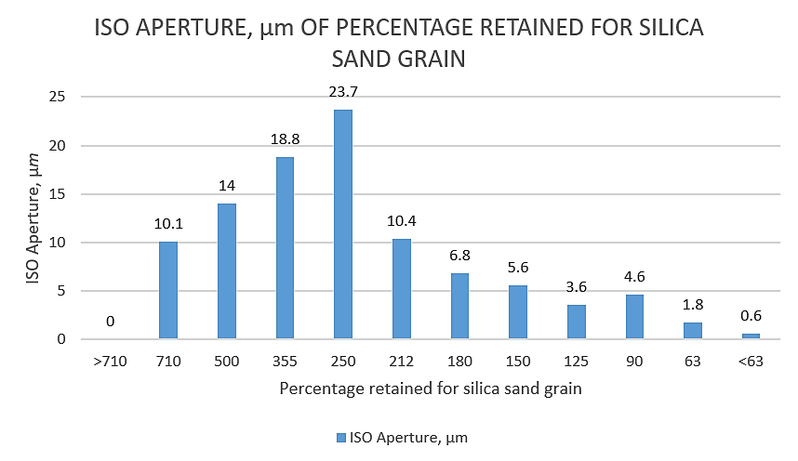

**Figure 6**: Percentage retained for silica sand grain

**Result of Compression Test**

From the compression testing, several data were achieved from the Computer Control Electronic Universal Testing Machine (UE34100).

**Table 3**: Max Load and Max Stress of the Samples

|  |  |  |  |
| --- | --- | --- | --- |
| No | Samples Percentage | Max. Load, KN | Max. Stress, MPa |
| 1 | 10% foundry waste,  30% silica sand | 5.635 | 3 |
| 22.81 | 12 |
| 22.75 | 12 |
| 2 | 20% foundry waste,  20% silica sand | 19.33 | 10 |
| 21.17 | 11 |
| 17.46 | 9 |
| 3 | 30% foundry waste,  10% silica sand | 18.04 | 9 |
| 14.88 | 8 |
| 15.51 | 8 |
| 4 | 40% foundry waste,  0% silica sand | 1.350 | 1 |
| 10.53 | 5 |
| 10.52 | 4 |
| 5 | 0% foundry waste,  40% silica sand | 24.07 | 12 |
| 16.41 | 8 |
| 22.31 | 11 |

**Table 4**: Average Max Load and Average Max Stress

|  |  |  |  |
| --- | --- | --- | --- |
| No | Samples Percentage | Average Max. Load, KN | Average Max. Stress, MPa |
| 1 | 10% foundry waste,  30% silica sand | 17.065 | 9 |
| 2 | 20% foundry waste,  20% silica sand | 19.32 | 10 |
| 3 | 30% foundry waste,  10% silica sand | 16.14 | 8.33 |
| 4 | 40% foundry waste,  0% silica sand | 7.47 | 3.33 |
| 5 | 0% foundry waste,  40% silica sand | 20.93 | 10.33 |

**Figure 7**: Max load versus different percentage of foundry waste

**Figure 8**: Average Max Stress versus different percentage of foundry waste

**Result Rate of Absorption Water**

**Table 5**: Rate of Absorption Water

|  |  |  |  |  |  |
| --- | --- | --- | --- | --- | --- |
| No | Samples percentage | Weight before, g | Weight  after, g | % Water  absorbed | Average % water absorbed |
| 1 | 10% foundry waste,  30% silica sand | 220 | 233 | 5.91 | 6.58 |
| 205 | 219 | 6.83 |
| 214 | 229 | 7.01 |
| 2 | 20% foundry waste,  20% silica sand | 198 | 213 | 7.58 | 7.66 |
| 197 | 212 | 7.61 |
| 205 | 221 | 7.80 |
| 3 | 30% foundry waste,  10% silica sand | 193 | 206 | 6.74 | 7.03 |
| 191 | 205 | 7.33 |
| 185 | 198 | 7.03 |
| 4 | 40% foundry waste,  0% silica sand | 175 | 187 | 6.86 | 7.52 |
| 166 | 179 | 7.83 |
| 165 | 178 | 7.88 |
| 5 | 0% foundry waste,  40% silica sand | 230 | 236 | 2.61 | 3.64 |
| 230 | 237 | 3.04 |
| 228 | 240 | 5.26 |

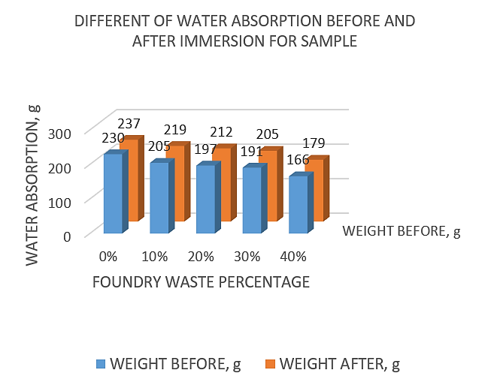

**Figure 9**: Different of water absorption before and after immersion for sample

**Figure 10**: Percentage of water absorbed by different foundry waste ratio

**Result of Flexural Bend Test**

**Table 6**: Result of flexural bend test

|  |  |  |  |
| --- | --- | --- | --- |
| No | Samples percentage | Maximum Load, KN | Maximum Stress, MPa |
| 1 | 10% foundry waste,  30% silica sand | 9.310 | 1.099 |
| 2 | 20% foundry waste,  20% silica sand | 7.850 | 0.926 |
| 3 | 30% foundry waste,  10% silica sand | 7.325 | 0.864 |
| 4 | 40% foundry waste,  0% silica sand | 1.035 | 0.554 |
| 5 | 0% foundry waste,  40% silica sand | 11.23 | 1.326 |

**Figure 11**: Data maximum load

**Figure 12**: Data Maximum Stress

**Result of Density Test**

**Table 7**: Result density test

|  |  |  |  |  |
| --- | --- | --- | --- | --- |
| No | Samples percentage | Mass of samples, g | Volume of samples, ml | Density of sample, g/ml |
| 1 | 10% foundry waste,  30% silica sand | 4561 | 2200 | 2.0732 |
| 2 | 20% foundry waste,  20% silica sand | 4671 | 2000 | 2.3355 |
| 3 | 30% foundry waste,  10% silica sand | 4620 | 2080 | 2.2212 |
| 4 | 40% foundry waste,  0% silica sand | 4548 | 2200 | 2.0673 |
| 5 | 0% foundry waste,  40% silica sand | 4637 | 2100 | 2.2081 |

**Figure 13**: Data density test

From the test that was being undergo that is compressive test and water absorption test, the highest average max load and highest average max stress is the percentage 20% foundry waste and 20% silica sand that is 19.32 KN for the average max load and 10 MPa for the average max stress. 0% foundry waste and 40% silica sand were the actual specimen for the ordinary cement brick, so we can conclude that 20% foundry waste and 20% silica sand has slightly same max load and max stress, but the ‘Foundry Waste Green Masonry Brick’ was cheaper and have longer elastic range compared to ordinary cement. For the water absorption rate, all the specimens of our project can be considered good quality brick because all the percentage of the specimens was below 20% for the weight of the specimens after being immersed in the fresh water. From the flexural bend test, the result for the maximum load for foundry waste was highest at 10% foundry waste that is 9.310 KN while the maximum stress for the specimens was kept the same that is 1 MPa except for 40% foundry waste that has 0.553 MPa maximum stress. For the density test, the denser sample among all is 20% foundry waste that is 2.3355 g/ml while the minimum dense is 40% foundry waste that is 2.0673. Next, the average finess for foundry waste grain was 176.76 μm while for the highest grain number for foundry waste was 150 μm and for the average fineness number for silica sand grain was 410.67 μm and the highest grain number for silica sand was 250 μm. Lastly, chemical presence test indicated that foundry waste green masonry brick appeared to have chemical presence in it compared to ordinary cement brick.

**CONCLUSION**

The success of this project is to make sure that all objective and scope that required that had been plan and had been stated at the past chapter was successfully achieved. After undergoing several stage and problem to produce or to make new type building brick, at last the best optimum ratio or percentage was achieved that is 20% foundry waste and 20% silica sand will give result of 19.32 KN of average max load and 10 MPa average max stress. ‘Foundry Waste Green Masonry Brick’ cover the theme that had been chosen that is green technology, where the product use CO2 casting sand process waste to make the building brick.

The material that been use is use CO2 casting sand process waste, cement, silica sand and water that had been separated into several ratio or percentage to build optimum grade of building brick, but the ordinary cement brick has slightly more max load and max stress compared to the ‘Foundry Waste Green Masonry Brick’. The deficiency of ‘Foundry Waste Green Masonry Brick’ is it absorbed more water that is 7.66% of water compared to the ordinary cement brick that is 3.64% of water but still the grade product or the new type of the building brick still can be accepted and still can be considered as good quality building brick because the percentage of ‘Foundry Waste Green Masonry Brick’ still below 20% that is the marking level of the rate water absorption test.

The flexural strength for composition 20% foundry waste and 20% silica sand was moderately differ from the ordinary cement brick that is from 11.23 KN to 7.85 KN but still it can be used for small to medium size building or architecture construction because it moderates mechanical strength and its maximum stress that same level as the ordinary cement brick. To be used inside house or other building the Foundry Waste Green Masonry Brick must not be in coating condition with another coating material such as plaster coating to prevent the user being affected by the chemical substance inside the brick itself.

**REFERENCES**

[ASTM C185-15a, Standard Test Method for Air Content of Hydraulic Cement Mortar](http://www.astm.org/cgi-bin/resolver.cgi?C185). www.ASTM.org. West Conshohocken, PA: [ASTM International](https://en.wikipedia.org/wiki/ASTM_International). 2015. [doi](https://en.wikipedia.org/wiki/Digital_object_identifier):[10.1520/C0185-15A](https://doi.org/10.1520%2FC0185-15A). Retrieved on 16 May 2021.

American Foundrymen's Society. Alternative Utilization of Foundry Waste Sand. Final Report (Phase I) prepared by American Foundrymen's Society Inc. for Illinois Department of Commerce and Community Affairs, Des Plaines, Illinois, July, 1991.

Basar, H.M. & Aksoy, N.D. (2012). The effect of waste foundry sand (WFS) as partial replacement of sand on the mechanical, leaching and micro-structural characteristics of ready-mixed concrete. Construction and Building Materials, Volume 35, 2012, pp. 508-515.

Borchelt, J. G., Danforth, L.. Jr., and Hunsicker, R.. (2006). Specifying Brick: Getting what you want for appearance and function. The Construction Specifier, Construction Specifications Institute, Alexandria, VA, pp. 20-28.

Collins, R. J. and S. K. Ciesielski. Recycling and Use of Waste Materials and By-Products in Highway Construction, National Cooperative Highway Research Program Synthesis of Highway Practice 199, Transportation Research Board, Washington, DC, 1994.