**Modified monitoring energy system for telecommunication power base station based on photovoltaic energy**

***Bassam Zayer Salman AZZAWİ1,2,*, Inam Abbas Razooqi AL-SADDAEE1,3, Murat ARI1***

*1Department of Electrical and Electronics Engineering, Graduate School of Natural and Applied Sciences, Çankırı Karatekin Unıversity, Çankırı, Turkey*

*2Electromechanical Engineering Department, University of Technology, Baghdad, Iraq*

*3Department of Electrical Power and Machines Engineering, College of Engineering, University of Diyala, Diyala, Iraq*

|  |
| --- |
| **Abstract**  Renewable energy and energy efficiencies are the primary foundations of sustainability and environmental compatibility. This paper provides a monitoring system for an overview of environmentally friendly and energy-efficient cellular base stations (BSs), which use the most energy in cellular networks. Reduced network operating costs and continued profitability are crucial concerns for cellular network operators. Monitoring cellular base stations in off-grid locations is the topic of this research. Because of this, this study creates and puts into use a modern system for monitoring solar systems, which will make use of GSM technologies to transport data spanning great distances for the least expensive possible cost. To monitor PV systems that are situated in remote locations, this research article displays a resilient, authoritative, and secure control strategy that makes use of sensor networks and IoT technologies. Defining and archiving defects, collecting generation, and performing data for the study are made easier with this technology. In this paper, by using the PZEM-00T multimeter and Arduino UNO, the voltage and current coming out of the solar inverter are monitored, and data is transmitted through the GSM network using the SIM900 module to the ThingSpeak Cloud so that the data is monitored from long distances. |
| Keywords: PV, monitoring system, PZEM-004T multimeter, SIM900 module, ThingSpeak Cloud, Arduino UNO |

1. **Introduction**

At many telecommunication cell sites, the management of AC power and battery levels continues to be problematic. The management of mobile base station cell sites by Nigeria's telecom companies is incompetent, and the owners of the telecom networks continue to lose money [1]. At each cell location, no amount of one-person activities will yield the desired results. Site operators are fallible and should not be encouraged to work in situations where they might make mistakes. They were involved in the majority of site failures in the records as a result of slow response times, inadequate diesel tank fueling, a failure to detect tank leaks, etc.

The world's mobile phone towers now have solar panels installed on top of them, enabling the nation to transition to using fewer fossil fuels without incurring significant costs. Solar energy technology is developing. However, the best time for solar energy to create is during the day. To assure the availability of services, this requires energy storage in the form of batteries. By connecting to the internet and other services, telecom towers enable people to conduct business remotely [2, 3]. To be employed for a variety of tasks, the towers' power source must be dependable. The towers' solar panels will keep them powered even if the national grid fails, which will be an issue if it does so frequently [4].

The potential for sudden voltage dips and subsequent cutoffs, which happen without the end-user being aware of it, is a major issue for telecom tower operators. As a result, the output is reduced and essential electrical equipment, such as tower services, becomes inoperable. It is critical to understand that battery hydrogen gas is hazardous to the environment and human health [5, 6]. Therefore, features that can endanger public health and safety, such as variations in AC and DC voltage, must be watched for and eliminated. Two of the main causes of voltage variations that have been discovered are insufficient battery data visualization and the large number of devices that rely on batteries. Since they are unaware of the anticipated battery low voltage, they are unable to act quickly. Data access from a distance is now possible for many companies and people thanks to the Internet of Things (IoT). IoT is essential for remotely acquiring, monitoring, and analyzing information and responding appropriately [7].

To deliver data to the cloud over vast distances to obtain the lowest cost and the longest battery life, our efforts focus on the design and implementation of a state-of-the-art energy activity monitoring system for the PV systems of telecom towers.

1. **Requirements for System Design**

Figure 1 depicts the suggested layout for the GSM and Thingspeak cloud-based solar monitoring system. Figure 1 demonstrates how to obtain the necessary measurements from sensors (Voltage and Current) and transfer them to the cloud over the GSM network for remote monitoring. The primary hardware component types that will be employed in the final proposed system are presented in this section.

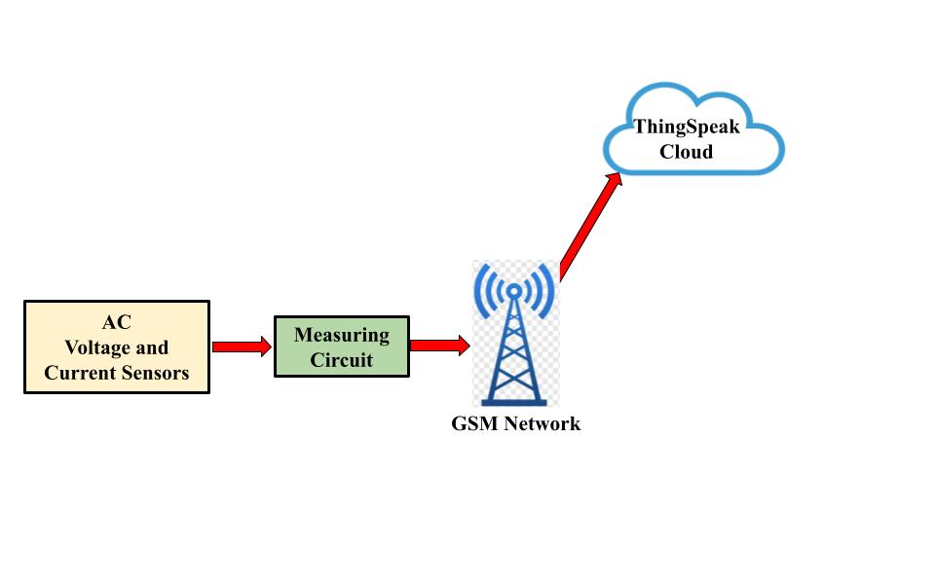

**Figure 1**. Proposed monitoring system based on IoT and GSM network.

**2.1. Required hardware**

An Arduino Uno R3 is a board of circuits that are built around the detachable, DIP (dual-inline-package), ATmega328 AVR microprocessor. Total 20 digital input and output pins (6 of which can be used as PWM outputs and 6 can be applied as analog inputs). The simple-to-use Arduino computer program can be used to load programs onto it. It's incredibly simple to start working with embedded electronics thanks to Arduino's large support community. The Arduino Uno's third and most recent model is known as the R3 (Figure 2a) [8].

|  |  |
| --- | --- |
| (a) | (b) |
| (c) | (d) |

**Figure 2**. Main Hardware Componnents: a) Arduino UNO R3 [8], b) PZEM-004T [9] , c) SIM900 Module [10], d) 20*04 LCD [11].

**2.2. Required Software**

The tool used to write code is called the Arduino IDE (Integrated Development Environment), and it may be downloaded as a file from the Arduino website (Figure 3a) [12].

ThingSpeak is an IoT analytics stage service that enables the collection, visualization, and analysis of live data streams in the cloud. ThingSpeak (Figure 3b) instantly visualizes data sent by smart devices to ThingSpeak [13].

|  |  |
| --- | --- |
| (a) | (b) |

**Figure 3**. Main Software Required: a) Arduino IDE [12], b) ThingSpeek Cloud [13].

1. **Results and Discussion**

The metering and transmission circuit is located in this part, as mentioned in the items in the previous part. In Figure 4, the final circuit is depicted. The hardware architecture is shown in Figure 5 for the final circuit connected to the GSM network and the measurement of the block diagram. Software called Fritzing was used to draw the electronic circuit [14]. With the use of CAD software developed as part of the open-source Fritzing software, electronic gear hobbyists and amateur designers will be able to build more reliable circuits from prototypes.

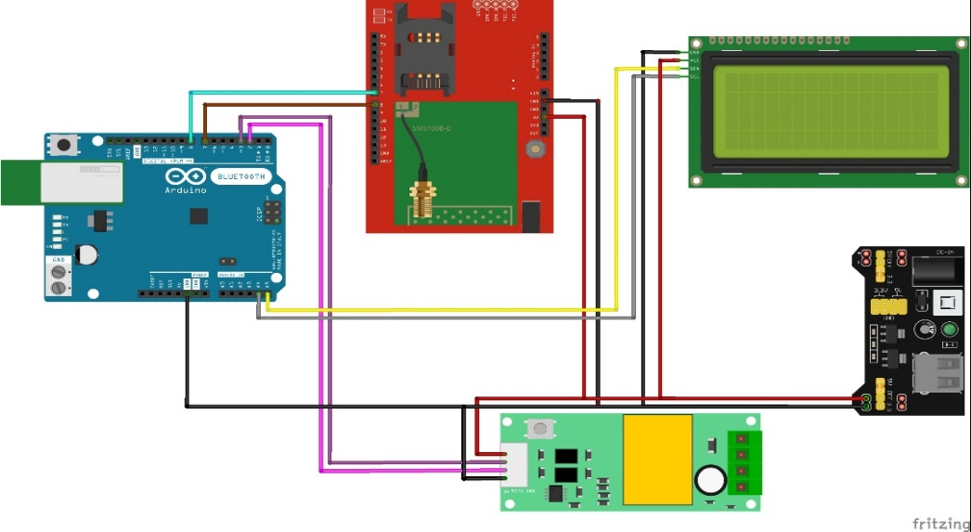

**Figure 4**. Main circuit block diagram.

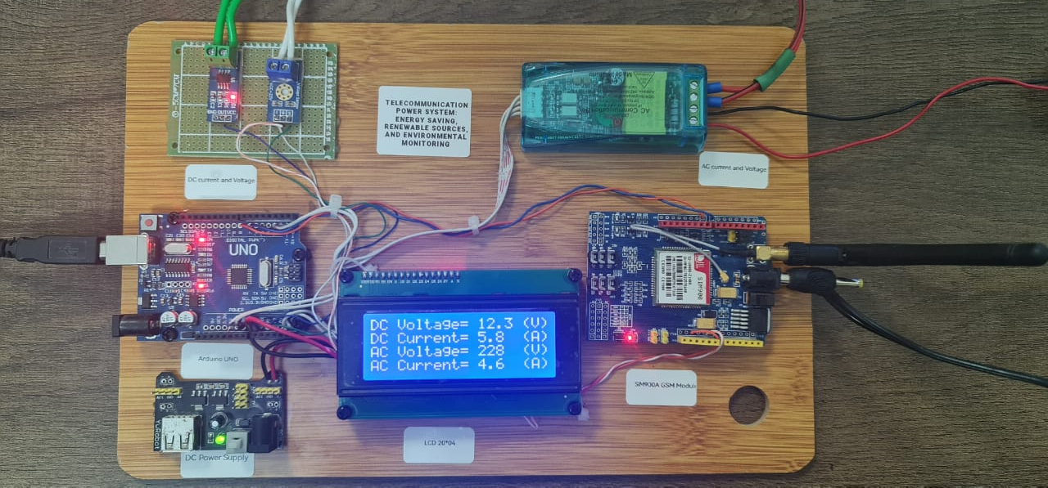

**Figure 5**. The hardware architecture board.

.

A flowchart for the final hardware board is shown in Figure 6. The flowchart shows how the Arduino UNO collects data from sensors (AC voltage and current), displays it on the 20*04LCD, and then determines whether the GSM network is available to begin transferring data to the ThingSpeak Cloud.

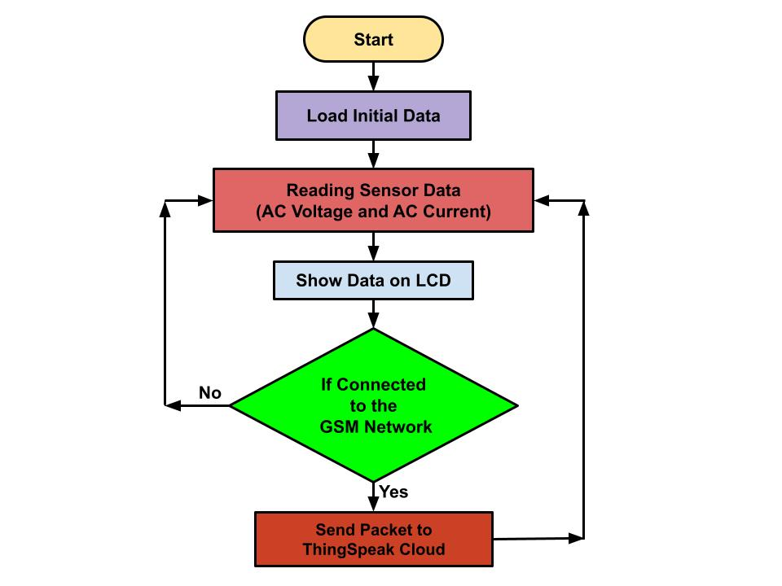

**Figure 6**. The flowchart of the final measuring circuit.

The data stored in the ThingSpeak cloud will be displayed. Collect, visualize and examine data streams in real-time using the cloud-based IoT analytics platform ThingSpeak. ThingSpeak displays real-time data transmitted by devices to ThingSpeak. The ability to execute MATLAB® code in ThingSpeak allows you to analyze and manage the data as it is being collected in real-time. For proof-of-concept for an IoT system and prototyping that requires analytics, ThingSpeak is widely used. Figure 7 displays the results for some time to assess the state of the photovoltaic system.

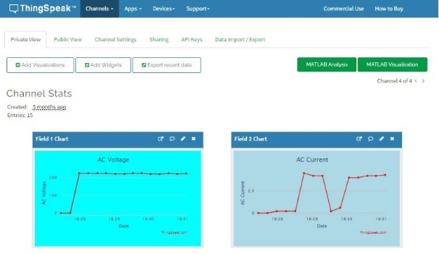

**Figure 7**. The main page of ThingSpead with results (AC voltage and AC current).

1. **Conclusion**

In this work, a brand-new monitoring system built on GSM technology has been developed and implemented. Data transfer over vast distances and with little power usage is made possible by GSM communication technology. The expansion of solar PV monitoring systems makes it possible for businesses and researchers working on solar PV to conduct further research based on IoT and ThingSpeak for PV-based applications that rely heavily on monitoring systems. Creating a monitoring-focused mobile application is suggested for future works.

**References**

1. A. Petraglia, A. Spagnuolo, C. Vetromile, A. D'Onofrio, C. Lubritto, 2015, “*Heat flows and energetic behavior of a telecommunication radio base station*,” Energy, vol. 89, pp. 75-83.
2. S. Bera, S. Misra, S. K. Roy and M. S. Obaidat, 2018, "*SoftWSN: Software-Defined WSN Management System for IoT Applications*," IEEE Systems Journal, vol. 12, no. 3, pp. 2074-2081.
3. A. olakovi and M. Hadiali, 2018, “*Internet of things (iot): A review of enabling technologies, challenges, and open research issues,*” Computer Networks, vol. 144, pp. 17 – 39.
4. Fantacci, R., Pecorella, T., Viti, R., Carlini, C., 2014, “*A Network Architecture Solution for Efficient IoT WSN Backhauling: Challenges and Opportunities,*” IEEE Wireless Communications. 21, 113–119.
5. Davoli, L.; Belli, L.; Cilfone, A.; Ferrari, G, 2018 “*From Micro to Macro IoT: Challenges and Solutions in the Integration of IEEE 802.15.4/802.11 and Sub-GHz Technologies,*” IEEE Internet Things J. 2018, 5, 784–793. doi:10.1109/JIOT.2017.2747900.
6. A. Zanella, N. Bui, A. Castellani, L. Vangelista, and M. Zorzi, 2014, “*Internet of Things for smart cities,*” IEEE Internet of Things Journal, vol. 1, no. 1, pp. 22–32.
7. Zhang, F.; Liu, M.; Zhou, Z.; Shen, W. 2016, “An IoT-based online monitoring system for continuous steel casting,” IEEE Internet Things J., 1355–1363.
8. Arduino UNO 3 Available at: “[*https://store.arduino.cc/products/arduino-uno-rev3*](https://store.arduino.cc/products/arduino-uno-rev3)”.
9. The PZEM-004T is Available at: “[*http://www.piddlerintheroot.com*](http://www.piddlerintheroot.com)”.
10. Sim900 GSM Module Available at: “[*https://randomnerdtutorials.com/sim900-gsm-gprs-shield-arduino/*](https://randomnerdtutorials.com/sim900-gsm-gprs-shield-arduino/)”.
11. Vishay, 2019, “*LCD-020N004B Vishay 20 x 4 Character LCD STANDARD VALUE UNIT ELECTRICAL CHARACTERISTICS ITEM SYMBOL CONDITION LCD-012N004B,*” Vishay, vol. 4, p. 3. Available at: “[*www.vishay.com*](http://www.vishay.com)”*.*
12. IDE Available at: “[*https://www.arduino.cc/en/software*](https://www.arduino.cc/en/software)”.
13. Thingspeak Available at: “[*https://thingspeak.com/*](https://thingspeak.com/) ”.
14. Fritzing Software is Available at: “[*https://fritzing.org/*](https://fritzing.org/) ”.