**Investigation Of Structural, Morphological And Electrical Properties Of SnO2 Thin Film Grown by SILAR Method**

***Tuğba ÇORLU1,\*[C:\Users\Abdullah\AppData\Local\Microsoft\Windows\INetCache\Content.Word\ORCID-iD_icon-16x16.gif](https://orcid.org/0000-0001-5828-207X), Selim ACAR2[C:\Users\Abdullah\AppData\Local\Microsoft\Windows\INetCache\Content.Word\ORCID-iD_icon-16x16.gif](https://orcid.org/0000-0003-4014-7800)***

*1 Innovative Technologies Application and Research Center, Suleyman Demirel University, Isparta, Turkey*

*2Department of Physics, Faculty of Science, Gazi University, Ankara, Turkey*

|  |
| --- |
| **Abstract**  Due to its wide band gap value and large applications, tin dioxide (SnO2) is useful multifunctional material. In this study, SnO2 thin film was grown by the Successive Ionic Layer Adsorption and Reaction (SILAR) method for 40 cycles on the silver interdigital contact. Structural and morphological properties, SEM and UV analysis were investigated. For electrical characterization, I-V and resistivity measurements were also taken. Electrical measurements were taken depending on temperature. The results showed that SnO2 thin film exhibits promising electrical applications for future work. |
| Keywords: SnO2, SILAR, Electrical Characterization |

1. **Introduction**

Due to its wide band gap value, tin dioxide (SnO2) is useful multifunctional material having wide applications such as gas sensors [1,2], catalysts [3], optoelectronic devices [4,5] and so on. In particular, SnO2-based semiconductors offer great potential for gas sensors because of their detection accuracy and high sensitivity to combustible gases [6].

SnO2 conforms to the O=Sn=O structure and is an n-type, wide band gap (3.6 eV) semiconductor oxide. Interestingly, the simultaneous occurrence of transparency and conductivity of SnO2 is a unique feature among the Group-IV elements of the periodic table. For example, its superior optical transparency is suitable for optically passive components in a number of devices. The study of SnO is triggered by its impressive range of applications in solar cells, as catalytic support materials, as solid-state chemical sensors, etc. [7]. It is very important to produce SnO2 thin film with the appropriate method with its wide usage area. The selection of the appropriate one among many production methods also affects the cost.

Physical vapor deposition method, sol-gel, chemical vapor deposition, spray pyrolysis, etc. these techniques require high temperatures and pressures, hence using these techniques thin film magnification becomes very costly. SILAR is capable of producing thin films at relatively low temperatures, is relatively simple, does not require expensive equipment, and there is minimal waste of chemicals as compared with other methods. The deposition rate and thickness of the film can be easily controlled by changing the deposition cycle [8].

In this work, we prepared SnO2 thin film grown by the SILAR method. The electrical properties of the thin film are investigated.

1. **Materials and Methods**

Succession Ionic Layer Adsorption and Reaction (SILAR) method was used for producing SnO2 thin fılm, on the silver coated glass substrate with 40 cycles. The silver metal contact has been evaporated on a side of the glass substrate. Then interdigital contact has been annealed under a nitrogen atmosphere (300◦C, 15 min). After this process, SnO2 material was grown by the SILAR method on the ready contacts.

To prepare the thin film, SnCl4 (99.9%, Sigma-Aldrich) of 0.1 M as a source for Sn and aqueous ammonia solution (NH3-28%, Sigma-Aldrich) have been used. As solvent deionized water was chosen and [Sn(NH3)4]4+ complex was obtained for producing process.

One SILAR cycle includes four steps and each step is shown in Figure 1. Production was completed in 40 SILAR cycles.

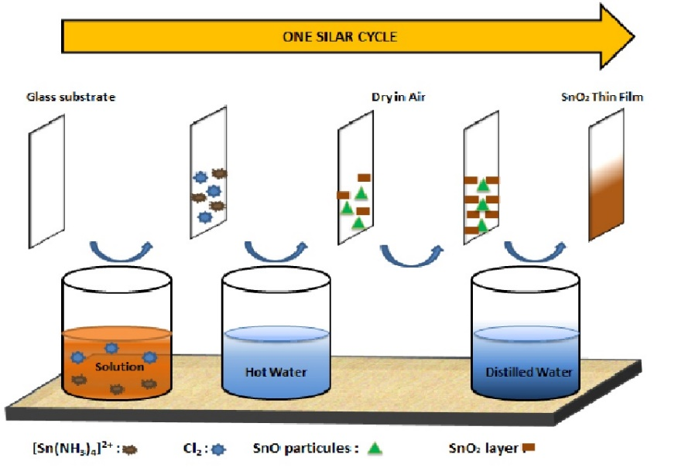

**Figure 1**. One SILAR cycle

1. **Results and Discussion**

SEM images were taken using the FEI Quanta FEG 450 model SEM and the results are given in Figure 2. Images show that the SnO2 material is covered over the entire surface. It was also observed that cracks formed on the surface as a result of 40 SILAR cycles. In addition, EDX results also support the healthy growth of the structure.

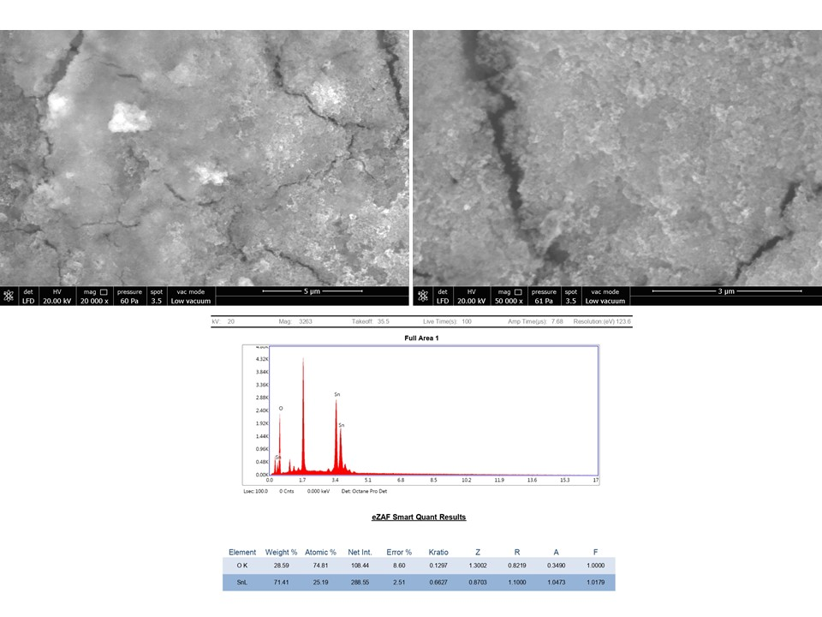

**Figure 2**. SEM and EDX images of SnO2 thin film

Fig. 3 shows the band gap graph of SnO2 thin film. The transition was plotted using the relative Tauc plot given in formula 1. Extrapolating the straight portion of the plot (*αhν*)2 against *hν* to the energy axis, the optical band gap energy value of 3.81 eV was determined. It has been observed that the band gap energy value calculated using the absorption data, is compatible with the literature [9].

$α=\frac{A({hϑ-E_{g})}^{n}}{hϑ}$ (1)

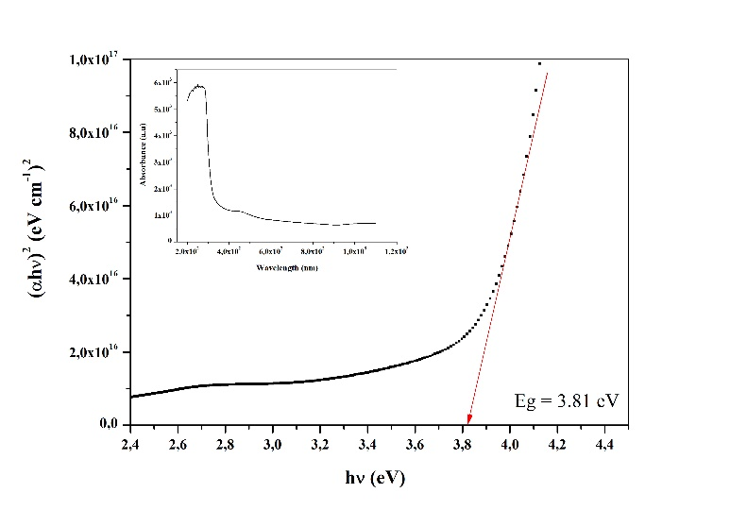

**Figure 3.** Bandgap graph of SnO2 thin film

Fig.4 shows the current-voltage characteristics for the different temperatures of SILAR-deposited SnO2 thin films. It was observed that the electrical characteristic of the thin film stabilized with increasing temperature. All measurements were taken between -5 volt and + 5 volts.

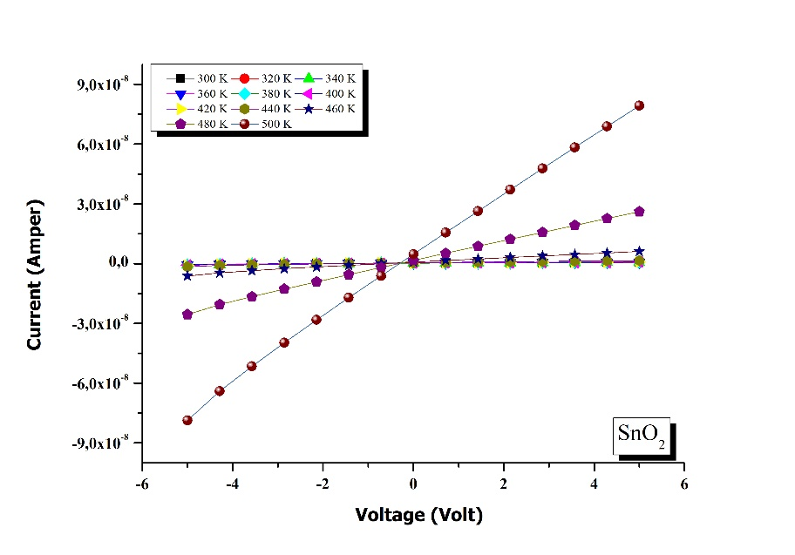

**Figure 4.** Current –Voltage characteristic of SnO2 thin film

Resistvity result is also one another important discussion for electrical applications. Fig 5. depicts lnρ against temperature. It can clearly say that with increasing temperature resistivity is getting stabilized. Especially after 400 ᵒK graph is getting flatter.

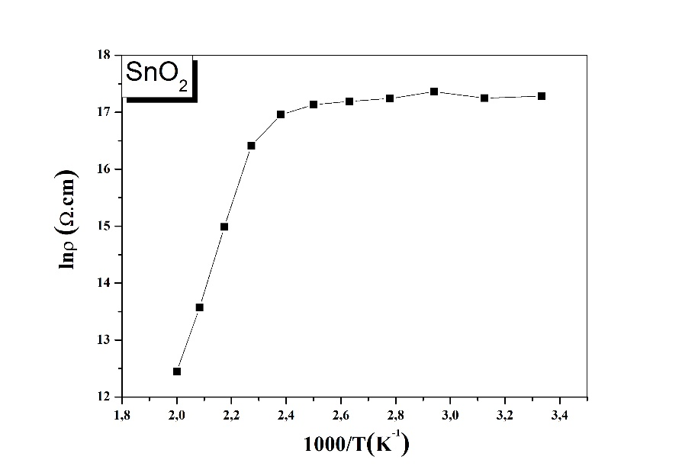

**Figure 5.** The plot of lnρ against 1000/T of SnO2 thin film

1. **Conclusion**

SnO2 thin film was produced by the SILAR method. The morphological and electrical properties were studied. The sensor results show that tin dioxide material is successfully grown on silver interdigital contact and exhibited promising electrical results.

**References**

1. Er Karaduman I.*,* Çağırtekin A.O., Çorlu T., Yıldırım M. A., Ateş A. & Acar S. (2019). Low-level NO gas sensing properties of Zn1−*x*Sn*x*O nanostructure sensors under UV light irradiation at room temperature. *Bull. Mater. Sci.* (2019) 42:32.
2. Suematsu K., Shin Y., Hua Z., Yoshida K., Kida T. & Shimanoe K. (2014). Nanoparticle Cluster Gas Sensor: Controlled Clustering of SnO2 Nanoparticles for Highly Sensitive Toluene Detection. *ACS Appl. Mater. Interfaces*, 6, 5319–5326.
3. Kamiuchi N., Mitsui T., Yamaguchi N., Muroyama H., Matsui T., Kikuchi R. & Eguchi K. (2010) Activation of Pt/SnO2 Catalyst for Catalytic Oxidation of Volatile Organic Compounds. *Catal. Today*, 157, 415–419.
4. Duan Y., Zheeng J., Fu N., Fang Y., Liu T., Zhang Q., Zhou X., Lin Y. & Pan F. (2015). Enhancing the Performance of Dye-Sensitized Solar Cells: Doping SnO2 Photoanodes with Al to Simultaneously Improve Conduction Band and Electron Lifetime, *J. Mater. Chem. A*, 3, 3066–3073.
5. Jia T., Wang W., Long F., Fu Z., Wang H. & Zhang Q. (2009). Synthesis, Characterization, and Photocatalytic Activity of Zn-Doped SnO2 Hierarchical Architectures Assembled by Nanocones. *J. Phys. Chem. C*, 113, 9071–9077.
6. Suematsu K., Ma N., Yuasa M., Kida T. & Shimanoea K. (2015). Surface-modification of SnO2 nanoparticles by incorporation of Al for the detection of combustible gases in a humid atmosphere. *The Royal Society of Chemistry*, (*5),* 86347–86354.
7. Das S., & V. Jayaraman. (2014). SnO2: A comprehensive review on structures and gas sensors. *Progress in Materials Science*, *66,* 112–255.
8. Çorlu T., Karaduman I., Yıldırım M. A., Ateş A. & Acar S. (2016). NH3 sensing properties of nanostructure ZnO thin film prepared by SILAR method. *High Temperatures-High Pressures*, Vol. 46, pp. 155–165
9. Khallaf H., Chen C.T., Chang L.B., Lupan O., Dutta A., Heinrich H., Haque F., Barco E. D. & Chow L. (2012). Chemical bath deposition of SnO2 and Cd2SnO4 thin films. *Applied Surface Science, 258, 6069– 6074*