**Applications of Industrial Robots in Manufacturing Processes**

***Malik Cabaravdic1,[1]*[C:\Users\Abdullah\AppData\Local\Microsoft\Windows\INetCache\Content.Word\ORCID-iD_icon-16x16.gif](https://orcid.org/0009-0008-0302-8216)***

*1 Chair of Automation and Metrology, Faculty of Mechanical Engineering, University of Zenica, Bosnia & Herzegovina*

|  |
| --- |
| **Abstract**  Production technologies are one of the most important areas (in addition to handling and quality control) of application of industrial robots. The application in various types of welding is the most common application of robots in production technologies, and this area is well studied. Here will be discussed the advantages and challenges of using robots in production technologies on the examples of belt grinding and incremental sheet metal forming. These operations use the flexibility of industrial robots and the possibility of their simple reprogramming to process different parts, so that production in smaller batches is possible. It is also possible to process products with complex sculptured surfaces. The main challenges that arise here are the definition of tool paths on the robot arm, as well as the elimination of errors on the geometry and surface of the product after processing. In this presentation, offline programming systems will be presented, with the possibility of graphically defining the path of the robot arm and the principles of online path correction with the aim of increasing the processing quality. |
| Keywords: Industrial Robot Applications, Belt Grinding, Incremental Sheet Metal Forming |

1. **Introduction**

Intelligent machines and systems of different levels of complexity are increasingly present today to perform various processes. Intelligent machine systems such as: robots, technological cells and the like form the pillar of the CIM-system (Computer Integrated Manufacturing) which represents the foundation of every conception of the factory of the future. Industrial robots are automated systems that use a computer as an intelligent control part.

The commercial application of industrial robots with computational control - computerized industrial robots - began in the 70s of the 20th century. The automation of processes and machines is used primarily in the execution of production processes and the management of machines, and to a lesser extent in other important production activities such as: serving the workplace, positioning the workpiece and the like.

Industrial robots are used for [1]:

* Serving the workplace,
* Keeping the material in the working position in various stages of production and operational transport,
* Technological operations (typical examples of this category have become welding, painting, grinding, soldering, gluing, cleaning, polishing etc.)
* Automatic assembly and
* Pre-process, process and post-process control.

Industrial robots are ideal for jobs that are considered difficult and unsuitable for humans. They are used for tasks that are repeated several times and as such are considered monotonic. In those processes where high quality and high productivity are required, industrial robots are also used.

Modern industrial production successfully uses robotic systems in most of its branches. When it comes to the mobility of individual links of the robot, the ability to perform different trajectories, the ability to reach any point of the manipulation space with the achievement of a certain orientation, it can be said that the possibilities of using robots in production are practically unlimited.

What limits the use of robots in certain operations is the issue of economy. It is not profitable for a robot structure with a large volume of work space, high speeds and power, to perform work tasks for which it does not fully utilize its capabilities. For this reason, a variety of manufacturing industrial robots are designed specifically for certain types of work tasks. One of the important reasons for the application of robotic systems in industry is the humanization of work, especially in jobs harmful to human health (work in a polluted environment, dust, high temperature, work in monotonous and tiring jobs). Robots find application not only in industry, but also in other areas of life. Robots are used in hospitals to help patients, for treatment or surgical procedures, in the household to perform various tasks such as cleaning the apartment, washing dishes, etc.

Production technologies are one of the most important areas of application of industrial robots. The application in various types of welding is the most common application of robots in production technologies, and this area is well studied. Here will be discussed the advantages and challenges of using robots in production technologies on the examples of belt grinding and incremental sheet metal forming.

1. **Industrial robot supported belt grinding processes**

The need for finely processed products with complex surfaces is constantly growing in the world. The main requirements for such products are functional (such as turbine blades) or aesthetic (sanitary, packaging of luxury products). For this reason, types of fine processing have been developed that can meet the high quality criteria of finished products. One of these types is belt grinding with elastic contact elements, which enables high quality processed complex product surfaces, thanks primarily to the elastic contact between the workpiece and the tool and the good adhesion of the working surfaces.

In order to increase the profitability and productivity of the fine processing process in developed countries, efforts have recently been made to increase the level of automation of workplaces where these processes are performed. In addition, it is necessary to increase the flexibility of the plant, which would enable quick adaptation of the system to different variants and types of products. For this reason, industrial robots are increasingly included in fine processing processes, which achieves a multiple positive effect: productivity increases, processing quality increases and becomes uniform, while at the same time workers are freed from difficult, monotonous and dangerous jobs and moved to safer workplaces.

No matter how carefully the fine processing processes and the processes that precede them (casting, forging...) are prepared and executed, it can always happen that the final product contains certain errors. At the same time, products that must meet high aesthetic criteria are particularly sensitive to defects that occur on the surface such as pores, notches, gas bubbles, cracks and the like. Even the smallest error on the surface of a sanitary fitting leads to the rejection of that product and the creation of additional costs. This is why modern systems must be able to check each product upon completion of processing (100% quality control) and automatically remove any observed errors [2]. Such a system, developed at the TU Dortmund [3] will be here described.

* 1. **Robot control system for automatic error correction**

The implementation of the system for quality assurance and automatic correction of errors in grinding and polishing was preceded by the development of software for the robot control system, which enables solving these tasks [4].

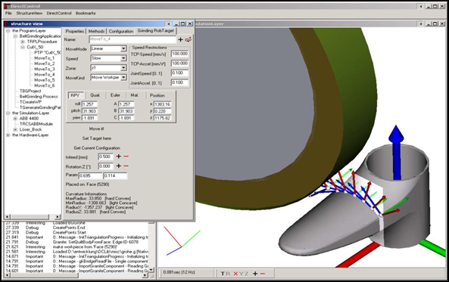

Figure 1. Graphical interface of the control and simulation system DirectControl [4].

During the development of this control system, the main problems that arise during automatic error correction were taken into account. The basic problem that had to be solved is reflected in the fact that error correction procedures must take place in online mode, i.e. without external user intervention. Complex calculations with CAD data on the workpiece surface cannot be performed in standard robotic programming languages. In addition, calculations related to complex dependencies between input (processing speed, pressure force between tool and workpiece, type of tool...) and output (amount of removed material, surface quality) parameters of the processing process cannot be covered by standard robot programming languages. Also, the new control system must enable online simulation and correction of individual robot trajectories during the execution of individual processing operations at the workplace.

In order to solve the mentioned problems, a new control and simulation system DirectControl was developed, whose graphical interface is shown in Figure 1.

This system is based on a new concept of robot control that envisages the integration of a robot as a server in an automated workplace. An external computer with new management software is included in the management. This software in online mode transmits individual working points and trajectories with all necessary parameters (speed, pressure force) to the robot. The robot executes these movements immediately after receiving commands from an external computer. Complex applications are no longer calculated directly in the robot's control unit and with the help of standard robot languages, but in an external computer and through software based on advanced programming languages. This control architecture enables the construction of programs for complex robotic applications, while eliminating the shortcomings of standard robot control programs. In addition, the mentioned open structure of the management system enables the integration of components specific to individual applications, such as e.g. error identification with the help of image processing systems, geometric modeling of paths based on CAD data and technological optimization of paths using a process model.

* 1. **Robot cell for automatic error correction**

The central position of the workplace for the automatic correction of errors in ground and polished products is occupied by the 6-axis industrial robot ABB 4400 with a load capacity of 45 kg. In addition, the workplace consists of an image processing system with a station for changing the grip orientation that allows the workpiece surface to be captured in several positions, then one modern belt grinding machine with two contact elements, two polishing machines (one for polishing and one for achieving additional shine on the surface of the product), a system for changing the end effectors (grippers) on the robot, as well as a work table on which a pallet with parts to be processed is attached (Figure 2) [5].

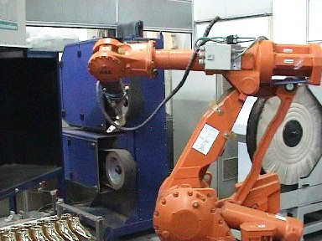

Image processing system

Robot

Gripper

Polishing machine

Belt grinding machine

Palet

Figure 2. Robotic workplace for automatic correction of errors in ground and polished products [5].

The possibilities of automatic error correction were tested on the example of the finishing of sanitary facilities. Trajectories for workpieces with a complex surface are defined with the help of the DirectControl control and simulation system and based on the CAD data of the workpiece itself (Figure 3).

Since the sensor systems for measuring deviations of cast workpieces from CAD drawings are not yet sufficiently developed for efficient use in production conditions, the created paths of the robot must be additionally optimized directly at the workplace. Processing is done in 4 stages: rough sanding (sanding belt with roughness P 100), fine sanding (roughness P 280), polishing and final polishing for extra shine).

Figure 3. Machining paths for grinding (left) and polishing (right).

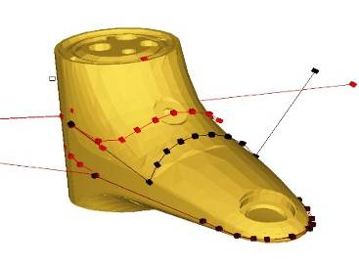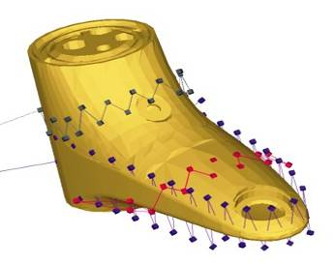

After finishing the fine processing, the product control process is carried out, where the robot grabs the finished piece with the help of special grippers and takes it to the image processing system. With a special camera, the product is recorded in several positions, so that the entire surface is covered. The image processing system recognizes errors on the surface.

Surface defects mainly occur during the casting process (eg pores, cracks, gas bubbles) and can only be detected after grinding and polishing. A smaller number of errors, such as fine notches or residues of polishing paste, occur in the fine processing process itself. Error classification is done with the help of artificial intelligence methods (Support Vector Machine) [6]. The parts on the surfaces of which errors were detected are separated and additionally finely processed based on the data on the size and position of the error. In order to reduce the post-processing cycle time, only the parts of the surface where errors are found are ground again.

An additional possibility to optimize the automatic error correction is offered through additional measurement of the depth of the error with the help of various sensors (eg precision tactile sensors, laser sensors, etc.). Based on information about the depth of the error, optimal values of the parameters of the processing process (pressure force between the workpiece and the tool, processing speed) can be determined with the help of the technological model of the grinding process [5]. In this way, surface defects can be completely corrected.

1. **Robot supported incremental sheet metal forming - Roboforming**

For the economical production of specific prototypes or sheet metal products in smaller quantities, incremental forming procedures have been intensively considered and developed in the last few decades using robots in various ways. In this regard, in literary sources and research papers, it is common today that the technological procedure of incremental forming conducted by a robot is called Roboforming. The application of Roboforming is carried out for the forming process without molds based on the principle of asymmetric incremental forming. In doing so, a procedure based on flexible shaping by synchronous movement and interaction of two universal shaping tools is most often used.

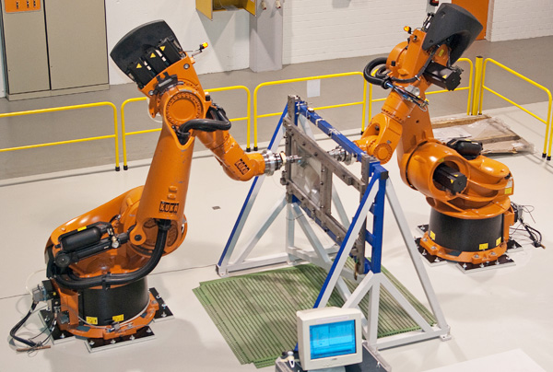Synchronized movement of the forming and support tools is provided by the freely programmable coordinated movement of two industrial robots. Accordingly, on this principle, for the purposes of research in the field of robotic incremental sheet metal forming, the Chair of Production Systems at the Ruhr University Bochum has developed a research facility consisting of two KUKA KR360 series robots and a frame, i.e. a frame as a holder of a sheet metal plate, Figure 6. Each robot is equipped with a tool holder with a spherical tip. The main or 'Master' robot is supported by a subordinate or 'slave' robot [7, 8].

Figure 4. Kuka RoboTeam in process of Roboforming

A plate of metal sheet is attached in a vertical plane between two robots in a solid frame. The main robot gradually acts on the sheet with a pressure force, forming the sheet metal workpiece according to the shape of the tool path. The slave robot provides support on the opposite side of the sheet so that the main robot can actively shape the sheet with a deformation pressure force on the metal sheet. The robots are networked in the so-called KUKA RoboTeam. This allows robots to perform cooperative transformations during the process through synchronous movements. The robots have appropriate sheet metal forming tools, which are attached to the flanges, and between them is positioned an FT-NET Omega191 force/torque sensor from SCHUNK GmbH & Co. KG. The sheet to be formed is fixed in a clamping frame and anchored in the floor between two robots. The clamping frame enables the fixing of sheets of different sizes, which can range from 220 mm x 220 mm to 1500 mm x 600 mm. Figure 5 shows in more detail the position of the tool and the structure of the clamping frame during forming. The research facility also contains KR C4 controllers that are attached to the robots and a hand-held programming device. All devices are part of the roboforming cell, and the computer used for process control, i.e. stiffness compensation and force control, is located outside the cell.

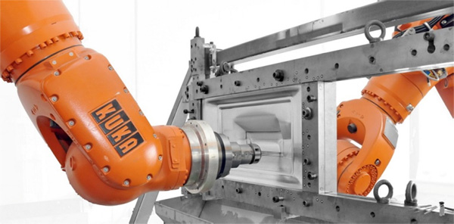

**Figure 5**. Roboforming process

The successful implementation of incremental forming technology implies the application of an adequate methodology that includes several steps when forming sheet metal products. Based on the model in CAM software, tool paths are generated taking into account the type of tool and the available working space after clamping the sheet on the frame. In the case of incremental forming using a robot, the generated toolpaths are translated into programs for controlling and simulating the robot's movements by post-processing. Process parameters are selected according to recommendations or literature sources. The most important parameters that need to be optimized are feed rate, tool rotation speed and tool vertical step. The sheet is clamped to the frame or device, and then the sheet is shaped. The procedure is usually performed in several passes. After forming, the sheet is released evenly from the clamping device. If necessary, additional processing such as cutting, cleaning, etc. can be performed. The last step is the analysis of the process and product, and possible process improvements are considered.

1. **Conclusion**

In this paper were discussed the advantages and challenges of using robots in production technologies on the examples of belt grinding and incremental sheet metal forming. These operations use the flexibility of industrial robots and the possibility of their simple reprogramming to process different parts, so that production in smaller batches is possible. It is also possible to process products with complex sculptured surfaces. The main challenges that arise here are the definition of tool paths on the robot arm, as well as the elimination of errors on the geometry and surface of the product after processing.

Construction of a robotic workplace for automatic correction and quality assurance of ground and polished products represents a big step in increasing the degree of automation of given fine processing processes. The advantages of the mentioned solution are reflected in the fact that thanks to the modern concept of the management system, the integration of modern components for process improvement is possible, such as the identification of surface defects with the help of image processing systems, online simulation of trajectories, and technological correction of trajectories based on the process model. All this enabled a 100% quality check of the surface of the finished products and automatic correction of any observed errors. In this way, the processing process has become much more efficient and the costs of rejecting the product, which can be quite high in the fine processing phase at the end of the production chain, have been greatly reduced.

Incremental forming is a sheet metal forming technology that produces complex geometric forms of high-quality sheet metal products. Their quality is reflected in the possibility of achieving dimensional precision of formed parts and their good mechanical properties, which are the result of material strengthening during cold plastic deformation. Presentation of an alternative method of production of sheet metal parts by incremental forming procedures using industrial robots indicate possible directions of development and further improvements beyond traditional sheet forming procedures. This significantly contributes to ensuring the high quality of cold-formed sheet metal products in the domain of prototyping, individual and small-batch production for the needs of highly demanding industries and medicine.

**References**

1. Določek, V., Karabegović, I., Voloder, A., & Čohodar, M. (2002). *Robotika*. Bihać, Bosnia and Herzegovina: Tehnički fakultet Bihać
2. Cabaravdic, M., A Robot-Cell for Quality Assurance of Ground and Polished Products, Conference “Quality 2011”, Neum, Bosnia and Herzegovina, June 2011
3. Cabaravdic, M., Kneupner, K., & Kuhlenkötter, B., Methods for Efficient Optimiza­tion of Robot Supported Grinding and Polishing Processes, Conference “TMT2003” University of Barcelona, Spain, 2003
4. Kneupner K., *Entwicklung eines Programmier- und Steuerungskonzepts für Robotersysteme auf der Basis eines Umweltmodells*, PhD Thesis, University of Dortmund, Faculty of Mechanical Engineering, 2004, 145 pages, Dortmund.
5. Cabaravdic, M., (2010). *Optimierung des Spanvolumens - beim industrierobotergestützen Bandschleifen frei geformter Oberflächen*. Saarbruecken, Germany: SVH Verlag.
6. Zhang X., *Contribution to Fully Automated Manufacturing of Free-Form Surfaces by Belt Grinding*, PhD Thesis, University of Dortmund, Faculty of Mechanical Engineering, 2006, 117 pages, Dortmund.
7. Cabaravdic, M., Möllensiep, D, Hypki, A. & Kuhlenkötter B., Analysis of Pressure Force in Robot Supported Sheet Metal Forming, The 11th International Conference Machine and Industrial Design in Mechanical Engineering „KOD21“, Novi Sad, Serbia, 10 - 12 June 2021
8. Plančić, I., Čabaravdim, M., & Begović, E., Characterıstıcs and Influentıal Parameters on the Qualıty of Products Made by Roboformıng Technology, Conference “Quality 2023”, Neum, Bosnia and Herzegovina, June 2023

1. * Corresponding author. *e-mail address: malik.cabaravdic@unze.ba*