Gastric dilatation and volvulus with congestive splenomegaly in a Alabai dog
Fatih HATİPOĞLU ^{1,2}∗ , İsmail ŞEN ³
¹Faculty of Veterinary Medicine, Department of Pathology, Selcuk University, Konya, Türkiye
²Faculty of Veterinary Medicine, Department of Pathology, Kyrgyz-Turkish Manas University, Bishkek, Kyrgyzstan
³Faculty of Veterinary Medicine, Department of Internal Medicine, Kyrgyz-Turkish Manas University, Bishkek, Kyrgyzstan
Abstract
Gastric dilatation and volvulus (GDV) is an acute, life-threatening condition that primarily affects large and giant breed dogs. In this case report, acute gastric dilatation due to ingested food and displacement of the stomach with congestive splenomegaly were described in a 2-year-old female Alabai dog. At necropsy; when the abdominal cavity was opened, it was observed that the stomach was on the right side of the abdominal cavity and extremely filled with gas, the stomach wall was tense, and large dark red congestive areas were observed through the serosa. When the stomach was opened, excessive gas accumulation in the lumen and occasional haemorrhages and congestion in the mucosa were detected. It was observed that the spleen was 3-4 times larger than normal, V-shaped and curved unlike its normal structure, the capsule was very tense and the sharp edges were blunt. In other parts of the intestine, the mucosa was hyperemic and a watery content was observed in the lumen. A foamy fluid was observed in the lumen of the trachea and bronchus (asphyxia). Costal imprints were also observed on the lung lobes. When the anamnesis and necropsy findings were evaluated, it was concluded that death was caused by acute gastric dilatation due to ingested food and consequent displacement of the stomach and acute passive hyperaemia in the spleen. It was also concluded that respiratory and circulatory disorders caused by the pressure of excessive dilatation of the stomach on the thoracic cavity played an important role in the development of death.

Keywords: Gastric Dilatation-Volvulus, Congestive Splenomegaly, Alabai, Dog

- Introduction
Gastric dilatation and volvulus (GDV) is more commonly referred to as “bloat”. It occurs when a dog’s stomach becomes dilated and distended due to an accumulation of gas or fluid (dilation) and then rotates around its small axis (volvulus), trapping the gas or fluid inside. Dilatation without volvulus (simple bloat) can also occur separately [1, 2]. GDV is an enlargement of the stomach associated with rotation on the mesenteric access. GDV is an acute, life-threatening condition that primarily affects large- and giant-breed dogs, with a mortality rate of 20%–45% in treated animals. Immediate medical and surgical intervention is required to optimize survival in patients with GDV [1-3]. Although often referred to as bloat, there is a difference between the two conditions. Bloat is the accumulation of gas, food, and/or fluid in the stomach that cannot evacuate via esophagus or duodenum. A GDV includes torsion of the stomach that complicates the evacuation of gastric contents and obstructs blood flow. Gastric distension usually occurs first, and then the torsion follows. Pressure on the diaphragm can impair ventilation and cause a hypoxia. Venous blood return to the heart decreases, creating a hypovolemic shock that will lead to multiple organ dysfunction and death [2-4].
It causes pathology of multiple organ systems and is rapidly fatal. It is common in large- and giant-breed dogs. The disease appears to have a familial predisposition. Thoracic depth/width ratio also appears to predispose dogs to GDV [1]. The condition occurs most commonly in large, deep-chested dog breeds, such as German Shepherds, Great Danes and Doberman Pinschers. However, even small and medium breed dogs with a deep chest conformation can develop GDV [4, 5].
Gastric dilatation precedes development of volvulus and is the result of the accumulation of gas and fluid in the stomach as a result either of mechanical or functional disturbances in pyloric outflow. As the stomach distends and rotates about the distal esophagus, displacement and occlusion of the pylorus and duodenum occur. Necrosis and perforation of the stomach wall and peritonitis are common causes of death [2, 5-7].
2. Materials and Methods
The material of this case was a 2 years old female Alabai y dog which was found dead and brought to Kyrgyz-Turkish Manas University Veterinary Faculty for necropsy. Necropsy was performed after the anamnesis taken from the owner. External examination was performed before necropsy and observed changes were recorded. The dog was placed in the supine position and the skin incision was made along the median line from under the mandible to the anus. After incisions on the inner side of the forelimbs and hind limbs, the skin was skinned to the dorsal region. After the abdominal and thoracic cavities were opened according to known methods, changes in the organs were recorded. Tissue samples were taken from the affected organs in 10% buffered formaldehyde for histopathological examinations. After this process, 5-μm thick sections were taken from the paraffin blocks prepared by routine laboratory methods in the microtome, and were stained with Hematoxylin&Eosin (H&E).
3. Results and Discussion
According to the anamnesis, it was stated that carbohydrate-rich food was added to the dog's diet and that the dog's appetite had decreased for 3 days and enemas were given for treatment. Despite this treatment, the dog was found dead in the morning the next day and a necropsy was requested by the owner to find out the cause of death. Necropsy was performed on the same day.
In the external examination before necropsy, it was observed that the abdominal region of the dog was extremely distended and the skin was tense. At necropsy; when the abdominal cavity was opened, it was observed that the stomach was dilated due to extremely filled with gas (Figure 1) and there was a bloody fluid of the abdominal cavity.
It was noted that the stomach wall was tense, there were large and dark red congestive areas that could be seen through the serosa and in the abdominal cavity (Figure 1). When the stomach was opened, excessive gas accumulation in the lumen and congestion with occasional haemorrhages in the mucosa were observed.
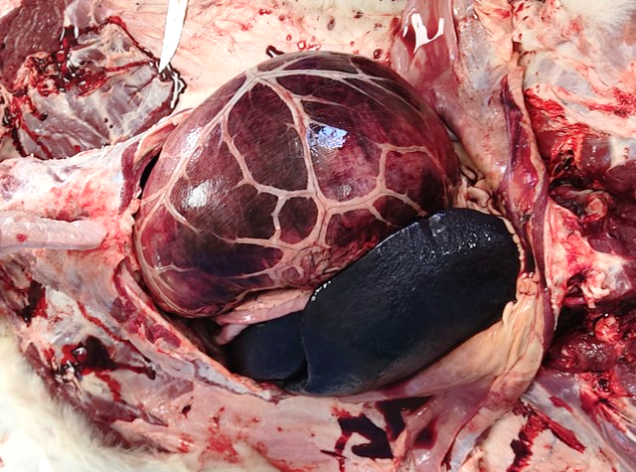
Figure 1. Gastric dilation-volvulus and congestive splenomegaly. Dilated stomach due to extremely filled with gas. Tense stomach wall and dark red congestive areas on serosa, and splenic congestion (arrow)
It was observed that the spleen was 3-4 times larger than normal, it was V-shaped and curved unlike its normal structure, its capsule was very tense and its sharp edges were blunt (Figure 2). A large amount of blood of dark red-black colour was oozing from the cut surface (Figure 3). In addition, a twisted and curved appearance was observed in the hilus region of the spleen.
A dark red coloured bloody content was observed in the lumen of duodenum. In other parts of the intestine, the mucosa was hyperemic and occasionally filled with a watery content. The liver was slightly pale and the liver tissue around the gallbladder was dark green in colour (biliary imbibition). At the thoracic cavity was opened, the right cranial and caudal lobes of the lung on the side where the animal was lying were well red and voluminous, with dark red blood leaking from the cut surface (hypostatic congestion) (Figure 4). A foamy fluid was observed in the lumen of the trachea and bronchus (asphyxia). Costal imprints were also observed on the lung lobes.
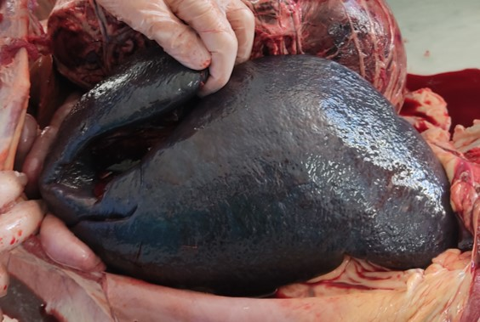
Figure 2. Congestive splenomegaly. Large, curled into a V shape, stretched capsule, blunt sharp edges.
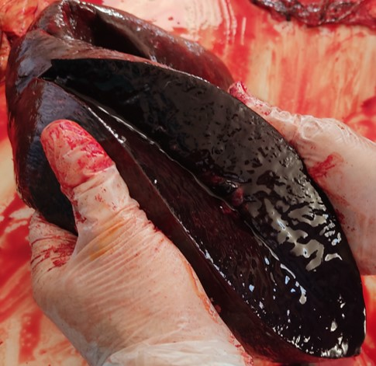
Figure 3. Congestive splenomegaly. An excessive amount of dark red-black colored blood on cut surface.
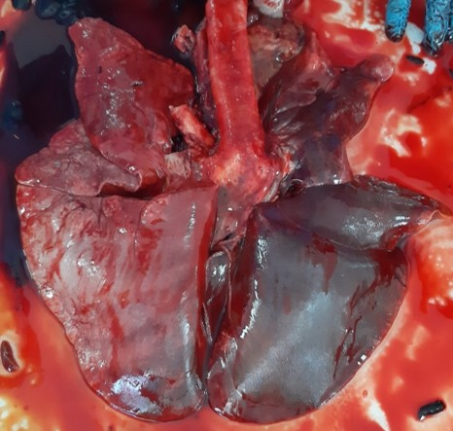
Figure 4. Lung, right cranial and caudal lobes, red-colored and voluminous appearance (hypostatic congestion).
Microscopic examinations showed a subcapsular hemorrhage in the spleen, as well as a dense accumulation of erythrocytes in the red pulp and macrophages loaded with hemosiderin (Figure 5). A depletion in lymphoid tissue was observed in the white pulp (Figure 6). In the lung, hyperemia was observed in the interalveolar capillaries and pink edematous fluid in the alveolar lumens (Figure 7). Hyperemia was noted in the vena centralis lumen in the liver. In the stomach, degeneration of the lamina epithelialis and intense erythrocyte accumulation in the lumens of the veins and oedema in the submucosa were observed (Figure 8).

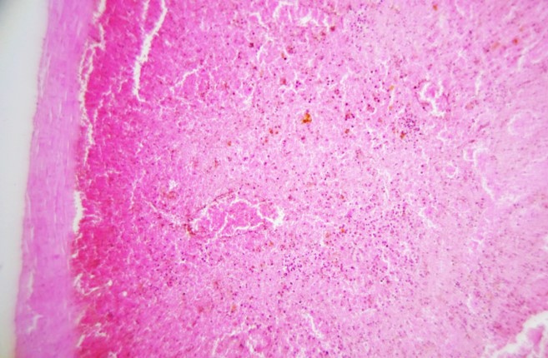
Figure 5. Spleen. Subcapsular hemorrhage (arrows) and dense erythrocytes accumulation in the red pulp and hemosiderin loaded macrophages.H&E, x100

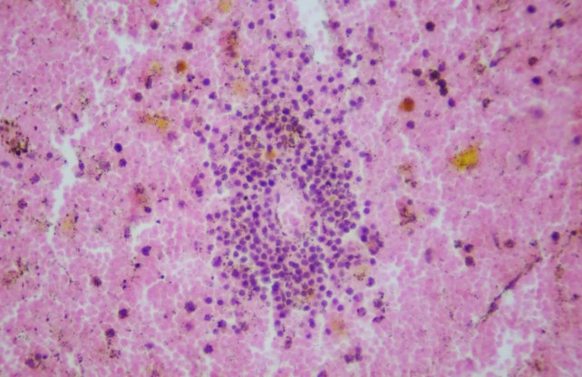
Figure 6. Spleen. Lymphoid tissue depletion in the white pulp and hemosiderin loaded macrophages, H&E, x400
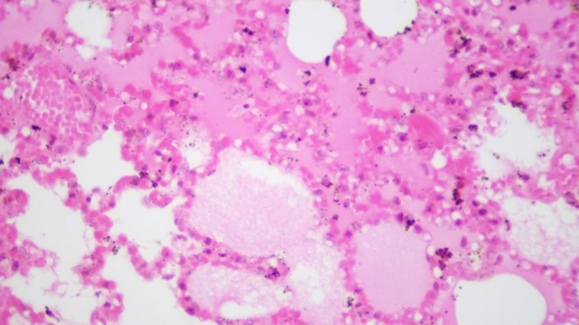
Figure 7. Lung. Hyperemic interalveolar capillaries and pink edematous fluid (asteriks) in the alveolar lumens, H&E, x400

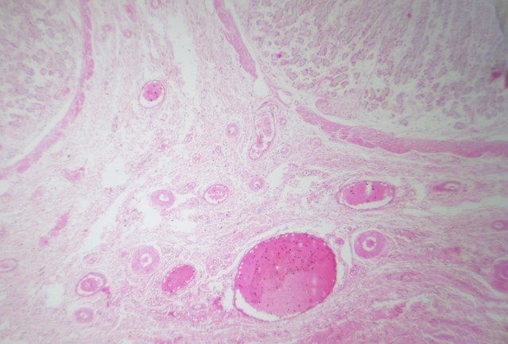
Figure 8. Stomach. Intense erythrocyte accumulation in the veins (arrow) and oedema in the submucosa, H&E, x40

Despite ongoing research, the specific cause of GDV remains unknown. The following risk factors are thought to contribute to bloat: overeating, eating very quickly, drinking a large quantity of water in a short period of time, raised food bowls, stress, exercising after eating, genetic factors and increased age. The conformation of the thorax appears to be a risk factor for GDV. Results from studies have shown that the risk of GDV is related to thoracic depth-to-width ratios, both for individuals [1, 4, 6]. In the presented case, the fact that the dog in which GDV occurs was from a large breed and there were problems with feeding supports the views stated above about the reasons.
Distension and displacement of the stomach cause obstruction of the caudal vena cava and portal vein resulting in venous stasis and sequestration of blood in splanchnic, renal, and posterior muscular capillary beds. This decrease in circulating blood volume (venous return) and subsequent decrease in cardiac output, arterial blood pressure, and tissue perfusion culminate in hypovolemic shock. Endotoxemia, a consequence of portal vein occlusion, contributes to the shock syndrome [2, 7]. The congestion observed in the spleen in this case supports the researchers' views and explains the cause of death of the dog in the presented case.
GDV develops without warning and can progress very quickly. Recognizing the early signs is essential to increasing the chances your dog will survive. Signs in the early stages of bloat can include: restlessness, pacing, swollen or distended abdomen painful abdomen, overall look of distress, retching or attempts to vomit with no success, excessive drooling, panting or rapid breathing, collapse/inability to stand [1, 3, 6].
Breed, history, and clinical presentation will aid in diagnosis. Radiographs will show gastric dilatation and possibly torsion. If passing a stomach tube is attempted, volvulus is suspected if the tube will not pass [1, 2, 6]. No matter what the order of treatment, the objectives remain the same. The goal is to correct circulatory shock, decompress the stomach, correct volvulus if necessary, and stabilize the patient. Decompression involves passing of a stomach tube (sedation may be required), temporary gastrotomy or trochar catheter, or surgical decompression. The stomach can be emptied through a stomach tube or surgically. Correction of volvulus requires a surgical fix. Additionally, if compromised a splenectomy can be performed during the surgical procedure [6-8].
Performing a gastropexy, to prevent future volvulus, completes the surgery. Correction of circulatory shock and supportive therapy includes oxygen therapy, IV fluids, and drug therapy. Antibiotics for endotoxemia, antiarrhythmic drugs, and antacids are used with GDV patients. The patients are hospitalized for monitoring and recovery and are monitored for continued gastric distension [ 6, 8]. Ultrasound-guided, temporary, percutaneous T-fastener gastropexy and gastrostomy catheter placement was safe and effective at providing sustained gastric decompression in dogs with GDV, suggesting that this technique would be ideal for dogs in which surgical delays are anticipated or unavoidable [9].
4. Conclusion
As a result of the evaluation of the anamnesis and necropsy findings, it was concluded that death was caused by acute gastric dilatation due to ingested food and consequent displacement of the stomach and acute passive hyperaemia (splenic congestion) of the spleen. In addition, it was thought that respiratory and circulatory disorders due to the pressure on the thoracic cavity as a result of excessive dilatation of the stomach due to gas were also effective in the death of the dog. In cases where GDV is suspected as a result of clinical and laboratory examinations in dogs with digestive system problems, starting treatment as soon as possible will make a significant contribution to preventing fatal cases.

References
[1] Broome, C.J., & Walsh, V.P. (2003). Gastric dilatation-volvulus in dogs. New Zealand Veterinary Journal, 51(6), 275-283.
[2] Hornbuckle, W.E., Simpson, K.W., & Tennant, B.C. (2008). Gastrointestinal Function. In J.J. Kaneko, J.W. Harvey, & M. L. Bruss (Eds), Clinical Biochemistry of Domestic Animals (p.413-457)., 6th Ed. New York , USA, Academic Press.
[3] Gibson, T.W.G. (2022) Gastric Dilation and Volvulus in Small Animals (Bloat). MSD Manual, Veterinary Manual (MSD Veterinary Manual (msdvetmanual.com).
[4] Bell, J.S. (2 014).Inherited and predisposing factors in the development of gastric dilatation volvulus in dogs. Top Companion Anim Med, 29, 60-63
[5] Raghavan, M., Glickman, N. W., & Glickman, L. T. (2006). The effect of ingredients in dry dog foods on the risk of gastric dilatation-volvulus in dogs. Journal of the American Animal Hospital Association, 42(1), 28–36.
[6] Johnson A (2014). Small Animal Pathology for Veterinary Technicians. Blackwell Publishing, pp.60-62.
[7] Sharp, C.R. & Rozanski, E.A. (2014). Cardiovascular and systemic effects of gastric dilatation and volvulus in dogs. Top Companion Anim Med, 29, 67-70.
[8] Arıcan, M., Uzunlu, E.O., &İncekara, O. (2021). Köpeklerde gastrik dilatasyon-volvulus olgularında cerrahi girişimler ve postoperatif hasta yönetimi. In A.P. Gökçe (Ed), Kedi ve Köpeklerde Gastrointestinal Hastalıklar (p.48-56). 1. Baskı. Ankara, Türkiye, Türkiye Klinikleri.
[9] Fox-Alvarez, W. A., Case, J. B., Lewis, D. D., Joyce, A. C., Cooke, K. L., & Toskich, B. (2019). Evaluation of a novel technique involving ultrasound-guided, temporary, percutaneous gastropexy and gastrostomy catheter placement for providing sustained gastric decompression in dogs with gastric dilatation-volvulus. Journal of the American Veterinary Medical Association, 255(9), 1027-1034.

* Corresponding author. e-mail address: fhatip@selcuk.edu.tr, fatih.hatipoglu@manas.edu.kg

