# ‘UTILISATION OF EBOOK IN A COMMUNICATIVE ENGLISH COURSE: ESL STUDENTS' PERCEPTIONS’

**Noor Alina Namami1, Masniza Mansor 2 & Dr. Diana Ahmad Busra 3**

English Language Unit Lecturers

General Studies Department

Politeknik Port Dickson, Negeri Sembilan

Malaysia

## Abstract

The use of ebooks in the classroom is widespread across many subject areas, particularly in developing nations. The use of ebooks provides educators, students, and organisations with an additional medium or educational tool that can support or improve the learning process. In order to promote student utilisation of resources particularly those at the tertiary level, educators make them easily accessible for all students. The resources give teachers the chance to engage students in interactive tasks and teaching input. This study investigates how ESL students at a TVET institution see the use of ebooks to supplement and assist their learning of a Communicative English course module. The Technology Acceptance Model (TAM) was applied in this study as the lens to examine perceived usefulness, perceived ease of use, and attitude toward using e-books to substitute the traditional textbook in the classroom. Students from four semester-three classes were requested to respond to two open-ended questions concerning the usefulness and ease of use of e-books in the ESL course. A total of 80 students participated in this study and responded to the questions. The students' responses revealed that they agreed that the advantages of ebook might be handy as a tool to help and advance their learning. However, the majority of them pointed out the drawbacks of technology's accessibility and the reliability of the internet. These indicate that for an ebook to be fully utilized by ESL learners, it is essential for the institution to improve its technology and internet facilities.

*Keyword: Electronic book (ebook), ESL, Second language learning, Polytechnic, TVET*

## 1.0 INTRODUCTION

### 1.1 Background to the study

Education all over the world emphasises the development of information, communication, and technology (ICT) skills that students need to succeed in their careers in the Fourth Industrial Revolution (4IR) era, in addition to other 21st-century skills like critical thinking, problem-solving, communication, and collaboration. The fourth industrial revolution (4IR) represents a major change in the way people live, work, and interact with one another, with tremendous technological developments comparable to those of the first, second, and third industrial revolutions (World Economic Forum, 2021). In lieu of the demand for educational institutions to comprehend 21st-century teaching and learning, where educators support students to study and participate constructively in a global society, the use of technology such as ebooks in classrooms is a trend nowadays. In accordance with Malaysia's National E-learning Policy (DePAN), (MOHE, 2011), and the Malaysia Education Blueprint 2015–2025 (Higher Education), The use of multimedia technology has been rapidly increasing as part of Politeknik Port Dickson's Strategic Plan 2021–2025 (4:leading the education system through TVET 4.0), particularly to enhance the quality of learning for polytechnic students and help them acquire the knowledge and skills they need to be productive in the 21st century and the 4IR era. In response to this goal, the English Language Unit (ELU) of Politeknik Port Dickson implemented the use of ebooks in its ESL teaching and learning context in 2019. An ebook is a book that has been converted to digital form and can be read on a computer, typically through network services (Lee, 2002). The students' long-used paper course materials have been replaced by the ebook.

### 1.2 Problem Statement

Scholars like Hernon et al. (2006) and Annamalai (2016) suggest that as books that have been converted to digital forms and can be read on a computer and network services (Lee, 2002), ebooks offer a range of advantages to students as they simplify students’ learning experience. Gone are the days when students had to fill their bags with files and books and carry them daily to classrooms and back home or hostel. With ebooks entering the educational domain, one device or application is enough to include the entire semester’s syllabus. Other scholars suggest that advantages of using ebooks in teaching and learning a particular subject include ease of use, accessibility and searching capabilities, mobility, saving of physical space, convenience, saving time and money (Casey, 1994; Shiratuddin et al., 2003; Hernon et al., 2006; Lam et al., 2009; Rosso, 2009; Annamalai et al., 2014; Annamalai, 2016). Ebooks also enhance students’ overall learning experience, as integrating ebooks into classroom teaching makes learning fun and engaging, as it helps students learn better and faster (Casey, 1994; Simon, 2002 & Wilson, 2003). Furthermore, its usage will develop students’ 21st-century abilities, namely technological competencies, and communicative skills, as intended by the course module.

However, the development of 21st-century abilities in students could be affected if they need help understanding the meaning of the shift from using printed learning units to ebooks and utilising their ebooks effectively. Studies also reported challenges, as not all students feel comfortable with the technology (Wilson, 2003; Sharma, 2009; Zabed Ahmed, 2014; Boakye, 2017; Isibika & Kavishe, 2018). For instance, compared with reading paper-based text, some students find reading long text on a small computer screen tiring, less efficient, and even ‘painful’ (Wilson, 2003, p. 11), and the poor navigational controls on ebooks are argued as “awkward, difficult or time-consuming to use” (p. 14). Therefore, there is a need for this study to be carried out in our context to enable us to understand how our students perceive the use of ebooks they used in learning a particular English language course.

### 1.3 Research Aims and Objectives

Since the introduction of ebooks in 2019, students taking communicative English courses no longer require printed learning modules. In this study, we explored students' perceived benefits and limitations of using ebooks in their learning setting based on the problem statement that was previously presented. We also suggested potential improvement measures.

### 1.4 Research Question(s)

The two research questions that have guided this study are:

1. *How do students perceive the use of ebook in their learning context?*
2. *What are the challenges faced by the students in using the ebook in their learning context?*

### 1.5 Significance of the research/study

The findings of this study will be redound to the students and teaching staff of the institution, particularly the English Language Unit (ELU), as the participants’ data revealed the need to improve the content and presentation of the ebook to support the use of the technology in its teaching and learning context. The ELU will be able to make room for improvement and innovation concerning the construction of the contents of ebooks based on the responses given by the participants. This research will help us as the researchers and educators of the institution to uncover critical areas in the educational field that have not been explored in our unique context.

### 1.6 Limitations of Research/Study

This study used only one type of data-generating instrument, which was open-ended questions. This means, our investigation relied heavily on students’ words and not actions due to constraints, namely time and safety, i.e. the Movement Control Order ( MCO) 1.0, which was imposed for months due to the COVID-19 pandemic, not allowing us to observe how the students use the ebook in their classrooms to triangulate and verify the findings generated from the open-ended questions.

## 2.0 LITERATURE REVIEW

### 2.1 Definition of Terms

Ebooks are “text in digital form, or digital reading material, or a book in a computer file format, or an electronic file of words and images” (Rao, 2003, pp. 86–87). Lee (2002) also included the definitions of an ebook from the Hi-Tech Dictionary and The New Concise Oxford English Dictionary respectively as a book that has been converted to digital form and could be read on a computer, usually through network services or CD-ROM. While Cox and Mohammed, as quoted by Lee (2002), an “ebooks is a term used to describe a text analogous to a book that is in digital form to be displayed on a computer”.

In addition, Wilson, 2001 cited by Abd Mutalib et. al., (2012) stated that hardware, often known as ‘a reader’, software, and ebook files, are the three fundamental parts of an ebook. Hardware-based ebook readers are portable electronic gadgets made primarily for reading publications of any kind. The pricing range is determined by the quality that the ebook readers portray. ebook readers have the storage space to hold several books' worth of content, which can be virtually accessed from anywhere. Moreover, a good ebook reader will be able to do things like print, play music and video, interact with touch screens, and even communicate wirelessly. Pereus (2000) in Abd Mutalib et. al. further explained that software-based ebook readers are applications that show an e-data Book's on a device. Examples of this software include Adobe Acrobat Reader, Microsoft Reader, and Adobe Acrobat ebook Reader. Software-based readers have the benefit of providing additional features through a keyboard and larger screen sizes in addition to the features of dedicated readers (Lynch, 2001). Because users can alter the display's settings using the keyboard utilities, this might provide easier access to the information. A file with an embedded signature is referred to as a file type. The operating system is informed of how to handle that file. By looking at the file extension at the end of the file name, a user can determine what kind of file an ebook is that they have.

Table 1 lists some examples of the most popular file types used for ebooks:

| ebook files types | |
| --- | --- |
| * Plain ASCII text files have the extension **.txt** * Microsoft Word files have the extension **.doc** * Adobe acrobat files have the extension **.pdf** * Html files have the extension **.html** or **.htm** * Adobe eBook files have the extension **.pdf** | |

### 2.2 Advantages of Ebook in Educational Settings

Ebooks are capable of displaying any audio or visual content, whether it is speech, text, music, animations, pictures, or videos, alone or in various combinations. Ebooks can connect several representations, including visual and aural cues, written and spoken material, video and subtitles, and other combinations that could improve teaching and learning (Casey, 1994). Scholars' opinions on the worth of academic ebooks differ. Lemken (1999) and other advocates claimed that technology should "bridge the gap between printed and digital information" (p. 4). Many benefits have been cited as being connected to this type of technology. Hernon et al. (2006) listed a few benefits, including portability, economy, ease, and use of more modern materials. According to Shiratuddin et al. (2003), students can create their own customised digital library. Several benefits of using ebooks were cited by Lam, Lam, and McNaught (2010), including access to more readings, remote reading, searchable readings, potential links to related multimedia materials, portable resources, and optimising reading time (e.g., during travel). Additionally, actual data shows that once children have access to technology, they read more quickly and with pleasure (Wilson, 2003). (Simon, 2002). Although the majority of the study's participants who used ebooks for learning had never done so before, Isaacson, S. A. (2017) found that after the reading sessions were over, they preferred ebooks to paper texts. The study's conclusions are in favour of including ebooks in ESL curricular.

The success of the ebook technology seems to be greatly influenced by how simple it is to read. Users view the ease of navigation through a clear user interface, a clear and logical structure to support readers' feeling of place in the ebooks, and the layout of the ebooks on screen as a significant motivational force, according to Malama, Landoni, and Wilson's (2004) research. With mobile ebooks, the best possible screen usage is even more crucial than with laptops or desktop PCs. Wilson, Landoni, and Gibb (2002) cited the book metaphor as a key design element, emphasising the need of having a cover, a table of contents, a unified typographic look, a clear division of book sections, and indicators of reading progress.

Ebooks include a wide range of functions, including searching, text scrolling, and page turning. Functionalities associated to ebooks are more sophisticated and often being added. Users value a quick and accurate search feature, an annotation function, and the presence of hypertexts and dictionaries on the reader, according to user input gathered by Wilson (2003) on the use of ebooks. In their 2009 evaluation of four well-known ebook readers available for PCs and PPCs, Lam, Lam, and McNaught concluded that the features were generally regarded as useful and acceptable. When saved on lightweight portable devices like tablets or smartphones, ebooks are both downloadable and portable. The usability issue relates to the practicality of the various procedures required to use the software and hardware and the ease of use of the technology. It pertains to concerns like interface design that promotes efficient human-computer interaction, for instance (Wilson et al., 2002).

### 2.3 Issues in Using ebooks

However, there are drawbacks to utilising technology in a learning environment. Not every student is at ease with technology. For instance, compared to reading text on paper, some students find reading lengthy texts on a small computer screen to be exhausting, ineffective, and even "painful" (Wilson, 2003, p. 11). Wilson (2003) also reported complaints about the ineffective navigational controls on ebooks readers as being “awkward, difficult or time-consuming to use” (p. 14).

According to a number of studies, students have trouble accessing online resources. Lack of knowledge about e-resources, poor information technology infrastructure (especially in developing nations), which results in limited access to computers, unstable network connectivity, and slow download speeds (Sharma, 2009; Zabed Ahmed, 2014; Boakye, 2017; Isibika & Kavishe, 2018), and limited access to e-resources, including computers, relevant titles and contents on specific subjects are a few of these (Zabed Ahmed, 2013).are just a few examples (Zabed Ahmed, 2013).

### 2.4 Ways To Improve The Usage

The presence of management support for the introduction and use of ebooks is one of the elements that can help remove barriers and usage of ebooks, particularly in school and university settings. According to the literature, some examples of this support include paying for paid ebook memberships (Wendo & Mwanzu, 2016) or offering quick and dependable internet connectivity, which can be a significant obstacle to the use of ebooks in developing nations (Leonard & Snyman, 2019).

Ebooks provide numerous benefits over print media, including multimedia, hypertext linkages, search and cross-referencing tools, and the ability to read an electronic version of a printed book on a Personal Computer or handheld device designed specifically for this purpose.

The 21st century teaching and learning process needs to be strengthened through the use of technology. Over the years, we have witnessed significant shifts and transitions that have advanced web-based technologies, computer hardware, and software toward education. Most significantly, there have been major changes in educational preferences and approaches to teaching various generations.

## 3.0 METHODOLOGY

### 3.1. Technology Acceptance Model (TAM)

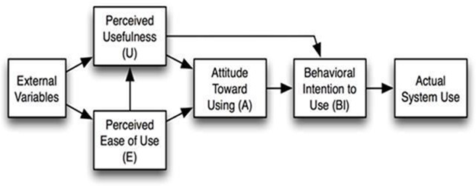

Figure 1: Technology Acceptance Model (TAM) (Davis, 1989)

Davis' Technology Acceptance Model (TAM) served as our model and the lens through which we conducted our entire inquiry. According to this concept, consumers' decisions regarding how and when to use new technology are influenced by a number of factors, along with: **Perceived usefulness (PU)** – Davis defined this as "the degree to which a person believes that using a particular system would enhance his or her job performance." It means whether or not someone perceives that technology to be useful for what they want to do. **Perceived ease-of-use (PEOU)** – Davis defined this as "the degree to which a person believes that using a particular system would be free from effort." If the technology is easy to use, then the barriers are conquered. If it is difficult to use and has a confusing user interface, no one will have a positive opinion of it. The attitude is greatly influenced by external factors like social influence. People will have the mindset and intention to use the technology once these items (TAM) are in place. However, because each person is unique, the perception may vary based on age and gender.

### 

### 3.2 Research Design

A qualitativeapproach has been chosen for this study in order for us to answer the research questions above effectively. According to the reviewed literature, qualitative research is used in the majority of studies that examine issues linked to attitudes and perceptions about using technology in teaching and learning (Johnson, 1994; Bigatel, 2007; Md. Yunus, 2007; Alabaikan, 2010; Attia, 2011; Ahmad Busra, 2020). When little is known about a phenomenon or when researchers want to identify variables that might later be tested statistically (quantitatively), qualitative methods are appropriate to be used in the study. In this case, the concept is how ESL students perceive the use of ebooks in their learning context (Hoepfl, 1997). The method enables a thorough analysis of the contextual intricacies involved as well as an in-depth comprehension of the issue under research. We generated our data for this study qualitatively using two open-ended questions, which were then distributed to 80 semester 3 students in Politeknik Port Dickson. They wrote their responses to 2 open-ended questions, which were created on Google Form.

### 3.3 Analysis of Data

The link to the open-ended questions was sent to students' groups on Whatsapp. We then analysed all the data using six steps adapted from Braun and Clark's Thematic Analysis (2006) approach (Figure 2) as our analytical framework (Figure 3). The processes involved familiarising ourselves with our data and generating initial codes after generating an initial list of ideas about what was in and interesting about the data. This was followed by searching for suitable sub-themes when all data had been initially coded and collated. Next, we reviewed and refined the sub-themes generated in step three by defining and naming the sub-themes and putting them under the elements of TAM; Perceived Usefulness (PU) and Perceived Ease of Use (PEOU). They were then further refined and put under the overarching themes of "Advantages" and "Challenges". Finally, we wrote the report findings once we had a set of fully worked-out data.

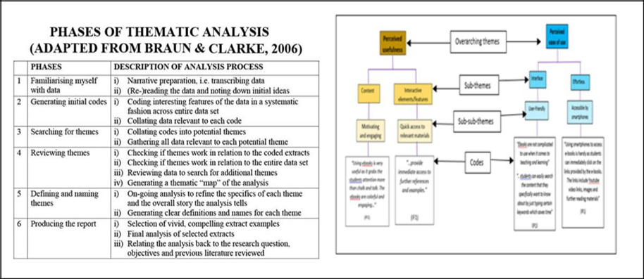

Figure 2: Braun and Clark's Thematic Analysis (2006)

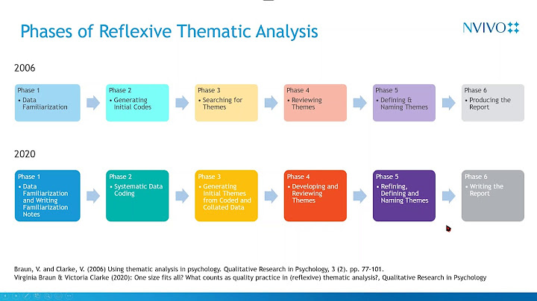

Figure 3: Analytical Framework

The following are the phases involved in our data collection methods:

**Phase 1: Data familiarisation**

The raw data gathered from students’ responses (Figure 4) were read and re-read. At the same time, initial ideas about each response were noted down in ‘memoing,’ i.e., the act of recording reflective notes about what the researcher is learning from the data. See our notes about each response in the blue column in Figure 4. 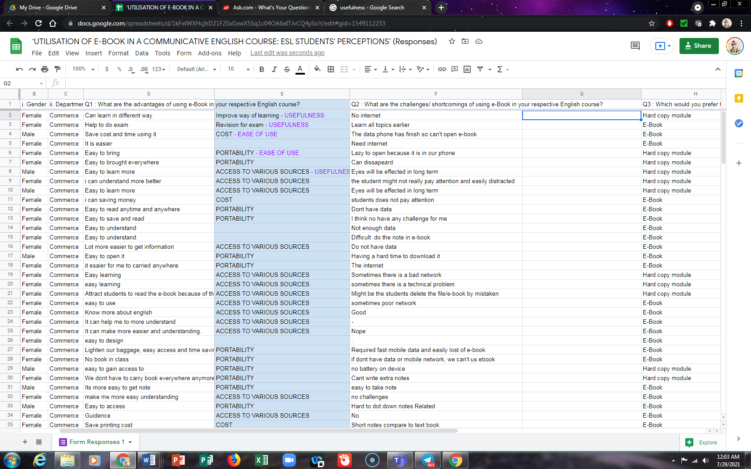

Figure 4: The Raw Data

**Phase 2 and 3: Generating initial codes and searching for themes**

Afterinitial codes were generated, we continued searching for themes, informed and guided by our literature review**.** Students’ responses were mainly short and precise and, thus, were already in the form of ‘codes.’ For easy coding, initial themes are coloured ‘purple’ and ‘red.’

**Phase 4: Reviewing themes**

We continuously checked if the themes worked in relation to the codes and the entire data set. The data set was continuously reviewed (Figure 5) to search for additional themes, generating the thematic “map” of the analysis (Phase 5).

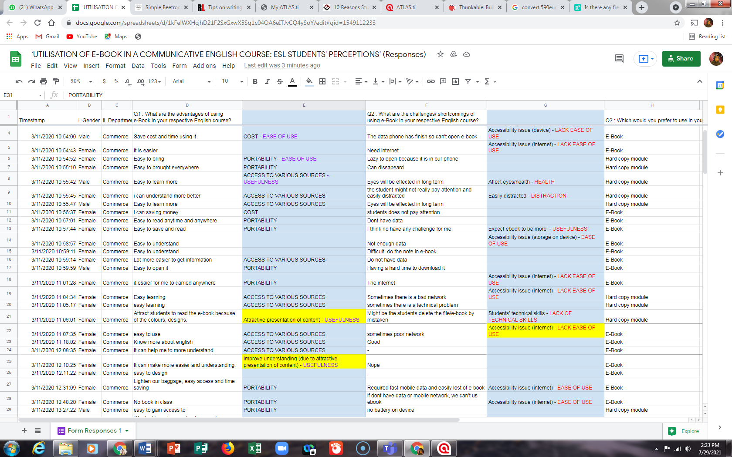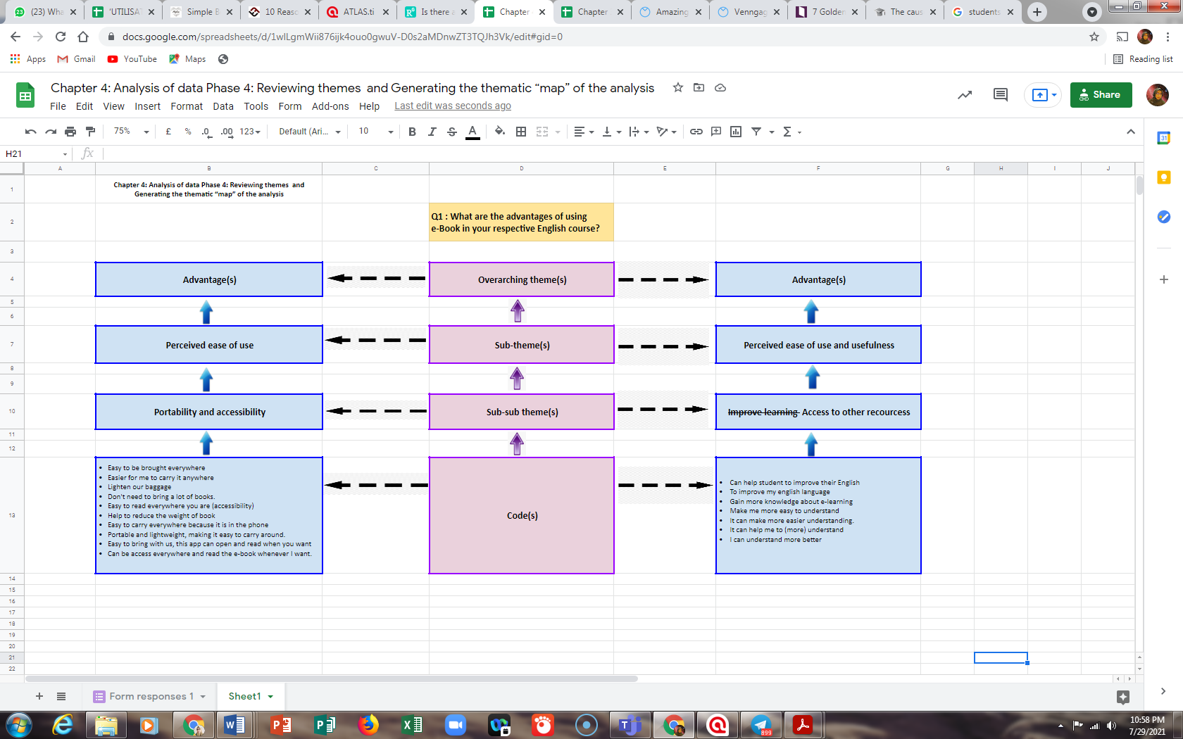

Figure 5: Creating Sub-themes

**Phase 5: Defining and naming themes**

After capturing the essence of what each theme is about and what aspect of the data each theme captures, we officially named our themes. Names given to the themes are concise and immediately give the reader a sense of the theme. After continuous revision of the themes in relation to our data, we were able to produce a final thematic map and describe each theme in sentences.

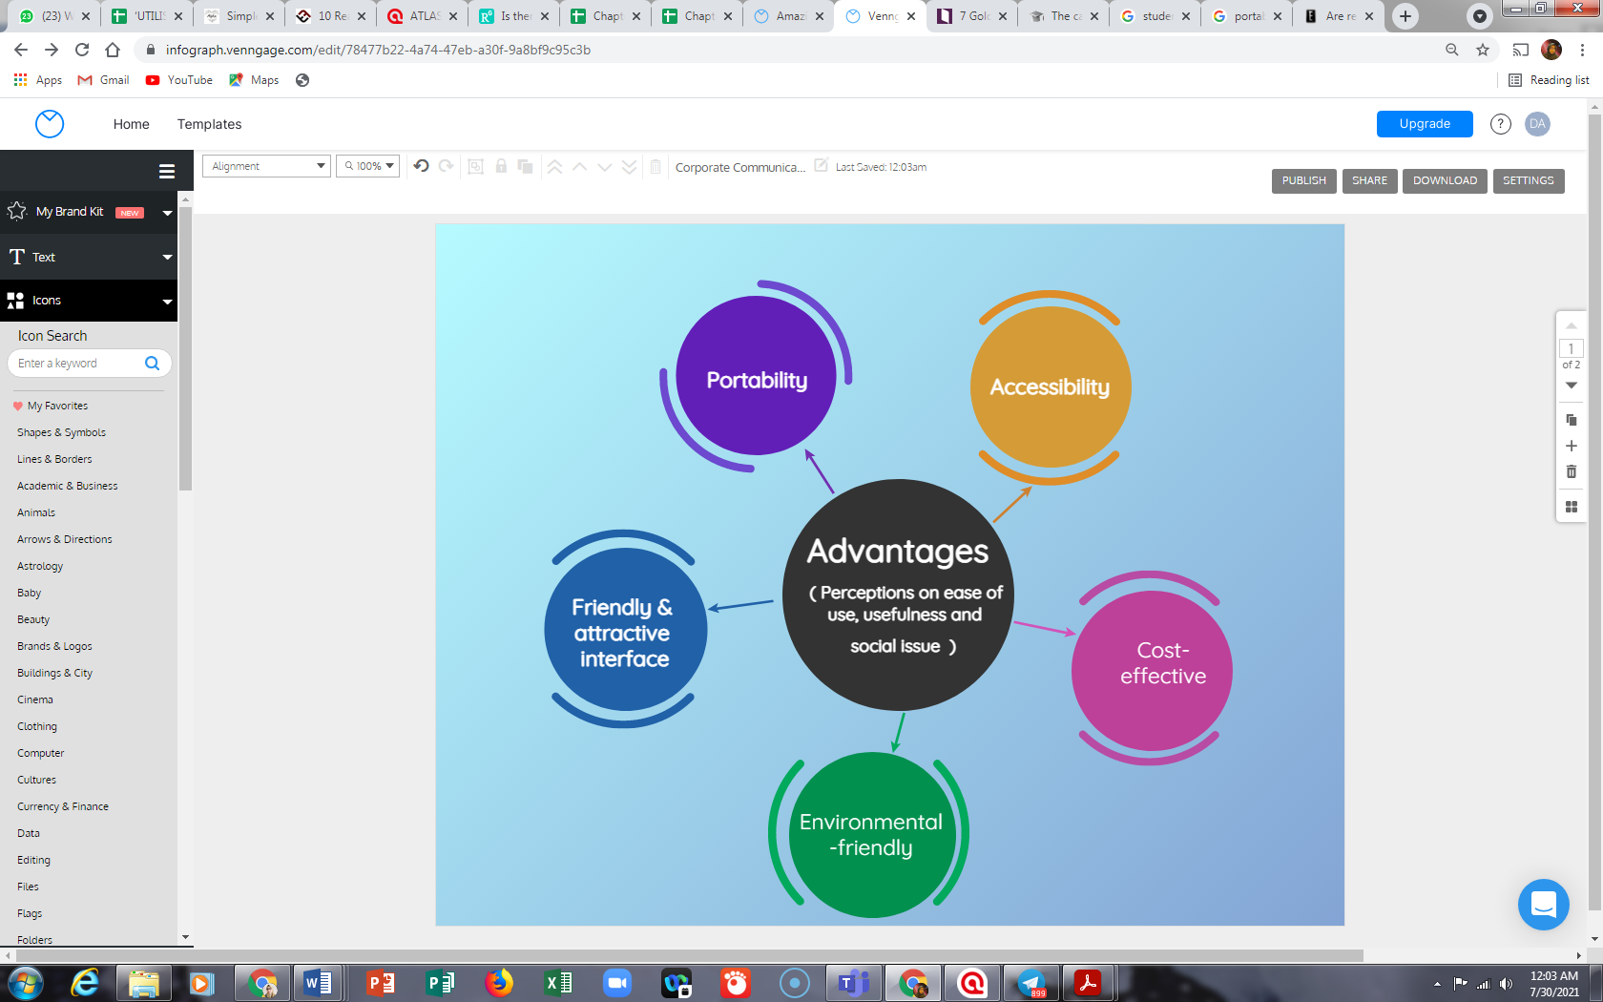

Figure 6: Themes Naming

## 4.0 FINDINGS AND DISCUSSIONS

This section presents the findings of this study in two categories: advantages and challenges regarding the usefulness and ease of use of ebooks that emerged from the analysis of the responses gathered.

**4.1 Advantages**

This study results reveal that students perceived utilisation of ebooks as advantageous, thus agreeing with Simon, 2002, Wilson (2003), Shiratuddin et al (2003), Hernon et al (2006), Lam et al (2009), Lam, Lam & McNaught (2010) and Isaacson, S. A. (2017). Reading ebooks has many advantages, and their usage is ever-increasing. Some prefer traditional printed books, but there is also a growing audience whose lifestyle and taste are suited to ebooks.

Participants were split evenly in their responses about whether they would or would not utilise an electronic book for their study. Those who stated they would do so cite factors including portability and advantages of the electronic medium like hypertext and searchability, which result in a greater grasp of the subject matter. Those who claimed they would not use an electronic book as a module cited factors such cost, short battery life, and weight; some users believed that portable electronic books offer no benefits over print or reading from a PC.

Reading ebooks can be more useful than reading printed materials in certain instances. Technical writings make up the majority of Politeknik's works. Because of this, many documents are lengthy, difficult to manage, and heavy to carry around. They are also harmful for the environment if we print them. On many occasions, the students don't even need to read the full book because using ebooks offers them so many benefits. For example, people can swiftly search for terms in a text, close it, and then immediately reopen it.

The students who participated in the study were divided in their opinions on whether students would find an ebooks device useful. Those who believed students would use ebooks gave the following reasons - respondents' data is gathered and categorized into five sub-themes:

*Portability*

The delivery of ebooks is virtually instantaneous; without getting up from their chairs, the students may quickly buy, download, and begin reading them. They do not have to wait for the physical books to arrive in the mail for days, weeks, or even longer, nor having to go to a bookshop to purchase them. ebooks are smaller in size, thus they do not require a room or a library. On their computer or reading device, thousands of ebooks can be saved. In addition, hundreds of books can be transported on a CD, laptop, smartphone, or any reader without being weighed down. Some respondents said they could read ebooks anywhere, on the bus, train, airport, and even while waiting in a class.

*Accessibility*

Our respondents further explained that links are available in ebooks for quick access to associated websites and further information. An ebook allows them to quickly search for any information without having to turn each page. By clicking on the hyperlinks given in texts, students can be redirected to the section they looked up. The traditional Table of Content with index numbering in a printed book is no longer required in an ebook. Moreover, there are no packing and shipping costs because ebooks are supplied online. Since ebooks are printable, students mentioned that they could easily and cheaply print them at home or any printing facility around the campus if they prefer to read an eBook the old-fashioned way.

*Cost-effective*

The cost of delivering book publications to their intended audience is the crucial distinction between ebooks and published books. Evidently, the total absence of printing, paper, and binding from the process of making ebooks, cuts costs. Selling ebooks online is more economical because there is no need for inventory or shelf space at sales locations, which soon will include kiosks. According to new research, as ebooks become more popular, distributors and merchants' percentage of the retail price will likely fall dramatically ("Economics of ebooks: What You Save, What You Stand to Gain - IBPA Independent,'' 2014).

*Environmental friendly*

Without a doubt, few of our respondents quoted this to be the most prominent advantage of reading electronic books. Millions of trees are cut each year to produce books and newspapers that are still printed on paper. Choosing ebooks over traditional printed books is essential if we want to avoid this. Although ebooks need resources to run properly, they are not harmful to the environment and the trees.

*Attractive interface*

Interactive ebooks that include audio, video, and animations can strengthen the author's intended message. Respondents feel it is a bonus point to ebooks over the traditional printed book to be embedded with interactive features such as YouTube videos, GIF moving pictures and icons, hyperlinks, QR codes, and other engaging elements.

**4.2 Challenges**

The results of this study also reveal downsides to overcome when it comes to ebooks’ wide publication, thus agreeing with Wilson (2003), Sharma (2009), Zabed Ahmed ( 2014), Boakye (2017), (Isibika & Kavishe, 2018), Kumar and Kumar, (2010), Chauhan and Mahajan (2014), and Isibika & Kavishe (2018). If ebooks are to become widely accepted, many of the advances in technology discussed above are not yet mature, and some of the advantages bring their inherent problems. The problems of ebooks publishing do not apply uniformly to all platforms, formats, or groups. The obstacles to ebooks publication can be broken down intoresistance to change, font issues, and digital rights management.

*Resistance to change*

While futuristic technology, new smartphones, and latest gadgets bring excitement, for some, they would just prefer to keep things classic. Most people, if not all of them, resist changing their fundamental routines. They might experiment with something new for a while, but they rarely look forward to making significant changes to the way they operate. One of those changes is reading ebooks. Ebooks are an electronic medium as opposed to a conventional paper-based book that readers can see and feel. They have no physical representation where you can exclusively store them in a bookshelf or mini library in your house. Ebooks are often kept in one’s smartphone or tablet which is used for all different purposes and functions. We multitask things using our phone. From sending and receiving email, checking and updating social media platforms, paying bills, doing shopping, booking travel itineraries, keeping receipts, to scribbling important lecture notes, thus, leaving no personal sentiment for the stored ebooks. The act of reading is altered. No more turning pages; instead, scrolling is being used. Some reading apps provide the option to try to mimic your present experience by adding the sound of a paper page turning as you flip between pages. This is done to lessen the abrupt change in the reading environment. The very enhancements that make ebooks a potentially superior reading experience may simply turn off people from switching.

*Font Issues*

For ebooks, fonts have both benefits and drawbacks. It is advantageous to have the option to resize fonts to accommodate blind readers' needs. However, computer typefaces that are the same size as those used in printed products are not as easy to read. When reading ebooks, the different font quality can cause eye strain. Typography is another font issue that ebooks encounter. Text can be resized in some ebook formats to fit the reader's physical limitations. This has benefits for many different kinds of information. But in certain books, the arrangement of the text on the page contributes to the message being conveyed.

*Digital Rights Management*

According to Stork Paul P. (The Problems of eBook Publishing, n.d.-b), one of the main issues when releasing books in digital form is copyright protection for authors. When copiers were widely accessible, similar worries were voiced regarding conventional publications. Although it is now possible to duplicate a whole book, the expense and inconvenience of doing it manually have limited this sort of piracy. If ebooks are to flourish, there must be a way to distribute them safely while protecting the authors' copyrights and profits. Microsoft, Xerox, and Adobe are just a handful of the businesses tackling this issue right now.

**5.0 CONCLUSION**

This study reveals that a number of factors influence ESL students' decisions regarding how and when to use new technology, such as ebooks, in their learning context. The English Language Unit (ELU) team should join forces to address problems and work on the elements that serve as implementation constraints if we are to encourage people to keep using the ebooks and boost the effectiveness of ebooks in their setting. This could be accomplished by offering clear instructions that lecturers could use as a resource whenever they run into issues, as well as by holding several pertinent professional development sessions, especially at the start of the semester, to impart technical and pedagogical knowledge for successful implementation. For future research, we would suggest developing suitable materials for the ebook, focusing on the TVET instructors.

**REFERENCES**

Annamalai, S. (2016). Implementing ARCS model to design a motivating multimedia ebook for polytechnic ESL classroom. *Journal of Telecommunication, Electronic and Computer Engineering*, *8*(8), 57-60.

Abd Mutalib et. al. (2012). ebooks as Textbooks in the Classroom. *Social and Behavioral Sciences,* Vol. 47, pp. 1802 - 1809.

Braun, V., & Clarke, V. (2006). Using thematic analysis in psychology. *Qualitative research in psychology*, *3*(2), 77-101.

Creswell, J. W. (1998). Qualitative inquiry and research design: Choosing among five traditions. Thousand Oaks, CA: Sage.

Davis, F.D. (1989), “Perceived usefulness, perceived ease of use, and user acceptance of information technology”, MIS Quarterly, Vol. 13, No. 3, pp. 319-340.

Davis, F.D., Bagozzi, R.P., Warshaw, P.R. (1989), “User acceptance of computer technology: a comparison of two theoretical models”, Management Science, Vol. 35, No. 8, pp. 982-1003

Hernon, P., Hopper, R., Leach, M. R., Saunders, L. L. & Zhang, J. (2006). ebook use by students: Undergraduates in economics, literature and nursing. *The Journal of Academic Librarianship,* 33(1), 3-13.

Lam, P., Lam, S. L., Lam, J., & McNaught, C. (2009). Usability and usefulness of eBooks on PPCs: How students' opinions vary over time. *Australasian journal of educational technology*, *25*(1).

Lam, P., Lam, J., & McNaught, C. (2010). How usable are eBooks in an mLearning environment?. *International Journal of Continuing Engineering Education and LifeLong Learning*, *20*(1), 6-20.

Lemken, B. (1999). ebooks: The missing link between paper and screen. Designing Electronic Books Workshop. In *Proceedings of the ACM CHI99 Conference on Human Factors in Computing Systems*. Pittsburgh, PA.

Lewis, J., & Ritchie, J. (2003). Generalising from qualitative research. *Qualitative research practice: A guide for social science students and researchers*, *2*, 347-362.

Lynch, C. (2001) The Battle to Define the Future of the Book in the Digital World. Retrieved on 14 November 2022 from <https://firstmonday.org/article/view/864/773>.

Malama, C., Landoni, M. & Wilson, R. (2004). Fiction electronic books: A usability study. *Eighth European Conference on Research and Advanced Technology for Digital Libraries*, Bath, 12–17 Sep.

*Malaysia Education Development Plan 2015-2025*. (n.d.).

*Pelan Strategik PPD | Portal Rasmi Politeknik Port Dickson*. (n.d.). https://www.polipd.edu.my/v5.1/page/pelan-strategik-ppd

Shiratuddin, N., Landoni, M., Gibb, F. & Hassan, S. (2003). ebook technology and its potential applications in distance education. *Journal of Digital Information,* 3(4).

Simon, E. J. (2002). An experiment using electronic books in the classroom. *Journal of Computers in Mathematics and Science Teaching,* 21(1)

Wilson, R. (2003). ebooks readers in higher education. *Educational Technology & Society,* 6(4), 8-17. <http://www.ifets.info/journals/6_4/3.pdf>

Wilson, R., Landoni, M. & Gibb, F. (2002). Guidelines for designing electronic books. *Sixth European Conference on Research and Advanced Technology for Digital Libraries (ECDL 2002)*, Rome, 16-18 September.

*Economics of Ebooks: What you save, what you stand to gain - IBPA independent*. IBPA. (2014, October 17). Retrieved November 15, 2022, from <https://articles.ibpa-online.org/article/the-economics-of-ebooks-what-you-save-what-you-stand-to-gain/>