**Evaluation of Traditional Wooden Toys and Laser Cut Wooden Toys In Terms of Production**

***Mehmet GÜNEŞ1,[[1]](#footnote-1)\*[C:\Users\Abdullah\AppData\Local\Microsoft\Windows\INetCache\Content.Word\ORCID-iD_icon-16x16.gif](https://orcid.org/0000-0002-1222-7590), Çağatay ERSİN2[C:\Users\Abdullah\AppData\Local\Microsoft\Windows\INetCache\Content.Word\ORCID-iD_icon-16x16.gif](https://orcid.org/0000-0001-5018-9313)***

*1Vocational School, Department of Design Interior Design Program, Cankiri Karatekin University, Cankiri, Turkey*

*2Vocational School, Department of Electronic and Automation Mechatronics Program, Cankiri Karatekin University, Cankiri, Turkey*

|  |
| --- |
| **Abstract**  Wooden toys have survived from the earliest periods of history to the present day. Toys are involved in many stages of human life, starting from infancy to childhood and adulthood. With the development of materials and production technology, the design and production of toys changed. Wooden toys are preferred today because they are natural materials and are easy to process. Although production tools are changing, traditional production techniques are still used in wooden toys. In addition to traditional workshop-type production, laser-cutting machines can produce more products in less time during the toy design and production stages. This research mentions the advantages and disadvantages of solid wooden toys produced by traditional methods and wood-based toys produced by laser cutting machines. |
| Keywords: Wooden, Toys, Laser Cut, Traditional, Production |

1. **Introduction**

The concepts of games and toys for children are as old as human history. Toys are objects that have existed since the first moments of human history [1]. So much so that it is possible to take the history of toys back to the ancient stone age. However, due to the problems arising from the shelter and security needs of the people of this period, the concept of toys could not be fulfilled [2]. Therefore, when we look at the history of toys, it is thought that the first toys known in history belonged to the Egyptians [3]. Games and toys play a very important role in the development of children by contributing to their mental, emotional and physical development [4]. Toys are materials that children use for play purposes, such as wood, rubber, soil, plastic, cloth, metal, etc. They are play tools made of materials [5].

Toys have changed over time not only in terms of their usage areas and appearance, but also in terms of the materials used in their construction. Various advances in human life have also been reflected in production methods, changes in production methods have affected all areas, and have rearranged the function and form relations of objects that we frequently encounter in daily life [6]. For this reason, it is possible to say that the materials used in toy making are affected by these changes.

As toymaking came to the fore in Germany in the 18th century, toys made of wood began to appear [7]. With the spread of moving toys in the same century, mechanical materials began to be used in toys, but the use of paper and cardboard in toy making continued [8]. While glass and handmade marbles were seen in Germany in the 19th century [9], the use of plastic in toys began to become widespread along with polystyrene in the 20th century [6]. It is noticeable that in the 21st century, chips began to be used in toys, as well as many other materials in toy making. Nowadays, the material mostly used in toy making is plastic. However, considering the damage caused by plastic to the environment, it seems that toys have largely turned to wood [9].

This study aims to comparatively evaluate traditional wooden toys and wooden toys produced by laser cutting in terms of their design features and use by children. Taking into account various parameters, the technical features of both toy groups such as production processes, costs, variety of details, durability, as well as their level of preference by children and their contribution to play experiences will be examined.

**2. Use of Wooden Materials in Toy Making**

The toy must have features suitable for the child in every respect. However, with the increasing interest in cheaper and easier to process raw materials, the use of plastic materials in toy production has surpassed other materials used in toy production. Being cheaper, providing ease of production due to its suitability for mold-supported manufacturing, allowing the use of advanced machinery suitable for mass production, being recyclable in some types, and being able to easily change its properties in the desired direction have made plastic the most commonly used material in toy making [10].

With the social, environmental and economic changes in recent years, people have become more aware of the harms of plastic toys, and families have turned to toys made of wooden materials in their toy preferences [4].

The fact that wood is a natural and renewable material makes it preferred in its production and purchasing. It is difficult to produce bacteria and therefore does not need to be disinfected. When used naturally, it does not contain any material harmful to health. Touching and playing with wood leads to a positive effect [11]. In addition to these, the reasons why wooden toys are preferred are listed below.

-It is environmentally friendly, made of natural wood material. It is a material that is harmless to the environment in its production, use and at the end of its useful life.

-There is no need for special facilities to destroy wooden products. It is possible to recycle wooden toys into nature. Wood is a material that can be used for many purposes.

-Wooden products have always seemed to people as a warm, cute and natural material with their different colors, textures and smells. It provides richness of imagination with its variety of patterns and harmony in its designs.

-It is possible to capture different formations in pictures and objects with color differences, as it is noticeable in gift ornaments, carving and market production.

-Wooden products, with their different odors, play a role in the development of the sense of smell, especially in developing children.

-It helps children develop their learning skills by improving their sense of touch with a variety of different weights and surfaces.

-It is possible to repair broken wooden toys. In addition to the white glue used in its repair, other glues are also used (D2-D3). Repairing a broken toy not only helps the communication between the child and his parents, but also helps his development.

-Wooden toys are products that are passed down from generation to generation and have continuity. Wooden play tools also enable integration between generations and cultures.

-It is completely recyclable. It is also possible to make wooden toys from carpenter's scraps, lumber and wood scraps.

-Wooden toys can be exhibited in showcases and living areas because they look beautiful and resemble a work of art.

-It is durable, does not deteriorate, can be glued when broken and you can change its color.

-Wooden toys can be used not only as toys and educational tools but also for therapy purposes.

-It is not necessary to use advanced production tools and systems to produce wooden toys. Handmade, chipped and carved items are especially valuable.

-Wooden toys without surface treatment can be purchased for children. Since the “acrylic paint” you will purchase is water-based, a product that the child can paint and contribute to can be obtained.

-It is always possible to change the shape of all kinds of wooden products using any tool and to obtain new products (hobby and model toys). It plays a role in the development of imagination [5].

**3. Traditional Wooden Toys**

Traditional wooden toys are generally handcrafted toys made of natural wood materials. They can generally be produced in small workshop environments. For their production, small hand tools as well as production tools such as circular saw machine, band saw machine, planer thickness machine, sanding machine are required. These types of toys are generally designed to develop children's creativity and imagination. Wooden toys are usually painted with colored paint or natural oils and attract attention with their simple designs. If wooden toys are categorized in detail, they can be defined as follows [12]:

Wooden Blocks Category: Shape-Size Different Blocks, Shape-Size Same Blocks, Lego (Interlocking Blocks), Tegu (Magnet Blocks). Bulyap Category: Geometric Shaped Bulyap, Traced/Notched Bulyap, Noah's Ark. Instrument Category: Rattle, Maracas, Singing, Castanets, Guiro, Xylophone, Drum, Tambourine, Whistle. Nail Drilling Category: Tapping Sticks, Dropping Spheres into the Channel, Stamping with a Seal. Çöğüncek Category: Balance Board, Scale-Weighing Scale Examples, Seesaw (Lever). Stringing and Threading Category: Stringing Beads on a String, Threading Objects through Wire, Twisted and Spiral Threading, Stringing with Notched Pieces, Threading a String on a Perforated Wooden Table. Organized Category: Pull and Drop Vehicles, Wind-Up Vehicles, Pedal Tricycle, Sound Puzzles, Sound Puzzles. House Category: Two-Storey (Roof and Open Sides) House, Floorless-Roofless (Top View) House, Three-Storey (Roof and Open Sides) House. Pinwheel Category: String Pinwheel, Handle Pinwheel, Spinning Top, Yoyo. Figures Category: Baby Figures, Soldier Figures, Animal Figures, Human Figures, Professional Figures. Letter Teaching Category: Letter Cubes, Slotted Letter Tray. Nesting Category: Matryoshka, Colored Boxes, Wooden Cups. Slide Category: Multi-layer Curved Channel Marble Roller, Layered Ramp Car Slide, Rotational Ball Rolling Tower, Layered Conical Sound Tree. Puppets Category: Pinocchio, Animal Figure Puppet, Human Figure Puppet, Robotic Puppet [13].

Wooden blocks are one of the most used educational toys in preschool and infancy. Figure 1 shows blocks made of one piece of solid wood. Picture 2 and Picture 3 show traditional type wheeled wooden toys. These toys are generally produced by adding wheels to a single piece. Picture 4 shows the wooden miniature children's house, which has more parts than other toys. Since its assembly and durability are lower than other toys, it may not be preferred by parents.

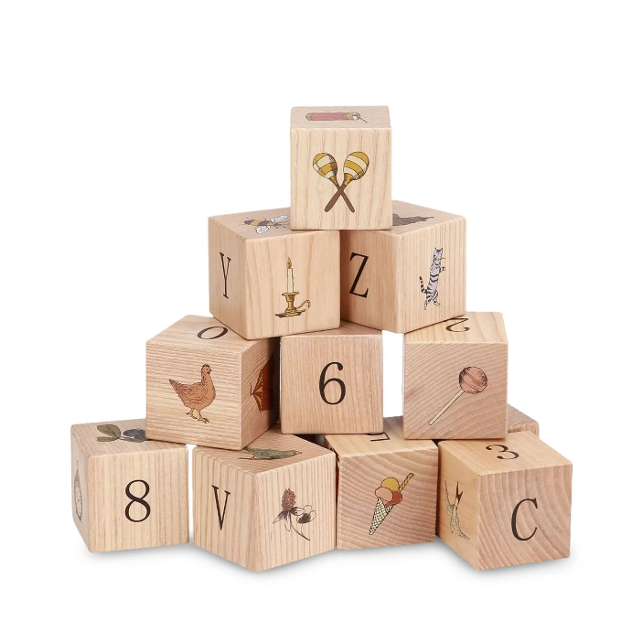 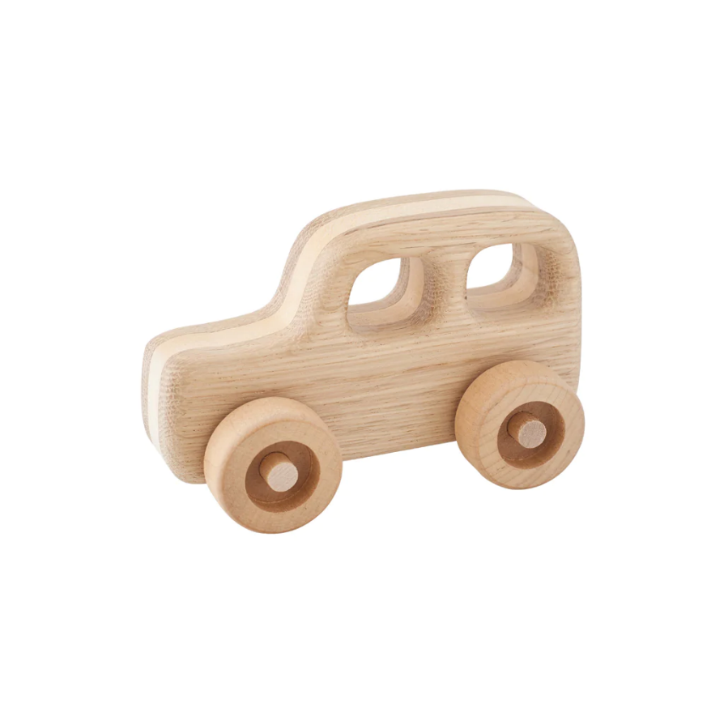

**Picture 1.** Solid wooden cubes. **Picture 2.** Solid toy car.

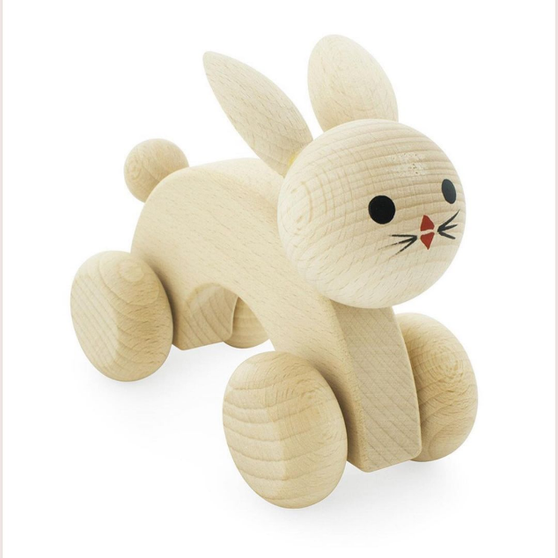 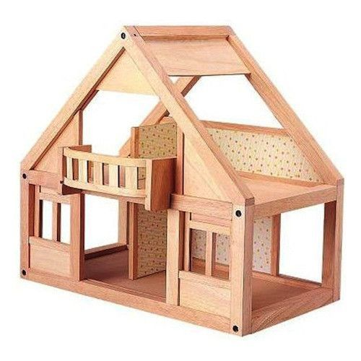

**Picture 3.** Wooden toy rabbit **Picture 4.** Wooden house with solid pieces

It is known that wooden toys produced from a single body have a longer lifespan than toys with multiple and more complex components.

**4. Laser Cut Wooden Toys**

In recent years, laser technology has been at the forefront of material processing. It is conceivable that it will probably replace traditional techniques such as sawing in the near future [14]. With computer numerically controlled (CNC) machine technology, manpower in production has started to decrease and be replaced by information processing. With the spread of laser technology, non-contact, precise and chip-free production methods have become widespread.

Laser technology is currently used in many fields such as automotive, shipping, aviation, military equipment, energy industry and medicine [15]. In addition, it has also found a place in applications such as semiconductor production, electronics and communications [16]. Hobby woodworking has also been involved in areas such as advertising and entertainment shows. With its use in measuring devices in industry, it has become a technology that has no alternative in most cases. Its use has gained importance especially in applications requiring high precision. As can be seen, laser technology has found its place in daily life for many different purposes, from small to large. In recent years, with the development of technology, there has been a trend towards the use of laser in industry [17].

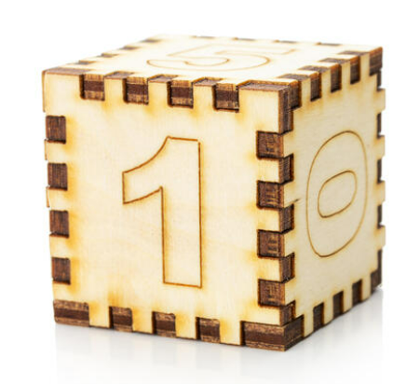 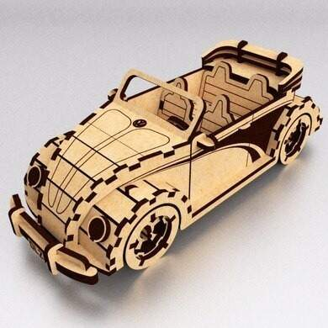

**Picture 5.** Laser cut wooden block **Picture 6.** Laser cut toy car

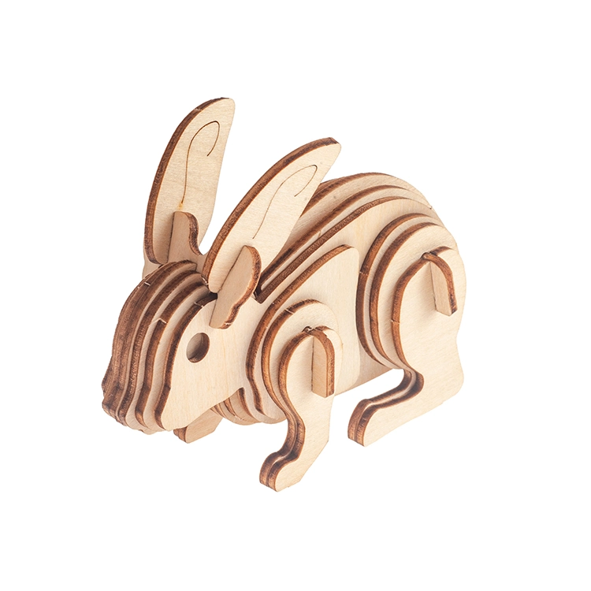 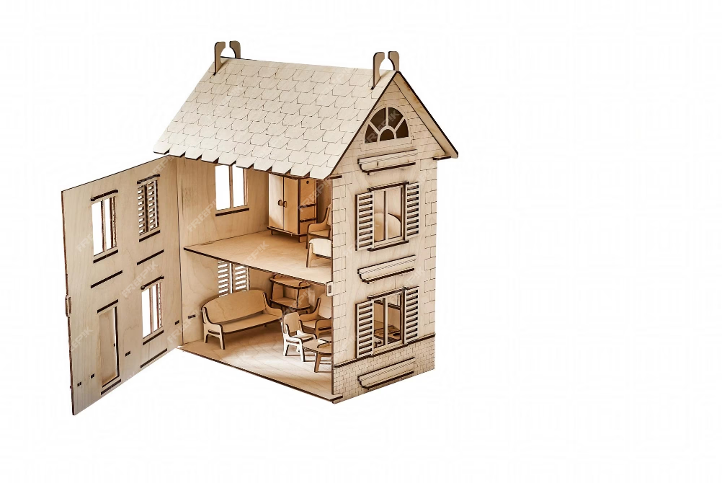

**Picture 7.** Laser cut layered wooden rabbit **Picture 8.** Plywood laser cut house

Toys produced by laser cutting are produced in a shorter time than traditional toys. As seen in Picture 5, Picture 6, Picture 7 and Picture 8, the high number of parts and low part thickness create a disadvantage in terms of strength.

**Result and Discussion**

Some of the main reasons why solid wooden toys have been used for centuries are that they are natural, renewable, can be easily applied on the surface, are healthy and can be easily repaired. With technological developments, the processing of wood has become easier and the production technique of most wooden toys has changed. It is understood that toy design and production with laser cutting and 3D programs, in addition to the traditional production technique, has many advantages but also disadvantages. The production and design of laser cut wooden toys is faster and simpler, saving time. However, a computer and a separate cutting device are required for design and production. In addition, its disadvantages are that it has a higher number of parts and is less durable than solid wood. Poisonous gases released during toy production by laser cutting must be removed from the workshop environment. Since toys produced with traditional hand tools and laser cutting have different advantages and disadvantages compared to each other, the selection should be made taking into account production costs and health procedures.

**References**

1. Vatandaş, S. (2020). Oyun ve oyuncak: teknolojik ve toplumsal dönüşüm sürecinde oyun ve oyuncağin anlamsal ve işlevsel değişimi. *Süleyman Demirel Üniversitesi Vizyoner Dergisi, 11(28),* 913-930.
2. Bekir, O. (1992). Tarih boyunca oyunlar ve oyuncaklar. *Ankara University Journal of Faculty of Educational Sciences (JFES), 25(2),* 365-386.
3. Kırman, A., *Çocuk kitaplarında oyun ve oyuncak kavramının incelenmesi*, PhD Thesis, Hacettepe Üniversitesi, Sağlık Bilimleri Enstitüsü, 2019, 190, Ankara.
4. Dalğar, T., & Kaya, A. İ. (2017). Oyuncak tercihinde ahşap malzeme özelliklerinin incelenmesi. *İleri Teknoloji Bilimleri Dergisi, 6(3),* 9-16.
5. Tuncer, Y. *Ahşap oyuncaklar*, Lisans tezi, Dumlupınar Üniversitesi, Simav Teknik Eğitim Fakültesi Mobilya ve Dekorasyon Eğitimi Bölümü, 2012, Kütahya.
6. Ak, D. *Oyun ve oyuncak kavramlarının tarihsel ve kültürel değişimine endüstriyel tasarım açısından bir bakış*, Yüksek Lisans Tezi, Anadolu Üniversitesi, Endüstriyel Sanatlar Anabilim Dalı, 2006, 84.
7. Erdoğdu, N. Ö., & Renda, F. Ş. (2021). Rönesans’tan modern döneme batı resim sanatında oyuncağın görünürlüğü. *Ulakbilge Sosyal Bilimler Dergisi, 58(9),* 406-423.
8. Gorman, A. B. (1985). Toys are us. *Time Machines: Artifacts and Culture, Volume VI, 2-18.*
9. Aydın, H. S. *Oyuncak tasariminda sürdürülebilirlik esaslarinin uygulanmasi: ahşap oyuncak örneği,* Yüksek Lisans Tezi, Anadolu Üniversitesi, Endüstriyel Sanatlar Anabilim Dalı, 2012, 104.
10. Elibol, G. C., Kılıç, Y., & Burdurlu, E. (2006). Okul öncesi çocuk oyuncaklarında malzeme kullanımı ve 4-6 yaş çocuklarının renk tercihleri. *Sosyal Politika Çalışmaları Dergisi, 9(9),* 35-44.
11. İlker, U., (2018). Genç yetişkinlerin bakışıyla okul öncesi çocuklar için ahşap oyuncaklar. *Mesleki Bilimler Dergisi (MBD),* 7(2), 99-122.
12. İlker, U. (2020). Çocukluk deneyimi yaşamiş genç yetişkinlerin okul öncesi dönem bağlaminda yeğledikleri ahşap oyuncak çeşitleri. *Mesleki Bilimler Dergisi (MBD), 9(1):* 1-28.
13. İlker, U. (2022). Ahşap oyuncak kategorizasyonu. *Avrasya Sosyal ve Ekonomi Araştırmaları Dergisi, 9(4),* 97-126.
14. Gaff, M., Rezaei, F., Sikora, A., Hýsek, Š., Sedlecký, M., Ditommaso, G., Corleto, R., Kamboj, G., Sethy, A., & Vališ, M. (2020). Interactions of monitored factors upon tensile glue shear strength on laser cut wood. *Composite Structures, 234,* 1-9.
15. Aniszewska, M., Maciak, A., Zychowicz, W., Zowczak, W., Mühlke, T., Christoph, B., Lamrini, S., & Sujecki, S. (2020). Infrared laser application to wood cutting. *Materials, 13(22),* 5222.
16. Knowles, M., Rutterford, G., Karnakis, D., & Ferguson, A. (2007). Micro-machining of metals, ceramics and polymers using nanosecond lasers. *The International Journal of Advanced Manufacturing Technology, 33,* 95-102.
17. Yurdakul, M., Tükel, T., İç, Y. T., İbrahim, Ü., Balcı, A., & Güneş, S. (2022). Bir imalat firmasında en iyi ürün kalitesi için lazer ile kesim parametrelerinin en iyilenmesi. *Journal of Turkish Operations Management, 6(1),* 977-996.

1. \* Corresponding author. *e-mail address: mehmetgunes@karatekin.edu.tr* [↑](#footnote-ref-1)