**Optimization approach to the design of dual band slotted circular microstrip antenna**

***Mahmud Esad YİĞİT1,2\*[C:\Users\Abdullah\AppData\Local\Microsoft\Windows\INetCache\Content.Word\ORCID-iD_icon-16x16.gif](https://orcid.org/0000-0002-0148-1913), Tayfun GÜNEL 3[C:\Users\Abdullah\AppData\Local\Microsoft\Windows\INetCache\Content.Word\ORCID-iD_icon-16x16.gif](https://orcid.org/0000-0002-7193-0016)***

*1Department of Electrical and Electronics Engineering, Çankırı Karatekin University, Çankırı, Türkiye*

*2Graduate School, Department of Electronics & Communication Engineering, Istanbul Technical University, Istanbul, Türkiye*

*3Department of Electronics & Communication Engineering, Istanbul Technical University, Istanbul, Türkiye*

|  |
| --- |
| **Abstract**  In this paper, a circular microstrip antenna with circular slots has been designed via optimization approach. Aim of the optimization is to design an antenna operating on dual WLAN bands with desired gains. Circular slots have been added to antenna patch in order to obtain desired resonance frequencies and gain. Optimization tool of ANSYS High Frequency Structural Simulator (HFSS) has been used for design process. Genetic Algortihm has been chosen as optimizer in HFSS optimization tool. HFSS optimization and simulation results have been given. |
| Keywords: Circular Microstrip Antenna, Dual Band Antenna, Optimization, Slotted Antenna, WLAN |

1. **Introduction**

In recent years, there has been an increasing interest in wireless communication. This interest has led to numerous studies on microstrip patch antennas and their applications [1-3]. Microstrip patch antennas have many advantages in terms of size, usability, easy installation, low cost, integration and durability. Microstrip patch antennas can also be modified by various techniques in order to obtain the desired results and improve performance of the antenna. Changing the feeding method, combining antennas, creating antenna arrays, adding slots etc. can be applied to microstrip antennas. Most of these tecniques are relatively easy to implement on microstrip antennas. Microstrip patch antennas can be designed in a variety of ways. Different antenna shapes show different radiation characteristics. The most commonly used shapes are rectangular, triangular and circular antennas. In this study, a circular microstrip patch antenna has been designed. The circular antenna gives similar characteristics to the rectangular antenna, but the patch size of it is smaller than that of rectangular antenna.

In this paper circular slots have been added to the antenna patch in order the improve antenna performance. There is no general formulation for every type and number of slots. Designers use trial and error method with their experience in order to achive desired antenna performance. Parametric analysis in simulation programs can give some perspective about the structure but there is no guarantee to obtain desired performance. The increase in slot numbers increases required time for design of the antenna.

In order to overcome these difficulties learning techniques such as Artificial Neural Networks (ANN) [4-8], Support Vector Reggression (SVR) [9-13] and optimization algorithms [14-18] have widely been used. In the present study, we aimed to design a circular microstrip antenna operating in WLAN frequency bands (2.4 GHz and 5 GHz) with satisfactory gains. In order to adjust resonance frequencies and improve the gain circular slots has been added to the antenna patch. Optimization tool of ANSYS High Frequency Structural Simulator (HFSS) [19] has been used to find the radii and center pozitions of circular slots that give the desired resonance frequencies and gains. In order to analyze antenna, Finite Element Method (FEM) is employed in HFSS.

1. **Circular Microstrip Antenna**

A circular microstrip antenna is presented in Fig. 1. Design of circular antenna is easier than rectangular antenna because only the radius of antenna patch is needed to find. For a resonance frequency of *fr* and substrate with a relative permittivity of *εr* and thickness of *h*, radius of the antenna patch (*a*) can be calculated by [1];

$a=\frac{F}{\sqrt{1+\frac{2h}{πε_{r}F}\left[ln\left(\frac{πF}{2h}\right)+1.7726\right]}}$ (1)

where

$F=\frac{8.791×{10}^{9}}{f_{r}\sqrt{ε_{r}}}$ (2)

where *fr* in Hz and *h* in cm.

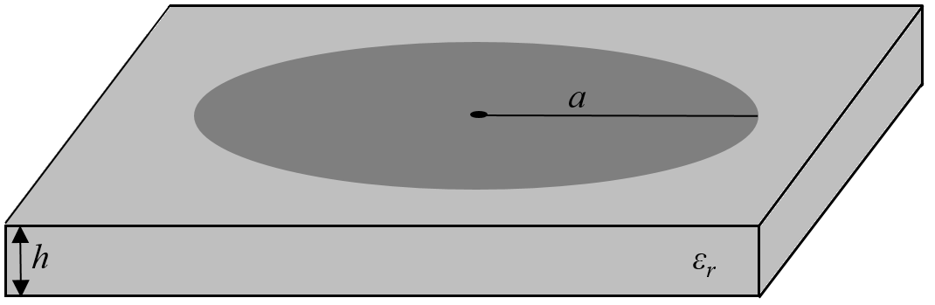

**Figure 1**. Schematic of the circular microstrip antenna.

In this study, Rogers RT/duroid 5880 antenna substrate with a relative permittivity of 2.2 and a thickness of 1.6 mm has been used. Antenna patch radius *a* is calculated via (1-2) as 23.62 mm for a resonance frequency of 2.4 GHz. HFSS simulation has been carried out with this radius value and resonance frequency is obtained as 2.38 GHz.

In order to obtain resonance frequencies and improve the antenna gain, circular slots has been formed on the circular antenna patch. Rogers RT/duroid 5880 substrate with a relative permittivity of 2.2 and a thickness of 1.6 mm is used. Antenna patch radius *a* is calculated to be 23.62 mm, antenna substrate length and width are both obtained as 53.75 mm. The feed point is found as *xf*=6.5 mm and *yf*=0 mm via parametric analysis. General schematic and HFSS drawing of the proposed slotted circular antenna are shown in Fig. 2a and 2b respectively.

|  |  |
| --- | --- |
| (a) | (b) |

**Figure 2**. a) The proposed slotted circular microstrip antenna, b) HFSS drawing of the antenna.

1. **Results and Discussion**

HFSS optimization tool is useful due to having different kind of optimization methods such as gradient based and search based algorithms. Designers can specify optimization parameters, design parameters and select goals by setting up various calculations. Optimization tool in HFSS uses HFSS’s own numerical electromagnetic analysis method for computing the value of cost function defined in optimization algorithm.

Genetic Algorithm (GA) [14, 20-24] has been selected as optimizer to estimate slot radii and centers of the antenna for desired resonance frequencies and gains. Optimization parameters for GA optimizer are given in Table 1. Slot radii *r*1, *r*2 and *r*3 and the slot center positions [*x*m1, *y*m1], [*x*m2, *y*m2] and [*x*m3, *y*m3] are selected asthe variables of optimization. Intervals of optimization variables are given in Table 2.

**Table 1.** Optimization parameters for genetic algortihm optimizer of HFSS

|  |  |
| --- | --- |
| Parameter | Value |
| Number of Individuals | 30 |
| Crossover Type | Simulated Binary |
| Mutation Type | Polynomial |
| Selection Type | Roulette |
| Maximum Number of Iterations | 1000 |
| Mutation Probability | 0.01 |
| Crossover Probability | 0.98 |
| Cost Function Norm Type | L1 |
| Weights | 1 |

**Table 2.** Intervals of optimization variables

|  |  |
| --- | --- |
| Variable | Interval |
| *r*1 |  |
| *r*2 |  |
| *r*3 |  |
| *x*m1 |  |
| *y*m1 |  |
| *x*m2 |  |
| *y*m2 |  |
| *x*m3 |  |
| *y*m3 |  |

Desired resonant frequencies areselected as *fr1*=2.4 GHz and *fr2*=5.1 GHz. Desired gains at resonance frequencies are selected as *g*=3dB. Minimum cost value is reached at the 539th iteration. HFSS optimization viaGA optimizer has been taken 4 hours and 12 minutes with a computer that has 2.4 GHz CPU and 8 GB RAM. Radii of slots are found as *r*1=3.73 mm, *r*2=1.89 mm and *r*3=4.84 mm. Center positions of slots are obtained as [*x*m1, *y*m1]=[-5.44 mm, 0], [*x*m2, *y*m2]=[19.33, 10.60 mm] and [*x*m3, *y*m3]=[19.33, -10.60 mm].

By using slot radii and center position values which are obtained by HFSS optimization, HFSS simulation has been carried out. HFSS drawing of the optimized antenna is given in Fig. 3. **|S11|** plot is given in Fig. 4. The resonance frequencies are obtained as 2.42 GHz and 5.09 GHz. The 10-dB bandwidth for 2.42 GHz is 60 MHz and for 5.09 GHz it is obtained as 150 MHz.

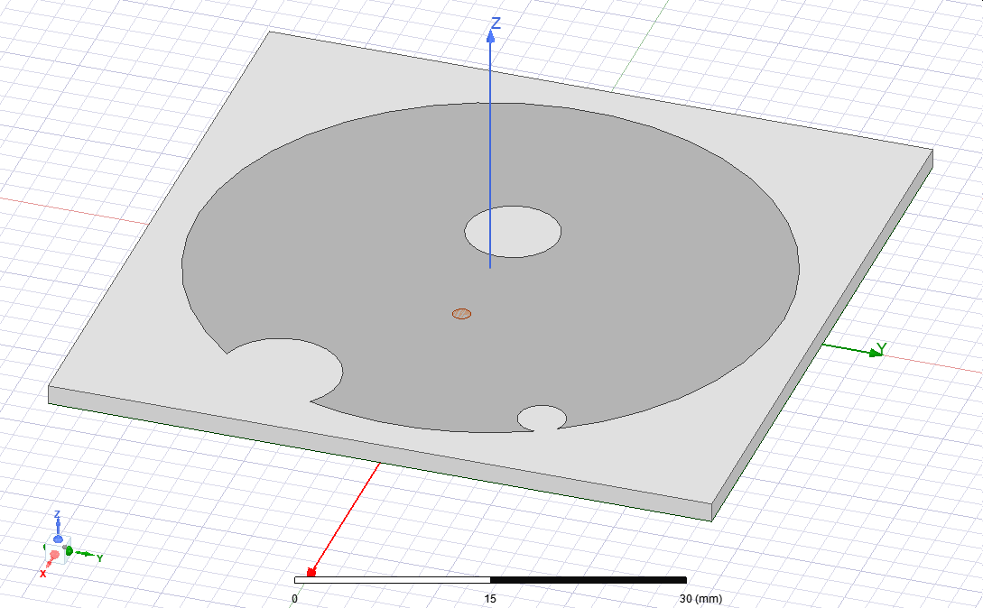

**Figure 3**. HFSS drawing of the optimized slotted circular microstrip antenna.

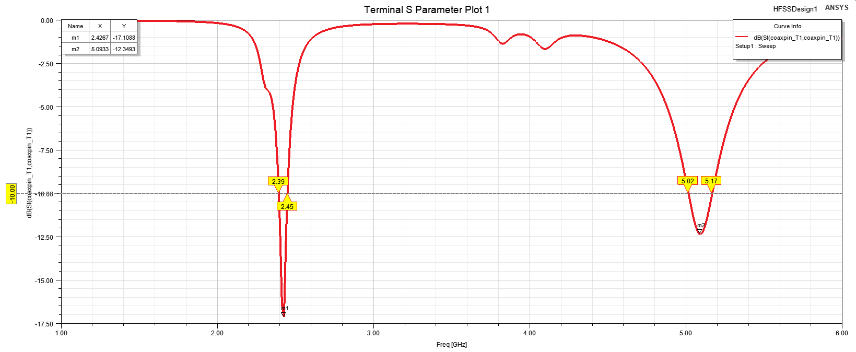

**Figure 4**. |S11| plot of slotted circular microstrip antenna.

Gain plots for 2.42 GHz and 5.09 GHz are presented in Fig. 5a and 5b, respectively. The antenna gain for 2.42 GHz is 3.9 dB and for 5.09 GHz it is obtained as 3.7 dB.

|  |  |
| --- | --- |
| (a) | (b) |

**Figure 5**. Gain plot of slotted circular microstrip antenna for a) 2.42 GHz, b) 5.09 GHz.

The radiation diagrams of slotted circular microstrip antenna for 2.42 GHz and 5.09 GHz are illustrated in Fig. 6a and 6b, respectively.

|  |  |
| --- | --- |
| (a) | (b) |

**Figure 6**. Radiation diagrams of slotted circular microstrip antenna for a) 2.42 GHz, b) 5.09 GHz (- xz-plane, -- yz-plane).

Surface current distributions of the antenna for 2.42 GHz and 5.09 GHz are shown in Fig. 7a and 7b, respectively.

|  |  |
| --- | --- |
| (a) | (b) |

**Figure 7**. Surface current distributions of slotted circular microstrip antenna for a) 2.42 GHz, b) 5.09 GHz.

In this work, a circular microstrip antenna with triple slots has been designed to operate in dual resonance frequencies of WLAN. HFSS optimization tool has been employed to find slot radii and slot center pozitions that give the desired resonant frequencies and desired gains. Genetic Algortihm has been selected as optimizer in HFSS optimization tool. HFSS simulation has been carried out by using the obtained slot radii and slot center pozitions from HFSS optimization. HFSS simulations shows that desired resonance frequencies and gains are obtained via HFSS optimization.

**References**

1. Balanis, C. A. (2005). *Antenna Theory Analysis and Design*, 3rd ed. NJ, USA:John Wiley & Sons, Inc.
2. Günel, T. (2004). Continuous hybrid approach to the modified resonant frequency calculation for circular microstrip antennas with and without air gaps. *Microwave and Optical Technology Letters*, 40(5), 423-427.
3. Günel, T. (2011). Modified resonant frequency calculation for E-shaped and H-shaped microstrip patch antennas. *Microwave and Optical Technology Letters*, 53(10), 2348-2351.
4. Haykin, S. (2009). *Neural Networks and Learning Machines*, 3rd ed. NJ, USA:Pearson Prentice Hall, 268-312.
5. Khan, T., & De, A. (2015) . Modeling of microstrip antennas using neural networks techniques: a review. *Int J RF and Microwave Comp Aid Eng*, 25, 747–757.
6. Wang, Z., Fang, S., Wang, Q., & Liu, H. (2012). An ANN-based synthesis model for the single-feed circularly-polarized square microstrip antenna with truncated corners. *IEEE Trans. on Antennas Propag.*, 60, 5989–5992.
7. Aneesh, M. J., Ansari, A., Kamakshi, A. S., & Sayeed, S. S. (2014). Investigations for performance improvement of X shaped RMSA using artiﬁcial neural network by predicting slot size. *Progress In Electromagnetics Research C*, 47, 55–63.
8. Aşık, U., Günel, T., & Erer, I. (2004). A wavelet-based radial basis function neural network approach to the inverse scattering of conducting cylinders. *Microwave and Optical Technology Letters*, 41(6), 506-510.
9. Cortes, C., & Vapnik, V. (1995). Support vector network. *Machine Learn.*, 20, 273-297.
10. Angiulli, G., Cacciola, M., & Versaci, M. (2007). Microwave devices and antennas modelling by support vector regression machines, *IEEE Transactions on Magnetics*, 43(4), 1589-1592.
11. Roy, C., Khan, T., & Kanaujia, B. (2016). Performance parameters prediction of slotted microstrip antennas with modified ground plane using support vector machine. *International Journal of Microwave and Wireless Technologies*, 9(5), 1169-1177.
12. Yiğit, M. E., Günel, T., & Günel, G. Ö., SVR Approach to the Design of Dual-Band Rectangular Microstrip Antenna with a Pair of Slots for WLAN Applications, 11th International Conference on Electrical and Electronics Engineering (ELECO), Bursa, Turkey, 2019, 659-663.
13. Yiğit, M. E., Günel, G. Ö., & Günel, T., SVR Based Design of Triple Band Rectangular Microstrip Antenna for WLAN and 5G Applications, 4th Int.Symp. on Advanced Electrical and Communication Technologies (ISAECT), Khobar, Suudi Arabia, 2021, pp. 1-5.
14. Haupt, R. L. (1995). An introduction to genetic algorithms for electromagnetics. *IEEE Antennas and Propagation Magazine*, 37(2), 7-15.
15. Robinson, J., & Rahmat-Samii, Y. (2004). Particle swarm optimization in electromagnetics. *IEEE Transactions on Antennas and Propagation*, 52(2), 397-407.
16. Günel, T., & Erer, I. (2002). Application of fuzzy genetic algorithm to the problem of synthesizing circular microstrip antenna elements with thick substrates. *AEÜ* *International Journal of Electron. Commun.*, 56(3), 215-217.
17. Aydemir, E., Günel, T., & Üstüner, F. (2006). Genetic approach to the minimization of the coupling between aircraft antennas. *AEÜ* *International Journal of Electron. Commun.*, 60(4), 299-305.
18. Günel, T., Yiğit, M. E., & Günel, G. Ö., Genetic-Based Approach to the Synthesis of Rectangular Microstrip Antenna Elements with Reduced Mutual Coupling, International Symposium on Advanced Electrical and Communication Technologies (ISAECT), Rabat-Kenitra, Morocco, 2018, 1-5.
19. ANSYS, ANSYS HFSS | 3D High Frequency Simulation Software. Available at: https://www.ansys.com/products/electronics/ansys-hfss. Retrieved July 27, 2022.
20. Goldberg, D. E. (1989). *Genetic Algorithms in Search*, *Optimization and Machine Learning Reading*, Boston, MA, USA: Addison-Wesley.
21. Haupt, R. L. (1994). Thinned arrays using genetic algorithms. *IEEE Transactions on Antennas and Propagation*, 42(7), 993-999.
22. Weile, D. S., & Michielssen, E. (1997). Genetic algorithm optimization applied to electromagnetics: a review. *IEEE Transactions on Antennas and Propagation*, 45(3), 343-353.
23. Johnson, J. M., & Rahmat-Samii, V. (1997). Genetic algorithms in engineering electromagnetics. *IEEE Antennas and Propagation Magazine*, (39)4, 7-21.
24. Haupt, R. L., & Werner, D. H. (2007). *Genetic Algorithm in Electromagnetics*. Hoboken, N.J., USA: Wiley-Interscience.