**Some physical Properties of B2 type AgY intermetallic compound from Ab-initio Calculations**

***Yasemin Öztekin ÇİFTCİ[[1]](#footnote-1)\*[C:\Users\Abdullah\AppData\Local\Microsoft\Windows\INetCache\Content.Word\ORCID-iD_icon-16x16.gif](https://orcid.org/xxxx-xxxx-xxxx-xxxx), İlknur Kars DURUKAN[C:\Users\Abdullah\AppData\Local\Microsoft\Windows\INetCache\Content.Word\ORCID-iD_icon-16x16.gif](https://orcid.org/xxxx-xxxx-xxxx-xxxx)***

*1 Science Faculty, Physics Department, Gazi University, Ankara, Turkey*

*2Science Faculty, Physics Department, Gazi University, Ankara, Turkey*

|  |
| --- |
| **Abstract**  Intermetallics have superior physical important properties than ordinary metals. Due to interesting properties such as high tensile strength, high melting point and stifness, good oxidation resistance , low mass density, these intermetallic compounds are suitable for many applications in engineering. and industry. Among the B2-type intermetallic compounds, there is a theoretical study on the defect properties of AgY . Here, we have studied structural, mechanics, electronic, vibrational and thermodynamic properties of AgY compound using first-principles methods based on density-functional theory. It can be concluded that AgY in B2 structure are metallic compounds from electronic band structure. AgY is also stable mechanically and dynamically. |
| Keywords: : DFT, B2 structure, electronic properties, elastic, properties, vibrational properties |

1. **Introduction**

The discovery of high ductility and fracture toughness at room temperature in certain B2 type- compounds, as described by Gschneidner et al. in 2003, is indeed noteworthy. The compounds mentioned exhibit promising mechanical properties without the need for additional elements or complex processing techniques[1-3]. The challenge of brittleness in intermetallic compounds has historically limited their practical applications. The improvement in ductility for these specific compounds is a significant advancement. The fact that these properties can be achieved by simply arc-melting equal amounts of pure elements in normal-humidity air without the addition of third elements adds to the practicality of these materials. Typically, methods to enhance ductility in intermetallic compounds involve techniques such as testing at high temperatures, zero-humidity atmospheres, adding dopants, introducing non-stoichiometry, or inducing metastable disorder. However, the mentioned compounds seem to exhibit desirable properties at room temperature without the need for such complex procedures. Understanding the ductility mechanism of these alloys is crucial for furthering their applications and optimizing their properties. While the elastic properties of YAg have been investigated by Russel and Gschneidner[4], it is highlighted that the ductility mechanism of these alloys has been reported very little. Further research and investigation into the underlying mechanisms responsible for the observed ductility in these intermetallic compounds can provide valuable insights for the development of new materials with improved mechanical characteristics. In summary, the discovery of intermetallic compounds with high ductility and fracture toughness at 300K opens up new possibilities for their use in various applications. The simplicity of the synthesis process and the absence of additional elements make these compounds particularly interesting for further exploration and development in the field of materials science[5-7].

The intermetallic compounds YM (where M represents Cu, Zn, and Ag) adopt a cubic CsCl-type structure characterized by a space group symmetry of Pm3m (No. 221). Extensive experimental and theoretical analyses have been conducted to explore their electronic, elastic, and mechanical properties, as documented in several studies [8–13]. There is no study onvibrational properties and thermodynamic properties of DyAg in B2 structure. We have aimed to investigate structural, mechanical, electronic, vibrational and thermodynamic properties of AgY intermatallic compound in B2 structure using ab-initio methods.

1. **Materials and Methods**

We have used the density functional theory (DFT) method to investigate of the B2-structured YAg compound's physical. The calculations were performed with the VASP software [14-17], employing the Generalized Gradient Approximation (GGA) for the exchange-correlation function [18]. Y and Ag exhibit valence-electron configurations of 4s²4p64d25s1 and 4d105s1 respectively. To optimize lattice parameters and atomic positions, a 17 × 17 x17 Monkhorst and Pack k-points grid [19] was applied for integration into the irreducible Brillouin region. The kinetic energy cutoff for the plane-wave basis set was set at 850 eV. Elastic constants were investigated using the stress-strain method [20,21]. For the analysis of vibrational properties, a supercells approach was employed, and phonon dispersion curves were calculated using the PHONOPY code [22]. This methodology provides a comprehensive exploration of both the physical and vibrational characteristics of AgY.

1. **Results and Discussion**
   1. **Structural and Mechanical Properties**

AgY adopts the B2 phase CsCl structure within the (2 2 1) space group. The atomic positions are designated as Ag(0, 0, 0) and Y(0.5, 0.5, 0.5) as illustrated in Fig. 1(a). To optimize the lattice constants of AgY, comprehensive structural relaxations were conducted. The resulting total energies-volume graphs, presented in Fig. 1(b), were fitted to the Murnaghan state equation [23] for determining the bulk modulus and its first derivative. The obtained data, detailed in Table 1, were compared with findings from literature. Our computed lattice parameter is comparable with the values reported in Ref. [24], attributed to the utilization of the GGA functional. Throughout subsequent calculations, this determined lattice parameter was consistently applied. The determined lower bulk modulus for YAg, at 66.08 GPa, signifies a slightly higher compressibility compared to values in [24]. The bulk modulus, indicative of resistance to volume change under mechanical effects, is accompanied by a first derivative of 4.32, which is lower than the corresponding result in Ref. [24].

**Table.1** Structural parameters for AgY in B2 structure

|  |  |  |  |  |
| --- | --- | --- | --- | --- |
|  | a(A) | B(GPa) | B’ | Etot (eV)/atom |
| This study | 3.653 | 66.08 | 4.32 | -4.985 |
| Theory (YAg)[24] | 3.641 | 68.5 | 5.0 |  |

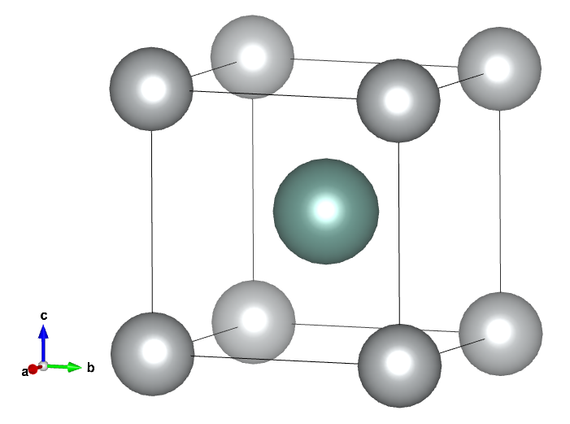 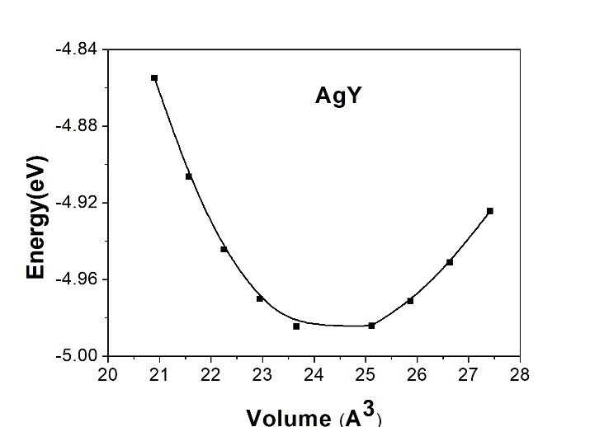

**Figure. 1** Unitcell of AgY **Figure.2** Energy- volume curves for AgY

Understanding elastic properties is crucial for comprehending a material's physical response, particularly in device applications. Elastic properties not only influence the material's effectiveness but also offer insights into its thermodynamic behavior. In the cubic system, three elastic constants play a pivotal role in characterizing the material's response to stress. C11 indicates the material's rigidity, C12 determines transverse expansion, and C44 is associated with shear deformation. These constants collectively contribute to the material's stability. The stability conditions of the cubic system encapsulated in the Born-Huang criteria [25], hinge on satisfying four essential criteria. These criteria provide a comprehensive framework for assessing the stability of the material and are integral to understanding its overall performance and reliability. Table 2 presents the our obtained findings of calculated elastic constants and mechanical properties, with C11, C12, and C44 satisfying the stability criteria for AgY.

**Table 2.** Obtained elastic constants (C11, C12, C44 in GPa unit), Young’s modulus (E in GPa), Anisotropy factor (A), Poisson ratio (v) and Hardness (Hv in GPa) for AgY

|  |  |  |  |  |  |  |  |  |
| --- | --- | --- | --- | --- | --- | --- | --- | --- |
|  | C11 | C12 | C44 | E | B/G | A | v | Hv |
| This study | 96.5 | 50.8 | 35.2 | 77.0 | 2.237 | 1.540 | 0.3054 | 3.2 |
| Theory [24] YAg | 99.30 | 54.3 | 38.5 | 81.0 | 2.209 | 1.71 | 0.305 | - |

Young's modulus (E, GPa) gauges the stress- strain ratio, primarily reflecting the chemical bonds between atoms in the material and providing information about the material's hardness. Notably, the AgY compound exhibits a lower Young's modulus, signifying its not hardness. Determination of ductile / brittle property involves factors like the B/G ratio showing the Paugh ratio, AgY is categorized as ductile based on the Paugh ratio. The Poisson ratio (v), which characterizes bonding forces in solids, serves as a key indicator. When v ranges from 0.25 to 0.50, it signifies the center of interatomic force, while a v of 0.5 indicates nearly incompressible material. Since limit values of Poisson’s ratio are 0.10 for covalent bonds, 0.25 for ionic bonds and 0.33 for metallic bonds [26], AgY has ionic bonding.The Hv parameter defines stiffness against deformation, and in the B2, hardness increases with C44. AgY, with a parameter value of 3.2 GPa, exhibits a soft structure. Values above 10 indicate hardness, and those exceeding 40 imply super-hardness. Zener anisotropy A, derived from elastic constants, indicates isotropy at a value of 1 and anisotropy at smaller or larger values. AgY displays an anisotropic nature.

**3.2 Electronic Properties**

Electronic energy band structure along the high symmetry direction, accompanied by the total density of states, provides insights into the electronic properties of AgY. Setting the Fermi level at 0 eV reveals the metallic nature of AgY, where the valence and conduction bands overlap, signifying conductivity contributed by electrons near the Fermi level as seen in Figure 3. In Fig. 4, the partial density of states (PDOS) for AgY is presented, showcasing distinct contributions from the Fermi level, valence band, and conductivity band. Predominantly, the Y-d states significantly influence the Fermi level, while the valence band is dominated by Ag-d states. The metallic character of AgY, attributed to conductivity, is primarily associated with Y-d and Y-p states in the conductivity band. The density of states (DOS) at the Fermi level registers at 1.58, a lower value of which typically indicates a more stable structure.

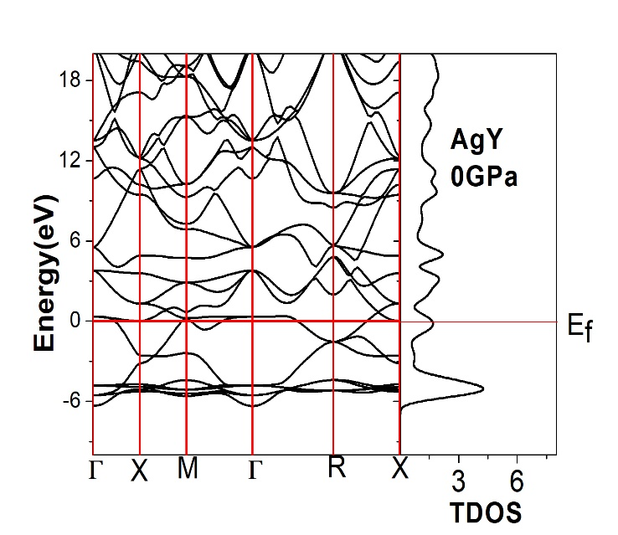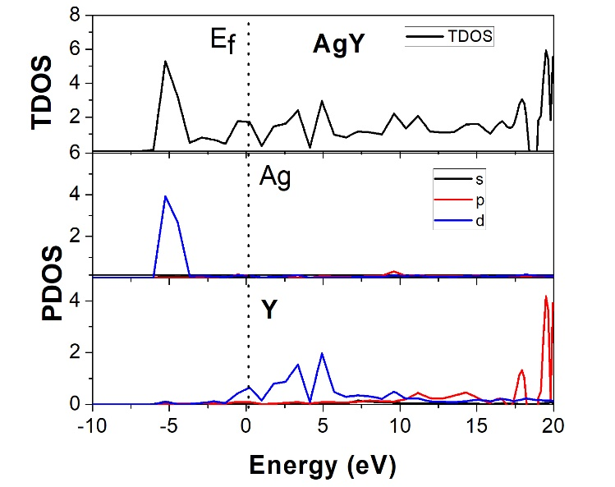

**Figure 3.** Electronic band structure for AgY **Figure 4.** Total and partial DOS for AgY

The charge density map for (100) planes of AgY, as sgiven in Figure 5, is crucial for analyzing the bond structure between atoms. Understanding the bond type involves considering electronegativity and inter-atomic charge transfer. When the electronegativity values differ significantly, as in this case, an ionic bond is formed; otherwise, a covalent bond is established. Figure 5 illustrates an ionic bond structure with varying electron densities.

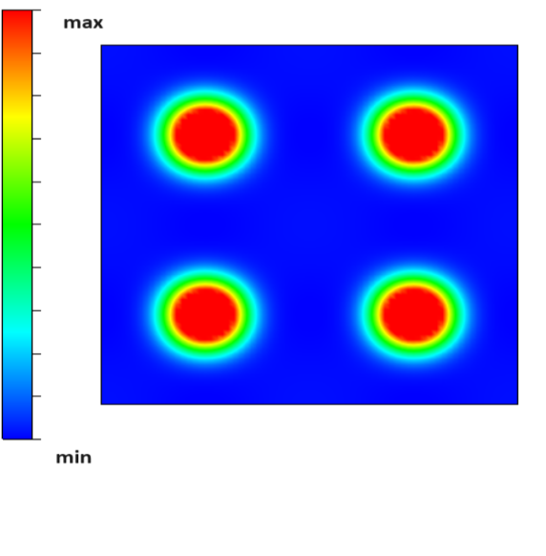

**Figure 5 .** Charge density map along [100] direction for AgY

**3.3 Vibrational Properties**

The PHONOPY open-source code [22] was employed to determine the phonon distribution spectrum of AgY compound. Analyzing this spectrum provides insights into various physical properties, including phase transitions, dynamic stability, and specific heat within the compound. Figure 6 illustrates phonon distribution curves along high symmetry directions, generated using 2 × 2 × 2 supercells. YbAu, characterized by two atoms in its unit cell, exhibits three acoustic vibration modes and three optic modes among the available six vibration modes. Here, all obtained frequencies for first Brillouin region are positive, indicating the absence of imaginary frequencies. Thus, AgY is dynamically stable at 0 GPa. From the PDOS of AgY, Y atoms in the region between 2.5-4.5 THz contributed more to the acoustic modes. Lower frequencies region of acoustic modes are mostly detected by vibrations of Ag atoms.

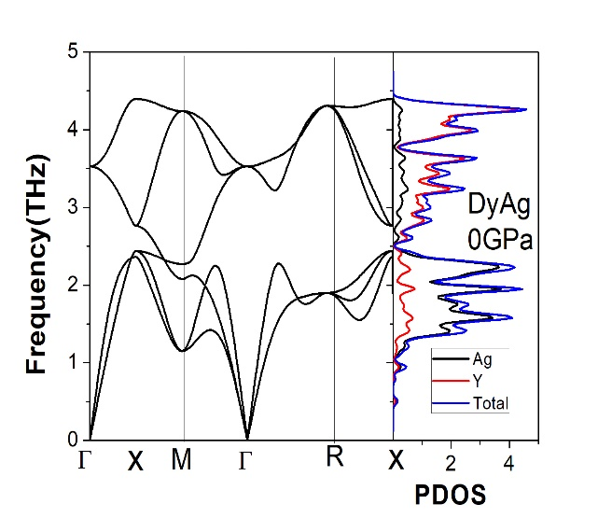

**Figure 6 .** Phonon dispersion curves for AgY

The properties dependent on temperature are explored through the quasi-harmonic approach, considering thermal electronic excitations. Thermodynamic parameters like heat capacity (Cv) and entropy (S) are calculated using phonon frequencies within the framework of the quasi-harmonic approximation. Figure 7 visually represents how lattice vibrations contribute to the entropy and heat capacity of AgY. To minimize the potential influence of anharmonicity, the temperature is limited to the range of 1000 K. The contribution of lattice vibrations to heat capacity follows the Debye model and gradually approaches the Dulong–Petit limit at higher temperatures. This analysis offers a thorough understanding of the system's temperature-dependent characteristics, especially concerning its thermodynamic parameters

. 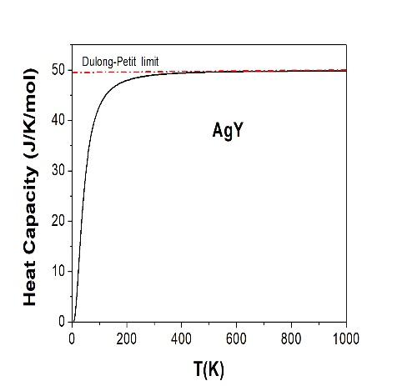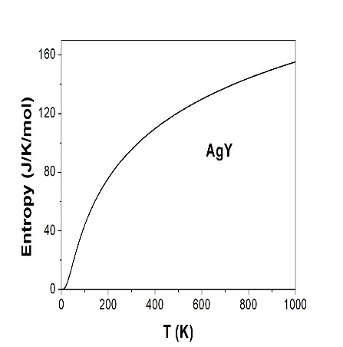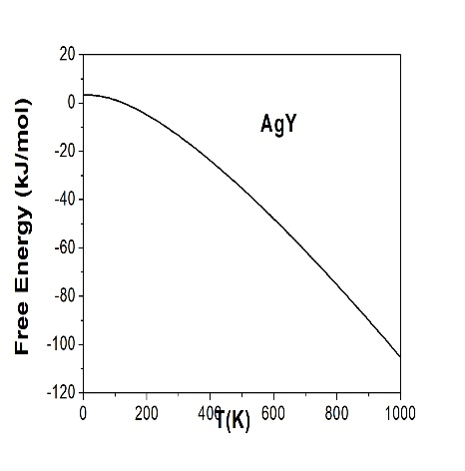

**Figure 7 .** Thermodynamic properties for AgY

1. **Conclusion**

We conducted a thorough exploration of AgY's structural, elastic, vibrational, electronic, and thermodynamic properties using first-principles methods. Our investigation into zero-pressure second-order elastic constants and related parameters confirmed the compound's malleable characteristics. In contrast, Poisson’s ratio (ν) values pointed towards the presence of ionic bonds, while elastic anisotropy (A) values indicated the compound's elasticity is anisotropic. The calculated structural and elastic constants results exhibited consistent agreement with previously reported data. Electronic band structure and density of state calculations brought to light the metallic nature of AgY. Despite observing a decline in free energy, both enthalpy and entropy demonstrated an increase at temperatures exceeding 1000 K.

**References**

[1] [C. T. Liu, E. P. George, P. J. Maziasz and J. H. Schneibel (1998), Mater. Sci. Eng. A **258** 84–98.](https://jlc.jst.go.jp/DN/JALC/00319891276?type=list&lang=en&from=J-STAGE&dispptn=1)

[[2] N. S. Stoloff, C. T. Liu and S. C. Deevis(2000), Intermetallics **8**  1313–1320.](https://jlc.jst.go.jp/DN/JALC/00069957314?type=list&lang=en&from=J-STAGE&dispptn=1)

[[3] D. B. Miracle, (1993) Acta Metall. Mater. **41** 649–684.](https://jlc.jst.go.jp/DN/JALC/00019530222?type=list&lang=en&from=J-STAGE&dispptn=1)

[[4] K. Gschneidner, A. Russell, A. Pecharsky, J. Morris, Z. Zhang, T. Lograsso, D. Hsu, C. H. Chester, Y. Y. Ye, A. Slager and D. Kesse (2003)Nature Mater. **2**  587–590.](https://jlc.jst.go.jp/DN/JALC/00232308769?type=list&lang=en&from=J-STAGE&dispptn=1)

[[5] Z. Zhang, A. M. Russell, S. B. Biner, K. Gschneidner and C. C. H. Lo (2005)Intermetallics **13** 559–564.](https://jlc.jst.go.jp/DN/JALC/00248917054?type=list&lang=en&from=J-STAGE&dispptn=1)

[[6] A. M. Russell, Z. Zhang, T. A. Lograsso, C. C. H. Lo, A. O. Pecharsky, J. R. Morris, Y. Ye, K. A. Gschneidner and A. J. Slager (2004)Acta Mater. **52** 4033–4040.](https://jlc.jst.go.jp/DN/JALC/00241975556?type=list&lang=en&from=J-STAGE&dispptn=1)

[[7] A. M. Russell, Z. Zhang, K. A. Gschneidner, T. A. Lograsso, A. O. Pecharsky, A. J. Slager and D. C. Kesse (2005)Intermetallics **13** 565–571.](https://jlc.jst.go.jp/DN/JALC/00248925318?type=list&lang=en&from=J-STAGE&dispptn=1)

[8] J.R. Morris, Y.Y. Ye, Y.B. Lee, B.N. Harmon, K.A. Gschneidner, A.M. Russell, (2004)Acta Mater. 53 4849. [9] Z. Zhang, A.M. Russell, S.B. Biner, K.A. Gschneidner, H.C.C. Lo, (2005) Intermetallics 13 559.

[10] S. Ugur, G. Ugur, F. Soyalp, R. Ellialtioglu, (2009) J. Rare Earths 27 664.

[11] G. Ugur, M. Civi, S. Ugur, F. Soyalp, R. Ellialtioglu, (2009) J. Rare Earths 27 661.

[12] C. Ritter, M.R. Ibarra, R.M. Ibberson, (1992) J. Phys. Condens. Matter 4 L39.

[13] Y.J. Shi, Y.L. Du, G. Chen, G.L. Chen, (2007) Phys. Lett. A 368 495.

[14] G. Kresse, J. Hafner, (1993) Ab initio molecular dynamics for liquid metals, Phys. Rev. B 47 558.

[15] G. Kresse, J. Hafner, (1994) Ab initio molecular-dynamics simulation of the liquid metal–amorphous-semiconductor transition in germanium, Phys. Rev. B 49 14251.

[16] G. Kresse, J. Furthmuller, (1996) Efficiency of ab-initio total energy calculations for metals and semiconductors using a plane-wave basis set, Comput. Mater. Sci. 6 15.

[17] G. Kresse, J. Furthmuller, (1996) Efficient iterative schemes for ab initio total-energy calculations using a plane-wave basis set, Phys. Rev. B 54 11169.

[18] J.P. Perdew, J.A. Chevary, S. Vosko, K.A. Jackson, M.R. Pederson, D.J. Singh, C. Fiolhais, (1992) Atoms, molecules, solids, and surfaces: applications of the generalized gradient approximation for exchange and correlation, Phys. Rev. B 46 6671.

[19] H.J. Monkhorst, J.D. Pack, (1976) Special points for Brillouin-zone integrations, Phys. Rev. B 13 5188.

[20] L. Page, P. Saxe, (2002)Symmetry-general least-squares extraction of elastic data for strained materials from ab initio calculations of stress, Phys. Rev. B 65 104104.

[21] M.J. Mehl, J.E. Osburn, D.A. Papaconstantopoulos, B.M. Klein, (1990) Structural properties of ordered high-melting-temperature intermetallic alloys from first-principles total-energy calculations, Phys. Rev. B 41 10311.

[22] A. Toga, F. Oba, I. Tanaka, (2008) First-principles calculations of the ferroelastic transition between rutile-type and CaCl2-type SiO2 at high pressures, Phys. Rev. B 78 (134106) 1–9.

[23] F.D. Murnaghan, (1944) The compressibility of media under extreme pressures, Proc. Natl. Acad. Sci. U.S.A. 30 244–247.

[24] S.Singh Chouhan, P. Soni, G. Pagare, S.P. Sanyal, M. Rajagopalan, (2011) Ab-initio study of electronic and elastic properties of B2-type ductileYM (M=Cu, Zn and Ag)intermetallics, Physica B 406 339–344

[25 ] Mouhat, F., Coudert, F.X. (2014). Necessary and sufficient elastic stability conditions in various crystal systems. Physical Review B - Condensed Matter and Materials Physics, 90(22), 1-4.

[26] P. Ravindran, L. Fast, P.A. Korzhavyi, B. Johansson, J. Wills, O. Eriksson, (1998)Density functional theory for the calculation of elastic properties of orthorhombic crystals: application to TiSi 2, J. Appl. Phys. 84 (9) 4891–4904.

1. \* Corresponding author. *e-mail address:yasemin@gazi.edu.tr.* [↑](#footnote-ref-1)