THE ROLE OF BIOMASS ENERGY IN SUSTAINABLE DEVELOPMENT AND ITS CONTRIBUTION TO ENVIRONMENTAL SUSTAINABILITY GOALS

***Dr. D. Kemal BAYRAKTAR1[C:\Users\Abdullah\AppData\Local\Microsoft\Windows\INetCache\Content.Word\ORCID-iD_icon-16x16.gif](https://orcid.org/0000-0003-4479-0684),Dr. Mehmet GÜNEŞ2 [C:\Users\Abdullah\AppData\Local\Microsoft\Windows\INetCache\Content.Word\ORCID-iD_icon-16x16.gif](https://orcid.org/0000-0002-1222-7590)***

*1* ***0000-0003-4479-0684,*** *Department of Forest Industrial Engineering, Karadeniz Technical University, Trabzon, Türkiye*

*2* ***0000-0002-1222-7590****, Çankırı Vocational School, Department of Design, Çankırı Karatekin University, Çankırı, Türkiye*

**Abstract**

Bioenergy, being a key element in sustainable development strategies, holds the promise of fostering inventive and eco-conscious solutions in energy generation to bolster economic advancement and contribute significantly to meeting ecological preservation objectives. Biomass energy is crucial in advancing sustainable development efforts and plays a key part in reaching environmental sustainability objectives. In developed nations, biomass stands out as a key energy source, originating from diverse biological resources like agricultural leftovers, wood chips, animal byproducts, and specialized energy crops. In a well-established country, about 342 million tons of biomass are used each year, meeting approximately 5% of the energy requirements. This involves utilizing corn grain for ethanol production, and wood or wood residues for generating heat and electricity. By tripling biomass production, the country has the potential to produce approximately 60 billion gallons of low greenhouse gas emission liquid fuel, meeting the future demands for food, animal feed, fiber, traditional forestry products, and exports. Untapped biomass resources possess the potential to greatly enhance the country's bioeconomy, potentially increasing the annual biomass supply by approximately 350 million tons on top of existing levels. In a mature market down the road, energy crops have the potential to provide over 400 million tons of biomass annually. The analysis highlights sustainability by taking into account potential effects on soil, air, and water quality, as well as ensuring the preservation of biodiversity. The range of methods encompassed in the technological processes for converting biomass into energy consists of incineration, pyrolysis, gasification, and anaerobic digestion. The study highlights the significant environmental advantages of biomass, including its carbon neutrality, ability to decrease dependency on fossil fuels, and capacity to provide energy access in rural regions while boosting local economies. Moreover, this study places a significant emphasis on the potential of biomass to fulfill the energy requirements of rural areas in developing nations and enhance its efficiency using contemporary biomass technologies. In summary, it is important to highlight that to unlock the full potential of biomass for achieving sustainable development objectives, it is crucial to address environmental and economic obstacles through cooperation among managers, scientists, and industry professionals.

***Keywords:*** *Biomass Energy, Sustainable Development, Environmental Impact*

**1. Introduction**

Biomass is perceived as a key component of renewable energy solutions in driving towards environmental sustainability objectives. In natural ecosystems, there is a continuous cycle that offers sustainable energy and materials through the recycling of organic waste. Yaşayan organizmalar (bitkiler, hayvanlar ve mikroorganizmalar) tarafından üretilen organik madde, karbon, hidrojen ve oksijen gibi temel elementlerin kombinasyonundan oluşur ve enerji üretimi, biyokimyasal süreçler ve endüstriyel uygulamalar için kullanılabilir.

These substances could potentially be utilized to provide energy through various methods. Biomass stands uniquely among other forms of renewable energy because it can easily be converted into liquid fuels, electricity, and heat. The extensive variety of biomass sources, such as agricultural residues, wood chips, animal waste, and purpose-grown energy crops, makes it a very versatile resource for generating energy.

Forest energy projects in developing countries that are sustainable have the ability to make a notable impact on fulfilling local energy requirements as well as global climate objectives. By blending forest management with energy production, such projects have the potential to improve rural livelihoods and lessen deforestation [1].

Finland's energy strategy underscores the importance of wood energy, particularly emphasizing the use of forest chips from small-sized trees and residual biomass from cuttings. It prioritizes the target of generating 5 million cubic meters of forest chips by 2010, amounting to 10 TWh. This highlights the significance of forest energy in achieving sustainable development objectives and decreasing carbon emissions[2].

"Biomass is organic material obtained from living organisms that can be harnessed as an energy source through different technological methods. " Biomass is composed of organic materials that come from plants, animals, and microorganisms, making it a versatile resource for energy production [3].

Biomass, particularly liquid fuels (biofuels), have a significant impact on the generation of electricity and heat. This occurs because biomass has the unique capability to be converted directly into different types of energy, a characteristic not shared by other renewable energy sources such as solar, wind, or hydropower [4].

The diversity of biomass sources is what makes biomass such a crucial resource in energy production. Agricultural residues such as. Materials such as straw, husks, corn cobs, wood chips, and animal wastes like manure), and energy crops grown in a specially tailored manner (e. g. Miscanthus and willow are among the various biomass sources mentioned [5].

The diversity of available sources greatly enhances the acknowledgment of biomass as a sustainable and renewable choice for generating energy. The versatility and adaptability of biomass energy enable it to undertake a crucial function in the worldwide energy shift. Moreover, biomass is being more widely used as a component of renewable energy sources to decrease reliance on fossil fuels and lower its carbon emissions [6].

Particularly in developing countries, biomass has a vital role in meeting the energy needs of rural areas and increasing access to energy sources [7].

**- Agricultural residues:** This involves crop residues like straw, husks, and bagasse. The figure displayed in Figure 1 illustrates how these leftover residues in the field post-harvest can be collected for energy production.

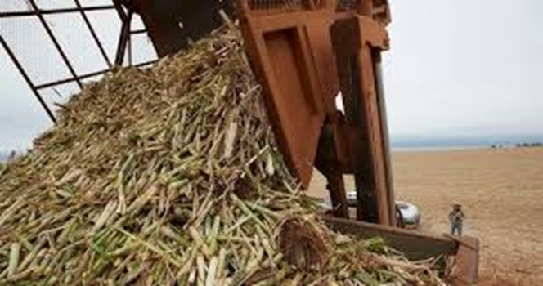

Fig. 1. Value-added agricultural residues.

**- Wood and Forestry Residues:** Wood chips, sawdust and other timber industry by-products are common sources of biomass. It is also shown in Figure 2 that forest thinning and logging residues provide an important biomass supply.

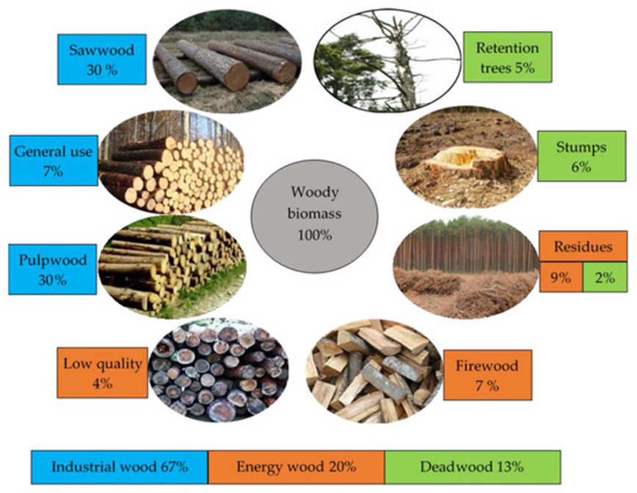

Fig. 2. Utilization of wood and wood residues as a renewable resource in sustainable forest management.

**- Animal Wastes:** Animal manure and other organic waste generated from animal husbandry operations serve as highly valuable resources for producing biogas, as illustrated in Figure 3.

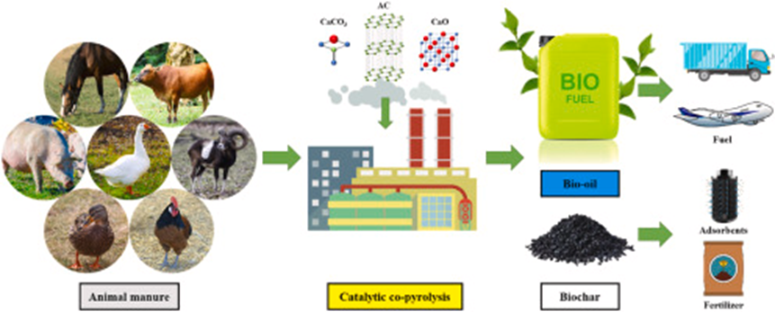

Figure 3. Utilization of animal manure through pyrolysis for bioenergy.

**- Municipal Solid Waste (MSW):** The organic fractions of MSW can be converted into energy through anaerobic digestion or incineration, including food waste and green waste.

Municipal and solid waste comprise a diverse range of materials that can be recycled, all gathered without prior sorting. Besides organic waste, there are various recyclable materials included in the input. Municipal and solid waste typically ranges in density from 0. 1 to 0. 3 Mg/cubic meter. To develop a captivating economic concept, it's crucial to gather and consider customer details on throughput capacity, waste composition, and objectives. A strong plant's bandwidth covers a spectrum from semi-automated to fully automated solutions. A considerable amount of flexibility and stability is needed. The illustration in Figure 4 displays the process of handling municipal and solid waste.

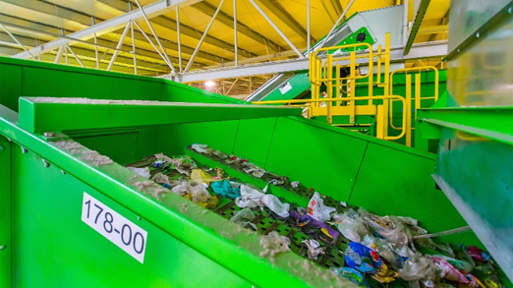

Fig. 4. Municipal and solid waste treatment.

**- Energy Plants:** These plants are grown with the specific purpose of producing energy, such as switchgrass, miscanthus, and rapidly growing trees like poplar and willow. The depiction in Figure 5 showcases the future of energy crops

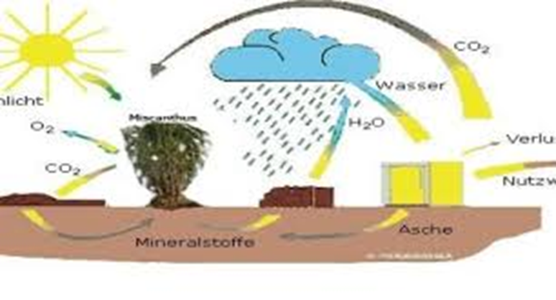

Fig. 5. Next generation energy.

**3. Transformation Technologies**

Biomass can be converted into energy in various technological ways:

**- Incineration:** The simplest method, incineration is the burning of biomass to produce heat. This heat can be used directly or converted into electricity.

**- Gasification:** In this process, biomass is converted into a combustible gas mixture through partial oxidation. This synthesis gas can be used for electricity generation or as a chemical feedstock.

**- Anaerobic Digestion:** Organic matter is broken down by bacteria in the absence of oxygen, producing biogas (a mixture of methane and carbon dioxide) and digestion products that can be used as fertilizer.

**- Pyrolysis:** Biomass is heated in the absence of oxygen to produce bio-oil, syngas and biochar. Pyrolysis is a promising technology for converting biomass into liquid fuels.

**- Fermentation:** Biomass, especially plants rich in sugar and starch, is fermented by microorganisms to produce ethanol, a widely used biofuel.

**4. Environmental Impacts**

The environmental impacts of biomass energy are multifaceted:

**- Carbon Neutrality**: Biomass is generally considered carbon neutral because the CO2 released during combustion is approximately equal to the CO2 absorbed during the growth of the biomass. However, factors such as land use changes and transportation emissions can upset this balance.

**- Deforestation and Land Use**: Large-scale production of energy crops can lead to deforestation and competition with food production, raising concerns about food security and biodiversity loss.

**- Air Quality**: Burning biomass can result in the emission of particulates, NOx and other pollutants, which can affect air quality.

**- Waste Management**: Biomass energy can help reduce waste disposal challenges by converting waste into useful energy.

**5. Biomass in Sustainable Development**

Biomass plays an important role in sustainable development, especially in rural and developing regions:

**- Access to Energy**: Biomass is often the primary source of energy in rural areas, providing cooking fuel and heat. Modern biomass technologies can increase energy access and reduce health risks associated with traditional biomass use.

**- Economic Development**: Biomass production and processing can create jobs and boost local economies, especially in agricultural regions.

**- Tackling Climate Change**: As a renewable energy source, biomass can contribute to reducing greenhouse gas emissions, provided that sustainable practices are employed in its production and utilization.

**6. Biomass Energy in Developing Countries**

In developing countries, biomass is a critical component of energy systems and often accounts for a significant share of total energy consumption. Traditional use of biomass for cooking and heating (such as wood, dung and crop residues) is common, but this use comes with health and environmental challenges. The transition to modern biomass technologies, such as improved cookstoves, biogas plants and biomass-based electricity generation can increase energy efficiency, reduce indoor air pollution and lower greenhouse gas emissions.

**7. Policies and Programs**

Governments and international organizations have recognized the importance of biomass in achieving the sustainable development goals (SDGs). Policies and programs that promote the sustainable production and use of biomass energy are vital. These include subsidies for renewable energy projects, incentives for growing energy crops, and research and development funds for advanced biomass technologies.

South-South cooperation for climate adaptation and sustainable development" was authored by the United Nations Conference on Trade and Development (UNCTAD). It discusses the severe impact of climate change on developing countries and proposes South-South cooperation as a viable solution for building climate resilience. The paper advocates for sharing green industrial policies and establishing a supportive trade and environment agenda at the World Trade Organization (WTO) to help these countries adapt to climate changes while achieving their sustainable development goals. It highlights successful examples of cooperation for climate mitigation and adaptation, offering valuable lessons for the Global South [8].

**8. Challenges and Future Perspectives**

Despite its potential, widespread adoption of biomass energy faces several challenges:

**- Technological Barriers:** Advanced biomass conversion technologies are often expensive and require significant research and development to become commercially viable.

**- Sustainability Concerns:** Ensuring that biomass production does not lead to deforestation, biodiversity loss or food insecurity is a critical challenge.

**- Infrastructure Needs:** Improving infrastructure for the collection, processing and distribution of biomass is essential to support the growth of the biomass energy sector.

However, the future of biomass energy is promising. Advances in technology and the growing need for sustainable energy solutions are likely to spur the expansion of biomass energy globally. Integrating biomass with other renewable energy sources, such as solar and wind, can also increase the resilience and sustainability of energy systems.

**9. Conclusion**

Biomass energy offers a versatile and renewable option to reduce dependence on fossil fuels and contribute to sustainable development. In developing countries, it plays a vital role by providing accessible, affordable and sustainable energy solutions. However, realizing the full potential of biomass energy requires addressing environmental, economic and technological challenges through comprehensive policies, sustainable practices and continuous innovation.

It highlights the importance of biomass in the global energy transition and calls for coordinated efforts to maximize the benefits of biomass while mitigating its potential downsides.

**References**

1. Smith, A., & Johnson, L. (2021). Integrating forest energy into sustainable development: Challenges and opportunities. Renewable and Sustainable Energy Reviews, 134, 110245. https://doi.org/10.1016/j.rser.2020.110245
2. Hakkila, P. (2003). Wood fuel from small-sized trees and cuttings in meeting Finland's energy strategy. Journal of Sustainable Energy, 5(2), 45-56.
3. Demirbas, A. (2009). Biomass feedstocks. Biofuels: Securing the Planet’s Future Energy Needs, 45-85.
4. Panwar, N. L., Kaushik, S. C., & Kothari, S. (2011). Solar greenhouse an option for renewable and sustainable farming. Renewable and Sustainable Energy Reviews, 15(8), 3934-3945.
5. Arora, R., Behera, S., & Kumar, S. (2015). Bioprospecting thermophilic/thermotolerant microbes for production of lignocellulosic ethanol: a future perspective. Renewable and sustainable energy reviews, 51, 699-717.
6. McKendry, P. (2002). Energy production from biomass (part 1): overview of biomass. Bioresource technology, 83(1), 37-46.
7. Bauen, A., Berndes, G., Junginger, M., Londo, M., & Vuille, F. (2009). Bioenergy-a Sustainable and Reliable Energy Source Main Report.
8. UNCTAD, (2022). South-South cooperation for climate adaptation and sustainable development. United Nations Conference on Trade and Development.