**Heat transfer analysis in a trapezoidal corrugated channel with circular** **obstacles at different locations**

***Nasser Abdoul Halim ISMAEL1, [C:\Users\Abdullah\AppData\Local\Microsoft\Windows\INetCache\Content.Word\ORCID-iD_icon-16x16.gif](https://orcid.org/xxxx-xxxx-xxxx-xxxx), SelmaAKÇAY2[[1]](#footnote-1)\*[C:\Users\Abdullah\AppData\Local\Microsoft\Windows\INetCache\Content.Word\ORCID-iD_icon-16x16.gif](https://orcid.org/0000-0003-2654-0702), Maher Abdulhameed Sadeq SADEQ3[C:\Users\Abdullah\AppData\Local\Microsoft\Windows\INetCache\Content.Word\ORCID-iD_icon-16x16.gif](https://orcid.org/xxxx-xxxx-xxxx-xxxx)***

*1* **0009-0003-4779-0847**, *Undergraduate Student of Mechanical Engineering, Çankırı Karatekin University, Çankırı, Türkiye*

*2\** **0000-0003-2654-0702**, *Çankırı Karatekin University, Engineering Faculty, Department of Mechanical Engineering, Çankırı, Türkiye*

*3* **xxxx-xxxx-xxxx-xxxx**, *Undergraduate Student of Mechanical Engineering, Çankırı Karatekin University, Çankırı, Türkiye*

|  |
| --- |
| **Abstract**  Corrugated surfaces significantly improve heat transfer compared to straight channels [1, 2]. For this reason, these surfaces are widely used in many engineering applications, especially in heat exchangers [1-3]. It is reported that obstacles or turbulators placed inside corrugated channels increase heat transfer [4, 5]. The geometry of these obstacles and their location inside the channel significantly affect the flow and heat transfer. This study numerically analyzes the effect of circular obstacles placed at different positions in an asymmetric trapezoidal corrugated channel on the flow and heat transfer. Numerical solutions are carried out with the ANSYS Fluent program. The working fluid is air. There are adiabatic straight sections at the inlet and outlet of the channel. Trapezoidal corrugated surfaces are maintained at a constant temperature (Tw=340K). The study was applied for three different locations of circular obstacles (t: 7 mm, 9 mm and 11 mm) and four different Reynolds numbers (Re: 3000, 4000, 5000 and 6000). For these parameters, channel outlet temperature (Tout), heat transfer coefficient (h), Nusselt number (Nu) and heat transfer enhancement ratio (ER) in the channel were obtained and the results were presented in graphs. To observe the effects of channel geometry, circular obstacles and Reynolds number on flow and heat transfer, flow and temperature contours were obtained at different parameters. As a result of the numerical study, it was observed that heat transfer increased with the increase in channel inlet velocity. It was seen that the location of circular obstacles affected the flow and heat transfer. This study showed that if appropriate parameters were selected, obstacles placed in corrugated channels could significantly increase heat transfer. |

|  |
| --- |
| Keywords: Circular obstacle, Heat transfer, Trapezoidal corrugated channel |

1. **Introduction**

Corrugated surfaces significantly improve heat transfer compared to straight channels [1, 2]. For this reason, these surfaces are widely used in many engineering applications, especially in heat exchangers [1-3]. It is reported that obstacles, turbulators or winglets placed inside corrugated channels increase heat transfer [4, 5]. Geometries of these obstacles and their locations inside the channel significantly affect the flow and heat transfer. For this purpose, many experimental and numerical studies have been carried out. The results of these studies have shown that the geometric structure and location of the turbulators or winglets added to the channel change the heat transfer behavior. [6].

Uysal and Akcay [3] conducted a numerical study on flow and heat transfer behaviour in hybrid corrugated channels and reported that the hybrid corrugated channels improved the heat transfer compared to the uniform wave geometry. Zheng et al. [4] carried out a numerical work investigating the effects of the vortex generators with different geometries on flow and heat transfer and reported that the fluid flow and heat transfer significantly changed by the geometries of the vortex generations. Brodniansk´a, & Kotˇsmíd [5] examined the heat transfer improvement in a new type of wavy channel heat exchanger with circular cylinders. They found that the circular vortex cylinders significantly enhanced heat transfer. Also, they reported that the heat transfer in wavy channels was increased by 1.98 times compared to the straight channel. In a numerical study, Akcay [6] investigated the flow and heat transfer characteristics of winglets placed at the center of a zigzag wavy channel. It was reported that the channel geometry and winglets have a significant effect on improving the heat transfer.

The shape of the wave profile, the geometry of the turbulators added into the channel, their locations, flow and fluid conditions affect the flow and heat transfer [7, 8]. Due to the many parameters to be examined, new research is needed. Therefore, in this study, effects on the flow and heat transfer of the different locations of circular obstacles in an asymmetric trapezoidal wavy channel were numerically examined for turbulent flow regime.

1. **Materials and Methods** 
   1. **Numerical geometry**

In Figure 1 is given the geometry of the asymmetric trapezoidal duct with circular obstacles used in the study. There are adiabatic straight parts with a length of L1 = 100 mm at the inlet and outlet of the duct. The asymmetric trapezoidal duct part (L2) is heated. This part is kept at a constant temperature of 340 K. Circular cylinders are placed inside the wavy duct. Analyses were performed for three different locations of circular obstacles ​​(t: 7 mm, 9 mm and 11 mm). The dimensions of the geometric parameters of the numerical model are indicated in Figure 1.

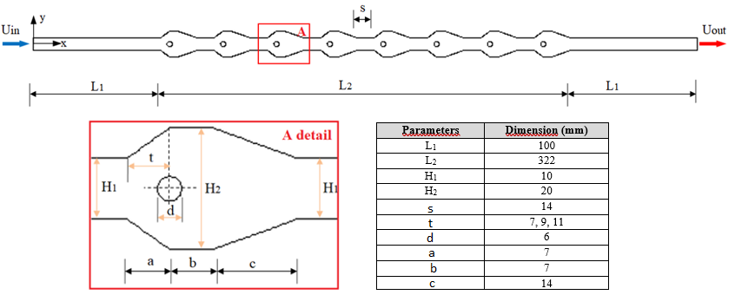

**Figure 1.** Geometry of the numerical model (with details)

* 1. **Governing equations**

In present study, the flow field is two dimensional (2d). Working fluid is air. Air is considered incompressible, single-phase and Newton type. The working fluid flows in turbulent regime and steady case. Viscous terms are ignored. It is assumed that the thermophysical properties of the fluid do not change with temperature and pressure. The effects of radiation and gravity are neglected. The governing equations are given below:

$\frac{∂}{∂x_{i}}\left(ρ{\overline{u}}_{i}\right)=0$ (1)

$\frac{∂}{∂t}\left(ρ{\overline{u}}_{i}\right)+\frac{∂}{∂x_{j}}\left(ρ{\overline{u}}_{i}{\overline{u}}_{j}\right)=-\frac{∂\overline{p}}{∂x_{i}}+\frac{∂}{∂x_{j}}\left[\left(μ+μ_{t}\right)\left(\frac{∂{\overline{u}}_{i}}{∂x_{j}}+\frac{∂{\overline{u}}_{j}}{∂x_{i}}\right)\right]-ρ\overline{u_{i}^{'}u_{j}^{'}}$ (2)

$\frac{∂}{∂t}\left(ρc\overline{T}\right)+\frac{∂}{∂x_{j}}\left(ρ{\overline{u}}_{i}\overline{T}\right)=\frac{∂}{∂x_{j}}\left[\left(Γ+Γ_{t}\right)\left(\frac{∂\overline{T}}{∂x_{j}}\right)\right]$ (3)

$-ρ\overline{u_{i}^{'}u_{j}^{'}}=(μ_{t})\left(\frac{∂u_{i}}{∂x_{j}}+\frac{∂u_{j}}{∂x_{i}}\right)$ (4)

$\frac{∂}{∂t}\left(ρk\right)+\frac{∂}{∂x_{i}}\left(ρk{\overline{u}}_{i}\right)=\frac{∂}{∂x_{j}}\left[\left(μ+\frac{μ_{t}}{σ_{k}}\right)\frac{∂k}{∂x_{j}}\right]+G_{k}-ρε$ (5)

$\frac{∂}{∂t}\left(ρε\right)+\frac{∂}{∂x_{i}}\left(ρε{\overline{u}}_{i}\right)=\frac{∂}{∂x_{j}}\left[\left(μ+\frac{μ_{t}}{σ_{ε}}\right)\frac{∂ε}{∂x_{j}}\right]+C_{1ε}\frac{ε}{k}G_{k}-C_{2ε}ρ\frac{ε^{2}}{k}$ (6)

In this study, the heat transfer in the asymmetric trapezoidal wavy duct with different locations of circular obstacles was investigated at different Reynolds numbers (Re: 3000, 4000, 5000 and 6000).

* 1. **Numerical procedure and boundary conditions**

The numerical study was carried out with the ANSYS Fluent program, which solves with a finite volume approach. The standard k- ε turbulence model was used as the viscous flow model. Governing equations were discretized with the finite volume approach and the velocity-pressure relationship was solved with the SIMPLE algorithm. The convergence criterion was as 10-7 for the energy equations and 10-4 for the other equations. For the mesh independence testing, the Nusselt numbers were calculated for different element numbers. As a result of mesh independence testing, it was determined that 169134 element numbers (for the channel without obstacles) are sufficient for the solutions. The mesh structure of the numerical model is given in detail in Figure 2.

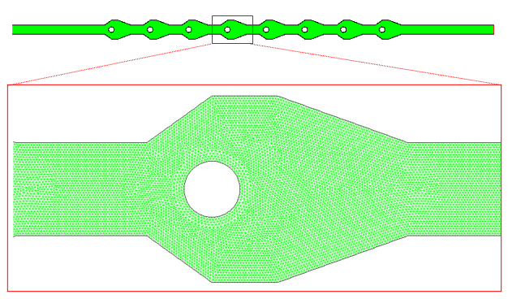

**Figure 2.** Element structures of the numerical model (with details)

The working fluid enters the channel at a constant velocity (Uin) and temperature (Tin=293 K). In the study, Reynolds number varied in the range of 3000≤Re≤6000. The surfaces of the wavy duct (L2) were kept constant at Tw=340 K. The non-slip wall condition is defined for the all walls. The circular obstacles are assumed to be adiabatic and non-slip conditions. The straight parts at the inlet and outlet of the channel are adiabatic.

* 1. **Mathematical Model**

The Reynolds number (Re) is given by Equation (7):

$Re=\frac{ρU_{in}D_{h}}{μ}$ (7)

where, Dh is the hydraulic diameter, ρ is the density, μ is the dynamic viscosity, and Uin is the inlet velocity.

The average Nusselt number (Nu) is calculated by Equation (8):

$Nu=\frac{hD_{h}}{k_{f}}$ (8)

where, h and kf are convective heat transfer coefficient and thermal conductivity, respectively.

$$h=\frac{q"}{{ΔT}_{log}}$$

where, q” and ΔTlog are heat flux and logaritmic temprerature difference, respectively.

Logaritmic temprerature difference is calculated by Equation (9):

${∆T}_{log}=\frac{\left[({T_{w}-T}_{out}{)-(T_{w}-T}_{in})\right]}{ln\left[\frac{\left(T_{w}{-T}_{out}\right)}{\left(T_{w}{-T}_{in}\right)}\right]}$ (9)

where, *Tin*, *Tout*, and *Tw* represent the inlet and outlet temperatures of the fluid and the temperature of the wavy surface, respectively.

The heat transfer enhancement ratio (ER) is described with Equation (10).

$ER=\frac{{Nu}_{w}}{{Nu}_{o}}$ (10)

where, Nuw shows the Nusselt number obtained in the asymmetric trapezoidal wavy duct with circular obstacles, and Nuo indicates the Nusselt number obtained in the asymmetric trapezoidal wavy duct without circular obstacles.

**Results and Discussion**

* 1. **Validation of the numerical results**

The numerical results obtained in this work were validated with the results of previous studies. Wang et al. [9] experimentally investigated heat transfer for the turbulent flow case of air in a straight duct. Figure 3 shows the comparison of the results of this study and Wang et al. [9].

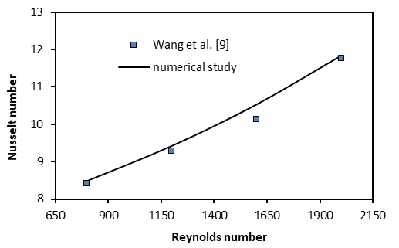

**Figure 3.** Validation of the numerical study

In this study, the velocity, temperature and turbulent kinetic energy contours were obtained to indicate the effects on flow and heat transfer of different locations of the circular obstacles in the asymmetric trapezoidal wavy duct. The contour images were also compared for the case without circular obstacles (t=0).

Figure 4 presents the velocity contours in different locations of the circular obstacles for Re=6000. The circular obstacles in the wavy channel affected the flow fields. The presence of stagnant fluid regions in the wavy cavities in the channel where there are no circular obstacles is noteworthy. It was observed that the fluid contacted the wavy surfaces better at t = 7 mm of the obstacle position. The shift of the obstacles in the flow direction increased the stagnant fluid area in the trapezoidal cavity. It was also observed that the flow passing around the circular obstacles converged at a longer distance at t = 7 mm and at a shorter distance at t = 11 mm.

In Figure 5 indicates the temperature contours in different locations of the circular obstacles for Re=6000. The locations of the circular obstacles significantly affected the temperature distributions. It was observed that the temperature gradient in the channel without obstacles (t=0) was higher than in the channel with obstacles. In channels with obstacles, the temperature gradient was increased by shifting the circular obstacles towards the flow direction. It seen that the temperature gradient of the obstacles at t=7 mm position was lower than that at t=11 mm position.

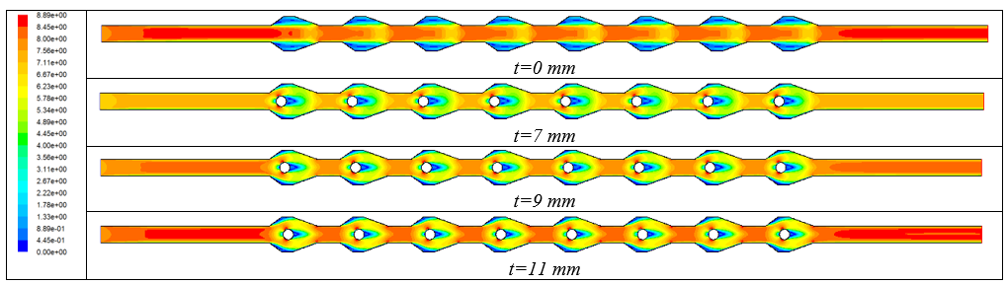

**Figure 4.** Velocity contours for different locations of the circular obstacles at Re=6000

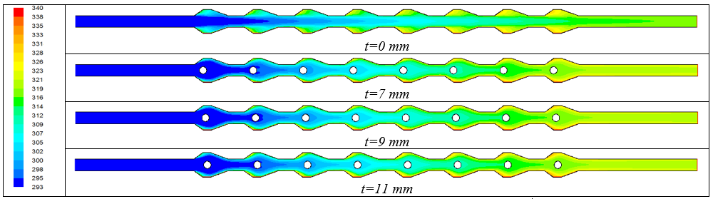

**Figure 5.** Temperature contours for different locations of the circular obstacles at Re=6000

Figure 6 indicates turbulent kinetic energy contours in the asymmetric trapezoidal wavy duct with different locations of circular obstacles for Re=6000. In the channel without circular obstacles, a significant increase in kinetic energy is observed in trapezoidal cavities. In channels with circular obstacles, an increase in kinetic energy is observed around circular obstacles. The shift of circular obstacles in the flow direction has increased the area where turbulent kinetic energy is effective.

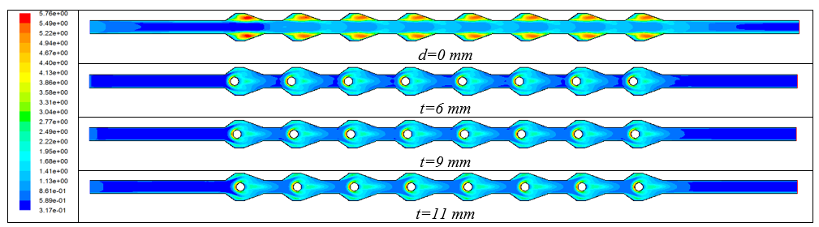

**Figure 6.** Turbulent kinetic energy contours for different locations of the circular obstacles at Re=6000

Figure 7 presents the outlet temperature of the fluid (a), heat transfer coefficient (W/m2K) (b), Nusselt number (c), and heat transfer enhancement ratio (d) with Reynolds number for the asymmetric trapezoidal wavy duct with/without obstacles. It was seen that the outlet temperature decreased with increasing Reynolds number for all channel cases. The highest outlet temperature was found in the channel with t=7 mm obstacle location (Fig. 5a). Increasing Re increased the heat transfer coefficient in all channel flows. The highest heat transfer coefficient was obtained to be h = 51.06 W/m2K in the obstacle location of t=7 mm (Fig. 5b). Increasing Re also increased the Nusselt number in all ducts. It is seen that the higher Nusselt number is found to be Nu = 34.47 in the obstacle location of t=7 mm (Fig. 5c). In Figure 5d, the channel without obstacles is taken as reference and the effects of different obstacle locations on heat transfer enhancement ratio are calculated. Heat transfer enhancement ratio decreased with increasing obstacle locations. At Re=6000, heat transfer in the obstacle location of d=7 mm increased by 1.27 times compared to the channel without obstacles (Fig. 5d).

As seen in Figure 7, the channel outlet temperature, heat transfer coefficient, Nusselt number and heat transfer enhancement ratio obtained at the t=7 mm obstacle location caused a more significant change compared to the other obstacle locations (t=9 mm and t=11 mm). The outlet temperature of the channel, heat transfer coefficient, Nusselt number and enhancement rate values ​​obtained at the t=9 and t=11 mm obstacle locations were found to be very close to each other.

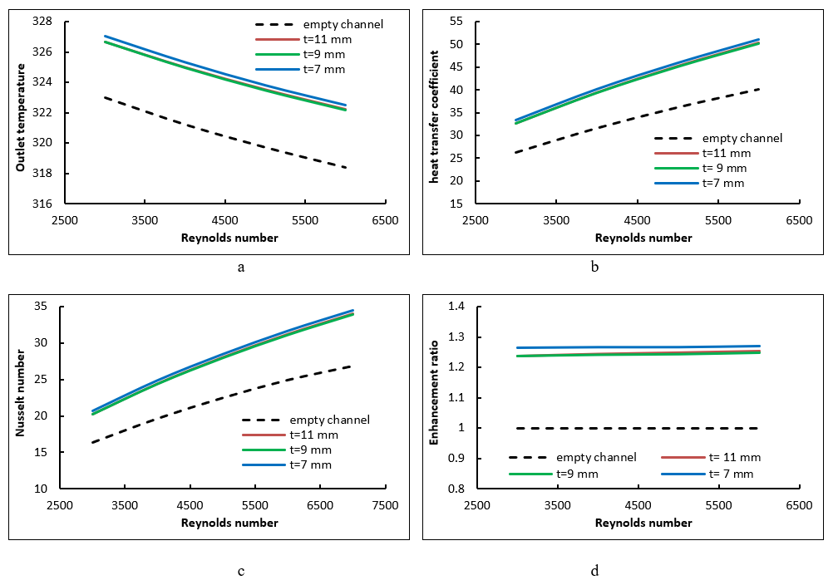

**Figure 7.** a- Outlet temperature, b- Heat transfer coefficient (W/m2K), c- Nusselt number, d- Enhancement ratio with Reynolds number

1. **Conclusion**

In this study, the effects of locations of the circular obstacles on the flow and heat transfer in an asymmetric trapezoidal wavy channel were numerically investigated under turbulent flow regime. The analyses were conducted for different locations of circular obstacles and Reynolds numbers in the range of 3000≤Re≤6000. In the study, the channel outlet temperature (Tout), heat transfer coefficient (h), Nusselt number (Nu) and heat transfer enhancement ratio (ER) obtained for different parameters were given as graphs. The velocity, temperature and turbulent kinetic energy contours were presented in the channel. The main results were given below:

* The locations of the circular obstacles added to the channel affected the flow and heat transfer.
* The outlet temperature of the channel decreased with increasing Reynolds number for all channel flows. The highest outlet temperature was obtained in the channel with t=7 mm obstacle location.
* Increasing Reynolds number increased the heat transfer coefficient in all channel flows. The highest heat transfer coefficient was found in the obstacle location of t=7 mm.
* Increasing Reynolds number increased the Nusselt number in all cases. It is seen that higher heat transfer was provided in t=7 mm obstacle location.
* The heat transfer enhancement ratio decreased with the shift of circular obstacles in the flow direction. At Re=6000, the heat transfer in the obstacle location of t=7 mm increased by 1.27 times compared to the channel without obstacles.
* The outlet temperature of the channel, heat transfer coefficient, Nusselt number and enhancement ratio obtained at the t=9 and t=11 mm obstacle locations were found to be very close to each other.

**Acknowledgement**

In this study, the financial support was provided by The Scientific and Technological Research Council of Turkey (TUBITAK), Project No: 1919B012319076 (2209A, University Students Research Projects Support Program, 2023-2). All numerical work was conducted in Çankırı Karatekin University Computer Laboratory. The authors would like to thanks to all supporters due to their precious contributions.

**References**

1. Alam, T., & Kim, M. H. (2018). A comprehensive review on single phase heat transfer enhancement techniques in heat exchanger applications. *Renewable and Sustainable Energy Reviews*, 81, 813-839.
2. Zhang, J., Zhu, X., Mondejar, M. E., & Haglind, F. (2019). A review of heat transfer enhancement techniques in plate heat exchangers. *Renewable and Sustainable Energy Reviews*, 101, 305-328.
3. Uysal, D., & Akçay, S. (2024). Numerical study of thermal and hydrodynamic characteristics of turbulent flow in hybrid corrugated channels with different wave profiles. *Journal of Mechanical Engineering and Sciences,* 18(2), 10026–10045.
4. Zheng, Y., Yang, H., Mazaheri, H., Aghaei, A., Mokhtari, N., & Afrand, M. (2021). An investigation on the influence of the shape of the vortex generator on fluid flow and turbulent heat transfer of hybrid nanofluid in a channel*. Journal Thermal Analysis and Calorimetry*, 143,1425–1438.
5. Brodniansk´a, Z., & Kotˇsmíd, S. (2023). Heat transfer enhancement in the novel wavy shaped heat exchanger channel with cylindrical vortex generators. *Applied Thermal Engineering*, 220, 119720.
6. Akcay, S. (2023). Numerical analysis of hydraulic and thermal performance of Al2O3-water nanofluid in a zigzag channel with central winglets, *Gazi University Journal of Science*, 36 (1), 383-397.
7. Akcay, S. (2021). Investigation of thermo-hydraulic performance of nanofluids in a zigzag channel with baffles. *Adıyaman Üniversitesi Mühendislik Bilimleri Dergisi*, 8(15), 525-534.
8. Akcay, S. (2022). İçerisinde dik bölmeler bulunan trapez bir kanalda bölme yüksekliğinin akış ve ısı transferine etkisinin incelenmesi. *Bitlis Eren Üniversitesi Fen Bilimleri Dergisi*, 11 (2), 479-490.
9. Wang, G., Qia, C., Liu, M., Li, C., Yan, Y., & Liang, L. (2019). Effect of corrugation pitch on thermo-hydraulic performance of nanofluids in corrugated tubes of heat exchanger system based on exergy efficiency. *Energy Conversion and Management*, [186](https://doi.org/10.1016/j.enconman.2019.02.046), 51–65.

1. \* Corresponding author. *e-mail address: selmaakcay@karatekin.edu.tr* [↑](#footnote-ref-1)