**A Photovoltaic MPPT Algorithm Based on Asymmetric Fuzzy Logic Controller**

***Sarmad khalid waheeb1,2,*, Murat ARI1***

*1Department of Electrical and Electronics Engineering, Graduate School of Natural and Applied Sciences, Çankırı Karatekin Unıversity, Çankırı, Turkey*

*2 Electrical department, Electrical Engineering, Tikrit University, Tikrit, Iraq*

|  |
| --- |
| **Abstract**  Uses Maximum Power Point Tracking (MPPT) Tracking Algorithm to discover and maintain the best operating point. Many other MPPT algorithms have been devised and studied, but most have efficiency, accuracy, and adaptability issues. Conventional controllers can't provide the ideal response due to the non-linearity of the current-voltage characteristics of the PV module and DC-DC converters. This is especially true regarding large-scale parameter changes or line transients. This paper compares two ways to optimize photovoltaically (PV) energy extraction. The maximum power that a PV module can collect varies with load, temperature, and solar radiation. To enhance the efficacy of a photovoltaic (PV) system, a maximum power point tracker (MPPT) gathers the most electricity a solar panel can provide and sends it to the load. The MPPT system contains a controller and a DC-DC converter. This project aims to use fuzzy logic control to create a maximum tracking powerpoint. This is the result of the endeavour. Fuzzy logic controllers are well-suited to nonlinear situations. This technique employs artificial intelligence (AI) to better model nonlinear systems. Buck, Boost, and Buck-Boost converter properties are examined to determine the optimal design for the PV system. The fuzzy logic controller design may be improved by running MATLAB models of PV module, transformer, and battery. According to the simulation findings, the fuzzy logic controller can achieve the desired results. Therefore, it may be used. In this work, two MPPT methods based on controllers are compared. PV systems and the DC-DC architecture are identical in both MPPTs. Thus, they are all equally effective. |
| Keywords: PV, MPPT, Fuzzy logic, DC-DC, PI |

1. **Introduction**

Industrialization and population expansion have boosted energy demand. Due to this challenge, R&D spending for increasing energy efficiency and extending access to renewable and sustainable energy has increased. As energy prices increase and fossil fuel use drops, the technique becomes less common and more costly. Finding a means to acquire the most energy and power at the lowest cost for the desired load is the most critical aspect of switching. Combining energy sources may boost power generation. This allows adjusting the proportion of electricity from each source based on usage. This project aims to create, implement, and optimize maximum power point monitoring and control for photovoltaic (PV), wind, and another renewable energy systems. Photovoltaic (PV) electricity production has grown rapidly in recent years and might replace fossil fuels soon. For this change to occur, photovoltaic (PV) power must be as cheap as fossil fuels. Solar cell material and assembly method are two of the most essential aspects in determining a PV module's efficiency. PV modules are just 12 to 26% efficient in converting solar irradiation into electricity [1]. Gallium arsenide solar cells are 29% efficient [2], whereas silicon cells are 12-14%. Load, module temperature, and solar insulation may all reduce efficiency. A solar module produces the most energy at full power. To do so, you need an MPPT controller. Solar photovoltaic modules are a non-linear power source because terminal operating voltage determines output power. The MPPT can thus tolerate solar cell current and voltage changes. MPPT changes module output voltage and current to find its most efficient operating point. The MPPT in a PV module identifies the module's peak energy output [3].

Because of its low efficiency and high cost per watt, photovoltaic (PV) power systems are seldom used. As a result, more effort must be done to improve PV system efficacy and reliability [4]. Modeling and simulation are the initial stages of improving PV module efficiency. Once a PV module has been accurately modeled and simulated, it may be improved in numerous ways. Several methodologies and tactics have been published on MPT in PV power applications. Most present procedures are inefficient, inaccurate, and sluggish. The accurate and dependable ways for estimating the electricity a PV system can generate in different climates. "Method" refers to fuzzy logic-based MPPT control. The control algorithm uses fuzzy logic's stronger representation and deduction skills to overcome earlier systems' flaws [5].

1. **Objective**

Fuzzy logic is used to design, develop, and install a solar tracker that functions at its maximum power point. Maximum power point tracking requires the use of a fuzzy logic controller and a DC-DC converter [6]. With all this information in hand, we can next evaluate the many different kinds of conversion devices used in photovoltaic (PV) systems and choose the optimal one for our purposes. The findings of a simulation using a solar module and a buck-boost converter indicate the ideal configuration for developing and fine-tuning fuzzy logic control for optimal power tracking.

1. **Photovoltaic Systems**

**3.1. Solar Power Generation Systems (PVs)**

Sunlight is transformed directly into electrons and volts to generate photovoltaic energy. Photovoltaic cells convert light into electricity. Solar photovoltaic (PV) cells are built of light-sensitive diodes like transistors and computer chips. PV cell steps: Semiconductors convert photons to electrons. Positively charged "holes" produced by light recombine with high-energy electrons to produce heat in semiconductors. The link between the two semiconductor types in a PV cell creates an electrical field, a voltage differential is formed. Cell current is drawn via the two terminals.

Photovoltaic (PV) cells create power like chemical batteries. A PV cell's output is limited by parameters such as irradiance, and temperature [7].

**3.2. PV cell characteristics**

The back side is a positive electric field and the front is a negative electric field of the typical silicon semiconducting resources. Solar cells, wires, shields, and supports make up a photovoltaic PV generator. Solar photons clash with a solar cell, breaking atomic bonds and releasing electrons. This "loosening" creates electron-hole pairs, to which positive and negative electrical conductors connect to. Moving electrons produce an Iph symbolized electric current in an electrical circuit. Solar cells operate like diodes when dark. It's a P-N junction that blocks voltage and current. Connecting the cell to a high-voltage external source generates an ID current. 1994 report (Lorenzo). This kind of circuit may be used in single cells, modules, and arrays [8].

How much sunlight is absorbed, the external voltage and the internal resistance of a photovoltaic (PV) cell all affect the amount of current produced. The voltage in a cell decreases to zero in a short circuit, and the current Isc rises. During the open circuit voltage (Voc) of the photovoltaic cell, the cell current does not change, even if the cell circuit is open. The current and voltage product is zero in both open and short circuits, therefore no electrical charge is generated. Circuits that are both open and shorted. A sign convention assigns a positive voltage to the sun because it generates a positive current when touched [8]. Positive voltage is always at cell ends.

1. **DC-DC Converter and Maximum Power Point Tracking**

Here, we'll take a look at three different converter designs (buck, boost, buck-boost). PV modules' power point tracking performance may be optimized using any of these parameters. This data will be used to create a model of the optimum topology, which will be used in simulations to examine the impact of non-ideal components On the output voltage and efficiency of the transformer. Converter components and control techniques may be selected based on simulation findings. Converter models are utilized in a full MPPT to adjust fuzzy logic controls.

**4.1. DC-DC Converters**

The transformer in Figure 1a converts the constant DC input voltage (Vg (t)) into the constant DC output voltage (vo (t)) [9]. The conversion would reduce converter losses. Figure 1b shows a buck-boost circuit with Q, T, L, and C. Modeling must include non-ideal system aspects. Here, the ideal inductor L is, in series, coupled to the resistance RL. Next, we model RC in series with a perfect capacitor; RL and RC may be used to measure inductor and capacitor power loss. Forward voltage drop (VT) is measured in volts, whereas transistor on-site resistance (Rt) is in ohms. Because the transistor's on-state voltage is low, it causes essentially little power loss. Since the transistor’s current is so low, its loses essentially little power when turned off. Pulse width influences average voltage output, not switching time Ts. The duty cycle d (t) in Fig. 1c is proportional to the ratio of the pulse width to the switching period [9].

|  |  |
| --- | --- |
| (a) | (b) |
| **(c)** | |
| **Figure 1**. a) DC-DC converter structure, b)A buck-boost converter circuit [10] and c) The transistor control signal [9]. | |

DC-DC converters do not use resistors to reduce loss. As long as the conditions are ideal, inductors and capacitors are employed. Topologies with different properties may be used to connect or combine electrical components. Buck-boost, buck, and boost converters are the most common. There are buck converters and boost converters. In buck-boost systems, both voltages may be generated.

**4.2. Maximum Power-Point Tracking**

Solar radiation, cell temperature, and operating voltage all influence output power as in Figure 2. The module's working point may be determined by adding a variable load resistance R to its extremities. It can determine the operating point by comparing the load's I-V characteristic to the module's I-V curve junction. Zone I provides the current, whereas Zone II provides the voltage. The internal impedance of the module is greater in Zone I than in Zone II. The Pmp is placed at the power curve's knees. Internal impedance decreases when the temperature rises due to solar radiation.

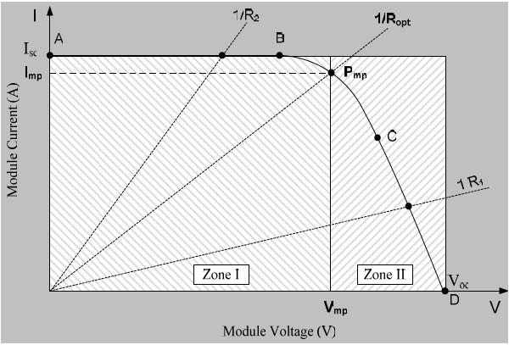

**Figure 2**. The Maximum power-point tracking for PV module [9].

The current flowing via a short-circuit increases. Voltage in the open circuit has decreased. The maximum power transfer hypothesis can only be used if the source and load impedances are equal. The slope of the I/V = I/R line may be able to estimate the characteristic of the load in question. As a result of the module's role as a continuous current source in AB, R is low. When the module is used to produce a constant voltage around Voc, R becomes significant [9].

To discover the maximum power-point by establishing the load and ambient variables that maximize Ropt, or by altering the load directly. A controller may alter the DC-DC converter's duty cycle to adjust the load line.

**4.3. Fuzzy logic Controller Parameter Design**

In this section, we'll look at how fuzzy logic control may be applied to determine the solar system's peak power output. In Simulink/MATLAB, fuzzy logic rules were built using solar panels and buck-boost converters.

### PV Module with MPPT Fuzzy Logic Controller

The Fuzzy controller only considers two state variables. The PV module voltage and current (Vm) must be addressed (Im). This modulator uses PWM to regulate the converter's switching (s). Fuzzy logic controllers use a closed loop system [11] as in Figure 3.

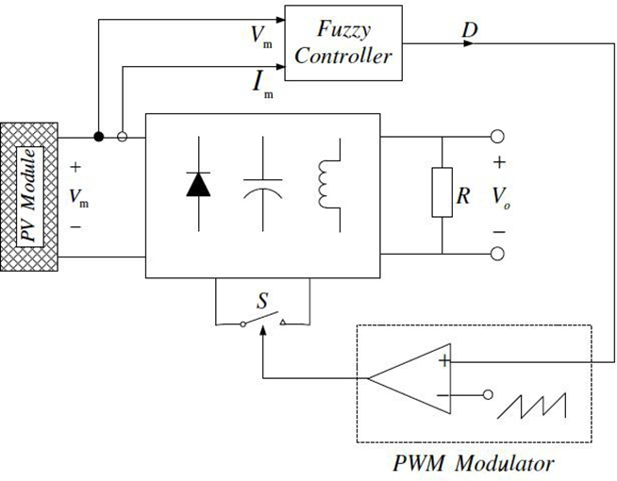

**Figure 3**. The Maximum power-point tracking of PV module [9].

### Function of Membership for proposed fuzzy system

Figure 3 shows fuzzy sets for input and output variables. The fuzzy controller's input and output variables were hazy (low, medium, or high). Figure 4 shows trapezoidal shapes representing membership functions. The PV voltage and current membership ranges have been changed to fit the recommended module of PV Voc 22 V, Isc 15 A and the converter of buck boost. To widen the buck-boost converter's operability, the duty cycle was set between zero and one, indicating the fuzzy controller's output.

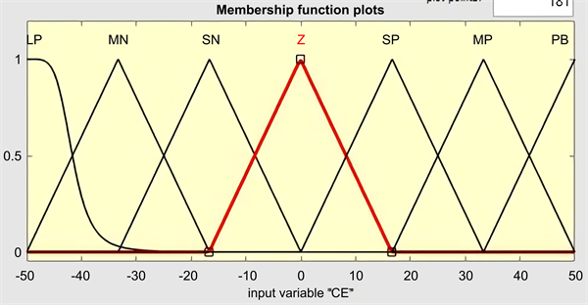

**Figure 4**. Membership functions fuzzy controller

1. **DC-Design Description and Results.**

MPPT, PI, and Fuzzy controllers will be utilized to develop, build, and simulate the Solar Energy management system as in Figure 5. To maximize the PV solar array, a proportional-integral (PI) controller will be created and deployed. We will build a Fuzzy Logic controller and use it to get the most power from solar PV. Adaptive neuro-based fussy inference system controllers for PV MPPT will be built and implemented to assure the highest, most optimal, and desired outputs from the model of solar PV arrays. Models of the SOLAR PV Array system will be simulated using multiple MPPT control methods, including PI and a Fuzzy Logic inference system. SOLAR MPPT's Simulink Design Model for Energy management system includes measurements, response outputs, and results monitoring.

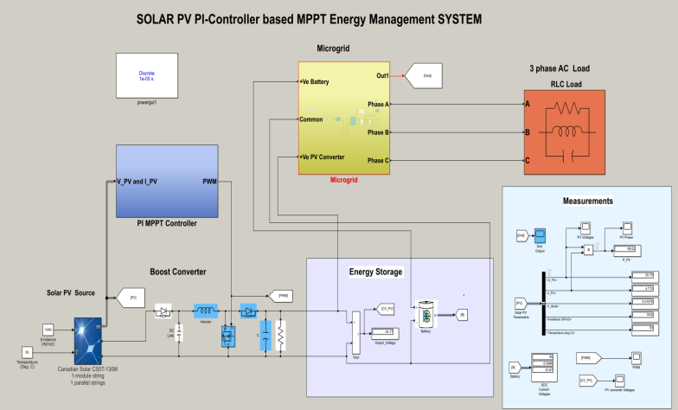

**Figure 5**. Complete Simulink Model Design SOLAR PV-based MPPT ENERGY Management System

**5.1. PV Results with PI MPPT controller:**

It is observed that the simulation of the PI system delivers the battery output voltages of 23 V at a state of charge of 50, and the power of PV is almost 99 Watts, the voltages supplied by the PV system is 20 v, and the current drawing through PV system is 4.7 amp, at applied solar radiation of 1000 watt/m^2 with solar heat up to 50-degree centigrade (Figure 5.1). The response indicates the output waveform of solar PV system maximum power delivered by PV system through MPPT with PI technique is shown in Figure 6a. The voltage waveform of the PV system is shown in Figure 6b, and the supplied voltages of the PV are shown in the figure.

|  |  |
| --- | --- |
| (a) | (b) |
| **Figure 6**. a)PV power with PI controller and b)PV Voltages signal | |

**5.2. PV Results with Fuzzy MPPT controller:**

It is observed that the simulation of the Fuzzy system delivers the battery output voltages of 23 V at a state of charge of 50, and power of PV is almost 106 Watts, the voltages supplied by the PV system is 22 v and current drawing through PV system is 4.7 amp, at applied solar irradiance of 1000 watt/m^2 with solar heat temperature of 50-degree centigrade (Figure 7a). The response indicates the output waveform of the solar PV system with maximum power delivered by the PV system through MPPT with the Fuzzy technique presented in Figure 6. The voltage waveform of the PV system is shown in Figure 7b.

|  |  |
| --- | --- |
| (a) | (b) |
| **Figure 7**. a)PV Power with Fuzzy Control and b) PV voltages with Fuzzy Control MPPT | |

1. **Conclusion**

The maximum power point tracking of PV modules and open defects allowed us to do this. To keep tabs on the most efficient use of energy, we suggested developing and using a fuzzy logic technique. Several components and subsystems were examined and modelled. The optimum power-point tracker model was created by combining the models that had been validated. In order to see whether the algorithm works in the real world. There were studies done on the most efficient buck-boost converter topologies for the highest-power tracker. buck-boost converter and solar panel were tested using Simulink. The Fuzzy-Logic Toolbox in MATLAB was used to construct fuzzy logic.

Our MPPT model was constructed using the fuzzy logic controller, PV modules, and converter models. Our results show that the PV module model is accurate and can be used to imitate the performance of any solar panel by using its data sheet specifications. According to our calculations, the fuzzy logic approach is 94.49% effective in a variety of noise and interference-filled environments. The fuzzy controller enhances maximum power-point oscillations, speed, and parameter sensitivity compared to the regular MPPT controller. Fuzzy logic controller rules may be identified and allocated for both small- and large-signal operations.

**References**

1. Ocran, T.A. et al, “*Artificial Neural Network Maximum Power Point Tracker for Solar Electric Vehicle, Tsinghua Science & Technology,* ” Vol. 10, No. 2, pp. 204-208, 2005.
2. Xiaoting Wang, John Byrne, Lado Kurdgelashvili1 & Allen Barnett (2012). Introduction. “*High-efficiency photovoltaics: on the way to becoming a major electricity source*. ”
3. W. Wu, N. Pongratananukul, W. Qiu, K. Rustom, T. Kasparis, and I. Batarseh, “*DSP-based multiple peak power tracking for expandable power system,*” in Conference Proceedings - IEEE Applied Power Electronics Conference and Exposition - APEC, 2003, vol. 1, pp. 525–530. doi: 10.1109/apec.2003.1179263.
4. X. Sun, W. Wu, X. Li, and Q. Zhao, “*A research on photovoltaic energy controlling system with maximum power point tracking,*” in Proceedings of the Power Conversion Conference-Osaka 2002, PCC-Osaka 2002, 2002, vol. 2, pp. 822–826. doi: 10.1109/PCC.2002.997626.
5. S. Assahout, H. Elaissaoui, A. el Ougli, B. Tidhaf, and H. Zrouri, “*A Neural Network and Fuzzy Logic based MPPT Algorithm for Photovoltaic Pumping System,*” International Journal of Power Electronics and Drive Systems (IJPEDS), vol. 9, no. 4, p. 1823, Dec. 2018, doi: 10.11591/ijpeds.v9.i4.pp1823-1833.
6. A. Ulinuha and A. Zulfikri, “*Enhancement of solar photovoltaic using maximum power point tracking based on hill climbing optimization algorithm,*” in Journal of Physics: Conference Series, May 2020, vol. 1517, no. 1. doi: 10.1088/1742-6596/1517/1/012096
7. Chouder, A., F. Guijoan, and S. Silvestre. "*Simulation of fuzzy-based MPP tracker and performance comparison with perturb & observe method.*" Revue des Energies Renouvelables 11.4 (2008): 577-586.
8. D. S. Karanjkar, S. Chatterji, A. Kumar, and S. L. Shimi, “*Fuzzy adaptive proportional-integral-derivative controller with dynamic set-point adjustment for maximum power point tracking in solar photovoltaic system,*” Systems Science and Control Engineering, vol. 2, no. 1, pp. 562–582, 2014, doi: 10.1080/21642583.2014.956267.
9. G. A. Kouzaev, Borje. Forssell, Geir. Oien, and WSEAS (Organization), “*Advanced Applications of Electrical Engineering* ,” Proceedings of the 7th WSEAS International Conference on Application of Electrical Engineering (AEE’08) : Trondheim, Norway, July 2-4, 2008. WSEAS Press, 2008.
10. A. Faizal, Sutoyo, Mulyono, R. Yendra, and A. Fudholi, “*Design maximum power point tracking (MPPT) on photovoltaic panels using fuzzy logic method*,” American Journal of Engineering and Applied Sciences, vol. 9, no. 4, pp. 789–797, 2016, doi: 10.3844/ajeassp.2016.789.797.
11. M. Venkateshkumar, “*Fuzzy Controller-Based MPPT of PV Power System,*” in Fuzzy Logic Based in Optimization Methods and Control Systems and its Applications, InTech, 2018. doi: 10.5772/intechopen.80065.