**FABRICATION OF RAINWATER HARVESTING FILTER WITH FOG COLLECTOR FOR CLEAN WATER HARVESTING IN VILLAGES**

Tze Ching ONG1*, Syed Amirul Mustaqim Bin SYED GHAZALI JALALULIN2, Jia Hang WU3 Chung Mee TIONG4, Dshine Deyol5, *Denilson Laja Anak JOSEPH6, Dayang Atiq Izzati7

tze@poliku.edu.my, Politeknik Kuching Sarawak, Malaysia, https://orcid.org/0000-0002-7126-33211

syed_amirul@poliku.edu.my, Politeknik Kuching Sarawak, Malaysia2

jhwu@poliku.edu.my, Politeknik Kuching Sarawak, Malaysia3

tchung_mee@yahoo.com, SJK Chung Hua Sungai Tapang Batu Kawa, Malaysia4

dshinedeyol@gmail.com, Politeknik Kuching Sarawak, Malaysia5

denilsonlaja0@gmail.com, Politeknik Kuching Sarawak, Malaysia6

atiqizzati93@gmail.com, Politeknik Kuching Sarawak, Malaysia7

Safe and clean water is essential for public health, whether it is used as drinking water, domestic usage, food production, irrigation, or for recreational purposes. Rainwater harvesting and fog collecting are integrated environment-friendly systems to produce renewable feedstock or water supply in the efforts to help reach the Sustainable Development Goals (SDG). Most of the villages in Kuching, Sarawak are supplied with water tanks to harvest the rainwater from the roof by collecting the rainwater in gutters. Therefore, the rainwater may be contaminated with residues such as dry leaves, rotting leaves, dead plants, twigs and others. Rainwater harvesting can be problematic, particularly within the dry season, although there might be a significant amount of fog in the mountainous areas of the country. Hence, this project aims to fabricate a rainwater filter integrated with a fog collector to obtain clean water. The system can channel up to 90% of rainwater into the storage tank. The system consists of a self-designed and 3D-printed body with a mesh filtration tube as the core to collect large residues before the rainwater drops into the storage tank. Meanwhile, the fog collector works to capture water from the ambient using the concept of a fog harp utilizing vertical parallel wires. In the post-testing, it is found that the system was able to channel up to 92.6% of water. Meanwhile, the fog collector was able to accumulate 485ml volume of water for 5 days period at Kampung Duyoh hilltop village. It is also noted that the system is relatively easy to operate, requires low maintenance, and has a reasonable cost. In the end, the objectives of fabricating a rainwater filter with a fog collector are successfully achieved and can be utilized by the villagers to obtain clean water and water supply.

**1. INTRODUCTION**

Water is our most precious natural resource and essential for all life. It plays an important role in transforming the lives of people into better and healthier ones. Clean water and sanitation belong to one of the 17 sustainable development goals (SDG) under goal number 6. It aims to achieve universal and equitable access to safe and affordable drinking water for all, provide adequate and equitable sanitation and hygiene for all and end open defecation, paying special attention to the needs of women and girls and those in vulnerable situations. These can be successfully achieved by substantially increasing water-use efficiency across all sectors and ensuring sustainable withdrawals and supply of freshwater to address water scarcity. Therefore, these measures will reduce the number of people suffering from water scarcity and improve the water quality through various methods such as reducing pollution, eliminating dumping and minimizing the release of hazardous chemicals and materials, halving the proportion of untreated wastewater and increasing recycling and safe reuse of water. Hence, these are very important for sustainable development as it helps in poverty reduction, economic progress, and environmental sustainability. However, in recent decades, environmental destruction, pollution, and climate change happen drastically globally due to human activity. From United Nations facts and figures (Nations, n.d.), two billion people live without safely managed drinking water services in the year 2020, with 1.2 billion people lacking even a basic level of service.

Utilization of the rainwater harvesting system can reduce the demand for mains water supply. A simple and carefree method for harvesting rainwater is essential to make it more sustainable and the easiest method is rooftop rainwater harvesting. Rainwater harvesting for house systems comprises some basic components (Figure 1). The rooftop will be the catchment area to capture rainfall. Then, a conveyance system such as a gutter will move the captured rainwater from the roof to a storage tank and a storage tank is used to store the rainwater for future usage. Finally, a distribution system is installed to flow the rainwater for various purposes such as garden/lawn irrigation, toilet flushing, clothes washing, car washing, showering/bathing, and even for drinking (after water treatment methods). Treatment of rainwater is typically performed by the diversion of the first flush and the use of strainers to retain gross particles (e.g. leaves) (Ltd., n.d.).

**Figure 1: Rainwater harvesting system for house [2]**

The rainwater harvesting methods vary from traditional to modern solutions and it evolves rapidly. Traditional rainwater harvesting is a process that requires the concentration, collection, and storage of rainwater such as the Khadin system. Khadin is a water conservation system designed to store surface runoff water from sloping farmland to form a reservoir. This helps moisten the soil and helps in preventing the loss of topsoil. Additionally, spillways are provided to ensure that excess water is drained off to the shallow dug well. This system of water conservation is common in the areas of Jaisalmer and Barmer in Rajasthan (Teachoo, 2023). As time passes, the rainwater harvesting method develops into a more holistic and sustainable strategy. In the modern world, the rainwater harvesting practice has evolved using different types of techniques to collect and store rainwater from rooftops and land surfaces. Among the modern types of rainwater harvesting devices in the market is the Wisy Vortex filter. The product is a unique patented design that uses the principle of adhesion, where water ‘sticks’ to a smooth surface, in this case, the outer layer of a vertical cylinder. This process causes the water to ‘pull’ through the fine mesh inner layer, leaving behind any leaves, insects, and any other particles greater than 0.28mm. The vortex filter also oxygenates the water to keep quality at its peak and inhibit the growth of anaerobic bacteria, which can cause the water to develop a bad odor (Ag, n.d.). Then, there is the Superhead Leaf Screen, a conventional method of installing the downpipe in any building vertically from top to bottom. The rainwater catchment area is normally placed on the roof, and the collected rainwater will flow down in the pipe vertically at high speed. By utilizing the gravitational force with the speed of rainwater flow, the rainwater can pass through the filter screen right below the inlet easily due to the extra downward force. This design enhances the filtration efficiency as the particles are quickly removed without contaminating the filter screen (Solutions, 2021). There is also FSP first flush filter collector as shown in Figure 2 that has a dual function which is filter & first flush. The concept follows vertical filtration and provides effective separation of collected rainwater from sediment, leaves, moss & insects. It has fine filtration that prevents mosquitoes from breeding and maintains a full cross-section of downpipe which means no obstruction of rainwater flow. This device can be easily connected to round or other types of rainwater downpipes (Store, 2023).

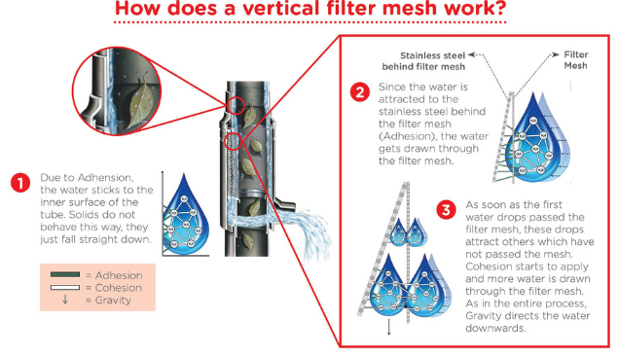

**Figure 2: FSP First Flush Filter Collector [6]**

Meanwhile, fog harvesting provides an alternative source of freshwater through a technique used to capture water from wind-driven fog. Fog harvesting is a non-conventional method to produce freshwater. Fog is one of those water resources and it is important to maximize renewable resources such as water and elaborates the role of textiles to enhance the efficiency of fog water collectors. Fog is composed of micrometer-sized water droplets that form when the air becomes saturated with water vapor. Fog is a thick cloud that remains suspended in the atmosphere. Water condenses onto the array of parallel wires and collects at the bottom of the net. This requires no external energy and is facilitated naturally through temperature fluctuation, making it attractive for deployment in less developed areas. Fog harvesting systems are typically installed in areas where the presence of fog is naturally high, typically coastal and mountainous regions (Bhushan, 2020). Fog can be harvested using simple and low-cost collection systems and afterward, the captured water can then be used for agricultural irrigation and domestic use. The systems are usually consisting of a mesh net in between two posts that are spread out at an angle perpendicular to the prevailing wind carrying the fog. As the wind passes through the mesh, drops of freshwater form and drip into an underlying gutter to lead the water into a storage tank (Network, 2016).

On the other hand, the fog harvesting technology also can consist of a double-layer mesh net supported by two posts rising from the ground. Mesh panels can be varied in size, design, and type of material used which contribute to the efficiency of fog harvesting. Among the high-efficiency fog collector is the heterogeneous rough conical wires. The artificial periodic roughness-gradient conical copper wire (PCCW) can harvest fog on periodic points of the conical surface from air and transports the drops for a long distance without external force. The effectiveness of the fog collector depends on the tilt angle (Xu et al., 2016). Then, there is the fog harp method inspired by linear needles of redwood trees where vertical wires were used compared to traditional mesh structures. Research findings illustrated the fog harp collected more water either in light or moderate fog conditions when compared to mesh harvesters. An optimal fog harp (Figure 3) should feature high-tension, uncoated wires within a large aspect ratio frame to avoid tangling and promote efficient and reliable fog harvesting(Shi et al., 2020). In addition, there is the cactus kirigami type where the simplified cactus-inspired fog collecting spines from a 3D cone to a 2D triangle. The wax-infused kirigami with an anisotropic shape can reproduce the efficient capture of fog droplets through rapid refreshing of the collecting interface. Research showed the harvesting rate improved significantly compared to harp-like and plate collectors with lower costs (Bai et al., 2020).

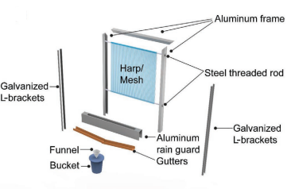

**Figure 3: Fog Harp [10]**

Safe and readily available water is important for public health, whether it is used for drinking, domestic use, food production, or recreational purposes. Improved water supply and sanitation, as well as improved management of water resources, may help countries develop economically and reduce poverty. Everyone has the right to sufficient, continuous, safe, acceptable, physically accessible, and affordable water for personal and domestic use. Contaminated water can lead to diseases such as cholera, diarrhea, dysentery, hepatitis A, typhoid, and polio. While inadequate management of urban, industrial, and agricultural wastewater means the water of hundreds of millions of people is dangerously contaminated or chemically polluted. The natural presence of chemicals, particularly in groundwater, can also be of health significance, including arsenic and fluoride, while other chemicals, such as lead, may be elevated in drinking water because of leaching from water supply components in contact with drinking water (Organization, 2023).

Despite several products available in the market that can produce or filter rainwater, most of the people in Kuching, Sarawak is still unaware of or do not use them. From the observation, many of the villagers in rural areas were given free water tanks as the water reservoir for rooftop rainwater harvesting. However, it is not equipped with any water filtering system for clean water. This contributes to the unclean water catchment and dirty water shortage with residues such as leaves, dirt, or dust, especially during the dry season. Therefore, the objectives of the project are to fabricate a rainwater water filter combination of fog collectors for water harvesting and conduct post-testing to evaluate the performance of the fog collector. Some of the scope and limitations of this project are a maximum of 5 days to collect water storage for the post-testing due to the hot season in Kuching, Malaysia which is in the month of May to August and only one outdoor field site was selected for fog harvesting.

**2. Methodology**

The development of the rainwater harvesting filter with a fog collector was based on the flow chart in Figure 4.

Start

End

Design

Fabrication and printing of main body, leaf filter and fog frame

Assembly process

Finishing

Testing

Yes

No

**Figure 4. Flow chart of rainwater harvesting filter with fog collector**

The first process is the design process using Autodesk Inventor. Figure 5 shows the final design of the project. During this process, various sketches were developed based on the literature review conducted and the final design was selected from a morphology chart with criteria such as filter type, size, effectiveness, cost and technical aspect taken into consideration.

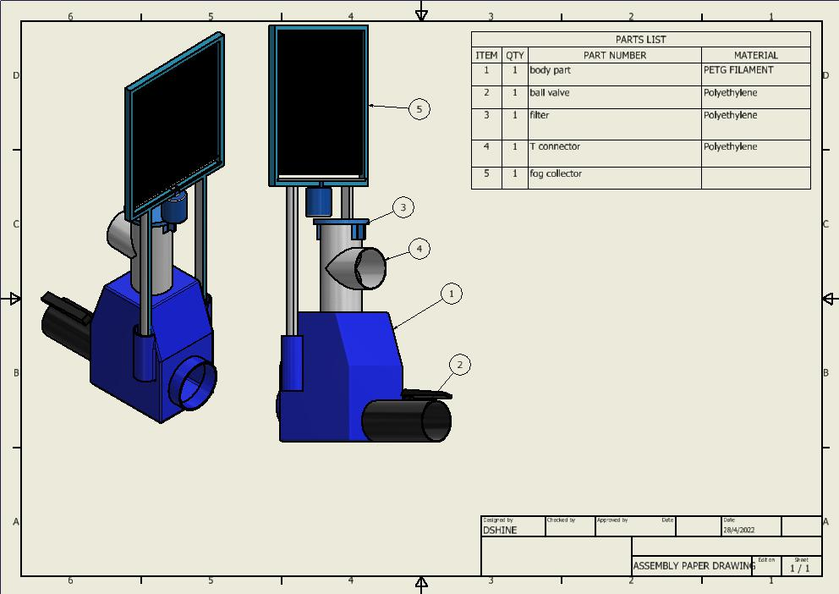

**Figure 5: rainwater harvesting filter with fog collector using Autodesk Inventor**

Once the final design was determined, the next step was the printing process of the main body. The body for the rainwater filter and ‘cap’ (Figure 6) were designed using Inventor software with the dimension of 20 x 12 x 21 cm while the diameter of the ‘cap’ of 11cm. Then, the designed parts were transferred to Ultimaker Cura software to slice the model. The software estimated and calculated the route and the amount of filament required to print the parts. Next, the software generated the G-Code files. The sliced files were uploaded into the 3D printer for the printing process. Eventually, the final touch was required to remove the unwanted filament on the printed parts.

|  |  |
| --- | --- |
| **3d printing rainwater filter body**  (a) | **WhatsApp Image 2022-08-17 at 6.22.57 PM**  (b) |

**Figure 6: 3D printed parts; (a) Filter body, (b) Cap**

As for the leaf filter, a length of 320mm with 78mm diameter PVC pipe was cut vertically using a hand grinder and divided into four equal parts from the bottom. Then, a rectangle with a length of 140mm was created on both sides of the pipe. After finishing the cutting process, to attach the PVC netting as the leaf filter (Figure 3.7 (a)), a hole was made to attach the netting to the pipe by thrusting it with a hot nail. Then, the pipe was aligned to the hole in the middle of the T-connector and marked. The marked part was then drilled (Figure 3.7(b)). Then the hole was polished and the printed cap was attached to the filter pipe using pipe-fitting tape (Figure 3.7 (c)). Subsequently, the T-connector was cut vertically with a length of 3cm on both sides using a hand grinder to slot in the cap for the leaf filter insertion.

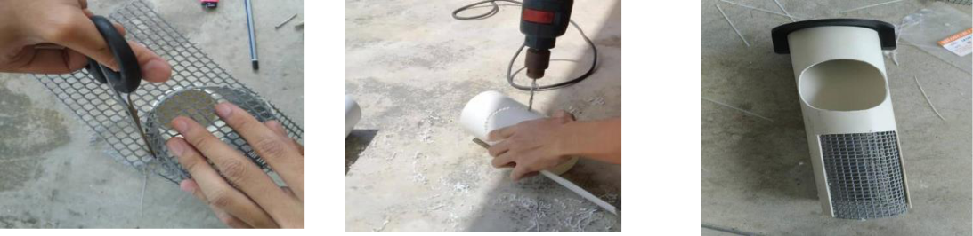

(a) (b) (c)

**Figure 7: Leaf filter-making process; (a) Attach PVC netting to pipe, (b) Drilling Pipe, (c) Leaf Filter**

As for the fog collector, a PVC pipe with a diameter of 20mm was cut to form a 29cm x 33cm frame (Figure 8 (a)). To support the frame, the PVC pipe was cut to various lengths of 8cm, 10cm and 37cm for 2 pieces each (Figure 8 (b)). All the pipe was connected using the T and L connectors. Next, the bottom part of the frame was cut into half to form a gutter for the water to flow (Figure 8(c)). Finally, two 4.5mm stainless steel rods were inserted into the frame horizontally through the holes and fishing lines were attached around the rod vertically to form the fog collector.

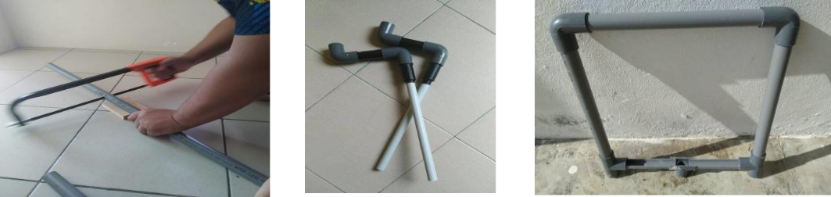

(a) (b) (c)

**Figure 8: Making fog collector, (a) Cutting Pipe, (b) Poles, (c) Gutter**

Finally, all the components were assembled and a ball valve was attached to the main body too as the overflow valve and dirt trap. Post-testing was conducted by placing a rainwater harvesting filter with a fog collector on the ground level and hilltop level at Kampung Duyoh, Bau for 5 days. The volume of the water accumulated in 5 days was taken as the results to determine the best placement of the fog system. To evaluate the effectiveness of the filter, we also tried to pour 10 liters of water containing dry leaves into the filter system. A short post-testing survey was also conducted using questionnaire distribution to seven villagers in the same village to obtain their feedback on this innovation project.

* 1. **Results and discussion**

The completed rainwater harvesting filter with a fog collector is shown in Figure 9. The filter is simple via less maintenance at a relatively low cost as compared to modern and complex filters which are available in the market. Additionally, this will encourage the replication by the community and industry to achieve clean water to support the SDG activity.

|  |  |
| --- | --- |
| (a) | (b) |
| (c) | (d) |

**Figure 9: Completed rainwater harvesting filter with fog collector; (a) Plan (b) Isometric (c) Front (d) Side**

The operation of the rainwater harvesting filter with a fog collector is straightforward. First, a single person is adequate to install the filter on the rooftop with the filter inserted into the rainwater filter body through the 80mm T connector pipe (Figure 10 (a)). Then the fog collector poles are inserted into the slot beside the body (Figure 10 (b)) and a hose is used as the funnel to channel the fog water to the filter through the cap. After the device is assembled, the other part of the T connector is connected to the roof pipe where the water flows from the roof gutter while the outlet for the water is at the opposite chamber for the ball valve. Figure 10 (c) shows the water flow and the initial point is when the water flows from the roof to the gutter during rain and turns into the water inlet from the roofing pipe to pass through the filter mesh. The blue arrows indicate water movement and any particles that are larger than the size of the mesh will be filtered. Next, the clean water will flow out from the filter compartment into the water tank as the outlet. The remaining water with heavy residues might be trapped at the bottom of the body compartment and can be removed by using the ball valve. Meanwhile, the fog collector functions when abundant fog is trapped by the fog harp. The accumulated water will flow to the gutter and the body compartment through the hose connected as a funnel.

|  |  |
| --- | --- |
| (a) | (b) |
| (c) | |

**Figure 10: Installation of the** **rainwater harvesting filter with fog collector; (a) Leaf filter (b)Fog collector (c) Operation**

Figure 11 shows the water quality and leaves filter for the post-testing. It is quite obvious that the leaf filter works well with a lot of trapped leaves (Figure 11 (d)) via cleaner water in Figure 11 (b). From the observation, only small residues and particles can pass through the mesh. Therefore, this filter is the best method to produce clean rainwater for houses built in estates or farms which surrounding areas covered with trees. During the post-testing also, it is found the efficiency of the rainwater filter is 92.6% with 740ml collected as blowdown water with some heavy residues such as sand through the ball valve.

|  |  |
| --- | --- |
| (a) | (b) |
| (c) | (d) |

**Figure 11: Post-testing; (a) water with dry leaves (b) water after filtration (c) Empty leaf filter (d) After water filtration**

Subsequently, the fog collector was installed at the ground level and hilltop in Kampung Duyoh, Bau, Sarawak and the results are shown in Figure 12. After being left for 5 days, the volume of water collected is tabulated in Table 1. During the post-testing, no rain occurred and therefore, the accumulated water was assumed from the fog itself only. From the figure and table, it is clear and visible the fog collector works fabulously with clean droplets collected and free from impurities after 5 days. The results also show the suitable location to install a fog collector is on the hilltop compared to ground level. This argument is coherent with the literature (Bhushan, 2020) stated geographical position will determine the amount of fog collected. Therefore, this can be suggested that the fog collector serves as the main alternative to obtain clean water, particularly for the hilltop residents.

**Table 1: Fog collector performance**

|  |  |
| --- | --- |
| **Area** | **Volume (mL)** |
| Ground | 360 |
| Hilltop | 485 |

|  |  |
| --- | --- |
| (a) | (b) |
| (c) | (d) |

**Figure 12: Fog collector; (a) 1 day at ground level (b) 5 days at ground level**

**(c) 1 day at hilltop (d) 5 days at hilltop**

As for the quantitative post-testing survey, it is found that samples which consist of seven villages agreed on the filter with fog collector machine can provide a cleaner water supply to the existing rainwater rooftop system. The main advantages of the current filter system are it does not require any electricity to operate, has minimal maintenance, has easy installation and can be fitted into existing piping systems. Lastly, the cost of this machine is approximately RM 214.68 (Table 2) which is a relatively cheaper option when compared to the filters sold in the market. Hence, this filter is an attractive option and recommended for small and medium hilltop farms and estate villagers.

**Table 2: Cost of the filter**

|  |  |  |  |  |
| --- | --- | --- | --- | --- |
| **No.** | **Material** | **Quantity** | **Price Per Unit (RM)** | **Total Cost**  **(RM)** |
| 1 | 19mm pvc pipe (3 meter) | 1 | 3.50 | 3.50 |
| 2 | 20mm pvc pipe (2meter) | 1 | 10.50 | 10.50 |
| 3 | 75mm pvc pipe | 1 | 17.50 | 17.50 |
| 4 | PVC netting (1m x 1m) | 1 | 5.50 | 5.50 |
| 5 | Cable tie | 1 | 1.00 | 1.00 |
| 6 | 45mm stainless steel rod | 1 | 10.00 | 10.00 |
| 7 | 50mm ball valve | 1 | 21.00 | 21.00 |
| 8 | 3D printed body + cap | 1 | 122.08 | 122.08 |
| 9 | 80mm T connector pipe | 1 | 12.50 | 12.50 |
| 10 | 20mm T connector pipe | 2 | 1.95 | 3.90 |
| 11 | 20mm elbow | 6 | 1.20 | 7.20 |
|  |  |  |  | 214.68 |

**CONCLUSION**

The objective of this project is successfully achieved as the rainwater harvesting filter with fog collector is produced. The post-testing results also produced positive outcomes when 92.6% of clean water passed through the filter with big residues such as leaves collected by the mesh and 485mL of water collected from the fog collector after 5 days at the hilltop of the test field site. A qualitative survey also obtained positive feedback from the villages. Lastly, the cost of this filter is RM214.68 and this makes it very affordable in the market when compared to complex filters. With the aforementioned features and benefits, this filter can be utilized in activities to obtain clean water for the sustainability of the earth in long-term prospects. As for the suggestion to improve the current design, more empirical work on the fog collector can be done as variables such as tilt-angle and mesh-gap might play crucial roles in fog harvesting.

**REFERENCES**

Ag, W. (n.d.). *WISY AG | WFF 100 Process- and Rainwater Filter*. Retrieved April 17, 2023, from https://wisy-water.com/en/products/rainwater-filter/vortex-filter/wff-100

Bai, H., Zhao, T., Wang, X., Wu, Y., Li, K., Yu, C., Jiang, L., & Cao, M. (2020). Cactus kirigami for efficient fog harvesting: Simplifying a 3D cactus into 2D paper art. *Journal of Materials Chemistry A*, *8*(27), 13452–13458. https://doi.org/10.1039/d0ta01204a

Bhushan, B. (2020). Commercial Applications, Projections of Water Collection, and Design of Water Harvesting Towers. *Springer Series in Materials Science*, *299*, 155–160. https://doi.org/10.1007/978-3-030-42132-8_6

Ltd., A. E. S. P. (n.d.). *Rainwater Harvesting for House | Rainwater Harvesting System for House | Top Benefits of Rainwater Harvesting for House*. Retrieved April 17, 2023, from https://www.neoakruthi.com/blog/rainwater-harvesting-for-house.html

Nations, U. (n.d.). *Water and Sanitation - United Nations Sustainable Development*. Retrieved April 17, 2023, from https://www.un.org/sustainabledevelopment/water-and-sanitation/

Network, T. C. T. C. and. (2016). *Fog harvesting*. https://www.ctc-n.org/technologies/fog-harvesting

Organization, W. H. (2023). *Drinking-water*. https://www.who.int/news-room/fact-sheets/detail/drinking-water

Shi, W., van der Sloot, T. W., Hart, B. J., Kennedy, B. S., & Boreyko, J. B. (2020). Harps Enable Water Harvesting under Light Fog Conditions. *Advanced Sustainable Systems*, *4*(6), 1–10. https://doi.org/10.1002/adsu.202000040

Solutions, B. W. (2021). *Superhead First Flush Rainwater Tank Filter*. https://baobabwater.co.za/products/superhead-first-flush-rainwater-tank-filter/

Store, B. O. (2023). *BACFREE FS-P First Flush Rainwater Filter Collector Ø100mm Downpipe Rainwater Harvesting System*. https://www.shop.bacfree.com.my/rainwater-harvesting-system?product_id=344

Teachoo. (2023). *Traditional Methods of Rainwater Harvesting*. https://www.teachoo.com/11232/3239/Traditional-Methods-of-Rainwater-Harvesting/category/Concepts/

Xu, T., Lin, Y., Zhang, M., Shi, W., & Zheng, Y. (2016). High-Efficiency Fog Collector: Water Unidirectional Transport on Heterogeneous Rough Conical Wires. *ACS Nano*, *10*(12), 10681–10688. https://doi.org/10.1021/acsnano.6b05595