**Entrepreneurship in the Democratic Republic of Congo: A study with young entrepreneurs: case of lubumbashi’s city.**

Dr. MPANYA MPANYA Jeannot 1  Grace KHAKI TA'MBO 2

**1** Professor Doctor and Director General, Higher Technical Institute of Lubumbashi

Corespond E-mail : [jeanotmpanya26@gmail.com](mailto:jeanotmpanya26@gmail.com) ORCID:0000-0003-0227-2387

**2** Research Assistant, Higher Technical Institute of Lubumbashi

**ABSTRACT**

# The African continent has one of the youngest populations in the world. With over 60% of Africa's population under the age of 30, we need to learn how to tap into this pool that these young people can offer. Africa's development is therefore closely linked to the well-being of its young people. In 2010, 33% of the 66 million inhabitants of the Democratic Republic of Congo (DRC) were in the 10 to 24 age bracket. The number of young people will increase to 31.6 million by 2025 and 42.9 million in 2050. This growing youth population has enormous potential to strengthen or undermine national goals in the areas of governance and economic development. and social. Long years of conflict have hampered the ability of the DRC government to deliver social services. Many children have died, become combatants and/or been displaced due to this instability. On Wednesday , February 19, 2020, the official launch ceremony of the micro, small and medium-sized enterprise development support project (PADMPME) financed by the World Bank to the tune of USD 100 million took place in Lubumbashi. The development objective of this project is to support the growth of SMEs and increase employment and entrepreneurship opportunities for young people and women.

# This research aims to study the obstacles encountered by young Congolese graduates in the creation of their businesses. Identifying these obstacles provides useful knowledge to help young people succeed in their entrepreneurial activities and projects. To this end, we examine a sample of 115 young Haut-Katangais graduates of higher and university education located in the city of Lubumbashi, in the Democratic Republic of Congo (DRC). A research approach composed of quantitative techniques, specifically the questionnaire survey, made it possible to collect the data needed to understand the obstacles to business creation by young Congolese graduates. We opted for an exploratory research. Three groups of major obstacles are mentioned in this research: individual obstacles to business creation among young people, obstacles related to the economic, institutional and regulatory, cultural, social and educational environment of business creation companies and finally, the obstacles related to the business creation project. The results of the study reveal that young people perceive difficult access to financing, difficult access to credit, lack of professional experience, absence or insufficiency of support and guidance, lack of personal funds, insufficient education and training programs, difficulties in preparing the business plan, lack of entrepreneurial culture, guidance and information policy, and skills and knowledge in entrepreneurship as the main obstacles to starting a business. This study concludes with recommendations on how to improve youth entrepreneurship in the DRC.

**Keywords:** Entrepreneurship, Young graduates , Haut-Katanga

INTRODUCTION

# The young Congolese show a lot of determination to meet their challenges but they have also shown their frustration because of the multiple obstacles. The majority are young people who have the idea of starting their own business [1]. However, it is clear that very few of them actually manage to take the plunge and that their failure rate exceeds that observed in the older population [2]. This demonstrates the existence of obstacles hindering youth entrepreneurship. Similarly, the work carried out by the researchers confirms the presence of many obstacles that young people face in their entrepreneurial drive.

Obstacles are elements that represent barriers to the development or progress of something.

In the context of this study, we define “barriers to business creation” as any element that represents a blockage, a barrier or an obstacle to the development or progress of the business creation process. Indeed, the obstacles or obstacles to business creation are elements that act negatively and can constrain, hinder or inhibit the entrepreneurial process upstream in its various phases. Barriers are factors that hinder the development and emergence of youth entrepreneurship.

The study seeks to answer the question: What are the obstacles that hinder the entrepreneurship of young people in the Democratic Republic of Congo and young graduates from Haut-Katangais in particular, and how to overcome them? Our objective is to study the factors which constitute a handicap to the passage of young Congolese and particularly young graduates from Haut-Katangais, to the entrepreneurial act, by emphasizing the preparation and the implementation of the project, the profile of the entrepreneur and the entrepreneurial environment and finally, to present some means of action. This research is part of the desire to improve the business creation process and further promote the entrepreneurial culture among young graduates in the DRC. It is for us, as future graduates, a way to contribute to increasing knowledge in the field of entrepreneurship and to promote the entrepreneurial culture among young people in the country.

# LITERATURE PAPER

There is little literature and data on the situation of young Congolese, although this demographic group represents the majority of the underemployed or unemployed population. The near-permanent state of conflict in the DRC since independence in 1960 and widespread poverty (despite abundant natural resources) partially contribute to this lack of information.

The DRC is a young country: about half of its population is under 35 years old. With an annual population growth estimate ranging from 2.6 to 3.1%, the population is expected to reach 85 million in 2020. [3]The 2013 UN Human Development Report projects a population of 106 million in 2030. [4]The dependency ratio of young people by 86.4% (those likely to be economically dependent on the support of others) clearly underlines the need to invest more in education, employment, health and other social services for young people.[5]

# Young people in the DRC aspire to become agents of change for their country. However, the current education and training system is failing young Congolese who are poorly educated, largely unemployed and ill-equipped for the world of work. According to the Ministry of Planning, youth unemployment in the formal economy is 32.2%, almost twice the national average of 17.8%. [6]The 2012 edition *of the African Economic Outlook* claims that more than 70% of young people between the ages of 15 and 24 are unemployed and those in urban and peri-urban areas are the hardest hit.

Underemployed or unemployed youth cannot wait for economic growth to reach them. In the DRC, recent studies and surveys show that although there is growing momentum, job creation is modest. [7]The International Monetary Fund (IMF) analysis of the previous poverty reduction strategy shows that only two of the 25 actions planned for job creation have been carried out — the drafting of a national employment policy, the vocational training and capacity building of government agencies responsible for labor management. [8]Although the GRDC has created the Observatory for Employment and Vocational Training and Better Management of the Labor Market through the Effective Data Processing Program (PIEGMA), the IMF's interim report remains silent on actual jobs created.[9]

The DRC will need to create between 2 and 4 million jobs each year to absorb those entering the labor market and reduce poverty. [10]This work requires a strong commitment from both donor partners and the GRDC to foster youth employment. In the DSCRP 2, the GRDC committed to creating 900,000 jobs for young people between 2012 and 2016.[11]

Authors A. Ayadi and J. Arlotto confirm that the list of possible obstacles to youth entrepreneurship is long, we can cite: - lack of funding, skills or infrastructure, gender discrimination, fear failure, financial risk, lack of mentorship or support, poor economic climate, ongoing military conflicts, lack of entrepreneurial culture, corruption, lack of entrepreneurial education, funding issues affordable, high crime rate or poor administration.[12]

In their study on the brakes and motivations of young Tunisians, Brahmi Halima and Jellali Majida , [13]note that the brakes or the obstacles to entrepreneurship by young graduates are manifested above all in the insufficient education and training programs, the poor societal perception of entrepreneurship, the lack of previous professional and entrepreneurial experience of young graduates, the lack of initial financial resources, the usual availability of limited social capital and a limited network of professional contacts and the confrontation with various barriers inherent in the especially financial markets.

FJ Akpa, in his article: African youth faced with entrepreneurship: issues and challenges [14], shows that despite the progress that entrepreneurship has made in Africa, young people who want to undertake or who are already entrepreneurs encounter still many difficulties. These include societal attitudes towards entrepreneurship, lack of skills, insufficient training in entrepreneurship, lack of work experience, lack of funds own, the absence of contacts and barriers inherent in the market, the formalities are heavier and longer, the cost of start-up, the compulsory minimum capital and the lack of access to information particularly relevant for entrepreneurial activities.

Under these conditions, it is urgent that African governments put in place policies to further strengthen the entrepreneurial activities of young people in order to reduce unemployment.

For us, we propose to talk about the obstacles to the entrepreneurship of young Congolese by analyzing three aspects: the creative individual, the environment of business creation and the business creation project. Therefore, three groups of barriers to business creation by young people will be discussed. The first are those specific to the individual who wants to create a business, the second come from the environment (economic, institutional and regulatory, cultural, social, educational, etc.) in which business creation projects emerge and evolve. companies of young graduates, and the third are those who stand up during the preparation and realization of their business creation projects.

## PERSONAL BARRIERS TO STARTING A BUSINESS

These are obstacles that are associated with the individual who wants to set up a business. Certainly, any business creator often encounters constraints related to his personal situation during the realization of his project.

Speaking of individual obstacles, we see that: the age of the project leader can constitute a major obstacle to his entrepreneurial approach, discrimination between the sexes (man and woman), the fear of not succeeding in his project, the complex inferiority, lack of knowledge and/or knowledge related to entrepreneurship, lack of professional experience, lack of financial and social capital, lack of business relationships, etc.

## OBSTACLES RELATED TO THE BUSINESS CREATION ENVIRONMENT

Apart from the profile of the business creator, the environment that represents the conditions under which one interacts plays a very crucial role in the process of entrepreneurship.

For S. Jabraoui and A. Boulahoual , the business creation environment plays a fundamental role as a facilitator or blocker in business creation [15].

The business creation project is always part of an environment, which should therefore be taken into account. This environment can be favorable or unfavorable for the entrepreneur, but it does not constitute a factor of success or an obstacle in itself [16].

Given that the future entrepreneur lives in a given society, at a well-determined time, his activities and his representations with a view to action are not only influenced by environmental factors, including the economic, political, social, cultural, family and educational.

Among the various obstacles related to the environment of the creator and the business creation project, we can retain: the absence or weak entrepreneurial culture, the negative attitude of society towards the entrepreneurship of young people, the lack of entrepreneurship, lack of family or community support or low family involvement, witchcraft and magical practices, insufficient education and training programs, lack of entrepreneurship education, absence of an information and guidance policy, high taxation, government instability, complex formalities and high costs for setting up a business, corruption, insufficient institutional and legal framework, military conflicts ongoing, the slow and cumbersome administrative procedures, intense competition, the unfavorable economic context, the difficulties linked to the economic situation, the high crime rate vee, etc.

## OBSTACLES RELATED TO THE BUSINESS CREATION PROJECT

This third category of obstacles takes all the barriers related to the preparation and realization of the business creation project.

The difficulties encountered during the preparation and implementation of the business creation project are numerous, among others: difficult access to financing, difficult access to credit, lack of personal funds, difficulties in recruiting qualified/competent and reliable personnel, the little or lack of equipment, the lack of energy and water, the mediocrity of physical infrastructure, the difficulties in the development of the product/service, the difficulties of access to technologies and Internet services, the absence or insufficiency of support and guidance services, difficulties in preparing the business plan, the inadequacy between the project and the individual, the difficulties related to access to information particularly relevant for entrepreneurial activities, etc.

Note, in addition to some of these barriers, such as access to financing, access to credit, the absence or inadequacy of support and guidance services, low financial and social capital, etc. are transversal, i.e. they belong to more than one group of factors mentioned above. Similarly, many of these factors are interdependent and mutually reinforcing. Finally, the nature and extent of these obstacles vary according to the local environmental context.

# METHODOLOGY

For this study, our main concern is entrepreneurship and we analyze the obstacles or barriers to entrepreneurship of young graduates from Haut-Katangais in the Democratic Republic of Congo. To achieve this, we opted for an exploratory research.

We proceeded by the quantitative technique, specifically, thanks to a questionnaire of investigation we collected the important data to facilitate the comprehension of the obstacles to the entrepreneurship of the Young Haut-Katangais.

The sample of the study focused on young graduates of higher education and university found in the city of Lubumbashi, of all options, public and private institutions, men and women, having studied in the city of Lubumbashi as in the different territories and towns of Haut-Katanga. We worked with 115 young graduates for the survey. Note that we used accidental sampling.

The data analysis is carried out from the entry and compilation of the answers to the questionnaire and the processing is quantitative descriptive.

# RESULTS AND DISCUSSIONS

## PARTICIPANTS AND RESPONSE RATES

Of the 150 questionnaires administered, we received 115 properly completed and therefore a response rate of 76.66%. The rest (ie 10 questionnaires of which 23.34%) were the subject of non-response or incorrectly completed, something which forced us to eliminate them from our study, given the lack of their credibility (not exploitable).

Let us keep as a sample 115 young graduates from higher and university institutions combined and residing in Lubumbashi during the period of our study.

## PERSONAL CHARACTERISTICS AND PROFILES OF YOUNG GRADUATES INTERVIEWED

Of the 115 young graduates interviewed, 59% are boys and 41% are girls. Regarding age groups. Young people aged 20 to 35 represent 62% of respondents compared to 38% of young people aged 36 to 45. Young single graduates are in the majority with a rate of 66% of respondents, married people come in second place with 28% of respondents, divorced or separated people with 5%, and finally, widowers with 1%.

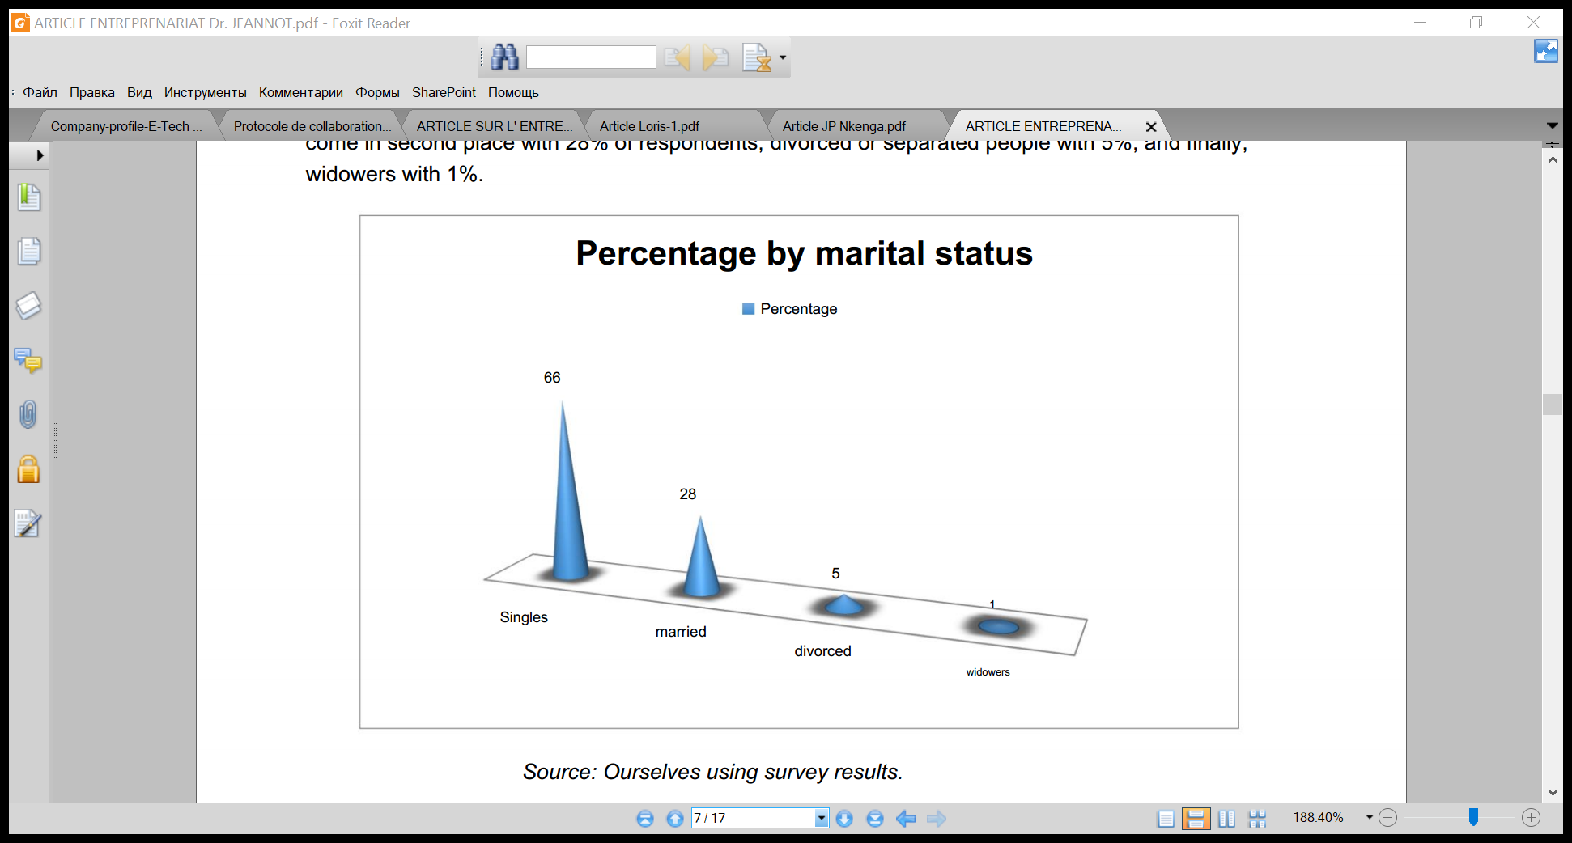

*Source: Ourselves using survey results.*

The analysis of the entrepreneurial experiences of young graduates reveals that 87.9% of the whole group declared that they had not started a business before compared to 12.1% who had already created a business.

It appears from the results of the level of education of the respondents that almost half of them have at least a bachelor's degree with 51.5%, while 35.5% have a graduate degree (undergraduate university). . Other types of university degrees represent 10%. Holders of master's degrees are poorly represented, with 3% respectively.

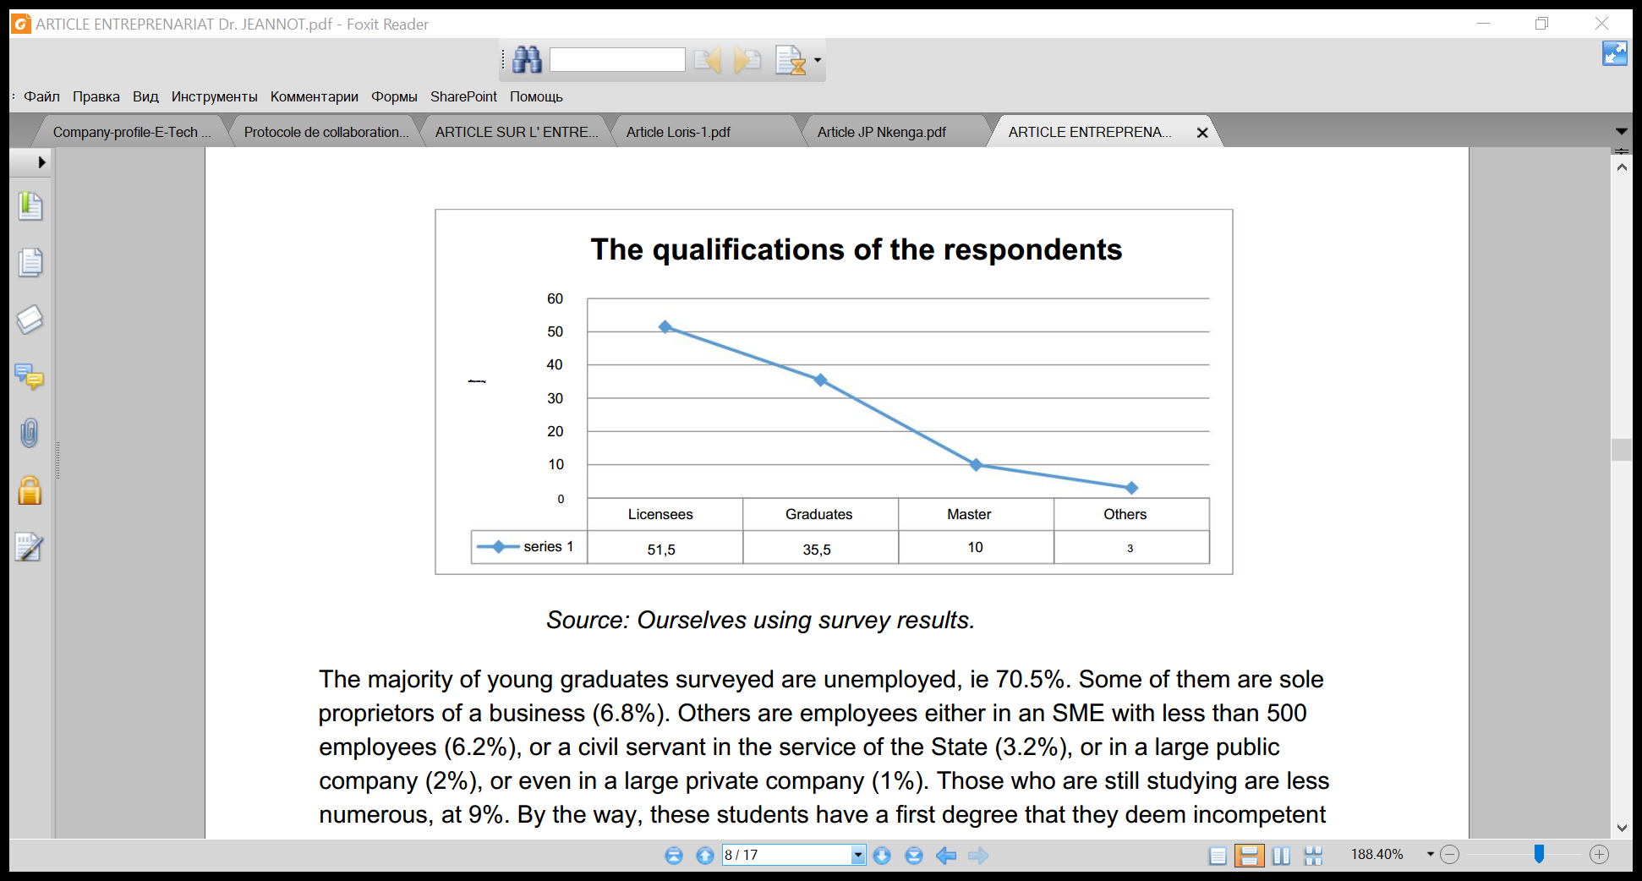

*Source: Ourselves using survey results.*

The majority of young graduates surveyed are unemployed, ie 70.5%. Some of them are sole proprietors of a business (6.8%). Others are employees either in an SME with less than 500 employees (6.2%), or a civil servant in the service of the State (3.2%), or in a large public company (2%), or even in a large private company (1%). Those who are still studying are less numerous, at 9%. By the way, these students have a first degree that they deem incompetent or of a lower level, and set out to obtain another at a higher level or in the field that they envy.

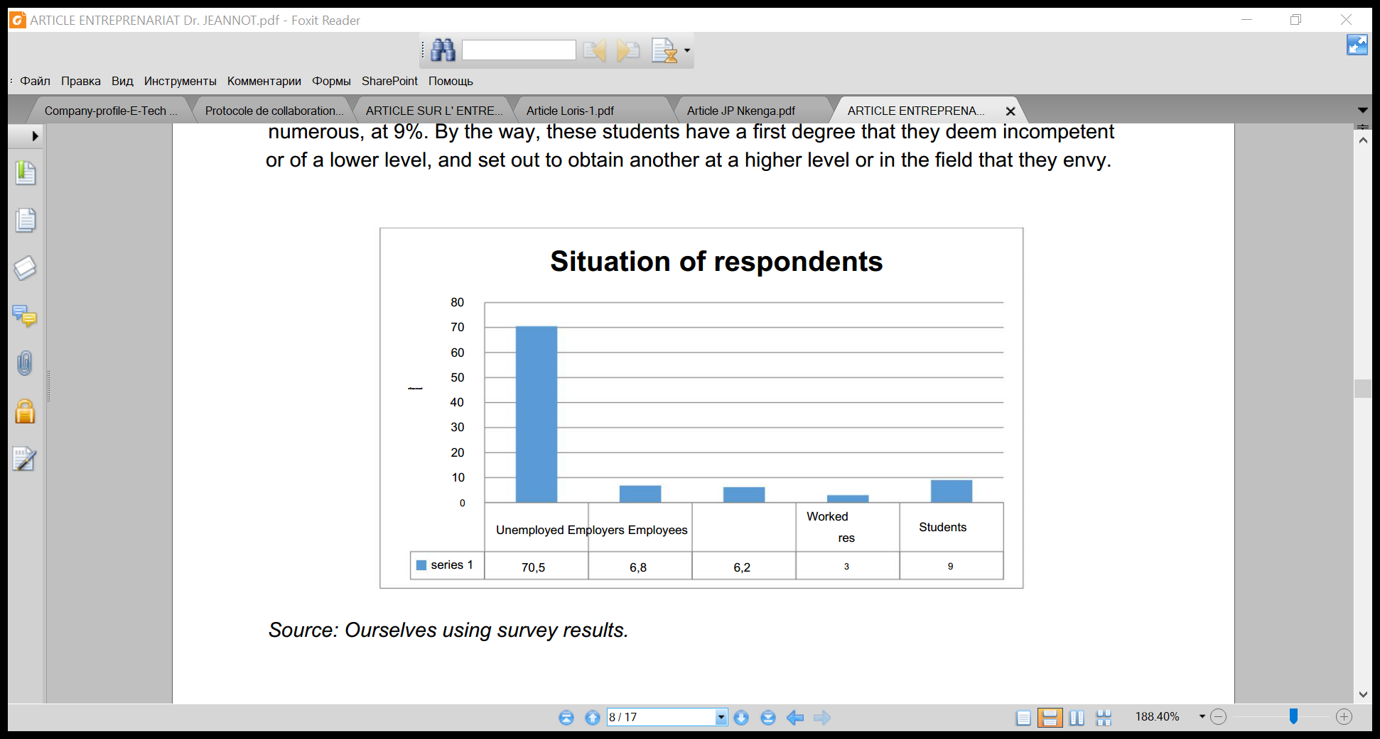

*Source: Ourselves using survey results*.

### OBSTACLES OR BLOCKAGES RELATED TO THE PERSON OF THE CONTRACTOR

#### Table 1. Individual obstacles to business creation by young Haut-Katanga graduates (N=115)

|  |  |  |
| --- | --- | --- |
| Obstacles | Frequency | Percentage |
| Lack of work experience | 91 | 79.13 |
| Lack of entrepreneurial skills and knowledge | 87 | 75.65 |
| Lack of business connections | 75 | 65.22 |
| Young age of the creator (discrimination) | 36 | 31.30 |
| Low social capital | 19 | 16.52 |
| fear of failure | 9 | 7.83 |
| Lack of self-confidence | 7 | 6.09 |

*Source: Field survey*

**Comments:**

Almost all of the young graduates surveyed lack previous professional experience (79.13%). This is due to the fact that they do not have the facility to find a job. Moreover, the majority of the young graduates surveyed have been unemployed (70.5%) since the end of their studies, and have never started a business before. This is why they have no previous professional or entrepreneurial experience.

Young Congolese graduates do not have the skills necessary for entrepreneurship (75.65). Although their training is superior, it does not contribute to an initiation to entrepreneurship, so these young people are not able to understand all the aspects of business creation because after their studies, these young entrepreneurs find themselves after their studies oriented towards theoretical and practical skills and also receive erroneous information from previous entrepreneurs who confuse them. Economic activity is therefore not transparent. This distrust means that these young entrepreneurs most often act alone, carry their problems alone, and do not have many opportunities to learn from others. Thus, the lack of skills and good information is an obstacle to the success of business creation. Indeed, the project leader or business creator should have knowledge and skills in entrepreneurship.

In addition, young Congolese graduates are often discriminated against because of their age by institutions or public authorities and by their suppliers or their customers, and sometimes they are not taken seriously by their colleagues or business contacts, etc.

Furthermore, young Congolese graduates have low social capital and lack business connections, which is a very important element in entrepreneurship. These young people do not belong to any professional or business network. Moreover, with the arrival of social networks, young people favor more friendly, romantic and local networks rather than more effective networks in terms of economic benefits, such as national and international professional networks, to which young people adhere more easily. men.

**OBSTACLES OR BLOCKAGES RELATING TO THE ENVIRONMENT OF BUSINESS CREATION BY YOUNG GRADUATES IN HAUT-KATANGAIS**

#### Table 2. Obstacles relating to the business creation environment for young graduates from Haut-Katangais (N=115)

|  |  |  |
| --- | --- | --- |
| Obstacles | Frequency | Percentage |
| Insufficient education and training programs | 101 | 87.8 |
| Lack/Absence of entrepreneurship in the education system | 99 | 86.0 |
| Absence of an information and guidance policy | 90 | 78.2 |
| Lack of recognition of entrepreneurship in the community | 89 | 77.3 |
| Absence or weak entrepreneurial culture | 85 | 73.9 |
| High taxation | 74 | 64.3 |
| Government instability | 61 | 53.0 |
| Difficulties related to the economic situation | 58 | 50.4 |
| Witchcraft and magical practices | 55 | 47.8 |
| intense competition | 34 | 29.5 |
| Lack of support from family or friends | 8 | 6.9 |
| Negative societal attitude towards youth entrepreneurship | 7 | 6.0 |
| Corruption | 3 | 2.6 |
| Complex formalities and high costs when setting up a business | 2 | 1.7 |
| Slow and cumbersome administrative procedures | 1 | 0.8 |

*Source: Field survey*

**Comments:**

The majority of the young graduates surveyed (87.8) declare that the education and training programs are insufficient, this is explained by the fact that the training is expensive, many of the young people do not participate not only for lack of means but also the fact that young Congolese do not have the culture to pay for their self-training. It is also necessary to underline that the trainers are often private.

In the school and academic path, there are not many subjects that prepare future graduates to create their own businesses, which justifies the reactions of 86.0% of young people surveyed, this creates an obstacle to the creation of business because the national program prepares future graduates for the management of businesses that have already been created.

The absence or weak entrepreneurial culture is a major cultural obstacle in the DRC, or 73.9 according to our surveys. This justifies an entrepreneurial culture that is still underdeveloped in the DRC.

The young graduates interviewed testify that entrepreneurship is not valued in the DRC (77.3%). This is explained by the absence of measures taken by the competent authorities to encourage the development of entrepreneurship, particularly in the business creation phase, also by the absence of prizes to be awarded to the best young entrepreneurs in the year, to finally motivate the rest of the young people for example and finally, by the absence of promotion of entrepreneurship in schools and universities. This result reveals the origin of the weaknesses of young graduates. This leads us to think that the lack of valuation of entrepreneurship in Congolese culture means that there is no entrepreneurial culture among young graduates. Therefore, there is no creativity or entrepreneurship among young people.

In the DRC, salaried employment is more preferred, and more particularly a lifelong career in the public service or a large company. Entrepreneurship is seen as a secondary activity to a main job. Another cultural barrier is society's negative attitude towards youth entrepreneurship. Society considers it less important to start your own business or to be self-employed, and therefore discourages young people from doing so. And the successful creation of a business by a young person is considered an initiation into magical and fetishistic practices. Thus, the absence of an entrepreneurial culture, the lack of valuation of entrepreneurship and the negative societal attitude to youth entrepreneurship do not promote the development of entrepreneurship among young graduates.

Some respondents emphasize the lack of support from family or those around them. Indeed, some families of young graduates are not very committed to supporting and accompanying young people in their entrepreneurial process, they rather prefer to see them find salaried employment, and more particularly a career for life in a large company or in multinational companies, rather than creating a personal business with a lot of risk.

Among the obstacles linked to the institutional and regulatory environment which can handicap business creation, according to the respondents, we have high taxation (64.3%), government instability (53.0%) and difficulties linked to the economic situation (50.4%). On the other hand, corruption (2.6%), complex formalities and high start-up costs (1.7%) and administrative slowness and cumbersomeness (0.8%) were rarely cited by our respondents because of the establishment of a one-stop shop for business creation.

High taxation is a major obstacle for young graduates who want to set up their own businesses. It manifests itself in the multitude of taxes and levies. This discourages the entrepreneurial spirit of young Congolese graduates and develops the informal sector. It manifests itself at the start of the business. Government instability among the obstacles to starting a business (53.0%). Indeed, the DRC has experienced a period of strong political turbulence since 1994 characterized by wars (1996 and 1998) and rebellions in different provinces of the country (2004, 2009, 2012). Indeed, the conflicts that this country has experienced have had a huge impact on government stability and this keeps young people from being able to engage in entrepreneurial activities.

The Congolese business creation environment is characterized by competition (39.6%) and an unfavorable local economic context which manifests itself in difficulties related to the economic situation (50.3%). an unhealthy economic environment in the DRC, which does not encourage youth entrepreneurship.

### OBSTACLES OR BLOCKAGES RELATED TO THE BUSINESS CREATION PROJECT

#### Table 3. Obstacles related to the business creation project (N=115)

|  |  |  |
| --- | --- | --- |
| **Obstacles** | **Frequency** | **Percentage** |
| Difficult access to financing | 102 | 88.6 |
| Difficult access to credit | 100 | 86.9 |
| Lack of personal funds | 98 | 85.2 |
| Absence/insufficiency of support and support services | 92 | 80.0 |
| Difficulties in preparing the business plan | 86 | 74.7 |
| Difficult access to relevant information | 69 | 60.0 |
| Little or lack of equipment | 58 | 50.4 |
| Difficulties in accessing Internet technologies and services | 16 | 13.9 |
| Poor physical infrastructure | 12 | 10.4 |
| Energy and water deficit | 10 | 8.6 |
| Difficulties in the development of the product/service | 8 | 6.9 |
| Difficulties in recruiting competent and reliable staff | 7 | 6.0 |

*Source: Field survey*

**Comment**

The difficulty of access to financing remains the biggest obstacle to starting a business, as mentioned by 88.6% of young Congolese graduates surveyed and a concern that comes up all the time, even if sometimes they do not have a clear project. , they all dream of having access to the capital that will optimize their business. Indeed, many young graduates are unable to carry out their project due to a lack of financial means. They are generally stuck with sometimes well-developed projects on paper. Young entrepreneurs or future entrepreneurs find it difficult to access financing from the banking system because of restrictive guarantee procedures and to save following the emergencies they face in daily newspapers. To discipline themselves, these young people often save as a group via the tontine system where each person gives a set amount to the fund daily, and each day one of the group members pockets the savings of all the others.

This system allows them to discipline themselves through group pressure, although sometimes, in large groups, those who have already pocketed their capital leave prematurely, not paying what they owe to others. Sometimes some young graduates combine their financial means to set up a business, but very often conflicts arise concerning the management of money. This observation agrees with that of A. Ayadi and J. Arlotto , who indicate that financial resources remain the major obstacle to the creation of a youth enterprise.

The vast majority of our respondents (86.9%) say they have difficulty accessing credit during business creation. This is due to the lack of financing structures and the complications of banks, mainly the restrictive guarantee procedures put in place by them.

Most of the young graduates interviewed say that they do not often call on financial institutions to capitalize their business out of fear because of guarantees, interest rates which seem high to them and also out of fear that financial institutions will require the formalization of their business, with all the annoyances they imagine.

However, as we can see, young graduates do not yet have any possessions to give to the banker to have a personal guarantee, hence the blockage. From the perspective of banks, young people are known to be unreliable.

Lack of start-up funds is one of the problems most frequently cited by young people looking to start their own business (85.2%). This is mainly due to the fact that most young graduates were unemployed, and are poor. These results demonstrate that a large percentage of the failure of entrepreneurial ventures is attributed to insufficient capital or poor resources.

Most young graduates suffer from equipment or materials to start an activity, i.e. 50.4%. the cost of their investment to be able to start as soon as possible. This makes it difficult to start their projects. Especially, when the projects are of a professional or industrial nature. Other respondents underline the mediocrity of the physical infrastructures (10.4%), the difficulties of access to technologies and internet services due to their high costs (13.9%) and finally, the difficulties in the development of the product or service. (3.6%).

The lack of support and support structures for entrepreneurs with entrepreneurial projects is a major handicap for young graduates in the DRC. However, skills in methods and project management are therefore consolidated by support from the various support structures. This is due to the fact that the DRC has not yet developed such structures, but it has already planned to do so soon in its business creation assistance policy.

The majority of young graduates surveyed find it difficult to plan their entrepreneurial projects by writing a business plan (74.7%). This can be explained by three things: first, the quality of the training they received, second, the neglect of writing a business plan, and third, the absence of support and guidance services.

A significant proportion of young Congolese graduates surveyed say they have difficulty accessing relevant information for the creation of their businesses. This can be explained by the absence of a support and accompaniment structure for the promoters of entrepreneurial projects and by the lack of websites dedicated to young people for information of an entrepreneurial nature. In addition, the channels used to disseminate relevant information on entrepreneurial activities are not suitable with this category of people.

**CONCLUSION**

The study was conducted to determine the specific factors that hinder the creation of businesses by young Congolese graduates, and which militate against the development of their entrepreneurship in our country.

The results of our study revealed that there are various barriers that prevent young graduates in the DRC from engaging in entrepreneurship. The most important are: difficult access to financing, difficult access to credit, lack of professional experience, absence or insufficiency of support and accompaniment, lack of personal funds, insufficient education and training, difficulties in preparing the business plan, the absence or weak entrepreneurial culture, the absence of an orientation and information policy, the lack of skills and knowledge in entrepreneurship, the limited network of contacts, high taxation, government instability, lack or inadequacy of equipment, intense competition, difficulties in accessing relevant information on entrepreneurial activities, the unfavorable economic context, the mismatch between individual and project, discrimination due to young age.

The fight against these obstacles can help encourage the realization of entrepreneurial projects through the creation of businesses by young graduates through: entrepreneurial education (by inserting entrepreneurship in the education system and in the training center), support technical assistance and support for project leaders, information relevant to business creation for young graduates, reduction of financial barriers, promotion of entrepreneurship in Congolese culture, establishment of support networks related to the entrepreneurial project, the creation of educational spaces, a strengthening of activities aimed at raising entrepreneurial awareness among young Congolese, a strengthening of the capacities of Congolese universities that can offer training programs adapted to local social contexts, etc.

Additionally, government, non-governmental organizations and private financial institutions such as banks should provide ongoing support to motivate young entrepreneurs at all stages of their business development. Support should not be limited to making financial resources available to them, but should also include mentoring to enable them to develop new entrepreneurial skills. In addition, governments need to remove barriers to formal sector enterprises, while improving conditions for the informal sector. Also, they must promote entrepreneurship, including agriculture, which can be a stable source of employment in economies heavily dependent on agriculture in the short and medium term. Finally, we say that young graduates encounter many difficulties when setting up a business. Our research focused only on difficulties related to business creation.

**SUGGESTION**

The decrease in the unemployment rate is one of the elements showing the development of a country; thus to achieve this, entrepreneurship is one of the mechanisms that can contribute to this reduction.

To facilitate the initiative person in our country we suggest:

**In the state :**

* to support young people by granting funds, subsidies and measures that will be a stimulus for young people in the entrepreneurial perception
* to reduce taxation in the process of creating a business because it is said that too much tax kills tax so that young people cannot evolve in the informal sector
* to make available to young people in their educational program relevant information that will push them to have a vision to initiate their own activities than to train young people in the hope of being hired somewhere

And in the end, the person of the entrepreneur must understand that in all areas of life zero risk is almost impossible, hence he must not be afraid of failure, or the discouragement of his loved ones, or the competition on the market, Congolese culture, or discrimination, but he must be confident, sure of himself whatever his professional relations, the words of his relatives...

The first step has always been hard and even difficult, you must first start, try to dare, not give up, as those who have undertaken and succeeded have made us understand, and have affirmed that skills come with time. .

**REFERENCES**

1. FJ Akpa, African youth facing entrepreneurship: issues and challenges. Research Gate, 2019. [Online] Available : https://www.researchgate.net/publication/335146553, (January 20, 2020).
2. Brahmi Halima and Jellali Majida , Brakes and motivations of young Tunisian entrepreneurs: an exploratory study. International Journal of Economics & Strategic Management of Business Process (ESMB), Vol.6, pp.1-5, 2016.
3. Johannes Herderschee , and Daniel Mukoko Samba, *Resilience of an African Giant* (Washington, DC: World Bank, 2012), 13.
4. UNDP, *Human Development Report* (2013).
5. DRC Ministry of Planning, *Growth and Poverty Reduction Strategy Paper - 2nd generation* (2011).
6. Johannes Herderschee , Kai-Alexander Kaiser, and Daniel Mukoko Samba, *Resilience of an African Giant* , (Washington DC: World Bank, 2012), 96.
7. African Development Bank, *2012 Africa Economic Outlook* (2012),
8. A. Ayadi and J. Arlotto , Assessing the scope of educational competitions for business creation: the case of a VSE resulting from the Challenge Projets d'Entreprendre®. Proceedings of the 7th International Francophone Conference on SMEs (CIFPME), October 27-28 and 29, 2004, Montpellier, France.
9. S. Jabraoui and A. Boulahoual , "The determining factors of the success of entrepreneurship in Morocco: case of the Casablanca region", International Conference on Prospective under the theme "Entrepreneurship: towards an Entrepreneurial Morocco", Casablanca, 25 Nov 2016.
10. UNCTAD (United Nations Conference on Trade and Development), Entrepreneurship and Building Productive Capacity : Creating Jobs through Enterprise Development. Note by the UNCTAD secretariat. TD/B/ C.II /24, Geneva, 2012

1. FJ Akpa, African youth facing entrepreneurship: issues and challenges. Research Gate, 2019. [Online] Available : https://www.researchgate.net/publication/335146553, (January 20, 2020).
2. Brahmi Halima and Jellali Majida , Brakes and motivations of young Tunisian entrepreneurs: an exploratory study. International Journal of Economics & Strategic Management of Business Process (ESMB), Vol.6, pp.1-5, 2016.
3. Johannes Herderschee , and Daniel Mukoko Samba, *Resilience of an African Giant* (Washington, DC: World Bank, 2012), 13.
4. UNDP, *Human Development Report* (2013).
5. *Defining Dependency Ratios , CIA World Factbook,* accessed November 2013 https://www.cia.gov/library/publications/the-world-factbook/docs/notesanddefs.html?fieldkey=2261&alphaletter=D&term=Dependency%20ratios
6. DRC Ministry of Planning, *Growth and Poverty Reduction Strategy Paper - 2nd generation* (2011).
7. Johannes Herderschee , Kai-Alexander Kaiser, and Daniel Mukoko Samba, *Resilience of an African Giant* , (Washington DC: World Bank, 2012), 96.
8. According to the International Monetary Fund (IMF), DRC's National Bureau of Employment is implementing a registration system for the unemployed and issues biometric cards to holders.
9. The IMF describes the PEIGMA as responsible for producing indicators on job opportunities and job seekers; publication of key market indicators; conduct periodic surveys to determine work needs; and preparation of job description to inform job seekers about opportunities.
10. African Development Bank, *2012 Africa Economic Outlook* (2012), 15
11. Ibid.
12. A. Ayadi and J. Arlotto , Assessing the scope of educational competitions for business creation: the case of a VSE resulting from the Challenge Projets d'Entreprendre®. Proceedings of the 7th International Francophone Conference on SMEs (CIFPME), October 27-28 and 29, 2004, Montpellier, France.
13. OpCit . _
14. OpCit _
15. S. Jabraoui and A. Boulahoual , "The determining factors of the success of entrepreneurship in Morocco: case of the Casablanca region", International Conference on Prospective under the theme "Entrepreneurship: towards an Entrepreneurial Morocco", Casablanca, 25 Nov 2016.
16. UNCTAD (United Nations Conference on Trade and Development), Entrepreneurship and Building Productive Capacity: Creating Jobs through Enterprise Development. Note by the UNCTAD secretariat. TD/B/C.II/24, Geneva, 2014.