Lithium İon Batteries: Battery Failure&Fire and Intervention Methods for Battery Fire in Electrical Vehicles
Sezgin YAŞA^{1,}∗ , Sedat BARUTCU² ,
¹ Engineering Faculty, Mechanical Engineering Department, Çankırı Karatekin University, Çankırı, Türkiye
² Social Sciences Vocational School, Civil Defense and Firefighting Program, Çankırı Karatekin University, Çankırı-Türkiye

Abstract
Lithium-ion batteries (LiBs) are widely used and especially with the widespread use of electric vehicles, the use of LiBs are increasing. Lithium-ion batteries simply consist of anode, cathode, electrolyte, separator and current collectors such as copper and aluminum. LiBs are intricate industrial products that may cause mistakes in design, manufacture, and usage, which can result in safety incidents. To improve battery safety, it's critical to have a thorough understanding of the failure mechanisms that might arise in different scenarios. In particular, the types of damage that can occur can be classified as mechanical damage, thermal damage and electrical damage. Another important issue is the intervention method to be applied to lithium-ion batteries after the damage occurs. In the scope of this study, the structure of LiBs, LiB types, the types of damage that can occur in LiBs used in electric vehicles in particular and the methods of intervention in possible fires will be discussed.
Keywords: Li-ion Battery, Failure, Battery Fire, Intervation
- Introduction

In contrast to other rechargeable systems, lithium ion batteries (LIBs) have dominated the energy sector because of their unparalleled qualities, which include a high energy density, a small size, and the capacity to fulfill a variety of performance requirements. Li-ion battery research is being conducted extensively by both government organizations and businesses in an effort to create an economy that is energy-sustainable [1].

The anode, cathode, and electrolyte are the three main functioning parts of a lithium ion battery. In a typical lithium ion cell, the electrolyte is a lithium salt in an organic solvent, the cathode is a metal oxide, and the anode is composed of carbon. Graphite is the most often used anode material in commerce. One of three substances is often used as the cathode: a spinel (like lithium manganese oxide), a polyanion (like lithium iron phosphate), or a layered oxide (like lithium cobalt oxide). Usually, complexes of lithium ions are present in the electrolyte, which is a combination of organic carbonates like ethylene carbonate (EC) or diethyl carbonate (DEC). Non-coordinating anion salts including lithium hexafluorophosphate (LiPF₆), lithium hexafluoroarsenate monohydrate (LiAsF₆), lithium perchlorate (LiClO₄), and lithium tetrafluoroborate (LiBF₄) are typically used in these non-aqueous electrolytes. The anode and cathode must be separated using a separator. A extremely thin sheet of plastic with tiny holes in it serves as the divider. It divides the positive and negative electrodes while permitting ions to flow through, and it is situated between the cathode and the anode [2]. The Schematic of LiB and main component of it are shown in Fig 1.

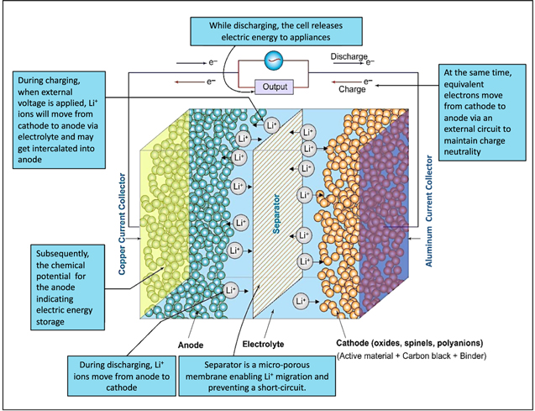
Figure 1. Diagrammatic representation of LIBs and summary of their main elements and purposes [1]
.

There are many types of different battery cathode materials such as; LiCoO₂ (LCO, Year introduced: 1991), LiFePO₄ (LFP, Year introduced: 1996) LiMn₂PO₄ (LMO, Year introduced: 1996) Li(Ni-Co-Al) (NCA, Year introduced: 1999) Li(Ni-Co-Mn) (NMC, Year introduced: 2008), (Fig 2) [3].Efforts are ongoing to reduce cobalt usage in NMC due to cost and ethical concerns [4].

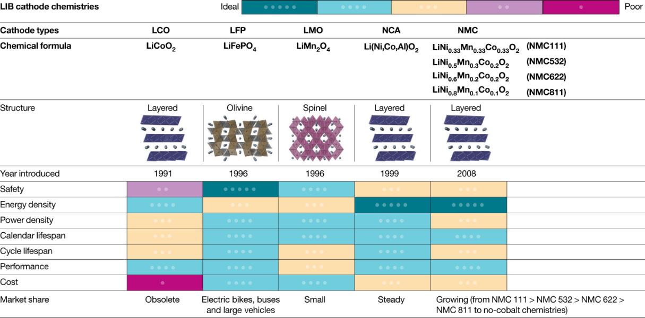

Figure 2. Schematic illustration of LIBs [3]

EV driving range is mostly determined by battery energy density, and existing Li-ion batteries, even with high densities (250 to 693 Wh L⁻¹), still can't match gasoline, underscoring the need for more development and study. With balanced energy density, power density, safety, and overall performance, NMC, LFP, and LMO are excellent options for EVs and energy storage systems [4].
Because LiBs are complex industrial goods, errors in their design, production, and use might lead to safety issues. Understanding the failure mechanisms that might occur in various situations is essential to enhancing battery safety. A battery may malfunction or possibly have thermal runaway throughout the course of its life due to a variety of reasons, including contaminants added during manufacturing or improper operation [5].

- Failure of the Li-ion batteries

In our nation as well as around the world, the number of registered hybrid and electric cars is rising. Despite its numerous benefits—such as their silent operation, cheap running costs, and zero emissions of pollutants—electric cars nevertheless present several difficulties. The hazards of fire and the enormous heat loads produced during flames are two of these difficulties. A battery pack's cells might all experience thermal runaway (TR). A fire is caused by TR, an uncontrollable chain reaction that happens at 60 °C or more. A sequence of recurrent fires occurs in each cell as a result of TR in one cell producing enough heat to ignite other battery cells. In order to minimize and lessen the impacts of TR in electric cars, manufacturers are developing a number of strategies. The normal working temperature range of lithium-ion batteries is between 15 and 45 °C, which is much less. Maintaining this temperature range is essential. It is highly advised to use liquid or air cooling management and monitoring systems to protect the battery, the car, and its occupants [6].
Battery casing damage, cell compression, crushing, puncturing, and bending are examples of mechanical damage. Internal short circuits, excessive power output (high C-rate), overcharging, and overdischarging can all result in electrical damage. Both self-heating and heating from an external heat source are examples of thermal damage. In the event of mechanical damage, the separator may rupture as a result of battery deformation. The separator may be punctured by dendritic development in the battery in the event of electrical damage. The separator may collapse in cases of thermal damage due to the high internal heat produced in the battery [6].
.
Thermal failure can also be brought on by external overheating and high ambient temperatures, in addition to overheating brought on by electrical or physical causes. Rapid increases in battery temperature due to thermal variables can result in a number of problems, including the melting of the membrane, the breakdown of electrodes and electrolytes, and a host of adverse effects [7].

Notably, the separator is compromised in each of the three damage situations. When the separator is damaged, the insulation between the anode and the cathode is removed, allowing electrons to flow and creating a short circuit that may ignite a fire [6].

Exothermic electrochemical reactions can cause a rapid rise in temperature, which influences aging, cell deterioration, and the kinetics of electrochemical processes. Strict temperature management hence prolongs battery life and gets rid of undesirable circumstances like thermal runaway and layer deterioration. Thermal runaway and overheating are two unavoidable and dangerous scenarios that threaten high-performance battery systems. To maintain the peak temperature level below the critical temperatures, the battery thermal management systems must meet the requirements for uniform temperature distribution and thermal control [8].

Fig. 3 shows how a battery failure in a LiB used in an electric vehicle develops and the stages that develop as a result of the fire. It is seen that even in the event of extinction, the battery can continue to burn again. The main reason for this is that the battery contains a large number of cells and the other cells are affected by the exposure and the combustion continues as they start to burn.
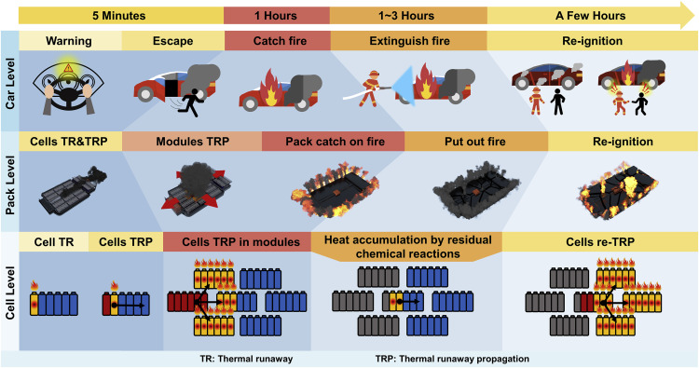
Figure 3. The Mechanism of Accidents in Electric Vehicles Associated with Battery Failure [9]

- Intervention Methods for Battery Fire in Electrical Vehicles
When the oxidation level in the lithium-ion battery is examined, especially in battery fires, very different intervention methods are used.
Although there are few literature studies, some step inferences have been formed from the events experienced and the experiences gained. The findings made from these inferences; It is quite difficult and difficult to bring together the controls of these products when nitrogen-ion batteries burn and change as a result of this burning, it is revealed that a lot of extinguishers are needed to extinguish explosions and that a re-ignition is likely to occur no matter what. First of all, in order to cool down an electric vehicle fire that has occurred for any reason, the extinguishing equipment called a fire blanket is laid in such a way that the top of the vehicle is completely covered. Although electric vehicles are not as complex as internal combustion engines with atmospheric engines in terms of mechanics, they pose many risks when the risks they pose are taken into consideration. Fire departments are trying to eliminate many risks by developing intervention methods within the possibilities [10].
Some hazards and intervention status for safe operation;
- Risks posed by high voltage hazards
- Risks posed by fire situation and safe intervention
- Effects of fire extinguishing kits
- Application of protective fire blanket before battery extinguishing
- Continuous monitoring of temperature values ​​with thermal camera

- Conclusion

The number of electric vehicles in particular has been rapidly increasing in the world and in our country in recent years. Therefore, it is inevitable that we will see more electric vehicles around us as time goes by. Therefore, battery safety systems in electric vehicles and the method of intervention in case of any battery fire will gain more importance. In this study, the structure of battery systems, error and fire mechanisms and the method of intervention in case of any battery fire that may occur are emphasized. In particular, the production of effective solutions on the safety of battery systems and the methods of intervention in case of any error and fire that may occur is an important necessity.

References

[1] G. Kaur, B.D. Gates, Review — Surface Coatings for Cathodes in Lithium Ion Batteries : From Crystal Structures to Electrochemical Performance Review — Surface Coatings for Cathodes in Lithium Ion Batteries : From Crystal Structures to Electrochemical Performance, J. Electrochem. Soc. 169 (2024) 043504. https://doi.org/10.1149/1945-7111/ac60f3.
[2] Q. Wang, P. Ping, X. Zhao, G. Chu, J. Sun, C. Chen, Thermal runaway caused fire and explosion of lithium ion battery, J. Power Sources 208 (2012) 210–224. https://doi.org/10.1016/j.jpowsour.2012.02.038.
[3] G. Harper, P. Slater, R. Stolkin, A. Walton, P. Christensen, O. Heidrich, Recycling lithium-ion batteries from electric vehicles, Nature 575 (2019) 75–86. https://doi.org/10.1038/s41586-019-1682-5.
[4] A.K. Koech, G. Mwandila, F. Mulolani, P. Mwaanga, South African Journal of Chemical Engineering Lithium-ion battery fundamentals and exploration of cathode materials : A review, South African J. Chem. Eng. 50 (2024) 321–339. https://doi.org/10.1016/j.sajce.2024.09.008.
[5] Y. Yang, R. Wang, Z. Shen, Q. Yu, R. Xiong, W. Shen, Towards a safer lithium-ion batteries: A critical review on cause, characteristics, warning and disposal strategy for thermal runaway, Adv. Appl. Energy 11 (2023) 100146. https://doi.org/10.1016/J.ADAPEN.2023.100146.
[6] M.İ. Karamangil, A. Sürmen, M. Tekin, Elektrikli Araçlarda Batarya Yangınlarına Genel Bakış, Uluslararası Yakıtlar Yanma Ve Yangın Derg. 11 (2023) 29–40. https://doi.org/10.52702/fce.1224612.
[7] M. Buldu, S. Altın, F. Bulut, Lityum İyon Bataryaları İçin Güvenlik Riskleri ve Çözüm Önerileri, J. Sustain. Eng. Appl. Technol. Dev. 7 (2024) 131–142. https://doi.org/10.51764/smutgd.1511977.
[8] S. Gungor, S. Gocmen, E. Cetkin, A review on battery thermal management strategies in lithium-ion and post-lithium batteries for electric vehicles, J. Therm. Eng. 9 (2023) 1078–1099. https://doi.org/10.18186/thermal.1334238.
[9] W. Huang, X. Feng, X. Han, W. Zhang, F. Jiang, Questions and Answers Relating to Lithium-Ion Battery Safety Issues, Cell Reports Phys. Sci. 2 (2021) 100285. https://doi.org/10.1016/j.xcrp.2020.100285.
[10] Tengilimoğlu E. S., & Barutcu S. (2024), Sosyal Bilimler, Elektrikli Araçlardaki Yangına Müdahale Stratejilerinin Belirlenmesi; İtfaiye Teşkilatlarının Hazırlık Seviyeleri, Afyonkarahisar, Türkiye, YAZ yayınları

* Corresponding author. e-mail address: sezginyasa@karatekin.edu.tr

