ANALYSIS OF LAKE WATER FOR AIR CONDITIONING: A CASE STUDY IN FACULTY OF ENGINEERING, UNIVERSITI PUTRA MALAYSIA

Jaslin Rasin¹, Razali Samin², Syed Amirul Mustaqim Bin Syed Ghazali Jalalulin³

^{1,3}Department of Engineering, Politeknik Kuching Sarawak, Km.22, Jalan Matang 93050 Kuching Sarawak, Malaysia.
²Department of Mechanical and Manufacturing Engineering, Faculty of Engineering, Universiti Putra Malaysia, 43400 UPM Serdang Selangor Darul Ehsan, Malaysia.

ABSTRACT
This report includes a detailed and simple explanation of the general introduction to Ground Sources Heat Pumps and several types of Ground Sources Heat Pump which is Surface Water Heat Pump as one of the parts of renewable energy technology. The surface Water Heat Pump focused on the deepest depth to get constant heat sources which can be used as chilled water supply to air conditioning for Auditorium Jurutera Building. The main purpose of this report is to analyze lake water for air conditioning: A case study in the Faculty of Engineering, UPM to obtain, a lake profile, the depth of the lake, and the deepest depth temperature in the lake. In achieving the objectives, there are some methods that need to be done which have been presented in the Methodology. All data resulting from the analysis of water lake depth temperature had shown some factors that can be considered as the influence to use available ground sources heat. The lake area and distance of the deepest point have also been calculated and provided information in this report. In conclusion and recommendation, even the water's deepest temperature cannot be used to supply chilled water to the cooling coil inside the Auditorium Jurutera building. The recommendation is also provided for the improvement of this project. In addition, this report also contains other types of Ground Sources Heat Pump with different applications that have been used nowadays.
This report also will help anyone seeking to know the profile of the Lake Faculty of Engineering and intends to study the surface water source heat pump as the cooling system.

Keywords: Renewable Technology, Ground Sources Heat Pump, Cooling load
JEL Classification:

- INTRODUCTION
Nowadays, all building application has been used conventional air conditioning to provide a cooling comfort zone. Year by year the temperature on the surrounding area increasing due to one of the several factor with use non-friendly refrigerants, which affected to ozone depletion. Conventional air conditioning also is a part of the main contribution electricity cost in the building operation. To use of renewable energy sources is the fundamental of the improvement energy efficiency and the reduction of the demand. Ground source heat pump (GSHP) is one of great importance due to less seasonal temperature changes with respect to the supply air and the possibility to achieve high energy efficiency. GSHPs mainly divided into three categories with ASHRAE on the basis of the use of groundwater from wells, surface or ground water directly coupled to the heat exchanger, as a heat source or sink. Water consumption generally allows advantages such as low initial cost and no surface area is required. Surface water heat pump (SWHP) can be valid as alternative for the building sited important proximity of surface water bodies such as rivers, lakes or the ocean. The SWHP is very popular in coastal cities which the temperature sea water was influences by outdoor air and by sea current sometime unfavorable. For this project, the consideration of use Surface water heat pump as a renewable energy technology will apply for Auditorium Jurutera building.

Surface Water Heat Pump (SWHPs) has been included in the subset of Ground Sources Heat Pump (GSHP) because of the more likely in application and installation methods. This method also can be either closed loop which similar to GCHPs or open loop systems similar to GWHPs. However, the thermal characteristics of surface water bodies are different than those of the ground or groundwater. SWHPs consist of water to air or water to water heat pump connected to the piping network, which placed in a lake, river, or other place touched with open water. A pump circulates water or a secondary fluid (antifreeze solution) through to heat pump water to refrigerant shell and tube heat exchange which to transfer heat from a body of water. The piping material suggestion to be used is thermally fused high-density PE tubing with Ultraviolet (UV) radiation protection to ensure heat can be transferred as well. The advantages of SWHPs are relatively low cost compared to GCHPs due to reduced excavation costs, low pumping energy requirement, low maintenance requirement and low operating cost. Beside of the advantages SWHPs, there also have the disadvantages which are the possibility the coil damage in public lakes and wide vibration water temperature with an outdoor condition if a lake is small and shallow. Faculty of Engineering, UPM has built by architecture cooling structure concept which evaporates / reduce heat from the floor / earth surface with water. Theoretically, if deeper a lake, more cooling can achieve because of low pressure and not exposed to the atmosphere. In this project, the main concern is to analyze sources of water lake depth, temperature whether suitable for use as cooling/chilled water for uses Auditorium Jurutera building.

Mainly air conditioning systems work at their design loads for only a small part of their life and it follows, therefore, that the designer should be concerned not only with the highest temperature gains and cooling loads but also with the means these changes during the day and over the year. Establishing the mock-up of such variations will be of help in choosing the right system and in selecting the greatest form of regular control. Applications recline in the marketable, industrial, institutional and domestic sectors for the climates of over the world. It must, thus, be estimated that the size of the input made by each of the key elements in the temperature gain will not be constant but, nevertheless, the come within reach of to the calculation will be basically the same in all instances while the same importance will not be attached to each constituent. The conventional air conditioning system consists of four main components to provide cooling solution inside the room or building, which is the compressor, condenser, expansion valve, and evaporator. All components have owned function to transfer heat in one refrigeration circuit such the compressor, to compress gas from low pressure and low temperature to high pressure and high temperature. Condenser, the condenser will reject heat and change phase from vapor gas to high-temperature liquid with maintaining high pressure. Expansion Valve, the expansion valve will expand a liquid high temperature and high pressure to liquid low temperature and low pressure.
Evaporator, the evaporator will absorb heat from room to be cool and change phase from low temperature liquid phase to low temperature gas with maintaining low pressure. These four components will link each other in one circuit which called refrigeration circuit. All the main components must be installing to follow the sequence and functioning of the component. The first component is the compressor which we call a heart of refrigeration cycle. The compressor pumping the refrigerant and distribute to the second component which is the condenser. The condenser will reject heat inside the condenser coil with helping motor and direct flow fan to surface fins and condenser coil before distributing liquid high temperature to the expansion valve. The expansion valve will expand the high-temperature liquid refrigerant to low temperature liquid depend on the demand of evaporator. The evaporator structure design almost same with the condensing coil which has coil and fins to increase heat exchange, but evaporator will absorb heat from surrounding room and provide comfort zone with helping blower fan to distribute and suck air the room. Each component requires electric power to make it function in the system application, and the higher uses electric power is compressor which needs to run the motor compressor and followed by the motor fan and blower fan.

The objectives for the project as follows:-
a. To review building criteria and cooling load selection.
b. To measure lake water profile and depth for air conditioning data requirement.
c. To analyses the data of lake water for use as Ground Sources Heat Pump (GSHP).

- LITERATURE REVIEW

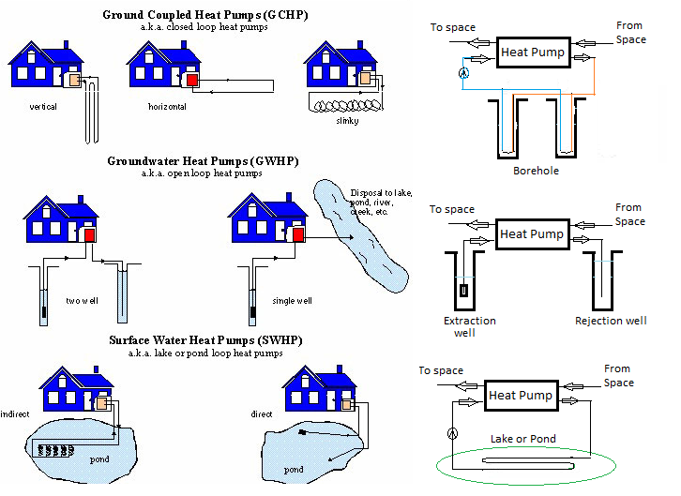
Figure 2.1: Schematic of different ground sources heat pumps.

From Figure 2.1, the Ground Water Heat Pump, which utilizes ground water as heat sources or heat sink, has some marked advantages including low initial cost and minimal requirement for the ground surface area over the Ground Source Heat Pump systems. However, a number of factors seriously control the wide application of the Ground Water Heat Pump system, such as the limited availability of ground water and the high maintenance cost due to fouling corrosion in pipelines and equipment. In addition, many legal issues have arisen over ground water withdrawal and reinjection in some regions, which also restrict the Ground Water Heat Pump applications to a large extent. In an SWHP system, heat rejection extraction is accomplished by the circulating working fluid through high-density polyethylene (HDPE) pipes positioned at an adequate depth within a lake, pond, reservoir, or other suitable open channels. Natural convection becomes the primary role in the heat exchangers of the Surface Water Heat Pump (SWHP) system rather than heat transfer process in a Ground Coupled Heat Pump (GCHP) system, which tends to have higher heat exchange capability than a Ground Coupled Heat Pump system (D.A. Ball, 1983).

2.1 Types of ground sources heat pump

A significant portion of world energy consumption is attributable to domestic heating and cooling. GSHPs are preferred and widely used in many applications due to their high utilization. There are two types systems of GSHPs:

2.1.1 Opened loop systems

Open-loop method, groundwater is usually supplied to the heat pump by a drilled well with a submersible pump system. If a recharge well is to be used, it should be drilled at the same time as the primary well. The groundwater should be tested for acidity, dissolved solids, and mineral content. The open loop system is shown in Figure 2.1 (D.A.Ball,1983).

2.1.2 Closed loop systems

The most typical Ground Sources Heat Pump setting up utilizes a closed loop system. Closed loop method, a loop of piping be covered underground and filled with water on the secondary fluid to protect water from freeze and continuously circulate all the way through the system. There are four main types of closed loop geothermal system, which are vertical, horizontal, slinky coils and pond loops.

2.1.2.1 Vertical loop

A vertical loop is the most general type of closed loop, as it requires the latest amount of ground to contain it. However, it is the most expensive but most resourceful as the ground earth’s temperature is steadier with depth allow. To install a loop system firstly a vertical bore holes are drilled 50 to 100 meters deep and at least 5 meters apart, this gap ensures that the individual loops do not encroach on the available heat energy in the soil. When the required number of boreholes has been drilled (the contractor will have calculated the number required to suit the buildings heating requisite) the U shape pipe typically between ¾” and 1 ¼” diameter, are then inserted down into the borehole. An efficient heat transferring sealing compound or grout is poured into the gap between the pipe and the soil. This is not only to ensure a good contact between the pipe and the ground but also to prevent rainwater from penetrating into the borehole. When all the pipes have been inserted and grouted, they are connected up to an inlet and outlet manifold which supply and return the loop circulating fluid, a blend of water and secondary fluid antifreeze to and from the heat pump via the circulating pump. The vertical loop systems are shown in Figure 2.1 (D.A.Ball,1983).

2.1.2.2 Horizontal loop

Provided there is plenty of ground available, this design of ground loop is very economical, as it only requires a digger with a backhoe to excavate the required number of 2 meter deep trenches, over an area of ¼” to ¾” acre for a typical dwelling house which is a much cheaper option than a vertical loop. When the required number of trenches is dug, the prefabricated U-shaped pipes are laid horizontally at the foundation of the trenches and the whole area backfilled leaving the pipe tails exposed. These tales are connected to inlet and outlet manifolds, supplying the fluid to and from heat pump via the circulating pump. The one disadvantage of horizontal ground sources heats pumps loops has been that it cannot be used in any location subject to thermal frost.

2.2 Surface water heat pump

Surface water heat pump (SWHP) system, heat rejection extraction is accomplished by the circulating working fluid through high-density polyethylene (HDPE) pipes positioned at an adequate depth within a lake, pond, reservoir, or other suitable open channels. Natural convection becomes the primary role in the heat exchangers of the Surface Water Heat Pump (SWHP) system. SWHP is part of the renewable technology which current trend develops to improve energy efficiency and reduction on demand building operation cost and to support to achieve the Kyoto protocol about reduction the fuel consumption and related to carbon dioxide (CO2) emission. Currently, the European Union with the recast of the Energy Performance Building Directive (EPBD) was focused in the building energy consumption which the most important factor to achieve the target by 20% decrease on CO2 emission, energy generation through renewable sources, and increase in energy efficiency by year 2020 by promoting to use renewable energy sources to supply to the building requirement.
Some other article has been done with the analysis Surface Water Sources Heat Pump air conditioning system for the operation performance and was found with the burden of the cooling load, heat exchanger structure parameter of surface water and cooling water flow rate does not change, reduction of surface water temperature will cause a slight decrease in the total heat transfer rate per unit length of the tube, but the coefficient of performance will be improved. With the decline in surface water temperature, air temperature varies between the surface and the inner tube increases, so the heat exchanger is much stronger, which makes coil outlet water temperature reduces surface. Reduction of cooling water inlet temperature of the condenser resulting in the collapse of the condensation temperature, which makes condensation heat load decreases slightly. With increasing length of the tube, the heat transfer is more intense, causing surface air temperatures decrease the coil outlet.

3. METHODOLOGY
The methodology is a process to make a study from beginning the study until the study is finished, it consists all step that required make sure the objective of this study is complete and achieve, in this step all the study material will make the study easier.
The methodology is a systematic, theoretical analysis of the methods applied to the projects as a guide to achieve 3 objectives of this project. This section explains flow chart of the project as shown in Figure 3.1.
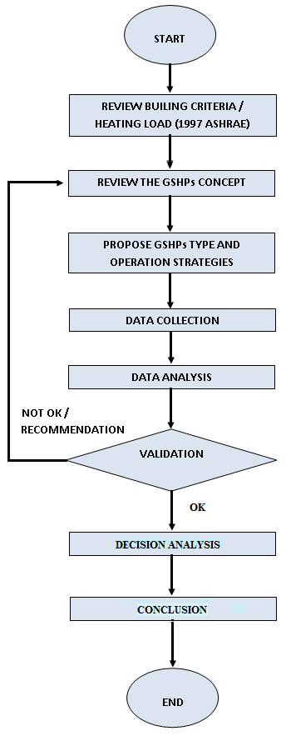
Figure 3.1 Methodology flow chart

3.1 Decide Location for the Project

A location for the project must be selected based on a few criteria such as space availability, the size of project plans, ease of project developments and the building for the project itself. Auditorium faculty of engineering building (Figure 3.9) has been selected as it has suitable for as a reference for this project. This report also showed the location and pictures of Auditorium Jurutera and Water Lake in faculty of Engineering, Universiti Putra Malaysia in several zone views as below Figures.

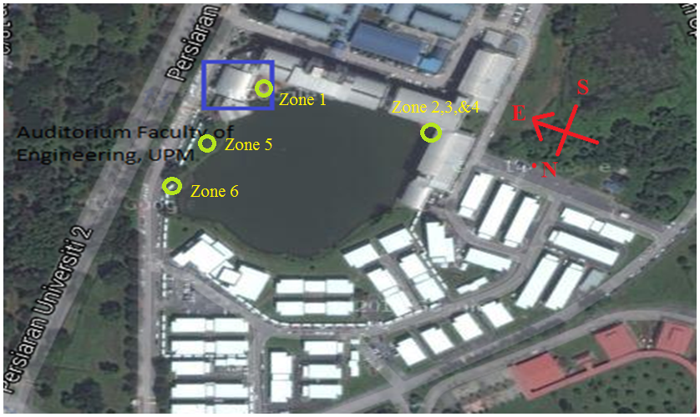
Figure 3.2: Location Auditorium Jurutera and Water Lake from top view.

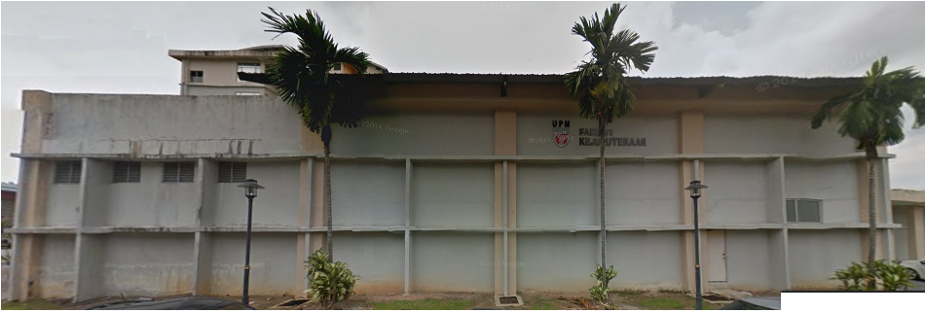
Figure 3.9: Auditorium Faculty of Engineering UPM

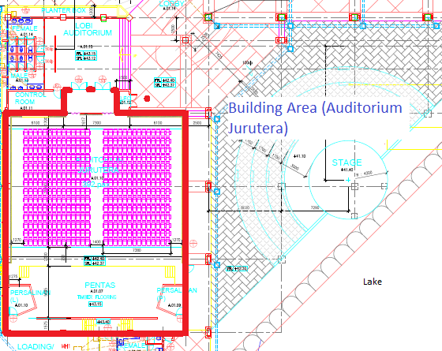
Figure 3.10: Auditorium Jurutera Building As-Built Drawing.

3.2 Proposed Type of Ground Sources Heat Pump
GSHPs has several types and operation strategies, depends on the design and applications for the building. The types are Ground Water Heat Pump, Surface Water Heat Pump, and Ground Coupled Heat Pump. For this project, types of Ground Source Heat Pump will use is Surface Water Heat Pump. The factors of selected that type / method is because of building location near with a lake, low initial cost, less public activity in the lake, and natural convection in primary role heat exchangers.
3.3 Method of Data Collection
Some data are required before conducting this project. The data are including building structure / plan and characteristic, and sources of Water Lake profile data or geographic information system (GIS) from civil engineering. Building structure or architecture (refer Appendix) need to have for calculating heat load. Heat load are a concern of wall surface, window, door, floor, roof, and etc which is exposed to the sun. The operation inside the building, people, and item which generating heat also a part of heat load.
By using special tools or software to generate analysis building cooling or heating load, Carrier’s Hourly Analysis Program (HAP) will be used. HAP is a computer tool which assists engineers in designing HVAC systems for commercial buildings. HAP is two tools in one. First it is a tool for estimating loads and designing systems. Second, it is a tool for simulating building energy use and calculating energy costs. HAP uses the ASHRAE-endorsed transfer function method for load calculations and detailed 8,760-hour by-hour simulation techniques for the energy analysis. Specifically, HAP performs the following tasks during an energy analysis:
- Simulates hour-by-hour operation of all heating and air conditioning systems in the building.
- Simulates hour-by-hour operation of all plant equipment in the building.
- Simulates hour-by-hour operation of non-HVAC systems including lighting and appliances.
- Uses results of the hour-by-hour simulations to calculate total annual energy use and energy costs.
- Costs are calculated using actual utility rate features such as stepped, time-of-day and demand charges if specified.
- Generates tabular and graphical reports of hourly, daily, monthly and annual data.

3.4 Surveying in order to determine depth and profile of the lake.
To do surveying in order to determine depth and profile of the lake need to have several tools before start conduct surveying. First of thing, refer to Geographic Information System (GIS) Department, Dr. Helmi Zulhaidi and Dr. Biswajeet Pradhan to get more information and management support. With information and management supporting, Mr. Wan Zakaria bin Wan Yusoff was from the lab as a technical person have advice suitable tools to conduct this task. The common tools / items need to have is,
- Life Jacket
- Small Boat
- Leveling Rod
- Digital time watch
- Thermocouple Thermometer and
- GPSMAP 76CSx

3.4.1 Life Jacket for safety during taking measurement on the water lake.
Standard of procedure to entering lake of faculty engineering must use life jacket to ensure safety during taking data requirement as shown in Figure 3.17. When use the life jacket, make sure tight the string properly with correct position. This is to avoid when any causes problem occurs, the life jacket cannot use properly.
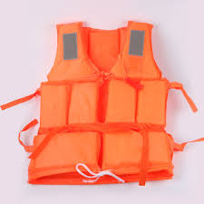
Figure 3.17: Life Jacket for safety during taking measurement on the water lake.

3.4.2 Small Boat to use for measurement water lake depth.
A boat is a watercraft of any size designed to float or plane, to work or travel on water. Small boats are typically found on inland (lakes) as shown in Figure 3.18, which will be used for taking measurement lake depth and temperature water depth. Before use this small boat, please make the sure physically unit in good condition from leakage or damage to avoid water come inside the boat.
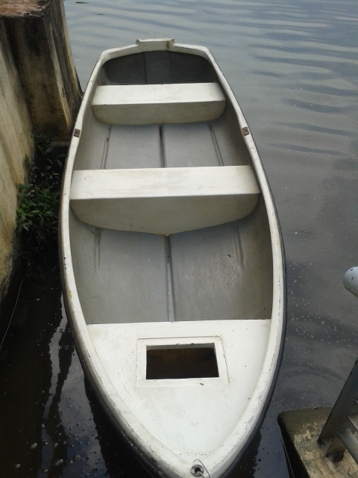
Figure 3.18: Small Boat to use for measurement water lake depth.

3.4.3 Leveling Rod to measure depth of the lake.
A level staff and also called leveling rod, is a graduated wooden or aluminum rod, used with a leveling instrument to determine the difference in height between points or heights of points above a depth surface. For this project will be using aluminum rod as shown in Figure 3.19, because of to measure inside the water. Leveling rod has to indicate two-unit numbers which is the Metric unit and Imperial unit. The unit number will be selected depends on the depth of the lake.
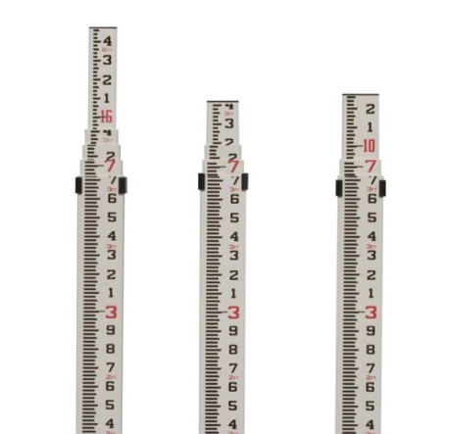
Figure 3.19: Leveling Rod to measure depth of the lake.

3.4.4 Digital time watch to set times each data measurement.
A watch is a small timepiece intended to be carried or worn by anyone. It is designed to keep working although the motions caused by the activities. Most application to used mainly for timekeeping, are electronic watches with quartz movements as shown in Figure 3.20. The purpose to have digital time watch is to record time during taking data measurement and to see the different surrounding temperature time to time.

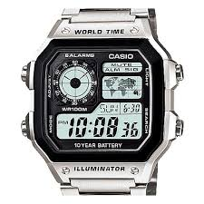
Figure 3.20: Digital time watch to set times each data measurement.
2.4.5 Thermocouple thermometer to measure water lake depth temperature.
A thermocouple is an electrical device consisting of two different conductors forming electrical junctions at differing temperatures. A thermocouple produces a temperature dependent voltage as a result of the thermoelectric effect, and this voltage can be interpreted to measure temperature as shown in Figure 3.21. Thermocouples are commonly used type of temperature sensor. But make sure check Thermocouple thermometer as shown in Figure 3.22, battery power before start taking data. If battery not enough power, that will affect to get a proper temperature reading. Thermocouple wire Temperature 1 (T1), sensing bulb placed 10 cm above from bottom leveling rod, and Temperature 2 (T2), sensing bulb placed 30.48 cm bottom from the top water surface.

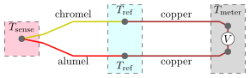
Figure 3.21: K type thermocouple measurement

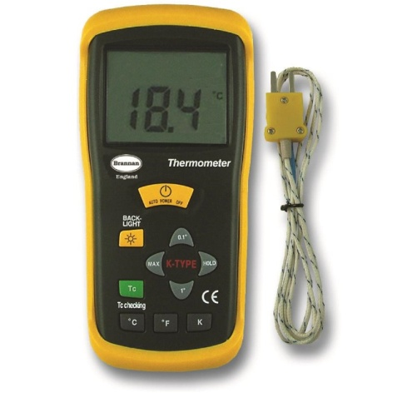
Figure 3.22: Thermocouple Thermometer to measure water lake depth temperature.

3.4.6 GPSMAP 76CSx to set coordinates during survey the lake.
The GPS concept is based on time. The satellites carry very stable atomic clocks that are synchronized to each other and to ground clocks. Any glide from true time maintained on the ground is corrected every day. More likely, the satellite locations are monitored specifically. GPS receivers have clocks as well. However, they are not tally with true time and not stable. GPS satellites will transmit time to time current time and position. A GPS receiver monitors multiple satellites and solves equations to determine the exact position of the receiver and its deviation from true time. Normally four satellites will view of the receiver for it to figure four unknown quantities which is three position coordinates and clock deviation from satellite time.
Garmin Map Source as shown in Figure 3.23 provides with geographic data that can be viewed on PC and added to the base map of compatible Garmin GPS device. With Map Source, you can:
- Transfer saved waypoints, routes, and tracks from your GPS device and save them to your PC.
- Create, view, and edit waypoints, routes, and tracks.
- Find items, addresses, and Points of Interest included in the map data.
- Transfer map data, waypoints, routes, and tracks to your GPS device.

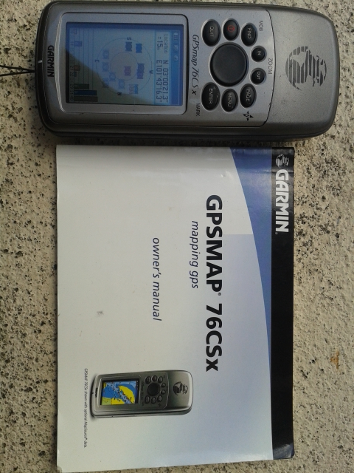
Figure 3.23: GPSMAP 76CSx to set coordinate during survey the lake.

3.5 Data Analysis
For the results of data analysis, in this subtopic, the results will be discussed based on method project conduct to achieve the objectives. The last objective is concern about can be water lake faculty of engineering depth temperature use as supply chilled water? If water lake depth temperature can achieve below than 20°C, possibility to use as chilled water to cool down room temperature will be positive. If the depth of water temperature is more than 25°C? So, water lake faculty of engineering only can use as replacement cooling tower to reject heat from condenser shell and tube.

  - Decision Analysis

Data result building load will be used as the main parameter as guidance for data analysis of lake water. The result of Data Lake has been recorded, will be consider three important things, which is the point deepest and deepest depth temperature in the lake, and distance length to the building load. Theoretically, as mentioned in a literature review, the deepest a lake, the better temperature resulting. The minimum length distance to building load also has been considered to save installation and operational cost.

If the deepest depth water temperature can achieve as per design cooling load with consideration the parameter guidance. Lake water Faculty of Engineering has potential as supply chilled water to the building load. If the data analysis cannot achieve as per building load requirement, then to consider as condenser cooling water to replace cooling tower still can be made or to other application which can use the benefit of the lake of water Faculty of Engineering, UPM from data analysis given.
  - Summary

For this final stage of methodology, the summary will be made for the entire aspects of this project; it will review back all the chapters in term of expectations and achievements for each chapter. This chapter will answer if the objectives of the project are achieved or not, and also either the procedures are well structured and followed or not. It also will include the benefits of the project and any suggestions or recommendations for a better quality of the project.

- RESULT AND DISCUSSION

4.1 Measurement area building project.
Before start calculate building heat load calculation. The criteria or structure building must be reviewing first to see actual building condition. Some of the procedure also needs to concern especially room zonings. If inside the building have more partitions, so the calculation must do separately and sum in when need to calculate cooling capacity requirement. After reviewed building area which is need comfort zone, noted inside the auditorium only have single zone, so the space area required cooling comfort is 5,568 square feet and the average ceiling height is 19 feet.

4.2 Cooling Load.
By using special tools or software to generate analysis building cooling or heating load, Carrier’s Hourly Analysis Program (HAP) will be used. HAP is a computer tool which assists engineers in designing HVAC systems for commercial buildings. HAP is two tools in one. First it is a tool for estimating loads and designing systems. Second, it is a tool for simulating building energy use and calculating energy costs. HAP uses the ASHRAE endorsed transfer function method for load calculations and detailed 8,760-hour by-hour simulation techniques for the energy analysis.
For this project, we are focusing on the estimating load and designing system. After fill up data building information in the E20 / HAP, the result show for Air system sizing, Air zone sizing, Ventilation sizing, System load, Zone load, Space load, Hourly air system, Hourly zone and System psychometric and etc.

Table 4.1: Air System Sizing Summary for Cooling Ventilation
From Table 4.1, the auditorium building required cooling capacity 27.1 Ton refrigerants, and entering air dry bulb, wet bulb respective 26.9 °C / 21.3 °C with relative humidity 64%. The data result much helpful for engineer to design air cooling ventilation system for this auditorium.

Table 4.2: Air zone sizing

Table 4.2, shown data result for air zone sizing which is calculated since January to December months for Auditorium Jurutera. If have many zone required conform zone, zone terminal sizing required for this system to split airflow requirement and cooling sensible each zone. For this project, only required single zone because of no partition or room need comfort zone inside the building. From the data of result, Auditorium zone required designing airflow 8704 cfm, Individual space airflow per area 1.56 cfm/ft², and cooling sensible energy is 159.4 MBH.

Table 4.3: Ventilation Sizing

Table 4.3 shown data result ventilation sizing for inside the Auditorium Jurutera building. The method of ventilating sizing which required fresh air intake is to know area building comfort, maximum occupants inside the building, maximum supply air (CFM), and factor required fresh air in building space area. For this project, the Auditorium Jurutera building designed ventilation airflow rate is 2294.1 CFM.

Table 4.4: Zone designing load

Table 4.4 shown result data zone designing load Auditorium Jurutera building. The main factor to consider zone designing is needed to know building structure and characteristic. Building structure can be referring into Architecture drawing to get more information about building material used. Basically, the information needs to know is building a compass, wall, roof, window, and door types with factor “U”. Factory “U” is the material conductivity for difference types of material and application.
Building characteristic or operation can be referring to actual job site which how the building operates and energy used with followed the activities inside the building. For this project, the concern is only about the building heating / cooling load to support the objectives. As the result, this building cooling zone sensible capacity load is 159.3 MBH and the Latent capacity load is 803.6 MBH.
To calculate building energy application, by using this software also, can much helpful. The next researcher only needs to understand and know what types of the application contribute electricity for that building. Find the sources of electricity tariff and pricing, and simulate the building application for the operation and cost per daily, weekly, monthly or yearly for the building selected. From that result, the researcher can apply or think the solution how to reduce building operation cost to become green building categories.
Figure 4.1: System psychometric

Figure 4.1 shown psychometric charts which for July design cooling day. The actual building was located in Serdang, Selangor, but wheatear condition selected is Kuala Lumpur during upload weather data in the software. This is because of weather data condition in the software only having Kuala Lumpur. Figure 4.1 has indicated five important points which need to know when designing cooling zone. The result as shown below,
- Point 1 – Outdoor air
- Point 2 – Mixed air
- Point 3 – Central cooling coil outlet
- Point 4 – Supply fan outlet
- Point 5 – Room air

The result data of each point from Figure 4.1 as below,
  - Point 1 – Dry bulb / Wet bulb = (92.4 / 77.6) ˚F
  - Point 2 – Dry bulb / Wet bulb = (80.5 / 70.3) ˚F
  - Point 3 – Dry bulb / Wet bulb = (59.8 / 58.9) ˚F
  - Point 4 – Dry bulb / Wet bulb = (59.8 / 58.9) ˚F
  - Point 5 – Dry bulb / Wet bulb = (77.0 / 69.1) ˚F
  - Relative Humidity room = 64%
  - Specific Humidity room = 0.0125 lb/lb

From all above result data cooling load, the most important information needs to know to link with surface water heat pump are coil capacity, coil water flow rate, and coil leaving water temperature. Water lake depth temperature requirement should be below than leaving water temperature to supply cooling coil as chilled water. If water temperature above than temperature requirement, water depth temperature cannot be used as sources of the cooling coil. For Coil water flow rate data will be use for selecting water pump after distance from late depth temperature allocated.
4.3 Surveying a lake profile, depth, and temperature for measure data requirement.
Surveying water lake profile and depth is one of the steps before applying Geographic Information System (GIS). To apply GIS, We need to know a lake area, depth, and surrounding condition the lake. By using tools which mentioned in Chapter 3, finally, all data which required answering the objectives was successful. In this chapter, I would like to share some of the information water lake profile, area, lake depth, the deepest water temperature, and etc.

Surveying Lake water was conduct on December 10 and 13 at the morning and afternoon. All items as per mentioned in Chapter 3- Methodology has been prepared. First 15 point has been taken on December 10 for survey area of the lake. The first point has been taken is near examination hall and cottage and the last round point was set up 104 feet (31 meters) to point number 1.
On December 13, point number 16 until 49 has been taken. During that time, the surrounding or ambient condition is about 30 to 32 degree Celsius dry bulb and 70 to 74% relative humidity. Point number 16 has been set up or taken inside the lake, which located the front of the cottage and examination hall. The last point number 49 was set up or taken which located near of entering the water to the lake and front of the faculty of engineering library. Data survey a lake Area has been summary in Table 4.5.

Figure 4.2, shown waypoint with using GPSMAP 76CSx which has been taken 49 points included surface area and inside the water lake. Surface area has been taken 15 points and inside the lake have been taken 34 points or reading.
Data survey inside the lake has been summary in Table 4.6.

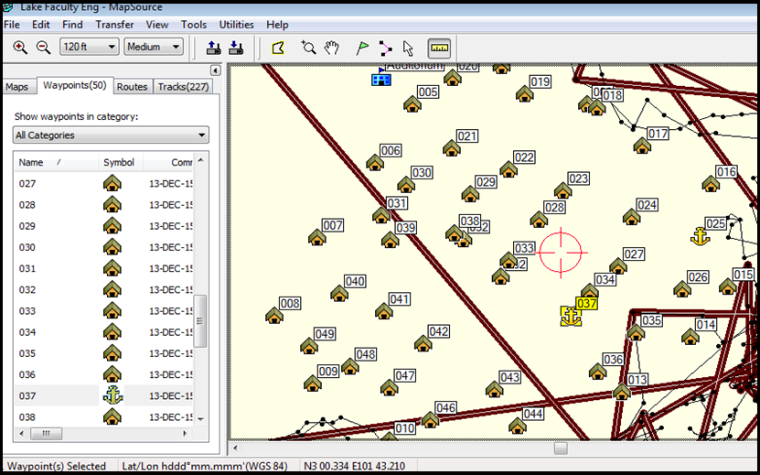
Figure 4.2: 49 Points located set by GPSMAP 76CSx during surveying the lake.

Table 4.5: Data survey a lake Area

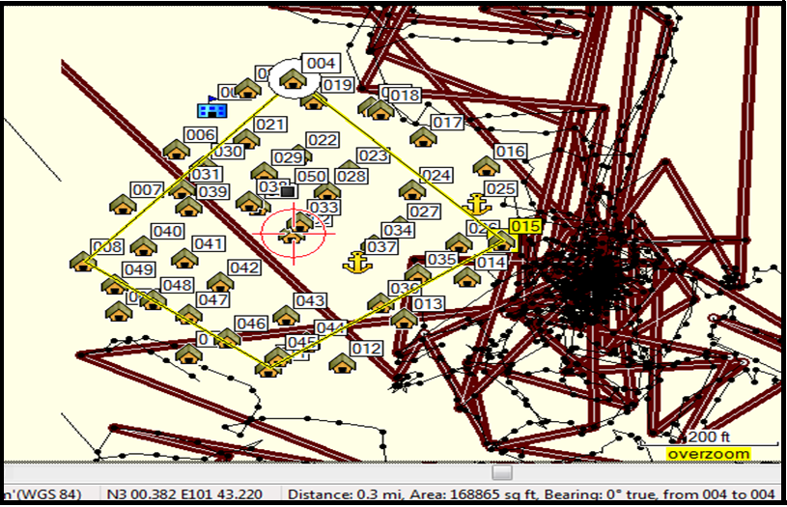
Figure 4.3: Area of the lake which set 4 points.

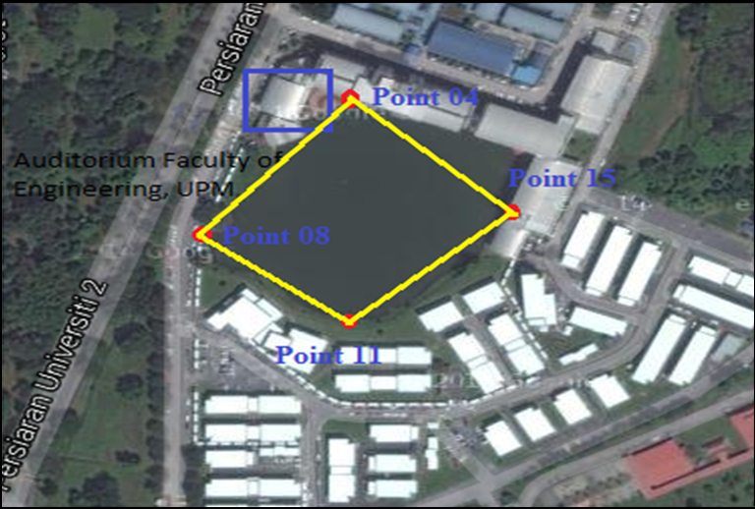
Figure 4.4: Sketch area 4 points of the lake.

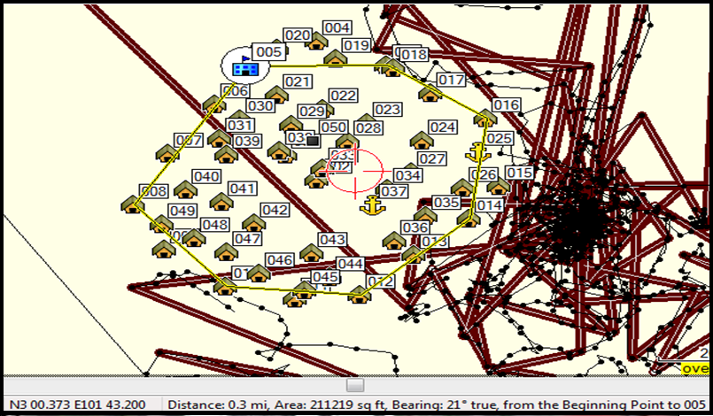
Figure 4.5: The Maximum length area of the lake.

4.3.1 Area of the lake
Area of the lake has been taken with consideration the highest or longest distance per square. Figures 4.2, 4.3, and 4.4, shown the area point have been set up or taken by GPSMAP 76CSx. To ensure better understanding and clear picture about the point already setup, by using website google earth satellite to the location lake of faculty engineering have been crop and sketch the waypoint. Area of the lake has been setup waypoint number 4, 8, 11, and 15 which the area is 168,865 square feet (ft²) or 15,696.7 square meters (m²). The maximum length which taken is several points (figure 4.5) is 211,219 square feet (ft²) or 19,632.94 square meters (m²).

4.3.2 Data Survey on the water Lake Faculty of Engineering
Surveying the water lake in the faculty of engineering actually, some of the parts already explained in the surveying area the lake part. Which during taking all data requirement, that time, the surrounding or ambient condition is about 30 to 32 degree Celsius dry bulb and 70 to 74% relative humidity? The ambient condition will affect the data requirement as the result in below Table 4.6.

Table 4.6: Data Survey a lake depth and water temperature
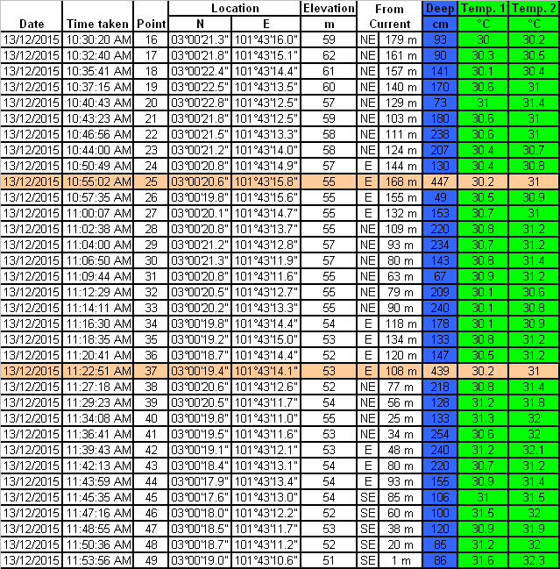

4.3.3 Lake profile and water temperature
From Table 4.6, only have 2 points deepest with the equal temperature reading. The two points deepest point number 25 and 37. Point 25, with the depth 447cm, can achieve 30.2 degree Celsius water temperature. While point 37 with the depth 439cm also can achieve temperature same with point number 25.
Refer Figures 4.6, 4.7, and 4.8 for the graph of lake profile and temperature.

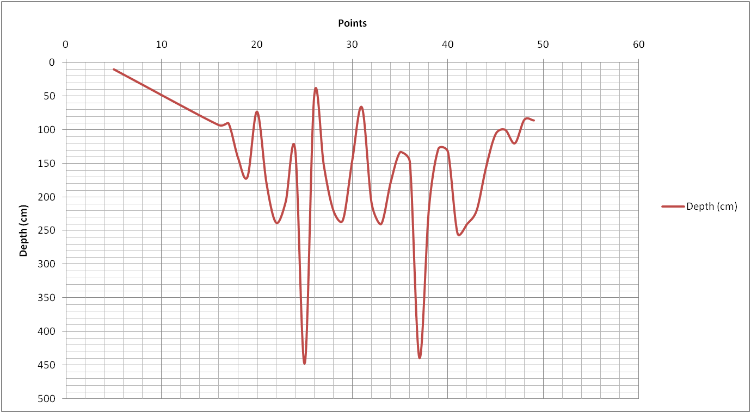
Figure 4.6: Water lake profile.

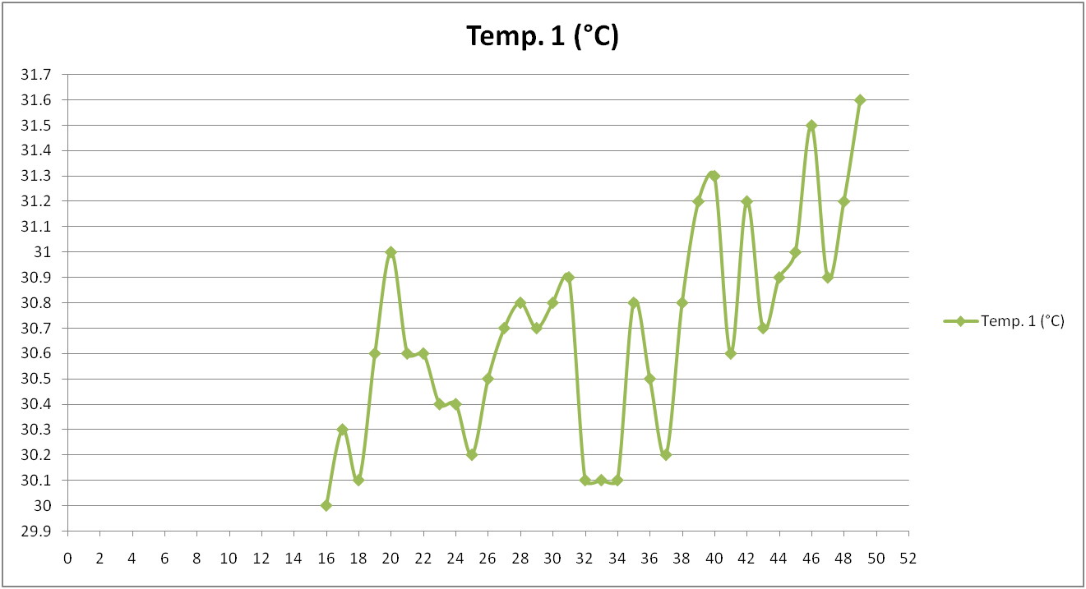
Figure 4.7: Water lake deepest temperature in degree Celsius (°C).

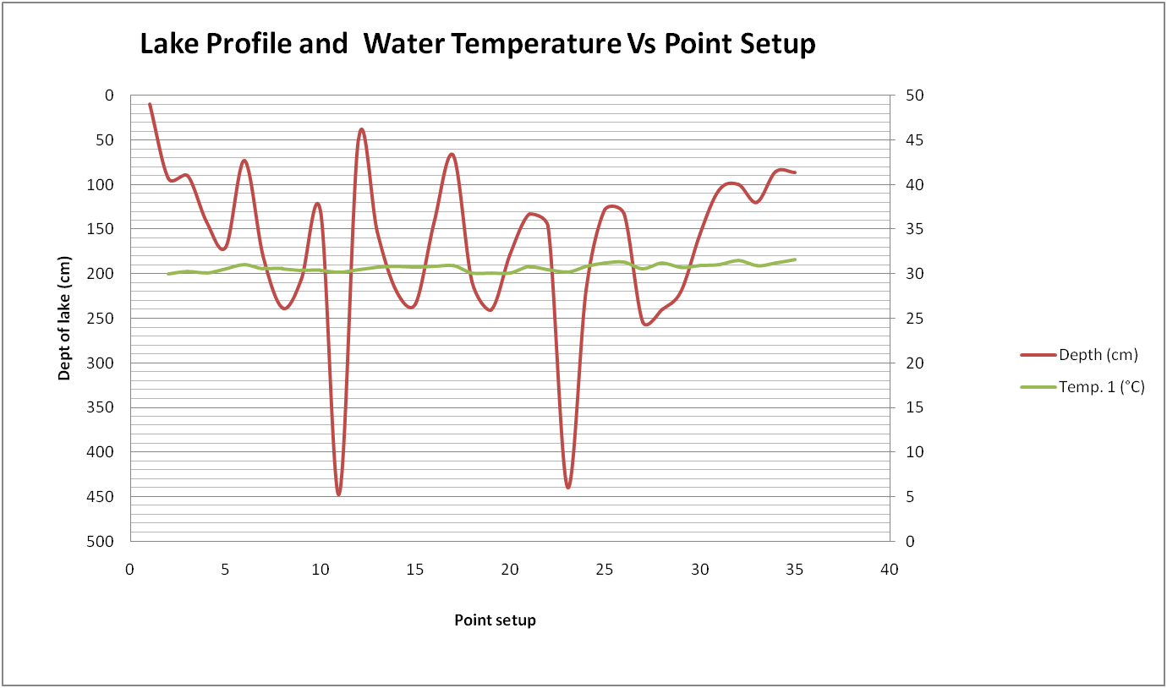
Figure 4.8: Lake profile, and water temperature versus point setup.

Figure 4.8 shown graphs a lake profile and water temperature for each point has been taken. For this project, point number 5 has been marked as a center because of nearest with Auditorium Jurutera building. Temperature 1 is the temperature sensor which located 10 cm above ground and stick into leveling rod during taking measurement depth and temperature.

4.3.4 Analyze water lake depth temperature and distance to the building.
From data Table 4.6 and Figure 4.8, the most depth with reasonable depth water temperature is only point’s number 25 and 37. Other than two points selected also have similar water temperature but because of the depth cannot guarantee the water depth temperature can maintain or consistency from exposing to the ambient temperature. So this is why only the most depth lake water temperature preferred even has another point lower water temperature compare to point number 25 and 37.
The summary of two points selected and distance to the point number 5 shown in Figures 4.9 and 4.10 as below:
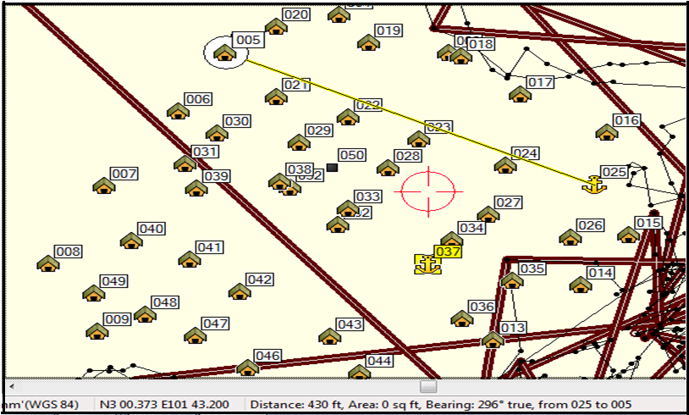
Figure 4.9: Length distance from point 25 to point 05.

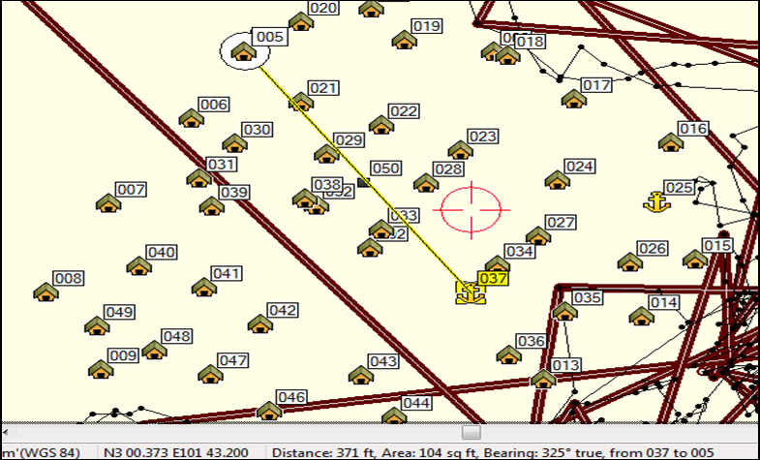
Figure 4.10: Length distance from point 37 to point 05.
Point 25:-
- Water depth temperature (WB) = 30.2°C (86.4°F)
- Depth = 447 cm (14.66 ft)
- Distance length to point 5 = 435 ft (132.6 m)
Point 37:-
- Water depth temperature (WB) = 30.2°C (86.4°F)
- Depth = 439 cm (14.4 ft)
- Distance length to point 5 = 370 ft (112.8 m)

Referring above data summary, compare to data previous objective which required water temperature to supply cooling coil is too much different.
Water depth temperature cannot supply as chilled water with delta temperature 15.3°C (59.5°F). Cooling coil water entering required 14.9°C (58.8°F), but water depth temperature only can produce 30.2°C (86.4°F).

4.4 Summary
As the result and discussion have been done, the Auditorium Jurutera building area is 5,568 ft² with ceiling height 19 ft. By using software E20 / HAP to calculate building cooling load, the result cooling capacity which required designing air conditioning is 27.1 Tons. In that software also have shown details report air system sizing, air zone sizing, ventilation sizing, system load, space load, hourly air system, hourly zone, psychometric, and etc.
Surveying lake water has been done in two days, the first day to measure lake area, and the second day to measure depth and temperature depth lake. During taking the measurement, the surrounding condition or ambient temperature is around 30 to 32 degree Celsius (°C), and 70 to 74 percentage (%) the relative humidity. 49 points have been set up, consist of the lake area and inside the lake by using tools as per mentioned in Chapter 3. In this Chapter 4, have shown the Figures and Tables to give a more clear picture and easy way to reader understand the analyses have been done.
The final result of the lake data measurement, only have 2 points was selected, which is point number 25 and 37 with the depth 447 cm and 439 cm at the same depth temperature 30.2 degree Celsius (°C). After, compare the result data lake to data cooling load which required water temperature to supply cooling coil is too much different. Water depth temperature cannot supply as chilled water with delta temperature 15.3°C (59.5°F). Cooling coil water entering required 14.9°C (58.8°F), but water depth temperature only can produce 30.2°C (86.4°F).

5. CONCLUSION AND RECOMMENDATION

Based on result data after conducting several task to complete the objectives, The Auditorium Jurutera Building required 27.1 Ton cooling capacity to provide a comfort zone. If using the conventional system, packaged chiller can be used as air conditioning system. Nowadays, conventional air conditioning become number one contribute high electricity cost in the building. Many researchers try to develop a new design or find a new solution with using natural heat / cooling to reduce uses electricity and also to help protect the environment from pollution and global warming potential. To introduce SWHP for replacing conventional air conditioning system has been one of the methods applied for this project. But unfortunately, for local application, lake of the Faculty of Engineering, UPM only can be achieved with water depth temperature 30.2°C (86.4°F) and with the minimum depth 447 cm (14.66ft).
During conduct this project, I have learned a lot of new things and knowledge which is how to survey Water Lake and obtain a lake profile. The challenging part when doing surveying a lake is to choose or get suitable equipment, and how to conduct small both during taking depth lake and temperature. To conduct this project required 2 people, but because of difficult to get supporting from other. This is the one factor why I’m only using GPSMAP 76CSx to survey Area Lake and inside the lake with stand up several areas which estimated 50 steps from one point to next point and set the coordinate. The problem when using GPS, we don’t have center marking as a guideline. For this case, point number 5 which is nearest with Auditorium Jurutera Building has been marked as central marking.
However, it’s really interesting and enjoying when to learn something new which never do before. If can do more further, another one step is to apply Geographic Information System (GIS). As conclusion, SWHP for local application could not be used as chilled water supply because of the temperature requirement to supply cooling coil inside the building is too high which is the different temperature is 15.3˚C.

5.1 Recommendation
Based on project analysis have been done, even the SWHP, depth water temperature could not used as chilled water to supply cooling coil inside the building. Its recommended can be tried to improve or use this project with below advice:-
- If depth Water Lake can achieve more than 10 meters, the potential to have consistency water depth temperature below than 30°C (86°F) will be positive. Increase depth in the deepest point with additional 19.68 ft (6 m) in the lake. (Estimated the mud inside the lake is almost 2 ft)

- Even the result of water depth temperature within 30°C (86°F) to 33°C (91.4°F), it still can use as replacement cooling tower for conventional air conditioning system. Standard design water cooled chiller for water entering condensing shell and tube is 29.4 (85°F) to 35°C (95°F), in the system application water condenser will be rejected heat at the cooling tower by pumping water pump and helping motor fan and surrounding temperature.

- Using SWHPs its can help to reduce uses electricity which is without using the motor fan and free maintenance to supply water to condenser shell and tube. But, to replace cooling tower, pump size need to consider whether is reasonable with piping length in term of costing as a replacement.

- Another application evaporative cooling also can be used for academic building or nearest building which is not too far from water Depth Lake. It can be useful to reduce humidity inside the room.

REFERENCES

Economic planning unit prime minister department (2015). Climate Resilient Development, Eleventh plan, 2016-2020: Way Forward.
Nan Lv, Qing Zhang, Dongsheng Wu, Zhenqian Chen (2015). Surface water sources heat pump air conditioning system simulation and operation performance analysis. 1877-7058 The Author.
Luigi Schibuola, Massimiliano Scarpa (2015). Experimental analysis of the performances of a surface water source heat pump. Energy and Buildings.
Engineering and case text book. Clean energy project analysis: Ground Sources Heat Pump Project Analysis. ISBN: 0-662-39150-0.
Engineering and case text book. Clean energy project analysis: Ground Sources Heat Pump Project Analysis. ISBN: 0-662-39150-0.
Siti Nor Afzan BUYADI, Wan Mohd Naim WAN MOHD and Alamah MISNI, Malaysia (2014): Quantifying Green Space Cooling Effects on the Urban Microclimate using Remote Sensing and GIS Techniques.
University of British Columbia (2013). ASHRAE Competition HVAC Design Calculations.
Xiaotang ZHOU, James E. BRAUN (2013). TRANSIENT MODELING OF CHILLED WATER COOLING COILS.
GREENHECK (2009), Building Value in Air: Coil dimension guidelines.
ASHRAE Handbooks. (2009). Chapter 28: Non-Residential Cooling and Heating Load Calculations; CLTD/CLF methods.
London, Chartered Institution of Building Services Engineers (2005). Climate change and the internal environment CIBSE TM36.
Lisa Lind (GNS Science), Stefan Mroczek (GNS Science) and Jo Bell (2001). Case study 18: University utilizes water lake for cooling in New Zealand.
2000 ASHRAE system and equipment Handbook (SI). Chapter 11: District Heating and Cooling.
W.P.Jones. Second edition 1997: Air conditioning application and design. ISBN 0-340-64554-7.
Kavanaugh, S.P (1991). Case study: Ground and water sources heat pumps. Oklahoma State University, Stillwater,OK.
OSU (1988a). Closed-loop ground sources heat pump systems installation guide. Journal of International Ground Sources Heat Pump Association. Oklahoma State University, Stillwater ,OK.
OSU. (1988b). Closed loop ground water heat pump systems. Oklahoma State University, Stillwater, OK.
Roscoe Moss Company (1985). The engineers manual for water well design, Roscoe Moss Company, Los Angeles, CA.
Wilbert F. Stocker and Jerolo W.Jones (1982). Text book 2nd Edition: Refrigeration & Air Conditioning. ISBN 0-07-066591-5
McGraw Hill (1970). Thermal comfort: Analysis and applications in environmental engineering

