***Evaluation of the success of planting trees in the rows of trees installed in the katapula tailing***

**Abrantes Antonio Bushiri 1*-2 , Arthur Kaniki 3 , Eric Bushiri Abrantes 4 , Melissa Kalala Kakazi 5**

**1\*** Department of Electromechanics, Polytechnic Faculty, University of Lubumbashi

**2** Researcher in the Engineering Department, Higher Technical Institute of Lubumbashi

**3** Department of Industrial Chemistry, Polytechnic Faculty, University of Lubumbashi

**4** Soil and Water Department, Faculty of Agronomic Sciences, University of Lubumbashi

5 Environmental Analysis Laboratory, Polytechnic Faculty, University of Lubumbashi

**Summary** . Assisted phytostabilization using trees and organic amendments has been installed on soil polluted with heavy metals in the Katapula sedimentation basin in Kipushi there at 16 years old. The objective of this work was to evaluate the success of tree planting in the corridors of trees installed in the tailing of Katapula 16 years after installation. The method of Braun Blanquet was used to assess the recovery (expressed in relative abundance). Floristic identification was carried out using 12m 2 quadrats delimited by the strings in which all the species present have been listed, after identification a determination of the relative abundances of the species with Excel was made. the result obtained shows a total of 31 species identified in the corridors of the entire device. C. trygina , I. cylindrica , M. altera , B. pseudoperennis , L. leucocephala , T. diversifolia , have been the most abundant with respectively 33.2%; 26.1%; 9.5%; 6.1%; 5.9%. The least species abundant was O. semiloba with 0.03%. Depending on the biological forms of the species, 3 groups stood out: woody species, perennial species and annuals.

Key words: Phytostabilization , Braun blanquet, relative abundance, floristic identification.

**Abstract**. Assisted phytostabilization using trees and organic amendments was installed on soil polluted with heavy metals in the Katapula sedimentation basin in Kipushi 16 years ago. The objective of this work was to evaluate the success of tree planting in the corridors of trees installed in the Katapula tailing 16 years after installation. Braun Blanquet's method was used to assess the recovery (expressed in relative abundance). The floristic identification was carried out using 12m2 quadrats delimited by strings in which all the species present were listed, after identification a determination of the relative abundances of the species with Excel was made. The result obtained shows a total of 31 species identified in the corridors of the entire system. *C. trygina, I. cylindrica, M. altera, B. pseudoperennis, L. leucocephala, T. diversifolia*, were the most abundant with 33.2% respectively; 26.1%; 9.5%; 6.1%; 5.9%. The least abundant species was *O. semiloba* with 0.03%. According to the biological forms of the species, 3 groups stand out: woody species, perennial species and annuals.

**Key words**: Phytostabilization, Braun blanquet, relative abundance, floristic identification

**Introduction**

Metallic trace elements (TMEs) and the dangers they present constitute a considerable concern that they are released into the environment, they are considered as contaminants and the most frequent are: cadmium (Cd)), chromium (Cr), copper (Cu), nickel (Ni), lead (Pb), zinc (Zn). Their accumulations of ETM in the different compartments in the environment and in the organism cause disturbances following to their toxicity (Prasad, 2008). Each source of contamination has its own adverse effects on plants, animals and ultimately on human health, but those that add metals heavy soils and waters are of great concern because of their persistence in the environment and their disturbance on human health. ( Garbisu and Alkorta , 2001; Gisbert et al., 2003).

The former Katanga was one of the provinces that contributed a lot to the economic sector of the   
Democratic Republic of Congo because of its areas rich in mineral deposits such as   
: copper, cobalt, zinc, manganese which were the main metals exploited in the province,   
whose capital was Lubumbashi, also called "copper capital". ( Kampunzu and   
Cailteux , 1999; Okitaudji , 2001). Mining activities are the basis of many   
harmful impacts on the region where they are located. If no remedial measures are put in   
place, these impacts can be the basis for the disappearance of vegetation due to the   
high concentration of heavy metals in the soil and acid rain ( Shutcha , 2010).

Indeed, given that the pollution of these different sites is a danger for the population living in the   
vicinity of the latter and that the accumulation of metallic trace elements in the soil can   
have an impact on plant production and the risk of severe contamination that heavy metals   
can cause on the health of the population ( Mpundu et al. , 2013), different   
soil remediation strategies have been developed (Zhejiang, 2008), the most recent of which is   
phytoremediation which is a method put in place to develop techniques that are less   
costly and compatible with environmental standards by using higher plants   
, algae or fungi to contain or extract metallic trace elements, radioelements or organic pollutants present in the ground or in the water resulting from   
human activities (Isabelle, 2010; Marchand, 2012).

Phytostabilization seems appropriate for the management of large surfaces contaminated by   
ETM. Indeed, it is based on the use of plants capable of limiting the transfer of   
pollutants to the aerial parts of plants, thereby limiting transfers to the food chains. (Robinson et al., 2006). Therefore , this work aims to assess the success of   
planting trees in the rows of trees installed in the tailing of Katapula 16 years after installation, through:

* the natural colonization of herbaceous and woody species (the richness and abundance species) in the rows of trees;
* regeneration of established tree species;
* and identify herbaceous and woody species with high potential for phytostabilization .

1. **Medium, materials and methods**

**1.1 Middle**

Located 30 km west of the city of Lubumbashi, the city of Kipushi ((11° 46' 27.1'' N and 27°   
16' 21.6'' E with an altitude of 1351 m) ( Kaniki , 2008) Treatment by flotation, carried out by   
the former Kipushi concentrator (ACK), gave enormous quantities of rejects which reached   
from the 1980s, 3,000 to 3,400 t/d for 4,000 t /d of supplied ores. The surface storage   
of these flotation rejects dates back to the 1960s, long after the commissioning   
of the concentrator. These rejects therefore led to the creation of artificial basins by the   
construction of earthen dykes in the valley of the Kipushi River for the retention of   
solid particles after decantation.Thus, two basins were completely filled with discharges   
(tailings) ( Kitobo et al ., 2007; Kaniki , 2008; Kitobo , 2009).   
residential places, its size and the danger it represents for public health, one of these   
two tailings parks ( Katapul tailing a or Changalae , photo 1) was targeted in the   
tree planting programme. This tailing covers about 146 hectares, but the area covered with trees   
is only 1.4 hectares. The plantation of trees composed of different species was installed   
in 2005 in planting holes 2 m in diameter and 1 m deep filled   
with organic amendments from urban waste.

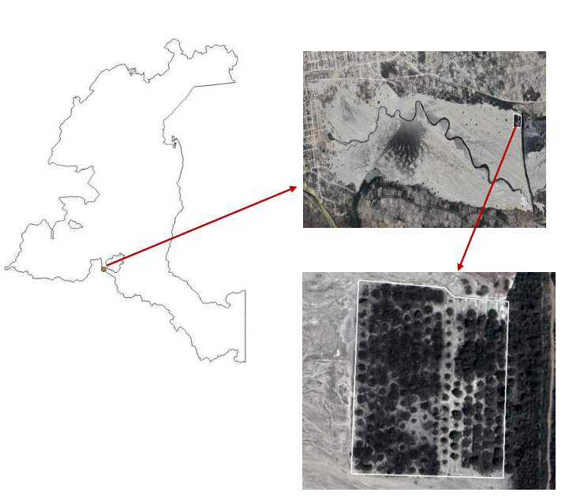

Figure 1 . Tailing of Katapula or Changalae

**1.2 Materials and Methods**

Floristic identification was carried out using 4m quadrats x 3 m delimited by the strings in which all the species present are listed (photo 2)

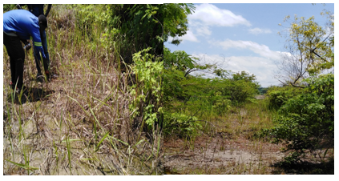

Figure 2 . Floristic identification was carried out using 4m x 3m quadrats

The floristic survey must take into account all the species present in the quadrat, which   
can pose some difficulties with regard to their identification in terms of systematic. This is particularly the case when not all species are in flower at   
the time of the survey. It is also important to note that the identification is only   
representative of the period in which it is carried out, the timing of flowering being different for   
many species. The method used is based on the use of the Braun Blanquet scale, which plans to assign an index from 1 to 5 (Table 1). These surveys represent the basis of the statistical definition of plant associations, which is based on the estimation, for each of the taxa in the survey, of various parameters such as abundance and dominance. Although the surveys should in principle concern the entire plant kingdom, most of them concern only higher seed-producing plants (Spermaphytes) (Gillet et al., 1991; Lahondère , 1997).

Table 1 . Recovery of plant species according to the Braun-Blanquet method

|  |  |
| --- | --- |
|  | |
| **Cash recovery** | **Abundance coefficient** |
| *Over 75%* | *5* |
| *Between 50% and 75%* | *4* |
| *Between 25% and 50%* | *3* |
| *Between 5% and 25%* | *2* |
| *Less than 5%* | *1* |
| *rare species* | *r* |

All the floristic survey data were entered in the Excel spreadsheet where the   
relative abundance calculation by the formula, the specific richness and the regeneration of woody plants were   
taken. $$A_{r}\left(\%\right)=\frac{la somme des especes X}{\sum{de toutes les sommes des especes}}×100$$

With: ***Ar*** the relative abundance.

# 3 Results

## 3.1. Relative abundance of species in the tree planting corridor

It was listed more than 32 spontaneous species during our study whose most predominant relative abundance is those of *Celosia trigyna* with 33.24%, *Imperata cylindrical* with 26.14%, *Microchloa change* with 9.47%, *Bulbostylis pseudoperennis* with 6.86%, *Leucaena leucocephala* with 6.07%, *Tithonia diversifolia* with 5.91%, *arthraxon hispidus* with 2.86% and the rest of the species had a relative abundance of less than 2%. Table 2 gives the list of spontaneous species and their relative abundances.

tree corridor (29 quadrats, quadrat area: 12m 2 )

|  |  |  |  |
| --- | --- | --- | --- |
| **No.** | **Spontaneous species** | **Recovery amount** | **Relative abundance (%)** |
| 1 | *Celosia trigyna* | 1221 | 33.24 |
| 2 | *Imperata cylindrical* | 960 | 26.14 |
| 3 | *Microchloa change* | 348 | 9.47 |
| 4 | *Bulbostyles pseudoperennial* | 252 | 6,86 |
| 5 | *Leucaena leucocephala* | 223 | 6,07 |
| 6 | *Tithonia diversifolia* | 217 | 5,91 |
| 7 | *Arthraxon ugly* | 105 | 2.86 |
| 8 | *The greatest panic* | 64 | 1.74 |
| 9 | *Bidens oligoflora* | 61 | 1.66 |
| 10 | *Myrtifolia oak* | 38 | 1.03 |
| 11 | *Cynodon typist* | 24 | 0.65 |
| 12 | *Ipomea cairica* | 21 | 0.57 |
| 13 | *Albizia Lebbeck* | 18 | 0.49 |
| 14 | *Glycine wightii* | 18 | 0.49 |
| 15 | *Hyparrhenia red* | 16 | 0.44 |
| 16 | *Commeline zigzag* | 15 | 0.41 |
| 17 | *Phragmites australis* | 15 | 0.41 |
| 18 | *Cypress sp* | 13 | 0.35 |
| 19 | *Lantana chamber* | 10 | 0.27 |
| 20 | *Amazing jalapa* | 4 | 0.11 |
| 21 | *Triumfetta sp* | 4 | 0.11 |
| 22 | *The highlight urticifolia* | 3 | 0.08 |
| 23 | *Crotalaria sp* | 3 | 0.08 |
| 24 | *Digital sp* | 3 | 0.08 |
| 25 | *Phyllantus muellerianus* | 3 | 0.08 |
| 26 | *Psidium guava* | 3 | 0.08 |
| 27 | *Unknown 2* | 3 | 0.08 |
| 28 | *Anona senegalensis* | 1 | 0.03 |
| 29 | *Oxalis semiloba* | 1 | 0.03 |
| 30 | *Poaceae 1* | 1 | 0.03 |
| 31 | *Unknown 1* | 1 | 0.03 |

## 3.2. Relative abundance of species according to their category or biological form

According to their category (or biological form) we found 3 types of species namely:

* Woody species
* Perennial species
* Annual species

### 3.2.1. Woody species in corridors

The woody species found in the corridors during the inventories were 6 in total, including *L. leucocephala* with an abundance of 77.9%, *Q. myrtifolia* with 13.3%, *A. lebbeck* with 6.3% and the resthad a relative abundance of less than 1.5%. Among the six woody species found , *A. senegalensis* was the least abundant (0.35%). The pie chart (Figure 3) summarizes the abundance of each woody species in the corridors or rows of trees.

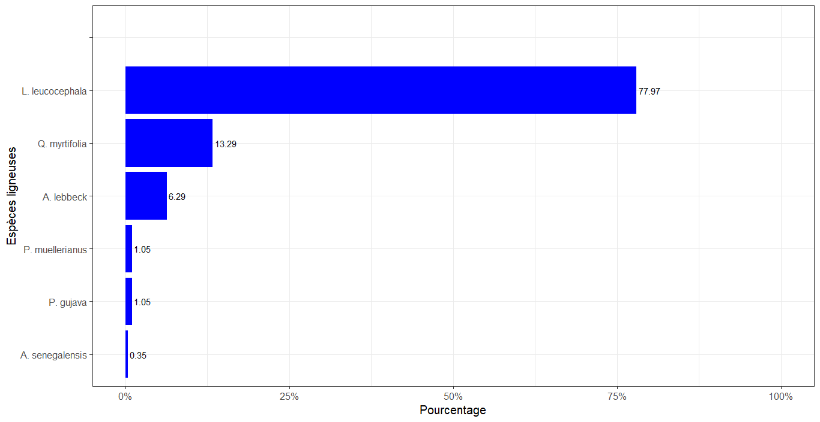

Figure 3. Distributions of woody species (29 quadrats and the total area of a quadrat: 12 m 2 )

### 3.2.2. Perennials in hallways

Eleven perennial species were found during the inventories *I. cylindrica* was the most abundant with 57.1% followed by *M. altera* (20.7%) and *T. disversifolia* (12.9%). *Digitaria sp* and *C. urticifolia* were the least abundant with a relative abundance of 0.18%. Figure 4 summarizes the abundance of each species.

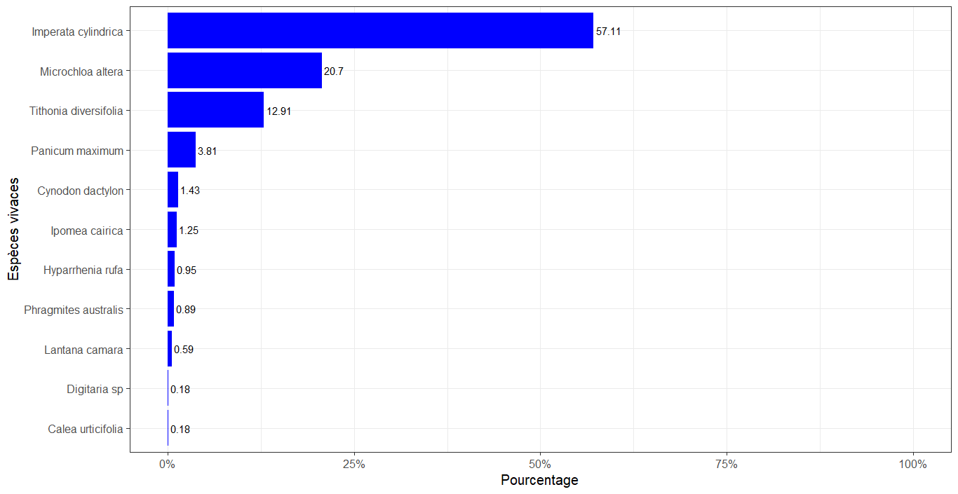

Figure 4. Distribution of perennial species (29 quadrats and the total area of a quadrat: 12 m 2 )

### 3.2.3. Annual species in corridors

Eleven annual species were recorded including *C. trigyna* which was the most abundant with 71.9% followed by *B. pseudoperennis* (14.8%) and *A. hispidus* (6.1%); and *O. semiloba* was the least abundant species at 0.06%. The pie chart (Figure 5) summarizes the abundance of each species.

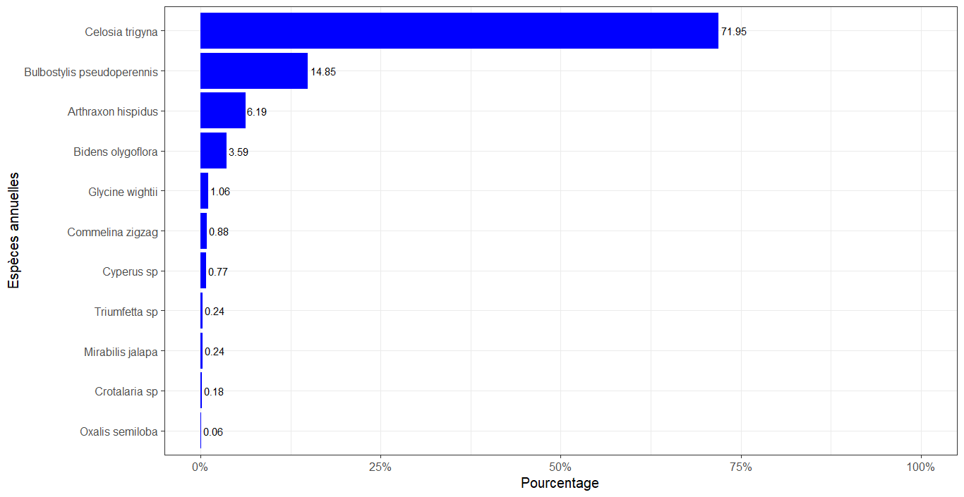

Figure 5. Distribution of annual species (29 quadrats and the total area of a quadrat: 12 m 2 )

## 3.3. Regeneration of woody species in the corridor

Three species managed to regenerate in the tree corridors of the device, this regeneration was largely dominated by *L. leucocephala* with a relative abundance of 6.1% and less than 1%. Table 3 gives the track of regenerated woody species and their relative abundances.

Table 3. Regeneration of woody species in the corridor

|  |  |
| --- | --- |
| **Woody species** | **Relative abundance (%)** |
| ***A. auriculiformis*** | 0.00 |
| ***A. polyacantha*** | 0.00 |
| ***A. lebbeck*** | 0.49 |
| ***C. lusitanica*** | 0.00 |
| ***L. leucocephala*** | 6.07 |
| ***P.sylvestris _*** | 0.00 |
| ***P. guajava*** | 0.08 |
| ***S. siamea*** | 0.00 |
| ***S. spectabilis*** | 0.00 |
| ***S.guineense _*** | 0.00 |

**4. Discussion of results**

**4.1. Relative abundance of species in the corridor**

Thirty-one species have been listed, including *C. trygina* , *I. cylindrica* , *M. altera* , *B. pseudoperennis , L. leucocephala* and *T. diversifolia* were the most abundant with   
respectively 33.2%; 26.1%; 9.5%; 6.1%; 5.9%; and the rest of the species were present   
with an abundance of less than 3%.

The results of this study also show that *C. trygina* , *I. cylindrica* , *M. altera* , *B. pseudoperennis , L. leucocephala* e *T. diversifolia* are the species that ensure good ground cover with overlap (varying from 6 to 34%) compared to other species whose abundance varies from 0 to 3% on average.

This result supports those of previous studies that *C. trygina* , *I. cylindrica* , *M. altera* , *B. pseudoperennis , L. leucocephala* and *T. diversifolia* are good candidates for phytostabilization of contaminated soils because it is able to colonize soils that are strongly contaminates heavy metals mainly copper ( Shutcha *et al.* , 2010). And that *C. trigyna* and *M. altera* are cuprophyte species which are in the list of the cupricultural flora of Katanga, and *I. cylindrica* , *Cyperus sp* and *H. rufa* are in the cruproresistant group , demonstrate by Leteinturier et *al* . (1999) and Leteinturier (2002). In addition most of these species are part of 600 species of flora from the metalliferous ecosystems of the Haut-Katanga region and a fifty grasses that live in plant communities distributed over the natural contamination gradient ( Leteinturier et al. 1999; Séleck et al. 2013).

**4.2. Relative abundance of species according to their category**

**4.2.1. Annual species**

The result obtained in this work shows that the annual plants that colonize the   
phytostabilization device the most are 11, led by *Celosia trygina* who occupies a wide distribution in terms of abundance. Indeed, Shutcha et al. (2010) had found that   
Celosia *trygina* was among the species *that* spontaneously colonized copper-contaminated soils   
in the Gécamines penga district penga after the incorporation of organic and limestone amendments in   
phytostabilization trials . Outside of *Celosia trygina ,*other species like *B. pseudoperennis* and *A.* _ *hispidus* , *Bidens olygoflora , Arthraxon   
hispidus* , *Glycine wightii* , *Triumfetta sp* were the most abundant annual species. This can be explained by the fact the contribution of the organic amendments on a soil richly contaminated favors the colonization of several ruderal species.

**4.2.2 Perennial species**

The result obtained in this work shows that the proportion of species according to the biological type is low for perennials, it is 57.1% for all species according to their category (woody, perennial and annual). These results are similar to those found by Ilunga (2010) who showed that on the metalliferous hills of Kinserve because of the geographical isolation on the one hand and the fact that the environmental factors which influence the plant communities differ from one hill to another : ETM levels in the soil, topography, bush fire regime, anthropogenic action , on the other hand. Regarding the high abundance of the *Imperata cylindrical* in the ground heavily contaminated can be explained by the fact that this species is a ubiquitous plant perennial with rhizomes. It can thrive on a wide variety of habitats, soil types, and under various climates (Kouassi et *al,* 2016).

In the result set for species annuals the result shows us that the species *I. cylindrica* was the most abundant followed by *Mr altera* and *T. disversifolia* whose abundances vary between 13 and 57% and the remains of perennial species of the device are presented with low distribution compared to the species to quote. *Tithonia diversifolia* being an invasive species (ruderal), which has the capacity to colonize more diverse anthropized environment ( Assil , 2014).

**4.2.3. Woody species**

The result of the woody species that colonize the planting corridors of the phytostabilization , shows that of the five identified species, *L. leucocephala* is the species the most abundant with 77.9%, followed by *Q. myrtifolia* (13.3%) and *A. lebbeck* with 6.3% and the   
rest had a relative abundance of less than 1.5%. Indeed, Mpundu et al., (2008) to show that *A* . *lebbeck* and *L.* _ *leucocephala* woody species were better candidates for the phytostabilization of contaminated soils in the neighborhood Gécamines in Lubumbashi by their ability to colonize soils contaminated with trace elements metals in the Haut-Katanga region. Of these two species, *L. leucocephala* is a species that exhibits high seed production on uncontaminated soils. Stanton et al., (2000) confirms this result by stating that, unlike annual species, the lengthening of the vegetative cycle in the remains of the perennial plants of the device is usually a response to environmental stress (Stanton et al., 2000).

**4.3. Regeneration of woody species in the corridor**

The results obtained in the context of this work show that *L. leucocephala had a* higher rate of regeneration than other species. Its proportion was 6.07 %. In effect, *L. leucocephala* is a species that presents a strong production of seeds on the uncontaminated soils, this ability to produce and colonize soils contaminated with ETM makes it capable of growing. Other studies in China (Xia & Cai, 2002), showed that *L. leucocephala* may also been selected for the revegetation of degraded sites.

**Conclusion**

The objective of this study was to assess the success of tree planting in the   
corridors of trees installed in the Katapula tailing 15 years after installation; this observed through the natural colonization of species, the regeneration of tree species initially settled and identify species with high potential for phytostabilization . The Braun Blanquet method was used to assess the recovery (expressed in relative abundance). A total of 31 species were identified in the corridors of the entire device, C. trygina , I.cylindrica , M. altera , B. pseudoperennis , L. leucocephala , T. diversifolia , were the most abundant with respectively 33.2%; 26.1%; 9.5%; 6.1%; 5.9%. The least species abundant was O. semiloba with 0.03%. Depending on the biological forms of the species, 3 groups stood out: woody species, perennial species and annuals. In the woody group L. leucocephala was much more abundant with 77.97% followed by Q. myrtifolia 13.2%; in the perennial species group: I. Cylindrica (57.1%), M. altera(20.7%) and T. diversifolia (12.9%); and in the annual species group C. trygina (71.9%) and B. pseudoperennis (14.8%) were the most abundant. Among the established woody species only 3 species have regenerated in the tailing corridors , these are: L. leucocephala , A.Lebbeck , P. guajava ; however it was the L. leucocephala who had presented a greater number of juveniles. The various indices observed (regeneration of woody species, natural colonization in the corridors, the specific richness observed) show that the planting of woody installed in the tailing was a success.

## References

**Kitobo WS (2009).** *Depollution and recovery of sulphide mining waste from Katanga: case   
of the cuttings of the former Kipushi concentrator.* Doctoral theses , Faculty of   
Applied Sciences, University of Liège. 254p.

**Kalenga NMP, Frenay J., Kongolo M., De Donato P. & Kaniki TA (2005)** . *Inventory of production, storage and discharge sites for mineral waste in Katanga and   
assessment of environmental impacts.* Scientific report of the inter-university scientific cooperation project   
2005 N°6312PS508. 214.

**Shutcha , NM, 2010.** Phytostabilization of soils contaminated with heavy metals by   
mining activity in Katanga. "Case of the Gécamines/ Pengapenga district contaminated with metals by   
emissions from the copper smelter of the Gécamines/Lubumbashi factory", *thesis Faculty of   
Agronomic Sciences/UNILU* p231.

**Shutcha, M. N., Mpundu, M.M., Faucon, M-P., Ngongo, L. M.Visser, M. Colinet, G. &  
Meerts P., 2010.** Phytostabilisation of copper-contaminated soil in Katanga : an experiment  
with three, Native grasses and two amendments. *International Journal of Phytoremediation*, 12:616–632.

**Leteinturier B. & Malaisse F. (1999** ). On the rehabilitation of soils polluted by   
copper mining in Central-Southern Africa. Bull. Session. Acad. R.Sci . _ Overseas 45 (4 ): 535-554 p.

**Leteinturier B., Baker AJM & Malaisse F. (1999)** . Early stages of natural revegetation of   
metalliferous mine workings in south central Africa: a preliminary survey, *Biotechnol . Agron . Soc. About.* 3 (1 ): 28–41p.

**Leteinturier B., Laroche J., Matera J. & Malaisse F. (2001).** Reclamation of lead/Zinc  
processing wastes at Kabwe, Zambia: a phytogeochemical approach.South African Journal of Science. 11/12, 97 p.

**Leteinturier B. (2002)** . Evaluation of the phytocenotic potential of copper deposits in   
Central and Southern Africa with a view to the phytoremediation of sites polluted by the activity mining. Doctoral thesis, University Faculty of Agronomic Sciences of Gembloux, 364 p.

**Mpundu M., Kaumbu K. & Masengo K. (2008).** Phytostabilization of soils contaminated by heavy metals in Lubumbashi: influence of the dose of limestone amendment and the   
harvesting site of *Leucaena seeds leucocephala* . Ann. College Sc. Agro ., I, (2). Lubumbashi, DRCongo , 26- 31p.

**Xia HP & Cai XA.** Ecological restoration technologies for mined lands: a review. Chin J Appl   
Ecol . 13(11 ): 1471–7 p.

**François, A., 1973.** The western end of the Shabian cupriferous arc , Gécamines/Likasi *geological study   
, Zaire.* pp1-65 *.*

**Oppel S, Hilton G, Ratcliffe N, Fenton C, Daley J, Gray G, Vickery J & Gibbons D, 2014** . Assessing population viability while accounting for demographic and environmental   
uncertainty. *Ecology,* **95** (7), 1809-1818.

**Patrício-Roberto G.B. & Campos M.J.O., 2014**. Aspects of Landscape and Pollinators-What is Important to Bee Conservation? *Diversity,* **6**(1), 158-175.

**Pimm S., Russell G.J., Gittleman J.L. & Brooks T.M., 1995**. The Future of Biodiversity. *Science,* **269**(5222), 347-350.

**Pocheville A., 2015. The ecological niche : History and recent controversies. *In :* Heams T., Huneman P., Lecointre G. & Silberstein M., eds**. *Handbook of Evolutionary Thinking in the Sciences.* Dordrecht : Springer Netherlands, 547-586.

**Rafferty N.E., 2017. Effects of global change on insect pollinators : multiple drivers lead to novel communities**. *Current Opinion in Insect Science* **23**, 22-27.

**Raven P.H., 1964. Catastrophic selection and edaphic endemism**. *Evolution,* **18**(2), 336-338. Rosen W.G., 1997. What’s in a Name ? *BioScience*, **47**(10), 708-712.

**Abu-Zahra, T.R. & Tahboub, A.B., 2008.** Effect of Organic Matter Sources on Chemical  
Properties of the Soil and Yield of Strawberry under Organic Farming Conditions.*World  
Applied Sciences Journal* 5 (3): 383-388.

**ADEME, 2006.** Biological treatment of polluted soils: research and innovation, Biological *treatment   
of polluted soils: research and innovation* , 92p.

**Assani AA & Muteb M., 1994.** Aspect of pollution of the Lubumbashi river by the   
Gécamines mining smelter . *Bulletin of the Belgian Society for Geographical Studies* , 2:   
211-223.

**Baize D., 1996.** Total cadmium content in French soils. Local geochemical   
backgrounds and soil contamination and transfer of pollutants in landscapes *. Soil   
study and management* , 3, 4.

**Brun , LA, Le Corff , J. & Maillet , J., 2002.** Effects of elevated soil copper on phenology,   
growth and reproduction of five ruderal plant species *. Environmental Pollution* 122, 361–368.

**Caro, T. M.,2003*.* Umbrella species:** Critique and lessons from East Africa*. Animal  
Conservation.* 6:171–181*.*

**Chipeng , KF , Hermans , C. , Colinet , G. , Faucon , MP. , Ngongo , M. , Meerts , P. & Verbruggen , N.,2009.** Copper in tolerance in the cuprophyte *Haumaniastrum catalyst* ( S.Moore ) PA Duvig & Plancke. *Plant soil* DOI 10.1007/s11104-009-0105z.

**Douay , F., 2010.** Potential non-food crops for phytoremediation *,   
phytener program.* Valbiom 7th biomass meeting, Gembloux, 17p.

**Dousset , S., Morel, JL & Wiart, J., 1999.** Influence of liming on the bioavailability of   
trace metal elements incorporated into the soil during sludge spreading. Soil *study and   
management* , 6, 2, pages 105 to 114.

**Dubourguier , HC, Petit, D., Annabel, D.& Logeay ,** C.   
**, 2011.** Phytomanagement . Synthesis elements . *Lille Polluted Sites and Sediments Competence Center , 49p* .

**Faucon , M.- P.; Shutcha , NM & Meerts , P., 2007.** Revisiting copper and cobaltconcentrations in supposed hyperaccumulators from SC Africa: influence ofwashing and metal concentrations in soil. *Plant Soil,* 301:29–36.

**Zhang X. X., Luo Q.D., Zheng R.S., Li Y. & Wang G. (2003).** Effect of pig manure and rice  
straw on biological activity of Cd- contaminated soil. Chinese Journal of Applied Ecology, 14 (11): 1997- 2000 p.

**Zhang C. (2006).** Using multivariate analyses and GIS to identify pollutants and their spatial  
patterns in urban soils in Galway, Ireland, Elsevier, Environmental Pollution 142, 501-511p