**SUSTAINABILITY ASSESSMENT OF AN ORC INTEGRATED WASTE HEAT RECOVERY SYSTEM FOR MARINE VESSELS**

**Olgun KONUR[1], Ömür Yaşar SAATÇIOĞLU1**

**ABSTRACT**

**Aim:**Assessment of the exergy destruction offers the opportunity to quantify the environmental impact and the sustainability of any energy system.  This study aims to assess the sustainability of an ORC integrated waste heat recovery system for marine vessels by indicating comparable quantified data with exergy-based sustainability indicators.

**Methodology:**In the present case, an ORC integrated heat exchanger network design was proposed for multiple heat sources located on a 1,221 TEU container ship using real data sets of waste heat sources. The exergy analyses results are used to derive exergetic sustainability indicators, which show the sustainability levels and improvement potentials with the utilization of proposed ORC integrated waste heat recovery system design. The sustainability indicators of exergy efficiency, waste exergy ratio, environmental effect factor, environmental destruction coefficient, exergetic sustainability index, sustainability index, and improvement potential are investigated in this study. The analyses are carried out for the propulsion engine loads of 100, 75, 50, and 25% MCR for nine different environmentally-friendly organic working fluids of ORC system to assess the most sustainable option for the proposed system design.

**Results:**The results show that the waste exergy ratio is minimum for R1234ze(Z) at 3000 kPa with the value of 0.106, but R245fa starts to perform better for ORC evaporator pressures less than 1600 kPa. Environmental effect factor and environmental destruction coefficient show a similar pattern as they both affected by the exergy efficiency and calculated as 0.174 and 1.173, respectively for R245fa working fluid at 2400 kPa. As the system efficiency gets higher, lower waste exergy ratios and environmental effects, as a result, higher sustainability index and environmental sustainability index are achieved. Improvement potential indicator shows how much more work could have been generated by the given exergy input to the system. As the engine load increases, the exergy input to the ORC system also increases and leaves more improvement potentials for each working fluid type.

**Discussion:**The sustainability assessment results of the proposed system will be beneficial at justifying an energy policy for policymakers, determining the impact of waste energy and exergy to the environment with and without the proposed system, and encouraging the ship owners for utilization of ORC integrated waste heat recovery systems for marine applications as an environmentally benign option.

1. **INTRODUCTION**

Exergy analysis is of major importance in assessment of sustainability, because exergy-based efficiency of systems and processes represent a true measure of imperfections. It also indicates the possible ways to improve the energy systems and to design better ones. Destruction of exergy must be reduced as much as possible. Assessment of the exergy destruction offers the opportunity to quantify the environmental impact and the sustainability of any energy system (Dincer & Zamfirescu, 2018). Ness et al. (2007) categorizes exergy as one of the emerging methods for sustainability assessment.

The exergy-based parameters for a system or an equipment reveal how their operating conditions and system characteristics affect the sustainability (Balli & Hepbasli, 2014; Turan et al., 2014). Some examples of exergetic sustainability indicators can be given as exergy efficiency, waste exergy ratio, recoverable exergy ratio, exergy destruction factor (depletion number), environmental effect factor, exergetic sustainability index, sustainability index, exergy utilization factor, lack of productivity, relative irreversibility, and exergo-emission indicator.

The exergy analyses and exergetic sustainability indicators have been successfully implemented as a tool to assess the sustainability of energy systems. In this study, an exergy based sustainability assessment is carried by using the exergy analyses results of the proposed ORC (Organic Rankine Cycle) integrated WHRS (waste heat recovery system) of the reference 1,221 TEU container ship presented in the study of Konur et al. (2020). The layout of the proposed ORC integrated HEN (heat exchanger network) design of the reference ship’s heat collection system and ORC system is shown in Figure 1.

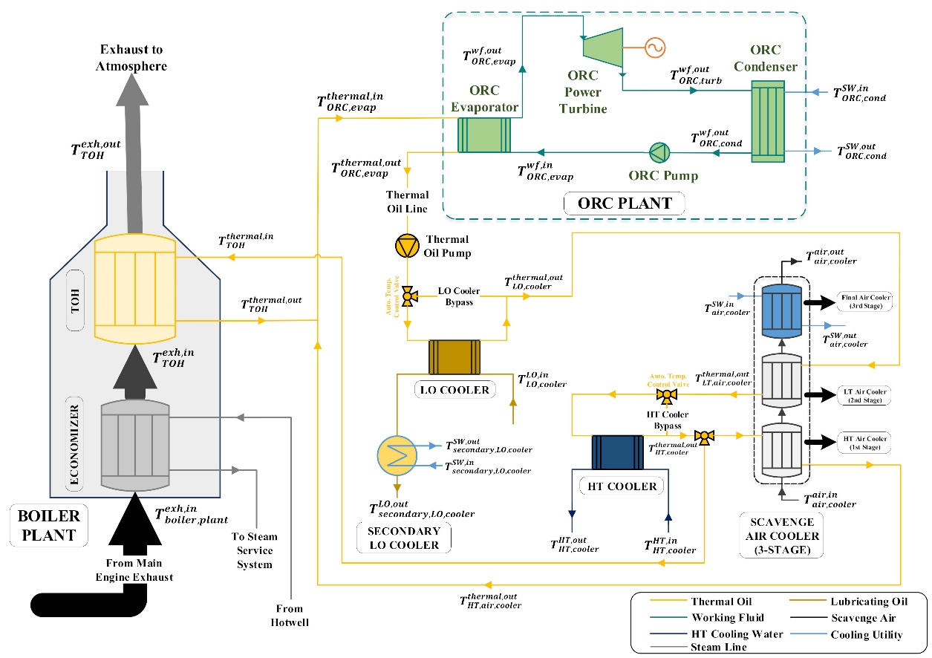

Figure 1 Layout of the integrated optimal HEN and ORC system for the reference ship (Konur et al., 2020)

This study aims at indicating comparable quantified data with the assessment results that show sustainability improvement potentials if the proposed design is applied. It is expected that the quantified sustainability assessment results will help decision-making processes of policy makers and ship owners to apply ORC systems to marine vessels for more energy efficient and environment-friendly operations.

1. **METHODOLOGY**

In the present case, an ORC integrated HEN design proposed by Konur et al. (2020) for multiple heat sources located on a 1,221 TEU container ship using real data sets of the vessel is utilized to assess the exergy-based sustainability of reference vessel with the proposed HEN design. The exergy analyses have been carried out using the verified thermodynamic model on the study of Konur et al. (2020). The exergy analyses results are used to derive exergetic sustainability indicators, which show the sustainability levels and improvement potentials with the utilization of proposed ORC integrated waste heat recovery system design. The sustainability indicators of exergy efficiency, waste exergy ratio, environmental effect factor, environmental destruction coefficient, exergetic sustainability index, sustainability index, and improvement potential are investigated in this study. The analyses are carried out for the propulsion engine loads of 100, 75, 50, and 25% MCR (maximum continuous rating) for nine different environmentally-friendly organic working fluids of ORC system as given in Table 1 to assess the most sustainable option for the proposed system design. Exergy based sustainability assessment of the proposed ORC integrated WHRS for the reference container ship is carried out using the Equations 1-7 (Aydin, 2013; Turan & Aydin, 2016; Tsougranis & Wu, 2018; Chowdhury et al., 2020; Jankowski & Borsukiewicz, 2020).

$\text{E}\text{xergy efficiency = }\frac{\text{Total useful exergy output}}{\text{Total exergy inlet}}$ (1)

$\text{Waste exergy ratio, WER = }\frac{\text{Total waste exergy out}}{\text{Total exergy inlet}}= \frac{\text{Total exergy destruction + Total exergy loss}}{\text{Total exergy inlet}}$ (2)

$\text{Environmental effect factor, EEF = }\frac{\text{WER}}{\text{Exergy efficiency}}$ (3) $\text{Sustainability index, SI = }\frac{\text{1}}{\text{1-Exergy efficiency}}$ (4)

$\text{Exergetic}\text{ sustainability index, ESI = }\frac{\text{1}}{\text{EEF}}$ (5)

$\text{Environmental destruction coefficient, EDC = }\frac{1}{\text{Exergy efficiency }}$ (6)

$\text{Improvement potential, IP = (1-Exergy efficiency)∙(}\text{E}\text{xergy inlet-Exergy output)}$ (7)

Table 1. Properties of the selected organic working fluids (Refrigerant Report, 2020; Linde Industrial Gases, 2021)

|  |  |  |  |  |  |  |  |  |  |
| --- | --- | --- | --- | --- | --- | --- | --- | --- | --- |
|  | R1234ze(Z) | R245fa | R600 | R236ea | Isobutane | R236fa | R152a | R134a | R1234yf |
| GWPa | <1 | 1030 | 4 | 1200 | 3 | 9400 | 124 | 1430 | 4 |
| ODPb | 0 | 0 | 0 | 0 | 0 | 0 | 0 | 0 | 0 |
| ASHRAE 34c | A2L | A1 | A1 | A1 | A3 | A1 | A2 | A1 | A2L |
| Critical Temp. (°C) | 150.1 | 154.0 | 152.0 | 139.3 | 134.7 | 124.9 | 113.3 | 101 | 94.7 |
| Critical Press. (kPa) | 3533 | 3651 | 3796 | 3429 | 3640 | 3200 | 4520 | 4059 | 3382 |

aGWP: global warming potential, relative to CO2.

bODP: ozone depletion potential, relative to R11.

cASHRAE Standard 34 - Refrigerant safety group classification. 1: Non-flammable; 2L: Mildly flammable; 2: Lower flammability; 3: Higher flammability; A: Lower toxicity; B: Higher toxicity.

1. **RESULTS**

Asone of the sustainability indicators, the exergy efficiency of the proposed ORC system design has been calculated using Equation 1 and the results has been given in Figure 2 for varying ORC evaporator pressures and different types of ORC working fluids.

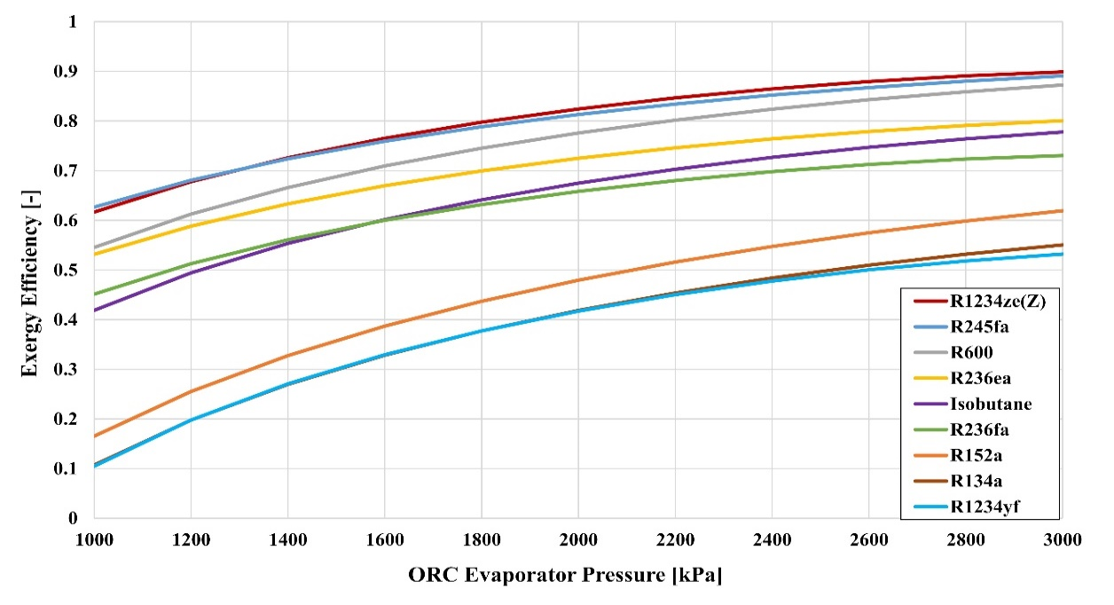

Figure 2 The effect of evaporator pressure and ORC fluid type on the exergy efficiency of the system

Waste exergy ratio (WER) is defined as ratio of total waste exergy to the total exergy inlet of the system. Total waste exergy is found as the sum of total exergy destruction from the ORC system and heat losses to the surroundings as in Equation 2. Total exergy inlet to the ORC system is the exergy inlet from the ORC evaporator to the ORC system. The effect of ORC evaporator pressure on WER for nine different working fluids are investigated and the results are presented in Figure 3. It can be deduced that WER is inversely related with the exergy efficiency of the ORC system. The maximum value of WER is obtained as 0.895 for R1234yf at 1000 kPa, which shows the worst performance in accordance with the results obtained from the energy and exergy analyses. The WER is minimum for R1234ze(Z) at 3 MPa with the value of 0.106, but R245fa starts to perform better for ORC evaporator pressures less than 1600 kPa.

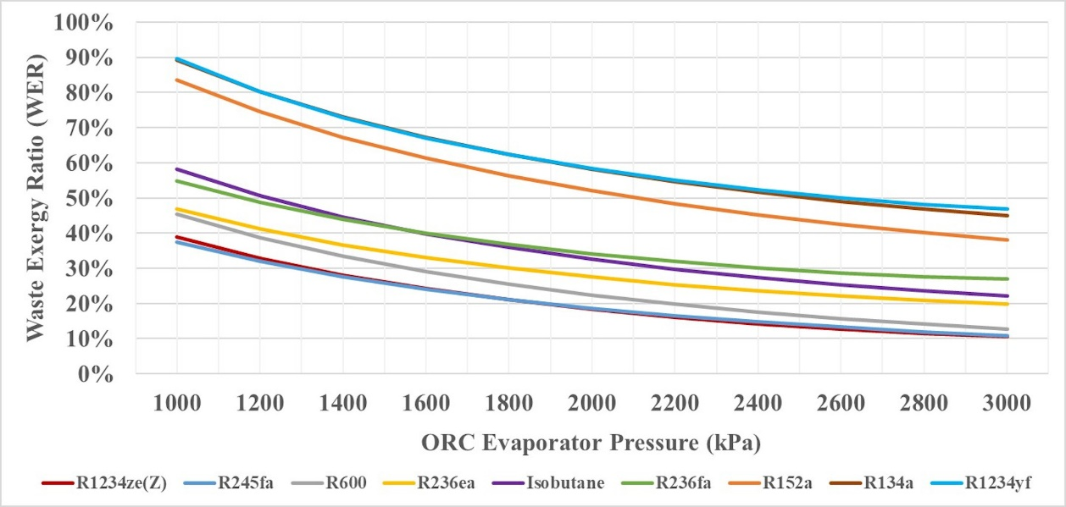

Figure 3 WER values obtained for different evaporator pressures and working fluids

Environmental effect factor (EEF) indicates whether the energy conversion system gives harms to the environment. EEF of a system is expected to increase with increased waste exergy output and reduced useful exergy output. EEF values for the proposed ORC integrated WHRS are calculated using Equation 3. Environmental destruction coefficient (EDC) is inversely proportional to the exergy efficiency of the system as can be seen in Equation 6. EDC shows a similar pattern with the EEF as they both affected by the exergy efficiency. In the sustainability perspective, EEF should be as close as to 0 (zero) that indicates the waste exergy of the system is minimized, however EDC values can vary between 1 to infinity and a system with EDC of closer to 1 will result in more sustainable operation. The EEF and EDC value calculated for the proposed system design are depicted on Figure 4 (a) and (b). R1234ze(Z) and R245fa working fluids show good environmental performance in this design with EEF values of 0.167 and 0.174 at the selected operating pressure of 2400 kPa, respectively. EDC values are calculated as 1.666 and 1.173 at the same conditions. The environmental effects can be further reduced with the increased evaporator pressure.

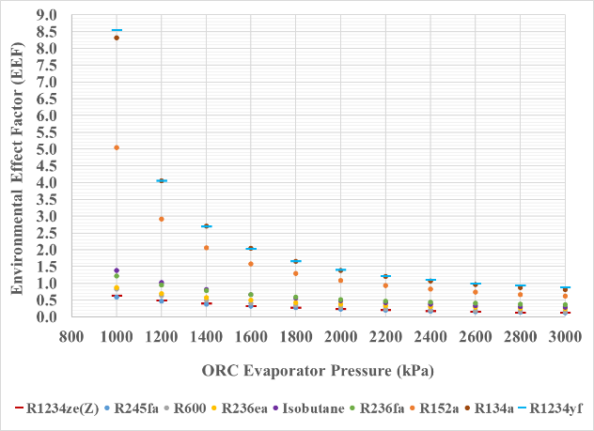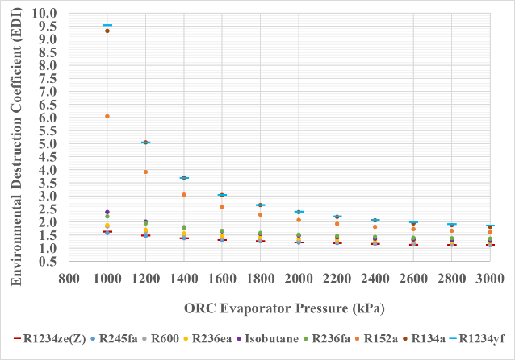

(a) (b)

Figure 4 (a) EEF (b) EDC values calculated for different evaporator pressures and working fluids

Exergetic sustainability index (ESI) and Sustainability index (SI) are among the most used exergy based sustainability indicators that indicate the degree of sustainability. ESI and SI work in a similar correlation as between EEF and EDI. ESI is the inverse of EEF as given in Equation 5; thereby directly affected from the exergy efficiency of the system. ESI varies between 0 and infinity, while SI values are between 1 and infinity according to Equation 4. As the system efficiency gets higher, lower waste exergy ratios and environmental effects as a result higher SI and ESI are achieved. The calculated ESI and SI values are given in Figure 5 (a) and (b), respectively. The maximum ESI and SI values are obtained from R1234ze(Z) at 3000 kPa at the value of 8.435 and 9.435. For the selected operating pressure of 2400 kPa and working fluid of R245fa, the calculations show ESI and SI values of 5.764 and 6.764.

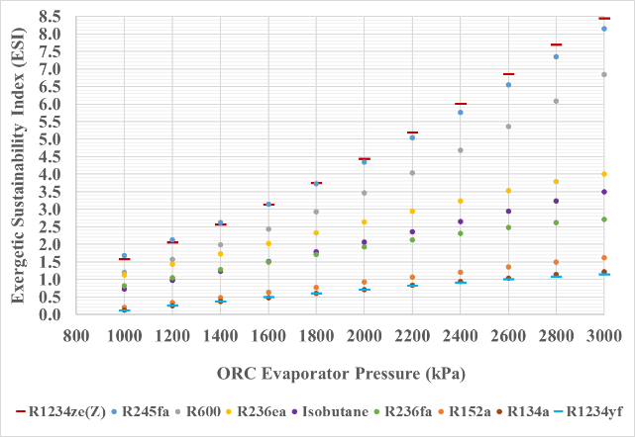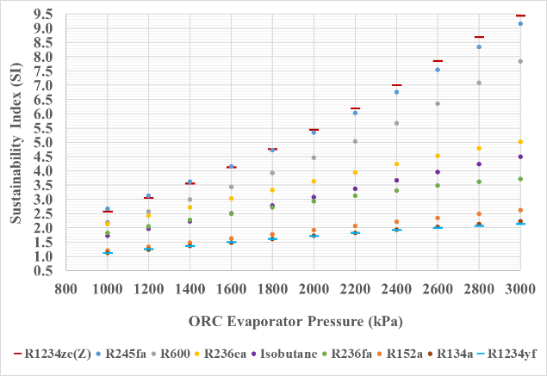

(a) (b)

Figure 5 (a) ESI (b) SI values calculated for different evaporator pressures and working fluids

Improvement potential (IP) shows how much more work could have been generated by the given exergy input to the system. IP indicator depends on the exergy efficiency with the exergy inputs and outputs as can be seen in Equation 7. The difference between the exergy inlet and output is constant at each engine load category for varying working fluid types because the heat flow to the ORC evaporator is limited by the target temperatures of thermal oil side. It means that the higher exergy efficiency values lead to lower IPs as illustrated in Figure 6. As the engine load increases, the exergy input to the ORC system also increases and leaves more improvement potentials for each working fluid types.

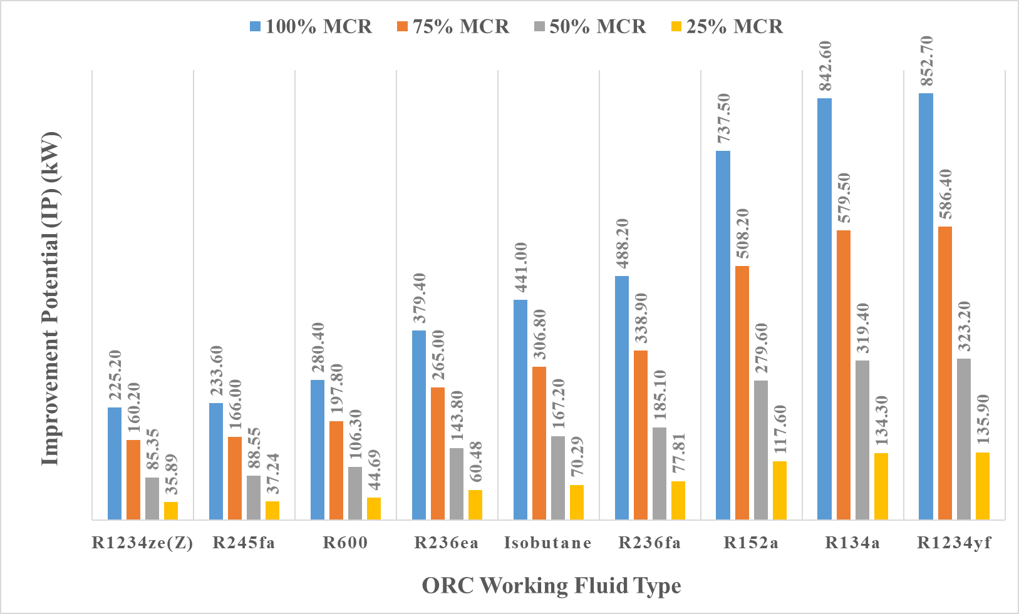

Figure 6 IP for different engine loads and working fluids at ORC evaporator pressure of 2400 kPa

1. **DISCUSSION**

The sustainability of the ORC integrated WHRS design is assessed using exergy based sustainability indicators of WER, EEF, EDI, ESI, SI, and IP. The minimum WER is obtained from R1234ze(Z) at 3 MPa with the value of 0.106. R1234ze(Z) and R245fa working fluids show good environmental performance for the proposed system design with EEF values of 0.167 and 0.174 at the selected operating pressure of 2400 kPa. The maximum ESI values are obtained from R1234ze(Z) and R245fa at 3000 kPa at the value of 8.435 and 8.154, respectively. The ESI value R245fa at 2400 kPa is calculated as 5.764. As the engine load gets higher, more IP is left out from the system. In addition, IP reduces with the increased exergy efficiency as expected.

The sustainability assessment results of the proposed system will be beneficial at justifying an energy policy for policymakers, determining the impact of waste energy and exergy to the environment with and without the proposed system, and encouraging the ship owners for utilization of ORC integrated waste heat recovery systems for marine applications as an environmentally benign option.

**REFERENCES**

Aydin, H. (2013). Exergetic sustainability analysis of LM6000 gas turbine power plant with steam cycle. *Energy 57*, 766–774. https://doi.org/10.1016/j.energy.2013.04.018.

Balli, O. & Hepbasli, A. (2014). Exergoeconomic, sustainability and environmental damage cost analyses of T56 turboprop engine. Energy, 64, 582-600.

Chowdhury, H., Chowdhury, T., Hossain, N., Chowdhury, P., Salam, B., Sait, S. M., & Mahlia, T. M. I. (2020). Exergetic sustainability analysis of industrial furnace: a case study. *Environmental Science and Pollution Research*, 1-8.

Dincer, I. & Zamfirescu, C. (2018). Sustainable Dimensions of Energy. In *Comprehensive energy systems. Vol.1: Energy fundamentals*. (102-151). Elsevier.

Jankowski, M. & Borsukiewicz, A. (2020). A Novel Exergy Indicator for Maximizing Energy Utilization in Low-Temperature ORC. *Energies, 13*(7), 1598.

Konur, O., Saatcioglu, O. Y., Korkmaz, S. A., Erdogan, A., & Colpan, C. O. (2020). Heat exchanger network design of an organic Rankine cycle integrated waste heat recovery system of a marine vessel using pinch point analysis. *International Journal of Energy Research,* 2020.

Linde Industrial Gases. (2021). *Refrigerants.* Retrieved January 16, 2021, from https://www.linde-gas.com/en/products_and_supply/refrigerants/index.html.

Ness, B., Urbel-Piirsalu, E., Anderberg, S., & Olsson, L. (2007). Categorising tools for sustainability assessment. *Ecological economics*, *60*(3), 498-508.

Refrigerant Report. (2012). *Refrigerant Report.* Retrieved January 16, 2021, from https://www.bitzer-refrigerantreport.com/fileadmin/user_upload/A-501-20.pdf.

Tsougranis, E. L., & Wu, D. (2018). A feasibility study of Organic Rankine Cycle (ORC) power generation using thermal and cryogenic waste energy on board an LNG passenger vessel. *International Journal of Energy Research, 42*(9), 3121-3142.

Turan, O. & Aydin, H. (2016). Exergy-based sustainability analysis of a low-bypass turbofan engine: A case study for JT8D. *Energy Procedia, 95*, 499-506.

1. Dokuz Eylul University Maritime Faculty