Investigation of Extreme Climate Indices Over Çankırı With CMIP6 Climate Models
Sertaç Oruç^{1,}∗, Berkin Gümüş², İsmail Yücel², M. Tuğrul Yılmaz²
¹Department of Civil Engineering, Çankırı Karatekin University, Çankırı, Türkiye
²Department of Civil Engineering, Middle East Technical University, Ankara, Türkiye

Abstract
This study investigated the anticipated changes in extreme temperature and precipitation indices in the Çankırı province due to climate change over the course of the 21st century. Utilizing a three-tiered future framework (near [2015-2040], middle [2041-2070], and far [2071-2100]), the analysis was conducted using Coupled Model Intercomparison Project Phase 6 (CMIP6) models under the Shared Socio-Economic Pathways (SSP) 5-8.5 and SSP-2-4.5. The Quantile Delta Mapping (QDM) method served as the statistical downscaling approach to enhance the resolution of low-resolution global climate models (GCMs). The European Centre for Medium-Range Weather Forecasts (ECMWF)’s fifth generation reanalysis (ERA5-Land) dataset with a spatial resolution of 0.1° × 0.1° (approximately 9km) was employed for this purpose [4]. Upon evaluation of the results, it was observed that there is no significant change in total precipitation throughout the century under the SSP 2-4.5 scenario in the study region. However, under the SSP 5-8.5 scenario, decreases of up to 10% by the end of the century were projected. Regarding extreme precipitation, both scenarios indicate that heavy precipitation events will become more severe. It is projected that total precipitation from the heaviest 1% will increase from 32 mm to 57 mm by the end of the century under the SSP 5-8.5 scenario. When compared to the decrease in total precipitation, it is anticipated that the proportion of extreme precipitation in total precipitation will rise from 5% to 10%. Regarding extreme temperature indices, both scenarios predict continuous warming until the end of the century. It is estimated that the annual average of daily maximum temperatures may increase up to 6 °C by the end of the century, while the increase in minimum daily temperatures stands at 5.3 °C. The number of days when the minimum temperature fell below 0 °C during the year was found to be 124 days on average in the historical period; however, in the future period, this value could decrease to 60 days. Overall, the findings suggest that the intensity and frequency of extreme climate events in Çankırı will increase as a result of climate change.

Keywords: CMIP6, climate change, extreme climate indices, quantile mapping

- Introduction

Precipitation and temperature extreme events, while inherently stochastic, necessitate the generation of forecasts that are as accurate as possible due to their critical importance. However, understanding the behaviors and cycles of these events requires access to long-term and high-quality data sets. Furthermore, the ability to predict sudden and multifaceted events such as urban flash flooding, to which urban settlements are frequently subjected, or heat waves, is imperative. Consequently, comprehending the behaviors and variabilities of extreme events is particularly essential for the development of effective adaptation and mitigation strategies with resilience planning.
The current intensifying extreme trends, as evidenced by both the moderate- and high-emission scenario outcomes, indicate a likelihood that they will persist throughout the 21st century [1]. The consequences of fluctuations in climate extremes can have considerable socioeconomic effects [2, 3], making it a critical issue to examine changes in climate extremes at various spatial scales, including the global, regional, and local levels [4, 5].
Using the Global Climate Model (GCM) projections under the SSP2-4.5 and SSP5-8.5 emission scenarios, the main aim of this research is to provide a comprehensive understanding of the expected shifts in extreme temperature and precipitation patterns for Çankırı province of Türkiye over three different future periods: the near future (2015–2040), the mid-21st century (2041–2070), and the distant future (2071–2100). For this purpose, weighted ensemble average methodology was implemented on the climate models. The Expert Team on Sector-specific Climate Indices (ET-SCI) of the World Meteorological Organization (WMO) was employed to assess possible alterations in the area, as described in previous research [6, 7]. Quantile delta mapping (QDM), a statistical downscaling and bias correction technique, was utilized to generate bias-corrected and downscaled CMIP6 GCM datasets by using the ERA5-Land as reference dataset. The aforementioned high-resolution GCM datasets were subsequently employed to produce the chosen ET-SCI indices for Çankırı with a spatial resolution of 0.1° × 0.1° (equivalent to approximately 9 km) for each grid referenced in ERA5-Land.

- Materials and Methods
In this study, European Centre for Medium-Range Weather Forecasts’ (ECMWF) ERA5-Land data were utilized to correct biases in CMIP6 global climate models and to assess the capability of the bias-adjusted data. ERA5-Land, as detailed by [8], offers an open-access data set that extends from 1950 to approximately 2-3 months prior to the present, delivering high-resolution hourly information on surface variables. This dataset is a result of reprocessing the land component of the ERA5 climate reanalysis with a more refined spatial resolution, featuring an approximate grid spacing of 9km. The most significant distinction of this set from its original is the provision of horizontal resolution at 0.10° x 0.10° instead of 0.25° x 0.25°, enabling work at more precise scales.
For future projections, the most current models, the CMIP6 global climate models, have been utilized. The models from the Coupled Model Intercomparison Project’s sixth phase (CMIP6), as described by [9, 10], are understood to outperform their predecessor, CMIP5. The advancements behind this progress can be attributed to improved quantification of radiative forcing, the inclusion of aerosols, and the effects of land use that provides a narrower band of uncertainty of future climate projections [9, 10, 11,12]. Despite being relatively new, there is a growing interest in the literature for the latest projections offered by CMIP6 [12, 13, 14]. Upon reviewing these studies, it is observed that there are differing outcomes between CMIP6 and CMIP5 results depending on the regions where the studies were conducted. In Turkey, it has been indicated by [10] that CMIP6 products perform better than CMIP5 in terms of precipitation and temperature, and the necessity of updating the results of climate change impact studies with the latest data has been highlighted by the findings of this study.
In climate modeling research, the multi-model ensemble average (MMEA) is frequently employed to account for the biases and uncertainties introduced by GCMs [15, 16]. Therefore, the capability of the models in simulating climate extremes was first evaluated using the K-S test, as described by [17, 18]. Consequently, the ensemble average of subsequent results was computed utilizing the weighted average of the model outputs. R software version 4.2.2 was utilized to conduct the analysis.

Table 1. CMIP6 models used to calculate weighted ensemble average
Models
ACCESS-CM2 (Australia) | E3SM-1-0 (USA) | IPSL-CM6A-LR (France)
ACCESS-ESM1-5 (Australia) | EC-Earth3 (Europe) | KACE-1-0-G (Republic of Korea)
AWI-CM-1-1-MR (Germany) | EC-Earth3-AerChem (Europe) | KIOST-ESM (Republic of Korea)
AWI-ESM-1-1-LR (Germany) | EC-Earth3-CC (Europe) | MIROC6 (Japan)
BCC-CSM2-MR (China) | EC-Earth3-Veg (Europe) | MIROC-ES2L (Japan)
BCC-ESM1 (China) | EC-Earth3-Veg-LR (Europe) | MPI-ESM-1-2-HAM (Switzerland)
CanESM5 (Canada) | FGOALS-f3-L (China) | MPI-ESM1-2-HR (Germany)
CESM2 (USA) | FGOALS-g3 (China) | MPI-ESM1-2-LR (Germany)
CESM2-FV2 (USA) | GFDL-ESM4 (USA) | MRI-ESM2-0 (Japan)
CESM2-WACCM (USA) | GISS-E2-1-G (USA) | NESM3 (China)
CMCC-CM2-HR4 (Italy) | HadGEM3-GC31-LL (UK) | NorCPM1 (Norway)
CMCC-CM2-SR5 (Italy) | HadGEM3-GC31-MM (UK) | NorESM2-LM (Norway)
CMCC-ESM2 (Italy) | IITM-ESM (India) | NorESM2-MM (Norway)
CNRM-CM6-1 (France) | INM-CM4-8 (Russia) | SAM0-UNICON (Republic of Korea)
CNRM-CM6-1-HR (France) | INM-CM5-0 (Russia) | TaiESM1
CNRM-ESM2-1 (France) | IPSL-CM5A2-INCA (France) | UKESM1-0-LL

The quantile delta mapping method (QDM) has been developed to eliminate systematic biases in model outputs, while simultaneously preserving the relative changes observed within the quantiles of the models’ variable under scrutiny [18]. The fundamental equation of the quantile delta mapping method consists of a bias-corrected value obtained using reference data and a relative change term derived from the model data. The distinction of this method from the detrended quantile mapping approach lies in considering not only the modeled mean but all modeled quantiles.
${\hat{x}}_{m,p}\left(t\right)={\hat{x}}_{o:m,h:p}\left(t\right)*Δ_{m}(t)$ (1)

${\hat{x}}_{o:m,h:p}\left(t\right)=F_{o,h}^{-1}\{F_{m,p}\left[x_{m,p}\left(t\right)\right]\}$ (2)

$Δ_{m}\left(t\right)=\frac{x_{m,p}\left(t\right)}{F_{m,h}^{-1}\left[F_{m,p}^{\left(t\right)}\left\{x_{m,p}\left(t\right)\right\}\right]}$ (3)

Where ${\hat{x}}_{o:m,h:p}\left(t\right)$ is the bias-corrected reference period data, and $Δ_{m}\left(t\right)$ denotes the relative change in the model data between the reference and projection periods.

The development of extremes indices aimed at analyzing the impact of climate extremes on various domains and the ET-SCI formed by WMO demonstrated a significant step towards this aim considering many different sectors [7, 19, 20]. Table 2 provides a comprehensive summary of the selected five temperature and five precipitation extreme indices that have been employed in the current study. This analysis involved the utilization of daily maximum and minimum near-surface temperature, as well as precipitation data.

Table 2. The selected temperature and precipitation indices
Short Name | Long Name |  | Definition | Units
FD |  | Frost days | Number of days when TN < 0 °C | days
ID |  | Ice Days | Number of days when TX < 0 °C | days
WSDI |  | Warm spell duration indicator | Annual number of days contributing to events where 6 or more consecutive days experience TX > 90th percentile | days
TXm |  | Mean TX | Mean daily maximum temperature | °C
TNm |  | Mean TN | Mean daily minimum temperature | °C
Short Name |  | Long Name | Definition | Units
CDD |  | Consecutive Dry Days | Maximum number of consecutive dry days (when PR < 1.0 mm) | days
R99p |  | Total annual PR from very heavy rain days | Annual sum of daily PR > 99th percentile | mm
Rx1day |  | Max 1-day PR | Maximum 1-day PR total | mm
PRCPTOT |  | Annual total wet-day PR | Sum of daily PR >= 1.0 mm | mm
R99pTOT |  | Contribution from very wet days | 100 × r99p/PRCPTOT | %

- Results and Discussion
The analyses results for aforementioned extreme indices were given for near, mid and far future periods and considering two SSP scenarios in Table 3 (for ID , TXm, WSDI, FD, TNm, PRCPTOT, RX1Day, R99, R99pTOT, CDD), Figure 1 and Figure 2 (for ID , TXm, FD, TNm, PRCPTOT, RX1Day, R99, R99pTOT).

Table 3. Reference and future period values of selected temperature and precipitation indices
Period | ID | TXm | WSDI | FD | TNm | PRCPTOT | RX1Day | R99 | R99pTOT | CDD
Reference | 29.18 | 14.16 | 11.99 | 124.13 | 3.58 | 581.21 | 25.64 | 31.55 | 5.18 | 41.79
SSP2-4.5-Near | 21.02 | 15.94 | 39.79 | 104.59 | 5.06 | 579.52 | 26.48 | 38.47 | 6.36 | 47.72
SSP2-4.5-Mid | 16.52 | 16.87 | 62.18 | 93.95 | 5.91 | 581.19 | 27.65 | 44.03 | 7.25 | 51.19
SSP2-4.5-Far | 13.21 | 17.66 | 85.90 | 84.41 | 6.65 | 580.72 | 28.33 | 47.65 | 7.83 | 54.30
SSP5-8.5-Near | 20.89 | 16.10 | 46.05 | 101.66 | 5.18 | 584.59 | 26.66 | 38.23 | 6.25 | 47.49
SSP5-8.5-Mid | 13.66 | 17.81 | 93.34 | 83.02 | 6.74 | 570.65 | 28.54 | 47.54 | 7.91 | 55.41
SSP5-8.5-Far | 7.22 | 20.20 | 167.70 | 60.77 | 8.87 | 538.78 | 29.81 | 56.45 | 9.95 | 64.10

Regarding extreme temperature indices, both scenarios predict continuous warming until the end of the century (Figure 1). It is estimated that the annual average of daily maximum temperatures may increase up to 6 °C by the end of the century, while the increase in minimum daily temperatures stands at 5.3 °C considering the SSP5-8.5 scenario. FD index was found to be 124 days on average in the historical period; however, in the future period, this value could decrease up to 60 days. Moreover, ID index also follows the same warming pattern and decreases from 29 days in the reference period up to 7 days. The WSDI index also exhibits a sharp increase for both scenarios compared to the reference period which is a signal of increasing drought periods and frequent hot extremes.

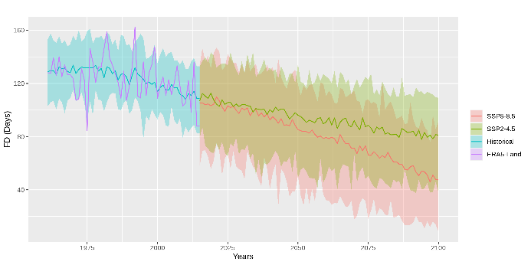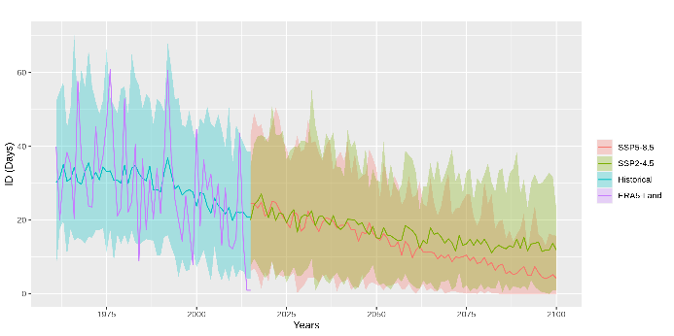
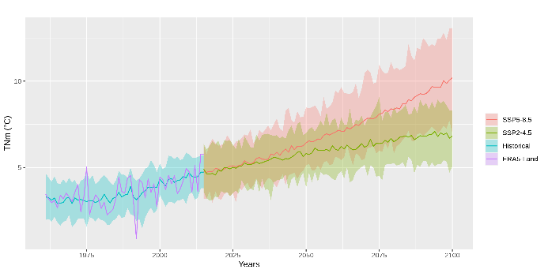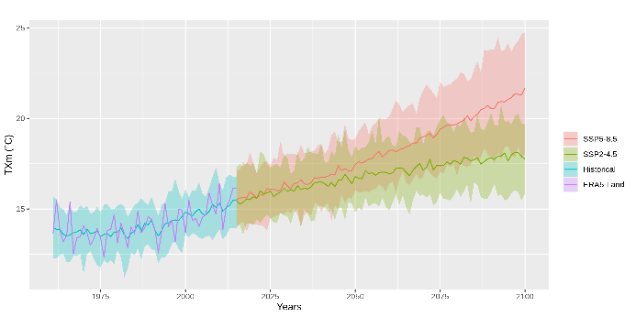
Figure 1. Time series of selected temperature indices for reference and future periods
Upon evaluation of the results, it was observed that there is no significant change in total precipitation throughout the century under the SSP 2-4.5 scenario in the study region (Table 3). However, under the SSP 5-8.5 scenario, decreases of up to 10% by the end of the century were projected. With regard to extreme precipitation, both scenarios indicate that heavy precipitation events will become more severe (Figure 2). It is projected that total precipitation from the heaviest 1% will increase from 32 mm to 57 mm by the end of the century under the SSP 5-8.5 scenario. When compared to the decrease in total precipitation, it is anticipated that the proportion of heavy precipitation in total precipitation amount will rise from 5% to 10%. Considering consecutive dry days, results indicate the increasing possibility of dry periods for Çankırı in the future. Both SSP2-4.5 and SSP5-8.5 results revealed incresing CDD values especially at the end of the century up to30% and 53% respectively.
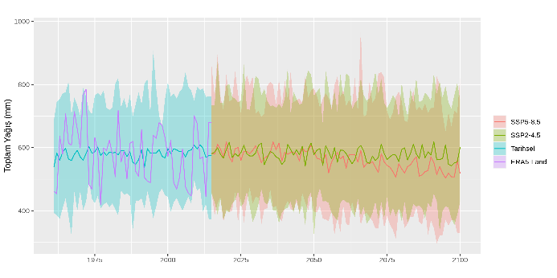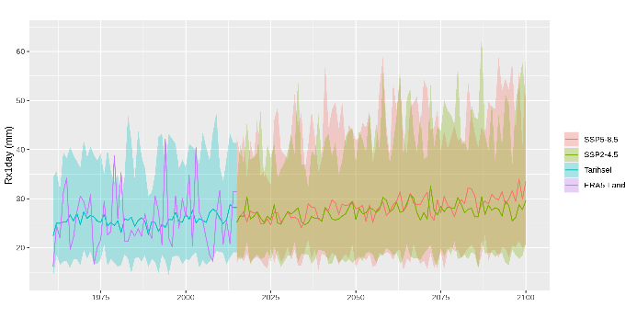
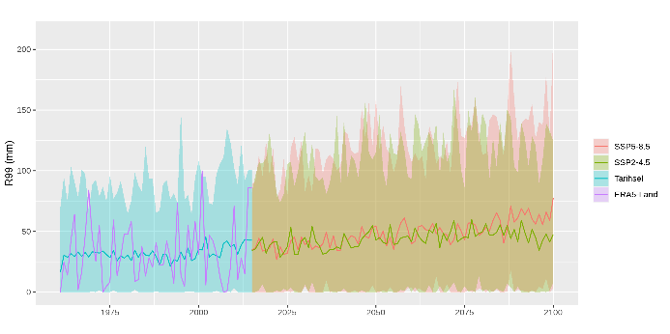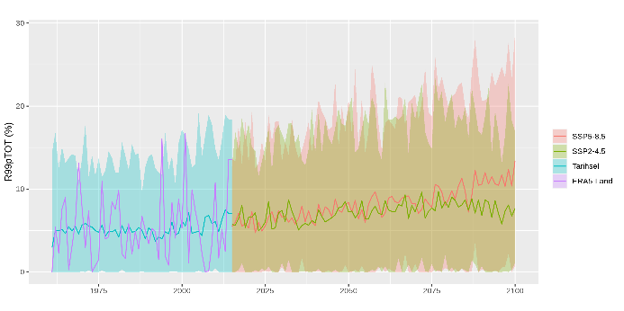
Figure 2. Time series of selected precipitation indices for reference and future periods

- Conclusion
The objective of this research was to examine the projected alterations in extreme temperature and precipitation indices within the Çankırı province as a consequence of climate change throughout the twenty-first century. The study employed Coupled Model Intercomparison Project Phase 6 (CMIP6) models in accordance with the Shared Socio-Economic Pathways (SSP) 5-8.5 and SSP-2-4.5, utilizing a three-tiered future framework (near [2015-2040], middle [2041-2070], and far [2071-2100]). As a statistical downscaling technique, the Quantile Delta Mapping (QDM) method was applied to improve the spatial accuracy of low-resolution global climate models (GCMs). For this purpose, the fifth-generation reanalysis (ERA5-Land) dataset from the European Centre for Medium-Range Weather Forecasts (ECMWF) was utilized. The dataset has a spatial resolution of 0.1° × 0.1° (equivalent to approximately 9km). After performing an evaluation of the findings, it was determined that the SSP 2-4.5 scenario does not account for any significant changes in total precipitation over the course of the century in the studied area. However, a decrease of up to 10% was anticipated by the end of the century, according to the SSP 5-8.5 scenario. In the context of extreme precipitation, both scenarios suggest an intensification of the severity of heavy precipitation events. In terms of extreme temperature indices, both scenarios forecast a century-long period of persistent warming. By the end of the century, there is a projection that the annual mean of daily maximum temperatures could experience an increase of 6 °C, whereas the increase in minimum daily temperatures represents 5.3 °C. The average number of days during the year when the minimum temperature dropped to 0 °C was determined to be 124 during the historical period; this number may decrease to 60 in the future. In conclusion, the results indicate that climate change will contribute to an intensification in both the severity and recurrence rate of extreme climate conditions in Çankırı.
Acknowledgement

This work is conducted as a part of the “High-Resolution Assessment of the Climate Change Impacts over Extreme Precipitation in Turkey using State of the Art Climate (CMIP6) Models” project supported by The Scientific and Technological Research Council of Türkiye (Grant No: 122Y259).

References

- Kouman, K.D.; Kabo-bah, A.T.; Kouadio, B.H.; Akpoti, K. Spatio-Temporal Trends of Precipitation and Temperature Extremes across the North-East Region of Côte d’Ivoire over the Period 1981–2020. Climate 2022, 10, 74.
- AghaKouchak, A.; Cheng, L.; Mazdiyasni, O.; Farahmand, A. Global warming and changes in risk of concurrent climate extremes: Insights from the 2014 California drought. Geophys. Res. Lett. 2014, 41, 8847–8852.
- Moazenzadeh, R.; Mohammadi, B.; Shamshirband, S.; Chau, K. Coupling a firefly algorithm with support vector regression to predict evaporation in northern Iran. Eng. Appl. Comput. Fluid Mech. 2018, 12, 584–597. https://doi.org/10.1080/19942060.2018.1482476.
- Wang, L.; Li, Y.; Li, M.; Li, L.; Liu, F.; Liu, D.L.; Pulatov, B. Projection of precipitation extremes in China’s mainland based on the statistical downscaled data from 27 GCMs in CMIP6. Atmos. Res. 2022, 280, 106462.
- Wudineh, F.A.; Moges, S.; Kidanewold, B.B. Detecting Hydrological Variability in Precipitation Extremes: Application of Reanalysis Climate Product in Data-Scarce Wabi Shebele Basin of Ethiopia. J. Hydrol. Eng. 2022, 27, 5021035.
- Alexander, L.; Yang, H.; Perkins, S. Clim PACT, Indices and software. A document prepared on behalf of the commission for climatology (CCl) expert team on climate risk and sector-specific climate indices (ET CRSCI). 2013.
- Alexander, L.; Herold, N. ClimPACT2: Indices and Software. A document prepared on behalf of the commission for climatology (CCl) expert team on sector-specific climate indices (ET-SCI). 2016.
- Muñoz-Sabater, J.; Dutra, E.; Agustí-Panareda, A.; Albergel, C.; Arduini, G.; Balsamo, G.; Boussetta, S.; Choulga, M.; Harrigan, S.; Hersbach, H.; et al. ERA5-Land: A state-of-the-art global reanalysis dataset for land applications. Earth Syst. Sci. Data 2021, 13, 4349–4383.
- Eyring, V.; Bony, S.; Meehl, G.A.; Senior, C.A.; Stevens, B.; Stouffer, R.J.; Taylor, K.E. Overview of the Coupled Model Intercomparison Project Phase 6 (CMIP6) experimental design and organization. Geosci. Model Dev. 2016, 9, 1937–1958.
- Bağçaci, S.Ç.; Yucel, I.; Duzenli, E.; Yilmaz, M.T. Intercomparison of the expected change in the temperature and the precipitation retrieved from CMIP6 and CMIP5 climate projections: A Mediterranean hot spot case, Turkiye. Atmos. Res. 2021, 256, 105576.
- Martel, J.-L., Brissette, F., Troin, M., Arsenault, R., Chen, J., Su, T.,& Lucas-Picher, P. (2022). CMIP5 and CMIP6 model projection comparison for hydrological impacts over North America. Geophysical Research Letters, 49, e2022GL098364.
- Gumus, B.; Oruc, S.; Yucel, I.; Yilmaz, M.T. Impacts of Climate Change on Extreme Climate Indices in Türkiye Driven by HighResolution Downscaled CMIP6 Climate Models. Sustainability 2023, 15, 7202.
- Bayar, A.S.; Yılmaz, M.T.; Yücel, İ.; Dirmeyer, P. CMIP6 Earth system models project greater acceleration of climate zone change due to stronger warming rates. Earth’s Future 2023, 11, e2022EF002972.
- Oruc, S. Performance of bias corrected monthly CMIP6 climate projections with different reference period data in Turkey. Acta Geophys. 2022, 70, 777–789.
- Kim, J.; Ivanov, V.Y.; Fatichi, S. Climate change and uncertainty assessment over a hydroclimatic transect of Michigan. Stoch. Environ. Res. Risk Assess 2016, 30, 923–944.
- Ahmed, K.; Sachindra, D.A.; Shahid, S.; Demirel, M.C.; Chung, E.S. Selection of multi-model ensemble of general circulation models for the simulation of precipitation and maximum and minimum temperature based on spatial assessment metrics. Hydrol. Earth Syst. Sci. 2019, 23, 4803–4824.
- Bürger, G.; Murdock, T.Q.; Werner, A.T.; Sobie, S.R.; Cannon, A.J. Downscaling extremes—An intercomparison of multiple statistical methods for present climate. J. Clim. 2012, 25, 4366–4388.
- Cannon, A.J.; Sobie, S.R.; Murdock, T.Q. Bias Correction of GCM Precipitation by Quantile Mapping: How Well Do Methods Preserve Changes in Quantiles and Extremes? J. Clim. 2015, 28, 6938–6959.
- Chapagain, D.; Dhaubanjar, S.; Bharati, L. Unpacking future climate extremes and their sectoral implications in western Nepal. Clim. Chang. 2021, 168, 8.
- Cooley, A.K.; Chang, H. Detecting change in precipitation indices using observed (1977–2016) and modeled future climate data in Portland, Oregon, USA. J. Water Clim. Chang. 2021, 12, 1135–1153.

* Corresponding author. e-mail address: sertacoruc@karatekin.edu.tr

