**OPTIMIZATION of ELECTROPOLYMERIZATION CONDITIONS for ENHANCED ANTICORROSIVE RESISTANCE of 2,6-BENZOPHENONE ON AISI316L: A RESPONSE SURFACE METHODOLOGY APPROACH**

***Ibrahim FILAZI 1,2,[[1]](#footnote-1)\*[C:\Users\Abdullah\AppData\Local\Microsoft\Windows\INetCache\Content.Word\ORCID-iD_icon-16x16.gif](https://orcid.org/0000-0002-8194-1421), Ali Tuncay OZYILMAZ 2[C:\Users\Abdullah\AppData\Local\Microsoft\Windows\INetCache\Content.Word\ORCID-iD_icon-16x16.gif](https://orcid.org/0000-0002-3657-8117), Gul OZYILMAZ 2[C:\Users\Abdullah\AppData\Local\Microsoft\Windows\INetCache\Content.Word\ORCID-iD_icon-16x16.gif](https://orcid.org/0000-0002-2373-6219), Cumali CELIK 3[C:\Users\Abdullah\AppData\Local\Microsoft\Windows\INetCache\Content.Word\ORCID-iD_icon-16x16.gif](https://orcid.org/0000-0002-7788-5703)***

*1 Cankiri Karatekin University, Central Research Laboratory (ÇANKAM), Cankiri, TÜRKİYE*

*2* *Hatay Mustafa Kemal University, Science & Art Faculty, Chemistry Department, Antakya, TÜRKİYE*

*3* *Yalova University, Yalova Vocational School, Property Protection and Security Department, Yalova, TÜRKİYE*

|  |
| --- |
| **Abstract**  This study researched the effect of electropolymerization conditions (monomer concentration, scan rate and electropolymerization time) of 5-hydroxy-2,2-diphenyl-4h-benzo[d][1,3]dioxin-4-one on the anti-corrosive performance via using response surface methodology (RSM). The coatings were carried out on the surfaces of AISI 316L working electrodes in the acetonitrile medium presence of 0.15 M LiClO4 electrolyte by cycling voltammetry (CV) technique according to the designed parameters. Electrodes monitored in 3,5% NaCl solution for 240h immersion time via AC impedance. Corrosion resistance data calculated from equivalent circuits representing the data obtained were analyzed with a quadratic model in the Box-Behnken technique. It was determined that the model obtained as a result of the study could explain the corrosion resistance, which is affected by 97.0% of the independent parameters studied, with 91.6% accuracy and high sensitivity. According to the obtained models, it was seen that the monomer concentration had the biggest effect on corrosion resistance and the electropolymerization time had the least effect. In addition, it was determined that the individual effects of monomer concentration and scan rate on the response were close to each other, but their combined changes were high. However, it was observed that this effect was less than the effect of the joint change of electropolymerization time and scan rate. The results were converted into response surface graphs and formulations that allowed parameters to be optimized to achieve the desired corrosion resistance. |
| Keywords: corrosion, response surface methodology, electropolymerization, stainless steel, 5-hydroxy-2,2-diphenyl-4h-benzo[d][1,3]dioxin-4-one |

1. **Introduction**

Corrosion, represents an electrochemical phenomenon that transpires when metals interact with their surroundings, causes various significant damages on metals. This intricate electrochemical reaction poses a significant threat to structures, equipment, and infrastructure, as metals exhibit a proclivity to revert to more stable oxide or sulfide forms, resulting in the formation of corrosion byproducts, such as rust. Beyond its visual impact, corrosion inflicts substantial damage on the structural integrity of materials and components, thereby eliciting repercussions that extend beyond mere aesthetics, encompassing economic and safety concerns. This omnipresent challenge in metal usage has prompted the development of innovative strategies for safeguarding metal structures and components, aligning with advancements in technology and science. Among these approaches, conductive polymer coatings through electropolymerization have emerged as a noteworthy solution recently. This method not only establishes a protective barrier against corrosive forces prevalent in diverse environments but also introduces some distinctive electrical properties that augment corrosion resistance. [1], [2]

Electropolymerization serves as a sophisticated technique for the controlled deposition of polymer layers onto metal surfaces, a crucial aspect in achieving optimal corrosion protection while preserving the integrity and functionality of the underlying metal substrate. The effectiveness of this technique in corrosion mitigation is intricately tied to several key parameters, including polymerization time, applied potential, and electrolyte composition. Fine-tuning these parameters enables the customization of coatings with regard to film thickness, adhesion, and chemical composition, thereby influencing the overall corrosion resistance of the metal. A nuanced understanding and manipulation of electropolymerization parameters hold significant promise in optimizing the protective performance of these coatings. [3]

This study examined the effect of electropolymerization & bath conditions of 5-hydroxy-2,2-diphenyl-4h-benzo[d][1,3]dioxin-4-one on the anti-corrosive performance of the resulting coating via using response surface methodology. Response surface methodology (RSM) offering distinct advantages over classic methods by efficiently resolving interactions among variables on complex data sets and identifying optimal conditions for enhanced outcomes. In contrast, with classic methods researchers often struggle to resolve intricate parameter relationships, leading to suboptimal results and requiring extensive experimental resources. The versatility and precision of RSM thus present a significant advancement in experimental design, providing a more systematic and resource-efficient approach compared to traditional methods [4].

1. **Materials and Methods**

In the study, medium obtained by dissolving 0.15 M LiClO4 in acetonitrile was used as the electrolyte solution. All chemicals were purchased from Merck in analytical purity. Freshly synthezied 5-hydroxy-2,2-diphenyl-4h-benzo[d][1,3]dioxin-4-one [5] was used as monomer (Figure 1). Cylindrical AISI 316L grade stainless steel (SS) electrodes with a surface area of 0.30 cm2 were used as working electrodes in 3-electrode cell setup, which were insulated with a thick polyester layer so that the working and connection surfaces were exposed. Before the study, the working surfaces of the electrodes were finely sanded and polished and then washed with bi-distilled water. A square platinum plate (99,9%) with a surface area of 0.50 cm2 was used as the counter electrode and Ag/AgCl (3M KCl, SI Analytics B3520+) electrode was used as a reference. Electropolymerization was performed by cyclic voltammetry (CV) technique with CHI608C electrochemical workstation. The experimental set of the electropolymerization conditions and bath parameters (monomer concentration, scan rate and electropolymerization time) were designed in the Design-Expert software using the ranges in Table 1 and Box-Behnken technique. The designed experiment set is given in Table 2. 2 parallel electrodes obtained for each experiment in the set were immersed in 3.5% NaCl solution and kept for 240 hours in. Corrosion performance at the end of that time was monitored by A.C. impedance (EIS) technique at an open circuit potential of 7 mV amplitude in the range of 100 kHz - 1 mHz with CHI608C electrochemical workstation. The data obtained were converted into equivalent circuits in ZView2 software and the resistance values obtained from these circuits were entered as responses to the designed experimental set. The experimental set was analyzed with a quadratic model and response surface plots and ANOVA data were obtained.

taslak, metin, diyagram, origami içeren bir resim

Açıklama otomatik olarak oluşturuldu

Figure 1. 5-hydroxy-2,2-diphenyl-4h-benzo[d][1,3]dioxin-4-one

Table 1. Design Parameters

|  |  |  |  |  |  |
| --- | --- | --- | --- | --- | --- |
| **Code** | **Factor** | **Unit** | **-1** | **0** | **+1** |
| **A** | Monomer Concentration | mM | 3,125 | 7,8125 | 12,50 |
| **B** | Scan Rate | mV/s | 50 | 100 | 150 |
| **C** | Electropolymerization Time  (Deposition Time) | seconds | 500 | 1000 | 1500 |

Table 2. Designed Experiment Set

|  |  |  |  |
| --- | --- | --- | --- |
| **Experiment Number (R)** | **Factor A** | **Factor B** | **Factor C** |
| 1 | 7,8125 | 100 | 1000 |
| 2 | 12,5 | 100 | 500 |
| 3 | 12,5 | 150 | 1000 |
| 4 | 3,125 | 50 | 1000 |
| 5 | 7,8125 | 100 | 1000 |
| 6 | 7,8125 | 100 | 1000 |
| 7 | 3,125 | 100 | 500 |
| 8 | 7,8125 | 50 | 500 |
| 9 | 7,8125 | 150 | 1500 |
| 10 | 7,8125 | 50 | 1500 |
| 11 | 12,5 | 100 | 1500 |
| 12 | 7,8125 | 100 | 1000 |
| 13 | 12,5 | 50 | 1000 |
| 14 | 7,8125 | 150 | 500 |
| 15 | 3,125 | 100 | 1500 |
| 16 | 3,125 | 150 | 1000 |
| 17 | 7,8125 | 100 | 1000 |

1. **Results and Discussion**

Electropolymerization was carried out at a potential in the range of -0.5 to 2 V in the bath prepared for the relevant experiment according to the designed experimental parameters at the relevant scan rate and time. Figure 2 shows the first 4 segments of the cyclic voltammetry voltammograms obtained for the working electrodes with a potential applied at a scan rate of 50 mV/s in the range from -0.2 to 2 V in an electrolyte medium containing 12.5 mM monomer and no-monomer. When the voltammograms were analyzed, a significant current increase peak around 1.06 V was observed in the first segment of monomer-containing medium. Based on the fact that this peak does not appear in the monomer-free medium, it can be said that this peak corresponds to monomer oxidation. Since a single monomer oxidation peak is observed, it is thought that the monomer used can be considered to be of high purity. It is also thought that the change in current behavior of surface following this peak is due to the formation of a layer on the surface. The current change starting around -0.08 V before the appearance of the peak is considered to be due to the change of electrolyte conductivity because of the monomer. In the return peak in the second segment, the peak seen in both electrolyte environments at a potential of 1.6V is thought to be the re-formation peak of the oxide layers disrupted on the surface. The high current value of this peak in the monomer-containing medium is thought to be due to the behavior of the layer formed on the surface. The current decreases seen in the following segments show that this layer on the surface grows. [6]

**metin, çizgi, öykü gelişim çizgisi; kumpas; grafiğini çıkarma, diyagram içeren bir resim

Açıklama otomatik olarak oluşturuldu**

Figure 2. Cyclic voltammetry voltammograms of SS in monomer-containing (▬) and monomer-free (▬) medium

Following the immersion of the electrodes, which worked as per the parameters in Table 2, in a corrosive environment for 240 hours, the corrosion resistance calculated from equivalent circuits representing the AC impedance data was entered as responses to the experimental set. The obtained ANOVA results, following analysis using a quadratic model and the Box-Behnken technique, are presented in Table 3. When the data were analyzed, it was seen that the corrosion resistance was affected by 96.99% of the independent variables studied, and the quadratic model used for the analysis could explain this effect with 91.58% accuracy. The p-value of the model is lower than 0.05 and the Lack-of-Fit p-value is higher than 0.05, indicating that the model is significant and usable for analysis. Adeq Precision value much higher than 4 indicates that the signal to noise ratio of the model is low, while the CV% value indicates that the results may deviate by 37.08% from the average. The formula designed according to this model, which allows the calculation of corrosion resistance according to the studied parameters, is given in Equation 1. The graph showing the comparison of the predicted values calculated using this formula with the actual values studied is given in Figure 3. As can be seen from this graph, the graph points obtained in accordance with the ANOVA results intersect with the line. This shows that the model can explain the study with high accuracy and precision. [4], [7]

When the ANOVA data in Table 3 are analyzed in terms of decreasing p-value and increasing F-value of the factors, it is seen that the monomer concentration and scan rate affect the corrosion resistance most individually, and the variation of these factors together has a high effect, but less effect than the variation of scan rate and electropolymerization time together. In the light of these data, when the response surface graphs are examined, it can be clearly seen that the variation of scan rate and electropolymerization time together affects the corrosion resistance in parallel with the ANOVA results as can be seen in Figure 4. For all monomer concentrations, corrosion resistance is high at the limit values of scan rate and electropolymerization time together, while corrosion resistance is low at their intermediate values. The highest corrosion resistance was obtained at medium values of monomer concentration, high scan rate and high electropolymerization time. When the effect of the changes in monomer concentration and electropolymerization time on corrosion resistance is examined in Figure 5, it is observed that there is high corrosion resistance at the middle values of the limit values, the maximum and minimum values at the limit values give low corrosion resistance; At the middle values, a similar behavior is observed, but corrosion resistance cannot be obtained as high as the limit values. When values are given to the scan rate in the graphs, it is seen that as the scan rate increases, the corrosion resistance increases on the high electropolymerization time side of the graph and decreases on the low time side of the graph. When the effect of monomer concentration and scan rate changes on corrosion resistance in Figure 6 is examined, it is seen that there is a similar changes with Figure 5. While the scan rate was low and the monomer concentration was at low-medium values, low electropolymerization time gave the highest corrosion resistance, while medium monomer concentrations at high scan rate with increasing electropolymerization time increased the corrosion resistance.

When all the results were evaluated, it was seen that, depending on the electropolymerization time, high scan rate at high electropolymerization times and low scan rate at low electropolymerization times gave better results, and monomer concentration gave the best corrosion resistance at medium values, independent of other factors. When the ion formation rate of the scan rate is evaluated, it is thought that these results are compatible; at high monomer concentrations, the monomer creates an inhibition effect and creates insulation on the surface, and at low monomer concentrations, ionized monomer in the environment is insufficient for the valid electropolymerization conditions and forms a thin and porous film.

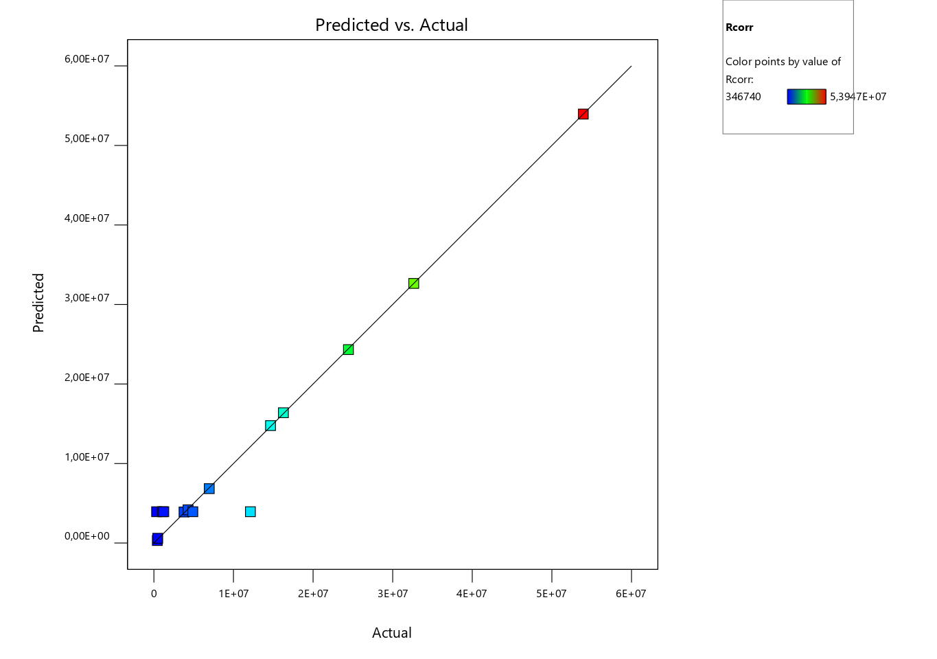

Figure 3. Predicted – Actual values

***Rcorr* =** 3,94061e+06 + -5,03388e+06 \* *A* + -6,82845e+06 \* *B* + 1,06918e+06 \* *C* + 5,17706e+06 \* *AB* + 259.675 \* *AC* + 9,58082e+06 \* *BC* + -1,81164e+07 \* *A*^2 + 2,14637e+07 *\* B*^2 + 2,47212e+07 \* *C*^2 (1)

Table 3. ANOVA Results

|  |  |  |  |  |  |  |
| --- | --- | --- | --- | --- | --- | --- |
| **Source** | **Sum of Squares** | **df** | **Mean Square** | **F-value** | **p-value** |  |
| **Model** | 3,109E+15 | 9 | 3,454E+14 | 17,92 | 0,0027 | *significant* |
| A-Monomer Conc. | 2,027E+14 | 1 | 2,027E+14 | 10,52 | 0,0229 |  |
| B-Scan Rate | 1,865E+14 | 1 | 1,865E+14 | 9,68 | 0,0265 |  |
| C-Electropolymerization Time | 4,573E+12 | 1 | 4,573E+12 | 0,2372 | 0,6468 |  |
| AB | 1,072E+14 | 1 | 1,072E+14 | 5,56 | 0,0649 |  |
| AC | 2,697E+11 | 1 | 2,697E+11 | 0,0140 | 0,9104 |  |
| BC | 1,224E+14 | 1 | 1,224E+14 | 6,35 | 0,0532 |  |
| A² | 9,054E+14 | 1 | 9,054E+14 | 46,97 | 0,0010 |  |
| B² | 1,271E+15 | 1 | 1,271E+15 | 65,93 | 0,0005 |  |
| C² | 1,686E+15 | 1 | 1,686E+15 | 87,46 | 0,0002 |  |
| **Residual** | 9,638E+13 | 5 | 1,928E+13 |  |  |  |
| Lack of Fit | 1,091E+11 | 1 | 1,091E+11 | 0,0045 | 0,9496 | *not significant* |
| Pure Error | 9,628E+13 | 4 | 2,407E+13 |  |  |  |
| **Cor Total** | 3,205E+15 | 14 |  |  |  |  |
| **Std. Dev.** | 4,391E+06 |  |  | **R²** | 0,9699 |  |
| **Mean** | 1,184E+07 |  |  | **Adjusted R²** | 0,9158 |  |
| **C.V. %** | 37,08 |  |  | **Adeq Precision** | 14,9603 |  |

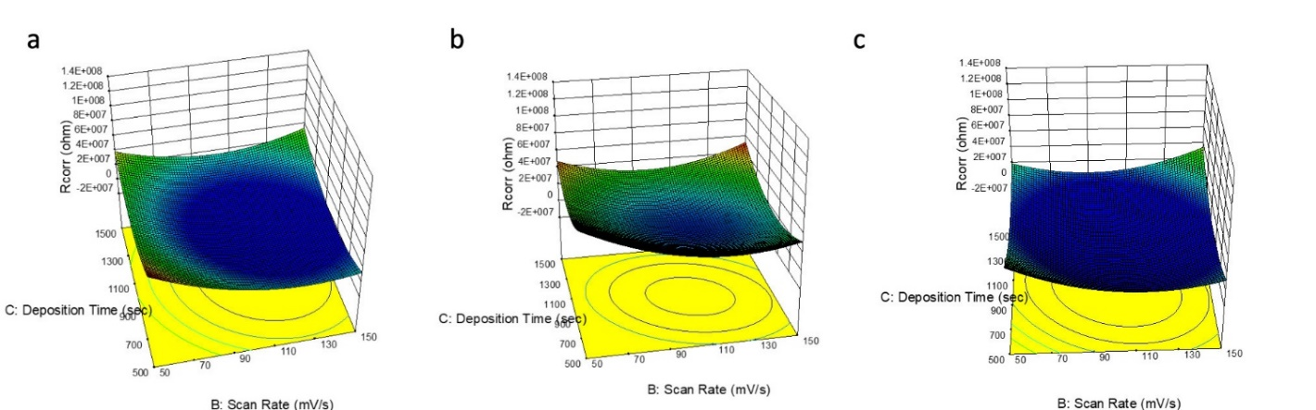

Figure 4. Response surface graph of variation of scan rate and electropolymerization (deposition) time together while monomer concentration (B) 3,125 mM (a), 7,8125 mM (b) and 12,5 mM (c)

metin, taslak, diyagram, origami içeren bir resim

Açıklama otomatik olarak oluşturuldu

Figure 5. Response surface graph of variation of monomer concentration and electropolymerization (deposition) time together while scan rate (B) 50 mV/s (a), 100 mV/s (b) and 150 mv/S (c)

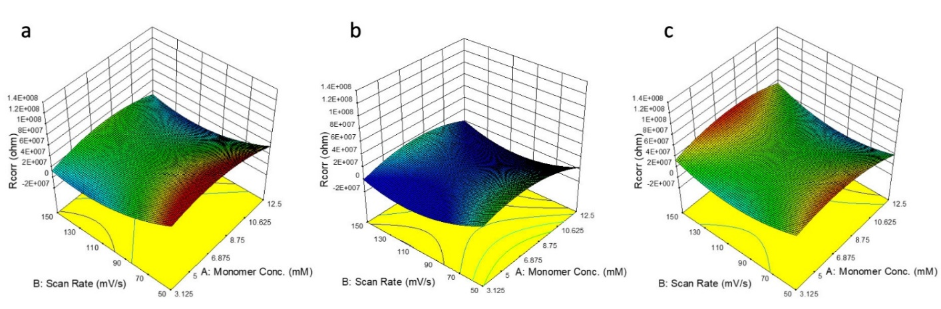

Figure 6. Response surface graph of variation of scan rate and monomer concentration together while electropolymerization time (C) 500 sec. (a), 1000 sec. (b) and 1500 sec. (c)

1. **Conclusion**

As a result of this study, a response surface model was able to explain the corrosion resistance, which was influenced by 97.0% of the independent parameters studied, with 91.6% accuracy and high sensitivity was determined for the electropolymerization of 5-hydroxy-2,2-diphenyl-4h-benzo[d][1,3]dioxin-4-one on the surface of AISI 316L to give the best corrosion resistance. According to the obtained model, it was seen that the monomer concentration had the biggest effect on corrosion resistance and the electropolymerization time had the least effect for 5-hydroxy-2,2-diphenyl-4h-benzo[d][1,3]dioxin-4-one electropolymerization. In addition, it was determined that the individual effects of monomer concentration and scan rate on the response were close to each other, but their combined changes were high. However, it was observed that this effect was less than the effect of the joint change of electropolymerization time and scan rate. The results were converted into response surface graphs and formulation that allowed parameters to be optimized to achieve the desired corrosion resistance.

**References**

[1] M. G. FONTANA, “Corrosion Engineering And Corrosion Science,” *Corrosion*, vol. 19, no. 6, pp. 199t-204t, Jun. 1963, doi: 10.5006/0010-9312-19.6.199.

[2] M. Ates, “A review on conducting polymer coatings for corrosion protection,” *J. Adhes. Sci. Technol.*, vol. 30, no. 14, pp. 1510–1536, Jul. 2016, doi: 10.1080/01694243.2016.1150662.

[3] A. T. Ozyilmaz, İ. Filazi, C. Surmelioglu, and G. Ozyilmaz, “Optimization of Anticorrosive PANi and PPy Synthesis Conditions on ZnNiMo Coated Copper Electrode Surface with Box Behnken Design,” *Prot. Met. Phys. Chem. Surfaces*, vol. 58, no. 4, pp. 883–897, Aug. 2022, doi: 10.1134/S2070205122040177.

[4] R. H. Myers, D. C. Montgomery, and C. M. Anderson-Cook, *Response surface methodology: Process and product optimization using designed experiments*, 3rd ed. New Jersey, USA: John Wiley & Sons, Inc., 2009.

[5] V. Kumbaraci, N. Talinli, and Y. Yagci, “Photoinduced Synthesis of Oligoesters,” *Macromolecules*, vol. 39, no. 18, pp. 6031–6035, Sep. 2006, doi: 10.1021/ma0607721.

[6] A. T. Özyılmaz, B. Özgen, and C. Çelik, “Poly(o-aminobenzyl alcohol) Films with and without Organic Compound on AISI 316 Surface; Synthesis and the Corrosion Performances,” *J. Turkish Chem. Soc. Sect. A Chem.*, vol. 7, no. 2, pp. 375–382, Jun. 2020, doi: 10.18596/jotcsa.641851.

[7] A. Aygün, “Tekstil endüstrisi reaktif ve dispers boya banyo atıksularının elektrokoagülasyon prosesi ile arıtımı: Yanıt yüzey yöntemi ile optimizasyon,” Doktora Tezi, Selçuk Üniversitesi Fen Bilimleri Enstitüsü, Konya, Türkiye, 2012.

1. \* Corresponding author. *e-mail address: mail@ifilazi.com* [↑](#footnote-ref-1)