DEVELOPMENT OF AN AUTOMATIC CABLE WINDER

FOR THE AVIATION HEADSET

Mohd Zulfazli Bin Raub Khan1, Shathasivam a/l Parumasivam2,

Mohd Faridh Bin Zaharuddin3

**ABSTRACT**

*In this project, an automatic cable winder is constructed which is specially designed for aviation industry headsets. The aim of this project is to develop an automatic cable winder for the aviation headset which is user friendly. The design comprises of a touch sensor that receives the inputs and actuates the DC motor with the presence of an electronic control system which consists of a forward and reverse speed adjustable motor, optocoupler relay module and breadboard power stick. Solid works is the only software used to fabricate 3D drawings into a usable prototype as well as simple analyses are also executed to determine the performances between the meshing parts and structures. All the structures were fabricated using a lightweight material, PLA to reduce overall weight of the design and minimize the load on the motor that leads in precise and smoother motor operation. Compared with other designs which are available on the market, the structures are designed to be more robust and easier to handle besides electronic control system integration that are simple yet easy for maintenance. It is also observed throughout the development that the adaptability of various electronic components is made to be as precise and accurate as possible for a reliable operation as well as makes the assembling process easy and neat with the completed hardware structures that done via 3D printer. Frequent testing and troubleshooting are also carried out for proper operation of the system which recorded the expansion time of the cable as 14.8 seconds and the retraction time as 24.8 seconds for high mode motor setting at 150 RPM speed level. Thus, these indicate the reduction time as much as 50% during expansion mode and as much as 75% while in retraction operation. As a result, the entire assembly is completed, the communication of the system with hardware structures relatively successful in dispensing and retracting the cable into and out of the system which improves the efficiency and performance of the aircraft operation in return.*

**Keywords:** *automatic cable winder, aviation headset, electronic control system, development, performances*

[mzulfazli@polibanting.edu.my](mailto:mzulfazli@polibanting.edu.my)1, Department of Aircraft Maintenance Engineering,

Politeknik Banting Selangor, Malaysia. ORCID: 0000-0001-8567-6234

[shatha1103@gmail.com](mailto:shatha1103@gmail.com)2, School of Mechanical Engineering, Faculty of Engineering,

Universiti Teknologi Malaysia, Johor, Malaysia.

ORCID: 0009-0002-7181-8312

[aeromechpbs@gmail.com](mailto:aeromechpbs@gmail.com)3, School of Mechanical Engineering, Faculty of Engineering,

Universiti Teknologi Malaysia, Johor, Malaysia.

ORCID: 0000-0002-8132-1003

**INTRODUCTION**

Due to the persistency of high demand to communicate within the exposure of high level of ambient noise environments, various headsets comprising of an active noise reduction (ANR) approach have been developed and introduced to the aviation industry wherein the headset is produced with the generation of anti-noise signal which will then added to the anticipated communication signal.

As the communication is filtered and amplified based on the user desire, cable has been playing an important role in which such communication signals will be carried by the conductor to the receiver. Even though, current aviation industries are being encouraged on the usage of wireless headset but due to the relative complexity and cost, potential users have avoided to purchase and continue to depend on straight cord headset as both the devices carry the same function which is used to achieve a proper communication with the ground personal and pilot.

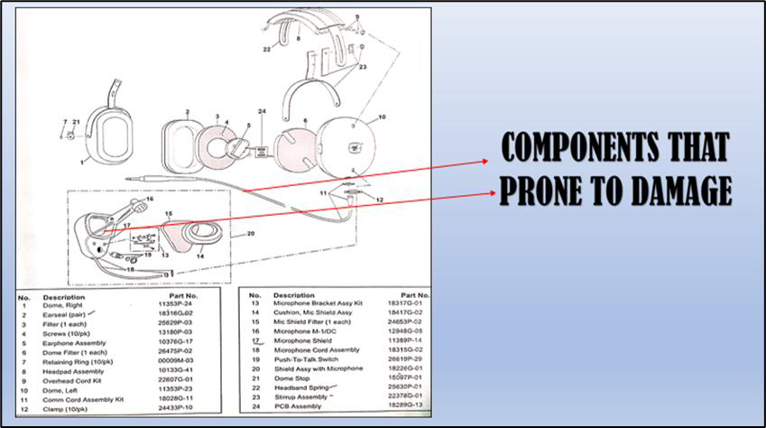Besides of advance research on the modifications of the headset on various aspects, research have not been emphasized much on the straight cord cable performance. In fact, the current design of the headset only comprises the headset assembly connected to the jacket as shown in Figure 1. As the cable is too long, it made the potential users feel uncomfortable holding the entire length of cable while performing their communications with pilot. This creates a situation where they place the excessive length of the cable on the ground and drag the cable while moving away from the aircraft. Apparently, this could damage the insulator and followed by conductor slowly. Once the cable reaches the maximum tension it leads to the breakage of the conductor that ends up making the user unable to communicate. Thus, an automatic cable winder is developed to reduce cable breakage and increase the cable life.

**Figure 1: Illustration of headset assembly.**

.

**1.0 Cable Design and Configuration**

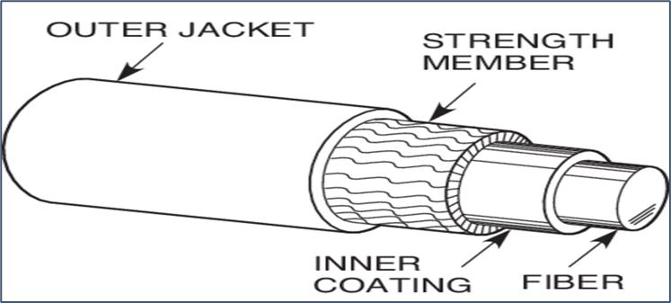The term “cable” refers to a flexible tension member that is added by strength member and power and/or signal conductors within the structure which is shown in Figure 2. Cable is usually used to transmit tensile loads to relocate locations, and they typically possess sufficient flexibility to compensate repeated bending over sheaves and drums (Gibson, Philip T.,2001).

**Figure 2: Configuration of cable.**

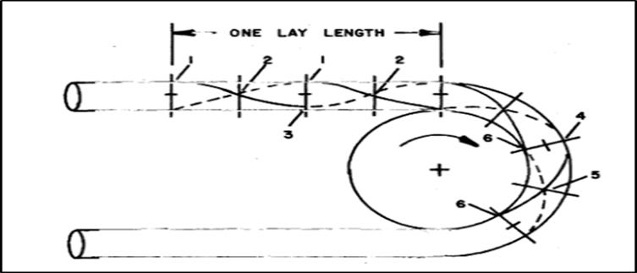When a cable is subjected to combined tension and bending, deterioration and final retirement of the cable will occur due to exertion of forces and motions on each individual element. This leads to a torque imbalance of the component layer that is caused by tension-induced or pressure-induced diameter reduction (Costello, G.A. and Sinha, S.K.,1977) as illustrated in Figure 3. Based on the Figure 3, by considering a cable that passes through a sheave, in a straight portion of the cable (indicated as one lay length) all the elements within a given layer have precisely the same length within a given length of cable. As it passes over a sheave, there is a torque imbalance occur due to bending. The upper outer layer will experience a tension (Position 4 to 5 in Figure 3) while the lower outer layer will experience a compression (Position 5 to 6 in Figure 3). Thus, the process of bending onto a sheave, to compensate helical geometry distortion the cable experiences relative motions among its individual elements that causes a torque imbalance (Gibson, Philip T.,2001).

**Figure 3: Motion of the cable while bending.**

**1.1 Minimum Bending Radius**

To reduce the torque imbalance, the strategy of determining the minimum bending radius is important in which such method will determines how tight a cable can be bent without putting too much stress on the cable. Besides that, it also provides a safe operational range for the cable’s application, ensuring optimal performance (Gleason Reel Corp., n.d). To visualize the method, Figure 4 illustrates the comparison between cable radius and performance of the cable based on the bending radius.

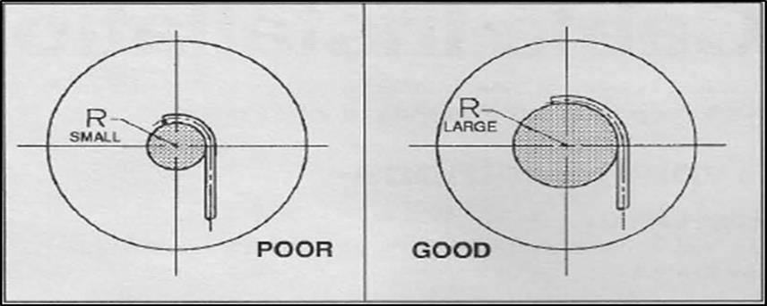

**Figure 4: Comparison between bending radius and the performance of cable**

**onto the sheave.**

To measure the minimum bending radius, we can refer to Table 1 that describes the type of cables and the suitable minimum bending radius based on the configuration of the cable (westflorida components, n.d).

**Table 1: Type of Conductor against Min. Bending Radius**

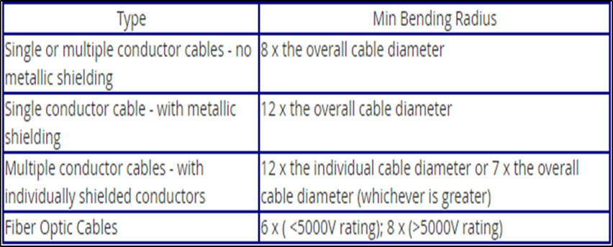

**2.0 Winding Reel Designs**

To design a self-retractable cable, it is vital to analyse the current designs of cable reeving systems in the market today. To ensure the good spooling of the cable on the drum, the angle between the barrel of the drum and the flange should be 90° (Samset, I., 2013). The device for attaching the end of the rope to the drum should be constructed so that it does not spoil the spooling (Gleason Reel Corp., n.d). The following Table 2 will explain the current designs and applications of the cable reeving system and its prominent impacts of the designs while it is being utilized in cables rolling application. The table is as follows:

**Table 2: Comparisons of current market winding reel designs and prominent impacts.**

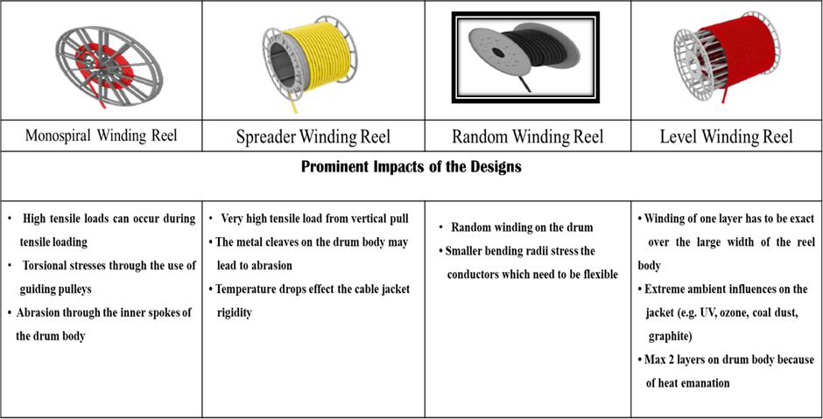

**2.1 Existing Designs of Similar Automatic Cable Winder**

Dominique et al. (1996) invented a reel assembly that can carry elongated flexible members or hose. This invention comprises of a reel that connects one end of the elongate member which will be supported by a rotatable frame, frame supported electric motor which used to retract the elongate member and at least one sensor to sense the reel rotational movement. Such an invention works when the sensor senses the rotational movement of the reel at first predetermined amount in payout direction that opposes the retraction direction and actuates the motor to dispense the elongate member. As the amount of second predetermined payout direction is greater than first predetermined direction, it actuates the motor to retracts the hose via a third predetermined amount lower than that necessary to retract completely the hose. The advantages of the invention are the motor is actuated to retract the elongate member completely into the system without depending on manual retraction such as using switch or remote-control unit as well as there is no tension force on the hose is required to unreel the hose from the reel.

On the other hand, Schwartz (1990) introduced the motor-driven electric cable assembly that functions like Dominique et al. (1996) where some minor improvements were made to the system. The operation of the assembly first started with applying some force on the actuator which can be operated by foot pedals. This causes the sidewall of the drum to rotate to a terminal position and engages the switches to activate so that current is supplied to the motor to rewind the cable onto the drum. When the reactance force produced due to the friction between cable and drum exceeds, the side wall of the drum will rotate reversely and disengage the switch and stop current supplies to the motor. Contrarily, to dispense the cable from the system, the cable is pulled out by applying some force on the cable. As an advantage of his invention, it is easier for the cable to drawn out from the drum when sufficient current is supplied to the motor besides of accommodating longer cable and the cable is reeled onto the drum slowly and smoothly that helps to reduce cable wearing which leads to the risk of impact to the cable.

**3.0 Methodology**

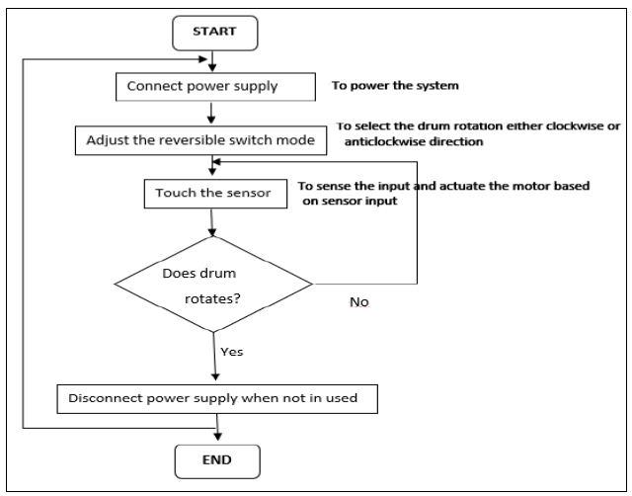

**Figure 5: Overall flowchart of the operation of the automatic cable winder.**

To describe the process flow, Figure 5 illustrates the required processes that is executed by the system from the beginning till the end. When the power source (rechargeable battery) is connected by fusing the jack of the rechargeable battery and receptacle of the electrical control system, the system will be switched on automatically. Upon this action is done, the reversible switch is pressed to change the mode of drum’s operation either rotates the drum clockwise or anticlockwise direction. Then, the touch sensor is touched by the user by means of placing his/her finger on the sensor pad to operate the system based on the switching mode as chosen during pressing the reversible switch. As a final step, the power system is switched off by disconnecting battery’s jack and the system’s receptacle.

**3.1 Integration of Hardware and Electronics Control System**

Upon all the hardware parts that are fabricated using 3D printer and the purchased electronic components are prepared, the assembly process is executed. The parts were designed using Solidworks and then 3D printed using PLA materials which are lightweight and withstand torque generated by the entire system while the cables are winded or dispensed from the system. The electronic circuit diagram connections which shown in Figure 6 is neatly arranged and embedded inside the casing.

Furthermore, on the electronic parts, a single channel capacitive touch sensor used as an input device to sense the physical motion namely sense of touch, a forward and reverse speed adjustable DC motor controller to adjust the mode of operation (clockwise and anticlockwise direction) as well as adjust the speed, a single channel optocoupler relay module to control 250VAC at 10A and to protect the micro controller, a breadboard power stick to convert battery voltage of 7.4V DC to 5V for circuit operation and a high torque DC gear motor to rotate the drum by means of a shaft and a driving gear.

**Figure 6: Electronics Control System Overview.**

**4.0 Results and Analysis**

The automatic cable winder is made by incorporating hardware parts and electronic control system. The electronic components were neatly arranged and glued at specific locations to prevent contact with the drum surface while in operation. The power supply (rechargeable battery) is a detachable unit that is fixed on the outer surface of the casing for the ease of connection and disconnection of the power supply. In Figure 7, the drum is rotated in an anticlockwise direction to dispense the cable out of the system while in Figure 8, the drum is rotated in clockwise direction to retract the cable into the system. The winding of the entire length of cable on the rotating drum is shown in Figure 9 followed by the overall assembly of the design in Figure 10. In overall, the performance of the system in retracting and dispensing the cable was smooth and there is no disturbance such as cable get stuck while the drum rotates is observed. The sensor does operate accurately and precisely when touch input is given, and this can be clearly seen when the motor shaft and gear train rotate the drum.

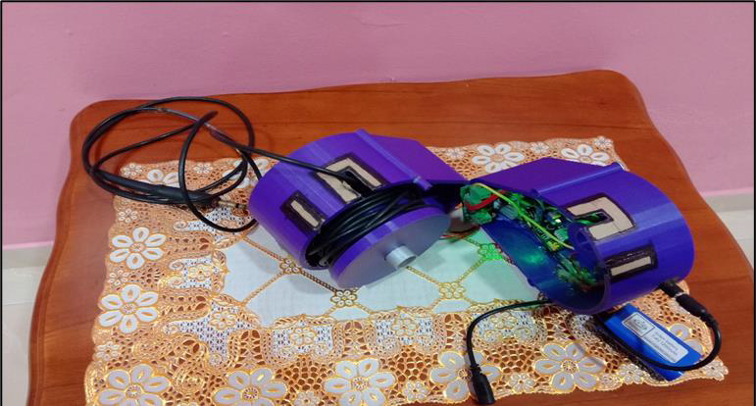

**Figure 7: Cable dispensing out of the system.**

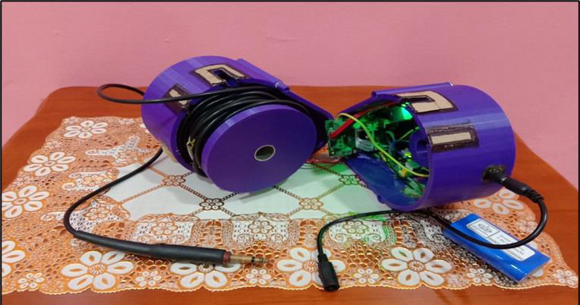

**Figure 8: Cable retracting into the system.**

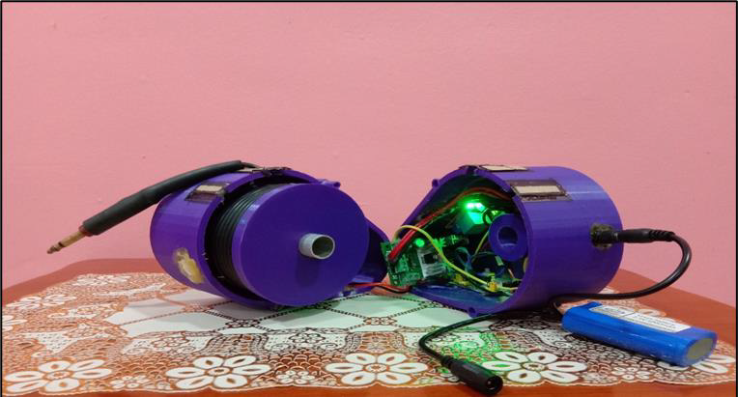

**Figure 9: Winding of the full length of cable on drum.**

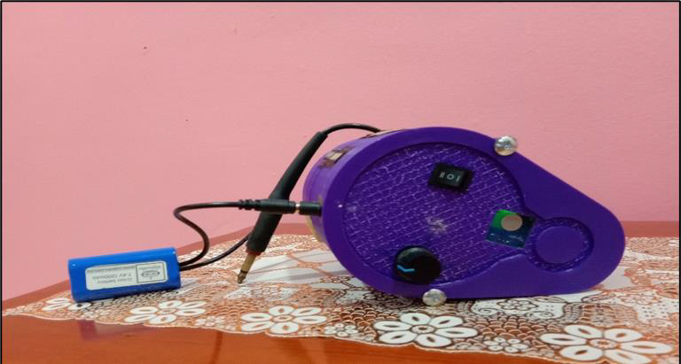

**Figure 10: Overall assembly of the automatic cable winder.**

To evaluate the performance of the system, a simple experiment is done, and results obtained are recorded in Table 3 which are as follows:

**Table 3: Results of the Experiment.**

|  |  |  |  |
| --- | --- | --- | --- |
| **Mode of Speed (RPM)** | **Time Taken for Cable (s)** | | **Operational Remarks** |
| **Dispense** | **Retract** |
| **Low (75 RPM)** | 34.5 | 81.2 | * The drum rotates slower that causes cable to be stuck in the middle of the operation. It consumed more time to retract and dispense the cable. The motor speed should be greater than cable rotation speed to counteract the forces. |
| **Medium (110 RPM)** | 22.7 | 49.8 | * Cable winded randomly on the drum. Cable dispenses and retracts properly and neatly while in operation. Motor speed is sufficient in counteracting the speed of cable rotation during retraction. |
| **High (150 RPM)** | 14.8 | 24.8 | * Cable winded randomly on the drum. More cable dispenses at one time that causes cable to be stuck in the system. Motor speed is more than the cable rotation speed. |

Based on Table 3, it can be observed that at low and high speed (RPM) the motor speed is either greater or lower than cable rotation speed. This retards the smooth and proper cable dispensing and retraction operation. At lower motor speed (RPM) cable consumes more time to retract and dispense in and out of the system and cable was stuck in middle way of the operation due to slower drum rotation. On the other hand, at high motor speed (RPM) more cable is dispensing out of the system at one time that causes cable to be stuck in the system even though cable winded randomly on the drum.

However, when the motor rotates at medium speed (RPM), the expected results of the performance of the prototype are achieved. Cable dispenses and retracts properly and neatly while on operation despite random winding of cable on the drum. It has also been observed that the motor speed is sufficient to counteract the speed of the cable rotation. Hence, for a proper and neat operation of the cable that leads to a reliable operation, it is suggested to fix the motor speed at 110RPM. The time taken for cable to dispense fully out of the system is 22.7s whereas to retract the cable fully into the system about 49.8s is needed. Apart from that, based on the Pos Aviation Technician, the turnaround time for the pushback of the aircraft is not more than 15 minutes. Thus, for such reason, the medium motor speed is more suitable to perform the intended functions by the automatic cable winder.

**CONCLUSION**

Upon completion of this project, the prototype design of the automatic cable winder is developed and fabricated which is specially designed to implement on the aviation headset. To do so, hardware parts are fabricated successfully, and it is then integrated within the electronic control system that is functioning efficiently as intended. The capacitive touch sensor together with the accompanied external power source and electronic control system circuit can be able to drive the motor to rotate the drum. The automatic cable winder is properly utilized as a winder mechanism to dispense and retract the cable based on the user input.

Frequent testing and troubleshooting must be done periodically on the system as well as further improvements to the system and hardware designs are encouraged. This includes designing a better frame of the casing that is easy to hold by hand rather than fixing onto the headset which could deteriorate the headset frames and structure due to added weight. Besides that, rather than using more electrical components that consumes lots of spaces and adding weight to the entire system, a more digitize system may introduce to eliminate components usage. This can be executed by implementing the programming into the design that incorporates all the functions into a system.

**REFERENCES**

1. Costello, G. A., & Sinha, S. K. (1977). Torsional stiffness of twisted wire cables. Journal of the Engineering Mechanics Division, 103(4), 766-770.
2. Dominique, C. G., Walter, E. L., & Franklin, N. L. (1996). U.S. Patent No. 5,495,995. Washington, DC: U.S. Patent and Trademark Office.
3. Gibson, Philip T. "Operational characteristics of ropes and cables." Handbook of oceanographic winch, wire and cable technology (2001).
4. Heavy duty reeling system. (n.d.). heavy duty reeling system. Retrieved from <https://hubbellcdn.com/brochure/GLEASON_MRW_BROCHURE.pdf>
5. Samset, I. (2013). Winch and cable systems (Vol. 18). Springer Science & Business Media.
6. Schwartz, O. (1990). U.S. Patent No. 4,893,037. Washington, DC: U.S. Patent and Trademark Office.
7. West Florida Components (n.d). Electronic Components Supplier. How to Determine Wire and Cable Minimum Bending Radius | West Florida Components. Retrieved from <http://www.westfloridacomponents.com/wire-bending-radius.html>