**Niobium Doping Effect on ZnO Nanorods**

***Hakan ÇOLAK1,2\*[C:\Users\Abdullah\AppData\Local\Microsoft\Windows\INetCache\Content.Word\ORCID-iD_icon-16x16.gif](https://orcid.org/0000-0001-5338-1749)***

*1ScienceFaculty, Chemistry Department, Çankırı Karatekin University, Çankırı, Türkiye*

*2* *Central Research Laboratory (ÇANKAM), Çankırı Karatekin University, Çankırı, Türkiye*

|  |
| --- |
| **Abstract**  Niobium metal doped ZnO nanorods were synthesized on a glass substrate by ultrasonic spray pyrolysis technique in two steps. The structural, morphological, and optical properties of the produced samples were investigated via x-ray diffractometer (XRD), a field emission scanning electron microscopy (FE-SEM) combined with energy dispersive x-ray spectroscopy (EDX), and an ultraviolet/visible spectrophotometer (UV/VIS). The XRD patterns were indexed in the hexagonal (wurtzite) unit cell for all the ZnO samples. Also, according to the XRD peaks it was understood that the crystals grow in the c-axis (002) direction. The morphological characteristics of the obtained thin films were analyzed by. From the SEM micrographs, it was observed that ZnO thin films doped with Nb had a nanorod structure in the c-axis direction. The presence of Nb ions in the samples was confirmed via EDX analysis. The optical transmittances of the samples were measured at a wavelength of 300-1000 nm. It was observed that the produced films had high optical transparency. The average optical transmittance value of the samples is 90 %. |
| Keywords: Zinc oxide, Nanorod structure, Doping process, Ultrasonic spray pyrolysis system. |

1. **Introduction**

ZnO is an II-VI semiconductor compound located at the border of covalent and ionic characters. Semiconductor ZnO crystals, formed by the combination of zinc and oxygen, have the appearance of a tetrahedral geometric structure formed by the surrounding of each zinc atom with 4 oxygen atoms [1]. The crystal structure of ZnO may be in the wurtzite (hexagonal), zinc-blend (cubic), or rock salt structures. The thermodynamically stable phase under normal conditions is the wurtzite. The zinc-blend phase becomes stable with the growth of cubic structures. The rock salt phase can be formed under high pressure [2]. In the hexagonal structure of the ZnO unit cell, each Zn atom is surrounded by four O atoms in the first shell and twelve Zn atoms in the second shell. As a result, the ZnO structure is quite open, and all octahedral positions are empty, while half of the tetrahedral positions are empty. For this reason, doping atoms can settle into the ZnO crystal lattice quite easily. This open structure also affects the type of defects and diffusion mechanism [2]. When dopants enter the crystal lattice of ZnO, they cause changes in the lattice structure. Some properties such as electrical and optical properties can be enhanced by using suitable dopants with the required amounts. Nanotechnology is an important research area of ​​materials science. Nanostructured materials have different physical and chemical properties from bulk materials. Nanostructured materials exhibit atom-like behaviors due to their large surface area [3]. Due to its superior properties, semiconductor materials such as ZnO attract great attention. ZnO has a wide band gap of 3.3 eV at room temperature, is abundant in nature and is an environmentally friendly material [4]. ZnO semiconductor material is used in light emitting diodes (LED), optoelectronic devices, solar cells, liquid crystal displays (LCD), gas sensors …etc. It is widely used in many device applications such as [5-7]. ZnO nanoparticles can be produced by different methods such as sol-gel, hydrothermal, spray pyrolysis, chemical precipitation, and thermal degradation [8]. Traditional chemical synthesis methods, on the other hand, can cause the formation of toxic wastes [9].

In this study, niobium (Nb)-doped ZnO nanorods were fabricated. Nb is a group V-B element, and the valence state is 5s2 4d3. The Tl metal enters into the ZnO crystal lattice as Nb5+ and has three more oxidation state than Zn2+. Therefore, Nb is thought to be a suitable dopant for ZnO.

1. **Materials and Methods**

**2.1. Fabricating the ZnO nanorods**

Nb-doped ZnO nanorods were produced on a glass substrate via ultrasonic spray pyrolysis technique (USP, HO-TH-04, HOLMARC, India) in two steps. The USP technique is represented as a schematic diagram in figure 1. Firstly, ZnO seed layer was produced on the cleaned glass substrate. At this stage, the aqueous stock solution with a concentration of 0.5 M was used. For this aim, Zn(Ac)2.2H2O (Sigma-Aldrich, 99-102 %), 2-methoxyethanol (C3H8O2, Sigma-Aldrich, ≥ 99.3 %), and monoethanolamine (MEA, C2H7NO, Merck, ≥ 99.5%) were used as a zinc source, a solvent, and a stabilizer, respectively. The molar ratio of Zn2+/MEA was 1:1. In the second step, undoped and Nb-doped ZnO nanorod structures were produced on ZnO seeded glass substrates by the USP system. For the second step, 0.1 M Zn(NO3)2.6H2O (Sigma-Aldrich, ≥ 99.0 %) solution was prepared in deionized water as a coating solution. Then, hexamethylenetetramine (HMT, C6H12N4, Sigma-Aldrich, ≥ 99.5 %) was added into the solution as a stabilizer with 1:1 molar ratio of Zn2+/HMT. For the Nb-doped ZnO nanorod structures, 0.5 M Zn(NO3)2.6H2O aqueous solution was used, and NbCl5 (Sigma-Aldrich, ≥ 99.9 %) was added into the solution. The dopant concentrations were 1-10 mol %.

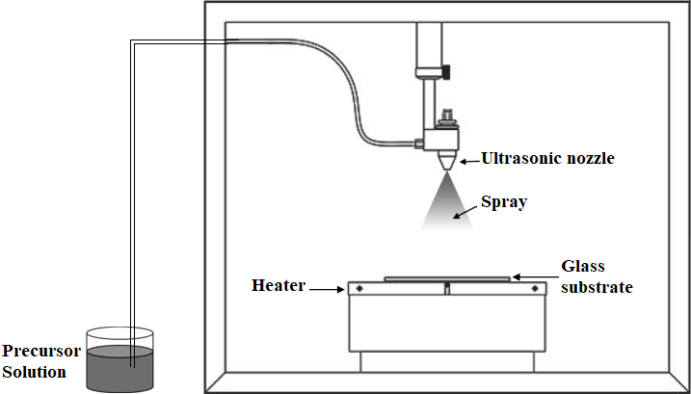

**Figure 1**. Schematic representation of the ultrasonic spray system.

**2.1. Characterizations**

The produced ZnO samples were characterized structurally and morphologically by an x-ray diffractometer system (Bruker AXS D8), a field emission scanning electron microscope with EDX (Zeiss, EVO LS 10), and a Uv/vis spectrophotometer (Rayleigh UV-2601).

**3. Results and Discussion**

**3.1. XRD analysis**

The XRD patterns of some samples are shown in figure 2. The results indicated that all ZnO samples have a wurtzite (hexagonal) structure. Any impurity peak was not observed in the patterns due to niobium metal, niobium/other oxides, or any zinc niobium phase, exhibiting that the as-synthesized samples have single phase. The Nb5+ ions were understood to have substituted the Zn2+ site without changing the hexagonal structure. But, from the patterns of 10 mol %, the Nb5+ ions have difficulty in entering the ZnO lattice. The undoped and Nb-doped ZnO structures have single crystalline (1D) structure owing to have single peak (002). The very strong (002) peak indicates that the c-axis is the fastest growth direction, and the film has rod shape structure.

**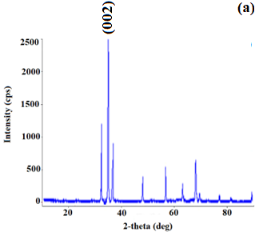 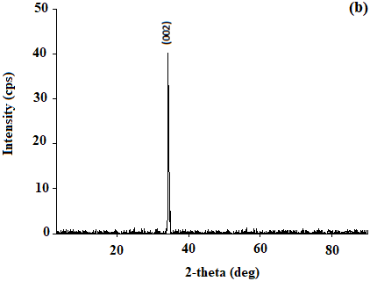**

**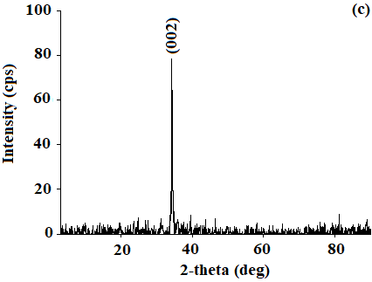 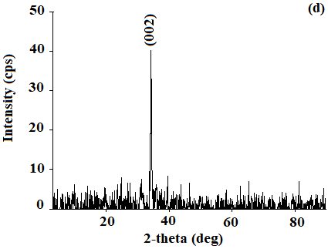**

**Figure 2**. XRD patterns of the samples: (a) u doped ZnO nanorod, (b) 1 mol % Nb-doped ZnO nanorod, (c) 5 mol % Nb-doped ZnO nanorod, (d) 10 mol % Nb-doped ZnO nanorod.

**3.2. FE-SEM analysis**

Figure 3 shows the top view SEM micrographs of undoped and Nb-doped ZnO nanorod samples. All the samples are of wurtzite structure and have a nanorod shape. From the SEM images, it is clear that the undoped and Nb-doped ZnO nanorod samples have homogeneous distribution on the glass substrate. The Nb composition of the doped ZnO nanorod samples was investigated by EDX, and the graphs are shown in figure 3. The EDX results confirm that Nb ions enter the crystal structure.

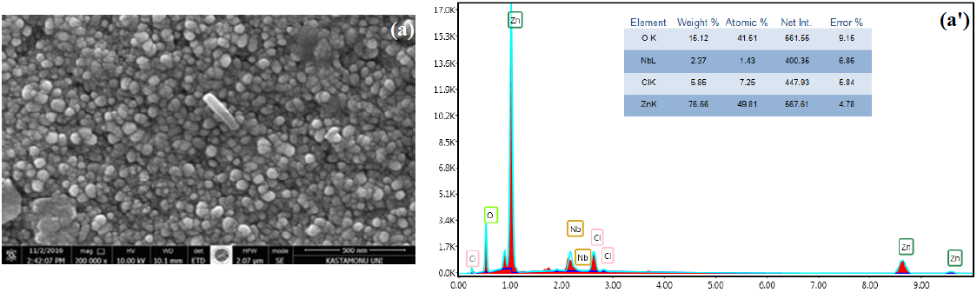

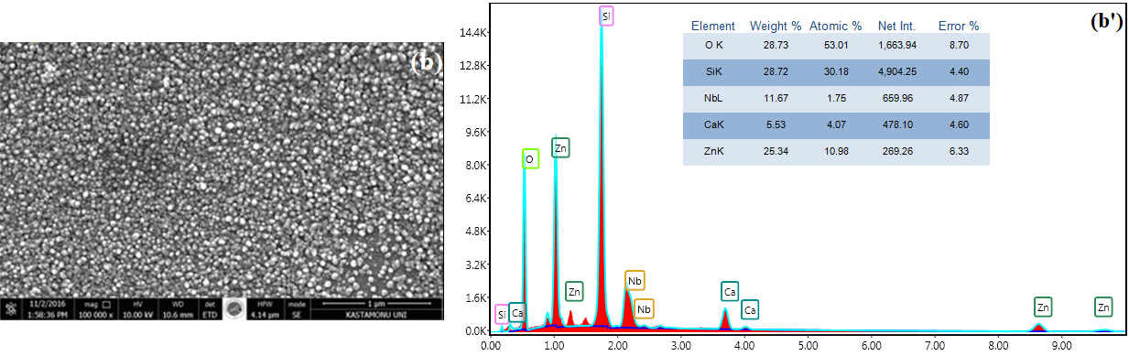

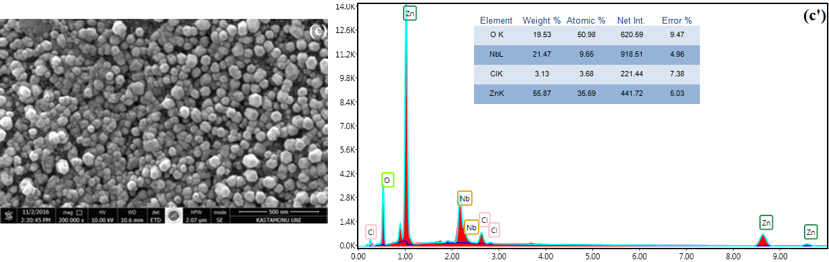

**Figure 3**. Top view FE-SEM images and EDX spectra of the ZnO samples: a-a' 1 mol %; b-b' 5 mol %; c-c' 10 mol % Nb-doped.

**3.3. Optical analysis**

In figure 4, the optical transmittance spectra of 1-10 mol % Nb5+-doped ZnO samples are shown. The optical transmittance values of Nb5+-doped samples are higher than those of undoped ZnO sample. The optical transmittance values of 1, 3, and 5 mol % Nb5+-doped samples are over 90 %. 1 mol % Nb5+-doped sample has the highest optical transmittance. For the doped samples with more than 1 mol %, the Nb5+ doping decreases the optical transmittance value.

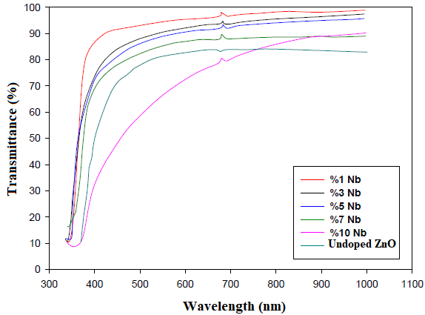

**Figure 4**. Optical transmittance graphs of the ZnO samples.

**Acknowledgment**

This research was financially supported by Çankırı Karatekin University Scientific Research Projects Coordinatorship (ÇAKÜ BAP), Project No. FF031114B05.

**References**

1. Pearton, S.J., Norton, D.P., Ip, K., Heo, Y.W., & Steiner, T. (2003). Recent progress in processing and properties of ZnO. *Superlattices and Microstructures*, 34 (1-2), 3-32.
2. Grzanka, E., Gierlotka, S., Stelmakh, S., Palos, B., Strachowski, T., Sroda, A.S., Kalisz, G., Lojkowski, W., & Porsch, F. (2006). Phase transition in nanocrystalline ZnO. *Zeitschrift für Kristallographie Supplements*, 23, 337-342.
3. Sirelkhatim, A., Mahmud, S., Seeni, A., Kaus, N.H.M., Ann, L.C., Bakhori, S.K.M., Hasan, H., & Mohamad, D. (2015). Review on zinc oxide nanoparticles: antibacterial activity and toxicity mechanism. *Nano-Micro Letters*, 7(3), 219–242.
4. Lee, J.B., Le, H.J., Seo, S.H., & Park, J.S. (2001). Characterization of undoped and Cu-doped ZnO films for surface Acoustic wave applications. *Thin Solid Films*, 398-399, 641-646.
5. Bagnall, D., Chen, Y., Zhu, Z., Yao, T., Koyama, S., Shen, M., & Goto, T., (1997). Optically pumped lasing of ZnO at room temperature. *Applied Physics Letters*, 70 (17), 2230-2232.
6. Tang, Z., Wong, G., Yu, P., Kawasaki, M., Ohtomo, A., Koinmura, H., & Segawa, Y. (1998). Room-temperature ultraviolet laser emission from self-assembled ZnO microcrystallite thin films. *Applied Physics Letters*, 72 (25), 3270-3272.
7. Lee, W., Kang, J., & Chang K. (2006). Electronic structure of phosphorus in ZnO. *Physica B: Condensed Matter*, 376-377, 699-702.
8. Çolak, H., & Karaköse, E. (2017). Green synthesis and characterization of nanostructured ZnO thin films using Citrus aurantifolia (lemon) peel extract by spin coating method. *Journal of Alloys and Compounds*, 690, 658-662.
9. Sangeetha, G., Rajeshwari, S., & Venckatesh, R. (2011). Green synthesis of zinc oxide nanoparticles by Aloe barbadensis miller leaf extract: structure and optical properties. *Materials Research Bulletin*, 46 (12), 2560-2566.