**Designing Fiber-Reinforced Concrete Overlays Adapted to Cold Climate Regions in Türkiye**

***Duygu KAPLANCA1[C:\Users\Abdullah\AppData\Local\Microsoft\Windows\INetCache\Content.Word\ORCID-iD_icon-16x16.gif](https://orcid.org/0009-0001-4822-2783),Dr. Emin ŞENGÜN2[C:\Users\Abdullah\AppData\Local\Microsoft\Windows\INetCache\Content.Word\ORCID-iD_icon-16x16.gif](https://orcid.org/0000-0001-7082-0061)***

*1Graduate Student, Graduate School of Natural and Applied Sciences, Master’s Program in Civil Engineering, Ankara Yildirim Beyazit University, Ankara, Türkiye*

*2Assistant Professor, Faculty of Engineering and Natural Sciences, Department of Civil Engineering, Ankara Yildirim Beyazit University, Ankara, Türkiye*

|  |
| --- |
| **Abstract**  Data from Türkiye’s Ministry of Transport and Infrastructure highlight that highways accounts for approximately 89% of freight and 91% of passenger transport. Over the past decade, records from the General Directorate of Highways reveal a 44% rise in freight and a 30% increase in passenger transport, suggesting a substantial future demand on road infrastructure due to heavy traffic loads. In contrast to practices in developed nations, awareness of rigid pavements (concrete roads) in Türkiye is relatively promising, with flexible pavements like asphalt and seal coats predominating. These types of pavements typically require frequent preventive maintenance, rehabilitation, and overlay applications under heavy traffic load. This study investigates bonded concrete overlay on asphalt (BCOA) as an alternative approach, which has garnered increasing interest in developed countries. The analysis focuses on three pilot cities (Erzurum, Kayseri, and Afyonkarahisar) that represent harsh climatic conditions. For each city, overlay design was developed considering two levels of existing pavement distress (moderate and severe), four traffic volume categories (low, low-moderate, moderate-high, high), and three subgrade conditions (poor, moderate, good). Additionally, with the growing interest in fiber reinforcement for thin concrete overlays, this study examines design variations for both non-reinforced and fiber-reinforced scenarios at dosages of 0, 2.5, and 3.5 kg/m³. These designs are evaluated under two different joint spacing configurations: 1x1 m and 2x2 m. The findings propose customized overlay designs for each city, considering subgrade quality, traffic volume, unique climate conditions, and other relevant factors. As expected, the required overlay thickness increases with higher traffic volumes, poorer subgrade quality, and deteriorated existing pavement conditions. Notably, in addition to the primary benefit of mitigating plastic shrinkage cracking through the fiber bridging effect, the incorporation of fibers enabled a reduction in the recommended overlay thickness by up to 30%. |

|  |  |
| --- | --- |
| Keywords: Concrete Overlay, Rigid Pavement Design, Mechanistic-Empirical Approach, Thickness Design Chart |  |

1. **Introduction**

As of 2024, data from Türkiye’s General Directorate of Highways (GDH) reveals that approximately 65% of the nation’s highways and state roads are surfaced with asphalt concrete (flexible pavement), while 33% are covered with chip-seal pavements. Furthermore, statistics from the Ministry of Transport and Infrastructure indicate that highways dominate freight and passenger transportation in Türkiye, accounting for 89.3% and 91.2%, respectively, compared to maritime, air, and rail transport. Although highways and state roads comprise roughly half of Türkiye’s total road network, they bear a disproportionately large share of transport demand. This heavy dependence on the road network for transport, coupled with significant increases in both freight (44%) and passenger (30%) traffic over the past decade, has led to a pushing need for regular maintenance, and major rehabilitation. In 2022, road freight transport in Türkiye reached 323.5 billion ton-km, while passenger transport totaled 348.5 billion passenger-km, with overall road usage amounting to 140.5 billion vehicle-km. Between 2005 and 2022, the vehicle-km metric increased by 143.3%, ton-km by 106.3%, and passenger-km by 99.9%, highlighting significant growth in road transportation demand over the past two decades [[1](#_ENREF_1)]. As of 2023, approximately 13% of the nation’s highways required major pavement rehabilitation, which entails significant structural reconstruction. Maintenance demands have been met by substantial efforts, including 839 km of HMA pavement construction and rehabilitation and 6,374 km of chip-seal pavement work completed in 2023 alone. Cumulatively, between 2003 and 2023, these figures amounted to 31,395 km of HMA pavement and 273,698 km of chip-seal pavement. The allocated budget for highway and state road repairs in 2024 underscores this effort, with 4.7 billion TL designated for highways and 37.1 billion TL for state roads [2]. Additionally, Türkiye’s increasing vehicle ownership—currently standing at around 28.7 million registered vehicles, according to TÜİK December 2023 data—increases the demand for higher-standard roads. With vehicle ownership rates of 167 cars per 1,000 people (compared to an EU average of 531), Türkiye is projected to see continued growth in traffic density, placing further strain on the existing infrastructure. As traffic volume and heavy-load transport requirements rise, maintenance costs increase, showing the need to explore new, more resilient pavement technologies [[3](#_ENREF_1)].

In many developed countries, concrete pavements are preferred for roads subjected to heavy traffic due to their durability and load-bearing capacity. For instance, in the United States, concrete pavements support a substantial share of traffic on high-volume highways. Similarly, in Canada’s Quebec province, although concrete roads comprise only 4% of the network, they accommodate approximately 75% of total traffic. In Europe, concrete pavements are extensively utilized, particularly in Germany, Austria, and Belgium. In Germany, concrete accounts for about one-fourth of high-traffic highways; in Austria, three-fourths; and in Belgium, nearly half. Furthermore, in Belgium, concrete overlays are used for 60% of village roads, highlighting their versatility and long-term performance [[4](#_ENREF_1)]**.** In Türkiye, concrete pavements are anticipated to play a crucial role in extending the service life of high-traffic, deformation-prone roads while reducing life cycle costs. Although GDH released technical specifications for concrete pavements in 2016, rigid pavement usage remains limited, with only 8.1 km of concrete roads under the GDH’s purview, including pilot projects in Afyon-İşçehisar, Hasdal Kavşağı-Kemerburgaz, Ordu-Ulubey National Road, and Karamürsel City Crossing. Efforts to expand concrete road networks continue through new bidding processes. At this time, the urgent need in Türkiye’s infrastructure lies not in new road construction but in the rehabilitation of existing roads through overlay applications to extend service life, restore ride and increase capacity. In this regard, bonded concrete overlays on asphalt (BCOA) have emerged as a promising alternative, attracting increased interest in developed countries as a cost-effective and durable solution.

Bonded concrete overlays are applied to existing asphalt in fair to good condition in order to repair surface flaws and/or restore structural capacity (Figure 1). To form a monolithic pavement layer, these overlays typically have a thickness of 5 to 15 cm. and are predicated on the idea that the overlay and the existing surface will form a long-lasting physical link. For a pre-overlay surface to be clean and to give the right amount of macrotexture for bonding, special attention to surface preparation tasks is necessary. Pre-overlay repairs may also be necessary to treat severe cracking, spalling, patches, punchouts, pumping, and/or settlement/heaving in the existing pavement in order to reduce the likelihood of reflective cracking [[5](#_ENREF_1)].

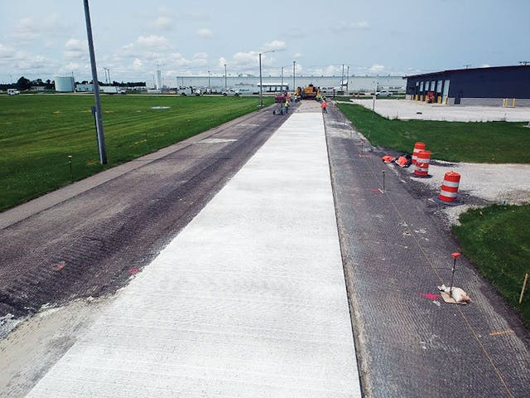

**Figure 1.** Bonded concrete overlay applications (adapted from guide to concrete overlays, 2012)

BCOA pavements can extend their service life by 10-20 years and are a cost-effective rehabilitation option for moderately damaged asphalt pavements**.** They are popular due to their low overlay thickness and ease of construction [[6](#_ENREF_1)]. As project performance data becomes available, better design guidelines may be created to advance their use. These include factors like traffic, climate, existing asphalt pavement structure, and concrete mix design. The design takes economy and utility into account in addition to mechanical factors. The design of bonded concrete overlay thickness is influenced by a number of input factors as traffic, temperature gradient, and existing asphalt modulus, traffic (ESAL), fiber content and joint spacing. The predicted ESALs are the sensitive input and need to be carefully evaluated to fulfill the bonded overlay's performance requirements. The current state of the pavement affects the drainage coefficients, load transmission, and modulus of rupture. In order to avoid overdesigning the thickness of the concrete overlay, pre-overlay repairs are usually carried out to correct significant load transfer and/or drainage defects prior to a bonded overlay being applied. In addition, a number of crucial design factors are listed by Riley (2006) and Roesler et al. (2008). These include the thickness and stiffness of the existing asphalt, the flexural strength of the concrete overlay, the size of the slab, the effective temperature gradient, and the use of structural fibers. In order to prevent excessive concrete drying shrinkage, caution must be used while choosing the concrete mixture design. The proportions of the concrete mixture chosen will still have a big impact on this attribute, even if adequate curing can lessen concrete's early-age shrinkage. Additionally, proper surface preparation is crucial. Debonding at the concrete-asphalt contact may result from excessive shrinkage and/or inadequate surface preparation [[7](#_ENREF_1)-8]**.**

1. **Materials and Methods**

This study selected three provinces in Turkiye's cold regions (Afyonkarahisar, Kayseri, Erzurum), each representing unique climatic conditions, to develop design charts and examine the factors influencing the design of BCOA pavements. The mechanistic-empirical (M-E) design approach was employed using the BCOA-ME software, a finite element-based tool developed by the University of Pittsburgh [9]. BCOA-ME allows for precise overlay thickness predictions for bonded concrete overlays on distressed Hot Mix Asphalt (HMA) pavements of various panel sizes. This tool is advantageous for designers, offering a comprehensive analysis platform for all bonded concrete overlays on HMA, and facilitates the evaluation of design variables such as traffic loads, soil conditions, climate, fiber reinforcement, and joint spacing on overlay performance [9-11]**.**

A 20-year service life was selected to reflect typical performance expectations across the provinces. The study considered three subgrade quality levels (poor, moderate, and good), four levels of Average Annual Daily Truck Traffic (AADT) to represent traffic volume ranges (low, low-moderate, moderate-high, and high), and a C30 concrete strength class. The reliability coefficient was consistently set at 85%, and the maximum allowable cracked slab percentage was limited to 15% in accordance with GHD project demands. Additionally, given the increasing preference for fiber reinforcement in thin concrete overlay applications, synthetic fiber was incorporated at three dosages (0, 2.5, and 3.5 kg/m³) to evaluate its impact on overlay design. Joint spacings of 1x1 m (3x3 ft) and 2x2 m (6x6 ft) were also included in the analysis. Moreover, the condition of the existing asphalt pavement where the overlay will be applied was categorized into two levels: moderate (adequate) and severe (marginal). Accordingly, the percentage of transverse cracks on the existing pavement was taken into consideration in the analysis. The parameters used in the analysis are summarized in Table 1, resulting in a total of 432 idealized design scenarios.

**Table 1.** Design variable values entered into the BCOA-ME Design Program.

|  |  |  |  |  |
| --- | --- | --- | --- | --- |
| Percent Trucks % | Low Traffic=3,3 | Low-Moderate Traffic=16 | Moderate-High Traffic=25 | High Traffic=50 |
| ESAL | 6231000 | 30211000 | 47204000 | 94408000 |
| Composite Modulus of Subgrade Reaction, k-value (Mpa/m) | Good=95 | Moderate=41 | Poor=14 | |
| Fiber Content (kg/m3) | 0% | 2,5% | 3,5% | |
| Existing HMA Performance | Adequate | | Marginal | |
| Joint Spacing (m) | 1x1 (Small Slab) | | 2x2 (Large Slab) | |

The climate data required for the M-E design approach for the selected provinces (Afyonkarahisar, Kayseri, Erzurum) were determined by matching them with values observed at a U.S. station. This method was necessary due to the lack of comprehensive climate data in Türkiye compatible with the BCOA-ME program. The matching process adhered to specified tolerance limits to ensure the selected provinces accurately represented the average conditions for each climate category, as referenced in a previous study [12]. In this way, the equivalent climate stations required for input into the BCOA-ME design program were identified. Figure 2 shows the selected provinces along with their corresponding related maps. AMDAT Region of three provinces is Zone 3. Sunshine zone is Zone 3 for Afyonkarahisar and Kayseri beside Zone 4 for Erzurum.

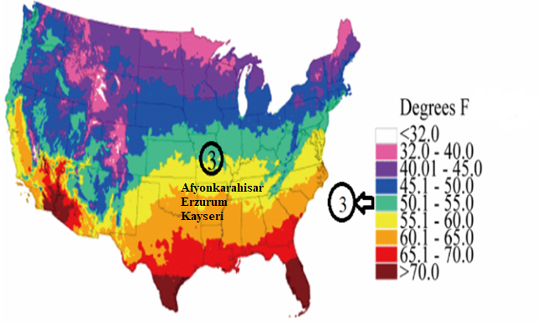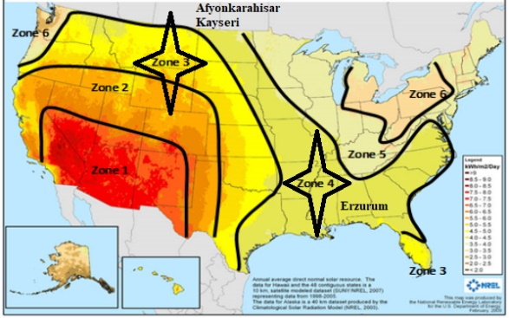

**Figure 2.** Map of AMDAT Region and Map of Sunshine Zone

1. **Results and Discussion**

This section of the study presents analyses conducted using the BCOA-ME program to evaluate bonded concrete overlays on existing asphalt pavements under varying design conditions across three provinces representing cold climate regions in Türkiye. The BCOA-ME program calculates the recommended overlay thickness based on a fatigue cracking model and assesses potential for reflective cracking. Thickness values marked with a “>” indicate that the program suggests using a larger slab size. As a result of 432 of bonded fiber-reinforced concrete overlay design studies across three different provinces of Türkiye, the recommended overlay thicknesses for varying traffic, subgrade, and existing asphalt pavement conditions are summarized in Table 2, Table 3 and Table 4. In these tables, the Composite Modulus of Subgrade Reaction is categorized as "G" for good, "M" for medium, and "P" for poor, reflecting the existing structure modulus in the k-value section. These tables provide a comprehensive overview of the recommended design thicknesses based on the specific conditions in each province.

**Table 2**. Recommended C30 Thin Concrete Overlay Thickness and Joint Spacing Under Different Conditions for Afyonkarahisar

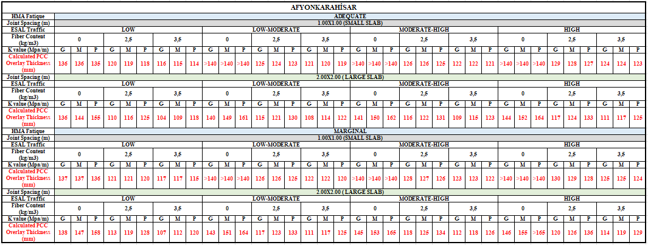

The use of fibers in thin concrete overlays is steadily increasing, primarily due to their ability to mitigate plastic shrinkage cracks through the bridging effect, as well as their enhancement of structural flexural performance when used in higher dosages. This advancement allows the construction of thin concrete overlays without the need for dowel or tie bars in some applications. In this study, it was observed that increasing fiber content resulted in a maximum calculated thickness reduction of approximately 30% in specific cases, notably where fatigue performance was adequate, subgrade conditions were poor, traffic volumes were low, and large slabs were employed. This effect is illustrated in Figure 3. Additionally, the parametric analyses revealed that the impact of fibers on thickness was more pronounced in large slabs compared to smaller slabs. Given the limited experimental studies exploring the influence of fibers on slab size in literature, further research focusing on this area is essential to deepen the understanding of fiber behavior in thin concrete overlays.

**Table 3**. Recommended C30 Thin Concrete Overlay Thickness and Joint Spacing Under Different Conditions for Kayseri

**Table 4.**  Recommended C30 Thin Concrete Overlay Thickness and Joint Spacing Under Different Conditions for Erzurum

**Figure 3.** PCC Thickness vs Fiber Amount Graphics of three provinces (for the case of ESAL-low, k value-poor, 2x2 m).

1. **Conclusion and Recommendations**

With the increasing traffic volumes, growing freight and passenger transportation demands, and rising vehicle ownership per capita, the exploration of new-generation pavement technologies has become crucial for Türkiye. Currently dominated by asphalt pavements, the nation's highway infrastructure requires frequent maintenance and major rehabilitation due to the damage of heavy traffic. In this context, concrete overlays on asphalt pavements, in other words thin whitetopping solution, present a significant opportunity for Türkiye, offering extended service life, ride quality and increased durability. This study focused on applying the BCOA-ME design methodology developed by Pittsburgh University to three provinces representing Türkiye's cold climate regions (Afyonkarahisar, Kayseri, Erzurum). Various scenarios were analyzed, incorporating different traffic levels, subgrade conditions, existing pavement structures, fiber reinforcement dosages, and slab sizes. Using the finite element-based BCOA-ME design program, a total of 432 scenarios were evaluated to generate recommended thickness charts under these conditions. The findings highlighted the substantial impact of fiber reinforcement on the structural design of thin overlay, with thickness reductions of up to 30% observed in certain cases. This can bring to mind the potential of fiber-reinforced thin concrete overlays as a cost-effective and durable solution for Türkiye's high-traffic roads, paving the way for future advancements in sustainable pavement technology.

**Acknowledgement**

This study is based on the master’s thesis research conducted by graduate student Duygu Kaplanca.

**References**

[1] Strateji Geliştirme Dairesi Başkanlığı. (2023*). 2023 Faaliyet Raporu,* Retrieved from [*https://www.kgm.gov.tr/SiteCollectionDocuments/KGMdocuments/MerkezBirimler/Kurumsal/FaaliyetRaporu/2023Faaliyet.pdf*](https://www.kgm.gov.tr/SiteCollectionDocuments/KGMdocuments/MerkezBirimler/Kurumsal/FaaliyetRaporu/2023Faaliyet.pdf)

[2] Karayolu Ulaşım İstatistikleri. (2023). Karayolu Ulaşım İstatistikleri (2023). Retrieved from [*https://www.kgm.gov.tr/SiteCollectionDocuments/KGMdocuments/Yayinlar/YayinPdf/KarayoluUlasimIstatistikleri2023.pdf*](https://www.kgm.gov.tr/SiteCollectionDocuments/KGMdocuments/Yayinlar/YayinPdf/KarayoluUlasimIstatistikleri2023.pdf)

[3] Performans Programı Strateji Geliştirme Dairesi Başkanlığı. (2024). Performans Programı 2024. Retrieved from [*https://www.kgm.gov.tr/SiteCollectionDocuments/KGMdocuments/MerkezBirimler/Kurumsal/PerformansProgrami/2024Performans.pdf*](https://www.kgm.gov.tr/SiteCollectionDocuments/KGMdocuments/MerkezBirimler/Kurumsal/PerformansProgrami/2024Performans.pdf)

[4] Sengun,E., Yaman, I. O., & Ceylan, H.  *“An overview on Rigid Pavement Specifications”, 1st European IRF Europe & Central Asia Regional Congress & Exhibition, presented, İstanbul, Türkiye, 15-18 September 2015.*

[5] Vandenbossche, J.M. and Barman, M. *Bonded Whitetopping Overlay Design Considerations for Prevention of Reflection Cracking, Joint Sealing, and the Use of Dowel Bars*. Transportation Research Record, No. 2155, 2010, pp. 3-11

[6] Agar, E., Sütas, İ., & Öztas, G. *Beton Asfalt Kaplama ile Beton Yol Karşılaştırması*. *Türkiye Hazır Beton Birliği, Beton Yollar Özel Sayısı, 48- 51.* (2001).

[7] Mateos A., Millan M.A., Harvey J.T., Paniagua F., Wu R. (2021) *Mechanisms of asphalt cracking and concrete-asphalt debonding in concrete overlay on asphalt pavements.* [*Construction and Building Materials*](https://www.sciencedirect.com/journal/construction-and-building-materials)*,* [*Volume 301*](https://www.sciencedirect.com/journal/construction-and-building-materials/vol/301/suppl/C)

[8] Barman M., Vandenbossche J.M.,  [Li](https://ascelibrary.org/doi/abs/10.1061/JPEODX.0000010" \l "con3) Z., *Influence of Interface Bond on the Performance of Bonded Concrete Overlays on Asphalt Pavements. Journal of Transportation Engineering, Part B: Pavements, Volume 143, Issue 3*

[9] DeSantis, J.W. *Modeling the Development of Joint Faulting for Bonded Concrete Overlays of Asphalt Pavements (BCOA)*. Ph.D. Dissertation, University of Pittsburgh, Pittsburgh, PA, 2020.

[10] Vandenbossche, J.M. and Barman, M. *Bonded Whitetopping Overlay Design Considerations for Prevention of Reflection Cracking, Joint Sealing, and the Use of Dowel Bars*. Transportation Research Record, No. 2155, 2010, pp. 3-11

[11] DeSantis, J.W., and J.M. Vandenbossche, “*Redevelopment of Artificial Neural Networks for Predicting the Response of Bonded Concrete Overlays of Asphalt in a Faulting Prediction Model*,” *Transportation Research Record: Journal of the Transportation Research Board,* TRB, National Research Council, DOI:[10.1177/03611981211001075](https://doi.org/10.1177%2F03611981211001075), 2021.

[12] Öztürk, HI., Şengün E., Yaman İÖ. (2019). *Comparison of jointed plain concrete pavement systems designed by mechanistic empirical (M-E) method for different traffic, subgrade, material and climatic conditions.* *Journal of the Faculty of Engineering and Architecture of Gazi University.*