**Application and essential components of serial and parallel chopper converters**

***Samatar ALI 1,[[1]](#footnote-1)\*[C:\Users\Abdullah\AppData\Local\Microsoft\Windows\INetCache\Content.Word\ORCID-iD_icon-16x16.gif](https://orcid.org/0009-0002-3777-3165), Murat ARI 2[C:\Users\Abdullah\AppData\Local\Microsoft\Windows\INetCache\Content.Word\ORCID-iD_icon-16x16.gif](https://orcid.org/0000-0002-2935-8204), Mahmud Esad YİĞİT3[C:\Users\Abdullah\AppData\Local\Microsoft\Windows\INetCache\Content.Word\ORCID-iD_icon-16x16.gif](https://orcid.org/0000-0002-0148-1913)***

*1***0009-0002-3777-3165** *Department of Electrical and Electronics Engineering, Çankırı Karatekin University, Çankırı, Türkiye*

*2***0000-0002-2935-8204** *Department of Electrical and Electronics Engineering, Çankırı Karatekin University, Çankırı, Türkiye*

*3***0000-0002-0148-1913** *Department of Electrical and Electronics Engineering, Çankırı Karatekin University, Çankırı, Türkiye*

|  |
| --- |
| **Abstract**  This article discusses the use of a chopper to convert a fixed DC input into a DC output voltage. Choppers are commonly employed in applications such as power supply and motor control. There are types of choppers, including series and parallel choppers. The primary goal of this research is to examine the practical aspects of choppers, in series and parallel configurations to enhance comprehension of their operation principles and control system design well as evaluate their performance in various uses cases. In a series chopper setup, the current (DC) voltage source is connected in series with the motor with the chopper controlling the voltage supplied to the motor. In contrast in a parallel configuration multiple choppers are linked together to increase output current while ensuring a voltage level, across each chopper. This special converter enables the use of devices that require an amount of current to function. |
| **Keywords:** *the current result, direct current voltage , the energy source ,control motor.* |

# 1. Introduction

Chopper converters are a type of power electronics devices that are commonly employed to regulate and transform power supply operations by adjusting the voltage and current to suit the load through the manipulation of semiconductor switch timings effectively managing power distribution in applications, like industrial motor drives and electric vehicles. Chopper converters – also called DC to DC converters – work to adjust the current (DC) voltage from a source to a different level of DC voltage, at the output by utilizing high frequency switching through components like transistors and inductors along, with diodes. The main types of chopper converters are buck converters that decrease the input voltage and boost converters that increase the input voltage as buck boost converters that can perform either function based on the control method employed. Different types of chopper converters have their functions and circuit setups designed to meet specific performance standards and application demands [1-2]. The importance of chopper converters in today’s technology landscape cannot be overlooked as they play a role in converting energy to reduce losses and enhance the overall effectiveness of electronic systems. For example : in energy setups like panels and wind turbines, chopper converters are crucial for streamlining the energy conversion process and ensuring it works seamlessly with the grid or the load. In industry these converters are crucial for electric cars as they regulate the battery power to ensure consistent performance for the driving system. Their efficiency and quick adjustment to varying power needs are also essential in devices such as laptops and smartphones aiding in maintaining stable voltage levels and effective power control.

# 2. Fundamentals Concepts

## 2.1 Basic Operation

Chopper converters are circuits that are built to manage the voltage level between the power source and the device by utilizing high speed switching elements specifically designed for this purpose. The main concept involves turning the power supply both on and off into a process known as duty cycle modulation which determines how long it is switched 'on' in relation, to the time elapsed. This manipulation of duty cycle enables regulation of the power reaching the device resulting in customized output voltage control as needed. Important elements that support this process consist of components, like transistors and diodes, as well as passive devices such as capacitors and inductors that aid in regulating the output and reducing fluctuations in voltage levels. The effectiveness of a chopper converter heavily relies on the frequency at which it switches and the quality of its parts; higher frequencies typically result in operation. Can also cause more heat stress, on the electronic components[3].

## 2.2 Types of Converters

Chopper converters come in varieties depending on their circuit setups. The connection, between input and output voltages are categorized broadly into various types such, as buck converters boost converters buck boost converters and Cuk converters A buck converter is used when there is a need to decrease the voltage from the input to the output bringing down the voltage while possibly boosting the current capacity On the side of things a boost converter works to raise the input voltage to an output voltage. This is usually applied in situations where the source voltage must be increased for use. The buck. Boost converter provides flexibility by being able to raise or lower the voltage based on the duty cycle, which proves handy in power supplies that must function under input voltage scenarios. The Cuk converter stands out for utilizing two inductors and capacitors to offer output flexibility along, with the advantage of maintaining pulsating input and output currents to reduce noise and enhance power supply quality—a key consideration when selecting the right converter, for a particular application based on specific electrical needs and operational conditions. Categorizing these systems do not help in the development and application but also highlights the wide-ranging potential and versatility of chopper converters, in today’s electronics and power setups [4].

**3. Serial Chopper Converters**

**3.1 Design and Components**

The setup of chopper converters prominently features an arrangement of semiconductor switches, like transistors or Mosfets and a diode for freewheeling and an inductor to manage energy during switching cycles. The functioning relies on regulating the flow of current in the circuit through the series switch with precision to control the output voltage effectively. The duration for which the switch conducts electricity. Known as the duty cycle. Plays a role in determining the output voltage supplied to the load. It's important to use an inductor because it helps to out the changes in current caused by switching actions and keeps the output stable to avoid voltage spikes. Moreover, you can also use capacitors at the output to reduce any remaining voltage fluctuations and ensure a DC output that works well for electronic devices[5].

**3.2 Applications and Advantages**

Serial chopper converters are widely used in scenarios that require voltage regulation and optimal efficiency as a priority. Hence, it's common to find them in gadgets powered by batteries to prolong battery life, by converting energy. Their presence is also crucial in electronics for vehicles to effectively handle the power flow between batteries and motors. Serial choppers excel at delivering an regulated output which makes them perfect, for supplying power to delicate systems needing consistent voltage even when the load changes. One of the benefits of chopper converters is their high efficiency and simple design approach compared to parallel converters. In a setup energy flows through components decreasing energy losses, from component resistance and leakage currents. This efficiency is especially advantageous for battery operated devices where conservating energy's key to prolong device life. Moreover, the uncomplicated circuit design makes implementation easier. Lowers manufacturing expenses making chopper converters a cost-efficient option, for various applications.

**4. Parallel Chopper Converters**

**4.1 Design and Components**

In the setup of chopper converters design framework that you see around a lot these days involves using a transistor or some other fancy switching device hooked up parallel to the load. The main job of this switch in this setup is to take turns powering the load by diversifying the current flow away from it now and then to manage how much voltage is hitting the load when it’s not being powered. A key part of this design is having a freewheel diode set up across the load to help keep the current flowing during those times when the switch takes a break from powering things up – this way there aren't any hiccups in how the load runs. This setup requires an inductor to be used connected in a row, with the power source to ensure a flow of current while switching occurs. Additionally, capacitors are utilized to stabilize the voltage and reduce any fluctuations. [6]

**4.2 Applications and Advantages**

In situations where quick and efficient voltage regulation's crucial and a rapid response is needed to handle changing load demands or potential faults in power systems, like applications for overload protection in power supplies. Parallel chopper converters are commonly used for their ability to swiftly redirect current flow. Their setup allows them to deliver performance in systems, with load changes which helps maintain stability and reliability of the voltage supply. The benefits of chopper converters are highlighted by their ability to handle abrupt shifts, in load demands effectively—a crucial aspect in scenarios with dynamic power needs. Encapsulated within the structure is a built-in safety net; should a switch falter, the load can be supplied power via the freewheel diode albeit at a diminished rate—thus guaranteeing equipment continuity. This aspect positions parallel converters as an option, for systems requiring constant power supply. Furthermore, these converters generally experience voltage strain on the switching parts, which can result in increased component longevity and decreased maintenance requirements. This adds to their attractiveness, in high reliability contexts[7].

**5. Managing and Regulating Series and Parallel Power Converters**

This research delves into the synchronization of phases in power converters that are vital for maintaining resilient power supply systems in various applications. By utilizing synchronization methods in these converters, they can efficiently handle loads and improve system reliability by enhancing current load distribution. The significance of this lies in energy scenarios where the dependable integration of power sources is crucial. The study merges ideas from dynamics and control theory to enhance converter efficiency and stability for performance, in demanding settings [8-9]. This research delves into the control techniques for transforming series configurations into systems. Discusses the crucial factors in distributing voltage and current among converter units to enhance the efficiency and dependability of intricate power networks. The study focuses on applications, in power arrangements commonly found in renewable energy systems where adaptability and expandability are key considerations. By examining theories and conducting experiments to confirm findings in practice; the research offers strategies, for regulating DC to Dc converters and DC, to Ac inverters in both series and parallel setups to maintain optimal performance when dealing with different loads.

**6. Simulation Results**

Understanding the behavior of choppers through simulations is essential for understanding their characteristics and evaluating their efficiency before putting them into use. Monitoring how voltage and current switches influence the optimization of design parameters and predicting problems such, as interference or current fluctuations is highly significant. Analyzing timing diagrams in simulations contributes to the enhancement and fine tuning of chopper converters. The diagram demonstrates the operation of the printer by depicting both its on) and inactive (off) states based on the switching mechanism. The setup includes: A DC power supply, E>0. A functioning electrical switch (when the connection is made u=0), with one-way current flow H. A device that consumes electricity.

The circuit is defined by the following relationship [10]:

$E=u_{h}+u$ (1)

When the switch labeled H moves back and forth it switches between being open and closed.

$T=t_{f}+t_{u}$ (2)

where; $t_{f}$ is the time when H closes and $t_{u}$ is the initial period.

$f=1/T$ (3)

The cyclic ratio α is given by:

$α=\frac{t_{f}}{T}; 0≤α≤1$ (5)



Figure 1. Circuit of step-down Serial chopper.

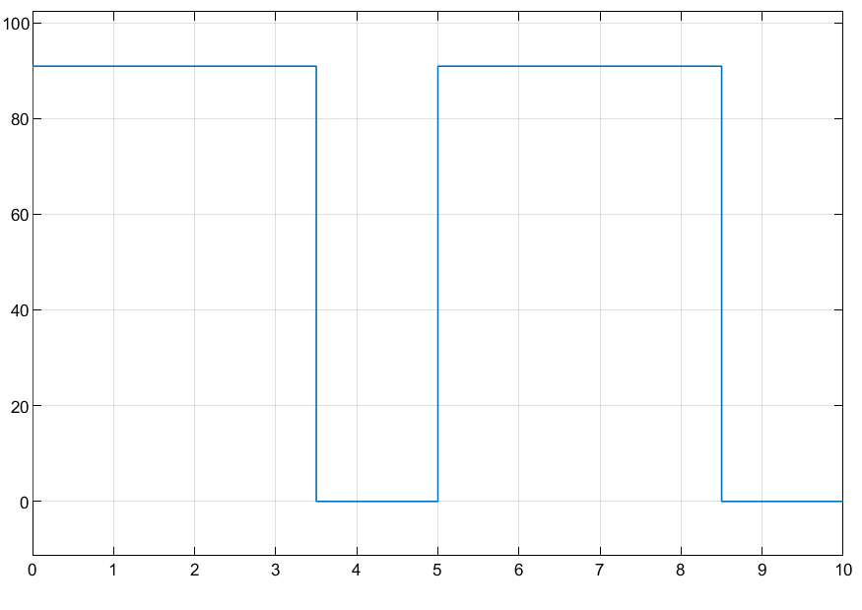

**Figure 2**. Serial chopper circuit diagram.

Analyzing and fine tuning the performance of a DC converter using a chopper parallel simulation allows for optimization without physically constructing the circuit. By utilizing software to model its behavior adjustments, to parameters can be made seamlessly. This predictive approach aids in assessing response, energy efficiency and overall stability paving the way for the creation of dependable solutions, across a range of industrial and technological settings.

The voltage output expression is given as:

${ V}_{out}=\frac{D}{1-d}*V_{in}$ (6)

Equation (6) can be used to relate the input voltage ${ V}_{in}$ to the output voltage ${ V}_{out}$. Since Dd is a variable (usually indicating the duty cycle in electronics), perform these steps:

1. Determine Range of Dd: Typically, Dd ranges from 0 to 1 (0% to 100%).

2. Plot Dd on the *x*-axis; this is the cycle ratio. Determine ${ V}_{out}$ for Dd values: Calculate ${ V}_{out}$ using the equation with Dd values from 0 to 1.

3. Plot n the y-axis: This shows the voltage at the output.

The objective of the two rotor simulation experiments is to investigate the effect of load fluctuations on voltage and current levels in a configuration consisting of a DC power supply in combination with elements such as keyhole transistors (such as MOSFET or IGBT). Free-rotating code for protected flux control. The BUCK converter acts as a reducing converter. It reduces the output amplitude compared to the input amplitude. The BOOST converter increases the output voltage above the input voltage level. As revealed by simulations and experimental tests. This is consistent with calculation errors resulting from readout errors and instrument inaccuracies. The decision to use a configuration depends on the application requirements, such as voltage and current requirements. and desired level of performance together with considerations of the complexity of designing and maintaining peak power and impedance in electrical systems.

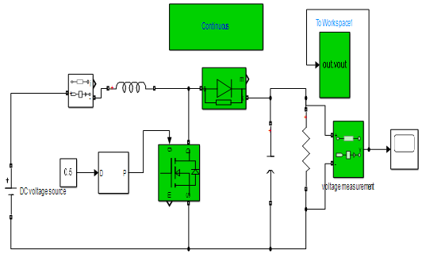

**Figure 3.** Parallel chopper circuit board.

**Figure 4**. diagram parallel circuit.

In simulations studies have shown that the choice, between a chopper and a parallel chopper largely depends on the needs of the application at hand. Serial choppers are known for their ability to regulate voltage and respond swiftly to changes in contrast to parallel choppers which can adjust to loads and maintain power efficiency in diverse scenarios. When deciding in this regard it is crucial to consider the intricacy of the design as the associated costs involved. Both types of choppers effectively handle output voltage requirements. With serial choppers being particularly strong, in accuracy and responsiveness while parallel choppers excel in providing stability for fluctuating or long-term loads.

**7. Conclusion**

In this study paper we have delved into the design and operational concepts of parallel chopper converters to explain their crucial functions, in today’s electronic and power systems world. After analyzing both setups thoroughly, each converter type comes with benefits tailored for uses which emphasize the flexibility and adjustability of chopper converters in efficiently handling and enhancing power distribution in diverse situations. Serial chopper converters are known for their effective design and high efficiency levels which make them valuable for situations where a consistent and reliable power supply is needed even with fluctuating conditions in operation settings. They can prolong the battery life of handheld devices. Are cost efficient to produce making them a popular choice in the consumer electronics and automotive sectors. On the chopper converters exhibit excellent performance, in scenarios that need quick dynamic responses, and strong operational safety measures These converters have a knack, for managing changes in workload and their fail safe mode makes them essential, for crucial power supply setups and protective electronic uses.

**References**

[1] Ahmad, H., & Hagiwara, M. (2020). Interleaved bidirectional chopper with auxiliary converters for DC electric railways. *IEEE Transactions on Power Electronics*, 36(5), pp.5336-5347.

[2] Du, S., & Liu, J. (2013). A study on DC voltage control for chopper-cell-based modular multilevel converters in D-STATCOM application. *IEEE Transactions on Power Delivery*, 28(4), 2030-2038.

[3] Bououd R., & Sbita L. An overview of chopper topologies. International Conference on Green Energy Conversion Systems (GECS), Hammamet, Tunisia,2017.

[4] Luo, F. L., & Ye, H. (2016). *Advanced DC/DC Converters*. CRC Press.

[5] Salinas, F., Ghanes, M., Barbot, J. P., Escalante, M. F., & Amghar, B. (2014). Modeling and control design based on petri nets for serial multicellular choppers. *IEEE Transactions on Control Systems Technology*, 23(1), pp.91-100.

[6] Ajami, A., Shokri, H., & Mokhberdoran, A. (2014). Parallel switch‐based chopper circuit for DC capacitor voltage balancing in diode‐clamped multilevel inverter*. IET Power Electronics*, 7(3), pp.503-514.

[7] Melkebeek, A., & Melkebeek, J. (2018). DC Chopper. Electrical Machines and Drives: Fundamentals and Advanced Modelling, pp.263-275.

[8] Giral, R., Martinez-Salamero, L., & Singer, S. (1999). Interleaved converters operation based on CMC*. IEEE Transactions on Power Electronics*, 14(4), pp.643-652.

[9] Mazumder, S., Nayfeh, A., & Borojevic, D. (2002). Robust control of parallel DC-DC buck converters by combining integral-variable-structure and multiple-sliding-surface control schemes. *IEEE Transactions on Power Electronics,* 17(3), pp.428-437.

[10] Ruan, X., Chen, W., Fang, T., Zhuang, K., Zhang, T., & Yan, H. (2019). Control of Series-Parallel Conversion Systems. Springer, Singapore.

1. \* Corresponding author. *e-mail address: samataralimiguil@gmail.com* [↑](#footnote-ref-1)